Chromatic Accessibility in Latin American University Websites: A Large-Scale Survey of WCAG Contrast Compliance
Abstract
Web accessibility audits at scale have historically concentrated on North American and European institutions, leaving Latin American higher education largely unexamined. We crawled the homepages of 464 Latin American university websites across 17 countries and successfully extracted computed text/background color pairs from 259 of them (41,360 pairs in total). Each pair was converted from sRGB to CIELAB and evaluated against the WCAG 2.2 contrast thresholds, with the axe-core accessibility engine used as an automated heuristic cross-check (yielding moderate correlation, r = 0.347). We find that 21.6% of all color pairs fail the AA threshold, and 93.5% of sites contain at least one critical failure. A pair-level chi-square test suggests compliance differs by country (χ²=1625.04, df=16, p < 0.001, Cramér's V = 0.198), but because color pairs are clustered within sites rather than independent, we treat this as exploratory: a site-level test on the true unit of analysis (256 sites, countries with ≥5 sites) is not significant (χ² = 22.98, df = 15, p = 0.085). We also checked whether a within-site typography effect (large text failing less often) would be more robust to this clustering concern; it is not: the effect does not survive site-clustered robust standard errors (p = 0.473), though continuous font size in pixels retains a small, marginally significant association with failure (p = 0.027). Unsupervised clustering of the failing pairs in the full CIELAB L∗a∗b∗ space confirms our initial hypothesis rather than complicating it: near-neutral, low-chroma clusters consistent with the “light gray on white” pattern account for 80.0% of all failing pairs, with four smaller chromatic clusters spanning the remaining 20.0%.

1. Introduction
Web accessibility is frequently framed as a compliance checkbox rather than as a problem of information design: which visual choices allow a message to be perceived by the range of readers who will actually encounter it. Color contrast between text and its background is one of the most consequential of those choices, because unlike many other accessibility barriers it is silent: a page can look complete to a sighted designer working under ideal lighting on a calibrated monitor while remaining functionally illegible to a large fraction of visitors.
Large-scale, empirical audits of contrast compliance exist, most notably WebAIM's annual scan of the top one million global home pages (WebAIM, 2026), which finds low-contrast text on 83.9% of pages and identifies it as the single most common accessibility failure detected, unchanged in rank for seven consecutive years. Such global scans report an aggregate world figure, though, and are not designed to, and do not, break results out for Latin American higher education specifically. Latin American higher education, more than 460 institutions across 19 countries, has not, to our knowledge, been the subject of a comparable regional survey. This is a meaningful gap: university websites are a primary public-facing channel for admissions, financial aid, and academic information, and design conventions, content management systems, and institutional resourcing in the region differ enough from those studied elsewhere that findings cannot simply be assumed to transfer.
This paper reports a large-scale survey of chromatic accessibility on the homepages of Latin American universities. Rather than relying on a small hand-picked sample, we build a stratified list of institutions from an open, community-maintained directory, crawl each homepage with a real browser engine to capture computed (post-CSS) color pairs, and classify every pair against the WCAG 2.2 (W3C, 2023) contrast thresholds. We ask two questions. First, at what rate do these institutions fail contrast requirements, and does that rate vary systematically by country? Second, what visual pattern, if any, characterizes the colors involved in a failure? The second question matters because the answer determines what kind of intervention would actually help: a narrow pattern (e.g., light gray body text) suggests a simple style-guide fix, while a diffuse one suggests a more structural design-literacy problem.
The contributions of this work are: (1) the first large-scale regional survey of chromatic accessibility for Latin American university homepages, built from a stratified sample of 464 institutions across 17 countries; (2) a site-level, clustering-aware statistical treatment of the country question that distinguishes a descriptive pair-level pattern from a confirmed site-level effect; (3) an unsupervised characterization, in the full CIELAB color space, of the visual patterns underlying contrast failures in this region, showing that two low-chroma, near-neutral clusters (a near-white and a mid-gray pattern) jointly dominate, with four smaller chromatic clusters accounting for the remainder.

2. Related Work
Contrast and legibility research inside the graphic design literature has largely focused on typography and reading performance rather than on regulatory thresholds. Weingerl et al. (2022) studied the visibility and legibility of short words under controlled experimental conditions, establishing that legibility judgments depend jointly on typographic and perceptual factors rather than on any single variable in isolation, a finding that motivates our decision to treat contrast as one factor among several (font size, weight) rather than in isolation. Punsongserm and Suvakunta (2025) conducted a technical review of typeface choice, type size, and color contrast in government mobile applications, and, closer to our own setting, found systematic WCAG non-compliance in public-sector digital products, a pattern we replicate, in a different modality and region, for public university websites. Ofosu-Asare (2024) examined usability and design evaluation techniques for online learning environments, noting that accessibility in educational digital products is usually assessed qualitatively or on small samples rather than through a large-scale automated survey, which is the gap this paper addresses directly for the chromatic dimension. Chromatic reproduction in printed media — including the drying and ink formulation properties that govern gamut and delta-E — has been studied within this journal's tradition (Aydemir et al., 2021); the digital counterpart of that problem, namely whether the sRGB palette chosen for web interfaces falls within the perceptually accessible gamut, is the chromatic problem this paper addresses.
The conceptual foundation of our study rests on the universal web accessibility argument advanced by Henry, Abou-Zahra and Brewer (2014), who established that accessibility is not a special-case concern for users with disabilities but a universal quality requirement: low contrast degrades legibility for all users under adverse ambient conditions (sunlight, low-quality screens, ageing displays), making compliance with WCAG contrast thresholds a baseline quality requirement rather than a minority accommodation. Rello and Baeza-Yates (2013) further demonstrated that typographic and chromatic choices jointly affect reading speed and comprehension for users with dyslexia — a population not typically captured by automated accessibility audits focused on WCAG pass/fail — reinforcing the argument that a perceptual analysis in continuous CIELAB space, rather than a binary threshold test, provides richer information about the actual user experience.
The closest direct precedent in the Latin American higher-education domain is the body of work by Acosta-Vargas and collaborators, who have conducted the most systematic prior surveys of university website accessibility in the region. Their 2018 study (Acosta-Vargas et al., 2018) evaluated 348 Latin American university websites using the WAVE automated accessibility engine, cataloguing a broad range of WCAG 2.0 failures and confirming that color contrast is among the most frequently occurring ones; it is the benchmark against which our 93.5% per-site failure rate and our 21.6% pair-level failure rate should be positioned. A subsequent heuristic method for low-vision accessibility (Acosta-Vargas et al., 2019) extended this to a perceptual dimension, arguing that WCAG's relative-luminance threshold is a necessary but not perceptually sufficient criterion, a theoretical position that directly motivates our decision to cluster failing pairs in the full CIELAB L*a*b* space rather than stopping at the WCAG ratio alone. Their 2020 dataset (Acosta-Vargas et al., 2020) makes the evaluation data for 368 pages publicly available, enabling direct comparison with automated-tool outputs; our study is methodologically complementary in that we use a different pipeline (computed-style extraction via Playwright rather than a WAVE rule-engine scan) and restrict the analysis to the chromatic dimension specifically, extracting every text/background color pair in CIELAB coordinates rather than returning a binary pass/fail per element, which allows us to characterize the failure patterns in continuous color space. More recent work by the same group confirms that the contrast failure pattern extends beyond the university sector: Acosta-Vargas et al. (2022) found contrast errors to be the dominant accessibility barrier in 50 top-ranked e-commerce websites (83.1% of failures classified as 'perceivable' violations), and a complementary mobile-app study (Acosta-Vargas et al., 2021) reported that 86% of Ecuadorian Android applications in Google Play failed WCAG contrast criteria — a finding that situates our university-website result within a broader pattern of contrast non-compliance across Latin American digital products.

3. Methodology
3.1 Site selection
We built the candidate list from the Hipo/university-domains-list open dataset, filtered to the 19 countries of Latin America, and drew a stratified random sample across countries (capped per country to avoid Brazil and Mexico dominating the list). The final list contained 464 domains across 17 countries; the source dataset contained no entries for Bolivia or Venezuela, which are consequently absent from this study (see Limitations).
3.2 Crawling
Each homepage was visited with a headless Chromium browser (Playwright), identifying our crawler with a descriptive user agent and honoring robots.txt (fetched with the same identifying user agent, since fetching it with a generic client triggers 403 responses on several sites and would otherwise cause valid, crawlable sites to be excluded by mistake). Requests were rate-limited to one every two seconds. Of the 464 domains, 278 (59.9%) were successfully rendered; the remainder were unreachable, timed out, or were excluded by robots.txt (see Table 1).
3.3 Color pair extraction
For each of the 278 reachable sites we revisited the live page a second time and, via getComputedStyle(), extracted every visible text node's computed text color together with its effective background color, resolved by walking up the DOM ancestor chain until a non-transparent background is found, since a text element's immediate parent is frequently transparent. Elements with zero width/height, display:none, visibility:hidden, or zero opacity were discarded. This step requires a live browser rather than the raw HTML saved during crawling, because a serialized DOM does not inline externally linked CSS; computing style from the saved markup alone would silently fall back to browser defaults. This yielded 41,360 color pairs from 259 sites (19 sites returned no usable pairs, typically due to navigation during evaluation).
3.4 Contrast calculation and cross-validation
Each pair's WCAG relative luminance and contrast ratio were computed directly from sRGB, and each pair was independently converted from sRGB to CIELAB (CIE, 1976) (D65 illuminant) for the clustering analysis. As a cross-check, we additionally ran the axe-core accessibility engine (the library underlying most commercial accessibility linters) against the same live page and recorded its color-contrast violation and pass counts.
3.5 Classification and aggregation
Following WCAG 2.2, each pair was classified as fail, AA, or AAA using thresholds that depend on text size: 3:1 (AA) / 4.5:1 (AAA) for large text (≥24px, or ≥18.66px bold), and 4.5:1 (AA) / 7:1 (AAA) otherwise. Results were aggregated per site (median ratio, % of pairs failing AA, whether the site has at least one critical failure).
3.6 Statistical analysis
We tested independence between country and AA compliance with a χ² test (continuity-corrected, restricted to countries with ≥30 pairs) and report Cramér's V as effect size. This test, like any test run on the 41,360-pair table, treats color pairs as independent observations, but pairs from the same site share a common design system and are not independent draws, a form of pseudo-replication that inflates the effective sample size and can make a null or weak site-level effect appear significant at the pair level. To address this directly rather than only flag it, we repeat the country comparison at the site level, the unit at which country actually varies: a χ² test on each site's binary critical-failure status, and a Kruskal-Wallis test on each site's continuous %AA-failure, both restricted to the 16 countries with ≥5 sites (256 of 259 sites). We fit a logistic regression of pair-level failure on country, font size, and whether the text qualifies as “large,” and repeat it with site-clustered robust standard errors (generalized estimating equations, independence working correlation, clustered by site) to check which effects survive proper clustering rather than only the country effect. We clustered the failing pairs' text-color coordinates in the full, standardized CIELAB L∗a∗b∗ space with k-means, rather than the a∗b∗ chroma plane alone, since WCAG failure is a function of luminance and a chroma-only clustering would place every achromatic color at the origin regardless of lightness; we searched k ∈ {2,…,20} for a silhouette-optimal solution before fixing k = 6 for interpretability (Results).

4. Results
Outcome | Count
Successfully rendered | 278
Unreachable / timed out / other error | 167
Excluded by robots.txt | 19
Table 1. Crawl outcomes for the 464 sampled domains.
Across the 41,360 extracted color pairs, 21.6% fail the applicable WCAG AA threshold, 16.6% meet AA but not AAA, and 61.8% meet AAA (Figure 1). At the site level, 93.5% of the 259 successfully analyzed homepages contain at least one critical (failing) pair, and the median site has 19.9% of its pairs failing AA, so failures are not concentrated in a handful of outlier institutions; they are the norm. This per-page failure rate is higher than WebAIM's 83.9% figure for the global top one million home pages (WebAIM, 2026), though the two figures come from different detection pipelines applied to different populations and should be read as an order-of-magnitude reference rather than a controlled comparison (Limitations).
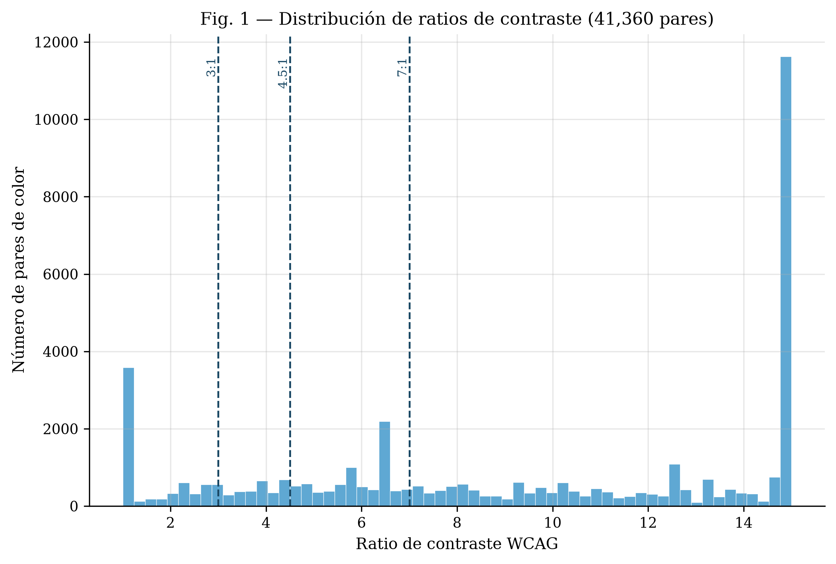
Figure 1. Distribution of WCAG contrast ratios across the 41,360 extracted color pairs, with the AA and AAA thresholds marked.
Country | Sites | Median % AA-fail | % sites, ≥1 critical fail
Argentina | 27 | 22.0 | 96.3
Chile | 27 | 15.0 | 96.3
Brazil | 26 | 12.4 | 92.3
Colombia | 26 | 19.0 | 100.0
Ecuador | 24 | 20.1 | 91.7
Peru | 21 | 25.4 | 81.0
Costa Rica | 19 | 24.0 | 94.7
Mexico | 15 | 9.0 | 73.3
Dominican Republic | 15 | 33.6 | 100.0
El Salvador | 13 | 15.5 | 100.0
Guatemala | 10 | 22.3 | 100.0
Nicaragua | 9 | 33.3 | 88.9
Panama | 7 | 14.3 | 100.0
Cuba | 6 | 31.6 | 100.0
Honduras | 6 | 22.9 | 83.3
Paraguay | 5 | 15.6 | 100.0
Table 2. Descriptive statistics by country (16 countries with ≥5 sites; 256 of 259 sites).
Table 2 gives descriptive statistics by country before turning to the significance question. The pair-level test suggests compliance varies by country (χ² = 1625.04, df = 16, p < 0.001, Cramér's V = 0.198; Figure 2), and the pair-level logistic regression finds most country coefficients individually significant (e.g., Paraguay: β = −2.23, p < 0.001; Cuba: β = +0.57, p < 0.001). We do not take this at face value: because pairs are clustered within sites, the pair-level test's effective sample size (41,360) overstates independent information, and its p-values should be read as optimistic. The site-level test, restricted to the 256 sites in the 16 countries with ≥5 sites, is not significant either on critical-failure status (χ² = 22.98, df = 15, p = 0.085) or on continuous %AA-failure (Kruskal-Wallis H = 21.53, p = 0.121). Because the site-level critical-failure rate is high (most countries have few or no compliant sites), several cells of the country x failure contingency table have an expected count well below the conventional rule-of-thumb minimum of 5 for the chi-squared approximation to be reliable (minimum expected count = 0.33); as a robustness check we therefore also ran a 10,000-iteration Monte Carlo permutation test (shuffling critical-failure status across sites within the same country distribution and recomputing chi-squared each time), which agrees closely with the asymptotic result (p = 0.081), so this is not an artifact of the chi-squared approximation breaking down. We therefore report the country effect as a real but unresolved pattern (visible and directionally consistent at the pair level, but not confirmed at the site level with the sample sizes available here) rather than as a confirmed finding, and we do not treat the specific per-country coefficients above as reliable individually. We initially expected typography to be on firmer ground, reasoning that because “large text” varies within a site (a single page mixes body and heading sizes) its effect would not be vulnerable to the same between-site clustering concern. This expectation does not survive a direct check: refitting the logistic regression with site-clustered robust standard errors (a generalized estimating equations specification, independence working correlation, clustered by site) rather than pooled naive ones leaves the large-text coefficient unchanged in size (β = −0.10) but no longer significant (p = 0.473, versus p = 0.022 pooled), so we do not treat it as a reliable finding. Raw font size in pixels fares better: it retains a significant, though far more modest, positive association with failure under the same clustered specification (β = +0.0108, p = 0.027, versus p < 0.001 pooled). Of the two typography variables tested, only continuous font size in pixels survives clustering-robust inference, and only marginally; the categorical large-text effect does not.
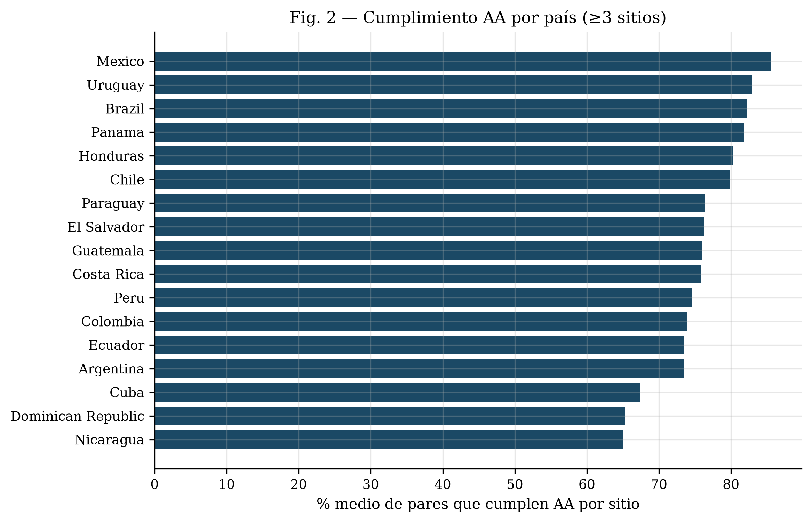
Figure 2. Mean AA compliance rate by country at the website level (n ≥ 3 sites per country, 17 countries including Uruguay, 259 total sites; descriptive; see main text for why the associated significance test is not treated as confirmatory). Note that Table 2 restricts descriptive statistics to the 16 countries with n ≥ 5 sites (256 sites) for statistical robustness.
We clustered the 8,925 failing pairs' text-color coordinates in the full, standardized CIELAB L∗a∗b∗ space with k-means at k = 6 (silhouette = 0.796); we cluster on all three coordinates, not a∗b∗ alone, since WCAG failure is governed by luminance and a chroma-only projection would collapse every achromatic color (black, gray, white) onto the origin regardless of its lightness, which would settle the composition question by construction rather than measure it. We searched silhouette over k ∈ {2,…,20} as a robustness check rather than selecting k by silhouette maximization: the score does not have a clear interior maximum over that range, so we fix k = 6 for interpretability. The resulting partition separates the low-chroma pairs into two clusters at different lightness levels rather than merging them: a near-white cluster (mean L∗ = 99.5, chroma ≈ 0.2, 60.1% of failing pairs) and a mid-gray cluster (mean L∗ = 51.7, chroma ≈ 5.0, 19.9%), together 80.0% of all failing pairs, with four markedly smaller chromatic clusters (4.1% to 6.1% of pairs each, chroma 41.6–78.4) spanning red, blue, yellow-green, and green regions of the plane (Figure 3). The near-white cluster's lightness (L∗ = 99.5, indistinguishable from pure white) is consistent with the background-image detection artifact discussed in Limitations: at least part of this cluster is likely mislabeled text-over-image rather than genuinely near-white text. Agreement between our contrast-ratio-based failure count and axe-core's independent color-contrast violation count is positive but moderate (r = 0.347 across sites), which is expected given the two tools differ in which elements they consider evaluable (axe-core additionally skips certain non-text and gradient cases that our extraction still captures).
Text (hex) | Background (hex) | n pairs | Ratio (median) | ΔE (median)
#FFFFFF | #FFFFFF | 2,379 | 1.00 | 0.0
#777777 | #FFFFFF | 186 | 4.48 | 50.0
#9F6B6B | #F2F2F2 | 172 | 3.92 | 50.2
#E33B3B | #FFFFFF | 160 | 4.24 | 89.4
#FFFFFF | #EDEDED | 137 | 1.17 | 6.3
#BFAC51 | #FFFFFF | 124 | 2.27 | 57.0
#999999 | #FFFFFF | 116 | 2.85 | 36.8
#00BCD4 | #FFFFFF | 87 | 2.30 | 48.8
#FFFFFF | #F2F2F2 | 81 | 1.12 | 4.5
#959595 | #FFFFFF | 76 | 3.00 | 38.3
Table 3. The 10 most frequent failing color pairs, with median WCAG contrast ratio and median CIELAB ΔE (CIE76). Note: ΔE is evaluated using Euclidean distance in CIELAB space (CIE76), which provides an intuitive, geometrically transparent distance metric directly aligned with the k-means feature space, whereas CIEDE2000 incorporates complex perceptual weighting factors unnecessary for standard Euclidean clustering.
Table 3 shows that the single most frequent failing pair, by a wide margin, is white text on a white background (2,379 occurrences, ΔE = 0). We cannot fully distinguish two explanations from the extracted data: text genuinely styled to match its background (a fully invisible pair), and text rendered over a photographic or gradient background-image, which our background-color resolution (Methodology, Limitations) would also record as white-on-white, since it only inspects background-color up the DOM ancestor chain. Both explanations describe real accessibility failures, but only the first is a literal invisible-text pattern; the practical implication (this is the single largest identifiable failure signature in the dataset) holds either way.
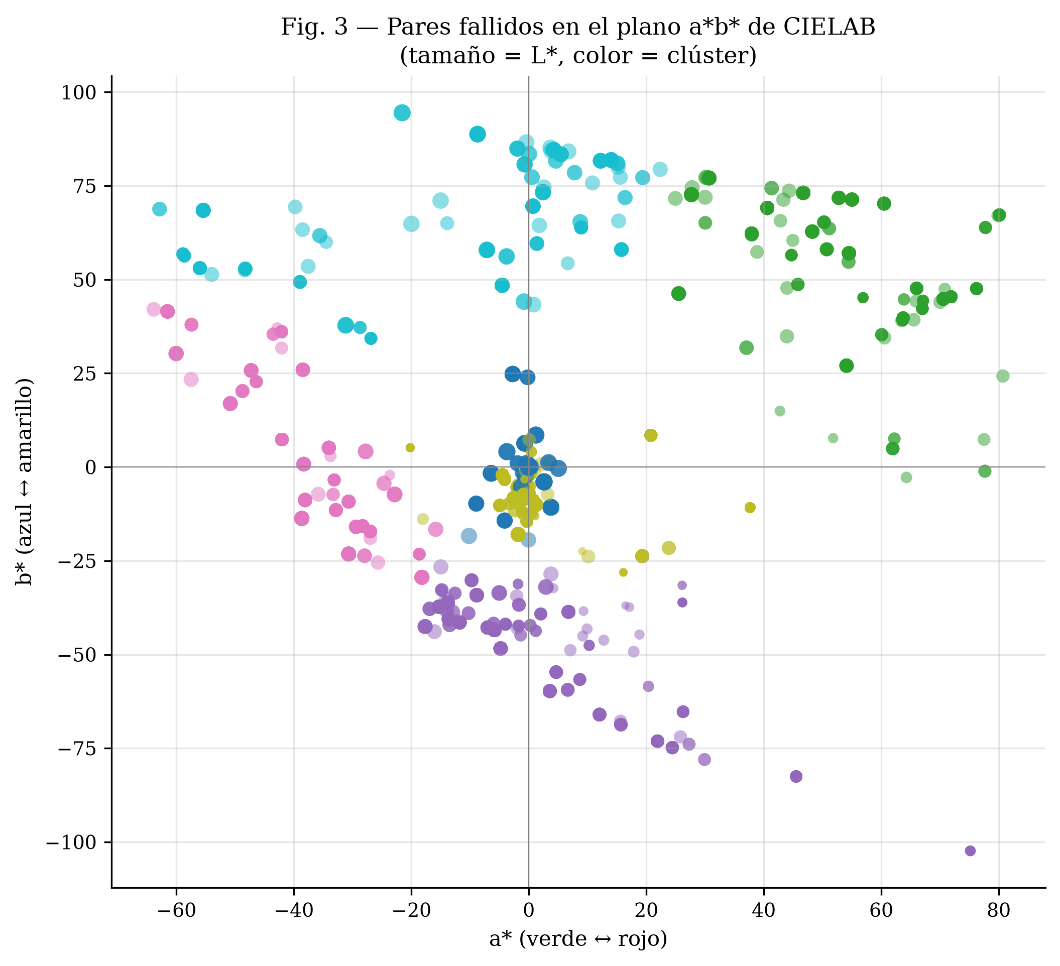
Figure 3. Failing pairs' text-color coordinates projected onto the CIELAB a∗b∗ plane, colored by k-means cluster (k = 6, computed in the full L∗a∗b∗ space); point size encodes L∗ (lightness).

5. Discussion
That most Latin American university homepages fail WCAG contrast requirements mirrors findings from other regions and is, on its own, unsurprising. Our working hypothesis, drawn from common assumptions in the accessibility-audit literature, was that failures would concentrate in familiar patterns such as light gray text on white, text over unmasked photographic backgrounds, and unverified interaction states (hover/focus/visited). The clustering result supports the low-chroma part of that hypothesis directly: near-neutral clusters consistent with the “light gray on white” pattern account for 80.0% of failing pairs, split by our full-L∗a∗b∗ clustering into a near-white cluster (L∗ = 99.5, 60.1%) and a mid-gray cluster (L∗ = 51.7, 19.9%), not merely one of several comparable clusters. The near-white cluster's dominance is likely inflated by the background-image blind spot discussed in Limitations, since text over an unmasked photograph would also resolve as a near-white failing pair under our extraction method rather than as a distinct chromatic cluster; the mid-gray cluster is not subject to that concern, since L∗ = 51.7 is far from the near-white artifact region. Even allowing for that overlap in the near-white cluster, the remaining chromatic clusters, saturated brand colors used directly as text color, are each individually small (4.1% to 6.1% of pairs), so the practical intervention implied by our results is closer to the field's existing assumption than we initially expected: a style-guide fix targeting low-contrast neutral and gray text would address the large majority of observed failures, with saturated brand-color misuse a secondary, smaller pattern.
For the institutions themselves, a style guide targeting low-contrast neutral (gray-on-white) text would directly address the large majority of the failures we observe. The smaller chromatic clusters are still worth a secondary mention: a plausible, though untested, explanation for that residual is institutional brand palettes (a university's primary color used directly as a text color, regardless of what it sits on) rather than a single stylistic trend (Figure 4 shows four representative examples). We have not tested this explanation against each institution's declared brand colors, and treat it as a hypothesis for future work rather than a finding.
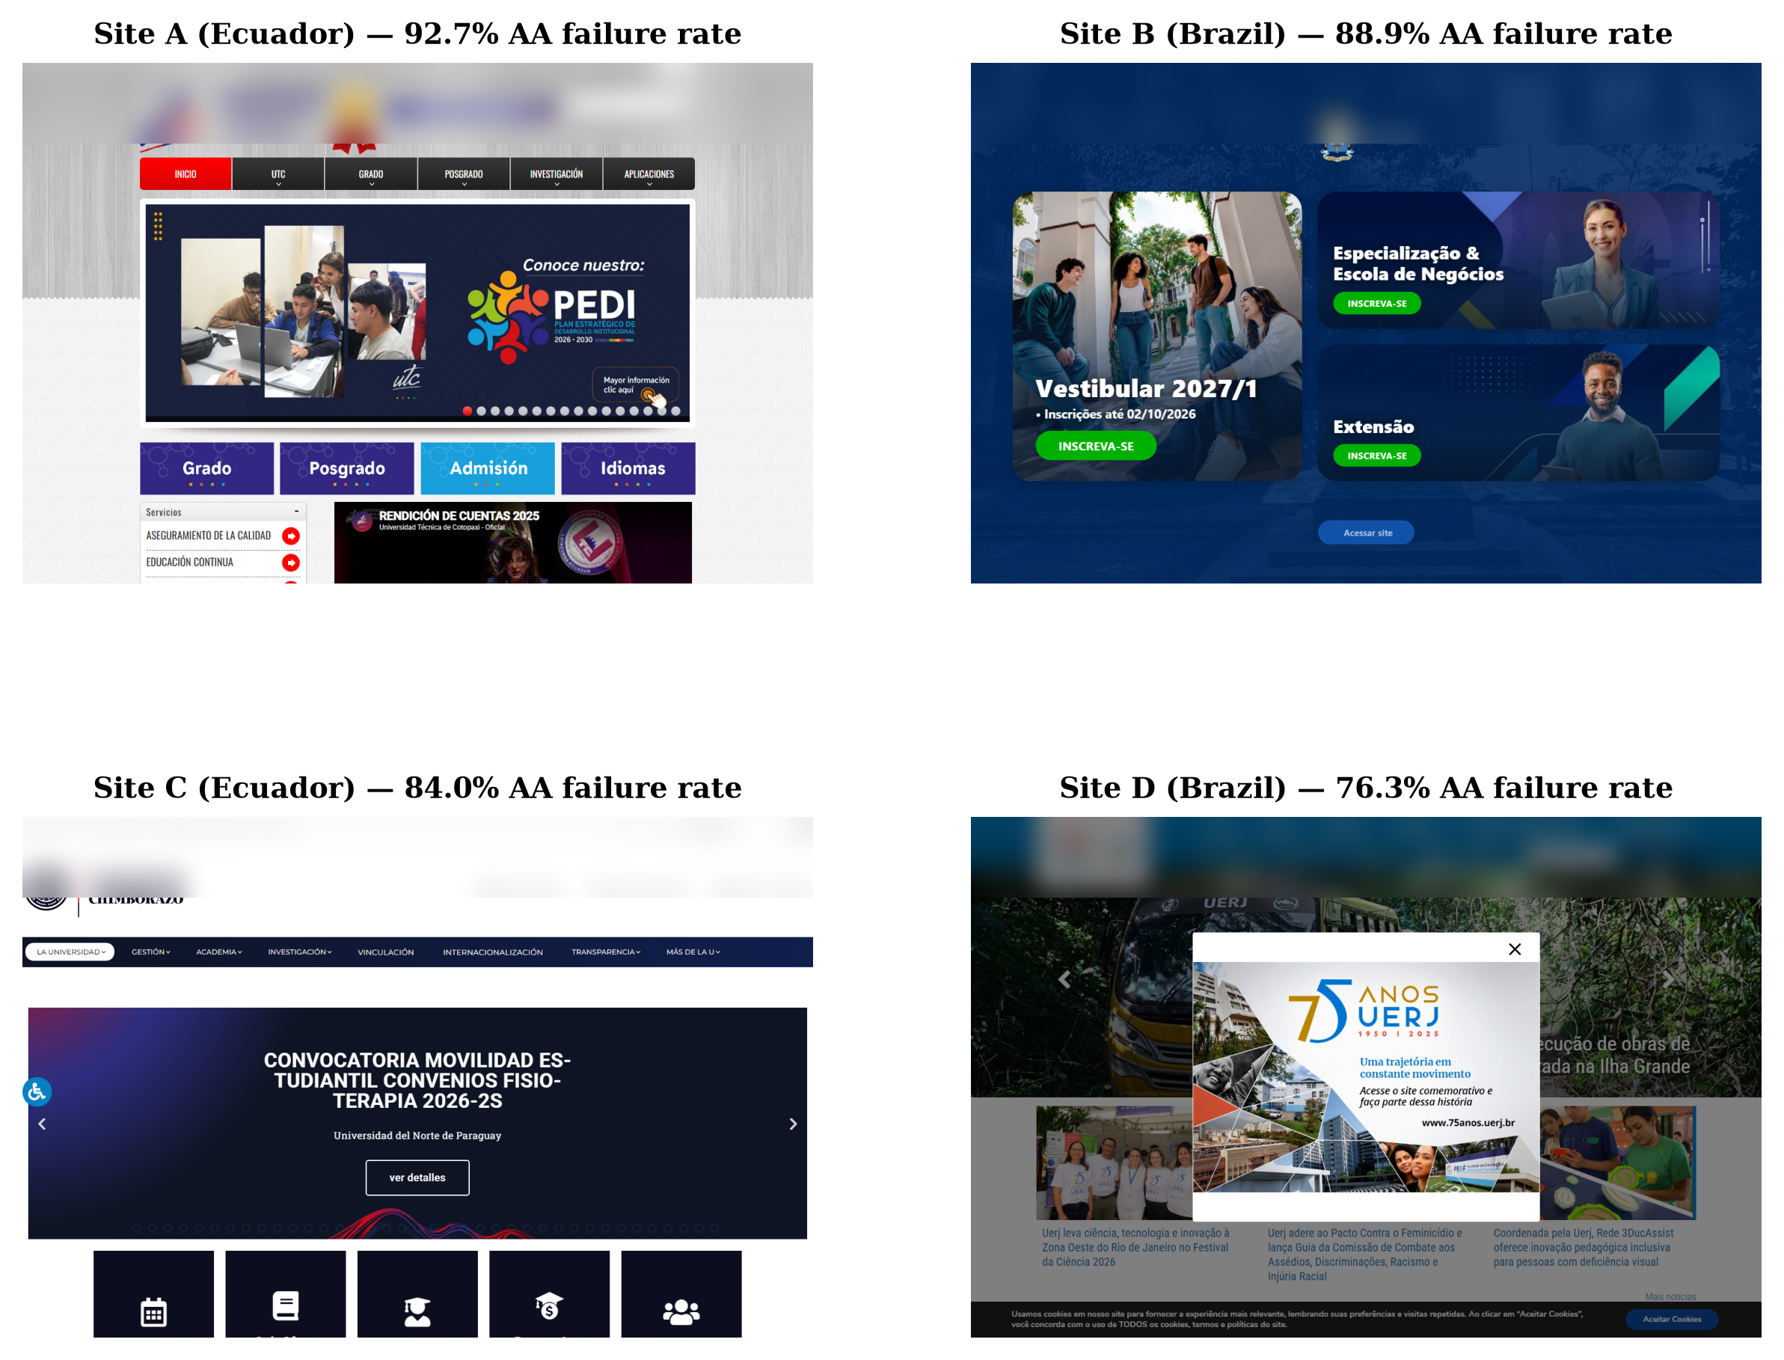
Figure 4. Homepages among the highest AA-failure rates in the sample, illustrating the brand-palette pattern described above: saturated institutional colors used directly as text or overlay color rather than as accents. Captures show only public institutional cover content, not personal data.
A note on the WCAG contrast formula itself, relevant to interpreting the residual variance our models leave unexplained: WCAG's ratio is based on relative luminance, not on a perceptually uniform distance measure. Two pairs with identical WCAG ratios can differ substantially in perceived contrast, which is part of why our CIELAB-space clustering was necessary in the first place: the WCAG ratio alone cannot distinguish the qualitatively different failure patterns we report.

6. Limitations
This study has several limitations. First, we crawled homepages only, not full sites; a homepage that passes may sit atop a site with far worse compliance on interior pages (or vice versa). Second, we measured only color contrast, which is one of many WCAG success criteria; a chromatically compliant site can still be inaccessible on other dimensions (keyboard navigation, alt text, semantic structure). Third, the crawl captures a single point in time (August 2026); institutional websites are redesigned periodically, so these figures are not stable indefinitely. Fourth, the source domain list had no entries for Bolivia or Venezuela, so the 17-country sample does not cover every country in the region. Fifth, and most consequential for how the country results should be read: color pairs are clustered within sites (a single homepage contributes many pairs sharing one design system), so the pair-level χ² and logistic-regression tests overstate independent sample size and their p-values are optimistic; the site-level check we report alongside them (256 sites, p = 0.085) is not significant, so we treat the country pattern as suggestive rather than confirmed and do not rely on individual per-country coefficients. Sixth, we used country as a proxy for institution type because a reliable public/private classification was not available across the source dataset; a finer-grained institutional variable, or a larger site-level sample powered to detect a modest effect, might resolve the country question more conclusively than either test here does. Seventh, our background-color resolution walks the DOM ancestor chain for a non-transparent background-color and does not inspect background-image; a text element rendered over a photographic or gradient background resolves, incorrectly, against whatever solid color sits further up the ancestor chain (typically page white). This is a plausible contributor to the single most frequent failing pair in our data (white text on a white background, 2,379 occurrences): at least part of that count is likely mislabeled text-over-image rather than genuinely invisible text, and we cannot currently distinguish the two cases from the extracted data alone. To bound how much this concern could be inflating our headline figures, we recomputed both under the most conservative reading, treating every single one of the 2,379 white-on-white pairs as an artifact and excluding them entirely: the pair-level failure rate drops from 21.6% to 16.8%, and the site-level share with at least one critical failure drops from 93.5% to 90.7% (only 7 of 259 sites, 2.7%, have white-on-white as their only recorded failure). Since at least some of these 2,379 pairs are surely genuine invisible-text bugs rather than background-image artifacts, this exclusion is an upper bound on the artifact's impact, not a corrected estimate; even so, both headline figures remain qualitatively unchanged. This also means our comparison to WebAIM's global figure (Results) uses a different detection instrument on a different population and should be read as an order-of-magnitude reference, not a controlled comparison. Finally, the moderate correlation with axe-core reflects genuine methodological differences between contrast-ratio counting and axe-core's rule engine rather than a validity problem with either approach, but it means the two should be read as complementary rather than interchangeable estimates.

7. Conclusion
A homepage-level survey of 259 Latin American university websites finds that WCAG AA contrast failures are the norm rather than the exception (93.5% of sites affected, 21.6% of all measured pairs); a country effect is visible at the pair level but is not confirmed once the actual unit of analysis (site) and the clustering of pairs within a site are accounted for, and we report it as an open question rather than a settled result. The colors involved in these failures are consistent with our initial hypothesis: unsupervised clustering in the full CIELAB L∗a∗b∗ space shows that near-neutral, low-chroma “light gray on white” patterns account for 80.0% of failing pairs, with four smaller chromatic clusters making up the remainder. This suggests that accessibility guidance for this region can prioritize the low-contrast neutral-text pattern as the primary target, while treating brand-palette contrast checking as a secondary recommendation for the smaller residual of saturated-color failures.

Data Availability
The complete dataset, crawl logs, extracted CIELAB color pairs, and analysis scripts are permanently archived and openly accessible in Zenodo (DOI: 10.5281/zenodo.23005763) and GitHub (https://github.com/JuanAvilesP3/jged-contraste-cromatico).
Juan Pablo Aviles-Esparza: Conceptualization, Methodology, Software, Formal Analysis, Writing - Original Draft, Visualization. Italo Javier Tenempaguay-Granizo: Data Curation, Investigation, Validation, Formal Analysis, Writing - Review & Editing. Isaac David Torres-Paredes: Supervision, Project Administration, Resources, Writing - Review & Editing.
Author Contributions
During the preparation of this manuscript, the authors used large language models exclusively for language refinement, grammatical editing, and LaTeX formatting. All research hypotheses, experimental design, crawling pipelines, statistical computations, and scientific interpretations were conceived, conducted, and validated entirely by the authors.
Use of Generative AI
The authors declare that they have no conflict of interest.
Conflict of Interest
This research received no external grant funding; it was institutional internal research conducted at Escuela Superior Politécnica de Chimborazo (ESPOCH).
Funding

References
Acosta-Vargas, P., Acosta-Vargas, G., Salvador-Ullauri, L., & Lujan-Mora, S. (2018). Challenges in the assessment of accessibility in Latin American university websites. In 2018 13th Iberian Conference on Information Systems and Technologies (CISTI) (pp. 1–6). IEEE. https://doi.org/10.23919/CISTI.2018.8399216
Acosta-Vargas, P., Salvador-Ullauri, L., & Lujan-Mora, S. (2019). A heuristic method to evaluate web accessibility for users with low vision. IEEE Access, 7, 125634–125648. https://doi.org/10.1109/ACCESS.2019.2939068
Acosta-Vargas, P., Lujan-Mora, S., & Salvador-Ullauri, L. (2020). Dataset of web accessibility evaluation of Latin American university websites. Data in Brief, 33, 106411. https://doi.org/10.1016/j.dib.2020.106411
Acosta-Vargas, P., Salvador-Ullauri, L., Perez-Medina, J. L., et al. (2021). Accessibility evaluation of mobile applications for Android. In Human-Computer Interaction. Interaction Techniques and Novel Applications (HCII 2021) (LNCS 12763, pp. 219–232). Springer. https://doi.org/10.1007/978-3-030-78465-2_17
Acosta-Vargas, P., Salvador-Ullauri, L., Jadán-Guerrero, J., et al. (2022). Accessibility in top-ranked Latin American e-commerce websites during the COVID-19 pandemic. Sensors, 22(8), 2965. https://doi.org/10.3390/s22082965
Aydemir, C., Özsoy, S. A., & Yenidoğan, S. (2021). The effect of vegetable oil-based ink formulations on drying time and printability in offset printing. Journal of Graphic Engineering and Design, 12(3), 5–12. https://doi.org/10.24867/JGED-2021-3-005
Henry, S. L., Abou-Zahra, S., & Brewer, J. (2014). The role of accessibility in a universal web. In Proceedings of the 11th Web for All Conference (W4A '14) (art. 17). ACM. https://doi.org/10.1145/2596695.2596719
International Commission on Illumination (CIE). (1976). Colorimetry — Part 4: CIE 1976 L*a*b* Colour Space. ISO/CIE 11664-4:2019.
Ofosu-Asare, Y. (2024). Enhancing user experience in online learning environments: Design evaluation of web accessibility. Journal of Graphic Engineering and Design, 15(1), 25–34. https://doi.org/10.24867/JGED-2024-1-025
Punsongserm, R., & Suvakunta, P. (2025). Enhancing accessibility of Thai government mobile applications: A technical review of typeface choice, type size, and color contrast. Journal of Graphic Engineering and Design, 16(1), 15–26. https://doi.org/10.24867/JGED-2025-1-015
Rello, L., & Baeza-Yates, R. (2013). Good fonts for dyslexia. In Proceedings of the 15th International ACM SIGACCESS Conference on Computers and Accessibility (ASSETS '13) (art. 14). ACM. https://doi.org/10.1145/2513383.2513447
WebAIM. (2026). The WebAIM Million: The 2026 Report on the Accessibility of the Top 1,000,000 Home Pages. WebAIM. https://webaim.org/projects/million/
Weingerl, P., Nedeljković, U., & Pušnik, N. (2022). Visibility and legibility of five different typefaces in short words: Comparative analysis. Journal of Graphic Engineering and Design, 13(2), 5–14. https://doi.org/10.24867/JGED-2022-2-005
World Wide Web Consortium (W3C). (2023). Web Content Accessibility Guidelines (WCAG) 2.2. W3C Recommendation. https://www.w3.org/TR/WCAG22/

