CONCEPT DRIFT IN URL-BASED PHISHING DETECTION: A TEMPORAL EVALUATION
Juan Pablo Aviles-Esparza, Italo Tenempaguay-Granizo, Isaac David Torres-Paredes*

ABSTRACT
Phishing detectors are almost universally evaluated with random train/test splits, which implicitly assume that aURL’scharacteristicsareexchangeableacrosstime.Wetestthatassumptionbytrainingthreelexical-feature classifiers(randomforest,XGBoost,logisticregression)on180daysofPhishTank-reportedphishingURLsplus amatchedsampleoflegitimatedomains,andevaluatingthemunderfourtemporaldesigns:arandomsplit(the field’sdefault),trainingontheearliestblockandtestingoneachsubsequentblock,aslidingretrainingwindow, and cumulative retraining. All three models achieve F1 above 0.98 in every configuration, and the gap between the random-split baseline and the worst temporally-displaced block is small in absolute terms (0.36 to 0.92 percentage points of F1, model-dependent). A regression of F1 on temporal distance is significant when pooled across models, and its precision improves substantially once model-level baseline differences are controlled for (p = 0.022 naive, p = 0.0048 controlling for model as a fixed effect); a Page test for a monotonic decreasing trend across the three models as judges agrees (Z = −2.66,p = 0.004). We argue the near-ceiling performance points partly to a design choice rather than a solved problem:removing the four features most associated with how the legitimate class was constructed(is_https,path_length,num_slashes,url_length)dropsF1by3.3to4.1percentage points across models,confirming that the choice of negative class (well-established top-ranked domains) inflates the reported ceiling; the four ablated features are not the sole source of the near-ceiling result, though the remain-ing features may still encode the same domain-versus-full-URL asymmetry; a negative class of full legitimate URLs would be needed to settle this.
KEYWORDS
Phishingdetection,Conceptdrift,Temporalevaluation,Adversarial machinelearning,Lexicalfeatures,Cy-bersecurity.
1 INTRODUCTION
Phishingisanadversarialinstanceofthebroaderconcept-driftprobleminmachinelearning[1]:attackers change URL patterns, hosting infrastructure, and lexical tricks specifically to evade whatever a detector has already learnedtoflag.Aclassifiertrainedandevaluatedwithasinglerandomtrain/testsplittreatseveryURLinthe dataset as drawn from one stationary distribution, which is precisely the assumption an adversarial, evolving threat violates. If that assumption is wrong,published accuracy figures based on random splits systematically overstate what a detector will achieve once deployed against future, unseen phishing campaigns.
This paper asks how much that gap actually is, using a temporal evaluation design rather than a random one, andcomparestwocommonmitigationstrategies,periodicretrainingwithaslidingwindowversuscumulative retraining that keeps all historical examples, to see whether either meaningfully closes it. We evaluate on 180 days of continuously reported phishing URLs, which lets us construct genuinely time-ordered evaluation blocks rather than simulating drift artificially.
Thecontributionsofthisworkare:(1)atemporal,block-basedevaluationoflexicalphishingclassifierson real, timestamped data, contrasted directly against the random-split baseline the field defaults to; (2) a statistically defensible estimate of the degradation trend’s significance, using an ANCOVA specification that separates within-modeldriftfrombetween-modelbaselinedifferences,alongsideaspecification-freePagetestasacross-check;
*Juan Pablo Aviles-Esparza, Italo Tenempaguay-Granizo, Isaac David Torres-Paredes is with the Software Engineering Department, Faculty of Informatics and Electronics, Escuela Superior Politecnica de Chimborazo (ESPOCH), Riobamba 060155, Ecuador. E-mail:juan.aviles@espoch.edu.ec
1

2 "Concept Drift in URL-Based Phishing Detection: A Temporal Evaluation", Juan Pablo Aviles-Esparza, Italo Tenempaguay-Granizo, Isaac David Torres-Paredes.
(3) a mechanistic account, grounded in feature-distribution and feature-importance evidence rather than aggregate metrics alone, of why the measured degradation is small:an easy negative class, not a solved drift problem.
2 RELATED WORK
Odeh et al. [2] propose PhiBoost, an adaptive-boosting phishing detector built on lexical and host-based URL features,andreportstrongwithin-distributionaccuracyusingaconventionalheld-outtestsplit,exactlytheeval-uation protocol this paper argues is insufficient on its own,since it cannot distinguish a detector that has learned durablephishingindicatorsfromonethathasoverfittotheparticularcampaignspresentinthetrainingwindow. Sahingoz et al. [3] benchmark seven classifiers (including Random Forest, the best-performing model in both their study and ours) on a mixed lexical-and-content feature set, and likewise report F1 scores above 0.97 using a stan-dard random 80/20 split; their feature set and evaluation setup are directly comparable to ours, making the temporal gap we identify a direct reinterpretation of their baseline rather than a critique of the specific classifier choice. Al-slman et al. [4] evaluate ensemble models (the same broad model family we use here) for DDoS attack detection at scale using Spark,and,like most applied network-security classification work,do not examine whether detec-tion performance is stable as the underlying attack traffic evolves over time; our temporal-block design is directly applicable to that setting as well, and we frame our contribution partly as a methodological recommendation that extendsbeyondphishingspecificallytosecurityclassificationtasksbuiltonadversarial,time-varyingdata.Fur-thermore, in a systematic survey within this journal’s scope, Ashi et al. [5] examine supervised machine-learning classifiers and dimensionality reduction techniques for network intrusion detection, underscoring that benchmarked detection performance is critically sensitive to feature choice and evaluation rigor; our study directly extends that methodological perspective by investigating how temporal drift affects lexical feature stability under longitudinal deployment.
This concern is not new to security classification in general: Pendlebury et al. [6] name and formalize the same failure mode for malware classifiers under the label temporal bias, showing that a naive random train/test split can silently mix future and past samples and thereby overstate real-world performance, and propose constraints (train-ing strictly on past data, realistic class-ratio testing) that our fixed, sliding-window, and cumulative designs already satisfy by construction; we are not aware of a comparable temporal-bias analysis having been applied to phishing URL classification specifically,which is the gap this paper addresses. Jemili et al. [7] extend this line of work to network intrusion detection, showing that a classifier that combines online concept-drift detection with incremental retraining substantially narrows the performance gap between static and adaptive systems;their empirical design confirms that drift is real and measurable in security-relevant classification streams,but they do not study lexical URL features or control for the contribution of class-boundary difficulty to the observed gap, which is the mecha-nistic question we pursue here. Apruzzese et al. [8] survey the gap between adversarial machine-learning research andoperationalpractice,arguingthatrealattackersrarelyemploythegradient-basedperturbationsmoststudied intheliterature,andthatthethreatmodelsimplicitinrandom-splitevaluationsarethereforedoublyunrealistic: boththetimeorderingandtheassumedadversarialcapabilitydepartfromdeploymentconditions.Wetakethat observation as additional motivation for a design that at least corrects the temporal dimension, even if it does not resolve the adversarial-realism dimension.
ThechallengeofconceptdriftincybersecurityclassificationisdocumentedatthesurveylevelbyBuczak and Guven [9], who review over 50 machine-learning methods for intrusion detection and identify temporal non-stationarity as one of five core challenges for production deployment, alongside class imbalance, feature selection, computational cost,and the scarcity of labeled attack data. Critically,they find that no single study among those reviewedaddressesallfivesimultaneously,andthattemporaldriftinparticularisusuallyhandledimplicitly(by retrainingfromscratchonnewdata)ratherthanbyaprincipledcomparisonofretrainingstrategies.Ourstudy contributes precisely that comparison for the phishing-URL domain, testing fixed, sliding-window, and cumulative retraining under controlled temporal separation. Varshney, Misra and Atrey [10] provide a complementary survey-leveltaxonomy,classifyingphishing-detectionschemesbyfeaturetype(visual,lexical,content-based,network-based);ourstudyoperatesexclusivelywithintheir“lexical”categoryandisdesignedtoansweraquestiontheir survey identifies but does not resolve empirically:whether lexical-only detectors maintain their reported accuracy as the phishing campaign population evolves over time.
The feature-engineering and modelling approaches evaluated in this paper have direct precedents in the phishing-detectionliterature.Mohammad,ThabtahandMcCluskey[11]introduceanintelligentrule-basedclassifierfor phishing websites using URL and page-level features, and in a companion study [12] apply self-structuring neural networkstothesamefeaturefamily;bothreporthighaccuracyunderconventionalrandomsplits,makingtheir baselinedirectlycomparabletotherandom-splitconditioninourtemporaldesignandthereforesubjecttothe

Jordanian Journal of Computers and Information Technology (JJCIT), Vol. 12, No. X, 2026.
Somesha et al. [14] compare ensemble classifiers (including Random Forest) against deep neural architectures for URL phishing detection, finding that tree-based ensembles achieve competitive or superior accuracy on tabular lexical representations without the substantial computational cost of deep models, consistent with our observation that Random Forest delivers the highest F1 scores across all four temporal designs.
3 METHODOLOGY
3.1 Data
PhishingURLsweredrawnfromPhishTank’spublicfeed,whichistheonlyphishingsourcewefoundthat ships a reliable, unauthenticated submission_time timestamp per URL (OpenPhish’s community feed and the staticUCIPhishingWebsites/PhiUSIILdatasetsdonotcarryacomparableper-recorddateandwereexcluded fromthisdesignforthatreason).Weretainedthemostrecent180days(29,299URLs),theearliestweeksof thefullhistoricalfeedhavingtoofewreportsperweektosupportbalancedtemporalblocks.LegitimateURLs weresampledfromtheTrancotop-1Mlist[16],chosenoveralternativessuchasthe(now-discontinued)Alexa rankingbecauseTrancoisspecificallydesignedtoresistthelist-manipulationattacksthatmakerawpopularity rankings an unreliable ground truth for security research. Because Tranco is a single ranked snapshot rather than a dated feed, each sampled legitimate URL was assigned a synthetic timestamp drawn uniformly over the same 180-day window as the phishing data, a deliberate simplification justified because domain reputation for an established, highly ranked site does not meaningfully change on a 180-day horizon, in contrast to phishing infrastructure, which isexactlywhatthisstudymeasuresaschanging.Thefinaldatasetisbalancedbyconstruction(29,299phishing, 29,299 legitimate).
3.2 Features
We extract 32 lexical features per URL requiring no live network access (URL/hostname/path length, counts ofdots/hyphens/digits/specialcharacters,subdomaincount,IP-literalhostnameflag,presenceofaknownURL shortener, Shannon entropy of the URL and hostname strings, a count of phishing-associated keywords, and related structural features). Table 1 lists all 32 with their definitions.
3.3 Temporal evaluation designs
Dataweresortedbytimestampanddividedintosixequal-sizedblocksbysamplecount.Weevaluatefour designs:(i)random,an80/20randomsplitignoringtime,asabaseline;(ii)fixed,trainingonceonblock1and evaluating separately on blocks 2 through 6, to isolate pure degradation with distance; (iii) sliding window, training on block k and evaluating on block k+1 for each consecutive pair, simulating periodic retraining on only the most recentdata;(iv)cumulative,trainingonblocks1throughkandevaluatingonblockk + 1,simulatingretraining thatkeepsthefullhistory.Allmodels(randomforest[17],XGBoost[18],logisticregression)shareidentical standardized features across designs.
3.4 Statistical analysis
We regress F1 on temporal distance for the fixed design, per model, pooled naively across models, and pooled withamodelfixedeffect(ANCOVA:f1~distance+model)toseparatethewithin-modeltrendwith distancefromthelargebetween-modeldifferencesinbaselineF1,whichanaivepooledregressionotherwise foldsintoitsresidualvarianceandtherebyunderstatesthetrend’ssignificance.Becausealinearregressionwith

4 "Concept Drift in URL-Based Phishing Detection: A Temporal Evaluation", Juan Pablo Aviles-Esparza, Italo Tenempaguay-Granizo, Isaac David Torres-Paredes.
Table 1. Lexical features extracted per URL.
Feature | Definition
url_length  hostname_length  path_length  num_dots  num_hyphens  num_underscores  num_slashes  num_question_marks num_equals  num_at  num_ampersands  num_percent  num_digits  digit_ratio  num_subdomains  has_ip_address  has_port  is_https  url_entropy  hostname_entropy  is_shortened | Character length of the full URL  Character length of the hostname  Character length of the URL path  Count of . characters in the URL  Count of - characters in the URL  Count of _ characters in the URL  Count of / characters in the URL  Count of ?characters in the URL  Count of = characters in the URL  Count of @ characters in the URL  Count of & characters in the URL  Count of % characters in the URL  Count of digit characters in the URL  Digit characters as a fraction of URL length  Number of hostname labels beyond domain and TLD 1 if the hostname is a literal IPv4 address  1 if a port number is present  1 if the scheme is https  Shannon entropy of the full URL string  Shannon entropy of the hostname string  1 if hostname matches a known URL-shortener domain

num_suspicious_keywords has_suspicious_keyword

Count of phishing-associated keywords (e.g., “login”, “verify”) 1 if any suspicious keyword is present

domain_length Character length of the second-level domain label

path_num_segments
has_double_slash_in_path

Number of non-empty path segments
1 if // appears inside the path

num_www 1 if the hostname starts with www.
longest_label_length Length of the longest hostname label
tld_length Character length of the top-level domain
has_at_symbol 1 if @ appears anywhere in the URL

num_dashes_in_hostname vowel_ratio_hostname

Count of - characters within the hostname only Vowel characters as a fraction of hostname length

onlythreemodelsprovideslimitedpowertodetectacommonmonotonictrendregardlessofspecification,we additionallyrunaPagetestforamonotonicdecreasingtrend,treatingthethreemodelsasjudgesrankingthe fivetemporal-distanceconditions,andcross-checkitsnormal-approximationp-valuewithanexactMonteCarlo permutationnull(100,000iterations)giventhetest’slownominalpoweratonlythreejudges.Wecomparethe sliding-window and cumulative strategies with a paired Wilcoxon signed-rank test per model.
4 RESULTS
All three modelsachieveF1> 0.98inevery one of the four designs:there is no configuration in which any model performs poorly in absolute terms (Figure 1). The comparison that matters is relative: Table 2 shows the gap betweentherandom-splitbaselineandthetemporallydisplaced(fixed-design)evaluationsissmall(0.09to0.35 percentage points of F1 on average across displaced blocks, model-dependent) but non-zero, and grows toward the worst-case block (up to 0.92 points for logistic regression); Table 3 gives the full breakdown by block and model.
Aper-modelOLSregressionofF1ontemporaldistanceisdirectionallynegativeforallthreemodelsbut reaches significance only for the pooled fit (β= −0.00136,p = 0.022, R2= 0.34); individually, logistic regression is marginal (p = 0.062) and the two tree ensembles are not significant on their own (p = 0.25 andp = 0.19). This naivepooledfit,however,conflatestwodifferentsourcesofvariance:thelarge,fixeddifferencesinbaselineF1 between models (logistic regression trails the two tree ensembles by roughly a full percentage point throughout) and the within-model trend with distance that is the actual quantity of interest. Controlling for model as a fixed effect (ANCOVA) removes the former from the residual: the slope estimate is unchanged (β = −0.00136, since the design is balanced across models) but its precision improves substantially (p = 0.0048, R2= 0.69), because the between-modelnoisethatwasinflatingthenaivetest’sresidualvarianceisnolongerattributedtothedistancetrend.We treat the Page test as a further, specification-free check of the same conclusion:treating the three models as judges

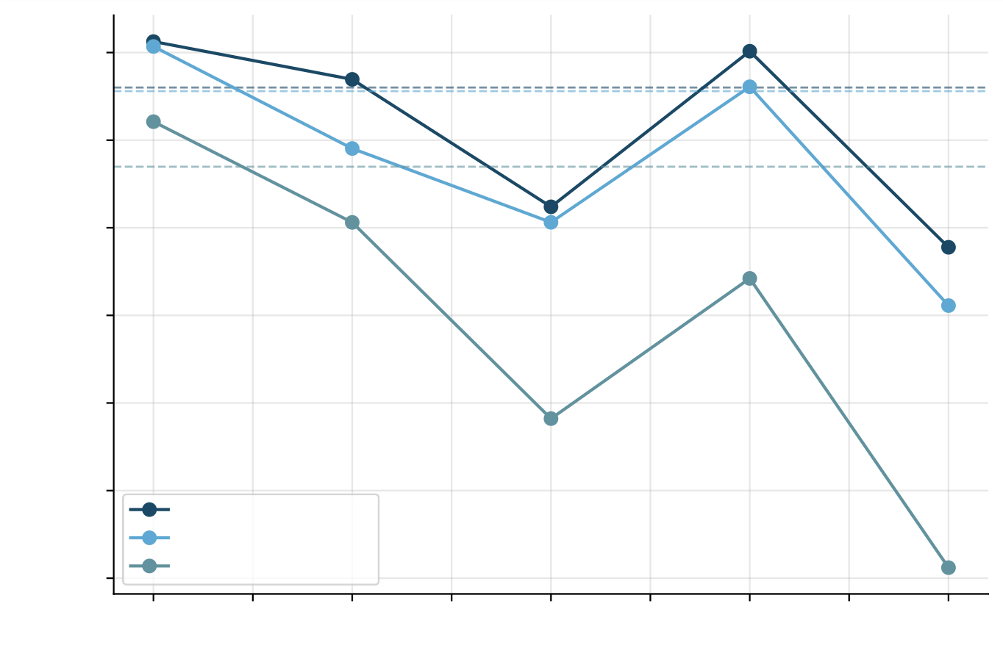
Jordanian Journal of Computers and Information Technology (JJCIT), Vol. 12, No. X, 2026.
Table 2. F1 under random vs. temporal (fixed-training) evaluation.
Model | F1 (random split) | F1 (temporal, avg.) | F1 (temporal, worst block)
Random Forest | 0.9952 | 0.9943 | 0.9916
XGBoost | 0.9951 | 0.9935 | 0.9902
Logistic Regression | 0.9934 | 0.9899 | 0.9842
Note:Therandomsplittrainson80%ofthefulldataset,whereasthefixed-trainingtemporaldesigntrainson roughly one-sixth (block 1 alone).
0.996
0.994
0.992
F1 Score | 0.990
0.988
0.986 | Random Forest
XGBoost
0.984 | 1.0 | Logistic Regression |  |  |  |  |  | 4.5 | 5.0
0.984 | 1.0 | 1.5 | 2.0 | 2.5 | 3.0 | 3.5 | 4.0 | 4.5 | 5.0
0.984 | 1.0 | Temporal distance to training block (blocks) |  |  |  |  |  | 4.5 | 5.0
Figure 1. F1 as a function of temporal distance (fixed-training design); dotted lines mark the random-split baseline for reference.
ranking F1 across the five temporal-distance conditions, the test rejects the null of no consistent ordering (L = 112, Z = −2.66,p = 0.004, one-sided). While there is a visible non-monotonic spike at distance 4 (block 5) for all three models (Figure 1), the Page test is sensitive to overall ordinal trend rather than requiring strict monotonicity at every step, making it an appropriate contrast here. With only three judges, the test’s normal approximation is known to have limited power and reliability, so we additionally computed an exact Monte Carlo permutation null (100,000 iterations, independently permuting each model’s ranking across the five conditions under the null of no association between rank and temporal distance):the permutation-basedp-value (p = 0.0026, one-sided) agrees closely with, and is if anything slightly more extreme than, the asymptotic estimate, so the small-sample caveat does not change the conclusion. All three approaches (naive pooled regression, model-controlled ANCOVA, and the non-parametric Page test,now itself cross-checked by exact permutation) agree on a real,if small,degradation trend common to all three models, with the ANCOVA giving the most statistically defensible estimate of its significance.
Comparing mitigation strategies, cumulative retraining outperforms sliding-window retraining for every model (Random Forest:0.9952 vs. 0.9950; XGBoost:0.9945 vs. 0.9939; Logistic Regression:0.9931 vs. 0.9923) (Fig-ure 2); a size-matched control (Limitations) shows this advantage is mostly, and for logistic regression entirely, a consequenceofcumulativeretraining’slargertraining-setsizeratherthanofretaininghistoricalexamplesbeing helpful per se,so we do not read this comparison as evidence that history itself is broadly beneficial. The paired Wilcoxontestonthefiveblock-levelF1valuespermodelhastoofewpairstoreachconventionalsignificance regardlessofthetrueeffectsize(p = 0.125–0.25),soweinsteadcomparethetwostrategieswithapairedboot-strapovertheunderlyingpredictions(2,000resamplesperevaluationblock,pooledacrossthefiveblocks):this confirms cumulative retraining outperforms sliding-window retraining for all three models,with 95% confidence intervalsexcludingzero(RandomForest:+0.00024,95%CI[0.00011,0.00040];XGBoost:+0.00067,95%CI [0.00035,0.00099]; Logistic Regression:+0.00080, 95% CI [0.00051,0.00109]; allp < 0.001). The effect is real but small in absolute F1 terms, consistent with the modest overall degradation reported above.

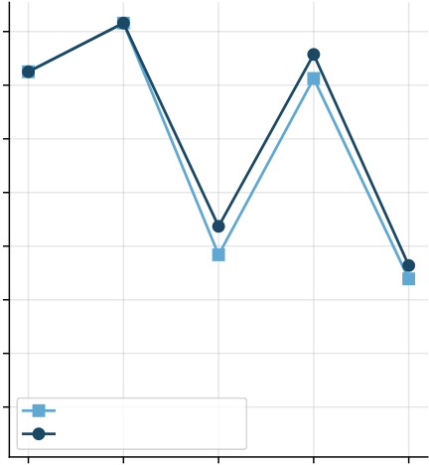
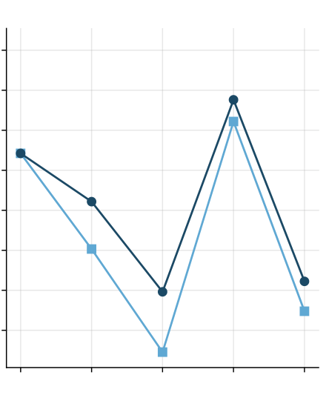
6 "Concept Drift in URL-Based Phishing Detection: A Temporal Evaluation", Juan Pablo Aviles-Esparza, Italo Tenempaguay-Granizo, Isaac David Torres-Paredes.
Table 3. F1 by evaluation block and model (fixed-training design: trained on block 1, evaluated on blocks 2 through 6, at increasing temporal distance).
 |  |  | Distance |  |  |  | Random Forest |  | XGBoost |  |  | Logistic Regression
 |  |  | 1 (block 2) |  |  |  | 0.9963 |  | 0.9961 |  |  | 0.9944
 |  |  | 2 (block 3) |  |  |  | 0.9954 |  | 0.9938 |  |  | 0.9921
 |  |  | 3 (block 4) |  |  |  | 0.9925 |  | 0.9921 |  |  | 0.9876
 |  |  | 4 (block 5) |  |  |  | 0.9960 |  | 0.9952 |  |  | 0.9908
 |  |  | 5 (block 6, worst) |  |  |  | 0.9916 |  | 0.9902 |  |  | 0.9842
F1 Score | 0.997 | 1 | Random Forest |  |  | 5 | XGBoost |  |  |  |  | Logistic Regression |  |  | 4 | 5
F1 Score | 0.997 | 1 | Sliding window |  |  | 5 | 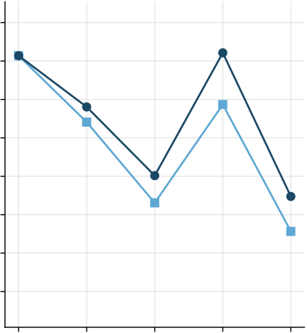 |  |  |  |  | 1 | 2 | 3 | 4 | 5
F1 Score | 0.996
F1 Score | 0.995
F1 Score | 0.994
F1 Score | 0.993
F1 Score | 0.992
F1 Score | 0.991
F1 Score | 0.990
F1 Score | 0.990 | 1 | Cumulative retraining
F1 Score | 0.990 | 1 | 2 | 3 | 4
 |  |  |  |  |  |  | 1 | 2 | 3 | 4 | 5
F1 Score | 0.990 | 1 | Evaluated block |  |  | 5 | Evaluated block |  |  |  |  | Evaluated block |  |  | 4 | 5
Figure 2. F1 under sliding-window vs. cumulative retraining, by model and evaluation block.
5 DISCUSSION
Degradationfromtemporaldisplacementisrealandstatisticallysupportedinaggregate,butfarsmallerin magnitudethanthefield’sframingofconceptdriftasafirst-orderthreatwouldsuggest,anunglamorousresult buttheonethedatasupport.Wethinkthisissubstantiallyexplainedbythedesignofthenegativeclassrather thanbythephishingdetectiontaskbeinginherentlyeasy:ourlegitimateURLscomefromTranco’stop-ranked, long-established domains, whose lexical signature (short, clean hostnames, no IP literals, low entropy, absence of phishing-associated keywords) is so different from phishing URLs that almost any reasonable classifier separates the two classes with ease, and that separation does not depend much on which specific phishing campaigns happen to be in the training set. A harder, more realistic negative class, such as newly registered legitimate domains [19] or domains with URL structures that superficially resemble phishing (long paths, subdomains, marketing redirect chains),wouldveryplausiblyshowalargertemporalgap,becausethedecisionboundarywouldthendepend more on the specific lexical tricks currently in fashion among phishers rather than on the broad, temporally stable distinctionbetweenanestablisheddomainandanadhocone.Recentlarge-scaleevidenceonnewlyregistered domainsconfirmsthisintuition:AgarwalandVasek[19]showthatphishingcampaignsoverwhelminglyexploit newlyregistereddomainsthathavenotyetaccumulatedthelexicalsimplicitythattop-rankedTrancositescarry bydefinition,afindingthatimpliesanyevaluationconstrainedtoTranco-classnegativeswillunderestimatethe operational difficulty of the classification task.
Directfeature-levelevidencesupportsthisreading.Thedistributionalshiftinindividuallexicalfeaturesbe-tween the earliest and latest temporal blocks is modest (Figure 3):url_entropy shows a small rightward shift, but url_length is essentially unchanged and both num_suspicious_keywords and has_ip_address remain near-constant, low-variance flags throughout the whole period. Feature importance is correspondingly sta-ble across all six temporal blocks (Figure 4):is_https, path_length, num_slashes, and url_length dominate in every block, with no block introducing a qualitatively different top feature. The model is not relying on a fragile, campaign-specific signal that erodes over time; it is relying on a small set of structural URL properties that stay informative because the negative class’s lexical signature stays put.
Becausethesefourfeaturesarealsoplausibleartifactsofhowthelegitimateclasswasconstructed(Tranco supplies bare domains, which are structurally shorter and path-free compared to full phishing URLs), we directly tested whether they are necessary for the near-ceiling performance by re-running the fixed-training design (block 1versusblocks2–6)withallfourremoved,leaving28features.Table4showstheresult:F1dropsby3.3to 4.1 percentage points across the three models (e.g., random forest:0.9943 to 0.9617 on average across displaced

Jordanian Journal of Computers and Information Technology (JJCIT), Vol. 12, No. X, 2026.
0.025 |  |  | url_length |  |  |  |  |  |  |  | 8 |  |  | num_suspicious_keywords
   |  |  |  |  |  |  |  |  |  | Block Block | 1 (earliest 6 (latest) | )
0.020
Density | 0.015  0.010 |  |  |  |  |  |  |  |  |  | Density |  | 6  4
0.005 |  |  |  |  |  |  |  |  |  |  | 2
0.000 |  |  |  |  |  |  |  |  |  |  | 0
 |  |  | 0 | 200 | 400 | 600 |  | 800 |  | 1000 |  |  |  | 0.0 | 0.5 | 1.0 | 1.5 | 2.0 | 2.5 | 3.0
 |  |  | url_entropy |  |  |  |  |  |  |  |  |  |  | has_ip_address
 |  |  |  |  |  |  |  |  |  |  | 30
1.6
1.4 |  |  |  |  |  |  |  |  |  |  | 25
1.2 |  |  |  |  |  |  |  |  |  |  | Density | 20 15
Density |  | 1.0 0.8
0.6 |  |  |  |  |  |  |  |  |  |  | 10
0.4 |  |  |  |  |  |  |  |  |  |  | 5
0.2
0.0 |  |  |  |  |  |  |  |  |  |  | 0
 |  |  | 3.0 | 3.5 | 4.0 | 4.5 | 5.0 |  | 5.5 | 6.0 |  |  |  | 0.0 | 0.2 | 0.4 | 0.6 | 0.8 |  | 1.0
Figure3.DistributionoffourkeylexicalfeaturesamongphishingURLs,earliestvs.latesttemporal block.
blocks), confirming that these four features carry real, non-trivial separating power and that part of the near-ceiling resultreflectsURL-constructiondifferencesbetweenthetwoclassesratherthanphishing-specificcontentalone. At the same time, F1 with those four features removed remains at 0.95–0.96, far above chance and only modestly below the full-feature result, so the remaining 28 lexical features carry substantial phishing-discriminating signal on their own. We read this as a partial, not a full, explanation of the near-ceiling result:the four structural features inflate the reported ceiling by a few points, but they are not the sole reason detection is easy.
Table4.F1(fixed-trainingdesign,averagedacrossdisplacedblocks2–6)withandwithoutthe fourfeaturesmostassociatedwithlegitimate-URLconstruction(is_https,path_length, num_slashes, url_length).
Model | F1, 32 features | F1, 28 features (ablated) | Drop
Random Forest | 0.9943 | 0.9617 | 0.0326
XGBoost | 0.9935 | 0.9601 | 0.0334
Logistic Regression | 0.9899 | 0.9490 | 0.0409
Theoperationalrisk,then,isnotthatlexicalphishingdetectorstrainedtodaywillfailoutrightnextmonth. Itisthatthenear-perfectperformancereportedunderarandomsplit(or,asweshow,evenundermosttemporal designs against an easy negative class) is a poor guide to performance against near-miss legitimate traffic,which is the regime that actually matters operationally. We would expect the degradation trend that is significant here in aggregate to become the dominant effect, not a marginal one, once the negative class is made realistically hard.
6 LIMITATIONS
Ourfeaturesarepurelylexical;wedonotusepagecontent,WHOISdata,ornetwork/hostingfeatures,all ofwhichcouldshiftthebalancebetweentemporaldriftandrawseparability.PhishTank’sreportscarryaknown reporting-timebias(submissiontimeisnotnecessarilyattack-launchtime,andpopular/obviousphishingcam-paigns are reported faster than sophisticated ones). The 180-day window, while the longest span with consistently high weekly volume in the feed we used, is short relative to multi-year drift dynamics reported elsewhere in the lit-

Jordanian Journal of Computers and Information Technology (JJCIT), Vol. 12, No. X, 2026.
regardless of when the phishing examples were collected, alongside the fact that assigning synthetic timestamps to the legitimate URLs makes half of each evaluation block i.i.d. by construction, halving the observable degradation effect before any evaluation even begins. We recommend that future phishing-detection evaluations pair temporal splitting with a harder negative class before concluding that concept drift is a marginal concern for this task.
DATA AVAILABILITY
The phishing dataset (PhishTank IDs and timestamps), the legitimate-domain sample, extracted features, and analysis code are permanently archived and openly accessible in Zenodo at https://doi.org/10.5281/zenodo.23005762 and GitHub at https://github.com/JuanAvilesP3/jjcit-deriva-phishing.
Juan Pablo Aviles-Esparza: Conceptualization, Methodology, Software, Writing - Original Draft. Italo Javier Tenempaguay-Granizo: Data Curation, Formal Analysis, Validation, Writing - Review & Editing. Isaac David Torres-Paredes: Supervision, Project Administration, Resources, Writing - Review & Editing.
AUTHOR CONTRIBUTIONS
During the preparation of this manuscript, the authors used large language models exclusively for language refinement, grammatical editing, and LaTeX formatting. All research hypotheses, experimental design, model training, statistical computations, and scientific interpretations were conceived, conducted, and validated entirely by the authors.
USE OF GENERATIVE AI
The authors declare that they have no conflict of interest.
CONFLICT OF INTEREST
This research received no external funding. It was conducted within the academic research framework of Escuela Superior Politécnica de Chimborazo (ESPOCH).
FUNDING
REFERENCES
[1]J. Gama, I. Žliobait˙e, A. Bifet, M. Pechenizkiy, and A. Bouchachia, “A survey on concept drift adaptation,”ACM Computing Surveys, vol. 46, no. 4, pp. 44:1–44:37, 2014.[Online], Available:.
[2]A. Odeh, I. Keshta, and E. Abdelfattah, “PhiBoost – a novel phishing detection model using adaptive boosting approach,”JordanianJournalofComputersandInformationTechnology(JJCIT),vol.7,no.1,pp.64–73, 2021.[Online], Available:.
[3]O. K. Sahingoz, E. Buber, O. Demir, and B. Diri, “Machine learning based phishing detection from URLs,”Expert Systems with Applications, vol. 117, pp. 345–357, 2019.[Online], Available: .
[4]Y. Alslman, A. Khalil, R. Younisse, E. Alnagi, J. Al-Saraireh, and R. Ghnemat, “DDoS attack-detection ap-proach based on ensemble models using spark,” Jordanian Journal of Computers and Information Technology (JJCIT), vol. 10, no. 2, pp. 123–137, 2024. [Online], Available: .
[5]Z. Ashi, L. Aburashed, M. Al-Qudah, and A. Qusef, “Network intrusion detection systems using supervised machinelearningclassificationanddimensionalityreductiontechniques:Asystematicreview,”Jordanian JournalofComputersandInformationTechnology(JJCIT),vol.7,no.4,pp.301–326,2021.[Online], Available:.
[6]F.Pendlebury,F.Pierazzi,R.Jordaney,J.Kinder,andL.Cavallaro,“TESSERACT:Eliminatingexperi-mentalbiasinmalwareclassificationacrossspaceandtime,”inProceedingsofthe28thUSENIXSecu-rity Symposium, pp. 729–746, 2019.[Online], Available:.
[7]F. Jemili, K. Jouini, and O. Korbaa, “Intrusion detection based on concept drift detection and online incremen-tal learning,” International Journal of Pervasive Computing and Communications, vol. 21, no. 1, pp. 81–115, 2024.[Online], Available:.
[8]G. Apruzzese,H. S. Anderson,S. Dambra,D. Freeman, F. Pierazzi,and K. Roundy,““Real attackers don’t compute gradients”:Bridging the gap between adversarial ML research and practice,” in Proceedings of the 2023 IEEE Conference on Secure and Trustworthy Machine Learning (SaTML), pp. 339–364, 2023. [Online], Available:.
[9]A. L. Buczak and E. Guven, “A survey of data mining and machine learning methods for cyber security intru-sion detection,” IEEE Communications Surveys & Tutorials, vol. 18, no. 2, pp. 1153–1176, 2016.[Online], Available:.
[10]G.Varshney,M.Misra,andP.K.Atrey,“Asurveyandclassificationofwebphishingdetectionschemes,”Security and Communication Networks, vol. 9, no. 18, pp. 6266–6284, 2016.[Online], Available:.
[11]R. M. Mohammad, F. Thabtah, and L. McCluskey, “Intelligent rule-based phishing websites classification,”IET Information Security, vol. 8, no. 3, pp. 153–160, 2014.[Online], Available:.

10 "Concept Drift in URL-Based Phishing Detection: A Temporal Evaluation", Juan Pablo Aviles-Esparza, Italo Tenempaguay-Granizo, Isaac David Torres-Paredes.
[12]R.M.Mohammad,F.Thabtah,andL.McCluskey,“Predictingphishingwebsitesbasedonself-structuring neural network,” Neural Computing and Applications, vol. 25, no. 2, pp. 443–458, 2014.[Online], Available: .
[13]P. Singh and Meenu,“Phishing website detection based on machine learning:A survey,”in 2020 6th Inter-nationalConferenceonAdvancedComputingandCommunicationSystems(ICACCS),pp.398–404,2020. [Online], Available:.
[14]M. Somesha, A. R. Pais, R. S. Rao, and V. S. Rathour, “Efficient deep learning techniques for the detection ofphishingwebsites,”S¯adhan¯a,vol.45,no.1,p.165,2020.[Online],Available:.
[15]A. Hannousse and S. Yahiouche, “Towards benchmark datasets for machine learning based website phishing detection:An experimental study,”Engineering Applications of Artificial Intelligence,vol. 104,p. 104347, 2021.[Online], Available:.
[16]V.LePochat,T.VanGoethem,S.Tajalizadehkhoob,M.Korczy´nski,andW.Joosen,“Tranco:Aresearch-orientedtopsitesrankinghardenedagainstmanipulation,”inProceedingsoftheNetworkandDistributed System Security Symposium (NDSS), 2019. [Online], Available: .
[17]L.Breiman,“Randomforests,”MachineLearning,vol.45,no.1,pp.5–32,2001. [Online],Available: .
[18]T.ChenandC.Guestrin,“XGBoost:Ascalabletreeboostingsystem,”inProceedingsofthe22ndACM SIGKDD International Conference on Knowledge Discovery and Data Mining, pp. 785–794, 2016.[Online], Available:.
[19]S. Agarwal and M. Vasek, “Examining newly registered phishing domains at scale,” Journal of Cybersecurity, vol. 12, no. 1, 2026.[Online], Available:.

