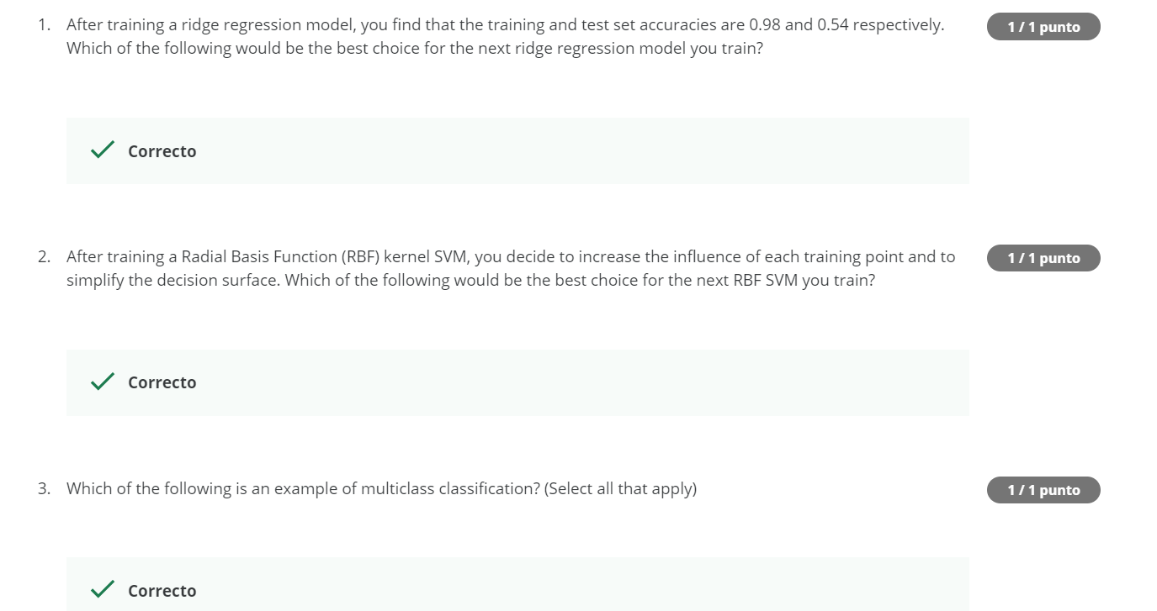
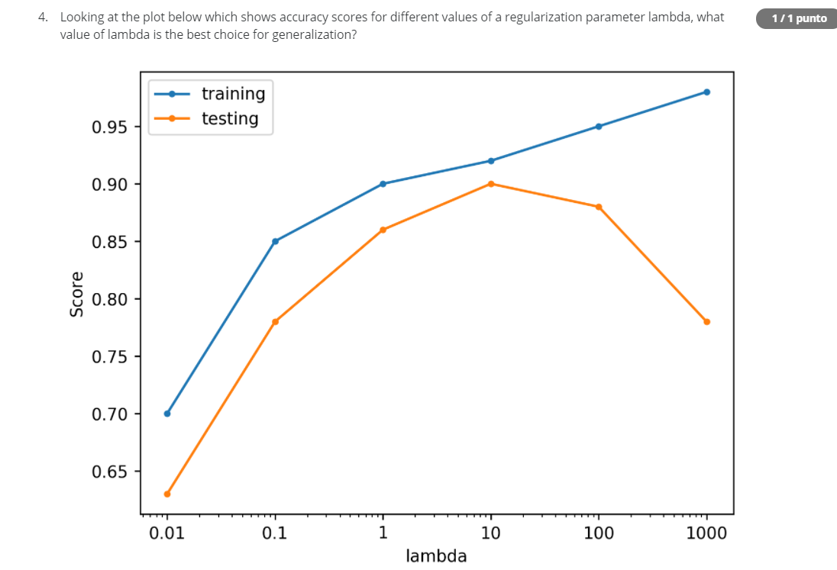
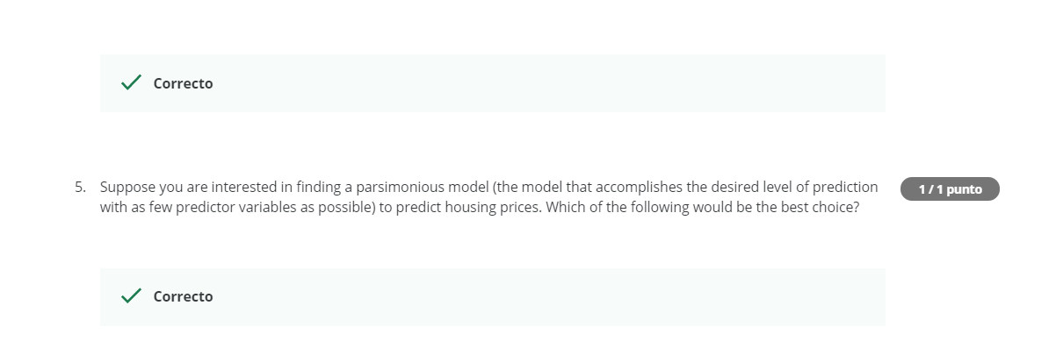
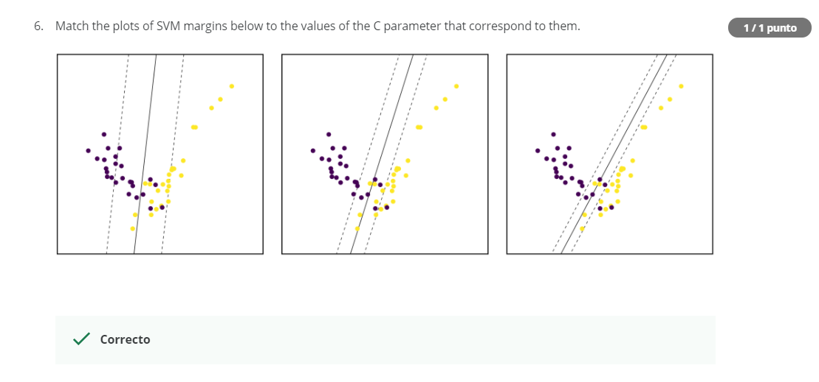
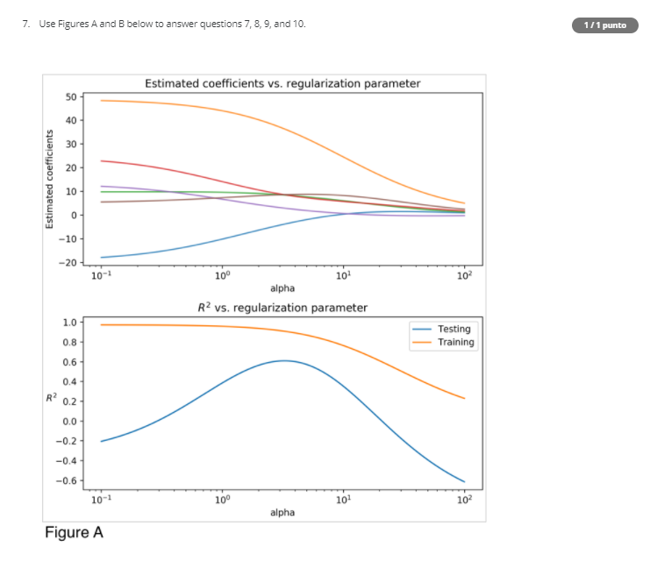
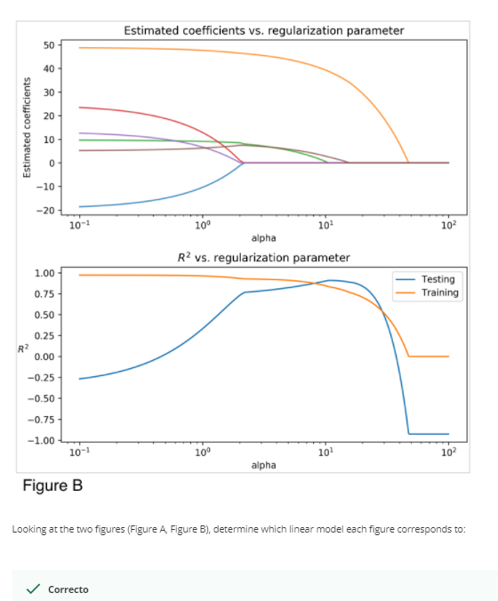
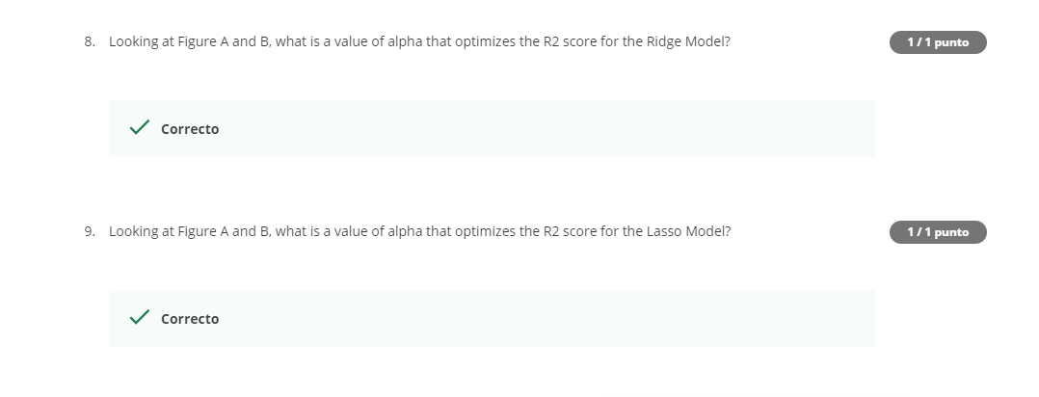
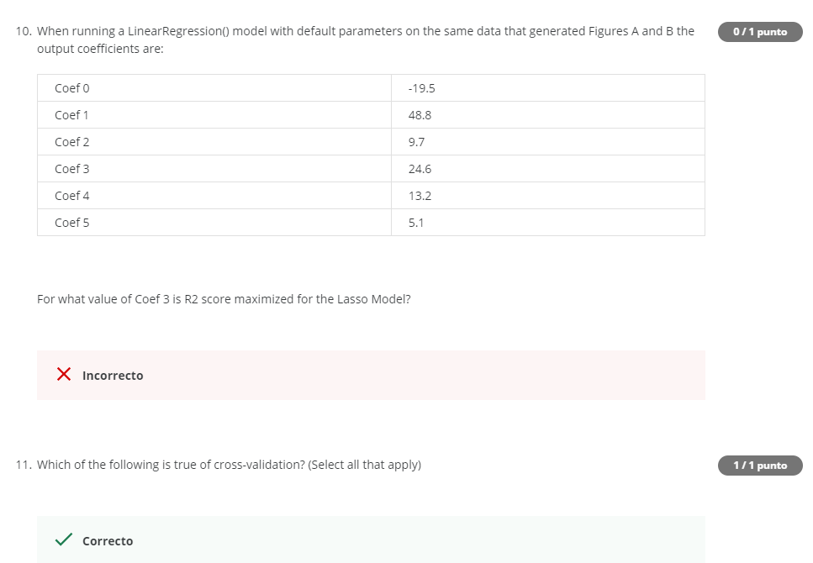
- Overfiting, higher alpha
- Decrease C and gama
- Classify a set of fruits
- 10
- Lasso
- 0.1, 1, 10.
- Ridge, Lasso
- 3
- 10
- No se (malas:1,2,10.)
- Fits, increases Gand computational complex, helps prevent.

