Chapter 1 – Testing and Documentation
Built-in tests
After studying the documentation on testing with dbt, you'd like to make sure you know which tests are built-in to dbt.
- Place each card into the appropriate group, whether it is a built-in test or not.
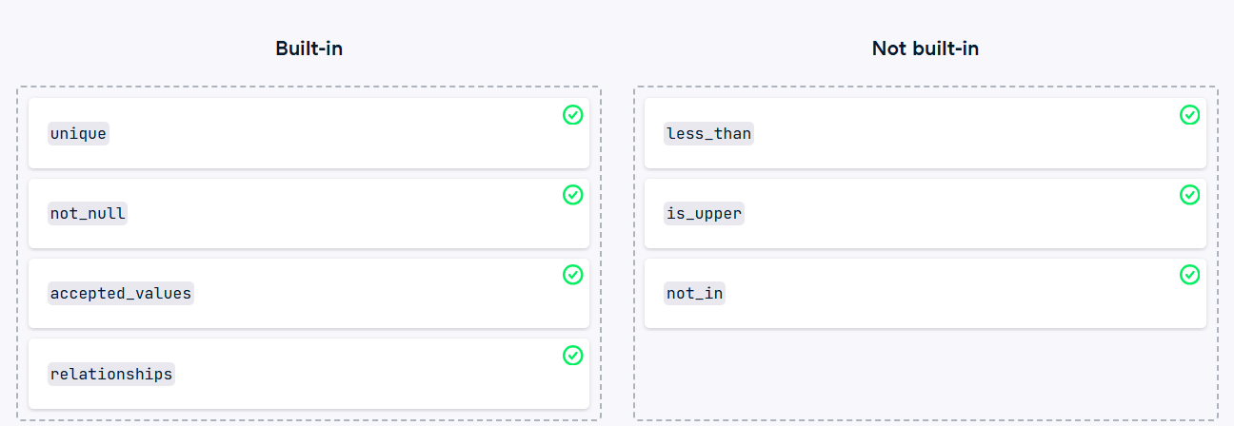

Defining tests on a model
After learning about tests within dbt, your manager has asked you to implement some quality tests on the data used by the marketing department. It seems some entries are appearing without values, while others have a value, but do not match up with what's expected in the data.
Specifically, the issues with the columns are as follows:
payment_type: Should not be null, Column values need to be between 1 and 6.
- Update the model_properties.yml file below to include the two appropriate tests for the payment_type column. Generate your models with dbt run. Test your data with the appropriate command.
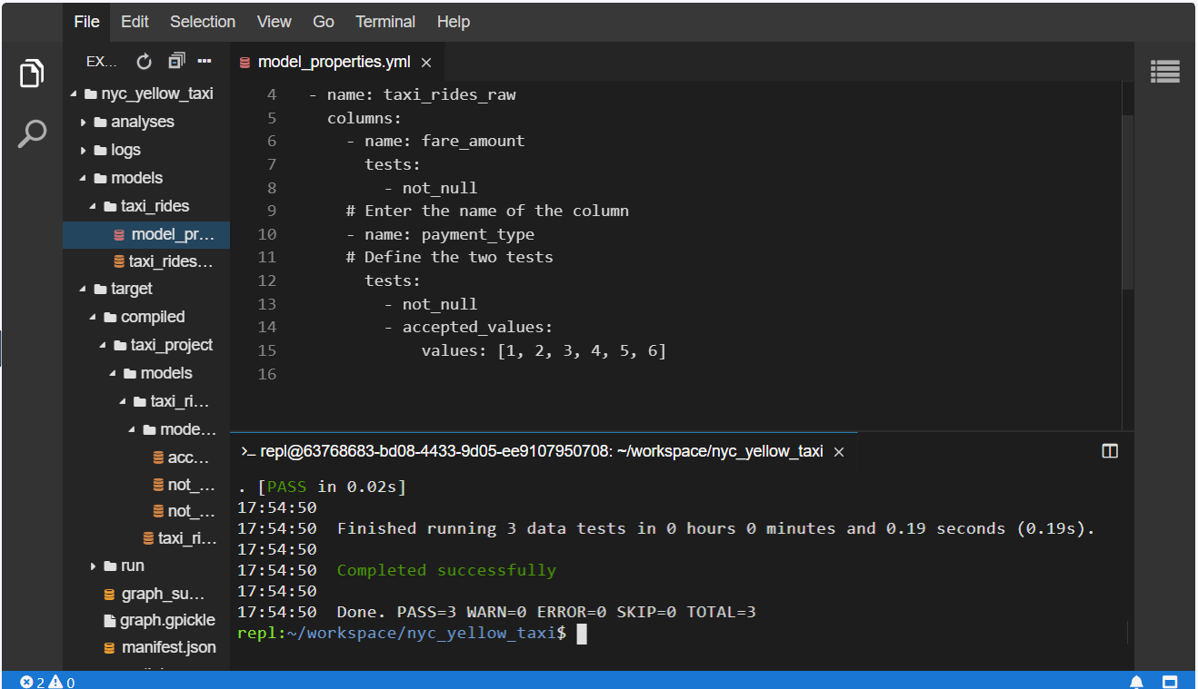
Finding bad data
Your manager is pleased with your progress - after implementing the data validation tests in your project, they ask you to verify the current dataset for any issues. As such, you plan to test the data, identify any problems, and update your model to handle the issues.
The initial project has been materialized for you with dbt run. You can test without running it first.
- Use the appropriate command to execute your data validations.
- If an error is present, determine which validation has failed. Make sure to scroll up in any output so you can see it all.
- Open the model file and update the SELECT statement to handle the case of a 0 value in the payment_type field.
model_properties.yml con tests agregados
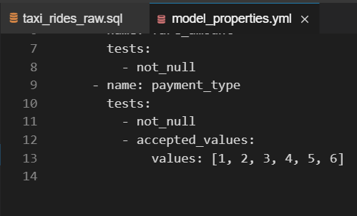
taxi_rides_raw.sql sin filtro
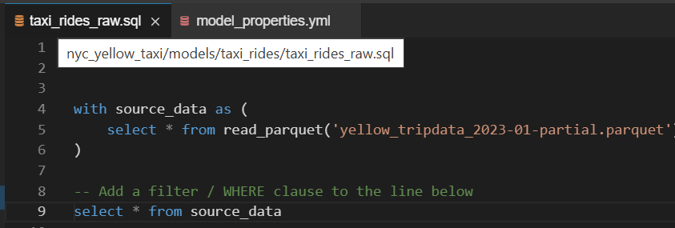
taxi_rides_raw.sql corregido: con filtro
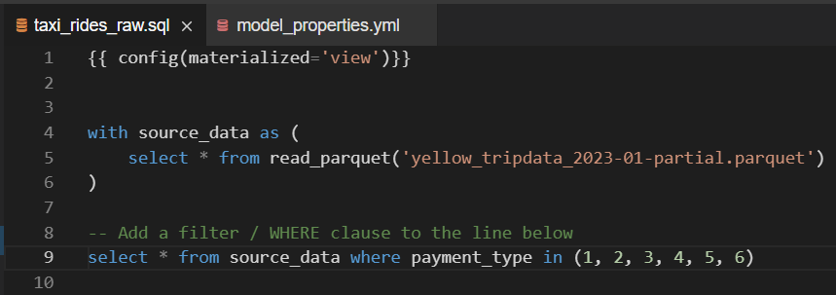
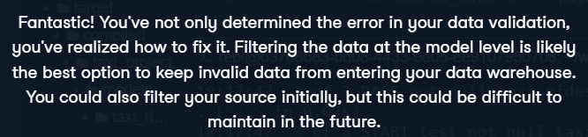

Steps to develop a singular test
You've just learned about singular tests in dbt. You'd like to make sure you understand the steps required to create a test and the order that they should occur.
- Place each item in the order it should happen, from first to last.
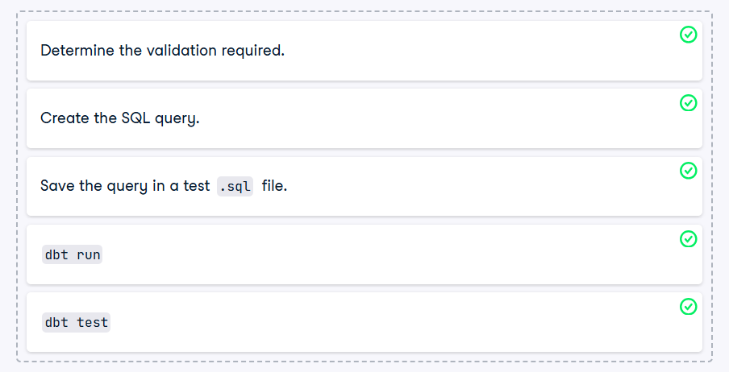
Verifying trip duration
Your teammate flags an issue in the source data: some rows have a trip duration of 0. While filtering is possible, downstream models store these. He asks you to create a test that fails if any trip has a duration of 0.
Reviewing the taxi_rides_raw schema, you find no direct trip duration field. You determine the issue arises when trip start and end times are identical. You decide to write a quick query to check for this.
You can refer to the schema_document for information about the fields in the taxi_rides_raw table.
Note that the dbt project has already been executed for you and should not be required.
- Open the test file named assert_trip_duration_gt_0.sql in the proper directory. Update the SQL statement to verify that the start and end values for the trip are not equal. Execute just your validation using the appropriate command and verify how many rows fail the test
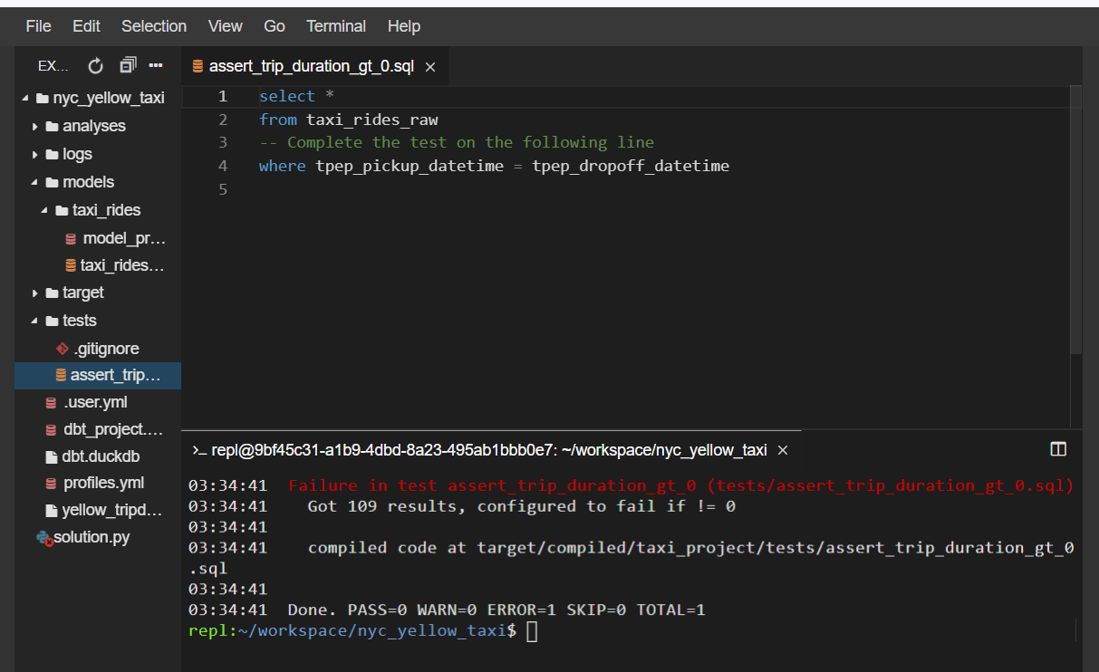
Verifying test queries
You've successfully implemented the assert_trip_duration_gt_0.sql query described in the previous exercise. As you've developed a successful test, you're tempted to leave it as is but you're curious if there are other solutions that would also provide proper validation for the test.
After working through some potential SQL queries, you need to decide which two of the following SQL statements will meet the validation requirements. Remember, you want to validate that the trip duration is greater than 0 minutes. You can refer to the schema document for information about the fields in the taxi_rides_raw table if needed.
- Drag each query into the appropriate bucket for if it is a valid query for our test.
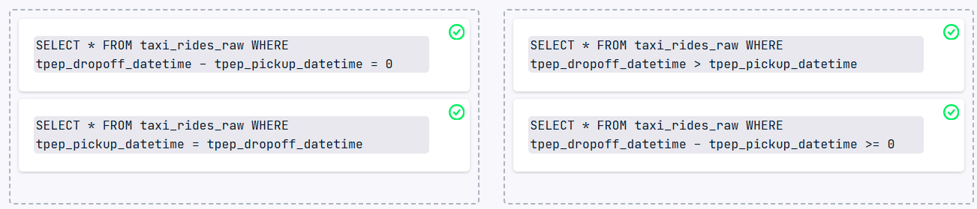
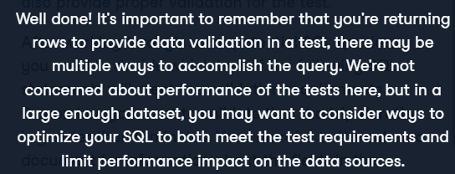
Testing, testing, testing
With all the styles of tests available in dbt, you want to make sure you understand exactly how and when to use them. As such, you decide to go through several examples of tests and determine what kind they best fit.
- Select which type of test best represents the example on each card.
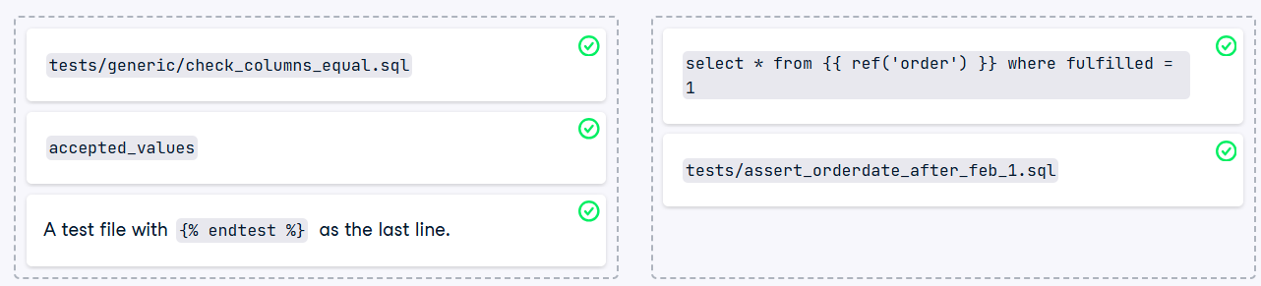
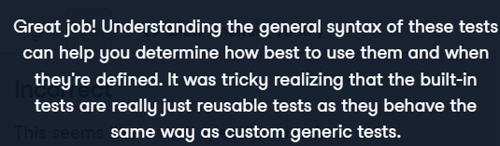

Implementing a reusable test
After learning about reusable tests, you realize that you'd love to build an in-house set of common tests for you and your team to use as you see fit. You notice that your datasets have several scenarios where you want to verify the columns contain values greater than 0. You decide to start your library by writing a reusable test for this purpose.
Note: Your data has not been materialized yet and, remember, we need to return rows that fail the test condition.
- In the file check_gt_0.sql, update the test file with the correct test name. Please note that the last character is a numeric zero, not a capital letter O.
- Add the test to the columns fare_amount and total_amount on the taxi_rides_raw table within model_properties.yml.
- Use the dbt run command to materialize your data within dbt prior to testing your data.
- Run the appropriate dbt test command to determine if there are any errors in the newly created .sql file.
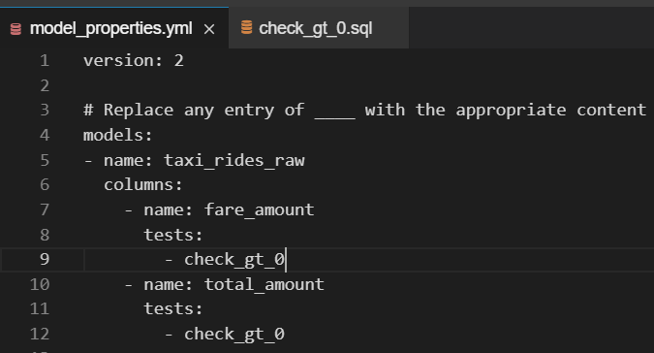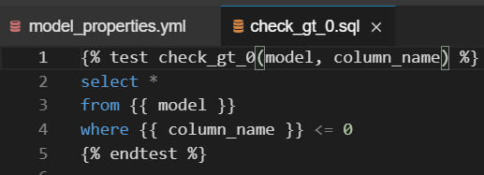
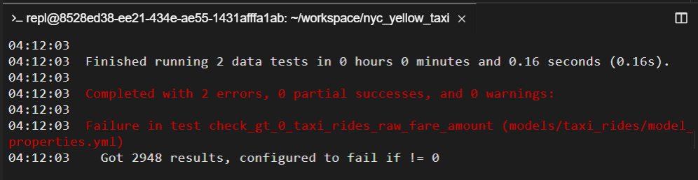


Updating from singular to reusable test
Having successfully implemented a reusable test, you decide to make a previous singular test reusable. Looking in your project files, you note that you previously created the assert_trip_duration_gt_0 test. You decide to try and create a reusable test that implements the same functionality.
Note: Your previous implementation is available and open to you for reference.
- Open the tests/generic/columns_equal.sql file and finish the implementation.
- Apply the columns_equal test to the taxi_rides_raw model, giving the tpep_pickup_datetime and tpep_dropoff_datetime as the column arguments and check that both columns are equal.
- Materialize your project using the appropriate dbt command.
- Test your model and verify that both tests fail with the same results. Make sure to use the appropriate .sql file for this!

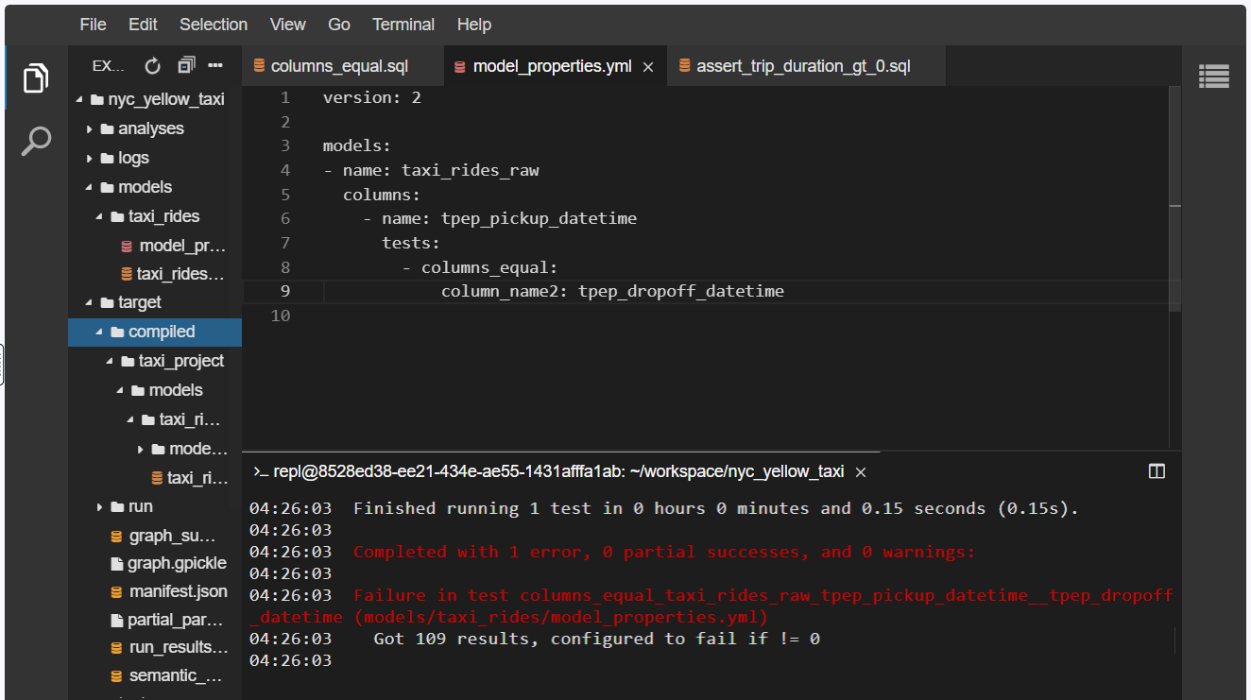
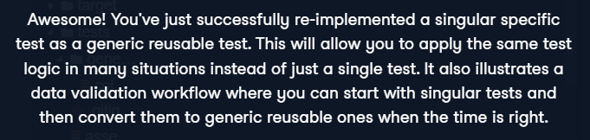

Chapter 2 – Implementing dbt in production
Models, sources, or both?
While studying about dbt's uses of sources, you realize there are a lot of similarities between models and sources. You discuss this with your tech lead, who asks you to create a quick cheat sheet for your team. She asks that you indicate the properties that are unique to the models, unique to the sources, and common to both.
- Move each item into the appropriate bucket, based on if the item is unique to models, unique to sources, or available in both object types.
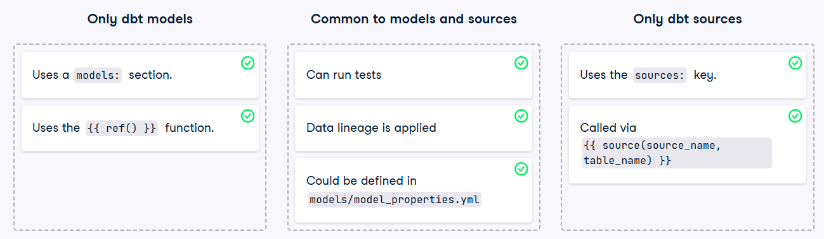
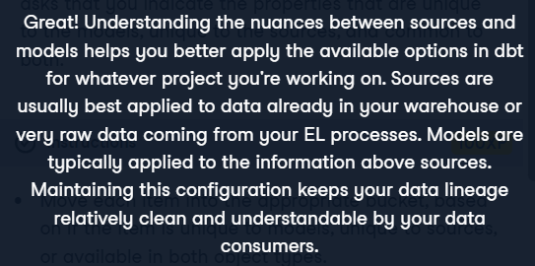
Adding a source
As you've learned about dbt sources, your manager has asked that you re-implement the taxi_rides_raw content as a dbt source rather than simply an existing table. To make this change, you'll need to add a source to the appropriate file, and then update the taxi_rides_raw model to query the correct source. The source name being used is raw, and the table name is taxi_rides.
Note: The data is already updated and in-place for you, but requires an updated reference before performing a dbt run command.
- Modify the models/model_properties.yml to add the source under raw.taxi_rides. Update the taxi_rides_raw model to query the new source. Tell dbt to generate the model using the appropriate subcommand. Enter ./datacheck in the terminal to run the datacheck program and verify your data is as expected.
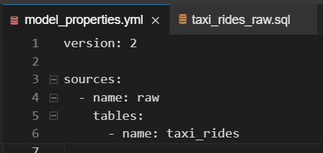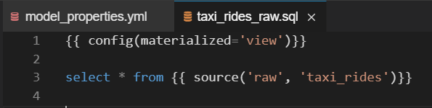
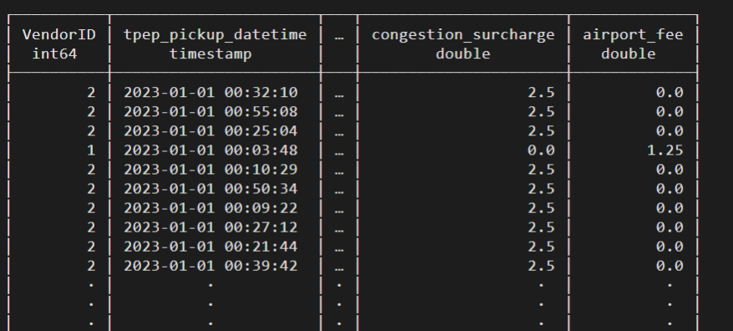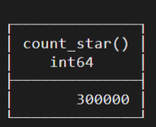
DBT SEEDS
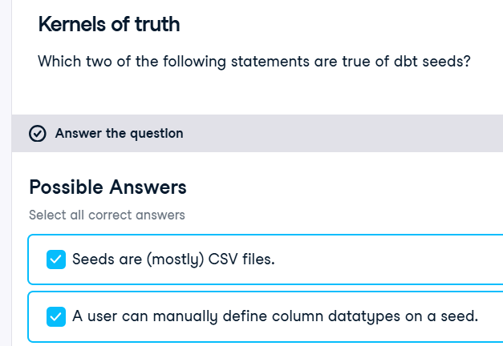
ZIP is the code
In preparation for your dbt projects, you realize that having a list of New York & New Jersey zip (postal) codes and some additional information would be good to add. Reading through the information, you realize that utilizing the dbt seed functionality would be a great way to add this information. For reference, zipcodes are 5 digit numeric values representing the postal code of an area in the US.
The format of the zip file in question is:
zipcode,place,state
07093,West New York,New Jersey
12007,Alcove,New York
12009,Altamont,New York
12023,Berne,New York

This file is already downloaded for you (as nynj_zipcodes.csv), but may not be in the correct location, nor have the correct configuration.
- Move the csv file nynj_zipcodes.csv into the appropriate subdirectory. Update the appropriate .yml file to define the zipcode column to preserve any leading zeros. Run the dbt seed command to generate the seed. Run the ./datacheck command to verify the data is available in your data warehouse.
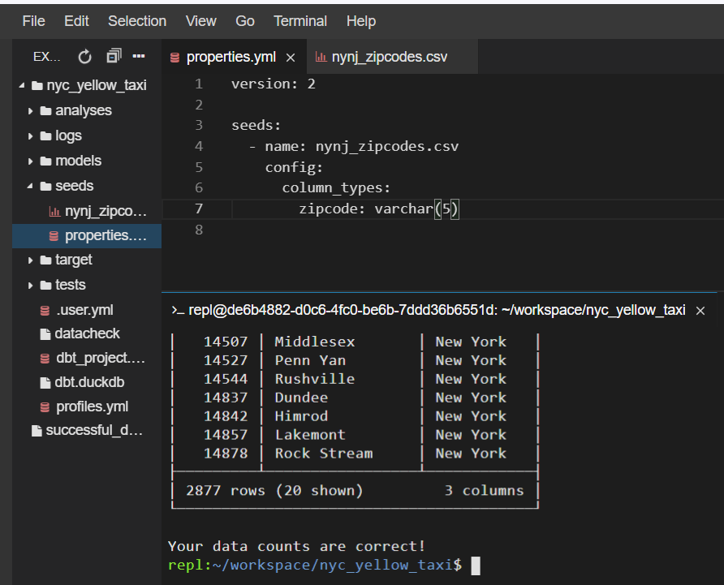

Snapshot process
After speaking with your manager, you decide that you should implement dbt snapshots on a given data table within your data warehouse. To make sure you have the correct process down, you decide to run through the order of implementing snapshots within dbt.
- Place each entry in order, from first to last, representing the process required to implement dbt snapshots.
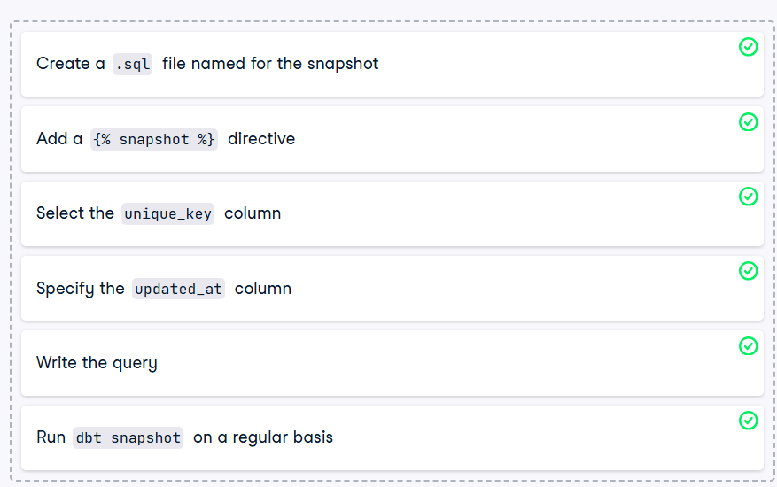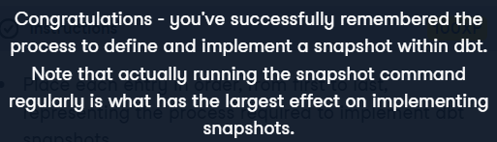
Snapshot Issue
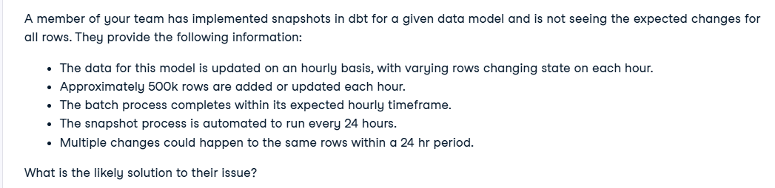
Adding a snapshot
When working with your team, you learn about a new tangential dataset being added to the data warehouse. This dataset represents the set of vehicles that will be in use for a given taxi license. While a taxi is likely to be used for quite some time, it is possible that the license may be reassigned to a new vehicle during a given timeframe. One of your colleagues realizes this may cause issues with future reporting as a ride may not be represented by the proper vehicle.
The dataset looks like the following:
column_name | description
license_id | The numeric ID assigned to the taxi company
vehicle_make | The manufacturer of the vehicle
vehicle_model | The model of the vehicle
vehicle_year | The year the vehicle was manufactured
last_updated | Date when the record was last modified
Looking at this information you realize this is a great time to implement snapshots using dbt. After discussing this with the team, your team lead asks you to implement the snapshot functionality in the nyc_yellow_taxi project, using the source named 'raw.vehicle_list'.
- Add the snapshot directive to the vehicle_list_snapshot snapshot definition. Update the config directive to use the proper entries based on the columns in the raw.vehicle_list source. Write a query to find all rows from the source. Run the appropriate command to generate the snapshot.
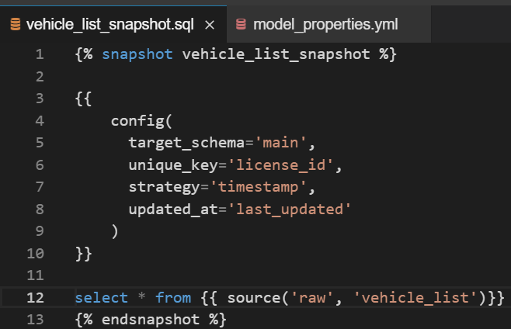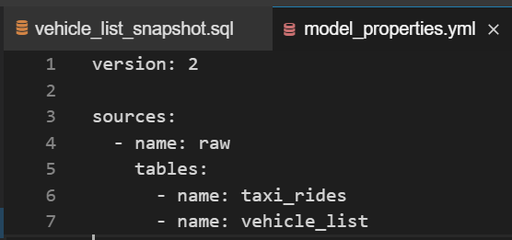
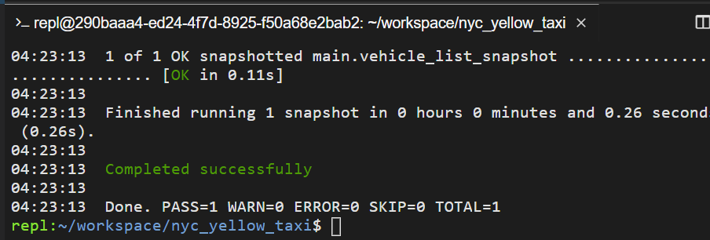

What can't dbt build do?
After learning about dbt build, you want to make sure you understand the components used within. You decide to look at the various subcommands and sort them accordingly.
- Place each subcommand into the appropriate bucket based if dbt build executes that step / subcommand.
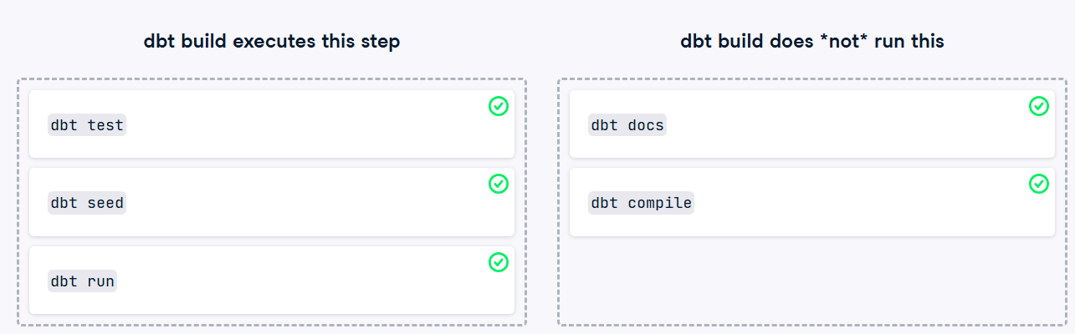
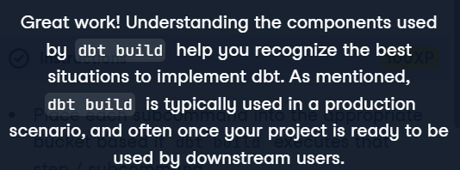

Helping the intern!
After learning about dbt, you've successfully implemented several projects with your team. As your knowledge has increased, your status as a solid dbt practitioner has developed with the rest of the team. One of the interns has tried re-implementing a project from scratch, but is having issues getting the project to compile. Your team lead has asked you to take a look and fix the known issues in the project.
Remember to look through the assorted YAML files to make sure things are named consistently in the project.
- Execute the dbt command as you would in production. Look for any errors related to snapshots and fix these. Re-execute the production dbt command.

Error 1
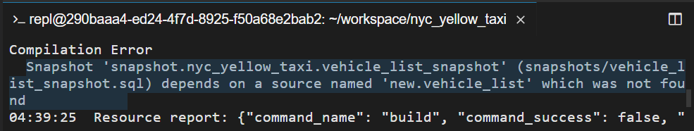
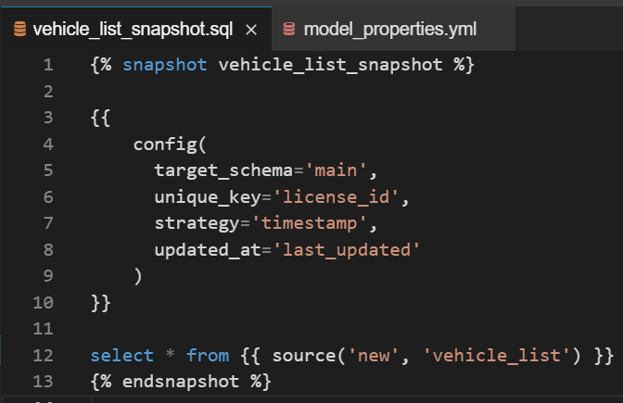
Error 2
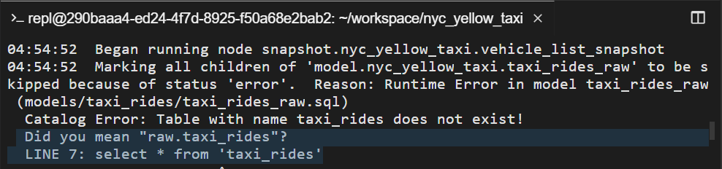
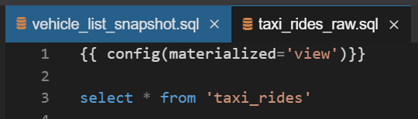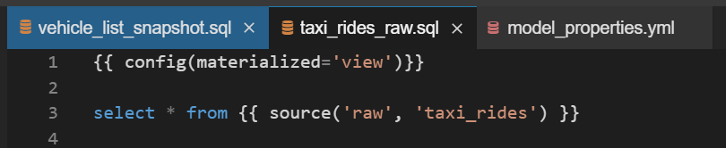

Putting it all together
You've successfully helped fix the issues your intern colleague experienced in their project. Now your team lead asks that you help with implementing the project in production. Now it's time to run through everything automatically and generate the appropriate output.
- Run the appropriate dbt subcommand to automatically build all models, run tests, and use the seeds.
- After verifying success, generate the documentation for all the project by running dbt docs generate
- Serve the documentation and verify all the dependencies are in place by running dbt docs serve
- Use Ctrl-C to exit the documentation service. Note that you may receive a Python error when you do so. You can safely ignore this error as it's expected.
