Chapter 1 – Introduction to dbt
Running the dbt command
Let's dive into dbt! Here is a quick introduction: you'll immediately get hands-on with the terminal in the IDE editor, and you'll run a simple dbt command
- In the terminal window (the bottom right panel with the text repl:~/workspace), run the command dbt. Use the scroll bars to review some of the details shown.
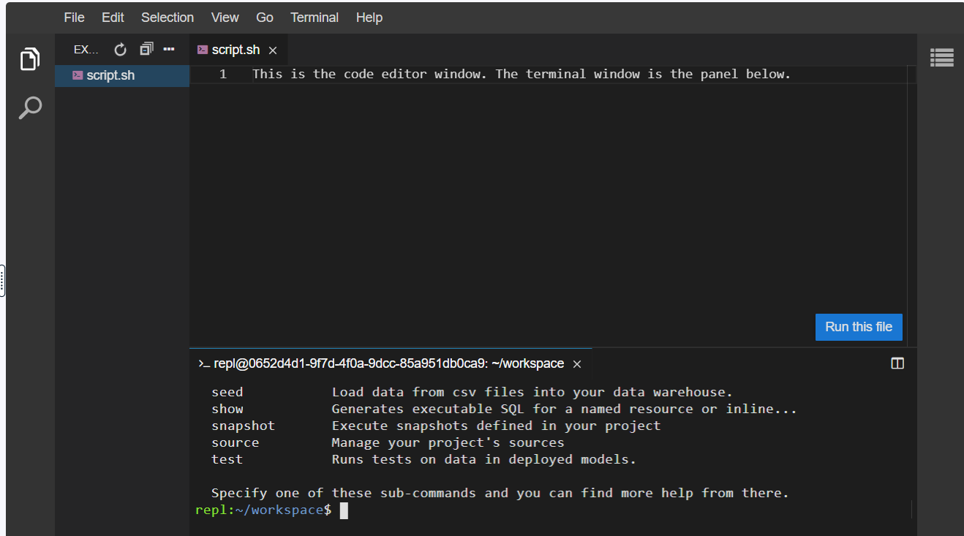
Version of dbt
While learning about dbt, your manager would like to know what version of dbt is being used.
- Run the appropriate dbt subcommand to determine what is installed on your system.
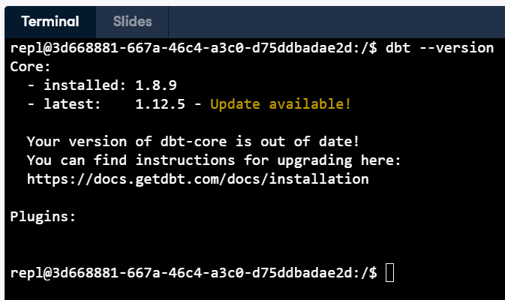
Getting help
After checking the version, your manager wants you to find out which commands are available in dbt. Uncertain exactly how to answer that question, you return the command-line with dbt and see what you can learn.
- Run dbt with the appropriate flag to get help (a list of possible commands to use).
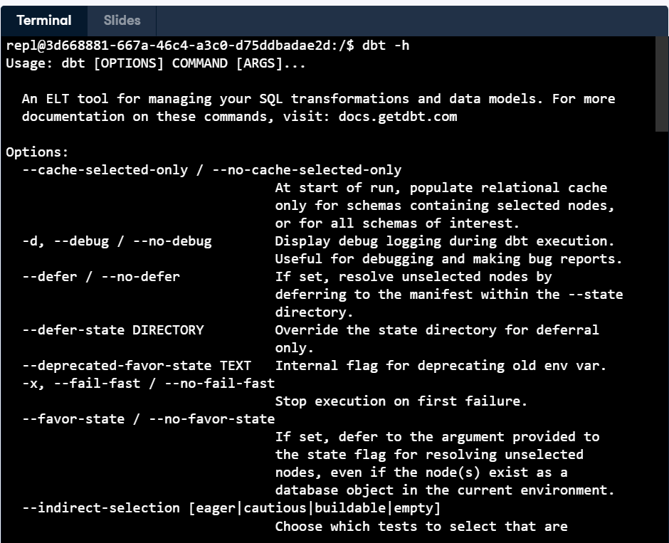

Initializing a dbt project
In order to become familiar with dbt, your manager has asked you to create a sample project to work with New York City's Yellow Taxi Cab dataset. You'll need to work through the basic configuration of the project, entering the appropriate commands as required.
- Run the appropriate dbt sub-command in the terminal window to initialize the project, using the information found in the ProjectInfo.txt file.
- Using the Linux command to change directory, change to the newly created project directory in the terminal window.
- Verify there are currently six main sub-directories (analyses, macros, models, seeds, snapshots, and tests).
- When finished, submit the exercise.
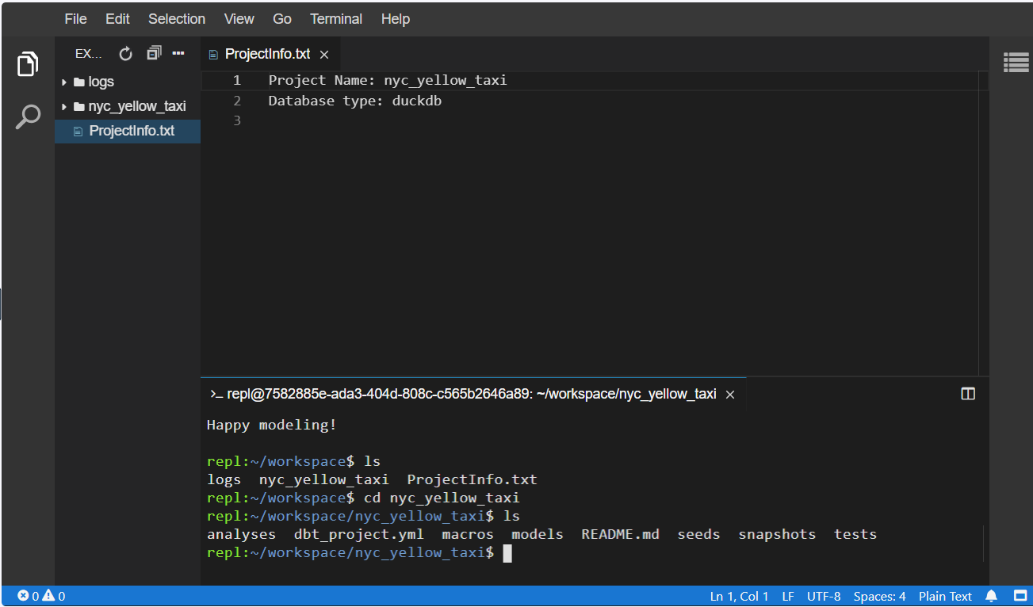

Creating a project profile
As requested by your manager, you've initialized your dbt project. Reading further through the documentation, you notice that you need to create the project profile, which defines where your database / data warehouse information is defined. Your project is experimental at this point, and needs to work with DuckDB, a locally running database tool.
You notice that dbt primarily uses YAML (abbreviated .yml) files for its configuration. On YAML files, you'll need to maintain spacing / formatting as illustrated to make sure the file parsing succeeds.
- Open the nyc_yellow_taxi/profiles.yml file in the editor window. Modify the project name (the first line) to nyc_yellow_taxi. Change the type: to duckdb. In the terminal, use the command dbt debug to verify there are no errors. When finished, submit the exercise.
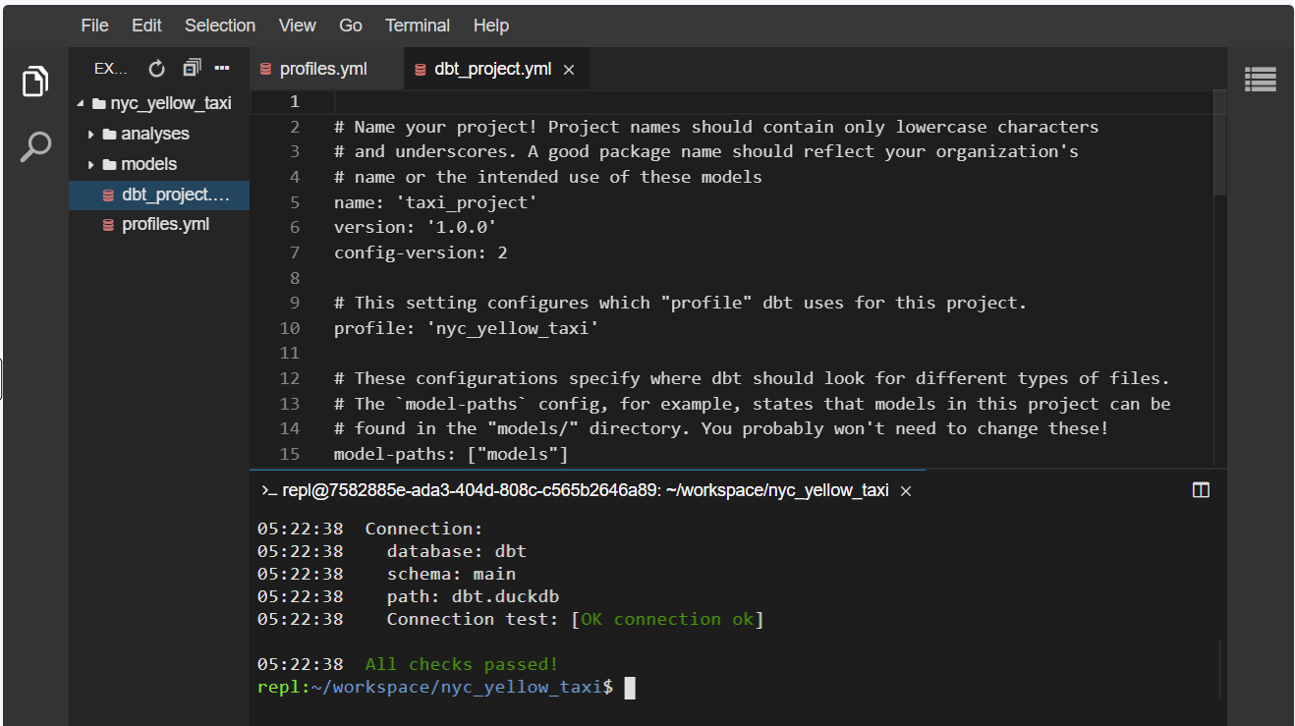
Chapter 2 – dbt projects and models
dbt project workflow
As you've learned about dbt, you realize there are many steps to a workflow within a project. You wish to verify that you understand the proper order of a project workflow.
- Place each step in the proper order of a dbt workflow, with the beginning step on top and the ending step at bottom.
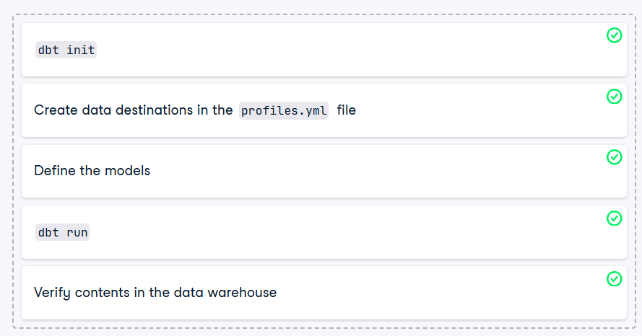

Running a project
You've successfully created a project and defined the required parameters to connect to your data warehouse. Your manager is pleased with your accomplishments thus far and would like to see the project run in demo form. They would like the data to be materialized into the data warehouse from the initial data source, using some example configurations a colleague tested with previously.
Note that your colleagues have provided a test script called datacheck to validate the contents of the data warehouse.
- Use the command dbt run to materialize the data into the data warehouse, noting the error that appears.
- The query in the taxi_rides_raw.sql file needs to be updated. Change the text to use the following query: select * from read_parquet('yellow_tripdata_2023-01-partial.parquet')
- Run the project again and verify the error has been fixed.
- In the terminal, run the command ./datacheck to verify there are 300000 total_rides and look at a sample of the content from the data warehouse. Please note that ./datacheck is a python script used for verification only and is not part of dbt.

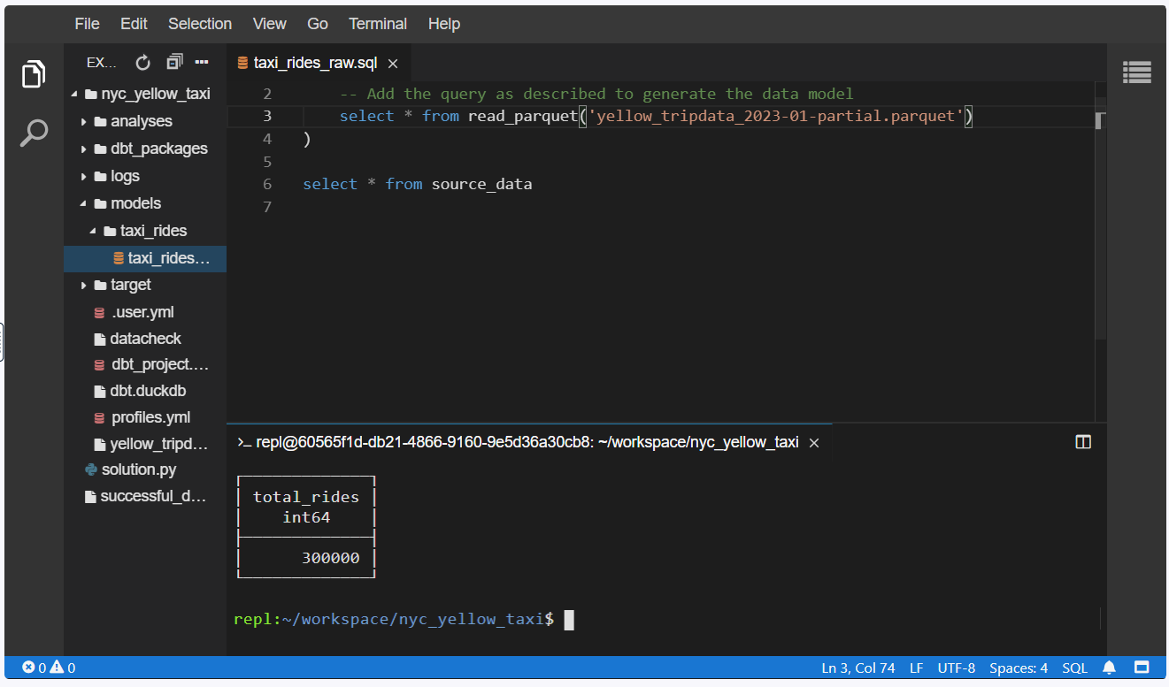
Features of a data model
As you're learning about dbt, you realize you should have a solid understanding of the basics of data models. While reading through some details of data modeling, you decide to determine which features are true of a data model, and which are not.
- Move the items that are true or false into their respective areas.
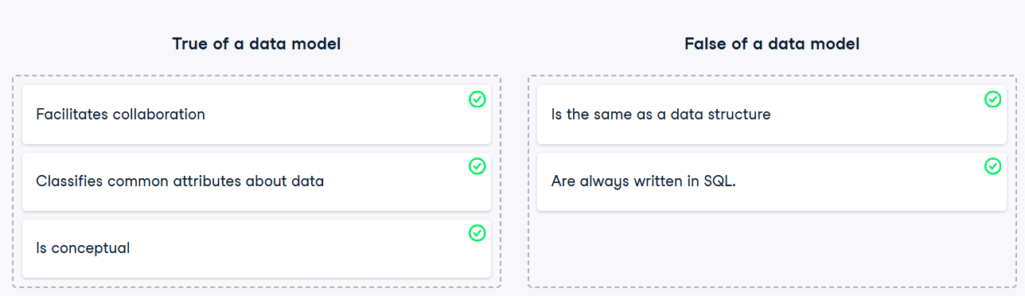

Creating a dbt model
You've learned a bit about models in dbt, but decide you'd like to implement one of your own prior to creating any for your team. You've decided to use the NYC Yellow taxi dataset to create a simple model representing all the trips taken on Jan 2, 2023.
After looking at the NYC Yellow Taxi dataset, you decide it will be best to create a simple model that uses all columns in the NYC Yellow Taxi Parquet file.
- In the nyc_yellow_taxi/models/taxi_rides/taxi_rides_raw.sql file, update the query to select all data from the yellow_tripdata_2023-01-partial.parquet file. Replace the ____ with the parquet filename.
- In the terminal window, use the cd command to change to the nyc_yellow_taxi directory.
- Execute the appropriate dbt subcommand from the nyc_yellow_taxi/ directory to materialize the model.
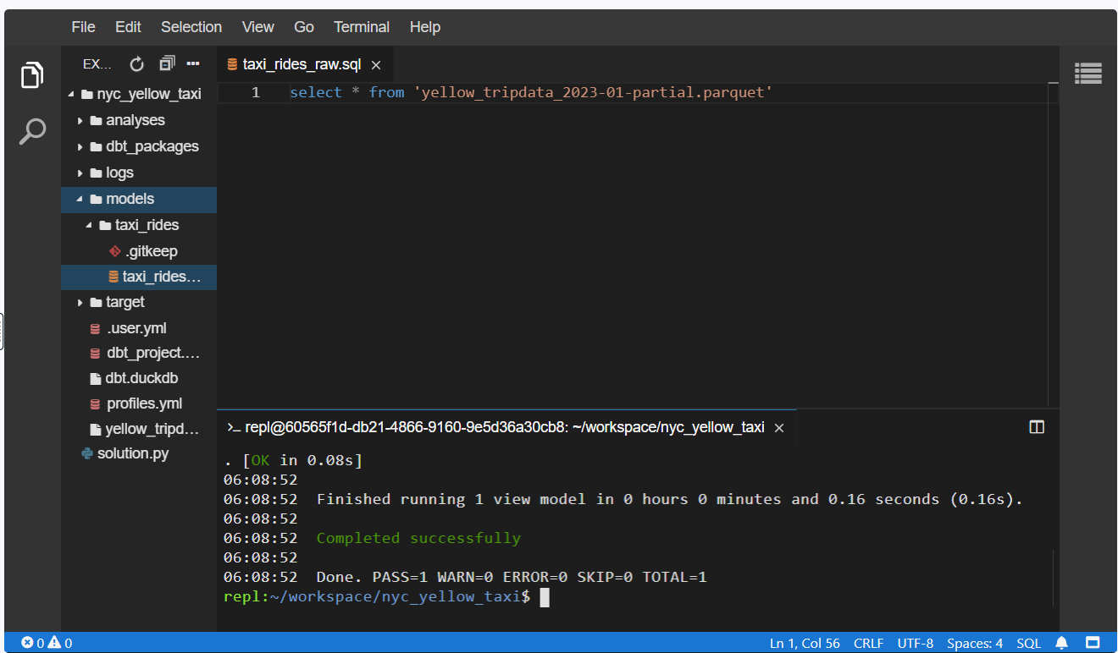
Config files
You've just discovered the YAML files for dbt properties and want to make sure you understand how these and other configuration files are used. You decide to test your knowledge and verify the filenames work as you expect.
- Place each filename in the appropriate bucket, whether for the dbt project as a whole, or for a model.
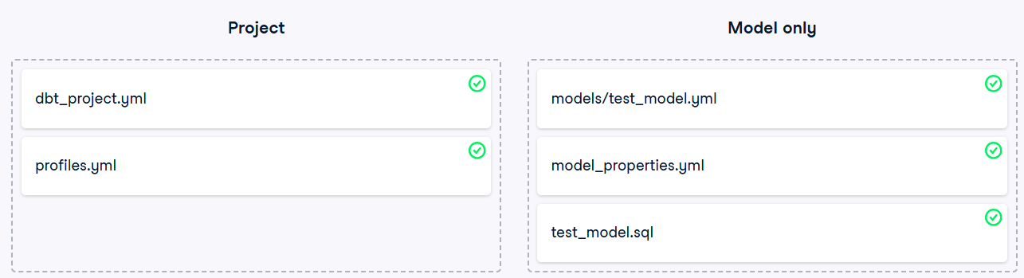
Updating a dbt model
Your team lead just forwarded you an email with a data request from the marketing department. They'd like to count all the credit card users by day be available in the data warehouse and automatically updated based on the current dbt models. The new model should be called total_creditcard_riders_by_day and contain columns for day and total_cc_riders.
There is currently a model (meaning a SQL table) available under the name taxi_rides_raw that you can query against.
- Update the SQL model code with the requirements listed above, using the NYC Yellow Taxi data schema to determine how to filter the model.
- Initiate the dbt command to execute the model.
- Run the validation command ./datacheck in the nyc_yellow_taxi directory to check the contents match. Please note that the ./datacheck tool is a python script provided for data verification and is not part of dbt.
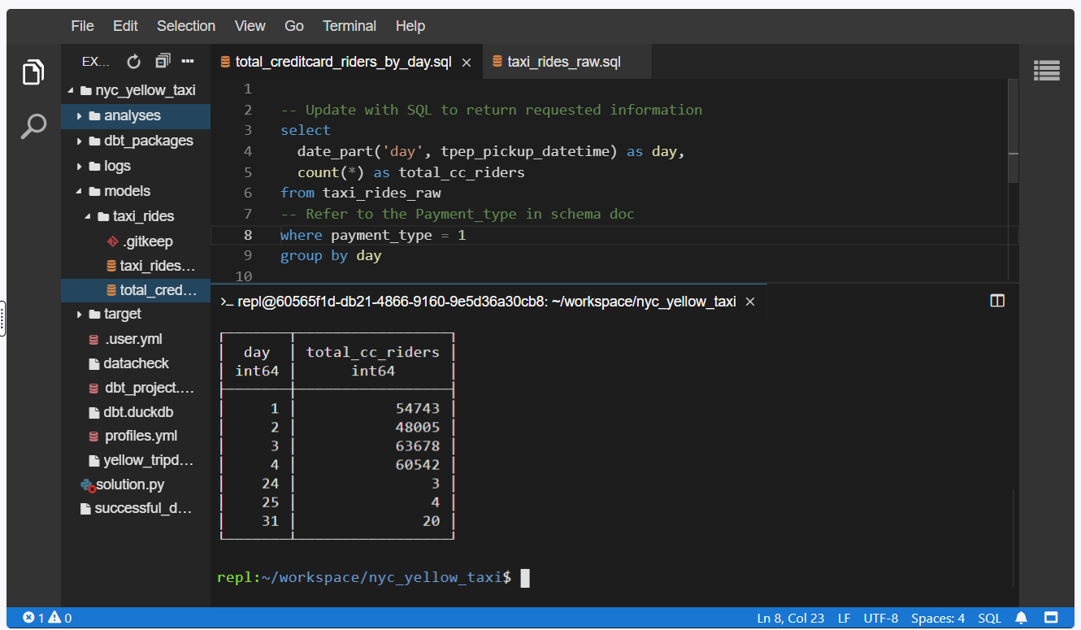
Chapter 3 – More on dbt models
dbt documentation flow
You've learned about the process for adding documentation for your dbt project and are excited to implement this functionality for your team. After proposing this to your team lead, she asks that you provide an example set of steps required in order to implement and provide the documentation to your team and data consumers.
- Place each task in order to successfully implement documentation in dbt, from the first task required at top to the final task at bottom.
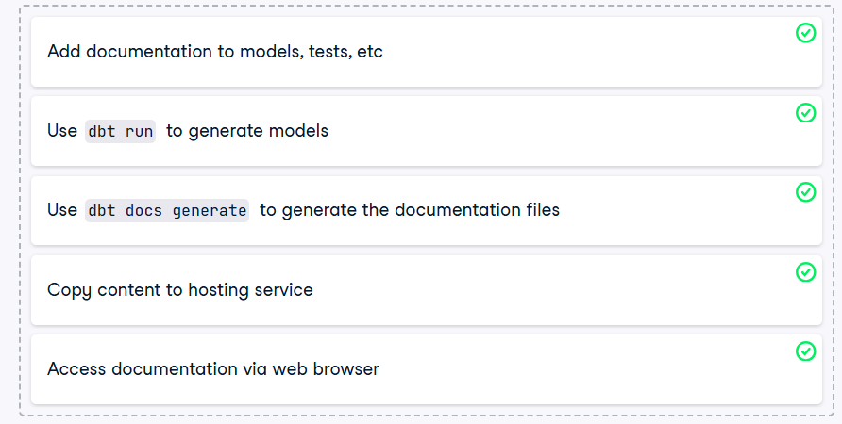
Creating dbt documentation
Your ELT projects are moving forward well, and your team is pleased with the work you've done thus far. You've noticed that you're spending more time providing information about the models, the data types, and so forth. As updates are ongoing, you'd like to automate as much of your process as possible.
While reading the documentation for dbt, you discover the dbt docs commands and realize it would be a great solution to your problems. You would like to implement these into your project for your current and future models and then serve the data to other users. Please note that we will not view the documentation within this exercise but rather make sure the content can be served.
- Modify the models/model_properties.yml file to add the following description to the appropriate line: Initial import of the NYC Yellow Taxi trip data from Parquet source
- Use the appropriate dbt command to write out the documentation.
- Run the command to start the dbt documentation server. Use Ctrl-C to cancel the documentation server.
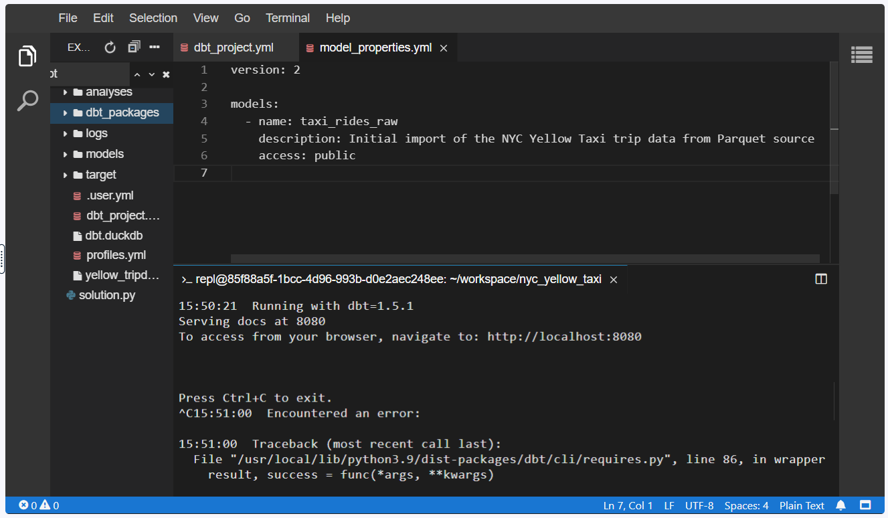
Jinja templates
What can Jinja do? Which types of operations can a Jinja template perform?
Answers: Substitution functions, Calculations, Loops.

Process a Jinja template
While learning about Jinja, your manager asks that you look at the difference between Jinja templated SQL and the generated code. They mention that you don't need to understand the SQL itself, just try to follow the difference between the template and the actual generated code.
- Review the sql model file models/taxi_rides/total_amounts.sql, specifically noting the areas that represent a Jinja template.
- Use the appropriate dbt command to generate your project's output.
- Open the file target/compiled/nyc_yellow_taxi/models/taxi_rides/total_amounts.sql using the file picker on the left.
- Read and consider the difference between the source total_amounts.sql file and the generated one. After comparing the files, choose the Submit Answer button.
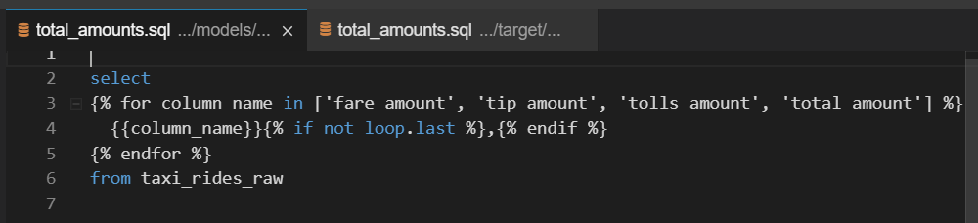
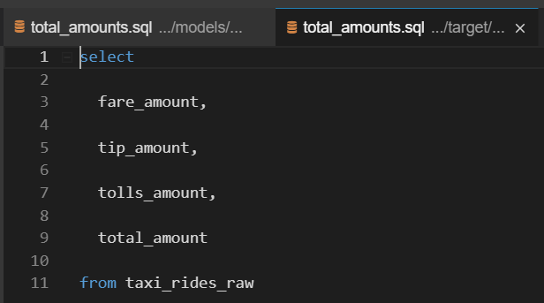

Hierarchical model creation
Consider you have the following 4 models defined: sales_raw, all_weekend_sales, total_sales_by_rep, new_products_purchased_this_week
If all of the models except for sales_raw have a Jinja template in place of the table name (such as {{ ref('sales_raw') }}), in what order will dbt execute them?
- Place the models in the order they will be created, from first to last.
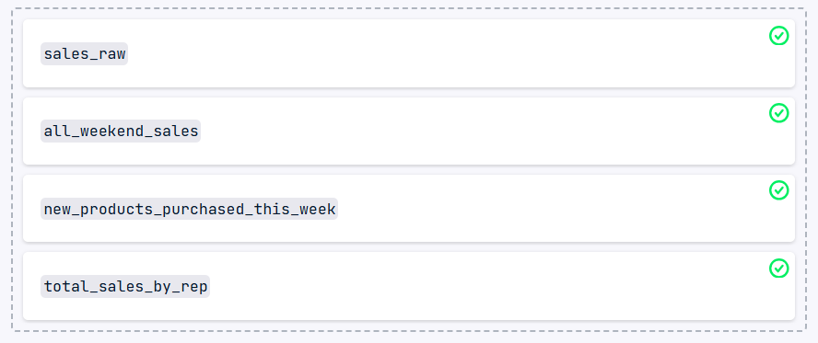
Updating model hierarchies
You've successfully created and updated a couple of models in your dbt project. Your manager has asked that you verify all models will be generated in the appropriate order so that there are no errors during the materialization process.
Note: be mindful of the spacing when writing functions.
Execute your dbt project using dbt run and look for any error messages. Open the model file referenced in the error. Update the SQL to use a Jinja ref template and save the file. Rerun your dbt project to verify the error has been remedied. This time, include the -f switch to guarantee everything is updated.
