BanerInferior
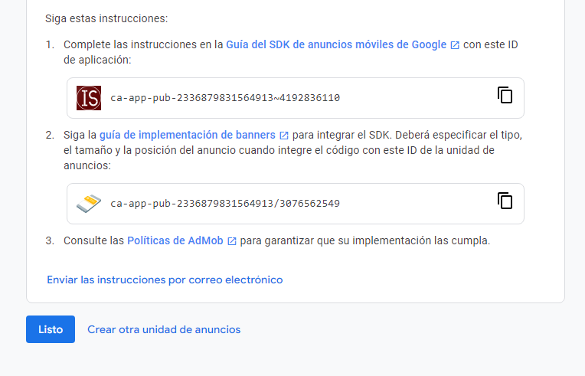

ca-app-pub-2336879831564913~4192836110
ca-app-pub-2336879831564913/3076562549

BanerPaginaCompleta
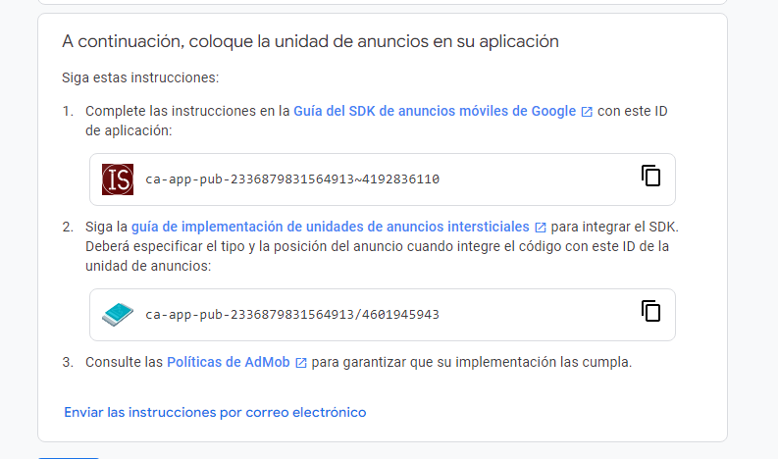
ca-app-pub-2336879831564913~4192836110
ca-app-pub-2336879831564913/4601945943

BanerNativo

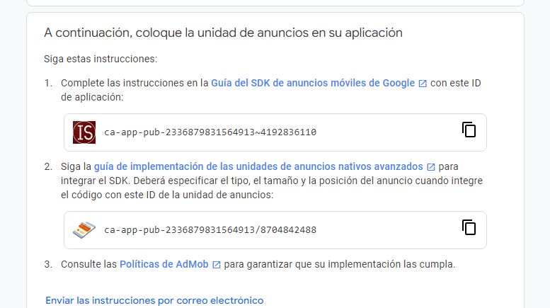

ca-app-pub-2336879831564913~4192836110
ca-app-pub-2336879831564913/8704842488

BanerAbierto

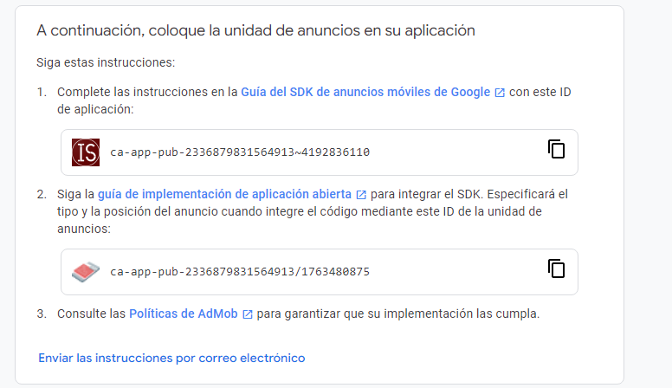

ca-app-pub-2336879831564913~4192836110

ca-app-pub-2336879831564913/1763480875

