Juan Carmona

Project 8

Demo_Instrument:

Instrument_Parts:

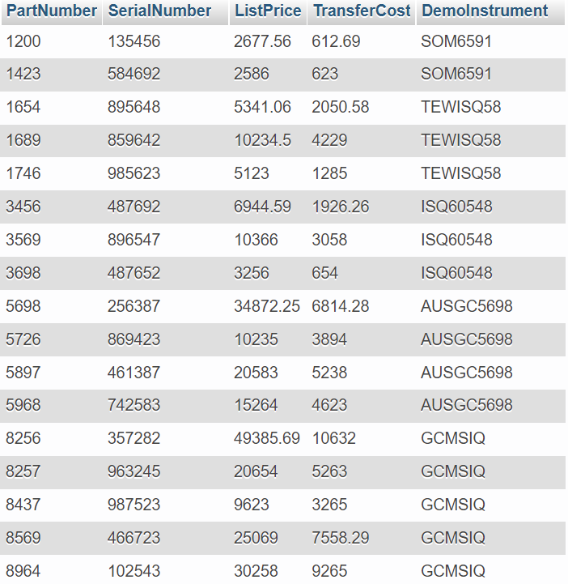

Employee:

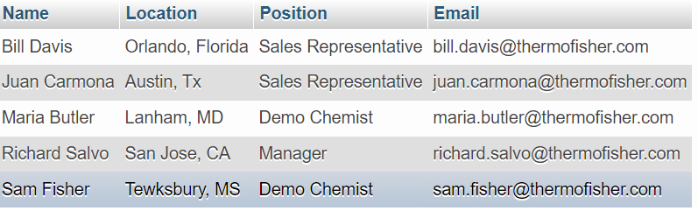

Orders:

Transfer_Orders:

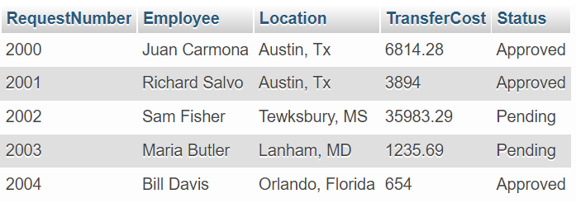

ER Model:

Queries:

1. Determines total list price of Instrument Parts 8256, 8257, 8437.

2. Displays all parts of the demo instrument AUSGC5698.

3. Determines total transfer price of Instrument Parts 8256, 8257, 8437.

4. Displays joined tables of Demo_Instrument and Instrument_Parts.

5. Displays all active instruments.

6. Displays parts of retired instruments.

7. Displays demo instruments with more than 5 years of useful life.

8. Displays employee information of the owner of AUSGC5698.

9. Displays pending transfer requests.

10. Displays information on purchased instruments.

Input:

New Instrument:

Transfer Request:

Quote input:



Output:

Demo Instrument:

Order Records:

Transfer Records:

