FRDM-KL05Z
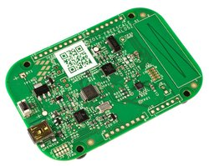
The FRDM-KL05Z is an ultra-low-cost development platform enabled by the Kinetis L Series KL0x MCU family built on the ARM® Cortex™-M0+ processor. Features include easy access to MCU I/O, battery-ready, low-power operation, a standard-based form factor with expansion board options and a built-in debug interface for flash programming and run-control. The FRDM-KL05Z is supported by a range of NXP and third-party development software.

Overview
The FRDM-KL05Z has been designed by NXP in collaboration with mbed for prototyping all sorts of devices, especially those requiring the size and price point offered by Cortex-M0+. It is packaged as a development board with connectors to break out to strip board and breadboard, and includes a built-in USB FLASH programmer.
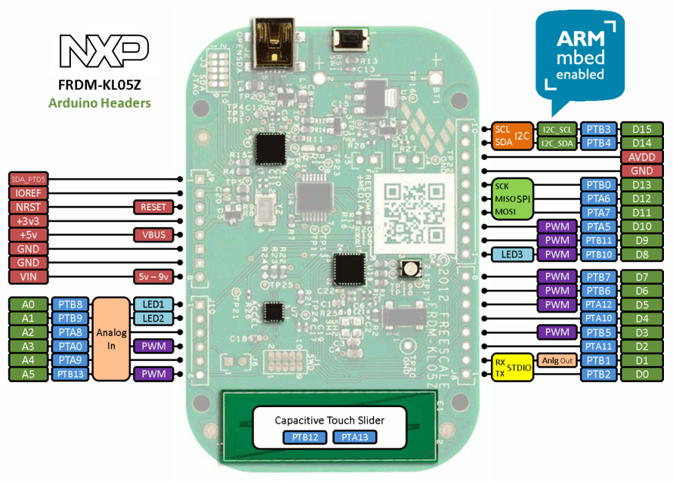
It is based on the NXP KL05Z, with a 32-bit ARM Cortex-M0+ core running at 48MHz. It includes 32KB FLASH, 4KB RAM and lots of interfaces including SPI, I2C, ADC, DAC, PWM, Touch Sensor and other I/O interfaces.

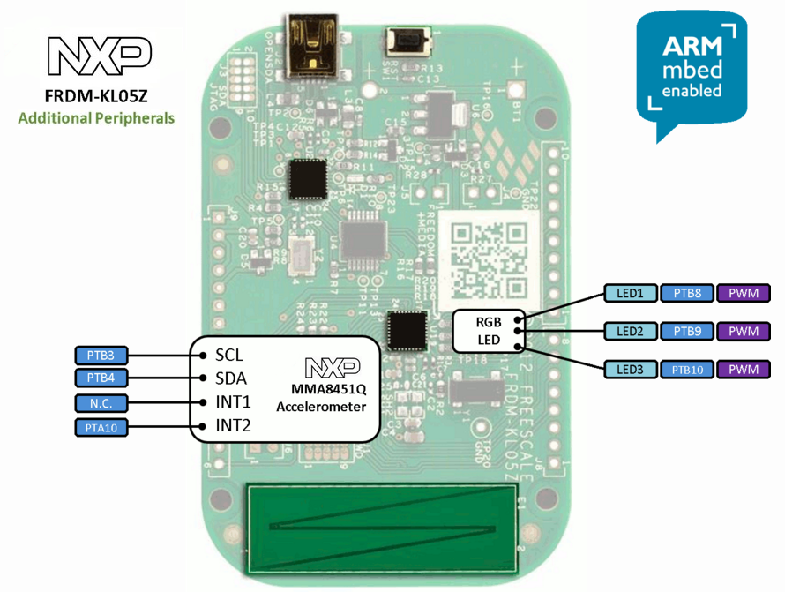

The FRDM-KL05Z is fully supported in the mbed platform, so it gets access to the free tools and SDK that provides experienced embedded developers with powerful and productive tools for building proof-of-concepts. The pinout above shows the commonly used interfaces and their locations. Note that all the numbered pins (PT_XX) can also be used as DigitalIn and DigitalOut interfaces.

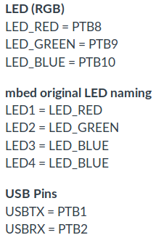
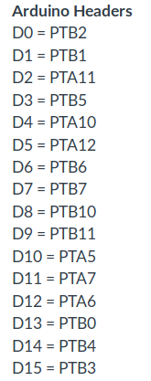
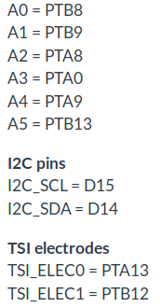
Mbed Pin Names

Features¶
NXP KL05Z Kinetis KL4 MCU (MKL05Z32VFM4)
  - High performance ARM® Cortex™-M0+ Core
  - 48MHz, 4KB RAM, 32KB FLASH
  - SPI (1)
  - I2C (1)
  - UART (1)
  - PWM (8)
  - ADC (6)
  - DAC (1x 12bit)
  - Touch Sensor
  - GPIO (28)
- FRDM-KL05Z Onboard Sensors
  - MMA8451Q - 3-axis accelerometer
  - Capacitive touch sensor
- Evalution Form factor
  - 81mm x 53mm
  - 5V USB or 4.5-9V supply
  - Built-in USB drag 'n' drop FLASH programmer
- mbed HDK & SDK enabled
  - Drag-n-drop programming
  - USB Serial Port
  - CMSIS-DAP
  - Online development tools
  - Easy to use C/C++ SDK
  - Lots of published libraries and projects
- Status
  - Production

More Information: https://os.mbed.com/platforms/FRDM-KL05Z/

