FRDM-KL46Z
The FRDM-KL46Z is an ultra-low-cost development platform enabled by the Kinetis L series KL4x MCU family built on the ARM® Cortex™-M0+ processor. Features include easy access to MCU I/O, battery-ready, low-power operation, a standard-based form factor with expansion board options and a built-in debug interface for flash programming and run-control. The FRDM-KL46Z is supported by a range of NXP and third-party development software.

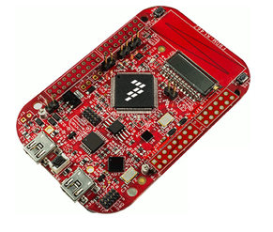

Overview
The FRDM-KL46Z has been designed by NXP in collaboration with mbed for prototyping all sorts of devices, especially those requiring the size and price point offered by Cortex-M0+ and the power of USB Host and Device. It is packaged as a development board with connectors to break out to strip board and breadboard, and includes a built-in USB FLASH programmer.
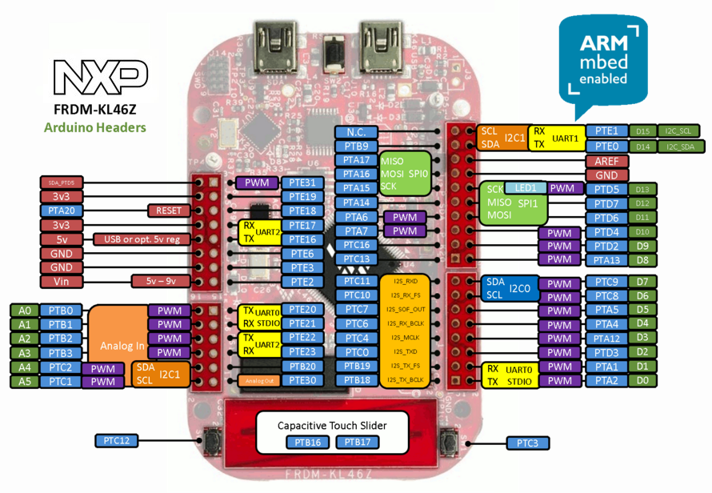

It is based on the NXP KL46Z, with a 32-bit ARM Cortex-M0+ core running at 48MHz. It includes 256KB FLASH, 32KB RAM and lots of interfaces including USB Host, USB Device, SPI, I2C, ADC, DAC, PWM, LCD Controller, Touch Sensor and other I/O interfaces.
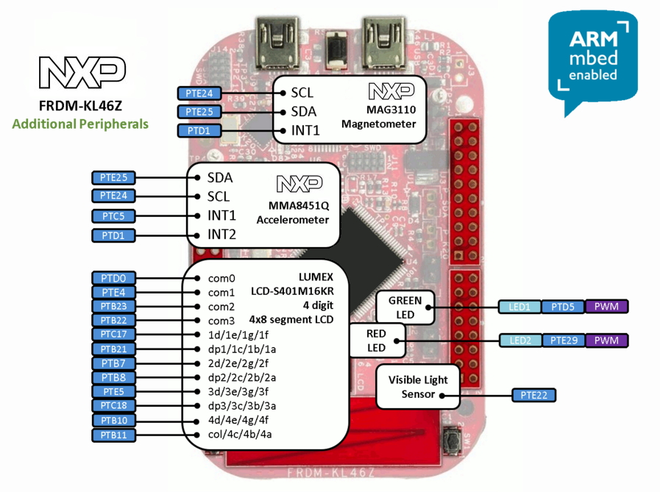

The FRDM-KL46Z is fully supported in the mbed platform, so it gets access to the free tools and SDK that provides experienced embedded developers with powerful and productive tools for building proof-of-concepts. The pinout above shows the commonly used interfaces and their locations. Note that all the numbered pins (PT_XX) can also be used as DigitalIn and DigitalOut interfaces.

Mbed Pin Names
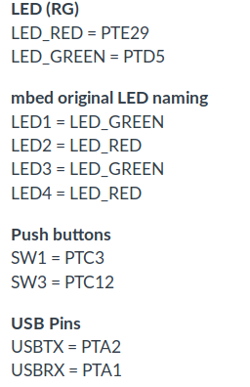
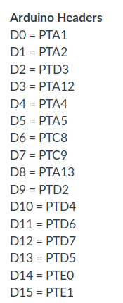
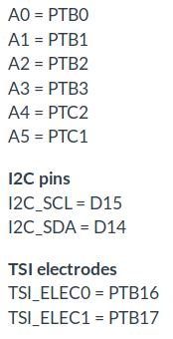

Features¶
NXP KL46Z Kinetis KL4 MCU (MKL46Z256VLL4)
  - High performance ARM® Cortex™-M0+ Core
  - 48MHz, 32KB RAM, 256KB FLASH
  - USB (Host/Device)
  - SPI (2)
  - I2C (2)
  - I2S (1)
  - UART (3)
  - PWM (6)
  - ADC (6)
  - DAC (1x 6bit, 1x 12bit)
  - Touch Sensor
  - GPIO (84)
  - LCD Controller
FRDM-KL46Z Onboard Sensors
  - MMA8451Q - 3-axis accelerometer
  - Capacitive touch sensor
  - MAG3110 - Magnetometer
  - LCD-S401M16KR - 4-digit, 4x8 segment LCD
  - Visible light sensor - ALS-PT19-315C/L177/TR8
Evalution Form factor
  - 81mm x 53mm
  - 5V USB or 4.5-9V supply
  - Built-in USB drag 'n' drop FLASH programmer
mbed HDK & SDK enabled
  - Drag-n-drop programming
  - USB Serial Port
  - CMSIS-DAP
  - Online development tools
  - Easy to use C/C++ SDK
  - Lots of published libraries and projects
Status
  - Production

More Information: https://os.mbed.com/platforms/FRDM-KL46Z/

