Juan Mauricio Condori Ortiz

Consigna:

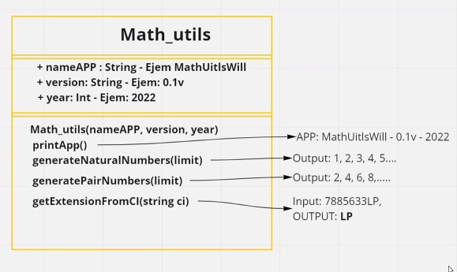

Código:

class Math_util:  
 nameapp = ''  
 version = ''  
 year = ''  
  
 def _init_(self, name, v, y):  
 self.nameapp = name  
 self.version = v  
 self.version = y  
  
 def get_nameapp(self):  
 return self.nameapp  
  
 def get_version(self):  
 return self.version  
  
 def get_year(self):  
 return self.year  
  
 def set_nameapp(self, text):  
 self.nameapp = text  
  
 def set_version(self, num):  
 self.version = num  
  
 def set_year(self, num):  
 self.year = num  
  
 def print_app(self):  
 print(self.nameapp, " ", self.version, " ", self.year)  
  
 def generate_serie(selfself, inicio, hasta, increment):  
 result = " "  
 for i in range(inicio, hasta + 1, increment):  
 if i == (hasta):  
 result = result + str(i) + ","  
 else:  
 result = result + str(i) + ","  
 return result  
  
 def extention_from_ci(self, ci):  
 print(ci[-2:-1])

from Math_util import Math_util  
  
instancia = Math_util("app Juan Mauricio C.O", "1.0", "2022")  
instancia.print_app()  
  
print(instancia.generate_serie(0, 10, 1))  
  
print(instancia.generate_serie(2, 10, 2))  
  
instancia.extention_from_ci("6064980LP")