Juan’s Brazil Trip 2026 - Field Notes
Conference & Crop Tour

Executive Summary
This crop is huge - if not the largest, the second-largest on record - and I see virtually nothing affecting the size, the price on the contrary can rally if frost are realised, btw El Niño makes frost less likely. The bearish case for September and December is intact: once the crop fills the pipeline and stocks rebuild, prices should come under pressure. The complication is behavioural. Farmers have no target price, are numb to high levels, and are trying to hold, which sets up the potential for squeezes if coffee doesn't flow smoothly out of the farms and warehouses.
Three things keep this from being a one-way bearish story. First, the pipeline itself: warehouse stocks I saw were roughly double last year, but the big export warehouses are still waiting to receive new crop, so flow - not absolute volume - is the swing factor. Second, exchange stocks in NY and Europe are the number to watch; with quality skewing good this year, I expect a real incentive to restock. Third, fertiliser timing acts as a natural release valve - farmers needing to buy from September will likely be forced to sell even if they'd rather hold.
Net view: structurally bearish on size, but tactically cautious – before I was optimistic about July but I think it can be too eraly. Hold the bearish bias for the back half of the year while watching exchange stocks, the rate of farmer selling, and pipeline flow for the squeeze risk that would interrupt it.

Part One - The Conference

Global & Brazilian Economy
A large part of the conference was given over to the macro picture, both globally and for Brazil. The Iran war and the resulting jump in oil prices dominated the headwinds discussion, with the obvious knock-on effects for cost of living and for the volatility of the real against the dollar. This currency dynamic can actually help coffee export selling - coffee is priced in dollars while the farmer's costs are in reais, so dollar strength works in the exporter's favour. Global demand is still projected to grow at roughly the same pace, though several people flagged the risk of a slowdown if the broader crisis deepens.
US tariffs and the wider deglobalisation phase were a recurring theme, especially the shrinking US role in the global economy and the country's growing isolation. Even so, the US remains the largest coffee consumer globally and was the number-one buyer of Brazilian coffee - Germany is now number one following the tariff shock. The consensus was that this leaves a gap for a new power to fill, and that Brazil sits interestingly in the middle, both as a commodities producer and as an economy deeply connected to the rest of the world. On balance this was framed as an opportunity for Brazil.
The Brazil–China relationship came through loud and clear, and it was physically obvious on the crop tours: almost everything we saw was either Chinese or Brazilian-made Chinese product. On the demand side, China's growing middle class is drinking more and more coffee, which could push demand higher still. A similar pattern is emerging across South East Asia, where cafés are spreading and coffee-drinking is read as a marker of Western culture. Even our driver was obsessed with China and wanted to migrate there for work - he drives a BYD.

Brazilian Elections
The two weeks before the conference saw real political movement. The day I arrived, a new scandal broke: Bolsonaro Jr. was revealed to have used public funds from the owner of Banco Master - reportedly including pension fund money - to produce a film about his father. This landed at a moment when the polls were pointing to a Bolsonaro win in the second round, and it has since flipped the picture: a poll released two days ago now has Lula as the more likely winner. It's still early, and in a Latin American election everything can change within two weeks.
Views inside the coffee industry are split. Some are frustrated with Lula, feeling they are paying for people who aren't working. Others can't stand Bolsonaro's dictatorial streak and see a potential win for him as a threat to democracy.
To do: build a new scenario for a Lula win in terms of dollar behaviour.

Port Infrastructure & Export Logistics
There were plenty of complaints about inefficiency at Santos. Ship owners have grown the fleet operating in Brazil by around 40%, but port infrastructure hasn't kept pace. A new port is under construction in Bahia, mainly benefiting conilon from Espírito Santo, which is expected to help conilon exports dramatically. More broadly, the conversation kept circling back to how to keep up with rising export demand. Around 11 billion reais will be invested in Santos through 2029 to improve the port.

Internal Brazilian Demand
The conference narrative was that Brazilians love their coffee - anecdotally, Thiago was drinking up to seven cups a day - and have done since childhood. The trends panel was bullish on internal consumption growing, with more people using different brands and preparation methods at different times of day. ABIC have their internal consumption at 21.4 for 2025.
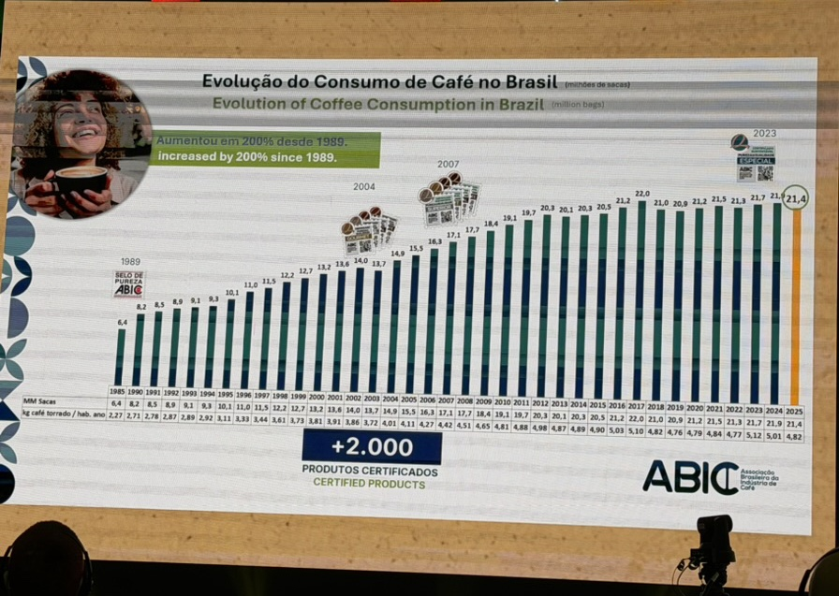
I'm not convinced. A broker in Minas was very explicit: the proliferation of new coffee brands isn't necessarily increasing actual consumption. It's more a function of the supermarket model, where profit comes less from sales than from renting shelf space to products. What is real on the ground is the rise of speciality and certified coffees chasing a share of the speciality segment - though the open question is how much speciality can actually take from world demand for ordinary roasted coffee. Brazil is currently producing roughly 10 million bags of speciality coffee.

EUDR - European Deforestation Regulation
Frankly, the EUDR discussion was meh - much the same conversation I was having four years ago at ECOM, with the core issues still unresolved. The regulation still can't reliably measure or distinguish forest from non-forest land, and worse, it can't tell planted trees from genuine natural forest, which is especially awkward for farms near those areas. The one real positive is traceability, and here I was genuinely impressed: at the warehouse level they know exactly which farm the coffee came from and have all the key farm data on hand.
There was no real conversation about how the regulation will actually be implemented - people just don't care much right now. But the closer we get to the deadline, the more bullish it could read for the market.

Weather & the Coffee Pipeline
El Niño took a lot of attention, but the effect is likely concentrated in the conilon areas of northern Brazil and parts of Espírito Santo. There was no clear picture for arabica, beyond the sense that if weather turns unstable things get very tricky. People were talking about production-forecast revisions due to El Niño in Colombia, Indonesia, Vietnam and Central America. My own view on Vietnam is that the worst of El Niño will likely come later in the year. Paradoxically, a lack of rain can help Vietnam: a strong El Niño in Q4 would coincide with when drying conditions are wanted, so it may not be as negative for Vietnam as some expect.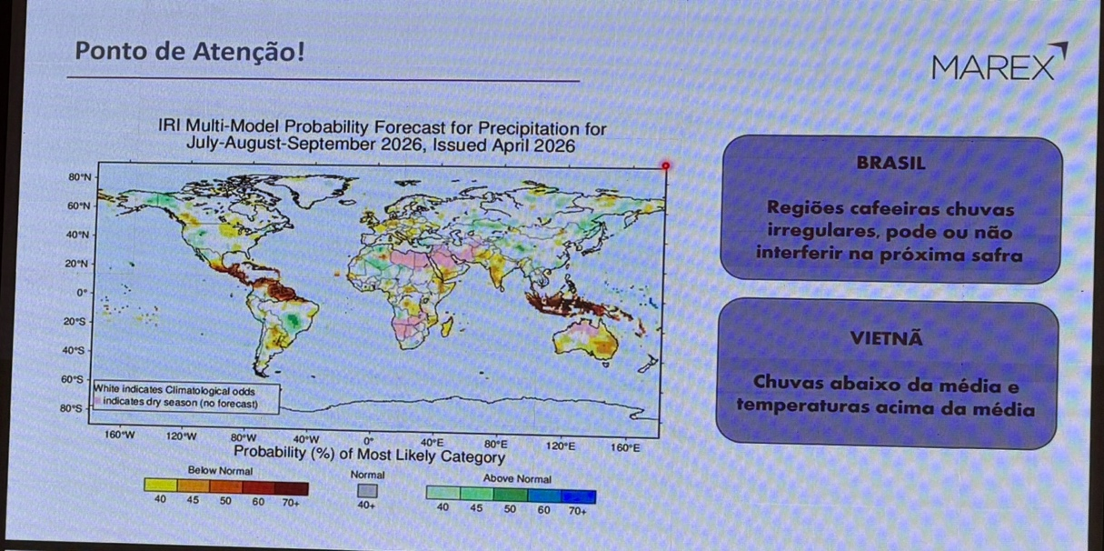
There were concerns about quality if the weather turns wet. It was raining heavily in Santos and in the coffee areas during the conference, which I suspect made people talk about rain more than they otherwise would. The rains didn't hit the harvest itself but probably delayed it by a couple of days. One contact was among the first to flag potential pipeline problems - specifically delays from the warehouses all the way to the ports.
The broad consensus is bearish for September and December, once the crop arrives, fills the pipeline and replenishes stocks. For now there's still a lot of uncertainty and the picture isn't fully clear. The farmer-level worry is simple: rain for more than three days during harvest is the trigger to start worrying. Rain during drying or harvest can encourage cold growing and hurt quality, and a lot of green cherries coming in would drag quality down too.

Internal Blends & Coverage
Internal blends for Brazil look fairly static. Large internal roasters have bought up to 90 days of coverage, while small roasters are more hand-to-mouth - and that is exactly where the buying pressure will come from, forcing farmers to sell. People talked about an 80–20 conilon–arabica split, with perhaps room for 75–25 in the coming months once the crop is moving through the pipeline.

Cost of Production
The headline problem right now is labour, on two fronts: it's getting more expensive, and fewer people want to work in coffee. That makes it hard for small and medium fazendeiros to find harvest labour. Medium operations of 50–100 ha are hit hardest - more area to cover, without the scale of the big players. Small farmers help each other through harvest, which effectively lowers their cost (though they don't formally book harvest costs in their economics). The clear winners are the large fazendeiros: very wealthy, with automated harvesting, post-harvest infrastructure, and even drones to spray the crop. We saw all of it - it was amazing.
Higher crude prices are already feeding through to fertiliser costs, which have almost doubled. Overall, cost of production is estimated to rise 12–15%. Farmers will need to start applying with the September rains, if they materialise - fertiliser needs spreading from late October to December to catch them. Any delay in the September rains therefore creates a cascading risk for next year's crop nutrition. Importantly, the need to buy fertiliser means that any farmers still holding by then will be forced to sell.

Part Two - The Crop Tour

Market Positioning & Sector Structure
I came into the conference very bearish, given the crop size and all my work on global coffee flow, and I remain convinced this crop is huge. That said, I'm a touch more cautious than before, because farmers are behaving somewhat irrationally - they will hold, whether on the farm or in cooperatives. The conference consensus is still bearish for September and December once the crop fills the pipeline and stocks rebuild. The key uncertainty stays the same: we don't yet have the full picture on old-crop numbers or on how the pipeline will flow. Some squeezes are likely if farmers hold or if coffee doesn't flow smoothly, and the key figure to watch is exchange stocks in NY and Europe - given the quality this year, I think there will be a real incentive to restock.
One structural note worth recording: roughly 80% of farms are small fazendas and 20% are large, but the share of the crop is the inverse - about 20% from the small farms and 80% from the big ones.

Farm Visits & Yields
We visited more than 20 farms and drove through a good deal more of the surrounding area - I probably saw over 100 from the car. The rough breakdown of the farms we visited and measured: about 70% were running yields of 80 bags/ha or higher (some even 100!); around 10% had been lightly pruned last year, so they're at zero this cycle; and the remaining 20% were new or fully renovated, with modest yields of 30–40 bags/ha. For context, even if every farm averaged 45 bags/ha it would still be a very good crop. It was amazing to see the fields so full of coffee.
On yield methodology, I also calculated using nodes per branch × branches × fruits per node, which is the proper way to size the crop. In places my numbers came out even higher than Thiago's calculations in other parts of the farm, but were roughly the same overall - a huge crop.

Farmers' Attitude to Prices & Holding
It was very clear that farmers this year have no target sale price. They're numb to the high prices and genuinely trying to hold. The interesting wrinkle is storage: I interviewed farmers, cooperatives, brokers and researchers, and none gave me a consistent answer on capacity.
Farmers do have the potential to hold, but scale matters - a small Brazilian farmer might have 10–20 ha, against 1 ha for a small Vietnamese farmer who can literally store coffee under the bed. Brazilians can't do that. They could in theory build new storage - not a crazy idea - but it's unlikely, since they'd rather put the money into technology or crop renovation. The more probable route is selling to cooperatives, where they can store cheaply with a guaranteed price, which is an even better deal. And the crop is so massive that there simply has to be enough room for the new crop on top of last year's carry.

Stock Levels & Warehouse Visits
At the conference I befriended the general manager of a medium-to-large private warehouse with capacity for 1 million bags. He gave me a tour, and I was genuinely amazed by the new, fully automated technology they use to clean, classify and filter coffee. We also visited a smaller private warehouse (300,000 bags), a cooperative of similar size, and COFCO's warehouse.
In all of them the amount of coffee was roughly double in comparison with last year's. This sits awkwardly against Luis's numbers, which look smaller. My read is that we're early in the harvest and technically still closing out the crop year - the private warehouses, and to some degree the cooperatives, may be acting as sinks for old crop while the big export warehouses get ready to receive the new one. Worth monitoring.
My own estimates: carry-out inventories of about 12 million bags of arabica; internal conilon stocks of about 5 million bags; and COFCO holding 14 million arabica, though their figure was as of end-April.

Crop Size - Why It's So Large
Several things have combined to produce this crop: excellent weather, an on-cycle year, good husbandry incentivised by higher prices, and expansion of the planted area since the frost. This is, if not the largest, the second-largest crop on record. I have no reason to change my crop-size number, though I do have questions about the old-crop figures. Short of a widespread fire, I can't see anything materially changing the size - anecdotally, driving past, the farms were visibly red or yellow from the sheer volume of cherries.

Next Year - An Early Concern
I'm concerned about next year, because vegetative growth was limited on about 70% of the farms. On the other hand, I saw a lot of renovated or brand-new farms (2–4 years old) plus many 1–2 year-old plantings, though those won't produce much yet. Louis reckons there's about 2.5% expansion in potential area, and perhaps that extra area normalises next year's crop - assuming El Niño doesn't disrupt things too much.

Crop Quality
We saw new crop arriving in various warehouses. It's skewing towards good quality, with very few exceptional lots and very few low grades. Bean size was good - denser beans across all warehouses - and milling yields have been very good so far, confirmed by cooperatives and farmers who've already delivered. Quality can still be hit during harvest by heavy rain during drying or by a large volume of green cherries coming in.

Conilon
We didn't visit conilon farms on this tour. Farmer sentiment towards conilon is negative and there are plenty of complaints, though nothing substantial on crop size. This year conilon may come in slightly below last year.

Conclusions

Flat price & market direction
The fundamentals point lower into September and December. The crop is the second-largest on record, quality is good, and there is no production story to rescue the bulls short of a fire or a genuine weather shock. I keep my bearish bias for the back half of the year. The caveat is timing rather than direction: the market won't simply grind down if farmers sit on coffee and the pipeline stays clogged. Expect choppiness and the odd sharp squeeze before the weight of the crop reasserts itself, with the fertiliser-buying window from September the most likely trigger for forced farmer selling.

Differentials
Differentials are where the holding behaviour bites first. With farmers numb to flat price and trying to hold, and with the pipeline slow from warehouse to port, nearby differentials can stay firmer than the size of the crop would suggest - physical simply isn't moving freely yet. As the crop works through and forced selling kicks in later in the year, I'd expect differentials to soften. Conilon is the weaker leg: negative sentiment, a possible small year-on-year decline, but no real crop-size problem, and new Bahia port capacity ahead to ease exports. The mooted shift toward 75–25 conilon–arabica in blends is worth tracking as a demand signal for the arabica differential.

Exchange stocks (NY & Europe)
This is the single most important number to watch. Certified stocks in NY and Europe are the clearest read on whether the crop is actually reaching the market or being held back upstream. Given that quality is skewing good this year, there should be a genuine incentive to grade and restock, which would be the confirming signal for the bearish back-half view. The risk to that thesis is a stocks build that stays stubbornly slow - that would tell us the holding and pipeline friction is real, and would be the setup for a squeeze rather than a drift lower.

What to watch
- Exchange stocks: rate of certification and restocking in NY and Europe - the key confirming or contradicting signal.
- Pipeline flow: movement from private/cooperative warehouses (running ~2x last year) into the big export warehouses and on to port.
- Farmer selling: the September fertiliser-buying window as the likely forced-selling trigger.
- Old-crop numbers: reconcile my carry-out estimates against Luis's smaller figures and COFCO's end-April mark.
- Weather: rain during harvest/drying for quality, and El Niño in conilon areas and globally (Colombia, Vietnam, Central America, Indonesia).
- Currency & politics: the Lula-win dollar scenario and real volatility off the back of the oil shock.
