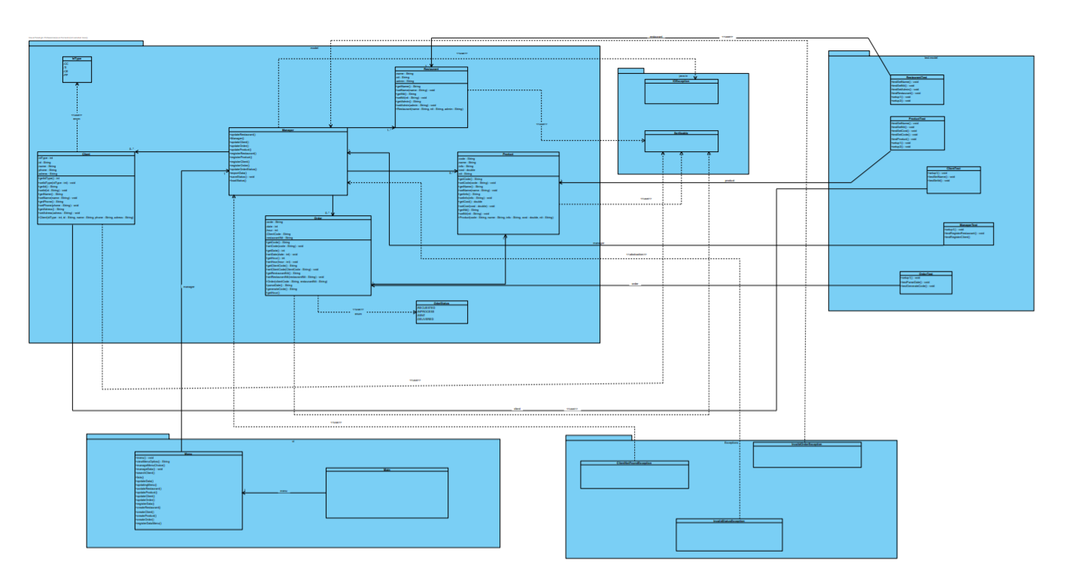

RF1. The program must be able to register a Restaurant object given a name, a nit code, and an admin name
RF2. The program must be able to update a Restaurant object given a nit, a new name, and a new Admin name
RF3. The program must be able to register a Client object given a name, an id type, an id, a phone number, and an address
RF4. The program must be able to update a Client object given an id, a new name, a new id type, a new phone number, and a new address
RF5. The program must be able to register a Product object given a name, a code, the nit of the restaurant which offer this product, and the cost
RF6. The program must be able to update a Product object given a code, a new product name, a new restaurant nit, and a new cost
RF7. The program must be able to register an order given the client id and the nit of the restaurant which the order was made
RF8. The program must be able to update an order given the client id and the new restaurant’s nit
RF9. The program must be able to change the order status given the new status (Requested, In process, sent or delivered)
RF10. The program must be able to save and load status by using serial files
RF11. The program must be able to export orders inform with all attributes of the order, and ordered
RF12. The program must be able to import data from files csv given the patron separator

