*HOSTING*

Hostinger

<https://www.hostinger.es/hostinger-pro>

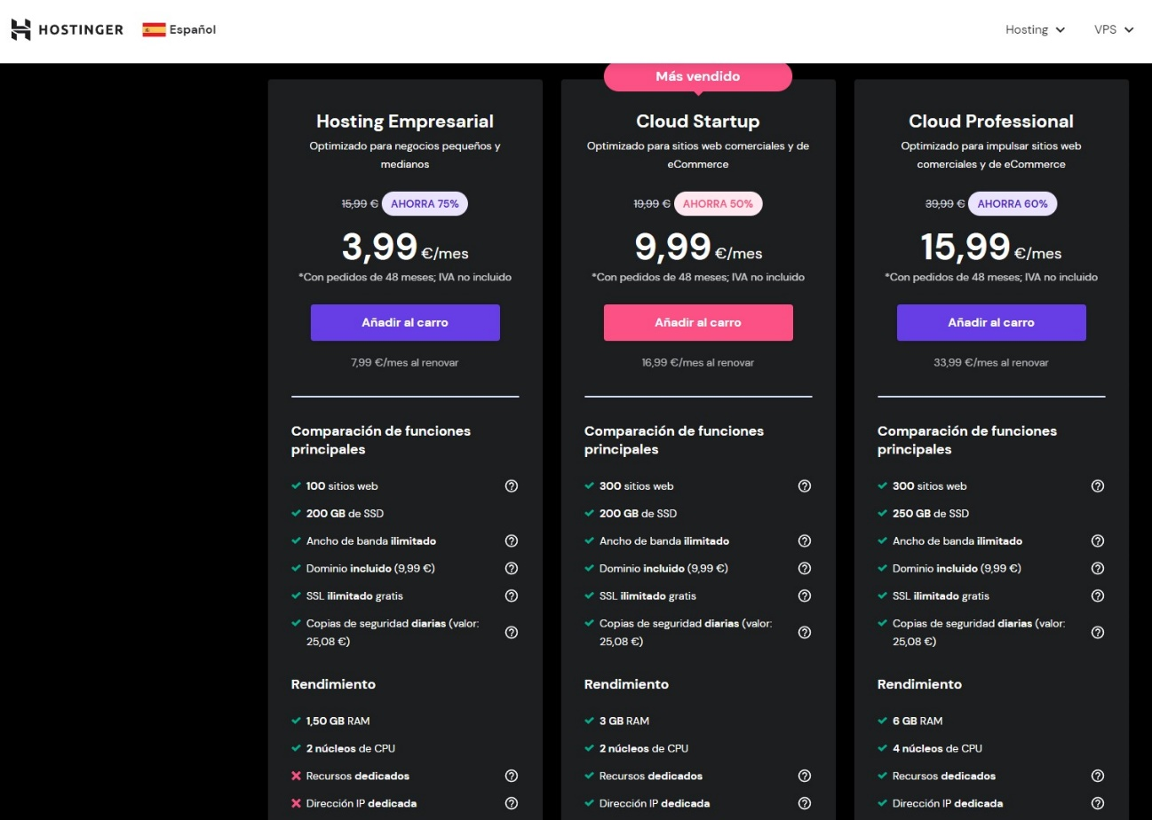

DINAHOSTING

<https://dinahosting.com/hosting/configurador/hosting-pro-wordpress>

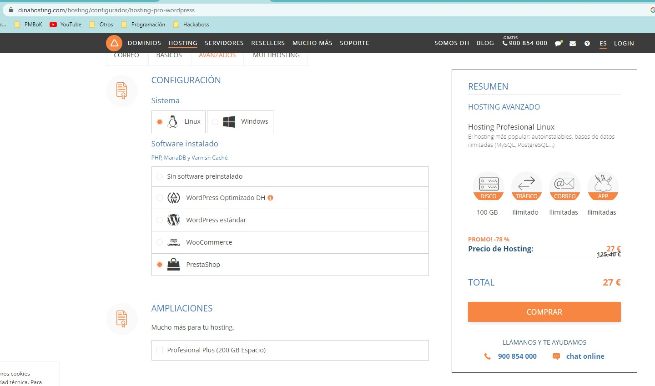

LOADING.ES

<https://www.loading.es/hosting-prestashop/index.html>

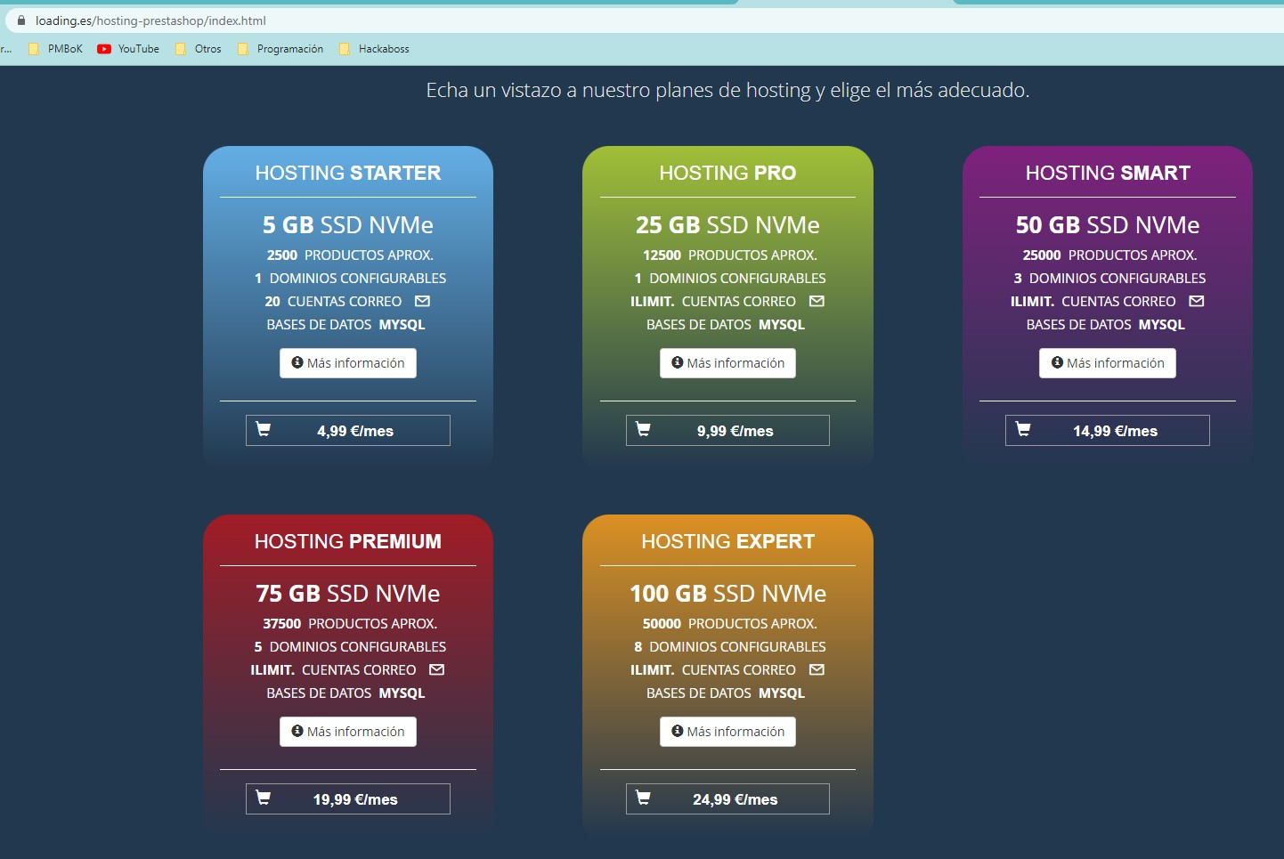

PROFESIONAL HOSTING

<https://www.profesionalhosting.com/hosting-prestashop/>

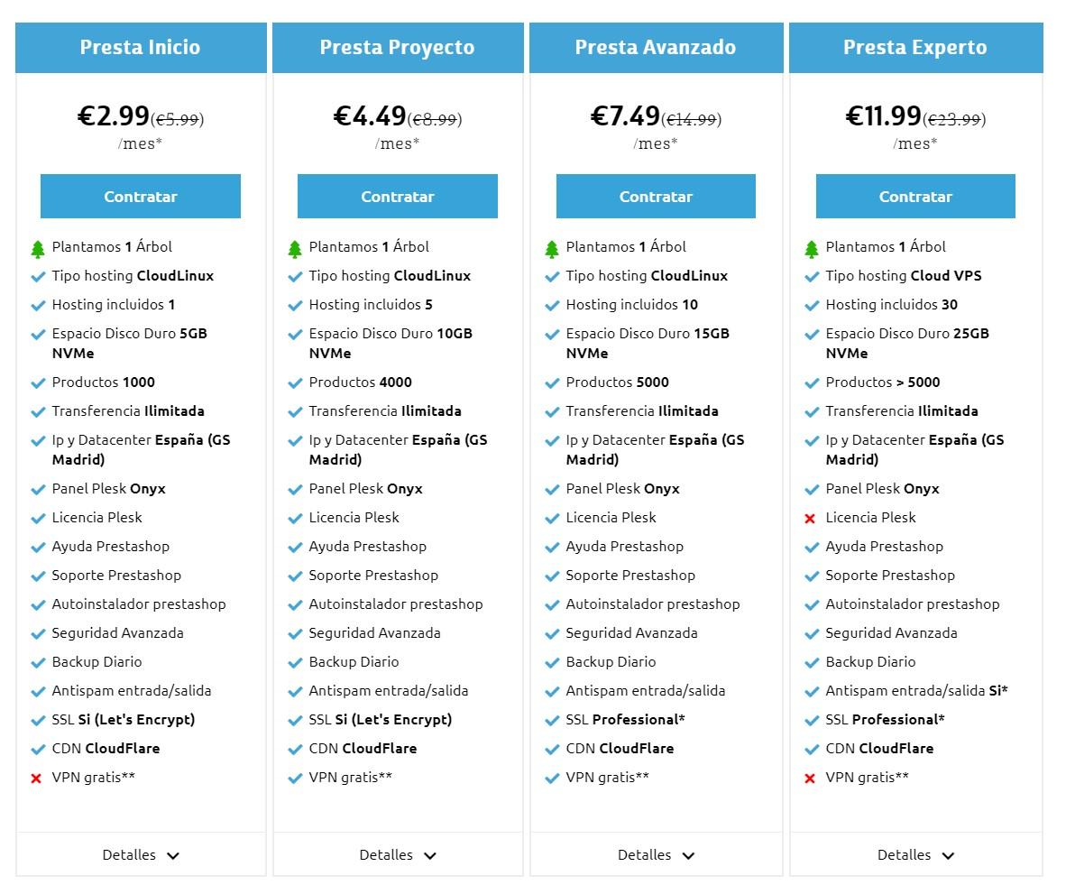

*PRESTASHOP*

Plantilla

Módulos

Pasarela de pago

Programación, instalación