深圳市新活力科技有限公司

PRODUCT SPECIFICATIONS

For Customer: |  |  |  |  |  | □ : APPROVAL FOR SPECIFICATION
 |  |  |  |  |  |  |  | □ : APPROVAL FOR SAMPLE
Customer Model No.
Module No.: SH010JGI40-01013L |  |  |  |  |  |  |  | Date : 2019.05.10
 |  |  |  |  |  |  |  | Version :A
1. Table of Contents
No. |  |  |  |  |  | Item |  |  | Page
1 | Cover Sheet(Table of Contents)
2 | Revision Record
3 | General Specifications
4 | Outline Drawing
5 | Absolute Maximum Ratings
6 | Electrical Specifications and Timing Characteristics
7 | Optical Characteristics
8 | Reliability Test Items and Criteria
9 | Quality Level
10 | Packing Reliability
For Customer’s Acceptance:
Approved By |  |  |  |  |  |  |  | Comment

PREPARED | CHECKED | VERIFIED BY QA | VERIFIED BY R&D
PREPARED | CHECKED | DEPT | DEPT

深圳市新活力科技有限公司

2. Revision Record

Date | Rev.No. | Page | Revision Items | Prepared
2020.05.10 | A |  | The first release

2
深圳市新活力科技有限公司

3. General Specifications

SH010JGI55-01013L is a TFT-LCD module. It is composed of a TFT-LCD panel, driver IC, FPC, a back light unit. The 10.1 display area contains 1024 x 600 pixels and can display up to 16.7M colors. This product accords with RoHS environmental criterion.

Item | Contents | Unit | Note
LCD Type | Normally Black,Transmissive | -
Display color | 16.7M |  | 1
Viewing Direction | ALL | -
Operating | -20~+70 | ℃
temperature | -20~+70 | ℃
Storage temperature | -30~+80 | ℃
Module size | 235.00(W)×143.00(H)×5.20(T) | mm | 2
Active Area(W×H) | 222.72(W)×125.28(H) | mm
Number of Dots | 1024×RGB×600 | dots
Backlight | 42-LEDs (white) | pcs
Data Transfer | RGB 24-bit | -
Driver IC | HX8282-A11+HX8696 | -

Note 1: Color tune is slightly changed by temperature and driving voltage.

Note 2: Without FPC and Solder.

3
深圳市新活力科技有限公司

4.Outline.Drawing
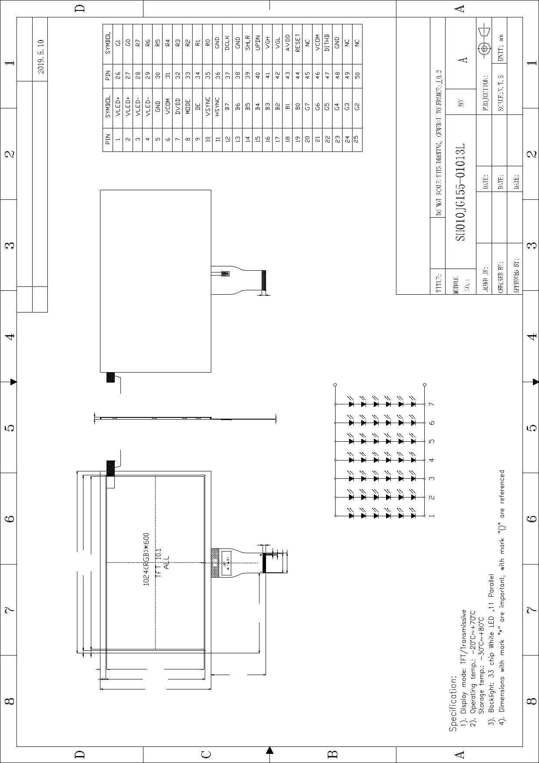

DATE |  |  |  |  |  |  |  |  |  |  |  |  |  |  |  | 1
 |  |  |  |  |  |  |  |  |  |  |  |  |  |  |  | OF
DESCRIPTION | 初版 |  |  |  |  | A K |  |  |  |  |  |  | SH 盛和科技有限公司 | ASSEMBLY |  | SHEET: 1
REV |  |  |  |  |  |  | 3. | 00±0.5
REV | A
 |  |  |  |  |  |  |  |  |  |  |  | A | K
 |  |  | 20±0.205. | 易拉纸 易拉纸 |  |  |  |  | 3±0.050. | ( )PI补强+FPC |  |  |  | LED 电路图 | Vf 16.-20.4V8 | IF=20*7=140mA(定电流测试)
 |  |  |  |  |  |  | 30. | 50±0.3 | 35±0.030. | 50±0.030. | 50±0.0524. | 50±0.1025.
 |  | 72±0.20(BZ)225.
 | 00±0.20235. | 72±0.20(BZ)225. | 72(A.A)222.
 |  |  |  |  |  |  |  |  | 60±0.50103.
 |  | 893. | 395.
 |  |  |  | 47.8 | .28(A.125A)
 |  |  |  |  |  | 50. | 00±0.55
 |  |  | 701. |  | .19±0.12820(BZ)
 |  |  |  |  | 20. | *14300±0.
 |  |  |  |  |  |  |  |  |  |  |  |  |  |  |  | 4

深圳市新活力科技有限公司

5. Absolute Maximum Ratings(Ta=25℃)

5.1 Electrical Absolute Maximum Ratings.(Vss=0V ,Ta=25℃)

Item | Symbol | Min. | Max. | Unit
Digital Supply Voltage | DVDD | -0.3 | 3.6 | V
Analog Supply Voltage | AVDD | 0 | 13.5 | V
TFT Gate ON Voltage | VGH | -0.3 | 20 | V
TFT Gate OFF Voltage | VGL | -20 | 0.3 | V
Operating Temperature | TOP | -20 | 70 | °C
Storage Temperature | TST | -30 | 80 | °C

Notes:

- If the module is above these absolute maximum ratings. It may become permanently damaged. Using the module within the following electrical characteristic conditions are also exceeded, the module will malfunction and cause poor reliability.
- VDD>VSS must be maintained.

- Please be sure users are grounded when handing LCD Module.

5.2 Environmental Absolute Maximum Ratings.

Item | Storage |  | Operating |  | Note
Item | MIN. | MAX. | MIN. | MAX. | Note
Ambient Temperature | -30℃ | 80℃ | -20℃ | 70℃ | 1,2
Humidity | - | - | - | - | 3

- The response time will become lower when operated at low temperature.

- Background color changes slightly depending on ambient temperature. The phenomenon is reversible.
- Ta<=40℃:85%RH MAX.

Ta>=40℃:Absolute humidity must be lower than the humidity of 85%RH at 40℃.

5
深圳市新活力科技有限公司

6. Electrical Specifications and Timing Characteristics

6.1 Electrical characteristics(VSS=0V ,Ta=25℃)

Item | Symbol | Min. | Typ | Max. | Unit
Digital Supply Voltage | DVDD | 3.0 | 3.3 | 3.6 | V
Analog Supply Voltage | AVDD | 9.5 | 9.6 | 9.7 | V
TFT Gate ON Voltage | VGH | 17.6 | 18 | 18.4 | V
TFT Gate OFF Voltage | VGL | -6.4 | -6 | -5.6 | V
TFT Common Electrode Voltage | VCOM | 4.0 | 4.2 | 4.4 | V

6.2 LED backlight specification(VSS=0V ,Ta=25℃)

Item | Symbol | Condition | Min | Typ | Max | Unit | Note
Supplyvoltage |  |  | - | - | 18.6
Supply current | If | - | - | 140 | - | mA | 2

A
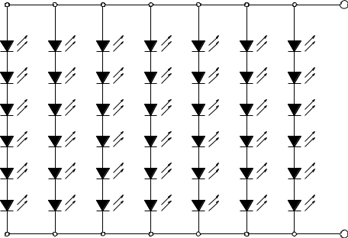

K

Note:

- VLED=VLED(+)-VLED(-).

2:The current of LED is 20mA.

A LED drive in constant current mode is recommended.

6
深圳市新活力科技有限公司

6.3 Interface signals

Pin | SYMBOL | I/O | DESCRIPTION | Remark
NO.
1 | VLED+ | - | Power for LED backlight (Anode)
2 | VLED+ | - | Power for LED backlight (Anode)
3 | VLED- | - | Power for LED backlight (Cathode)
4 | VLED- | - | Power for LED backlight (Cathode)
5 | GND | P | Power ground
6 | VCOM | I | Common Voltage
7 | DVDD | P | Digital Power
8 | MODE | I | DE/SYNC mode select. | Note 1
9 | DE | I | Data Enable signal
10 | VSYNC | I | Vertical sync input
11 | HSYNC | I | Horizontal sync input
12 | B7 | I | Blue data (MSB)
13 | B6 | I | Blue data
14 | B5 | I | Blue data
15 | B4 | I | Blue data
16 | B3 | I | Blue data
17 | B2 | I | Blue data
18 | B1 | I | Blue data | Note 2
19 | B0 | I | Blue data (LSB) | Note 2
20 | G7 | I | Green data (MSB)
21 | G6 | I | Green data
22 | G5 | I | Green data
23 | G4 | I | Green data
24 | G3 | I | Green data
25 | G2 | I | Green data
26 | G1 | I | Green data | Note 2
27 | G0 | I | Green data (LSB) | Note 2

7
深圳市新活力科技有限公司

28 |  | R7 |  | I | Red data (MSB)
29 |  | R6 |  | I | Red data
30 |  | R5 |  | I | Red data
31 |  | R4 |  | I | Red data
32 |  | R3 |  | I | Red data
33 |  | R2 |  | I | Red data
34 |  | R1 |  | I | Red data | Note 2
35 |  | R0 |  | I | Red data (LSB) | Note 2
36 |  | GND |  | P | Power ground
37 |  | DCLK |  | I | Clock input | Note 3
38 |  | GND |  | P | Power ground
39 |  | SHLR |  | I | Left / Right Selection | Note 4,5
40 |  | UPDN |  | I | Up / Down Selection | Note 4,5
41 |  | VGH |  | P | Gate ON Voltage
42 |  | VGL |  | P | Gate OFF Voltage
43 |  | AVDD |  | P | Power for Analog Circuit
44 |  | RESET |  | I | Global reset pin | Note 6
45 |  | NC |  | - | Not connection
46 |  | VCOM |  | I | Common Voltage
47 |  | DITH |  | I | Dithering function enable control | Note 7
48 |  | GND |  | P | Power ground
49 |  | NC |  | - | Not connection
50 |  | NC |  | - | Not connection
I: input, |  | O: output, |  | P: Power

Note 1: DE / SYNC mode select under TTL mode. Normally pull high

H : DE mode.

L : HSD/VSD mode.

Note 2: When input 18 bits RGB data,the two low bits of R,G and B data must be grounded

Note 3: Data shall be latched at the falling edge of DCLK

8
深圳市新活力科技有限公司
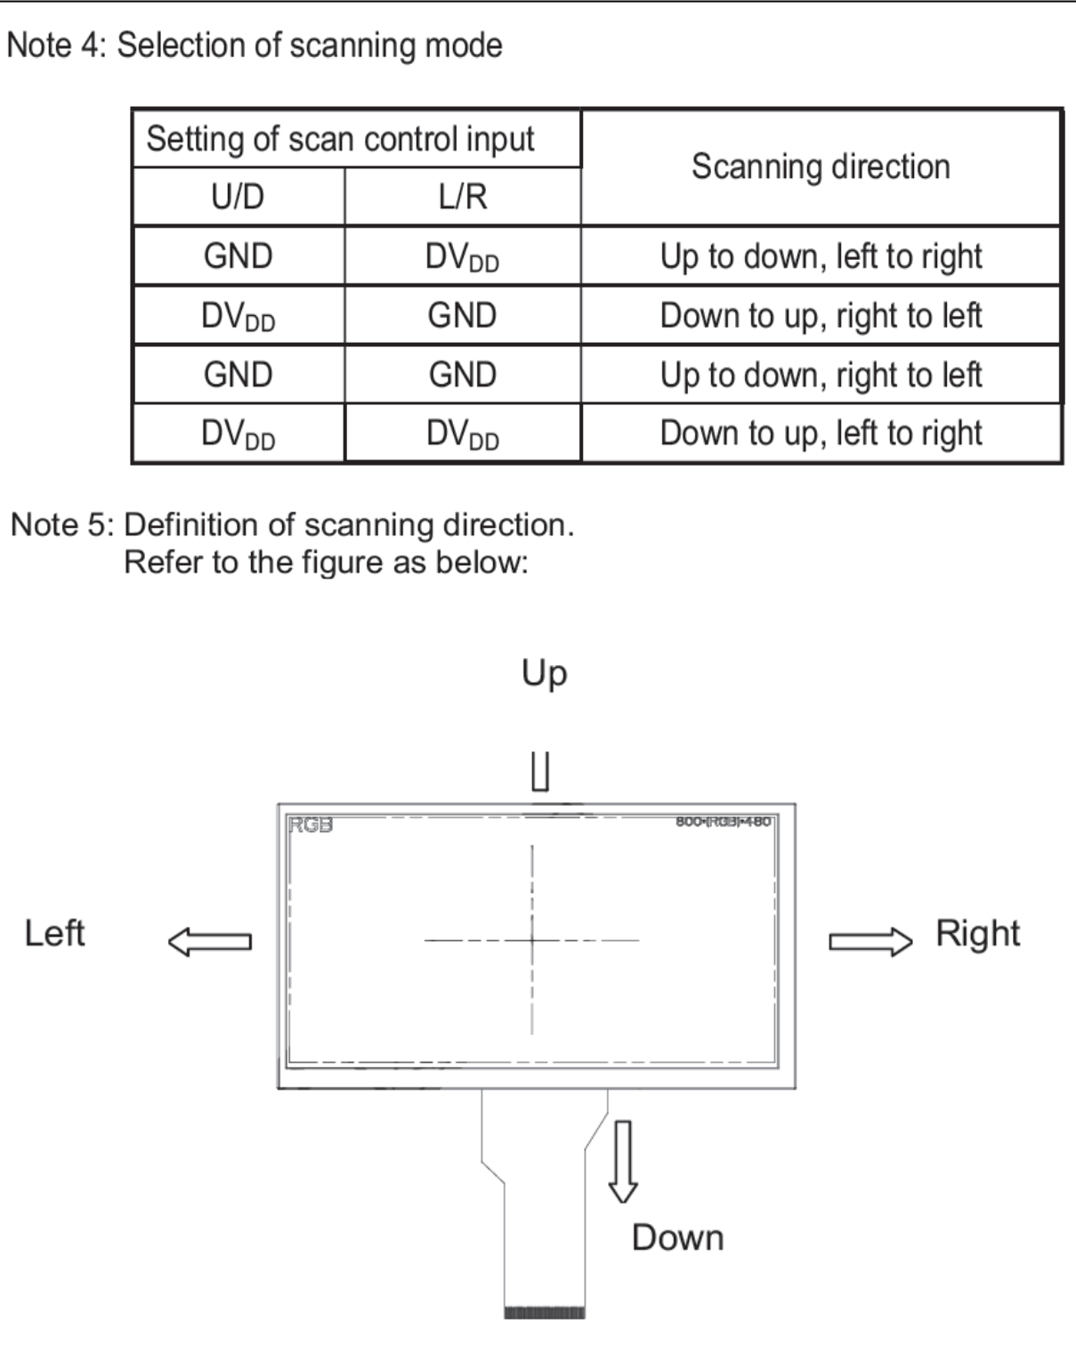

Note 6: Global reset pin. Active Low to enter Reset State. Normally pull high. It’s necessary to connecting with an RC delay circuit for stability.

(GRB delay VDD larger than 1ms)

Note 7: Dithering function enable control.

DITHER = “1”, Enable internal dithering function

DITHER = “0”, Disable internal dithering function.

9
深圳市新活力科技有限公司

6.4 Timing Characteristics
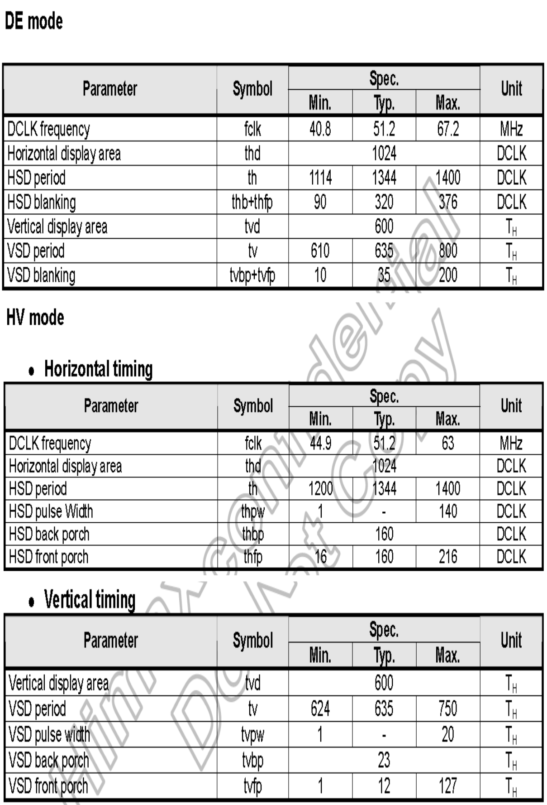

10
深圳市新活力科技有限公司

7. Optical Characteristics

Item | Symbol |  |  |  | Condition | Min. | Typ. | Max. | Unit | Note
Brightness |  |  | Bp |  | θ=0° | - | 550 | - | Cd/m² | 1
Uniformity |  | ⊿Bp |  |  | =0° | 75 | 80 | - | % | 1,2
 |  |  | 3:00 |  |  | 80 | 85 | -
Viewing |  |  | 6:00 |  | Cr≥10 | 80 | 85 | - | Deg | 3
Angle |  |  | 9:00 |  | Cr≥10 | 80 | 85 | - | Deg | 3
 | 12:00 |  |  |  |  | 80 | 85 | -
Contrast |  |  | Cr |  |  | 600 | 800 |  | - | 4
Ratio |  |  |  |  | θ=0° | 600 | 800 |  | - | 4
Response |  | Tr+Tf |  |  | =0° |  | 20 | 25 | ms | 5
Time
 | W |  |  | x |  |  |  |  | -
 |  |  |  | y |  |  |  |  | -
 | R |  |  | x |  |  | 0.605 |  | -
Color of | R
Color of | R |  |  | y | θ=0° | TYP | 0.328 | TYP | -
CIE |  |  |  |  |  |  |  |  |  | 1,6
CIE |  |  |  | x | =0° | -0.05 | 0.285 | +0.05 | - | 1,6
Coordinate | G
 | G |  |  | y |  |  | 0.516 |  | -
 | B |  |  | x |  |  | 0.153 |  | -
 | B |  |  | y |  |  | 0.149 |  | -

Note：The parameter is slightly changed by temperature, driving voltage and materiel

Note 1: The data are measured after LEDs are turned on for 5 minutes. LCM displays full white. The brightness is the average value of 9 measured spots. Measurement equipment PR-705 (Φ8mm)

Measuring condition:

- Measuring surroundings: Dark room.

- Measuring temperature: Ta=25℃.

- Adjust operating voltage to get optimum contrast at the center of the display.

Measured value at the center point of LCD panel after more than 5 minutes while backlight turning on.

11
深圳市新活力科技有限公司
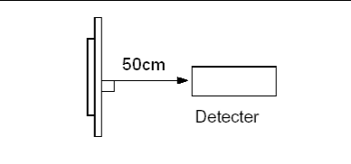

Note 2: The luminance uniformity is calculated by using following formula.

⊿Bp = Bp (Min.) / Bp (Max.)×100 (%)

Bp (Max.) = Maximum brightness in 9 measured spots

Bp (Min.) = Minimum brightness in 9 measured spots.
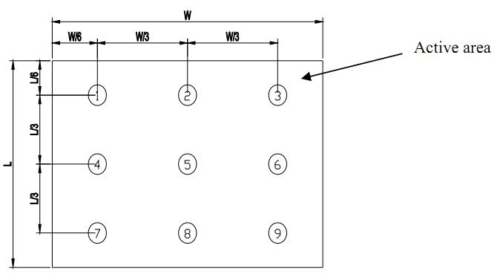

Note 3: The definition of viewing angle:

Refer to the graph below marked by θ and Ф

12
深圳市新活力科技有限公司
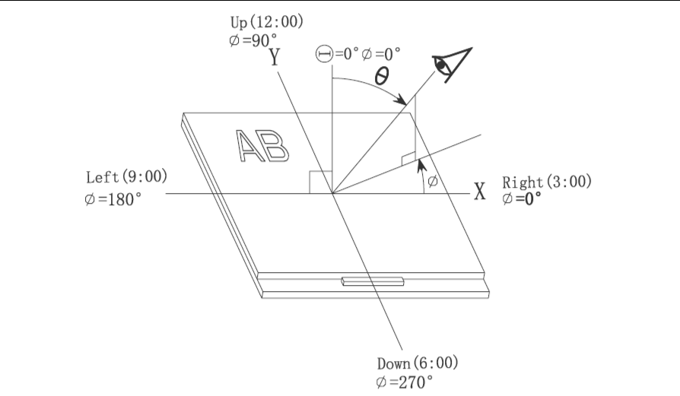

Note 4: Definition of contrast ratio.( Test LCD using DMS501)
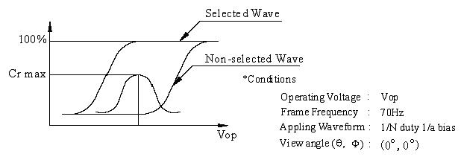

Contrast ratio Cr | Brightness of selected dots
Contrast ratio Cr | Brightness of non selected dots

Note 5: Definition of Response time. (Test LCD using DMS501):

The output signals of photo detector are measured when the input signals are changed from “black” to “white”(falling time) and from “white” to “black”(rising time), respectively. The response time is defined as the time interval between the 10% and 90% of amplitudes.Refer to figure as below.

13
深圳市新活力科技有限公司
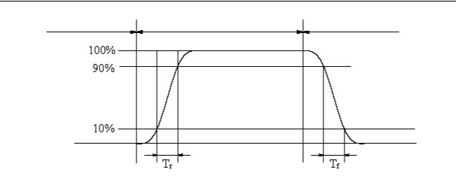

The definition of response time

Note 6: Definition of Color of CIE Coordinate and NTSC Ratio.
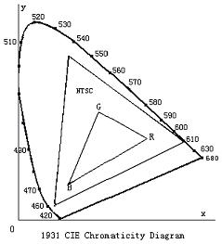

Color gamut:

_{S} area of RGB triangle _{100%} area of NTSC triangle

Note 7: Definition of cross talk.

Cross talk ratio(%)=|pattern A Brightness-pattern B Brightness|/pattern A Brightness*100
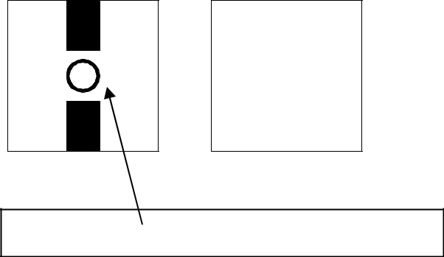

Pattern A Pattern B

Measurement point(center)

Electric volume value=3F+/-3Hex

14
深圳市新活力科技有限公司

8. Reliability Test Items and Criteria

No |  |  | Test Item |  |  | Test condition | Criterion
 |  |  |  |  | 80℃±2℃ 72H
1 |  | High Temperature Storage |  |  | Restore 2H at 25℃
 |  |  |  |  | Power off
 |  |  |  |  | -30℃±2℃ 72H
2 |  | Low Temperature Storage |  |  | Restore 2H at 25℃
 |  |  |  |  | Power off |  | 1. After testing,
 |  |  |  |  | 70℃±2℃ 72H |  | 1. After testing,
 |  |  |  |  |  |  | cosmetic and electrical
3 |  | High Temperature Operation |  |  | Restore 2H at 25℃ |  | cosmetic and electrical
 |  |  |  |  |  |  | defects should not
 |  |  |  |  | Power on |  | defects should not
 |  |  |  |  |  |  | happen.
4 |  |  |  |  | -20℃±2℃ 72H |  | 2. Total current
 |  | Low Temperature Operation |  |  | Restore 4H at 25℃ |  | consumption should
 |  |  |  |  | Power on |  | not be more than twice
 |  |  |  |  |  |  | of initial value.
5 |  | High | Temperature/Humidity |  | 50℃±2℃ 90%RH 72H |  | of initial value.
 |  | Operation |  |  | Power on
6 |  | Temperature Cycle(Storage)
 |  |  |  |  | after 5 cycle, Restore 2H at 25℃
 |  |  |  |  | Power off
7 |  | Vibration Test |  |  | 10Hz~150Hz, 100m/s², 120min |  | Not allowed cosmetic
 |  |  |  |  |  |  | and electrical defects.
8 |  | Shock Test |  |  | Half- sine wave,300m/s²,11ms |  | and electrical defects.
9 |  | ESD Test |  |  | Air discharge:+/-8KV,
 |  |  |  |  | Contact discharge:+/-4KV
 | Note: Operation: Supply 3.3V for logic system.
 |  | The inspection terms after reliability test, as below
 | ITEM |  |  | Inspection
 | Contrast |  |  | CR>50%
 | IDD |  |  | IDD<200%
 | Brightness |  |  | Brightness>60%
 | Color Tone |  |  | Color Tone+/-0,05
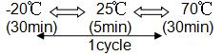

9 Quality level

9.1 Classification of defects

Major defects (MA): A major defect refers to a defect that may substantially degrade usability for product applications, including all functional defects(such as no
15
深圳市新活力科技有限公司

display, abnormal display, open or missing segment, short circuit, missing component), outline dimension beyond the drawing, progressive defects and those affecting reliability.

Minor defects (MI): A minor defect refers to a defect which is not considered to be able to substantially degrade the product application or a defect that deviates from existing standards almost unrelated to the effective use of the product or its operation, such as black spot, white spot, bright spot, pinhole, black line, white line, contrast variation, glass defect, polarizer defect, etc.

9.2 Definition of inspection range
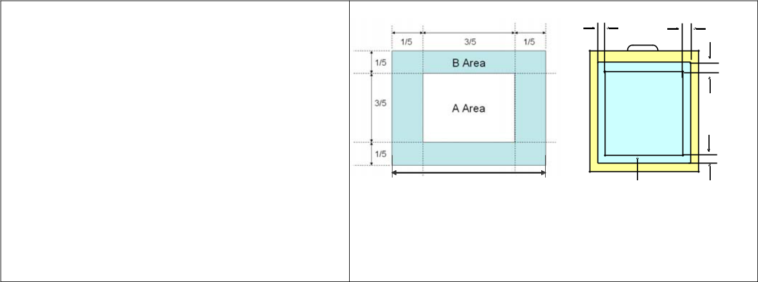

For dot defect of TFT LCD which is not smaller than 3 inches, dividing three areas to make a judgment (according to figure 1).
A area : center of viewing area

B area : periphery of viewing area

C area : Outside viewing area

For other defects, dividing two areas to make a judgment (according figure 2).
A zone : Inside Viewing area

B zone : Outside Viewing area

X1(A.A~V.A): 2mm X2(A.A~V.A): 2mm

Y1(A.A~V.A): 2mm Y2(A.A~V.A): 2mm

Viewing Area

Figure 1

X1 | X2
 | B zone | Y2
Active Area(AA)
 |  | Y1

A zone: Viewing Area(VA)

Figure 2

9.3 Inspection items and general notes

 | 1.Should any defects which are not specified in this standard happen, additional standard shall
 | be determined by mutual agreement between customer and SH.
 | 2.Viewing area should be the area which SH guarantees.
General | 3.Limit sample should be prior to this Inspection standard.
General | 4.Viewing judgment should be under static pattern.
notes
notes | 5.Inspection conditions
 | Inspection distance: 250 mm (from the sample) |  | Temperature | : 25±5 ºC
 | Inspection angle : 45 degrees in 6 o′clock direction (all defects in viewing area should be
 | inspected from this direction)
 | Pinhole, Bright spot, Black spot, | The color of a small area is different from the remainder.
 | White spot, Black line, White Line,
 | Foreign particle, Bubble | The phenomenon doesn’t change with voltage
 | Contrast variation | The color of a small area is different from the remainder.
 | Contrast variation | The phenomenon changes with voltage
Inspection
Inspection |  | Scratch, Dirt, | Particle, Bubble on | polarizer or between
items | Polarizer defect | Scratch, Dirt, | Particle, Bubble on | polarizer or between
 | Polarizer defect | polarizer and glass
 | Dot defect (TFT LCD) | The pixel appears bright or dark abnormally when display
 | Functional defect | No display, Abnormal display, Open or missing segment,
 | Functional defect | Short circuit, False viewing direction

16
深圳市新活力科技有限公司

 |  |  |  |  |  | Glass defect |  |  |  |  |  |  |  |  | Glass crack, Shaved corner of glass, Surplus glass
 |  |  |  |  |  |  | PCB defect |  |  |  |  |  |  |  | Components assembly defect
 |  |  | 9.4 Outgoing Inspection level
 | Outgoing Inspection |  |  |  |  |  |  |  | Inspection conditions |  |  |  |  |  |  |  |  |  |  |  |  | Inspection
 |  |  | standard
 |  |  |  |  |  |  |  |  |  |  |  |  |  |  |  |  |  | Min. | Max. |  |  | Unit |  | IL |  | AQL
 |  | Major Defects |  |  |  |  |  |  | See 8.3 general notes |  |  |  |  |  |  |  |  | See |  | 8.5 |  |  |  | II |  | 0.065
 |  | Minor Defects |  |  |  |  |  |  | See 8.3 general notes |  |  |  |  |  |  |  |  | See |  | 8.5 |  |  |  | II |  | 0.065
 | Note：Sampling standard conforms to GB2828
 |  |  | 9.5 Inspection Items and Criteria
 |  |  |  |  |  |  |  |  |  |  |  |  |  |  |  |  |  |  | Judgment standard
 |  |  |  |  | Inspection items |  |  |  |  |  |  |  |  |  |  |  | Category |  |  |  |  |  |  | Acceptable number
 |  |  |  |  |  |  |  |  |  |  |  |  |  |  |  |  |  |  |  |  |  |  |  | A zone |  | B zone
 |  |  |  |  |  |  |  |  |  |  |  |  |  |  | A |  | Φ<=0.20 |  |  |  |  |  | Neglected |  |  | Neglected
 |  |  | Black spot, White
 |  |  |  |  |  |  |  |  |  |  |  | b |  |  | B |  | 0.20<Φ<=0.25 |  |  |  |  |  | 3 |  |  | Neglected
 |  |  | spot,
 |  |  | Pinhole, Foreign |  |  |  |  |  | a |  |  |  |  |  | C |  | 0.25<Φ<=0.3 |  |  |  |  |  | 2 |  |  | Neglected
 | 1 |  | Particle, |  | Particle
 |  |  | in or on |  | glass, |  |  |  | Φ=(a+b)/2(mm |  |  |  |  |  | D |  | 0.3<Φ<=0.4 |  |  |  |  |  | 1 |  |  | 3
 |  |  | Scratch on glass
 |  |  |  |  |  |  |  |  |  |  |  |  |  |  | E |  | 0.4<Φ<=0.5 |  |  |  |  |  | 0 |  |  | 2
 |  |  |  |  |  |  |  |  | (a/b<2.5) |  |  |  |  |  | E
 |  |  |  |  |  |  |  |  |  |  |  |  |  |  | Total defective point(B,C) |  |  |  |  |  |  |  | 1 |  |  | -
 |  |  |  |  |  |  |  |  |  |  |  |  |  |  | A |  | W<=0.03 |  |  |  |  |  | Neglected |  |  | Neglected
 |  |  |  |  |  |  |  |  |  |  | W:
 |  |  |  |  |  |  |  |  |  |  |  |  |  |  | B |  | 0.03<W<=0.05 |  |  |  |  |  | 3 |  |  | Neglected
 |  |  |  |  |  |  |  |  |  |  | Width |  |  |  | B |  |  | L<=3.0
 |  |  | Black line, White |  |  |  |  |  | L:Length(mm)
 |  |  |  |  |  |  |  |  |  |  |  |  |  |  |  |  | 0.05<W<=0.1
 |  |  | line, and Particle |  |  |  |  |  |  |  |  |  |  |  | C |  |  |  |  |  |  |  | 2 |  |  | Neglected
 |  |  |  |  |  |  |  |  |  |  |  |  |  |  | C |  |  | L<=3.0
 | 2 |  | Between
 | 2 |  | Polarizer |  | and
 | 2 |  |  |  | and |  |  |  |  |  |  |  |  |  |  |  | 0.05<W<=0.1
 |  |  | glass, Scratch on |  |  |  |  |  | L/W>=2.5 |  |  |  |  |  | D |  |  |  |  |  |  |  | 1 |  |  | 3
 |  |  |  |  |  |  |  |  |  |  |  |  |  |  | D |  |  | L<=4.0
 |  |  | glass
 |  |  |  |  |  |  |  |  |  |  |  |  |  |  | E |  |  | W>0.1 |  |  |  |  | 0 |  |  | 2
 |  |  |  |  |  |  |  |  |  |  |  |  |  |  | E |  |  | L>4.0
 |  |  |  |  |  |  |  |  |  |  |  |  |  |  | Total defective point(B,C) |  |  |  |  |  |  |  | 1 |  |  | -
 | 3 |  | Bright spot |  |  |  |  |  |  |  |  |  |  |  |  |  | any size |  |  |  |  |  |  | none |  | none
 | 4 |  | Contrast |  |  |  |  |  |  |  |  |  |  |  | A |  |  | Φ<0.2 |  |  |  |  | Neglected |  |  | Neglected
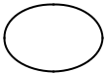
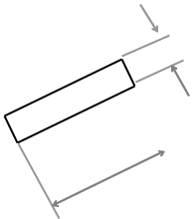

 |  | 深圳市新活力科技有限公司
 | variation |  |  | B | 0.2<Φ<=0.3 | 2
 |  |  | b | C | 0.3<Φ<=0.4 | 1
 |  | a |  | D | 0.4<Φ | 0
 |  | Φ=(a+b)/2(mm) |  | Total defective point(B,C) |  | 3
5 | Bubble inside cell |  |  |  | any size | none | none
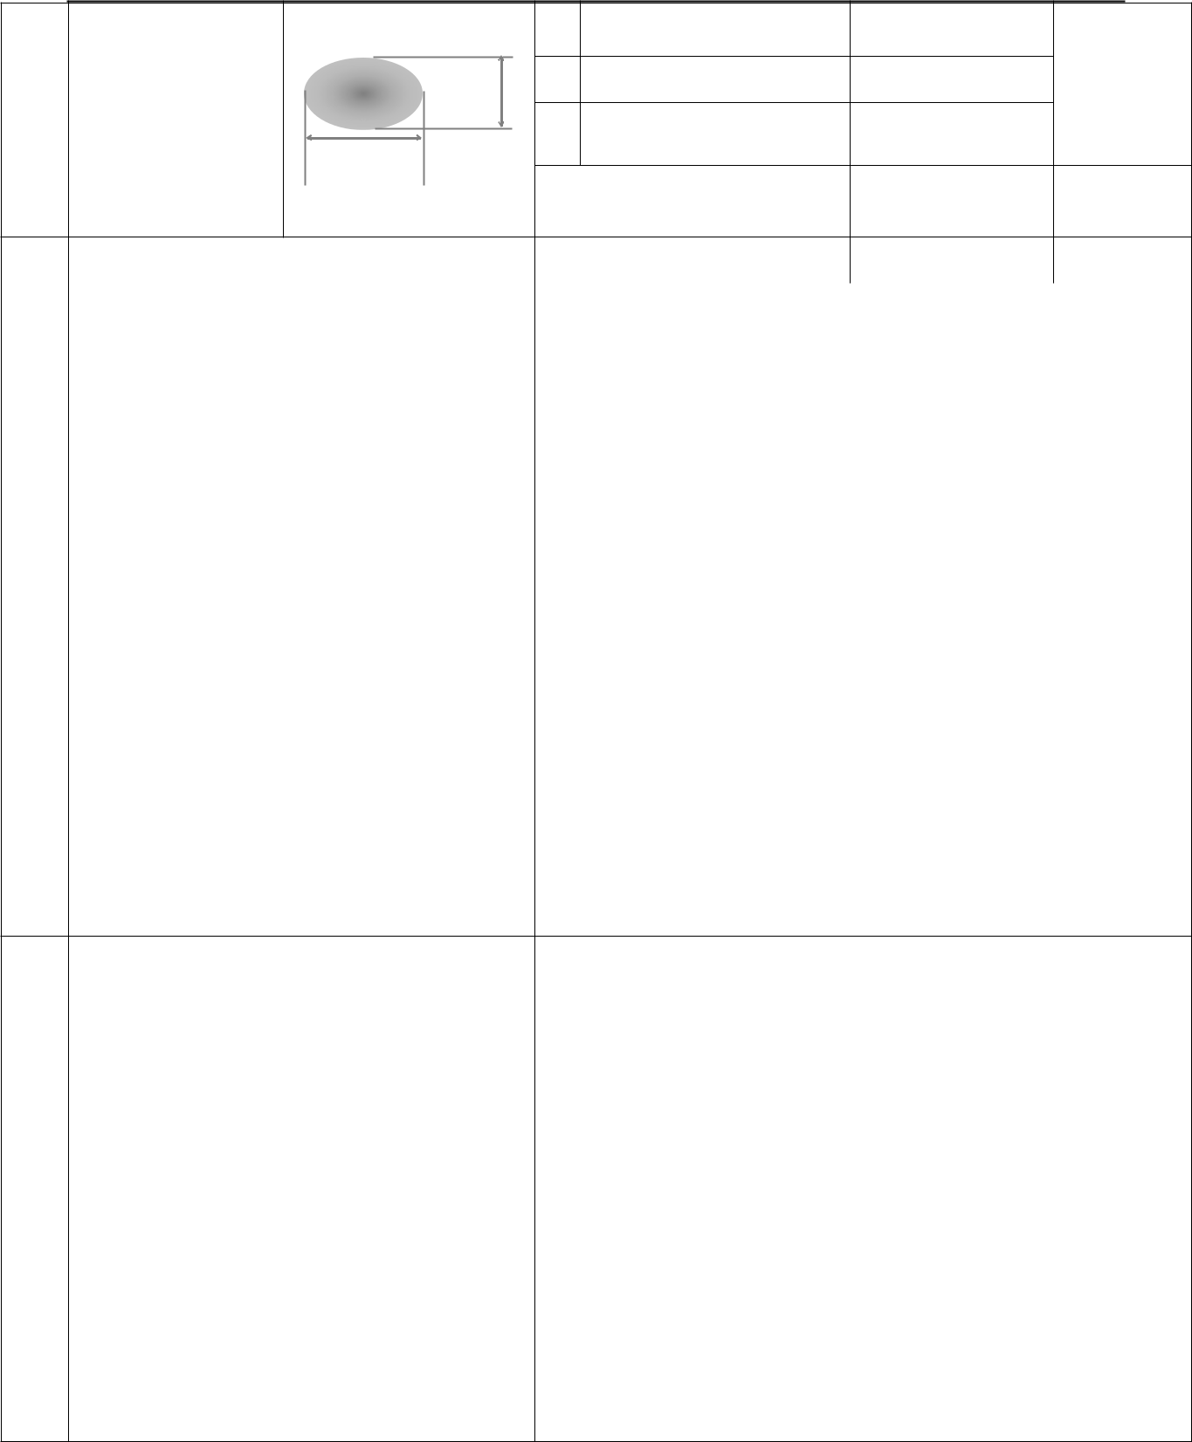
 | Scratch ,damage on | Refer to item 1 and item 2.
 | polarizer, Particle on
 | polarizer or between
Polarizer defect | polarizer and glass.
6 (if Polarizer is | Bubble, dent and | A | Φ<=0.1 | Neglected | Neglected
used) | convex |  |  |  | Neglected
 |  | B | 0.1 <Φ<=0.2 | 2 | Neglected
 |  | C | 0.2 <Φ<=0.3 | 1 | 2
 | Stage surplus glass

 b B<=0.3mm
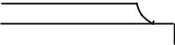

7 | Surplus
7 | Surplus | Surrounding surplus
7 | glass
 | glass |  | glass

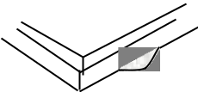

Should not influence outline dimension and assembling.

8 | Open segment or open common | Not permitted
9 | Short circuit | Not permitted
10 | False viewing direction | Not permitted
11 | Contrast ratio uneven | According to the limit specimen
12 | Crosstalk | According to the limit specimen
13 | Black /White spot(display) | Refer to item 1
14 | Black /White line(display) | Refer to item 2

18
深圳市新活力科技有限公司

 |  |  |  |  |  |  |  |  |  |  |  |  |  |  |  |  |  |  |  |  |  | Judgment standard
 |  | Inspection items
 |  |  |  |  |  |  |  |  |  |  |  |  |  |  |  |  |  |  |  |  | Category(application: B zone) |  | Acceptable
 |  |  |  |  |  |  |  |  |  |  |  |  |  |  |  |  |  |  |  |  |  |  | number
 |  | ⅰ)The front of lead terminals |  |  |  |  |  |  |  |  |  |  |  |  |  |  |  |  |  |  | A | a≤ t, b≤1/5W, c≤3mm
 |  |  |  |  |  |  |  |  |  |  |  |  |  |  |  |  |  | b
 |  |  |  |  |  |  |  |  |  |  |  |  |  |  |  |  |  |  |  |  | B | Crack at two sides of lead
 |  |  |  |  |  |  |  |  |  |  |  |  |  |  |  |  | c |  |  |  |  | terminals should not cover
 |  |  |  |  |  |  |  |  |  |  |  |  |  |  |  |  |  |  |  |  |  | patterns and alignment mark
 |  |  | w |  |  |  |  |  |  |  |  |  | a |  |  |  |  |  |  |  |  | patterns and alignment mark
 |  |  |  |  |  |  |  |  | t
 |  | ⅱ)Surrounding crack-non-contact side
 |  |  |  |  |  |  |  |  | seal
 |  |  |  |  |  |  |  |  |  |  | c |  |  | b | a |  |  | t
 |  |  |  |  |  |  |  |  |  |  |  |  |  | b |  |  |  |  |  |  | b < Inner borderline of the seal
 |  |  |  |  |  | Inner border line of the seal
 | Glass |  |  |  |  | Outer border line of the seal |  |  |  |  |  |  |  |  |  |  |  |  |  |  |  |  | Max.3
15 | defect |  |  |  |  |  |  |  |  |  |  |  |  |  |  |  |  |  |  |  |  |  | defects
15 | defect | ⅲ) Surrounding crack- contact side |  |  |  |  |  |  |  |  |  |  |  |  |  |  |  |  |  |  |  |  | defects
 | crack |  |  |  |  |  |  |  | seal |  |  |  |  |  |  |  |  | t |  |  |  |  | allowed
 |  |  |  |  |  |  |  |  |  | c |  |  |  | b |  | a |  |  |  |  | b < Outer borderline of the seal
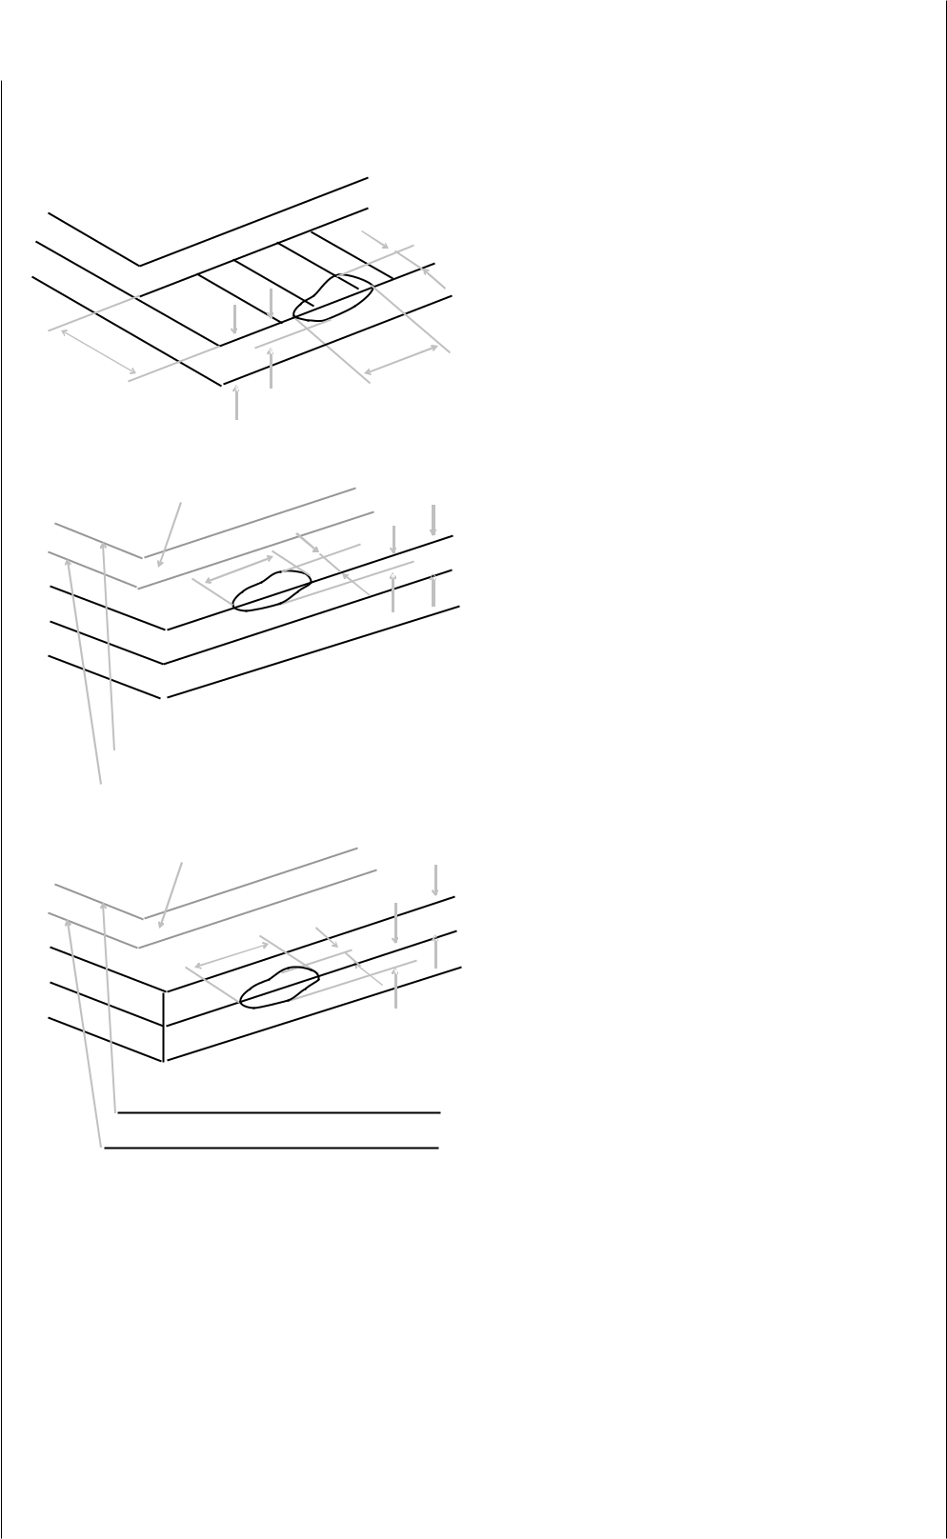

Inner border line of the seal

Outer border line of the seal

 | ⅳ)Corner |  |  |  |  |  | A | a <= t, b <= 3.0, c <= 3.0
 |  |  |  |  |  |  | B | Glass crack should not cover
 |  |  |  |  |  |  |  | patterns u and alignment mark
 |  |  |  | a |  | t |  | and patterns.
 |  |  |  | b
 |  | w |  | b | c
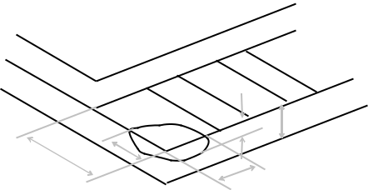

19
深圳市新活力科技有限公司

 |  | Inspection items |  |  |  |  |  |  | Judgment standard
 |  |  |  |  |  |  |  |  | Category(application: B zone)
 |  | Component soldering: |  |  |  |  |  |  | Component
 |  | No cold soldering、short、open circuit、
 |  | burr、tin ball
 |  | The | flat | encapsulation |  | component |  |  | L≤W/2 |  | W
 |  | position deviation must be less than 1/3 |  |  |  |  |  |  |  |  | W
 |  |  |  |  |  |  |  |  |  |  | Component
 |  | width of the pin (Pic.1)； |  |  |  |  |  |  | Soldering pad | Lead | Component
 |  | the sheet component deviation:
 |  | Pin deviates from the pad and contact |  |  |  |  |  |  |  |  | L1>0
 |  | with | the | near | components |  | is | not |  |  | L1>0
 |  |  |  |  |  |  |  |  | L2>0
 |  | permitted（Pic.2） |  |  |  |  |  |  | L2>0
 |  | lead defect:
 |  | The lead lack must be less than 1/3 of its
 |  | width;
 |  | The lead burr must be less than 1/3 of
16 | PCB | the seam;
16 | defect | Impurities connect with the near leads is
 |  | not permitted
 |  | Connector soldering:
 |  | Soldering tin is at contact position of the |  |  |  |  |  |  |  | head | Base Board
 |  | plug and socket is not permitted |  |  |  |  |  |  | Soldering tin is not permit in this area
 |  | No foundation is scald
 |  | Serious cave distortion on plug and
 |  | socket contact pin is not permitted |  |  |  |  |  |  | Soldering tin is not permit in this area
 |  |  |  |  |  |  |  |  |  | socket
 |  |  |  |  |  |  |  |  |  |  | Base Board
 |  |  |  |  |  |  |  |  |  |  | 20
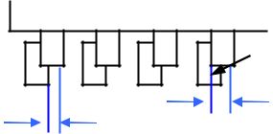
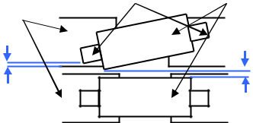
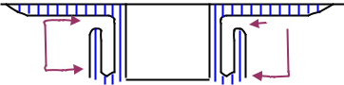
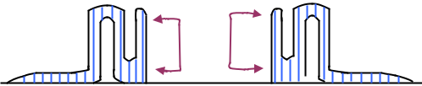
深圳市新活力科技有限公司

Glue on root of the speaker receiver and motor lead:
The insulative coat of the lead must join into the PCB; the protected glue must envelop to the insulative coat.

Glue Lead
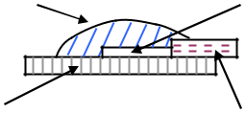

PCB | Insulative coat

10. Precautions for Use of LCD Modules

10.1 Handling Precautions

10.1.1 The display panel is made of glass. Do not subject it to a mechanical shock by dropping it from a high place, etc.

10.1.2 If the display panel is damaged and the liquid crystal substance inside it leaks out, be sure not to get any in your mouth, if the substance comes into contact with your skin or clothes, promptly wash it off using soap and water.

10.1.3 Do not apply excessive force to the display surface or the adjoining areas since this may cause the color tone to vary.

10.1.4 The polarizer covering the display surface of the LCD module is soft and easily scratched. Handle this polarizer carefully.

10.1.5 If the display surface is contaminated, breathe on the surface and gently wipe it with a soft dry cloth. If still not completely clear, moisten cloth with one of the following solvents:

— Isopropyl alcohol

— Ethyl alcohol

Solvents other than those mentioned above may damage the polarizer.

Especially, do not use the following:

— Water

— Ketone

— Aromatic solvents

10.1.6 Do not attempt to disassemble the LCD Module.

10.1.7 If the logic circuit power is off, do not apply the input signals.

21
深圳市新活力科技有限公司

10.1.8 To prevent destruction of the elements by static electricity, be careful to maintain an optimum work environment.

a. Be sure to ground the body when handling the LCD Modules.

b. Tools required for assembly, such as soldering irons, must be properly ground.

c. To reduce the amount of static electricity generated, do not conduct assembly and other work under dry conditions.

d. The LCD Module is coated with a film to protect the display surface. Be care when peeling off this protective film since static electricity may be generated.

10.2 Storage precautions

10.2.1 When storing the LCD modules, avoid exposure to direct sunlight or to the light of fluorescent lamps.

10.2.2 The LCD modules should be stored under the storage temperature range. If the LCD modules will be stored for a long time, the recommend condition is:

Temperature : | 0℃ ～ 40℃
Relatively humidity: | ≤80%

10.2.3 The LCD modules should be stored in the room without acid, alkali and harmful gas.

10.3 The LCD modules should be no falling and violent shocking during

transportation, and also should avoid excessive press, water, damp and

sunshine.

22

