Report II
Mission Requirements and Initial Sizing
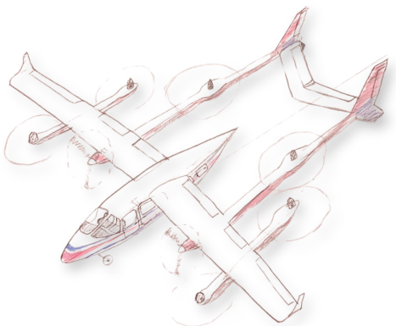March 27, 2024
Contents
1 Mission Statement . . . . . . . . . . . . . . . . . . . . . . . . . . . . . . . . 7 2 Operational Concept . . . . . . . . . . . . . . . . . . . . . . . . . . . . . . . 7 2.1 Basic . . . . . . . . . . . . . . . . . . . . . . . . . . . . . . . . . . . . 7 2.2 Enhanced . . . . . . . . . . . . . . . . . . . . . . . . . . . . . . . . . 8 3 Ground Effect Analysis . . . . . . . . . . . . . . . . . . . . . . . . . . . . . . 8 4 Requirement Analysis . . . . . . . . . . . . . . . . . . . . . . . . . . . . . . . 10 5 Configuration Analysis . . . . . . . . . . . . . . . . . . . . . . . . . . . . . . 11 5.1 Design 3 . . . . . . . . . . . . . . . . . . . . . . . . . . . . . . . . . . 11 5.2 Design 5 . . . . . . . . . . . . . . . . . . . . . . . . . . . . . . . . . . 14 5.3 Design 6 . . . . . . . . . . . . . . . . . . . . . . . . . . . . . . . . . . 16 5.4 Design 7 . . . . . . . . . . . . . . . . . . . . . . . . . . . . . . . . . . 18 5.5 Design 8 . . . . . . . . . . . . . . . . . . . . . . . . . . . . . . . . . . 20 6 Configuration Selection . . . . . . . . . . . . . . . . . . . . . . . . . . . . . . 21 7 Patent Notes . . . . . . . . . . . . . . . . . . . . . . . . . . . . . . . . . . . 23 8 All-electric and Hybrid Analysis . . . . . . . . . . . . . . . . . . . . . . . . . 26 9 Fuselage and Ergonomics . . . . . . . . . . . . . . . . . . . . . . . . . . . . . 28 10 Initial Sizing Validation . . . . . . . . . . . . . . . . . . . . . . . . . . . . . 29 11 Risk Analysis . . . . . . . . . . . . . . . . . . . . . . . . . . . . . . . . . . . 30 12 Conclusion . . . . . . . . . . . . . . . . . . . . . . . . . . . . . . . . . . . . . 33
1
List of Figures
2.1 Concept for a connection between cities not passing through congested areas 8 2.2 Flight profile for basic operation . . . . . . . . . . . . . . . . . . . . . . . . . 9 2.3 Concept for urban operation . . . . . . . . . . . . . . . . . . . . . . . . . . . 9 3.1 Ground Effect . . . . . . . . . . . . . . . . . . . . . . . . . . . . . . . . . . . 11 5.1 Design 3 sketch . . . . . . . . . . . . . . . . . . . . . . . . . . . . . . . . . . 12 5.2 Design 3 analysis . . . . . . . . . . . . . . . . . . . . . . . . . . . . . . . . . 13 5.3 Concept for Design 5 . . . . . . . . . . . . . . . . . . . . . . . . . . . . . . . 14 5.4 Design 5 sketch . . . . . . . . . . . . . . . . . . . . . . . . . . . . . . . . . . 15 5.5 Design 5 analysis . . . . . . . . . . . . . . . . . . . . . . . . . . . . . . . . . 15 5.6 Design 6 sketch . . . . . . . . . . . . . . . . . . . . . . . . . . . . . . . . . . 17 5.7 Design 6 analysis . . . . . . . . . . . . . . . . . . . . . . . . . . . . . . . . . 17 5.8 Design 7 sketch . . . . . . . . . . . . . . . . . . . . . . . . . . . . . . . . . . 18 5.9 Design 7 general dimensions . . . . . . . . . . . . . . . . . . . . . . . . . . . 19 5.10 Design 7 analysis . . . . . . . . . . . . . . . . . . . . . . . . . . . . . . . . . 19 5.11 Design 8 sketch . . . . . . . . . . . . . . . . . . . . . . . . . . . . . . . . . . 20 5.12 Design 8 analysis . . . . . . . . . . . . . . . . . . . . . . . . . . . . . . . . . 21 6.1 Proposed eVTOL 4 seater . . . . . . . . . . . . . . . . . . . . . . . . . . . . 21 6.2 Proposed eSTOL 4 seater . . . . . . . . . . . . . . . . . . . . . . . . . . . . 22 7.1 Potential patent infringements . . . . . . . . . . . . . . . . . . . . . . . . . . 23 9.1 Cabin space for passengers . . . . . . . . . . . . . . . . . . . . . . . . . . . . 28 9.2 External dimension of the fuselage . . . . . . . . . . . . . . . . . . . . . . . . 28
2
10.1 Size comparison with heliport . . . . . . . . . . . . . . . . . . . . . . . . . . 29 10.2 Size comparison with Tecnam p2006t . . . . . . . . . . . . . . . . . . . . . . 29
3
List of Tables
5.1 Design 3 parameters . . . . . . . . . . . . . . . . . . . . . . . . . . . . . . . 12 5.2 Design 5 parameters . . . . . . . . . . . . . . . . . . . . . . . . . . . . . . . 14 5.3 Design 6 parameters . . . . . . . . . . . . . . . . . . . . . . . . . . . . . . . 16 5.4 Design 7 parameters . . . . . . . . . . . . . . . . . . . . . . . . . . . . . . . 18 5.5 Design 8 parameters . . . . . . . . . . . . . . . . . . . . . . . . . . . . . . . 20 7.1 Designs preliminary patent evaluation part 1 . . . . . . . . . . . . . . . . . . 24 7.2 Designs preliminary patent evaluation part 2 . . . . . . . . . . . . . . . . . . 25 8.1 Main aircraft all-electric configuration requirements . . . . . . . . . . . . . . 26 8.2 Aircraft hybrid configuration evaluation . . . . . . . . . . . . . . . . . . . . . 27 11.1 Risks Likelihood and Severity . . . . . . . . . . . . . . . . . . . . . . . . . . 30 11.2 Risk Quantification Strategy . . . . . . . . . . . . . . . . . . . . . . . . . . . 30 11.3 Risks Consequences . . . . . . . . . . . . . . . . . . . . . . . . . . . . . . . . 31 11.4 Risks Identification . . . . . . . . . . . . . . . . . . . . . . . . . . . . . . . . 32
4
Executive Summary
The development of the electric Vertical Takeoff and Landing (eVTOL) aircraft represents a groundbreaking approach to urban air mobility, focusing on creating an aircraft that com bines the vertical lift capabilities of a helicopter with the efficient flight characteristics of an airplane. This project aims to introduce a versatile, efficient, and environmentally friendly mode of air transportation that can operate within urban areas and beyond, significantly reducing travel time for short to medium distances.
The core mission driving this project is to develop an aircraft that is not only versatile and efficient but also adaptable for various uses such as passenger transport, cargo delivery, and other specialized aerial services. Also the airplane can be modified in the future to fly in STOL and CTOL missions. The aircraft is designed with a six-seat configuration, allowing it to cater to small groups of passengers or cargo, making it ideal for a wide range of applications from commuter travel to logistics.
A crucial aspect of the aircraft’s design is its modularity. This means that the aircraft can be easily adapted or modified to meet different operational needs or to incorporate new technologies as they become available. This design philosophy ensures that the aircraft remains at the forefront of aviation technology, providing sustainable and efficient solutions for urban mobility.
A significant emphasis is placed on minimizing the environmental impact of the aircraft. By using electric power, the eVTOL aims to achieve zero emissions, contributing to cleaner air and less noise pollution in urban areas. This commitment to sustainability reflects a broader effort to align with global environmental standards and to promote green aviation practices.
Several key analyses have been conducted to optimize the eVTOL design, including ground effect analysis, requirement analysis, and configuration analysis. Ground effect anal ysis is crucial for understanding how the aircraft performs during takeoff and landing, par ticularly in the complex airflows found in urban environments. Requirement analysis has
5
helped define the essential characteristics needed for the aircraft to meet its operational goals, such as vertical takeoff and landing capabilities, electric propulsion, and modular ity. Configuration analysis led to the exploration of various design options, evaluating their feasibility, performance, and compliance with mission requirements. This rigorous analy sis process has been instrumental in refining the aircraft design, ensuring that it combines optimal performance with environmental sustainability.
After thorough review and analysis, a specific design configuration was selected for fur ther development. This configuration balances performance, efficiency, and adaptability, making it well-suited to meet the diverse needs of urban air mobility. Additionally, careful consideration has been given to patent and intellectual property issues, ensuring that the selected design respects existing patents while fostering innovation.
Risk management has been a critical component of the project, with a comprehensive analysis of potential risks and their mitigation strategies. This includes evaluating the likeli hood and severity of risks related to regulations, technology development, funding, manufac turing capabilities, modularity, proof-of-concept realization, market trends, and certification. By proactively addressing these risks, the project aims to ensure the successful development and implementation of the eVTOL aircraft.
6
1 Mission Statement
The mission is to develop a modular aircraft that encapsulates versatility and efficiency, catering to a spectrum of aviation needs from eVTOL, STOL to CTOL capabilities. The aircraft’s design will feature a consistent four-seat airframe, ensuring a broad operational range of 200 km across various configurations. This modularity aims to provide seamless adaptability for diverse applications including commuter travel, cargo transportation, and aerial services.
In adherence to the principles of green aviation, the design will be anchored in the appli cation of emerging environmentally friendly technologies. The commitment to sustainability will be reflected in the reduction of the aircraft’s carbon footprint, promoting energy effi ciency and lower emissions in compliance with global environmental standards.
The vision for this aircraft is to set a benchmark in the aviation industry for flexible design while upholding stringent environmental directives. It will exemplify the integration of innovative modular engineering with the values of eco-consciousness, paving the way for a new generation of aircraft that align with the imperatives of future-forward and sustainable aviation.
2 Operational Concept
2.1 Basic
For this category, the operations are the ones not included in the enhanced version, so everything that is different from Urban Air Mobility (UAM) or the Air Taxi concept. This means but is not limited to General Aviation, Special Operation, manned cargo and outside congested areas. It could also be classified by the number of passengers, for basic: 0 to 9 passengers. For this category, in the event of the loss of an engine, it would be necessary to complete a controlled emergency landing (CEL). For this type of operation, the trajectory shown in Figure 2.2 is proposed, so in case of failure the pilot could perform a landing in a
7
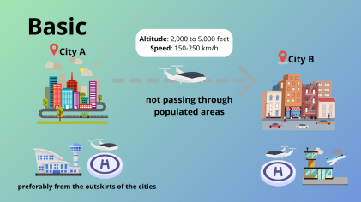Figure 2.1: Concept for a connection between cities not passing through congested areas
short runway as a STOL.
2.2 Enhanced
As mentioned before, the enhanced category include all the UAM passing through congested areas and air taxi service. It is classified for flights from 10 to 19 passengers. In case of a failure, it must perform a continuous safe flight and landing (CSFL), meaning it should perform the same original trajectory having multiple redundant systems or at least find another vertiport that where it could make the safe vertical landing. The same profile from the basic operation is proposed, but with the consideration that the vertiports should be at higher buildings, so there are no urban obstacles in the climbing stage.
3 Ground Effect Analysis
• Suck-Down Effect: A critical phenomenon for VTOL vehicles, caused by the ac celeration of the air mass around the vehicle due to viscosity, creating a downward
8
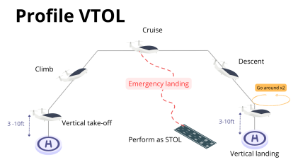Figure 2.2: Flight profile for basic operation
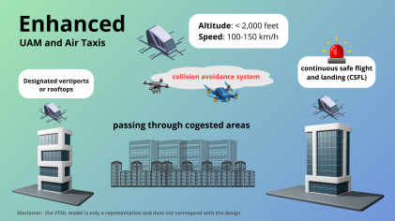Figure 2.3: Concept for urban operation
9
flowfield. This effect is intensified near the ground due to the improved mixing of the deflecting jet exhaust and adjacent air, which can represent a “vertical drag” of 2-6% of T/W in free air and up to 30% of T/W in ground effect.
• Ground Effect: An aerodynamic phenomenon that occurs when a vehicle is close to the ground, resulting in increased lift efficiency due to the restriction of wingtip vortices. This significantly affects VTOL vehicle operations, especially during takeoff and landing, by reducing induced drag and increasing thrust efficiency. This effect is shown in figure 3.1.
When propellers or rotors are used to provide necessary lift in VTOL vehicles, their placement is crucial because any part of the structure affected by the rotor’s wake produces a download, reducing net lift. The estimation given for VTOL vehicles using propellers indi cates that the ground effect can increase the “vertical drag” up to 30% of T/W, highlighting the importance of considering this effect in the design and operation of VTOL vehicles [1].
If rotors are used to provide the necessary lift, their placement has to be carefully consid ered. Any portion of the airframe surface impinged by the rotor’s wake produces a download, which reduces the net lift. The US Army Material Command’s Helicopter Design Handbook [2] gives the following equation to approximate this effect:
Download_{Hover =}¹_{2∗}T
S_{Disk}∗ S_{exposed to wake}
4 Requirement Analysis
The following requirements are assessed for the proposed configurations:
• VTOL for enhanced operations: This determines that the aircraft will operate in urban environments. Low noise, small aircraft footprint, and high safety standards.
• Electric propulsion system.
10
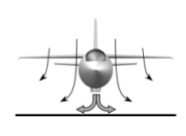
Figure 3.1: Ground Effect
• Modularity design for further development into STOL and CTOL aircraft • Spacious cabin with easy access and evacuation for 6 people.
• 100km in range.
• Automatic production consideration.
5 Configuration Analysis
9 Configurations were initially considered and 5 were pre-selected by the team to comply with the requirements. In the following section, each one of the configurations is shown with their respective parameters. Also, some weight, power, and energy estimations are made to predict the general sizing of the aircraft. This was done with our developed software using the equations and methods presented in the works of [3], [4], [5], [6] and [7].
5.1 Design 3
Double boom configuration (patent available) with 4 VTOL motors and 2 cruise motors. All fixed. H tail and big fuselage and door for payload. The main design parameters are shown
11
in Table 5.1, the sketch can be seen in figure 5.1 and the main weights, power and energy requirements are summarized in figure 5.2.
Table 5.1: Design 3 parameters
Patent state  Wingspan [m]  Mean chord [m]  Wing area [m²]  Fuselage length [m] Seats | Available 15  1.3  20  6  6 | Total motors  Motors used for VTOL Total power [kW]  Power per motor [kW] Total power [HP]  Power per motor [HP] | 6  4  924  231  1216  304

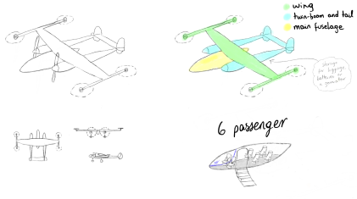Figure 5.1: Design 3 sketch
12
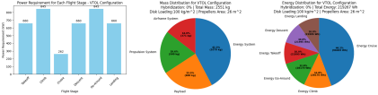Figure 5.2: Design 3 analysis
13
5.2 Design 5
Inspired by the design shown in figure 5.3, the following configuration is considered: Double boom configuration with 6 VTOL motors and 2 cruise motors. All fixed. H tail and big fuselage and door for payload. The main design parameters are shown in Table 5.2, the sketch can be seen in figure 5.4 and the main weights, power and energy requirements are summarized in figure 5.5.
Table 5.2: Design 5 parameters
Patent state  Wingspan [m]  Mean chord [m]  Wing area [m²]  Fuselage length [m] Seats | Infringement US9120560B1 15  1.3  20  8  6 | Total motors  Motors used for VTOL Total power [kW]  Power per motor [kW] Total power [HP]  Power per motor [HP] | 8  6  956  159  1258  210

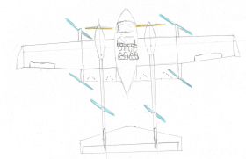
Figure 5.3: Concept for Design 5
14
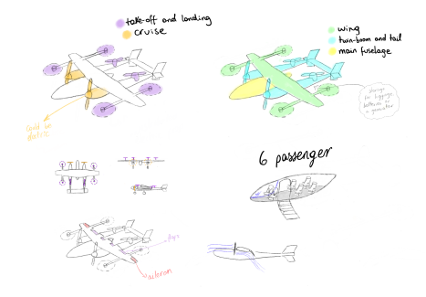Figure 5.4: Design 5 sketch
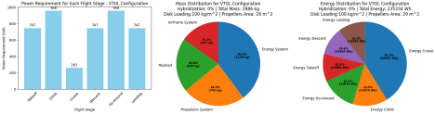Figure 5.5: Design 5 analysis
15
5.3 Design 6
A high wing design with 2 tilt rotors (external ones) and 6 fixed motors (only for vertical stages). T tail for control authority. Big fuselage area and door. Modularity in tail design. The main design parameters are shown in Table 5.3, the sketch can be seen in figure 5.6 and the main weights, power and energy requirements are summarized in figure 5.7
Table 5.3: Design 6 parameters
Patent state  Wingspan [m]  Mean chord [m]  Wing area [m²]  Fuselage length [m] Seats | Available - US20200391859A 15  1  15  10  6 | Total motors  Motors used for VTOL Total power [kW]  Power per motor [kW] Total power [HP]  Power per motor [HP] | 8  8  944  118  1242  155

16
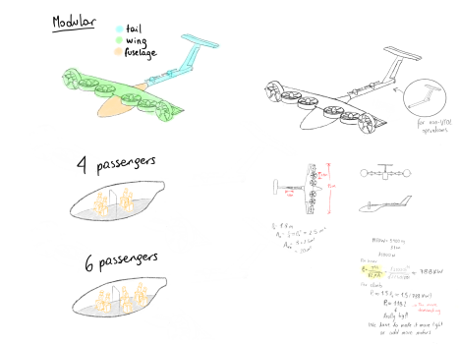Figure 5.6: Design 6 sketch
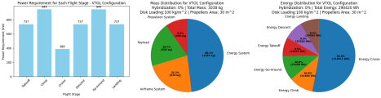Figure 5.7: Design 6 analysis
17
5.4 Design 7
A tandem wing design that allows for a wider center of gravity range, which allows passengers to use a wide door for easy boarding and deboarding. With a 4-tilt rotor system. This design has the goal of providing as much lift as possible with the available fixed wing surfaces and distributing the weight over the triple fuselage. The main design parameters are shown in Table 5.4, the sketch can be seen in figure 5.8 and 5.9. The main weights, power and energy requirements are summarized in figure 5.10.
Table 5.4: Design 7 parameters
Patent state  Wingspan [m]  Mean chord [m]  Wing area [m²]  Fuselage length [m] Seats | Available - US20200140079A1 12  1.3  31.2  9  6 | Total motors  Motors used for VTOL Total power [kW]  Power per motor [kW] Total power [HP]  Power per motor [HP] | 4  4  1062  266  1397  349

Figure 5.8: Design 7 sketch
18
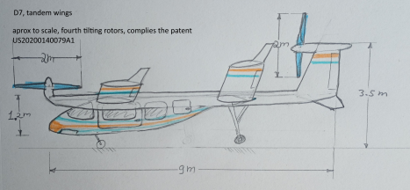Figure 5.9: Design 7 general dimensions
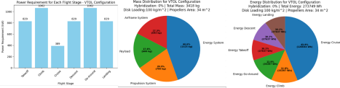Figure 5.10: Design 7 analysis
19
5.5 Design 8
High back wing (4 tilted rotors and 1 fixed pusher) with canard configuration (distributed ducted propulsion). Big fuselage area for six passengers. The main design parameters are shown in Table 5.5, the sketch can be seen in figure 5.11 and the main weights, power and energy requirements are summarized in figure 5.12
Table 5.5: Design 8 parameters
Patent state  Wingspan [m]  Mean chord [m]  Wing area [m²]  Fuselage length [m] Seats | Available 10  1.36  13.58  6.9  6 | Total motors  Motors used for VTOL Total power [kW]  Power per motor [kW] Total power [HP]  Power per motor [HP] | 13  12  911  76  1199  100

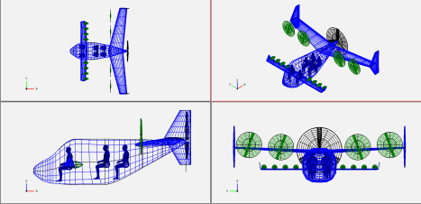Figure 5.11: Design 8 sketch
20
Figure 5.12: Design 8 analysis
6 Configuration Selection
After the committee review with Mr Radim Olbrecht, Leos Vybiral and Felipe Correa, of the proposals on March 26, 2024, the selected design to continue the design project is D5. The selected configuration is shown in figures 5.3 and 5.4. Furthermore, the following figures 6.1 and 6.2 show the eVTOL and eSTOL configurations. These proposed designs are for display only, showing the modularity of the design and its ability to have different missions.
Figure 6.1: Proposed eVTOL 4 seater
21
Figure 6.2: Proposed eSTOL 4 seater
22
7 Patent Notes
During the conceptual design phase, the project was developed with patent and intellectual property restrictions in mind.
To get a first iteration of this restriction, a search on google patents and USPTO (United States Patent and Trademark Office) with keywords such as: VTOL, aircraft. The search returns 44,557 results, including worldwide coverage.
Then a deeper search using keywords such as VTOL aircraft vertical takeoff and landing will narrow the result to 32,534.
Including the word tiltrotor reduces the results to 4,756.
Some results for abandoned patents include the following, which were suggested as pos sible design guidelines:us20200140079a1 from Bell Helicopters Textron. In tables 7.1 and 7.2 the preliminary analysis of the potential patent infringement was summarized related to the proposed designs.
With the design selected, the patents shown in figure 7.1 can have some similarity with the configuration.
Figure 7.1: Potential patent infringements
23
Table 7.1: Designs preliminary patent evaluation part 1
Drawing 1
Item 4 seats 6 seats
Comply with FAA mosaic YES NO
Multiporpuse Fuselage YES
Grow to 6-9 places YES
Patent and available design PI YES
Notes We suggest more searching of patents status, looks available Drawing 2
Item 4 seats 6 seats
Comply with FAA mosaic YES NO
Multiporpuse Fuselage YES
Grow to 6-9 places YES
Patent and available design PI NO
Notes Review Patent US11919630B2
Drawing 3
Item 4 seats 6 seats
Comply with FAA mosaic YES NO
Multiporpuse Fuselage YES
Grow to 6-9 places YES
Patent and available design PI YES
Notes We suggest more searching of patents status, looks available Drawing 4
Item 4 6 seats
Comply with FAA mosaic YES NO
Multiporpuse Fuselage YES
Grow to 6-9 places YES
Patent and available design PI NO
Notes Review Patent US20190061968A1
24
Table 7.2: Designs preliminary patent evaluation part 2
Drawing 5
Item 4 seats 6 seats
Comply with FAA mosaic YES NO
Multiporpuse Fuselage YES
Grow to 6-9 places YES
Patent and available design PI NO
Notes Infringement US9120560B1 Drawing 6
Item 4seats 6 seats
Comply with FAA mosaic YES NO
Multiporpuse Fuselage YES
Grow to 6-9 places YES
Patent and available design PI YES Notes Abandoned Patent US20200391859A Drawing 7
Item 4seats 6 seats
Comply with FAA mosaic YES NO
Multiporpuse Fuselage YES
Grow to 6-9 places YES
Patent and available design PI YES Notes Abandoned Patent US20200140079A1
25
8 All-electric and Hybrid Analysis
All-electric eVTOL aircraft present a mix of advantages and challenges rooted in electric propulsion and battery technology. Their electric motors offer high efficiency, reduced main tenance, and quieter operations, aligning with environmental goals by eliminating emissions. However, the main drawback is the limited energy density of batteries, which restricts range and payload, making these aircraft more suitable for short-range missions. The weight of batteries also demands more power for lift-off, further limiting operational capacity. While rapid charging and safety measures for battery management are evolving, overcoming these limitations is crucial for broadening the operational scope of all-electric eVTOLs [8], [9], [10], [11].
Table 8.1: Main aircraft all-electric configuration requirements
Units | eVTOL
kg  m/s (knots) m/s (knots) h  km  kg  kWh  kg  kW  kg | 2886  31 (60)  50 (97)  0.75  135  600  237  1150  960  320

Parameter eSTOL
MTOW 2100
Stall speed 31 (60)
Cruise speed 75 (145)
Endurance 0.75
Range 202
Payload 600
Battery capacity 130
Battery mass 660
Electric motors power 390
Motor mass 130
Hybrid eVTOL aircraft blend electric propulsion with Internal Combustion Engines (ICE), extending range and payload beyond all-electric limitations while maintaining pre cise, efficient maneuvers. This configuration, however, complicates design and operation with dual power systems, leading to potential increases in maintenance and costs. While they
26
reduce emissions compared to ICE-only models, they do not eliminate them, diluting some environmental benefits. Despite these trade-offs, hybrid eVTOLs serve as a transitional step, offering improved performance with a nod toward sustainability [12], [13].
In table 8.2 we can see the benefit of using an increasing hybridization level (by the amount of power generated from traditional fuel). This estimation results in almost a thousand-kilogram reduction of the total weight of the aircraft capable of the same mis sion. The reduction of battery weight results in an airframe weight which results in even a bigger MTOW reduction.
Table 8.2: Aircraft hybrid configuration evaluation
 |  |  | Hybridization level
Units | 0% | 25% | 50% | 75%
kg  kWh  kg  kg  kW | 2886  287  1149  0  956 | 2641  206  800  41  875 | 2411  131  525  77  800 | 2194  63  251  111  727

Parameter 100%
MTOW 1990
Battery capacity 0
Battery mass 0
Fuel mass 142
Electric motors power 660
27
9 Fuselage and Ergonomics
With the first sizing iteration, special attention was paid to the correct placement of two men side by side, as shown in figures 9.1 and 9.2.
Figure 9.1: Cabin space for passengers
Figure 9.2: External dimension of the fuselage
28
10 Initial Sizing Validation
Figure 10.1: Size comparison with heliport
Figure 10.2: Size comparison with Tecnam p2006t
29
11 Risk Analysis
For the entirety of the project, the main risks were evaluated and some mitigation techniques are proposed. The likelihood and severity of the risks are evaluated following the guide of table 11.1. Then the risk is quantified following table 11.2 and then, the consequences are as shown in table 11.3. The result of this risk analysis is finally shown and summarized in table 11.4.
Table 11.1: Risks Likelihood and Severity
Level |  | Likelihood | Severity
5 | Maximum | 100% | Unacceptable
4 | High | 10% | Major reduction in mission objectives
3 | Medium | 1% | Moderate reduction
2 | Low | 0.1% | Moderate reduction
1 | Minimum | less than 0.1% | Minimal or no impact

Table 11.2: Risk Quantification Strategy
Severity | 5 | 5 | 10 | 15 | 20 | 25
Severity | 4 | 4 | 8 | 12 | 16 | 20
Severity | 3 | 3 | 6 | 9 | 12 | 15
Severity | 2 | 2 | 4 | 6 | 8 | 10
Severity | 1 | 1 | 2 | 3 | 4 | 5
 |  | 1 | 2 | 3 | 4 | 5
 |  | Likelihood

30
Table 11.3: Risks Consequences
Risk Quantification | Consequence
>20 | Maximum disruption of project plan. Implement new process or plan
15-20 | High disruption of project plan. Implement new project or plan
10-14 | Some disruption of project plan. Consider alternative process
5-9 | Little disruption of project plan. Management actions
<5 | Little to no disruption. Mitigate with management

31
Table 11.4: Risks Identification
 | Code Risk Name |  |  |  | S L SxL Description | Mitigation Strategy
PL-1 | Regulations  change | 5 | 2 | 10 | Regulations change drasti cally in the next 5 years | Close regulation monitoring during design.
PL-2 | Battery tech nology level not achieved | 4 | 3 | 12 | The energy density level of available batteries does not surpass the 400 Wh/kg | Usage of alternative ener getic systems
PL-3 | In-house technol ogy development not achieved |  | 3 3 9 |  | The required propietary tech nologies are not developed successfully | Usage of comercial alterna tives compromising market competitiveness
PL-4 | Funding not achieved |  | 4 3 | 12 | Capital investors or funding opportunities are not inter ested in the project | Major project focus change to attract the capital neces sary
PL-5 | Manufacturing  capabilities not as efficient as estimated |  | 2 2 4 |  | The engineering and produc tion costs grow because of manufacturing limitations | Close production engineer ing monitoring from early stages of the design
PL-6 | Aircraft modular ity compromises the eVTOL mis sion |  | 5 3 | 15 | The modularity makes the project too complex and the resulting configurations are not as efficient as required | Top mission priorities def inition and system-level analysis from the beginning of the project
PL-7 | Proof-of-concept not achievable |  | 4 2 8 |  | The concept results unachiev able by the deadline for the PoC | Redefinition of the PoC and resource intesification to wards this objective
PL-8 | Market shift in mobility trends | 3 |  | 1 3 | The air mobility is no longer a need for the market | Shifting focus to other mar ket needs (cargo, military, etc)
PL-9 | Certification not achievable |  | 5 3 | 15 | The regulators impose higher  levels for certification that 32  make the aircraft non-viable | Major aircraft design changes need to be made

12 Conclusion
The design is intended to provide 6 seats, in a configuration of 4 passengers plus a pilot and co-pilot, to comply with enhanced operations or over urban and dense population areas. It must therefore have the ability to reach a vertiport in case of emergency. In addition, the aircraft must have the capability to operate as an eStol aircraft and Ctol, which means that traditional airports are also available to operate and provide services. The aircraft in a dirt or with hiperlift devices will have in ISA conditions a stall speed projected over 60 kn approximately if only two engines are operational. In eStol conditions the stall speed will be lower, this value will be available after the next iteration of the design. The cabin interior volume and areas are considered under the regulations, so the certification is achievable with 6 adults. The cabin width is above the value of an Embraer Phenom 300 jet, so as a reference the comfort is comparable to a luxury small jet.
The iteration provided a payload comparable to a Cessna 337 with similar arrangement with twin booms, but with the center fuselage commonality of parts to allow the design to grow for future versions or toe shrink to the smallest models. The sizing taking into consid eration the gross weight and power, is similar to a Cessna 208 Caravan, also the performance in stall and overall dimensions, this is a correlation that match the equations as a validation of the engineering calculations, this will be more precise during further analysis. This cabin sizing also provide capacity as CASEVAC, MEDEVAC, SAR CSAR for medical, search, rescue and related emergency services, this is a conceptual approach and will be analyzed in future engineering stages. The comparison to a heliport sized to a UH-60 Blackhawk, Augusta Westland AW139 and ASW532, so from an operational point of view. The design can operate in a similar regulation to Class 1 (a classification to operate over urban areas and with the performance to land safely even in case of failure of an engine) this will be more deeply analyzed in future engineering stages.
33
Bibliography
[1] D. P. Raymer, “The impact of vtol on the conceptual design process,” in 1988 Aircraft Design, Systems and Operations Conference, Atlanta, GA, USA, 1988.
[2] Army Materiel Command, Engineering Design Handbook - Helicopter Engineering - Part One: Preliminary Design, AMCP 706-201. Fort Belvoir, VA, USA: NTIS, 1974.
[3] S. Gudmundsson, General aviation aircraft design: Applied Methods and Procedures. Butterworth-Heinemann, 2013.
[4] D. F. Finger, “Methodology for multidisciplinary aircraft design under consideration of hybrid-electric propulsion technology,” Ph.D. dissertation, RMIT University, 2020.
[5] D. Raymer, Aircraft design: a conceptual approach. American Institute of Aeronautics and Astronautics, Inc., 2012.
[6] J. Roskam, Airplane design. DARcorporation, 1985.
[7] O. Ugwueze, T. Statheros, N. Horri, M. A. Bromfield, and J. Simo, “An efficient and robust sizing method for evtol aircraft configurations in conceptual design,” Aerospace, vol. 10, no. 3, p. 311, 2023.
[8] M. E. BALLI, “Evtol aircraft conceptual design and optimization,” 2019.
[9] F. G. Harmon, A. A. Frank, and J.-J. Chattot, “Conceptual design and simulation of a small hybrid-electric unmanned aerial vehicle,” Journal of aircraft, vol. 43, no. 5, pp. 1490–1498, 2006.
34
[10] J. K¨ohler and P. Jeschke, “Conceptual design and comparison of hybrid electric propul sion systems for small aircraft,” CEAS Aeronautical Journal, vol. 12, no. 4, pp. 907– 922, 2021.
[11] G. Palaia, K. Abu Salem, V. Cipolla, V. Binante, and D. Zanetti, “A conceptual design methodology for e-vtol aircraft for urban air mobility,” Applied Sciences, vol. 11, no. 22, p. 10 815, 2021.
[12] X. Ye, A. Savvarisal, A. Tsourdos, D. Zhang, and G. Jason, “Review of hybrid elec tric powered aircraft, its conceptual design and energy management methodologies,” Chinese Journal of Aeronautics, vol. 34, no. 4, pp. 432–450, 2021.
[13] T. Marzougui, K. Neuhaus, L. Labracherie, and G. Scalabrin, “Optimal sizing of hybrid electric propulsion system for evtol,” in IOP Conference Series: Materials Science and Engineering, IOP Publishing, vol. 1226, 2022, p. 012 070.
35

