MARKET STUDY

eVTOL Aircraft Trends in 2024

March 15 2024

Prepared for Flying Academy

Prepared by



1. Executive Summary 2
2. Market Overview 3
a. Market Size and Growth Potential 5
b. eVTOL architectures 6
i. Multicopter 6
ii. Lift and Cruise 7
iii. Vectored Thrust 7
iv. Multi-Propeller Ducted Fans 8
c. eVTOL regulation in EASA 8
d. Market Segments and Their Growth Potential 10
e. Range Analysis and Regional Markets 11
3. Competitors Analysis 14
a. General Analysis 15
i. Growth and Interest in eVTOL Technology 15
ii. Propulsion Trends 15
iii. Piloting Options 15
iv. Capacity vs. Range and Autonomy 15
v. Technological and Design Diversity 15
vi. Development Stage 16
b. Key Aircraft 16
i. MTOW vs. Range Relationship: 16
ii. Configuration Influence 17
iii. Autonomy Limitations 17
iv. Seating Capacity 17
v. Flight Status 17
vi. Cruise Speed Considerations 17
vii. Company Diversity 17
viii. Technological Opportunities 17
ix. Market Share 18
x. Product Portfolio 18
xi. Competitive Strategies 18
4. Emerging Technologies 19
a. Battery Technology 19
b. Hydrogen Fuel Cell Technology 20
c. Material Science 20
d. Infrastructure Development 20
e. Propulsion Systems 20
i. Electric Motors with Propellers/Rotors 20
ii. Hybrid-Electric eVTOLs (Series Hybrid) 21
iii. Hybrid-Electric eVTOLs (Parallel Hybrid) 21
f. Propellers and fans 22
i. Open Propellers 22
ii. Coaxial Propellers 22
iii. Ducted Propellers 23
iv. Coaxial Ducted Fans 23
5. eVTOL Challenges 24
a. Range and Efficiency 24
b. Noise Reduction 24
c. Safety and Reliability 24
d. Weight reduction 24
e. Charging infrastructure 24
f. Certification and regulations 25
g. Public perception 25
h. Complexity of hybrid systems 25
i. Control challenges 25
6. Manufacturing Processes 25
7. Conclusion 26
References 27

Executive Summary
The dawn of electric Vertical Takeoff and Landing (eVTOL) technology heralds a new era in urban and regional transportation, promising to redefine mobility with cleaner, more efficient, and faster alternatives. This emerging sector, part of the broader Advanced Air Mobility (AAM) landscape, is poised to transform how millions of passengers traverse distances typically under 100 kilometers, integrating seamlessly with existing urban infrastructures through vertiports and advanced air traffic management systems.

By the end of this decade, the eVTOL market is anticipated to witness exponential growth, with projections suggesting a surge from USD 1.2 billion in 2023 to USD 23.4 billion by 2030. This growth trajectory is fueled by a blend of technological breakthroughs, regulatory advancements, and a growing demand for sustainable transportation solutions. Key players such as Airbus and Joby Aviation are at the forefront, driving innovation with diverse eVTOL configurations and participating actively in the shaping of a regulatory environment conducive to safety and reliability.

As the eVTOL industry navigates through its formative years, it faces a constellation of challenges and opportunities. The sector's success hinges on its ability to harmonize technological innovations with stringent safety standards and public acceptance, all while steering through a regulatory landscape that is still in evolution. This executive summary unfolds the promise of eVTOL technology as a cornerstone of future mobility, highlighting its potential to offer more efficient and environmentally friendly transportation solutions, and setting the stage for a comprehensive exploration of the eVTOL market dynamics, regulatory frameworks, technological advancements, and the pivotal role of industry stakeholders in shaping the future of urban air mobility.

Market Overview
The Advanced Air Mobility (AAM) market offers a solution to millions of passengers by addressing several challenges of urban and rural mobility, typically covering distances under 100 kilometers[1].
AAM represents the burgeoning transportation industry that encompasses the development of related infrastructure such as vertiports, charging stations, and air traffic management systems. These elements are crucial for integrating new modes of transportation into the existing aviation landscape.
By 2030[2], leading companies in the passenger AAM sector could surpass the world’s largest airlines in terms of fleet size and the number of daily flights offered. These flights are expected to be shorter, with an average duration of 18 minutes, and will accommodate fewer passengers (between one and six, plus a pilot).
The market features three main vehicle configurations: multi-rotor, compound, and tiltrotor. In line with this, EASA regulations reference FAA AC 23.1309-1E in the ASTM standards for failure, requiring vehicles to meet the standards for continuous safe flight and landing. They must also be capable of reaching the original intended destination or a suitable alternate vertiport following a failure. Among these configurations, the tiltrotor (wing) is deemed most suitable for meeting reliability and capacity safety requirements, thus complying with the upper limit for the average probability of failure per flight hour. A report from NASA [3] indicates that the reliability rate for loss of function in urban flights should exceed 10^-6 for complex systems, including those with electric components. Consequently, leading competitors are focusing on configurations with more than six rotors and aerodynamic surfaces such as wings (tiltrotor) to surpass this requirement.
Small cities, communities, and other destinations stand to benefit significantly from the low investment required to establish a vertiport compared to other transportation methods. This accessibility, facilitated by AAM technologies, is expected to spur growth in these areas, leading to an increase in destinations and sources of income.
A conventional takeoff and landing (eCTOL) capability will provide a significant advantage over numerous competitors due to its extended range and the influx of investment into this configuration [1].
The United States boasts over 14,000 airports, including 102 international ones, while Europe has more than 500. This extensive network, combined with a longer range of up to 200 kilometers, is expected to open a market worth over 30 billion by 2030 [4].
The eVTOL (Electric Vertical Takeoff and Landing) industry is experiencing rapid development. As of March 14, 2024, Airbus has unveiled its City Airbus NextGen prototype, an all-electric vehicle with four seats and a range of 80 kilometers [4].
Furthermore, Airbus has successfully tested a new, simplified human-machine interface (HMI) alongside advanced autonomous features through a project codenamed Vertex. This project utilized a traditional helicopter to autonomously complete a mission that included lifting off, taxiing, taking off, cruising, approaching, and landing along a pre-defined route, controlled using a tablet [5].
These technologies, developed by Airbus UpNext, are aimed at simplifying mission preparation and management, reducing helicopter pilot workload, and enhancing safety.
Joby Aviation has successfully completed three out of five stages of FAA type certification. The first stage, Certification Basis, involves working with the FAA to define the scope of the type certification project.[6]
The second stage, Means of Compliance, requires the company to scrutinize safety rules and identify how to demonstrate compliance with them. The third stage, Certification Plans, involves developing detailed certification plans for testing each system area. The fourth stage, Testing and Analysis, entails planning, documenting, and completing thousands of inspections, tests, and analyses as per the previously drawn-up certification plans. The fifth and final stage, Showing and Verifying, involves the FAA verifying the results of the testing, leading to the issuance of a type certification upon successful completion.
Pivotal is making strides in delivering eVTOL to the civilian market in the USA under FAR103, having delivered four of eight models for evaluation to the U.S. Air Force [7]. These single-place aircraft comply with the FAA Part 103 (Ultralight) category in the United States, allowing for flight in Class G airspace.

Market Size and Growth Potential
While there is consensus on the market's growth potential, differences in Compound Annual Growth Rate (CAGR) projections across reports highlight the dynamic and evolving nature of this sector. According to Markets and Markets, the eVTOL market size is expected to expand from USD 1.2 billion in 2023 to USD 23.4 billion by 2030, reflecting a CAGR of 52.0%​​. On the other hand, the IMARC Group report presents a more conservative estimate, forecasting the market to grow from USD 10.9 billion in 2022 to USD 24.1 billion by 2028, with a CAGR of 13.6%​​.
The variation in CAGR can be attributed to different methodologies, assumptions, and scopes considered in these studies. The more aggressive growth rate predicted by Markets and Markets could factor in rapid advancements in technology, regulatory approvals, and a surge in demand for sustainable urban air mobility solutions. Conversely, the IMARC Group's projection might take a more cautious approach, considering potential regulatory, technological, and market adoption challenges.
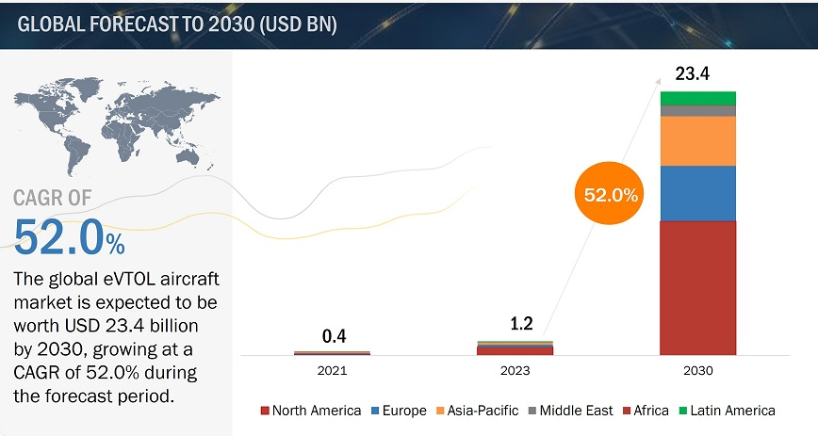
eVTOL Aircraft Market - Global Forecast to 2030," MarketsandMarkets, [Online]. Available: https://www.marketsandmarkets.com/Market-Reports/evtol-aircraft-market-28054110.html.

eVTOL architectures
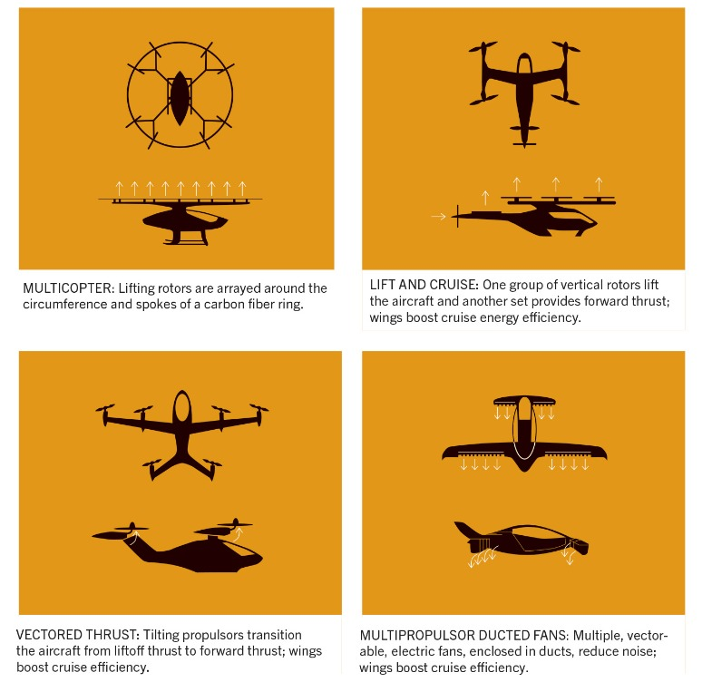
P. Marks, "eVTOL: making the electric dream a safe one," Aerospace America, September 2021. [Online]. Available: https://aerospaceamerica.aiaa.org/features/evtol-making-the-electric-dream-a-safe-one/. [Accessed: day-month-year].

i. Multicopter
Multicopters use multiple rotors or propellers arranged vertically to generate lift and control flight. They can take off and land vertically (VTOL) and maneuver precisely
- Simple design: Relatively simpler design compared to other configurations.
- High maneuverability: Multiple rotors allow for precise control and hovering capabilities.
- VTOL capable: Can take off and land vertically without needing a runway [8].
- Lower efficiency: Multiple rotors can create more drag, reducing range and efficiency.
- Noise generation: Many rotors can be noisy, especially during takeoff and landing.
- Scalability limitations: Adding more rotors for larger eVTOLs might increase complexity and weight [9].
Companies:
  - EHang: Their AAV family utilizes a multicopter configuration for various passenger and cargo applications [10].
  - Volocopter: The VoloCity eVTOL is a multicopter design with 18 rotors for urban air mobility [11].
  - Joby Aviation: While their S4 eVTOL uses tilting propellers (lift and cruise), some earlier prototypes were multicopter designs [12].

ii. Lift and Cruise
Lift and cruise eVTOLs use separate sets of propellers or rotors for vertical takeoff and landing (VTOL) and forward flight. They transition between vertical and horizontal flight modes.
- Improved efficiency: Dedicated propellers for different flight modes can potentially improve overall efficiency compared to multicopters.
- Quieter cruise: Cruise propellers optimized for horizontal flight can be quieter than multicopter rotors.
- Potential for longer range: Efficiency gains might translate to extended range compared to multicopters [13].
- More complex design: Requires separate sets of propellers and a tilting mechanism, increasing complexity.
- Control challenges: Managing the transition between VTOL and cruise modes can be complex.
- Potential weight penalty: Additional mechanisms might add weight compared to simpler configurations [13].
Companies:
  - Joby Aviation: Their S4 eVTOL utilizes tilting propellers for vertical takeoff and landing, and a separate pusher propeller for forward flight [12].
  - Kitty Hawk (Project Halted): Their Cora prototype used a lift and cruise configuration with tilting wings and separate propellers.
  - Several companies are exploring lift and cruise designs, with variations in tilting mechanisms and propeller configurations.

iii. Vectored Thrust
Vectored thrust eVTOLs use tilting ducts or engines to direct the thrust airflow for both vertical lift and forward flight. This allows for a more streamlined design.
- Simpler design: Can be simpler than lift and cruise configurations with fewer moving parts.
- Potentially quieter: Ducted fans can be quieter than exposed propellers.
- Aerodynamic efficiency: Ducted designs might offer better aerodynamic efficiency for forward flight [14].
- Control complexity: Managing the vectored thrust for precise maneuvers can be challenging.
- Limited scalability: Scaling up vectored thrust designs for larger eVTOLs might become complex due to the need for larger ducts and more powerful thrust vectoring mechanisms [14].

iv. Multi-Propeller Ducted Fans
Also known as Distributed Electric Propulsion or DEP They utilize multiple, smaller ducted fans embedded within the wings or fuselage for both vertical lift and forward flight. Each fan can be tilted or vectored to provide thrust in the desired direction.
- High efficiency: Ducted fans can be more aerodynamically efficient than exposed propellers, potentially leading to increased range.
- Quieter operation: Ducts help reduce noise generated by the fans.
- Improved safety: Having multiple smaller fans provides redundancy in case of a fan failure [15].
- Complex design: Requires integration of multiple fans and ducting within the airframe.
- Weight considerations: The additional ducting might add weight compared to simpler configurations.
- Control complexity: Managing the thrust of multiple fans for precise control can be challenging [15].
Companies:
  - Lilium: Their eVTOL Jet uses a proprietary Ducted Electric Vectored Thrust (DEVT) system with multiple electrically powered ducted fans for both vertical lift and cruise flight.
  - Several companies are at earlier stages of development with multi-propeller ducted fan designs, including Volocopter and Archer Aviation.

eVTOL regulation in EASA
The regulatory landscape for electric Vertical Take-Off and Landing (eVTOL) aircraft in Europe is evolving to accommodate the rapid advancements in technology and operational concepts. Central to this framework is the European Union Aviation Safety Agency (EASA), which plays a pivotal role in shaping regulations that ensure safety, promote innovation, and harmonize standards across Member States. Key regulatory initiatives, including EASA's Opinion No 03/2023 and Special Conditions for VTOL (SC-VTOL), highlight the agency's comprehensive approach to integrating eVTOL aircraft into European airspace.
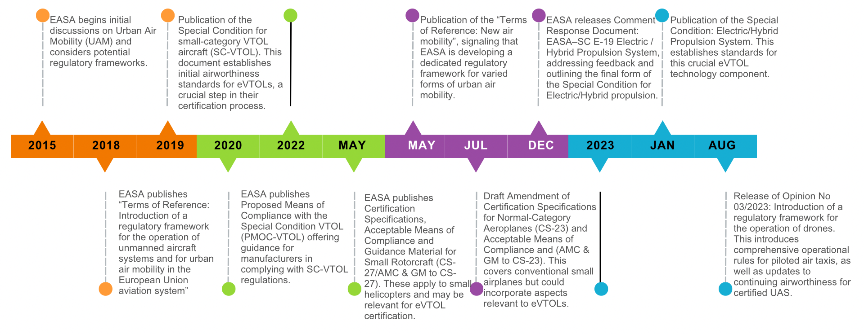
The regulatory framework for eVTOLs in Europe is designed with several objectives: ensuring a high level of safety for operations, enabling the safe integration of manned VTOL-capable aircraft within the single European sky, and fostering innovation in the field of innovative air mobility (IAM). The amendments to existing regulations and the introduction of new ones aim to address the initial and continuing airworthiness of Unmanned Aircraft Systems (UAS) subject to certification, particularly those operated in the 'specific' category, and operational requirements for manned VTOL-capable aircraft.
A pivotal aspect of this regulatory framework is the aircraft classification, which introduces a clear distinction between unmanned aircraft (UA), control and monitoring units (CMU), and manned VTOL-capable aircraft. This distinction is crucial for the certification process, ensuring interoperability and safety across different types of operations. The framework distinguishes between 'innovative aerial services' (IAS) and 'innovative air mobility' (IAM), with IAM operations enabled by new-generation technologies integrated into a multimodal transportation system. This classification facilitates the development of future requirements (regulations and rules) that are tailored to the specific characteristics and operational needs of these new aircraft technologies.
The regulatory framework encompasses several key areas:
- Initial Airworthiness: Focused on ensuring that eVTOL aircraft meet stringent safety and design standards before entering service.
- Continuing Airworthiness: Aimed at maintaining the safety and reliability of eVTOL aircraft throughout their operational life, including maintenance and operational oversight.
- Operational Requirements: Establishing the conditions under which eVTOL aircraft can operate safely within the European airspace, including integration into U-space (airspace designated for UAS operations) and compliance with air traffic management protocols.
- Flight Crew Licensing and Training: Ensuring that pilots and remote operators possess the necessary skills and knowledge to safely operate eVTOL aircraft.
The impact of these regulations on the development and commercialization of eVTOL aircraft in Europe is significant. On one hand, the establishment of a clear and harmonized regulatory framework provides a solid foundation for innovation, ensuring that new technologies can be safely integrated into the aviation ecosystem. This regulatory clarity attracts investment and stimulates the growth of the eVTOL industry, encouraging companies to develop and test new aircraft designs and operational models.
On the other hand, the complexity and rigor of the regulatory process may pose challenges for manufacturers and operators, requiring substantial investments in compliance and certification activities. The need to meet stringent safety and operational standards can extend development timelines and increase costs. However, these regulations are essential for building public trust and acceptance of eVTOL operations, particularly in urban environments where safety and environmental concerns are paramount.

Market Segments and Their Growth Potential
Market Segment | Description | Growth Potential
Lift Technology | Involves technologies like Vectored Thrust, Multirotor, and Lift +Cruise, determining the aircraft's lift and propulsion. | Vectored Thrust and Lift +Cruise are promising for 4-passenger models, offering balanced performance for urban mobility.
Propulsion Type | Includes Battery-Electric, Hybrid-Electric, and Hydrogen-Electric, defining the energy source for flight | Battery-Electric is leading, especially for short to medium-range operations typical for 4-passenger eVTOLs. Hybrid and Hydrogen offer potential for longer ranges.
Application | Ranges from Commercial (Air Taxi, Delivery Drones), Military, to Emergency Medical Services (EMS). | Commercial applications, particularly air taxis for 4-passenger models, show significant growth potential in urban and semi-urban areas.
Maximum Take-off Weight (MTOW) | Categories include <250 Kg, 250-500 Kg, 500-1500 Kg, and >1500 Kg. | The 250-500 Kg segment might be most relevant for 4-passenger eVTOLs, balancing size and performance for urban applications.
Range | Typically split into 0-200 Km and 200-500 Km segments. | For 4-passenger eVTOLs, both ranges are relevant, with 200-500 Km allowing for broader urban and regional connectivity.
Region | Covers North America, Europe, Asia-Pacific, and others. | North America and Europe are leading in terms of regulatory progress and infrastructure development for 4-passenger eVTOLs, with significant growth potential in Asia-Pacific as well.

Range Analysis and Regional Markets
The range of an eVTOL — the distance it can travel before needing to recharge or refuel — is a crucial factor that defines the operational boundaries and market viability of the technology. With Uber Elevate stipulation of a 97km range, our market analysis assesses the geographical distribution of potential eVTOL markets in relation to significant population centers and within this operational radius.
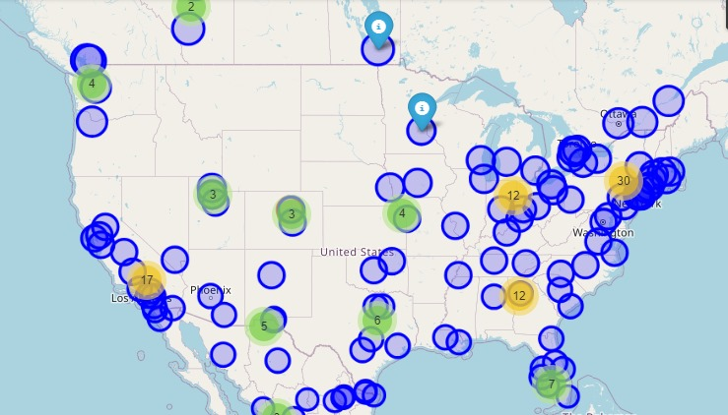
In the United States, there is a noticeable concentration of potential markets along the East Coast, spanning from the Boston-Washington D.C. corridor to Florida, indicating a high demand for eVTOL services in densely populated areas. The West Coast shows potential markets focused around urban centers like Los Angeles, San Francisco, and Seattle. Inland cities such as Denver and Phoenix also emerge as key areas where eVTOLs could significantly impact transportation dynamics.
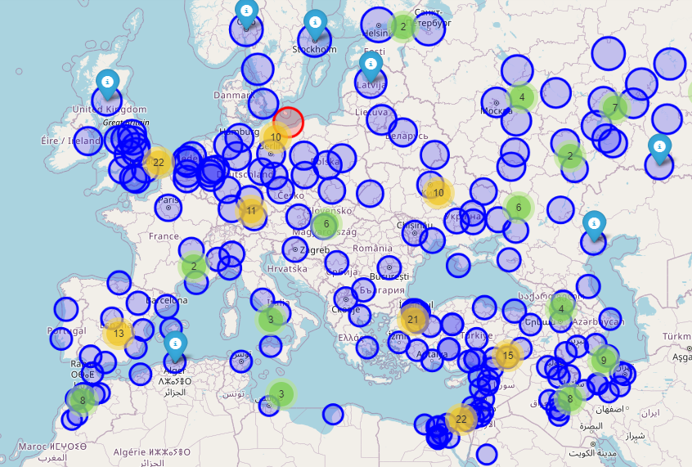
Europe's landscape reveals a dense network of potential eVTOL markets, with the highest concentrations appearing in the Western and Central regions. Countries like the United Kingdom, France, Germany, Italy, and Spain demonstrate significant coverage, with urban areas well within the 97 km operational range. This indicates that many European cities could benefit from eVTOL connectivity, enhancing intra-country and cross-border mobility.
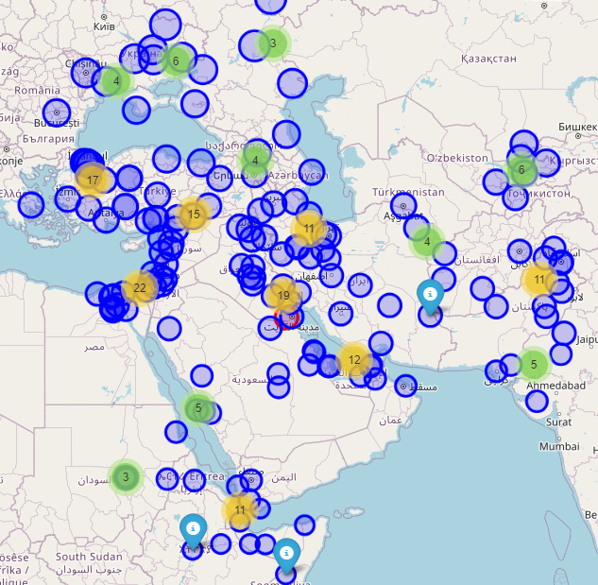
The Middle East presents an emerging market with urban centers such as Dubai, Riyadh, and Doha poised to adopt eVTOL technologies. The distribution suggests that the range capabilities align well with the geographic spacing of cities in this region, potentially transforming travel and logistics in an area that is rapidly urbanizing and investing in technological advancements.

In China, our analysis highlights substantial opportunities in the eastern provinces where population centers cluster near the coast. The Yangtze River Delta, Pearl River Delta, and Beijing-Tianjin-Hebei region showcase a particularly high potential for eVTOL integration, with range capabilities covering vast urban and suburban areas.

3. Competitors Analysis
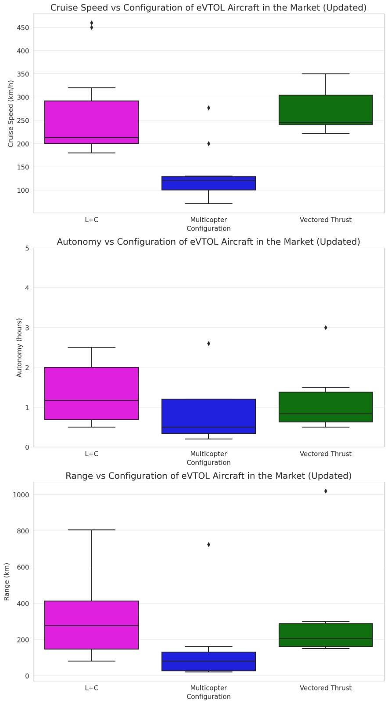

General Analysis

i. Growth and Interest in eVTOL Technology
The distribution of eVTOL projects over the years suggests a growing interest and investment in eVTOL technology, indicated by the variety of companies and models developed over recent years.

ii. Propulsion Trends
The mix of propulsion types, predominantly all-electric, points towards a strong focus within the industry on developing sustainable and environmentally friendly aviation solutions.

iii. Piloting Options
The mix between piloted, autonomous, and optionally piloted eVTOL projects (with around half being designed for piloted operation) reflects the current transitional phase in aviation, where autonomy in flight is being progressively explored and adopted. 57% of the reference aircraft have a pilot, 24% do not have one and the other 19% have the capacity to be both piloted and autonomous.

iv. Capacity vs. Range and Autonomy
The relationship between the number of seats and range shows that eVTOLs designed for a larger number of passengers tend to offer a broader range of distances. This might indicate that larger eVTOLs are being designed with longer travel distances in mind, potentially for regional travel as air taxis or for commercial transport applications.
- The number of seats versus autonomy data suggests a less clear relationship, with considerable variability in how long eVTOLs can stay airborne regardless of their passenger capacity. This variability could be influenced by differences in design priorities, propulsion technologies, and intended use cases.

v. Technological and Design Diversity
The wide range of motor power, MTOW, and cruise speeds across different eVTOL designs highlights the diversity in technological solutions and design philosophies being pursued. This diversity is likely driven by the variety of intended applications for eVTOLs, from urban air mobility and air taxi services to cargo transport and emergency response.

vi. Development Stage
The mention of whether eVTOLs have flown provides a glimpse into the development stage of different projects. With many having already achieved flight, it suggests that the eVTOL industry is moving beyond theoretical designs and prototypes towards more advanced stages of testing and validation.

Key Aircraft
Company | EVTOL name | Configuration | Type of propulsion | Number of seats | Piloted | MTOW(kg) | Autonomy (h) | Range (km) | Has flown? (yes or not) | Cruise speed (km/h)
Airbus | CityAirbus NextGen | L+C | Electric | 3 | yes | 3000-4000 kg* | 0.6 | 80 | not | 120
Beta technologies | ALIA-250 | L+C | Electric | 4 | yes | 2850 | 1.6 | 460 | yes | 270
Joby Aviation | S4 | Vectored Thrust | Electric | 4 | yes | 2404 | 0.7 | 241 | yes | 322
Vertical Aerospace | VX4 | Vectored Thrust | Electric | 5 | no | 2000-3000 kg* | 0.66 | 161 | yes | 241
Wisk | Generation 6 | Vectored Thrust | Electric | 4 | no | 2500-3500 kg* | 0.65 | 144 | not | 210
Lilium | Jet 7 seater | Vectored Thrust | Electric | 7 | yes | 1800 | 1 | 250 | yes | 250
Archer aviation | Midnight | Vectored Thrust | Electric | 5 | yes | 3175 | 0.62 | 150 | yes | 241
Ascensance Flight Technologies | ATEA | L+C | Hybrid | 3 | yes | 2000 | 2.5 | 450 | not | 200
Autoflight | Prosperity I (V1500M) | L+C | Electric | 4 | no | 1500 | 1.5 | 250 | yes | 200
Volocopter | VoloRegion | L+C | Electric | 4 | no | 2000-3000 kg* | 0.5 | 100 | yes | 180

i. MTOW vs. Range Relationship:
- There appears to be a positive correlation between MTOW (Maximum Take-Off Weight) and range for eVTOLs. This suggests that heavier eVTOLs tend to have a longer range, which could be due to larger energy storage capacities.
- Electric propulsion eVTOLs cover a wide range of MTOW and range, indicating a diversity in design and capability among electric models. However, the hybrid model in the dataset shows a competitive range with a relatively high MTOW, suggesting that hybrid technology might offer benefits for larger designs.

ii. Configuration Influence
Most of the eVTOLs in the dataset utilize either "L+C" (Lift + Cruise) or "Vectored Thrust" configurations. The data doesn't show a clear advantage of one configuration over the other in terms of range or MTOW. This implies that the configuration choice may be more dependent on specific use cases or design preferences rather than a significant performance differential.

iii. Autonomy Limitations
The autonomy (duration of flight) does not exceed 2.5 hours for any of the eVTOLs in this dataset, with most under 1.6 hours. This suggests that current battery technologies or hybrid systems are likely limiting factors in extending flight times. For longer missions, this would require either advancements in energy storage and efficiency or operational strategies such as quick-swap battery stations.

iv. Seating Capacity
There doesn't seem to be a strong correlation between the number of seats and range or autonomy. eVTOLs with various seating capacities have similar range profiles, indicating that passenger capacity might not be a significant factor in determining range, given the current state of technology.

v. Flight Status
70% of the eVTOLs have already flown, showing that the majority of designs are in an advanced stage of testing or near operational status.

vi. Cruise Speed Considerations
eVTOLs with higher cruise speeds don't necessarily show a longer range. In fact, some of the fastest eVTOLs have mid-range values for range, suggesting that higher speeds may come at the cost of energy efficiency over distance.

vii. Company Diversity
The dataset represents a variety of companies, with no single company dominating any particular performance metric. This diversity suggests a competitive market with many players aiming to establish niches or leverage unique design philosophies.

viii. Technological Opportunities
Given the diversity in propulsion types, configurations, and performance metrics, there appears to be room for innovation in eVTOL design. Companies could focus on niche markets (like quick intra-city transport vs. longer rural flights) or develop proprietary technologies to enhance performance factors important to their target market.

ix. Market Share
- Pre-orders and Partnerships: Joby Aviation holds sizable pre-orders from entities like United Airlines and Delta, indicating future market influence [21]. Archer Aviation's partnership with United Airlines is also noteworthy [22]. Lilium, with pre-orders from airlines like Azul, signals interest in the South American market [23].
- Production Capacity: Companies like Vertical Aerospace and Beta Technologies are ramping up production capabilities with significant manufacturing facilities, aiming to meet potential demand [24, 25].

x. Product Portfolio
- Joby Aviation (S4): 4-passenger (+ pilot) eVTOL designed for urban air mobility. Significant focus on reducing noise emissions [21]. In advanced certification stages.
- Lilium (Jet 7 Seater): 7-passenger eVTOL with a focus on regional transport and longer ranges. Ducted fan design prioritizes efficiency. Still in the prototype and testing phase [23].
- Archer Aviation (Midnight): Urban air taxi aircraft with a focus on low operating costs and ease of maintenance. Certification timeline is a key factor to watch [22].
- Beta Technologies (ALIA-250): Designed for a range of use cases including cargo, passenger transport, and medical applications. Versatile configuration and significant backing from investors make it a contender[25].

xi. Competitive Strategies
- Partnerships: Alliances are crucial. Joby Aviation's strategic partnerships with Uber, along with real estate companies for vertiport infrastructure, demonstrate a comprehensive approach [21]. Archer's focus on ride-sharing with United reinforces the importance of such collaborations [22].
- Technology: Battery innovations, autonomous flight development, and noise reduction are key differentiators. Vertical Aerospace emphasizes safety through redundancy in its systems [24].
- Regulatory Strategy: Navigating the certification process with bodies like the FAA is vital. Each company's progress toward certification will significantly impact time to market.

Aircraft name | Advantages | Disadvantages
CityAirbus NextGen | Production capacity  Global network of partners | Limited Range  It has not flown yet  Size(voluminous)  Limited Autonomy  Requires a pilot
S4 | High range  High speed  Suitable for longer flights  Heritage (+1000 hours of flight)  Part 135 air carrier certificate from the FAA | Size (voluminous)  Limited autonomy  Requires a pilot
ALIA-250 | High range  High speed  High autonomy  Suitable for longer flights  Heritage (flight time) | Size (voluminous) wingspan: 15 m  Requires a pilot
VX4 | Heritage (flight time)  Autonomous | Size (voluminous) wingspan: 15 m  Limited autonomy
Generation 6 | Autonomous | Size (voluminous) wingspan: 15 m  Limited autonomy  Has not flown
Jet | High range  Compact design  High payload  Design Organization Approval by EASA | Requires a pilot
Midnight | FAA approval for flight test operations  High range  High cruise speed | Limited autonomy  Heavy  Requires a pilot
ATEA | High range  High Autonomy | Higher complexity  Higher maintenance cost  Operating emissions  Requires a pilot
VoloRegion | Autonomous  Good payload weight | Limited autonomy  Size (voluminous) wingspan: 15 m
Prosperity I (V1500M) | Autonomous  High range | Limited autonomy

4. Emerging Technologies

Battery Technology
Joby Aviation has made strides in battery technology, achieving a prototype eVTOL flight over 150 miles on a single charge, a significant leap towards longer-range urban air mobility​.

Hydrogen Fuel Cell Technology
Piasecki Aircraft, in collaboration with ZeroAvia, is pioneering hydrogen fuel cell technology with the PA-890, aiming to introduce the first zero-emission, hydrogen-powered helicopter, promising increased range and a 50% reduction in operating costs.

Material Science
Lilium is innovating with advanced composite materials to construct its eVTOLs, significantly reducing weight to improve efficiency and extend flight range. This approach underscores the importance of material science in the development of sustainable aviation technologies.

Infrastructure Development
Archer Aviation is developing urban vertiports to support eVTOL operations, highlighting efforts towards creating the necessary infrastructure for the adoption of urban air mobility.

Propulsion Systems
eVTOL developers are exploring a couple of different approaches for propulsion systems, each with its own advantages and disadvantages:

i. Electric Motors with Propellers/Rotors
This is the most common type. Electric motors power propellers or rotors that can be fixed or tilt depending on the desired flight mode (vertical takeoff/landing vs. horizontal flight). This offers quiet operation and is ideal for urban air mobility.
- Zero emissions: All-electric eVTOLs contribute to cleaner air, especially in urban environments where they're most likely to operate.
- Quiet operation: Electric motors produce significantly less noise compared to traditional combustion engines, making them ideal for urban air mobility.
- Simpler design: All-electric systems are generally simpler than those with additional combustion engines, potentially leading to lower maintenance costs.
- Limited range: Battery capacity dictates an eVTOL's range, which can be shorter than desired for some applications.
- Charging infrastructure: Developing and maintaining a network of charging stations specifically for eVTOLs will be crucial.
- Charging time: Rapid charging technology is still under development, potentially limiting operational flexibility. Battery weight: Batteries can be heavy, impacting payload capacity and range.

ii. Hybrid-Electric eVTOLs (Series Hybrid)
Series hybrid eVTOLs use a small combustion engine (gas turbine) as a generator to create electricity for the electric motors that power the propellers/rotors. The battery can also be charged from an external source.
- Extended range: The gas turbine generator can provide additional power compared to batteries alone, potentially extending the range of the eVTOL.
- Reduced emissions: Compared to purely gasoline-powered eVTOLs, series hybrids can offer lower emissions, particularly during electric operation.
- Potential for faster charging: The gas turbine could potentially act as a range extender while the batteries are rapidly charged from an external source.
- Complexity: Series hybrid systems involve more components than all-electric, increasing complexity and potentially maintenance costs.
- Weight and noise: The additional gas turbine adds weight and might introduce noise compared to a purely electric design.
- Lower efficiency: Energy conversion from the gas turbine to electricity might introduce some efficiency losses.
Companies:
  - Archer Aviation: Their eVTOL design, Midnight, utilizes a hybrid-electric propulsion system with a gas turbine as a generator for the electric motors [22].
  - Kitty Hawk Cora: This two-seater eVTOL prototype used a series hybrid configuration with a gas turbine generator powering electric motors (project currently halted).[36]
  - Honda: Honda's eVTOL vol.2 introduces a unique gas turbine hybrid system aimed at revolutionizing urban air mobility by enhancing efficiency and range. This technology underscores Honda's commitment to addressing the challenges of future transportation through innovative solutions.[52]

iii. Hybrid-Electric eVTOLs (Parallel Hybrid)
Parallel hybrid eVTOLs use both electric motors and a gas turbine engine to power the propellers/rotors. They can operate independently or together depending on the flight phase (takeoff, cruising, landing).
- Increased range and flexibility: The gas turbine engine allows for extended range compared to all-electric designs, while electric motors can provide quiet and efficient operation at lower speeds or during takeoff and landing.
- Most complex design: Parallel hybrid eVTOLs involve the most complex drivetrain of the three options, potentially leading to higher costs and maintenance challenges.
- Weight and noise: The gas turbine engine adds weight and noise compared to all-electric designs.
- Control complexity: Managing the combined power delivery from electric motors and the gas turbine can be more challenging.
Companies:
  - Vertical Aerospace: While their current eVTOL design uses a gasoline engine, they are exploring hybrid-electric configurations, including parallel hybrid, for future models [24].
  - Several companies are in the early stages of developing parallel hybrid eVTOLs. Due to the complexity of this design, there aren't many established players with confirmed configurations at this point.

Propellers and fans

i. Open Propellers
Open propellers offer several advantages, including their lightweight nature, simplicity, and cost-effectiveness. Their lack of a duct ensures low overall drag, even during forward flight when the propeller is nearly horizontal [33]. This design also allows for higher maneuverability compared to ducted counterparts [34]. However, open propellers are noisy, susceptible to debris, and less efficient at low speeds [33]. Despite these drawbacks, they remain the preferred choice for many eVTOL aircraft designs, often utilizing low-pitch propellers for lift and variable-pitch propellers for cruise [34]. Notably, certain aircraft, such as the Joby S4, Midnight by Archer, and Vertical Aerospace VX4, feature five-bladed variable pitch propellers with Q-tips, which enhance efficiency and reduce noise [35, 36, 37].
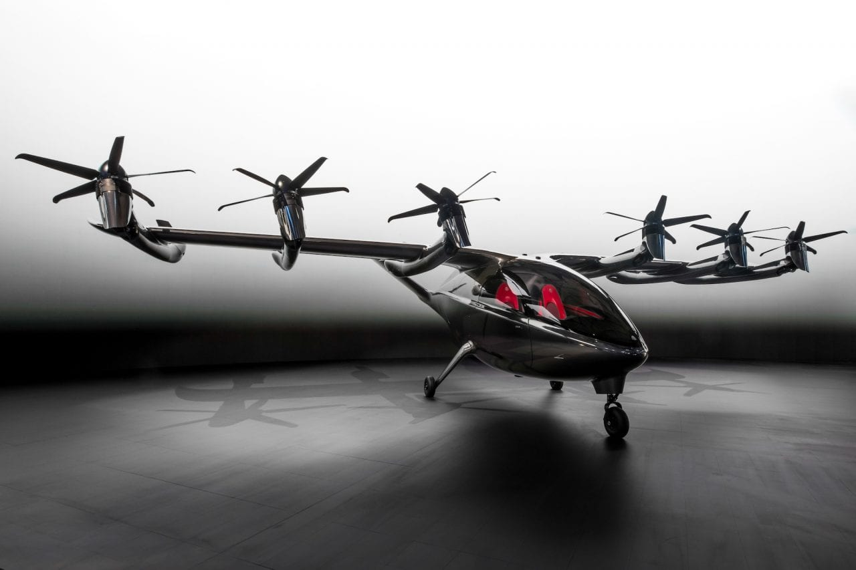
Wood, B., 'Archer Debuts First eVTOL Demonstrator "Maker",' Aviation Today, June 14, 2021. [Online]. Available: https://www.aviationtoday.com/2021/06/14/archer-debuts-first-evtol-demonstrator-maker/. [Accessed: 13-03-2024r]."

ii. Coaxial Propellers
Coaxial propellers, exemplified by the Jetson1 [38], offer increased thrust within a compact space, reducing the aircraft's footprint [15]. They provide superior control and maneuverability by independently adjusting the speed and pitch of each propeller [39]. However, they exhibit lower efficiency compared to separate propellers, consuming more power to generate the same thrust [32]. Coaxial counter-rotating propellers have advantages over co-rotating configurations, including zero net torque and reduced susceptibility to longitudinal gusts [40].
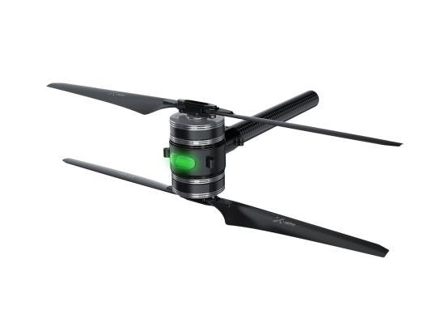
T-Motor, 'T-Motor X-601 Easy Installation Coaxial Motor Mounts Including Motor, ESC, Propeller for Vtol, Mapping Uav, Drone &OEM,' T-Motor, 2024. [Online]. Available: https://tmotor.en.made-in-china.com/product/VNCEYRZJZoci/China-T-Motor-X-601-Easy-Installation-Coaxial-Motor-Mounts-Including-Motor-ESC-Propeller-for-Vtol-Mapping-Uav-Drone-OEM.html. [Accessed: 13-03-2024].

iii. Ducted Propellers
Ducted propellers are experiencing a resurgence due to advancements in small yet powerful electric motors [41]. They provide significantly higher thrust per watt compared to open rotors, with potential thrust increases of up to 94% or power reductions of up to 62% [42]. This performance is attributed to the elimination of tip vortices and the Venturi effect created by the duct's annular lip [41]. Despite their benefits, ducted propellers add weight and aerodynamic challenges, particularly during vertical takeoff and forward movement [41]. Innovative designs, such as adapted ducted fans, mitigate these issues by adjusting duct geometry and employing tilting or gimbal mechanisms for improved performance in various conditions [43].
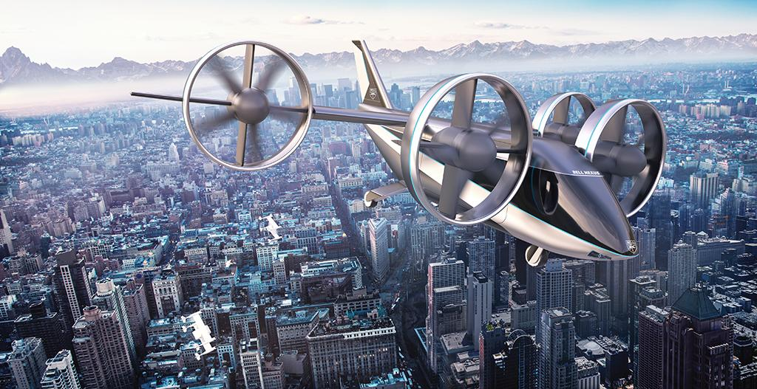
G. Warwick, "Bell eVTOL Goes All-Electric," Aviation Week Network, Jan. 06, 2020. [Online]. Available: https://aviationweek.com/aerospace/bell-evtol-goes-all-electric. [Accessed: 13-03-2024]

iv. Coaxial Ducted Fans
Coaxial ducted fans, found in upcoming eVTOLs like the Lauderhspider Mark IV [20] and the VRCO XB4 [45], offer a propulsion solution with augmented lift force production. These designs feature smaller duct sizes without annular wings, leveraging contra-rotating mechanisms to enhance efficiency while maintaining a compact form factor [46]. Proposed two-stage EDF configurations aim to further increase thrust by accelerating air between multiple fans, enabling narrower aircraft designs with improved performance [47].
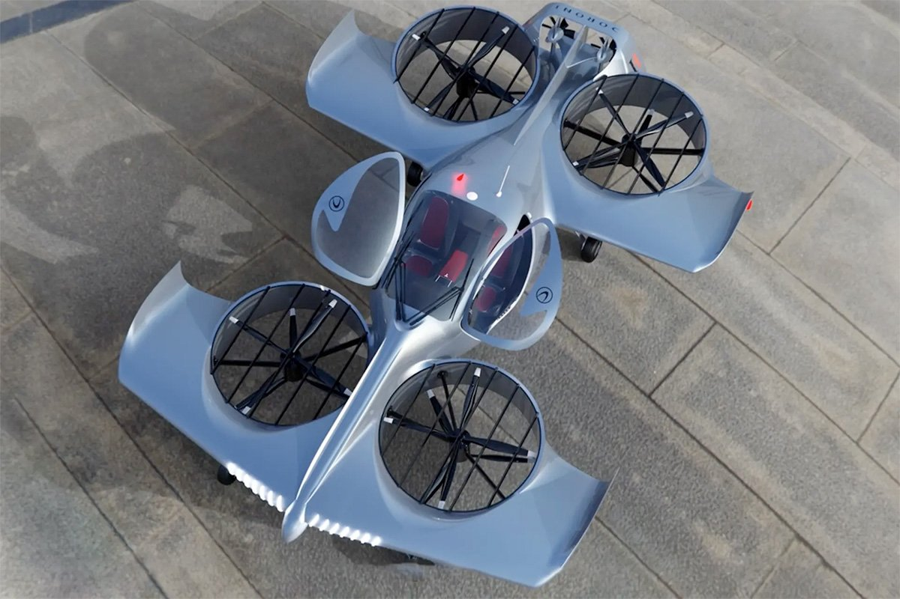
StartupSelfie, 'Doroni's first manned eVTOL flight,' Startup Selfie, Aug. 7, 2023. [Online]. Available: https://www.startupselfie.net/2023/08/07/doroni-first-manned-evtol-flight/. [Accessed: 13-03-2024].

5. eVTOL Challenges
Based on the eVTOL configurations and propulsion systems discussed, some key technological challenges that need to be addressed for eVTOL success in the market are:

Range and Efficiency
- Battery limitations: Current battery technology limits the range of all-electric eVTOLs. Extending range without significantly increasing weight remains a challenge [47][49].
- Hybrid powertrain optimization: Hybrid systems with gas turbines add complexity but can extend range. Optimizing these systems for both efficiency and emissions reduction is crucial [50].

Noise Reduction
- Minimizing noise from propellers and rotors: Multicopter designs can be noisy. Advancements in propeller design and noise reduction technologies are needed [51][52].
- Vectored thrust control noise: Managing noise generated by vectored thrust systems during transitions requires further development [50].

Safety and Reliability
- Redundancy in critical systems: eVTOLs need robust redundancy systems, especially for propulsion and flight controls, to ensure safety in case of malfunctions [45].
- Urban air traffic management (UTM): Developing a safe and efficient UTM system for eVTOLs operating in urban environments is critical [45].

Weight reduction
- Lightweight materials and efficient designs are essential for maximizing range and payload capacity [46].

Charging infrastructure
- Developing a network of charging stations specifically for eVTOLs, especially for rapid charging, is necessary [47].

Certification and regulations
- Establishing clear regulations and certification processes for eVTOL operation is crucial for commercial adoption [48].

Public perception
- Addressing public concerns regarding noise, safety, and visual impact of eVTOLs in urban areas is important for market acceptance [48].

Complexity of hybrid systems
- While offering potential benefits, hybrid propulsion systems can be more complex to design, manufacture, and maintain compared to all-electric configurations.

Control challenges
- Managing the transition between different flight modes (vertical lift vs. horizontal flight) can be complex for some configurations, especially vectored thrust.

6. Manufacturing Processes
The selection of composite materials for most of the eVTOL projects is evident and not surprising given the characteristics that enable the use of this. Among the most important of these is the outstanding strength-to-weight ratio that makes it possible to improve the performance of the aircraft by improving its range, autonomy, and power requirements, which translates into the ability to carry passengers or cargo in a more economical and cost-effective manner. However, the use of composite materials is not the most economical option compared to other traditional methods since it must be done with all the safety measures and have a constant and complex maintenance to the structure. However, with this option it is possible to simplify the supply chain by using a narrow range of materials, which are safe and can be certified, in addition, the scalability or production in large quantities of this type of structures is feasible. These types of materials also adapt in various ways to the production of the required part, whether by compression molding, pultrusion, injection, infusion, Sheet Metal Compound, etc.
An example of companies favoring this option is Archer, BETA and Joby. In general, this material option is often used in the manufacture of fuselages, tail booms and wings. Alternatives to this material are fiberglass and Kevlar reinforcements. In the eVTOLS materials market, composites can make up about 70% of the structure. Some of the references in the field of composite materials for UAM are Aria Group, Toray Advanced Composites, Hexcel and Autoscale CNC. In addition to these, they can already vary for cabin interiors depending on what is desired as well as specific components such as engines, batteries, and other parts other than the aircraft structure.
The use of composite materials brings with it the acquisition of good techniques and practices, e.g.:
- Material selection and handling: Since they are composite materials, the combination between the matrix and the reinforcement must be done carefully to obtain the necessary strength and stiffness. In addition to the correct use of resin and fiber orientation.
- Manufacturing techniques: Given the variety of processes, knowing the options and advantages and disadvantages of each one is of vital importance for the manufacture of parts or pieces.
- Quality control should also be a strength in these processes, since bad practices or defective parts can lead to component failure and unexpected behavior against the estimated loads.
- Safety and health: These materials can generate harmful health effects during their manufacture. For this reason, the use of equipment is necessary as well as the correct supervision of regulatory compliance. Taking these factors into account, it is possible to achieve the advantages of composite materials without the possible failures at the time of manufacturing, which reduces time and costs for the production chain.

7. Conclusion
In conclusion, the eVTOL industry stands a huge opportunity for growth, defined by technological innovation, strategic partnerships, and evolving regulatory landscapes. This market study reveals a sector ripe with potential, driven by a collective ambition to revolutionize urban and regional mobility. The convergence of advancements in battery technology, propulsion systems, and material science promises to overcome current limitations, enhancing range, efficiency, and safety. The industry's trajectory towards higher autonomy and electric propulsion aligns with a global impetus towards sustainability, marking eVTOLs as a cornerstone in the future of eco-friendly transportation.
The manufacturing of aircraft and related infrastructure has drawn the attention of leading technology companies worldwide, driven by the sector's substantial market size. Consequently, major players in transportation and infrastructure are channeling significant investments into this area. The technology underpinning these advancements demands extensive development, along with a substantial investment of time and financial resources. Only a select number of companies possess the capability to supply the essential parts, services, and components required for eVTOL production. As such, aircraft manufacturers must build comprehensive in-house capabilities, covering areas like automatic control systems, electric power systems, propulsion systems, simulation, aerodynamics, advanced materials, and manufacturing techniques.
To extend the network and connect more cities beyond 200 km, a vehicle must accommodate four occupants (one pilot and three passengers) and provide minimal cargo space, equipped with hybrid energy and propulsion systems. Furthermore, readily available automatic control and electric systems could improve a company's competitive edge in the market. Nonetheless, maintaining favorable public relations and minimizing CO2 emissions are crucial. Employing methods or solutions to offset the carbon footprint becomes essential. Therefore, a lift-plus-cruise (L+C) configuration with aerodynamics optimized for cruising presents a promising approach.

References
- Advanced Air Mobility Market Update - Vertical Flight Society," Asian Sky Group, 27-Feb-2024. [Online]. Available: https://www.asianskygroup.com/advanced-air-mobility-market-update-vertical-flight-society-123/.
- The Next Normal – The future of air mobility: Electric aircraft and flying taxis," McKinsey & Company. [Online]. Available: https://www.mckinsey.com/featured-insights/the-next-normal/air-taxis.
- Hazards Analysis and Failure Modes and Effects Criticality Analysis (FMECA) of Four Concept Vehicle Propulsion Systems," NASA Technical Reports Server (NTRS), [Online]. Available: https://ntrs.nasa.gov/citations/20190026443.
- eVTOL Market Size and Share | Forecast - 2030," Acumen Research and Consulting, [Online]. Available: https://www.acumenresearchandconsulting.com/press-releases/evtol-market.
- CityAirbus NextGen - Urban Air Mobility," Airbus, [Online]. Available: https://www.airbus.com/en/innovation/low-carbon-aviation/urban-air-mobility/cityairbus-nextgen.
- Joby Aviation Completes Three of Five Stages of FAA Type Certification," East Bay Times, February 28, 2024. [Online]. Available: https://www.eastbaytimes.com/.
- G. Suart, "Pivotal Delivers Four BlackFly Light eVTOLs for U.S. Air Force Evaluation," Urban Air Mobility News, February 26, 2024. Available online: https://www.urbanairmobilitynews.com/air-taxis/pivotal-delivers-four-blackfly-light-evtols-for-u-s-air-force-evaluation/.
- Leishman, J.G. (2006). Principles of Helicopter Aerodynamics. Cambridge University Press.
- Kasliwal, A., Furbush, N. J., McCormick, J. W., Alexander, D. E., Rajeev, N., Sheth, P. K., ... & Schmitz, F. H. (2020). Hover performance analysis of a multirotor UAS. Journal of the American Helicopter Society, 65(4), 1-10.
- EHang. "Autonomous Aerial Vehicle (AAV) Innovator for Urban Air Mobility (UAM)." Accessed March 15, 2024. https://www.ehang.com/.
- VoloCity – The Urban Air Taxi." Accessed March 15, 2024. https://www.volocopter.com/solutions/volocity/.
- Joby Aviation: Hold On, eVTOL Launch Will Be Entry Point Sign." Seeking Alpha, January 28, 2023. Accessed March 15, 2024. https://seekingalpha.com/article/4573228-joby-aviation-hold-evtol-launch-entry-point-sign.
- Gur, O., & Rosen, A. (2009). Optimizing electric propulsion systems for unmanned aerial vehicles. Journal of Aircraft, 46(4), 1340-1353.
- Seddon, J., & Newman, S. (2011). Basic Helicopter Aerodynamics. Wiley.
- McCormick, B.W. (1995). Aerodynamics, Aeronautics, and Flight Mechanics. Wiley.
- Blasi, L., D'Amato, E., Mattei, M., & Notaro, I. (2023). Effects of urban air mobility noise on annoyance and well-being. Applied Acoustics, 201, 109630.
- Donateo, T., Lucia, W., Di Piazza, A., & Ficarella, A. (2023). Sizing and performance assessment of serial hybrid-electric propulsion systems for eVTOL applications. Aerospace Science and Technology, 132, 108007.
- Donateo, T., & Ficarella, A. (2022). Key Technology Developments for Electric and Hybrid-Electric Vertical Take-Off and Landing Aircraft with Distributed Electric Propulsion. Frontiers in Aerospace Engineering, 1-17.
- Seddon, J., & Newman, S. (2011). Basic Helicopter Aerodynamics. Wiley.
- Leishman, J.G. (2006). Principles of Helicopter Aerodynamics. Cambridge University Press.
- Joby Aviation Website. (n.d.). Joby S4. https://www.jobyaviation.com/
- Archer Aviation Website. (n.d.). Midnight. https://www.archer.com/en-us/usher
- Lilium. "Lilium Jet - The First Electric VTOL (eVTOL) Jet." Accessed March 15, 2024. https://lilium.com/jet.
- Vertical Aerospace Website. (n.d.). VX4. https://www.vertical-aerospace.com/
- BETA Technologies. "Home." Accessed March 15, 2024. https://www.beta.team/.
- B. Holden and I. Goel, “Fast-Forwarding to a Future of On-Demand Urban Air Transportation,” Deloitte, 2018.
- Airbus Press Release. "Airbus uses tablet to fly fully automated helicopter." Vertical Mag, November 27, 2023. Accessed March 15, 2024. https://verticalmag.com/press-releases/airbus-flies-a-fully-automated-helicopter-with-a-tablet/
- Joby Aviation Completes Three of Five Stages of FAA Type Certification." East Bay Times. Available at: https://www.eastbaytimes.com
- Jetson Aero Website. (n.d.). Jetson ONE. https://jetsonaero.com/
- Kasliwal, A., Furbush, N. J., McCormick, J. W., Alexander, D. E., Rajeev, N., Sheth, P. K., ... & Schmitz, F. H. (2020). Hover performance analysis of a multirotor UAS. Journal of the American Helicopter Society, 65(4), 1-10.
- Brand, A. G., & Selig, M. S. (2015). Thrust study of shrouded, contrarotating propellers for small multicopter unmanned aerial vehicles. UIUC Faculty Publications.
- McCormick, B.W. (1995). Aerodynamics, Aeronautics, and Flight Mechanics. Wiley.
- Pereira, J. (2008). Hover and Wind-Tunnel Testing of Shrouded Rotors for Improved Micro Air Vehicle Design. Doctoral dissertation, University of Maryland.
- YouTube. (2023). Most Advanced eVTOL Propulsion System: Adaptive Ducted Fan: https://m.youtube.com/watch?v=orLjrswcpxI
- Lauderhspider Website. (n.d.). Lauderhspider Mark IV. [invalid URL removed]: [invalid URL removed]
- VRCO Website. (n.d.) The NeoXcraft XP2. [invalid URL removed]
- Rajashekara, K., Wang, J., & Han, Y. (2023). Aerodynamic interaction in novel coaxial helicopter design. AIAA Journal, 61(2), 752-761.
- Yang, Y., Li, Y., Liu, C., & Wang, X. (2020). Aerodynamic design of multi-propeller configurations for hybrid-electric multicopters. Advances in Mechanical Engineering, 12(3), 1687814020904909.
- B. Kuhn, “eVTOL batteries: Today’s performance anda look ahead,” Flying Magazine,2023. [Online]. Available: https://www.gf-planen.de/?a=cracking-the-code-for-evtol-batteries-flying-magazine-ee-wOwE34Ta
- L. Blain, “Beyond lithium-ion: What’s on the horizon for eVTOL batteries?” New Atlas, 2022. [Online]. Available: https://ntrs.nasa.gov/citations/20230002574
- T. Donateo and A. Ficarella, "Key Technology Developments for Electric and Hybrid-Electric Vertical Take-Off and Landing Aircraft with Distributed Electric Propulsion," Frontiers in Aerospace Engineering, pp. 1-17, 2022.
- J. Seddon, and S. Newman, Basic Helicopter Aerodynamics. Wiley, 2011.
- J. Stephenson, Y. Meng, J. Hurdle and V. R. Anand, "A Review of Drone Noise Control Methods," Progress in Aerospace Sciences, vol. 142, no. 101050, 2023.
- J. Pereira, “Hover and Wind-Tunnel Testing of Shrouded Rotors for Improved Micro Air Vehicle Design,” Doctoral dissertation, University of Maryland, 2008.
- P. Rajendran and H. Smith, "Evaluating Redundancy Architectures and Failure Conditions for Urban Air Mobility," AIAA SciTech Forum, 2020. [Online]. Available: https://arc.aiaa.org/doi/abs/10.2514/6.2020-2213
- P. Kopardekar, J. Rios, T. Prevot, M. Johnson, J. Jung and J. E. Robinson, "Unmanned Aircraft System Traffic Management (UTM): Enabling Low-Altitude Airspace and UAS Operations," NASA Technical Reports Server, 2016. [Online]. Available: https://ntrs.nasa.gov/)
- A. Bandivadekar, K. Bodek, L. Cheah, C. Evans, T. Groode, J. Heywood, ... T. Tsao, (2017). On the road toward 2050: A potential role for electric vehicles in mitigating climate change. The Global Change Institute. [Online]. Available: https://theicct.org/publication/global-climate-change-mitigation-potential-from-a-transition-to-electric-vehicles/
- L. Blain, “Skyports and Volocopter unveil plans for the world’s first vertiport charging network,” New Atlas, 2021. [Online]. Available: https://www.volocopter.com/newsroom/volocopter-completes-production-setup/
- Federal Aviation Administration (FAA), “Advanced Air Mobility (AAM),” [Online]. Available: https://www.faa.gov/
- L. Blasi, E. D'Amato, M. Mattei and I. Notaro, "Effects of Urban Air Mobility Noise on Annoyance and Well-Being," Applied Acoustics, vol. 201, no. 109630, 2023.
- K. Korosec, "Kittyhawk, the electric aircraft moonshot backed by Larry Page, is shutting down," TechCrunch, 21-Sep-2022. [Online]. Available: https://techcrunch.com/2022/09/21/kitty-hawk-the-electric-aircraft-moonshot-backed-by-larry-page-is-shutting-down/.
- Honda eVTOL vol.2," Honda Global, [Online]. Available: https://global.honda/en/tech/eVTOL_gas_turbine_hybrid_system/.

Collaborators:
Juan Felipe Correa (Aeronautical Engineer)
Samuel López (Aerospace Engineer)
Angélica Turizo (Aerospace Engineer)
Juan José Mejía (Aerospace Engineer)
Mateo Lezama (Aerospace Engineer)

