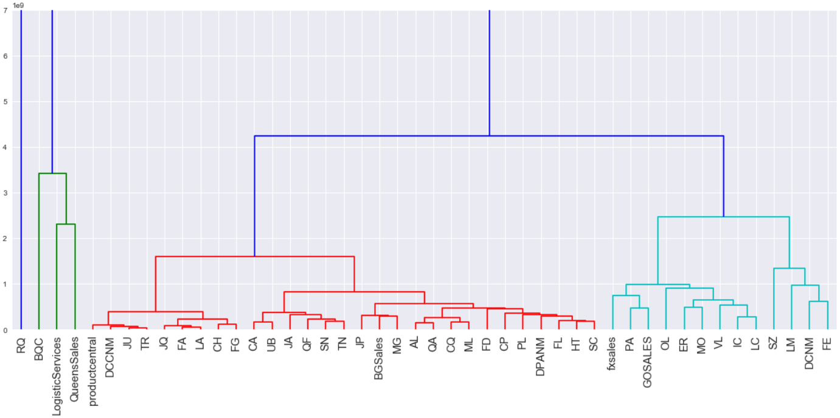

|  |  |
| --- | --- |
| Inicio: | 2020-03-12 |
| Fin | 2020-03-19 |
| Métrica | Salida de red en MB (Acumulado) |
| Ventana de Muestreo: | 5 minutos |

|  |  |
| --- | --- |
| Empresa | FE |
| Estado | **USUAL** |

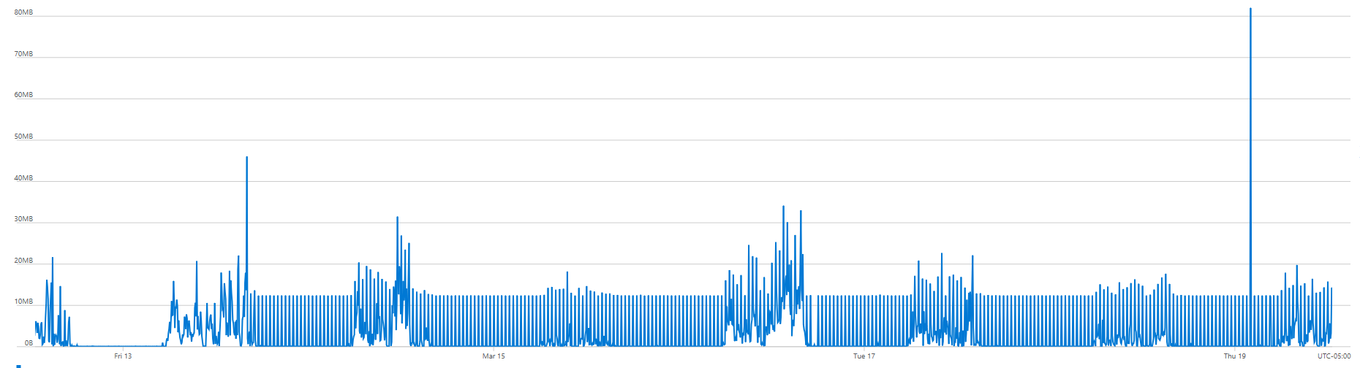

|  |  |
| --- | --- |
| Empresa | QueensSales |
| Estado | **USUAL** |

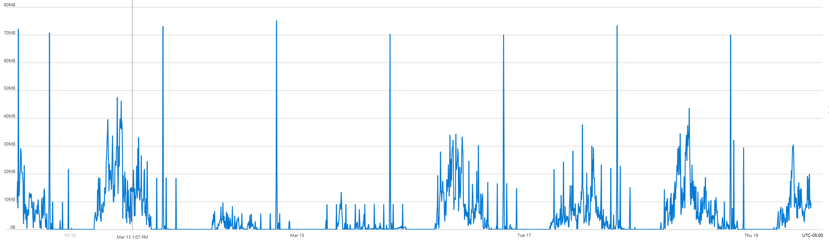

|  |  |
| --- | --- |
| Empresa | JQ |
| Estado | **DISMINUIDO** |

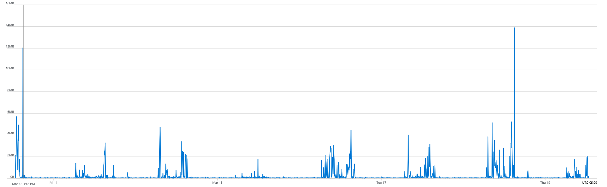

|  |  |
| --- | --- |
| Empresa | QF |
| Estado | **USUAL** |

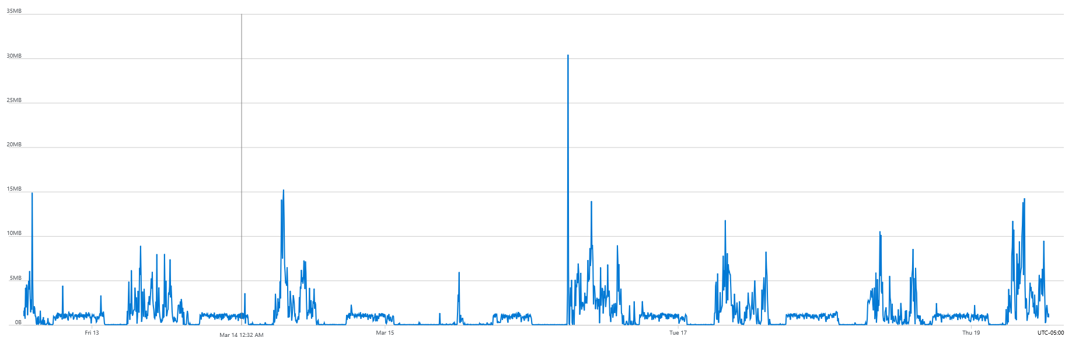

|  |  |
| --- | --- |
| Empresa | CQ |
| Estado | **USUAL** |

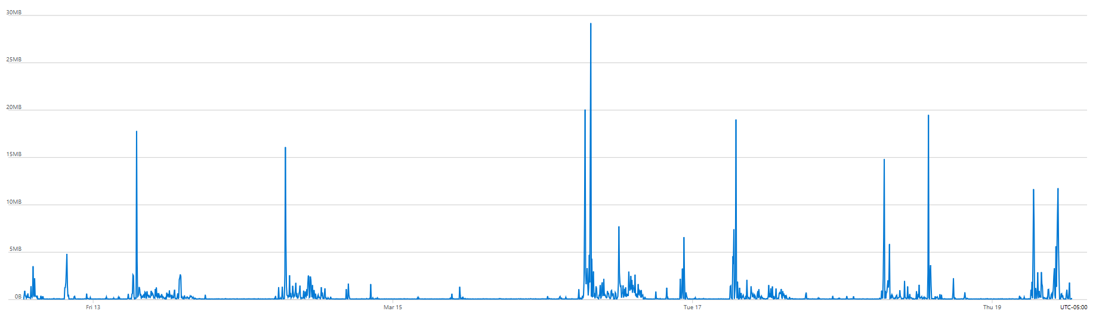

|  |  |
| --- | --- |
| Empresa | GOSALES |
| Estado | **USUAL** |

