Multi-Structure Interaction Diagram Report
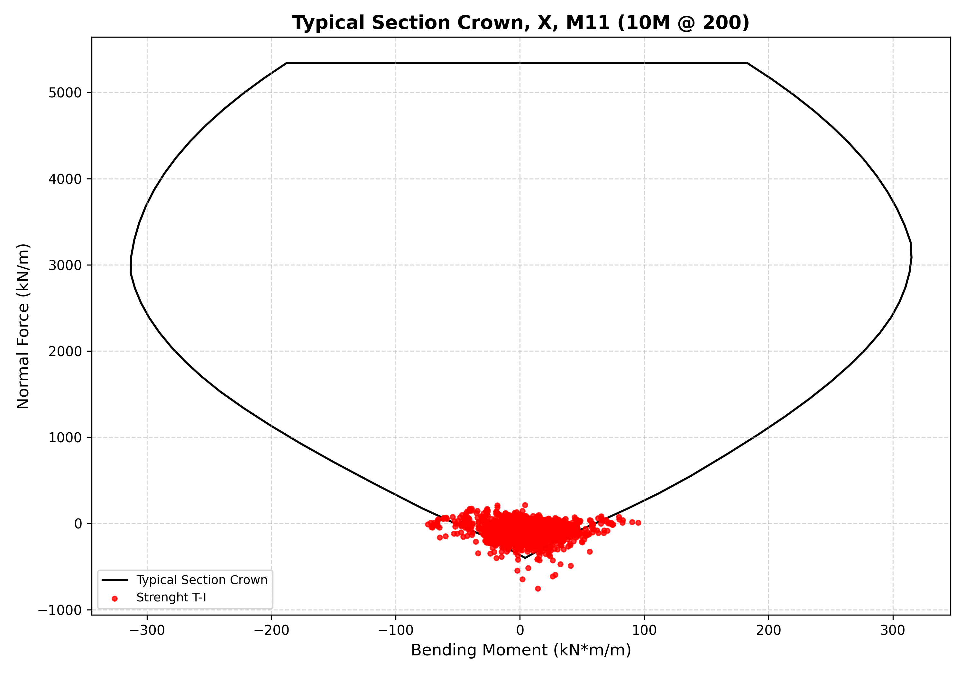
Figure 1: N-M diagram for Typical Section Crown X M11 10M 200

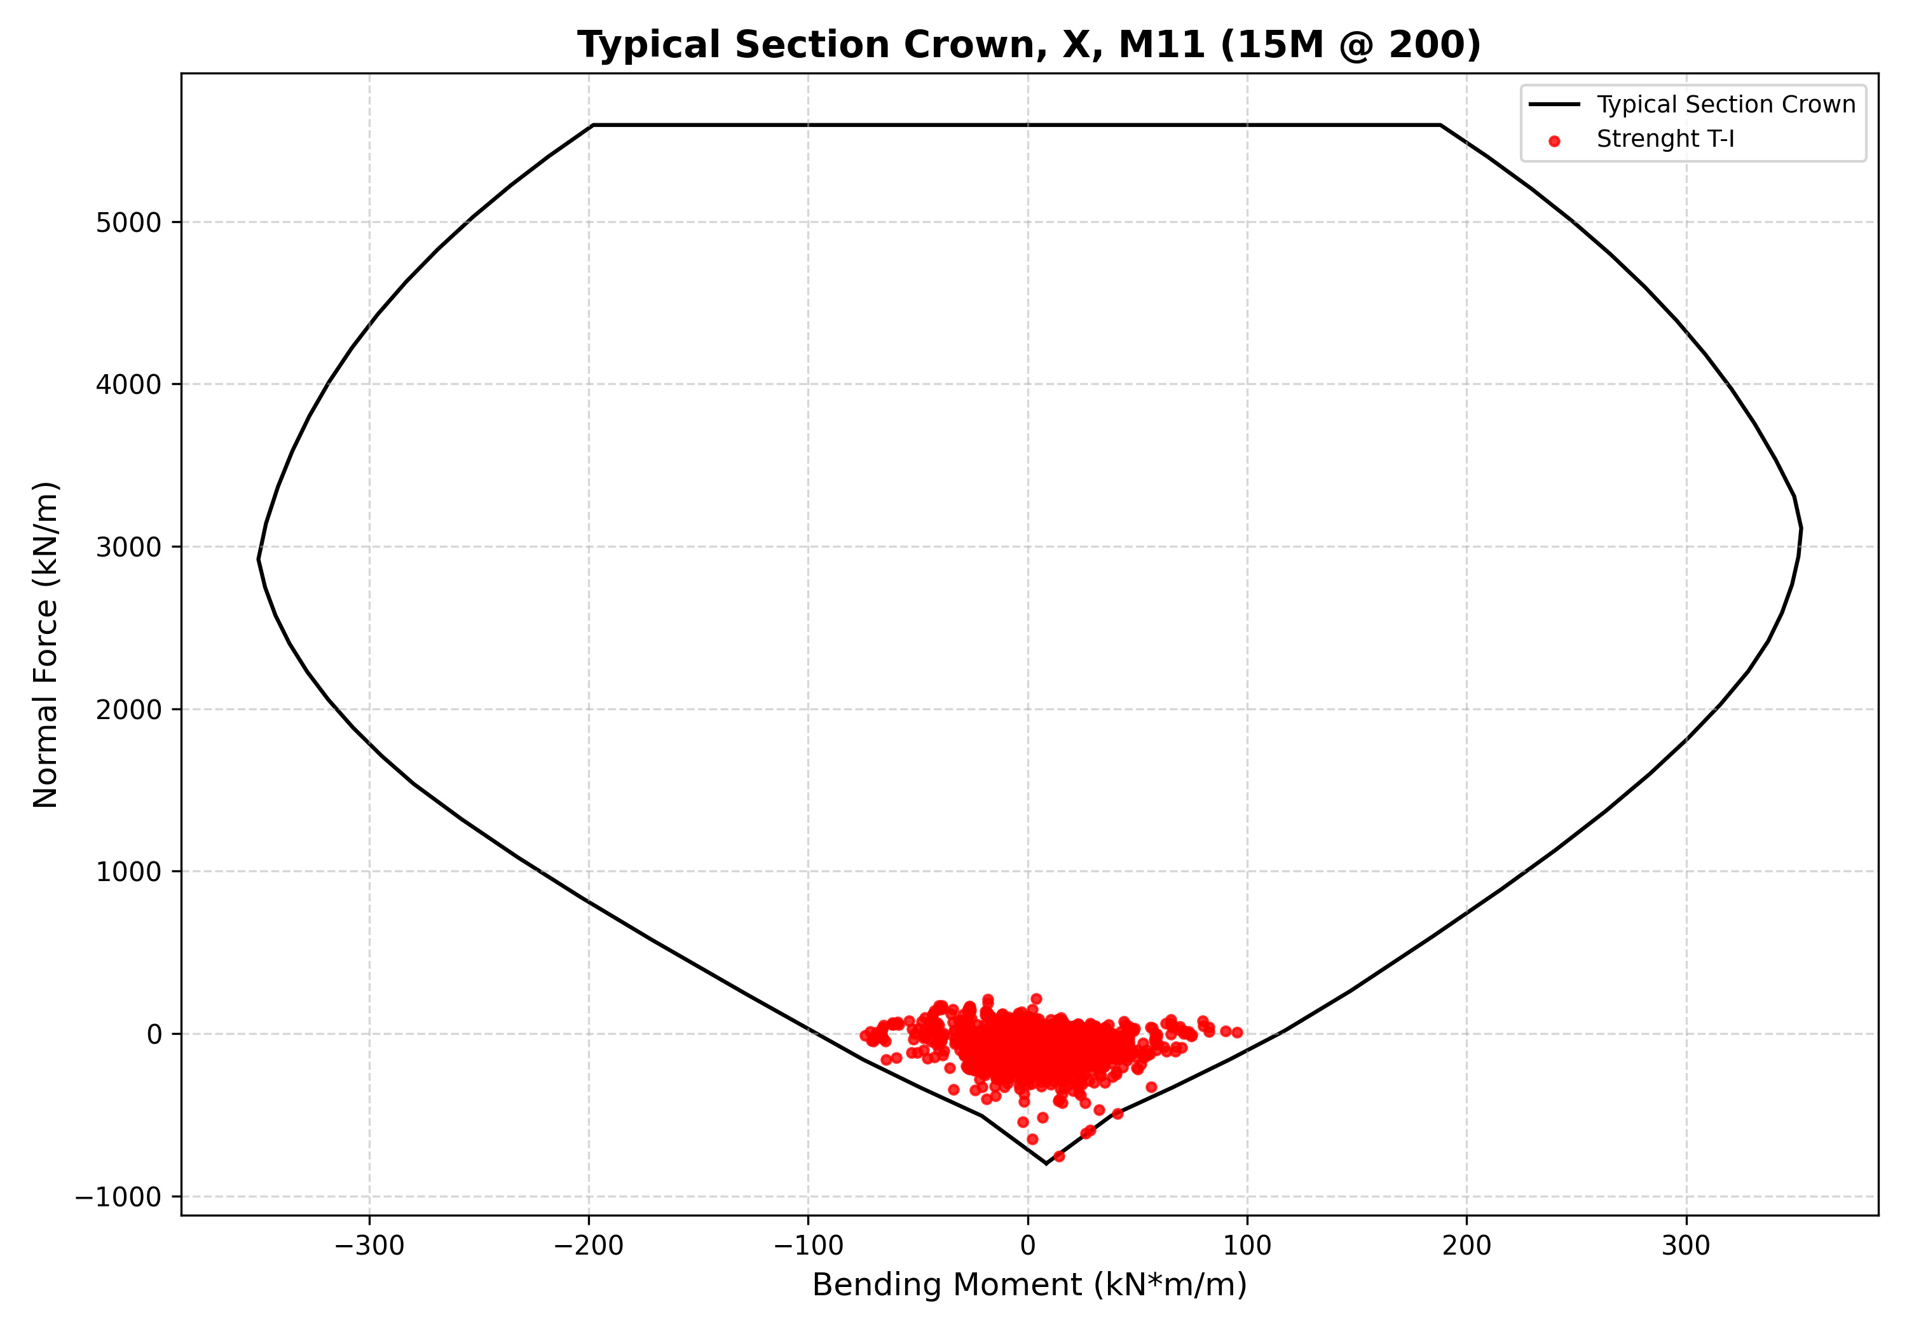
Figure 2: N-M diagram for Typical Section Crown X M11 15M 200

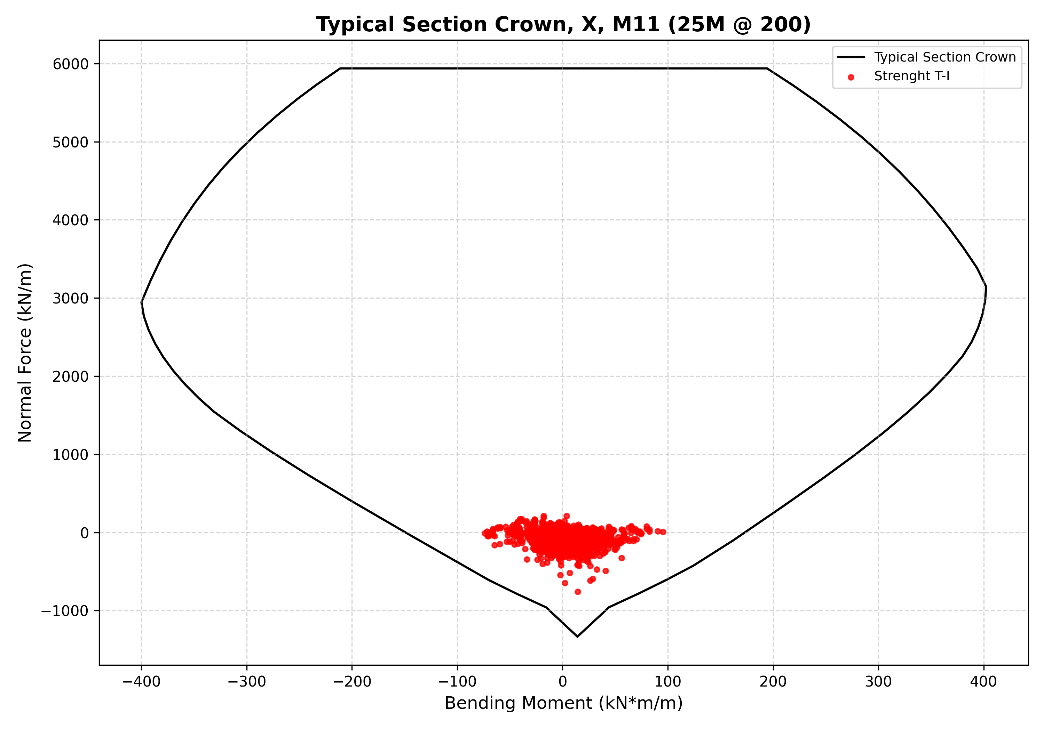
Figure 3: N-M diagram for Typical Section Crown X M11 25M 200

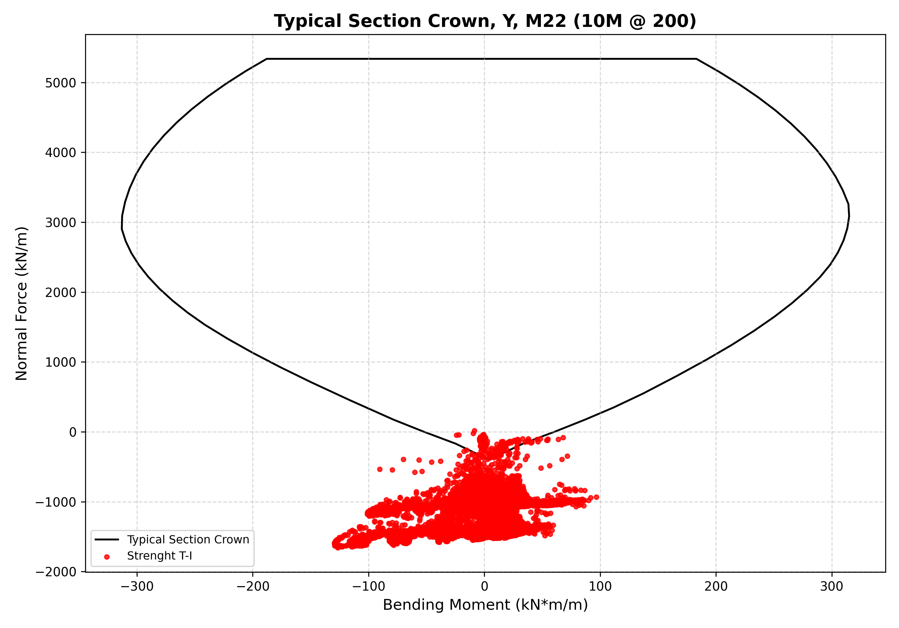
Figure 4: N-M diagram for Typical Section Crown Y M22 10M 200

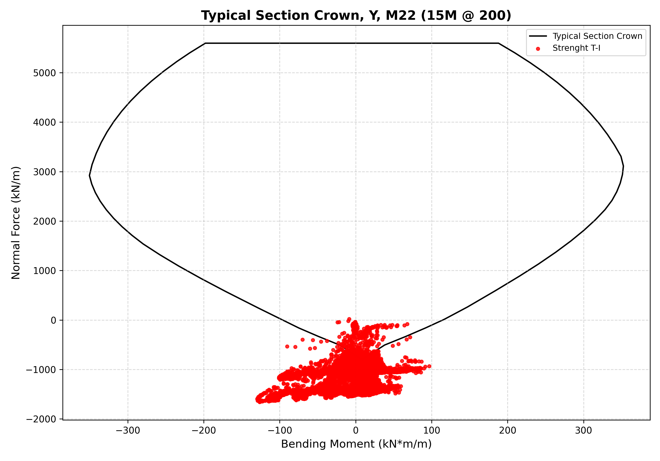
Figure 5: N-M diagram for Typical Section Crown Y M22 15M 200

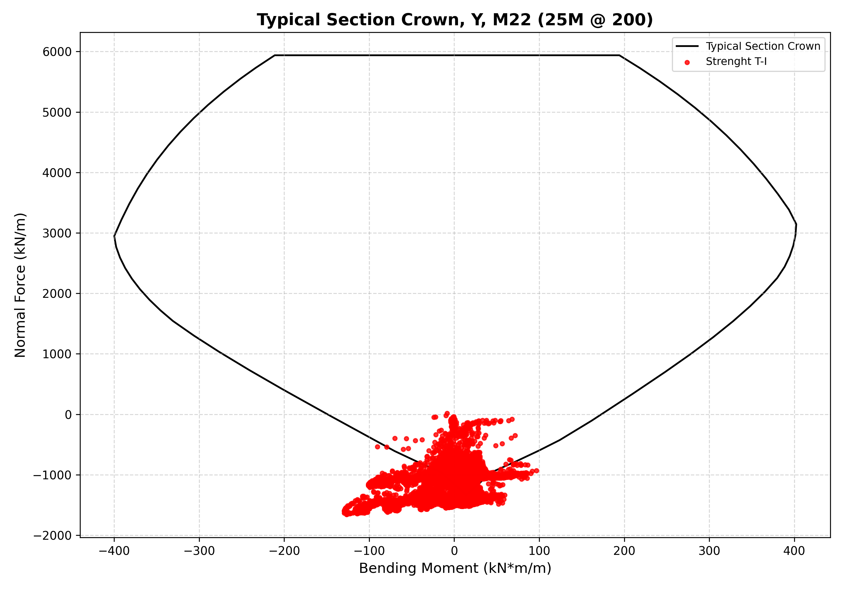
Figure 6: N-M diagram for Typical Section Crown Y M22 25M 200

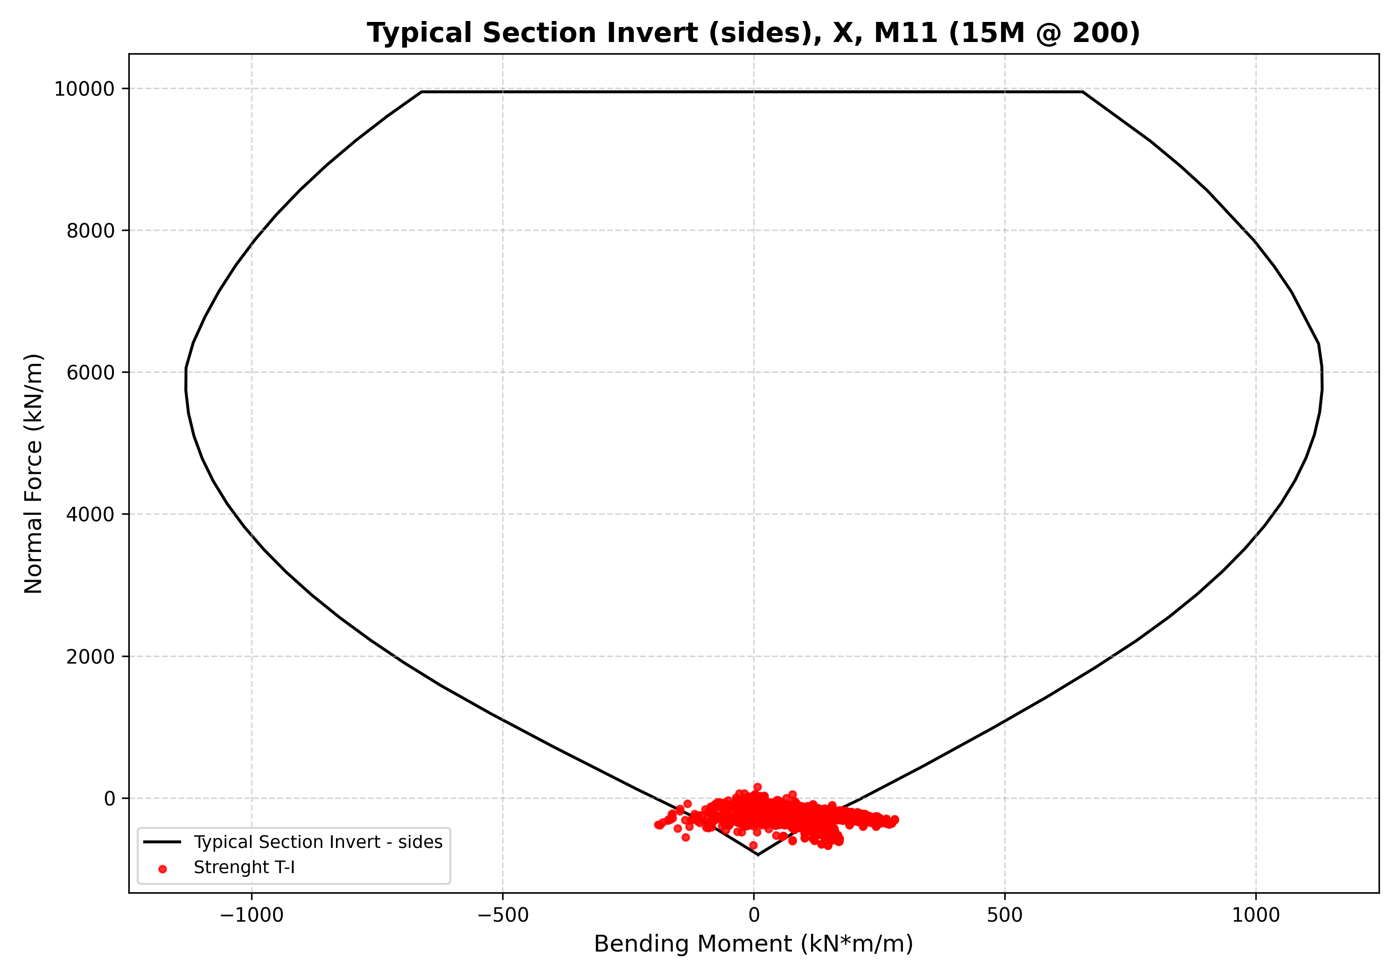
Figure 7: N-M diagram for Typical Section Invert sides X M11 15M 200

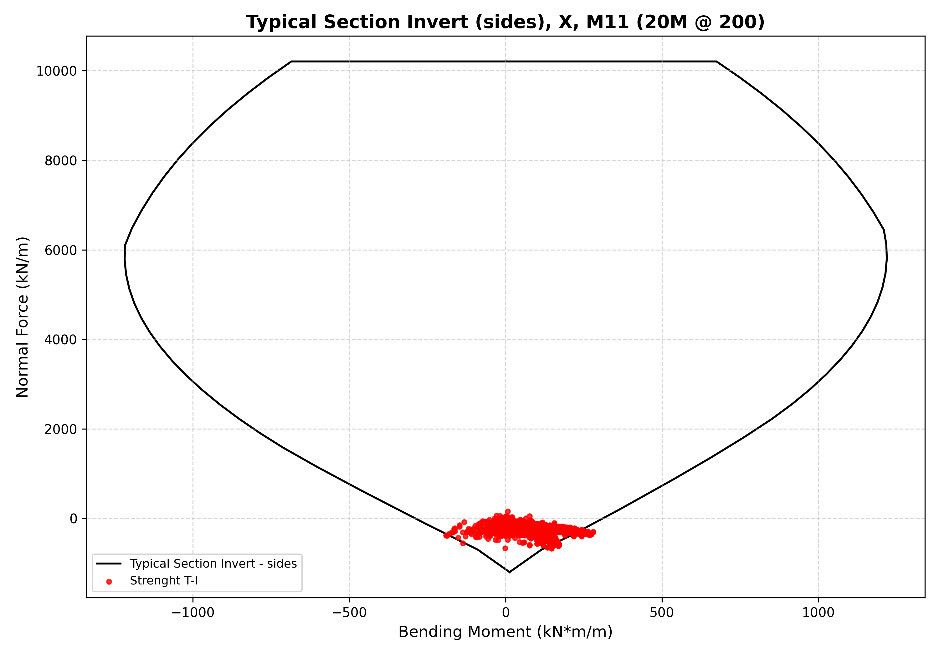
Figure 8: N-M diagram for Typical Section Invert sides X M11 20M 200

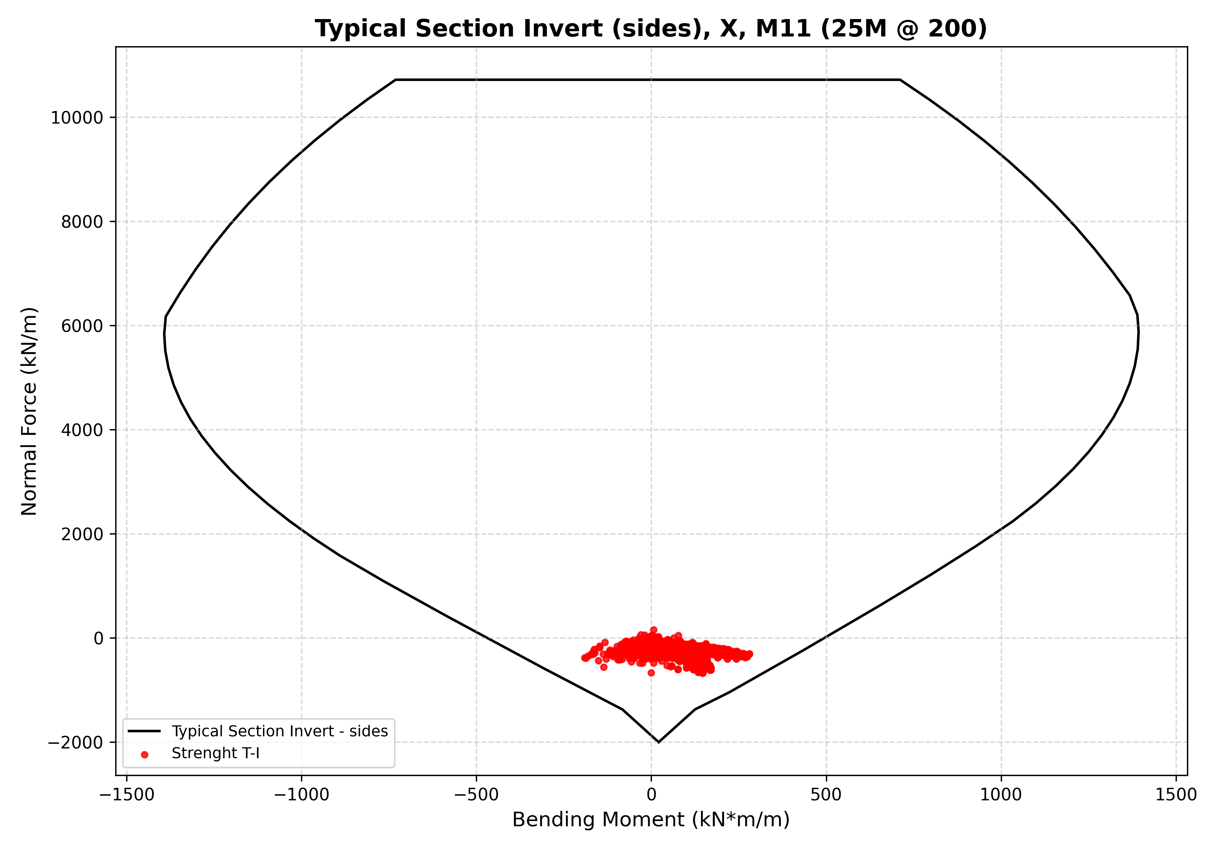
Figure 9: N-M diagram for Typical Section Invert sides X M11 25M 200

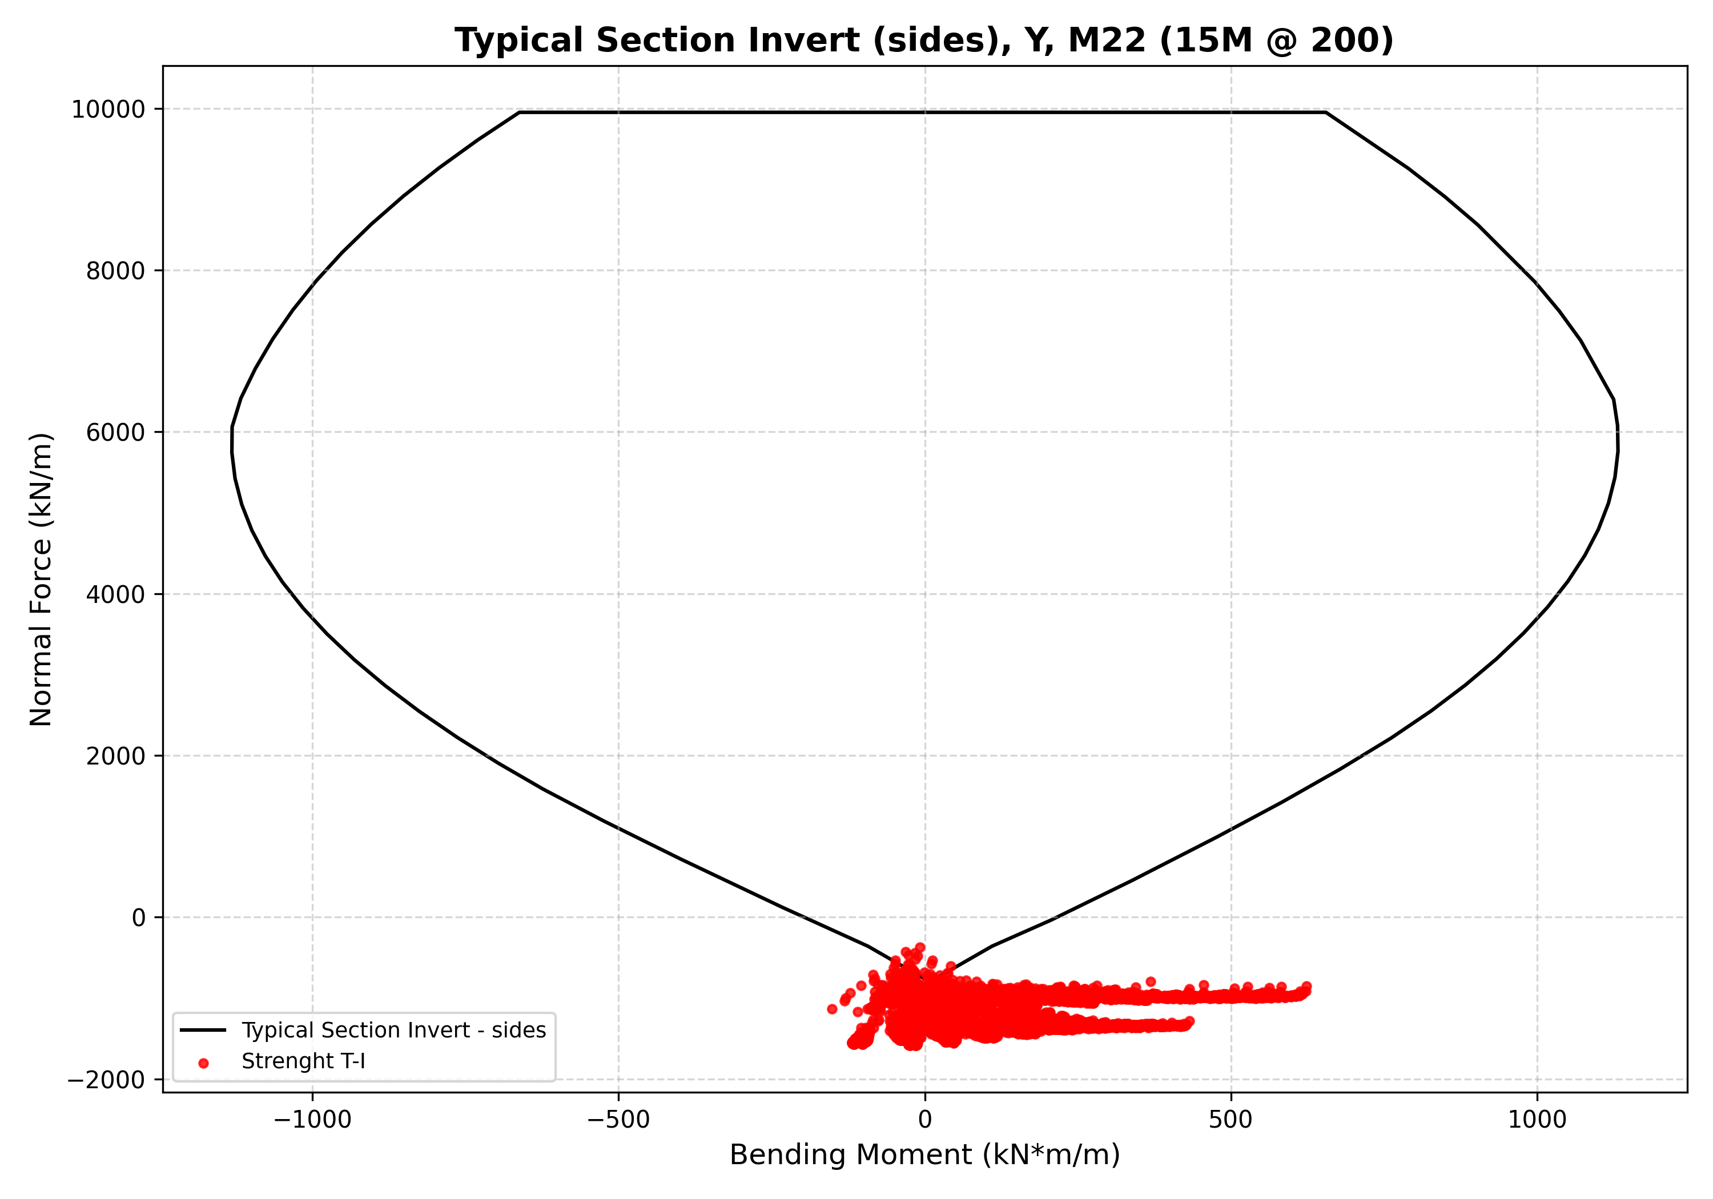
Figure 10: N-M diagram for Typical Section Invert sides Y M22 15M 200

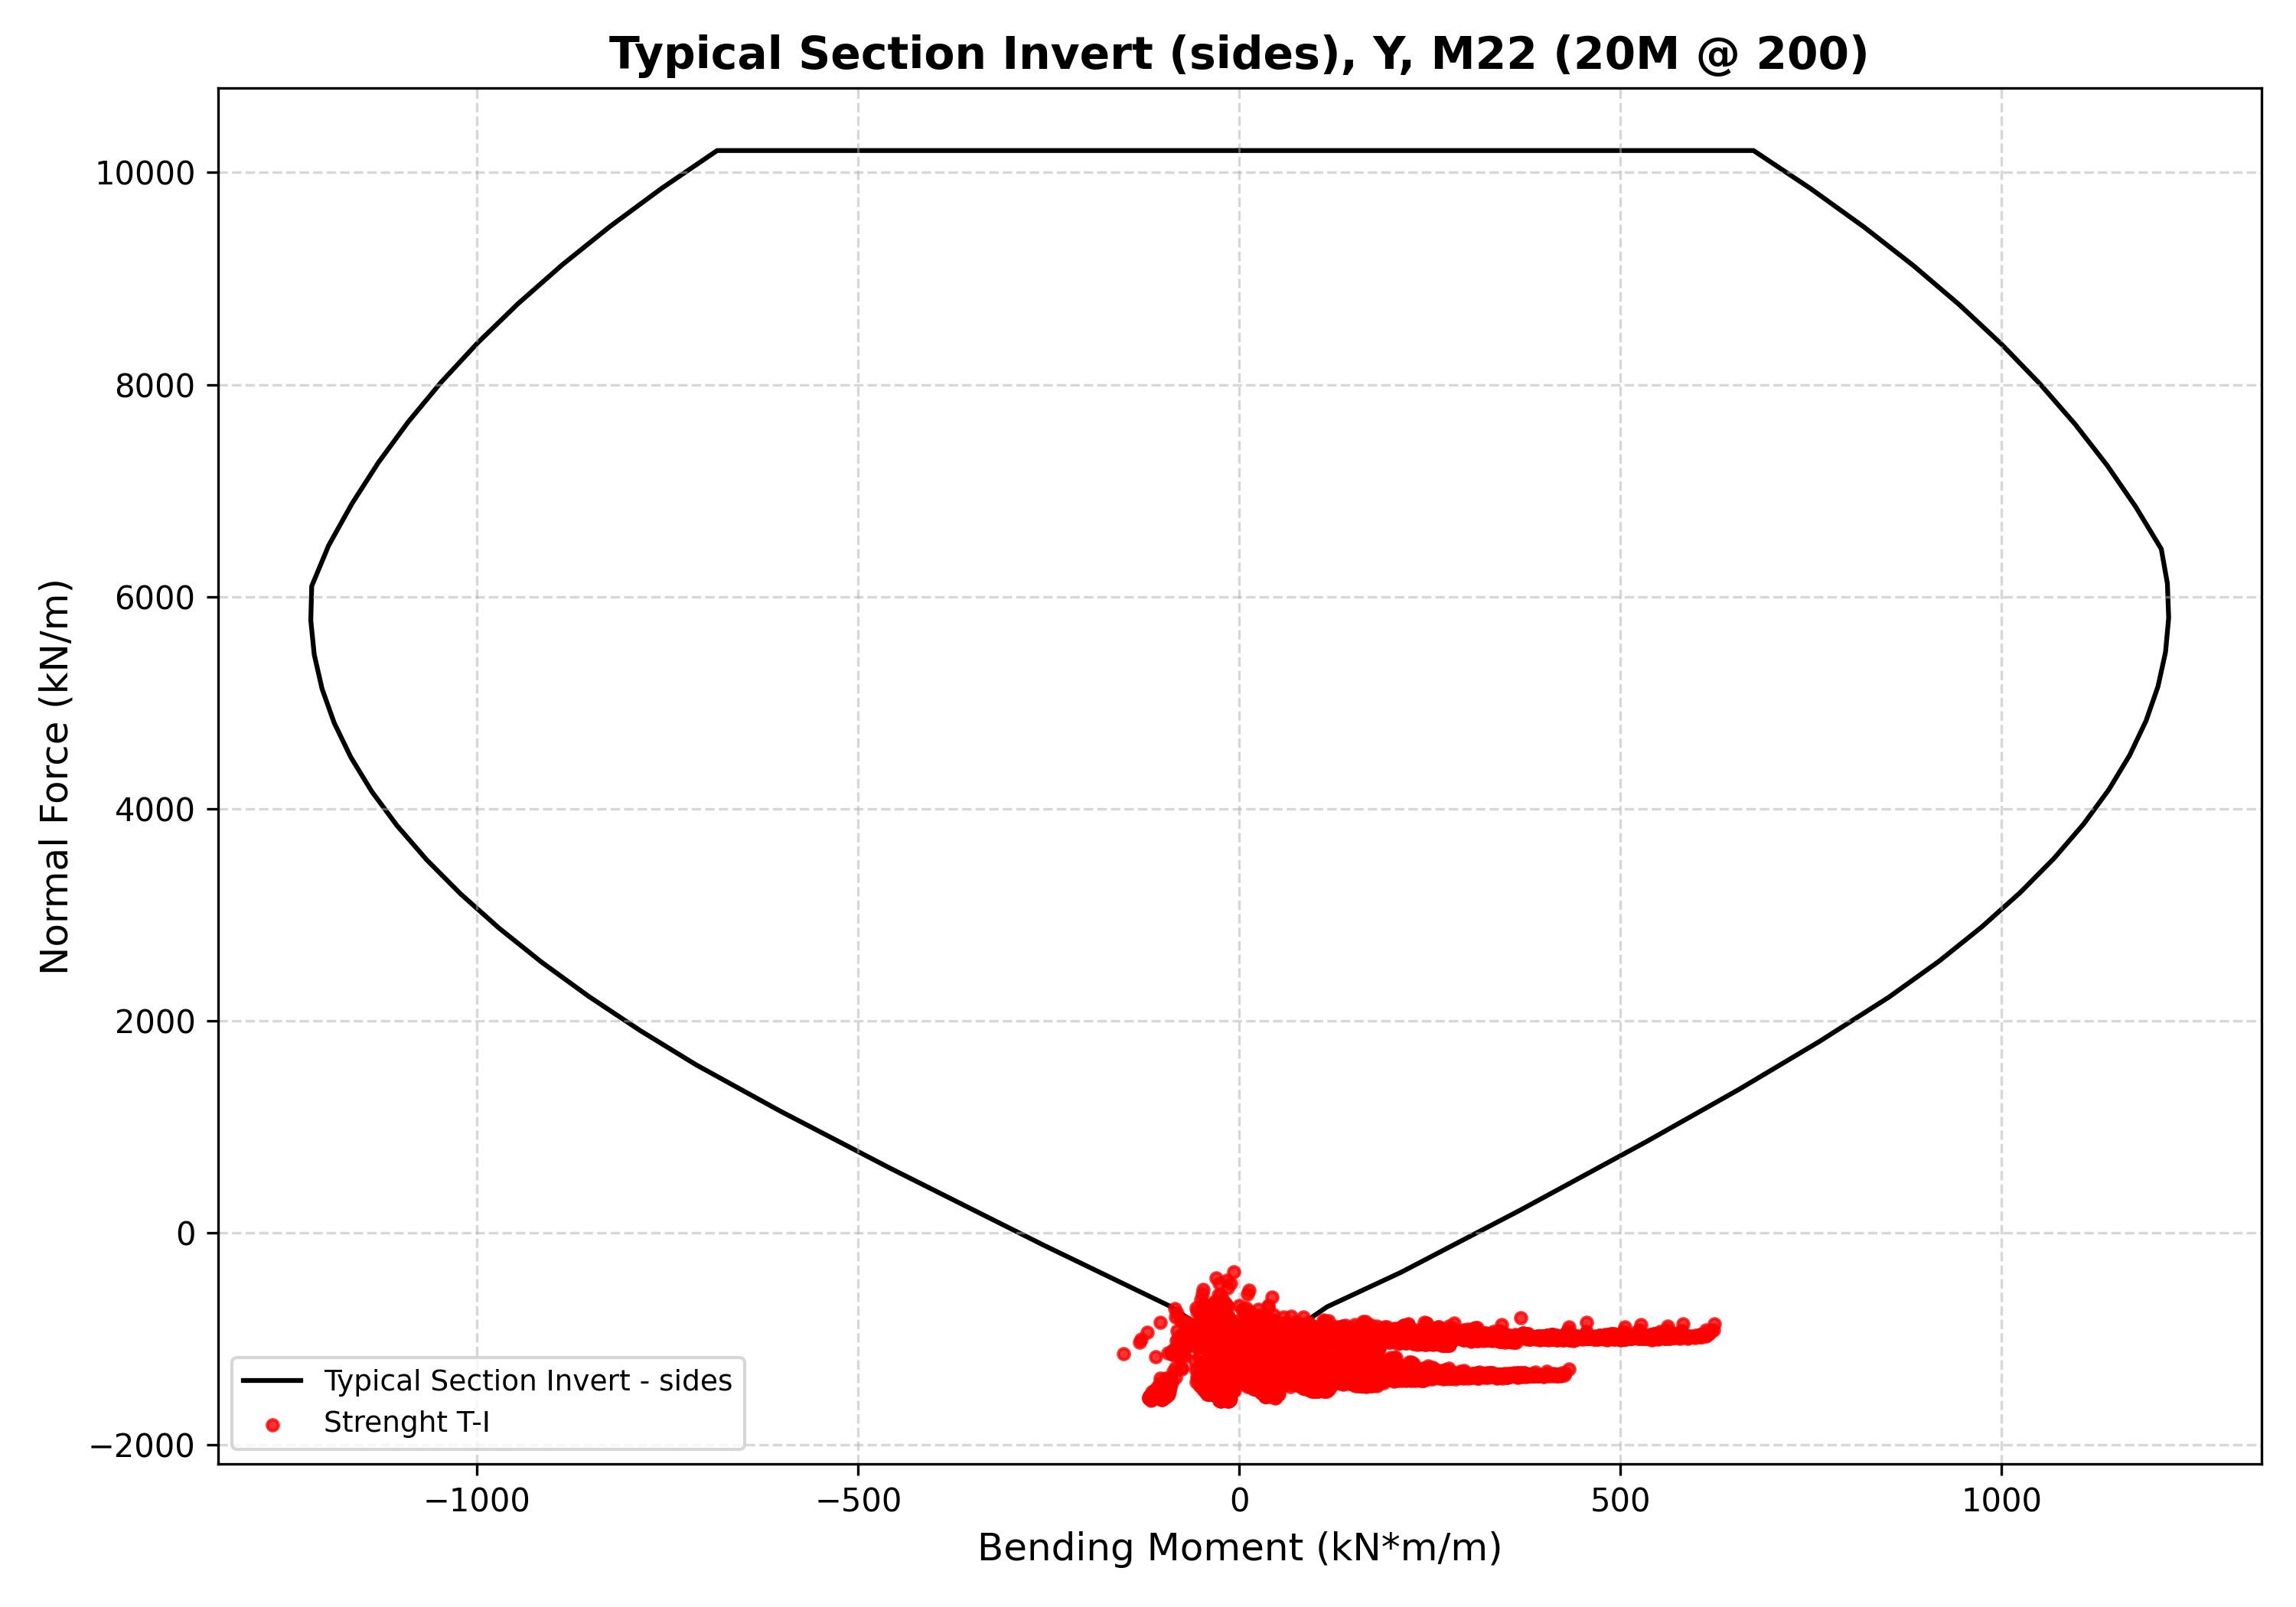
Figure 11: N-M diagram for Typical Section Invert sides Y M22 20M 200

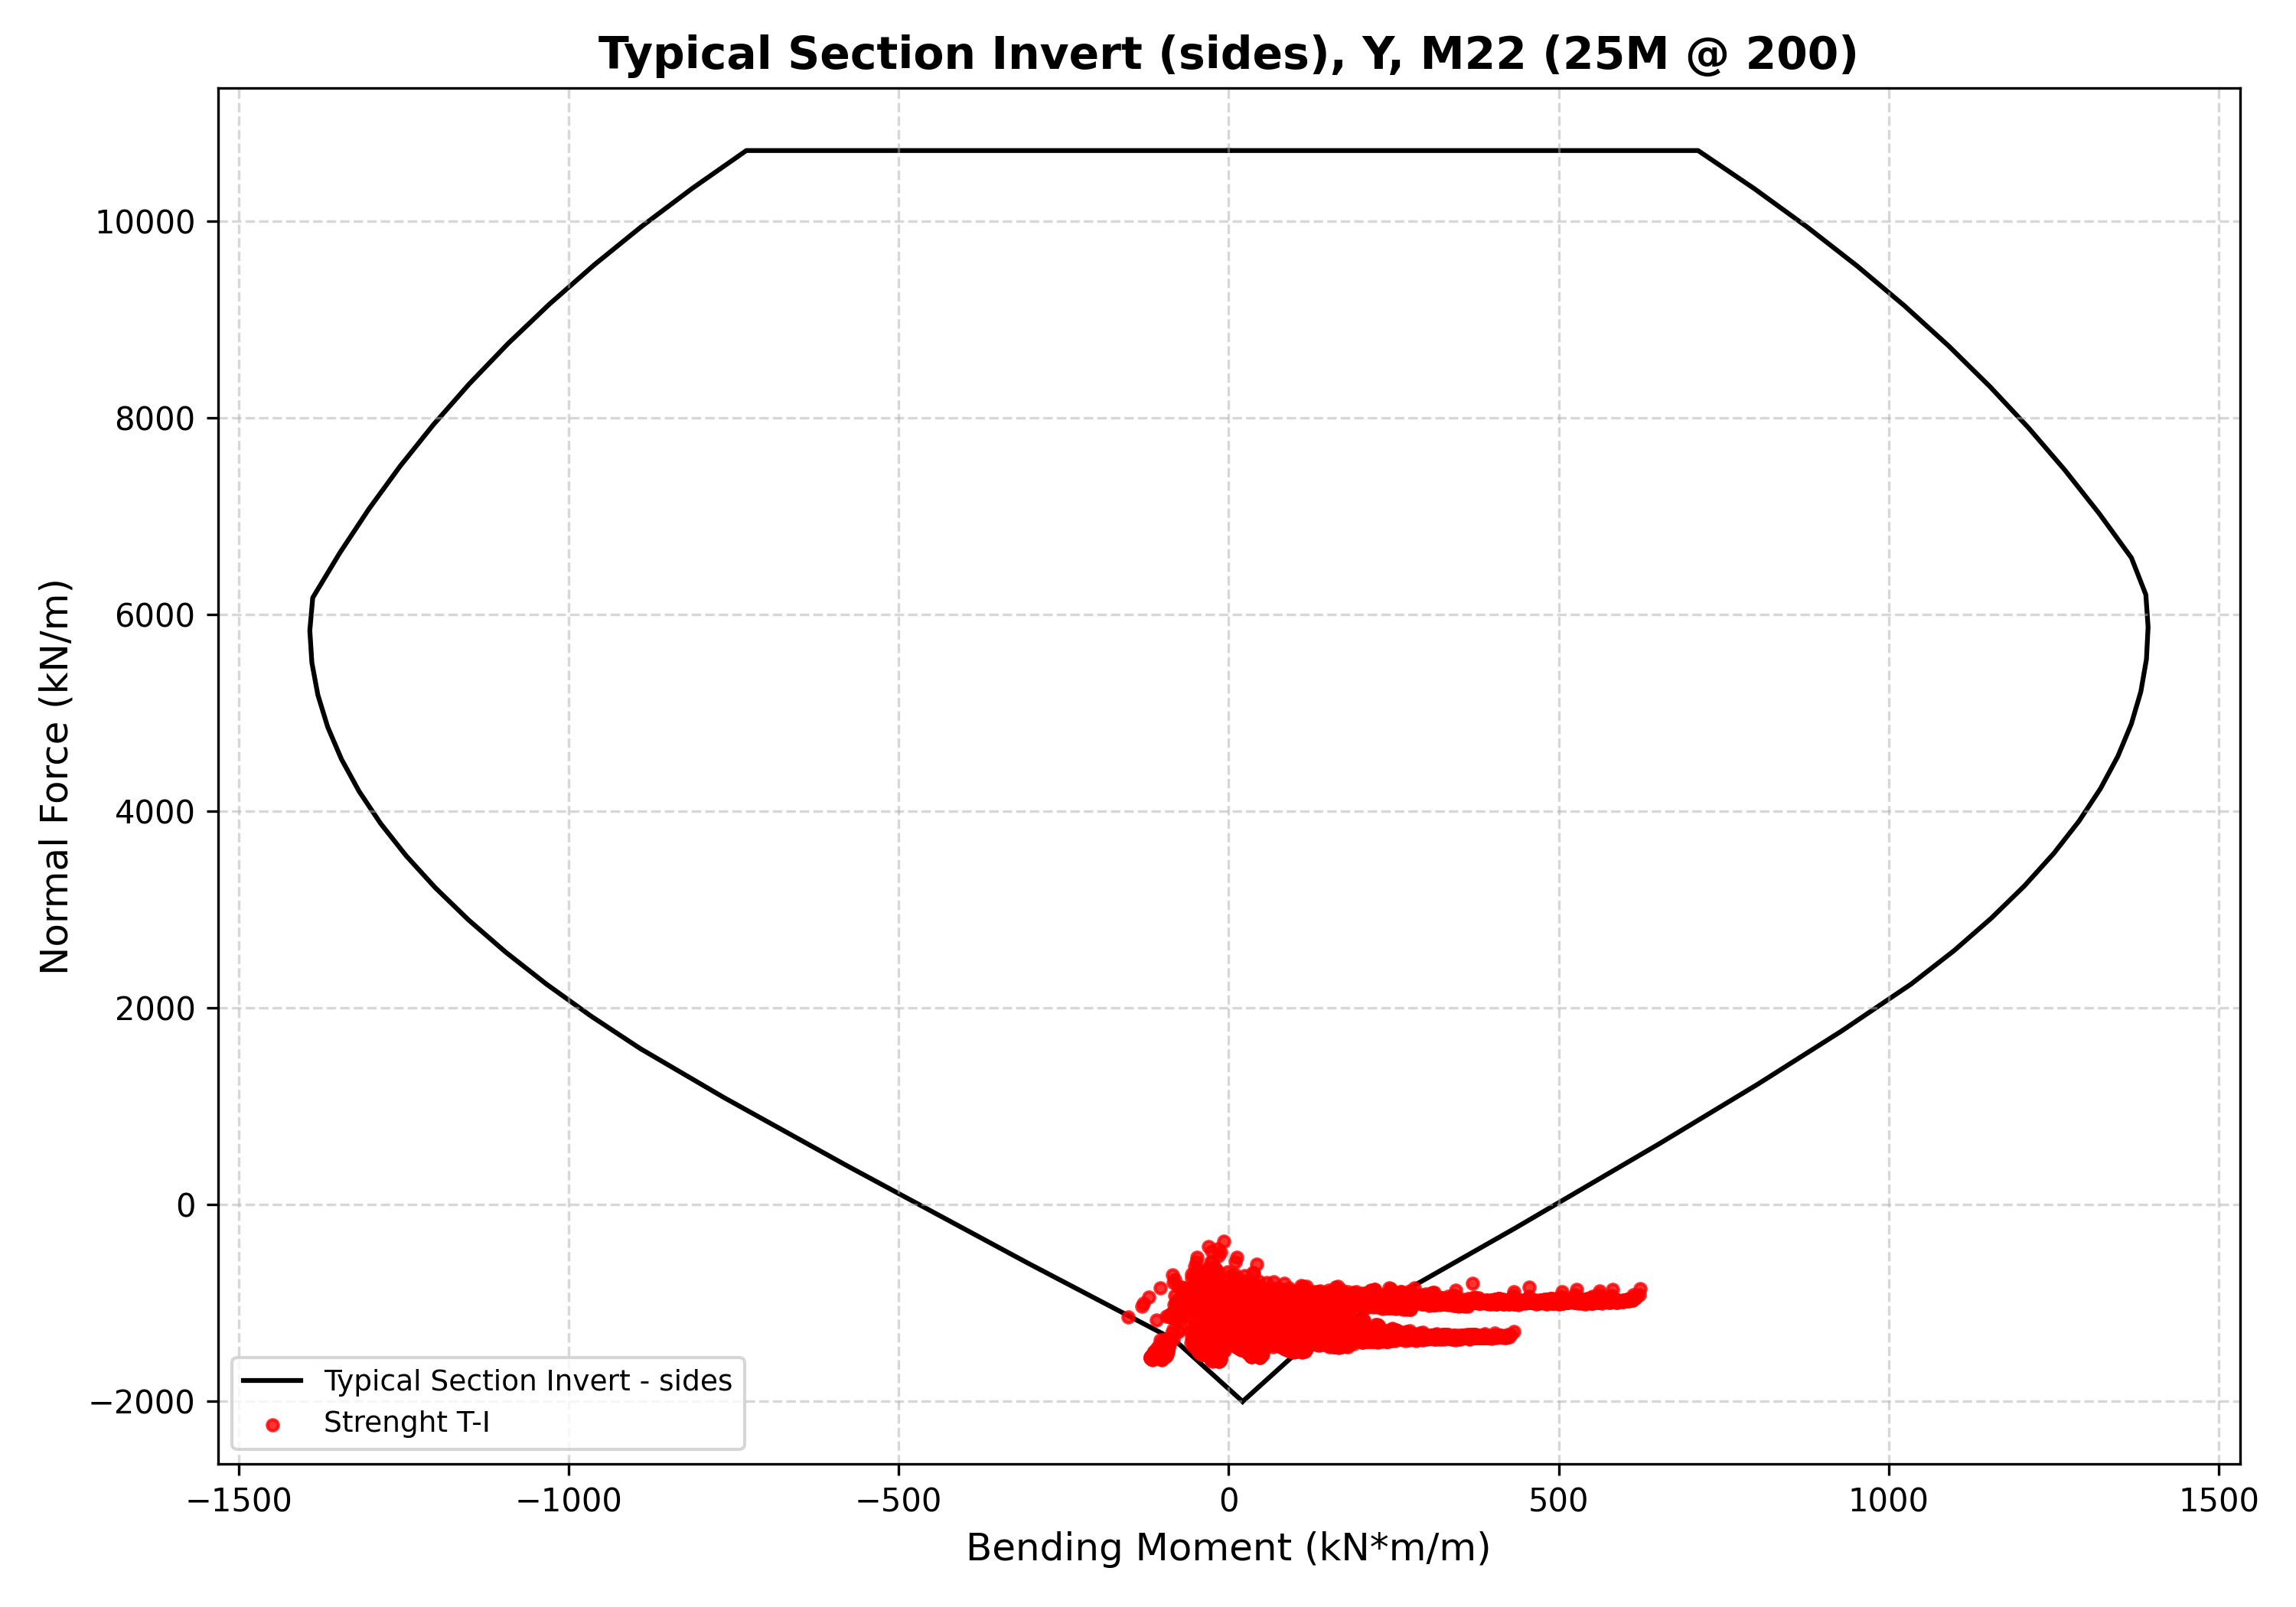
Figure 12: N-M diagram for Typical Section Invert sides Y M22 25M 200

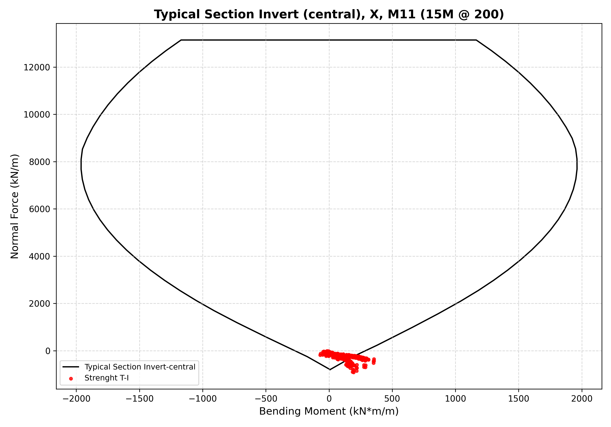
Figure 13: N-M diagram for Typical Section Invert central X M11 15M 200

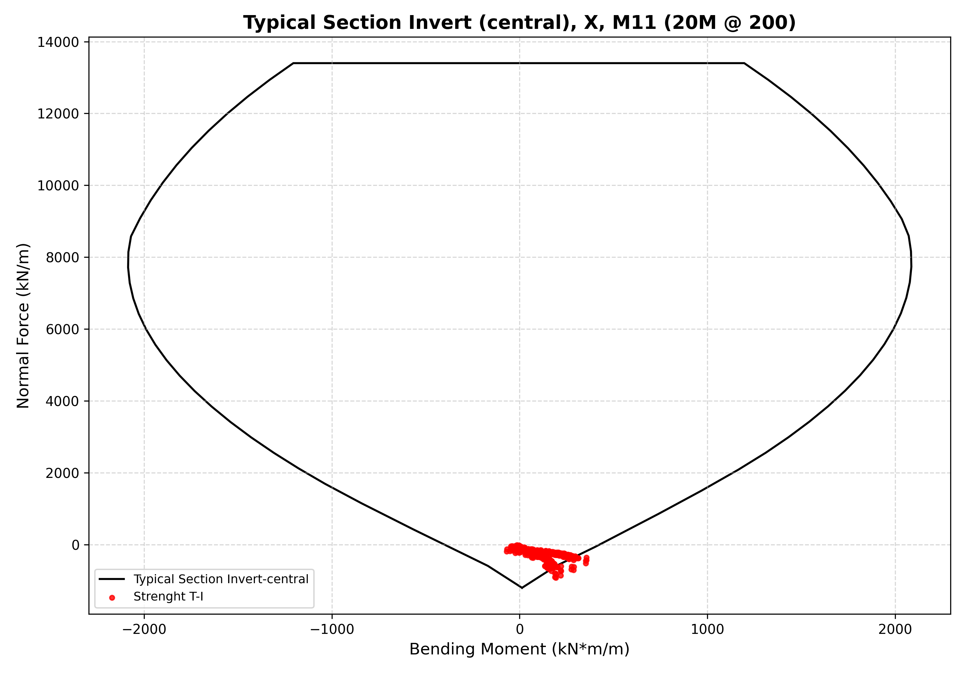
Figure 14: N-M diagram for Typical Section Invert central X M11 20M 200

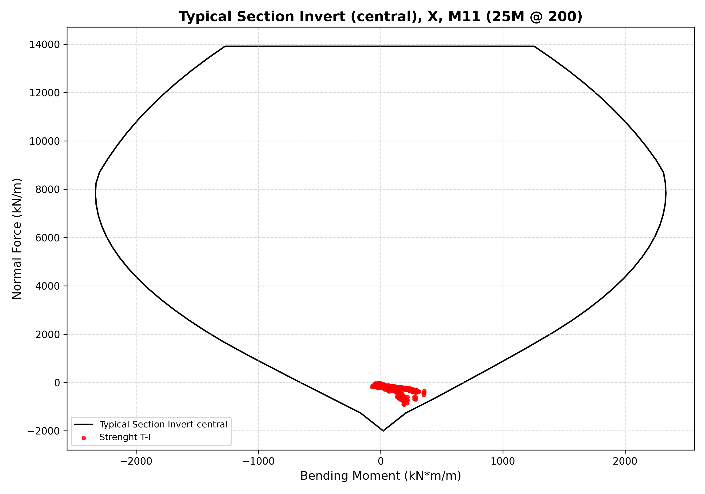
Figure 15: N-M diagram for Typical Section Invert central X M11 25M 200

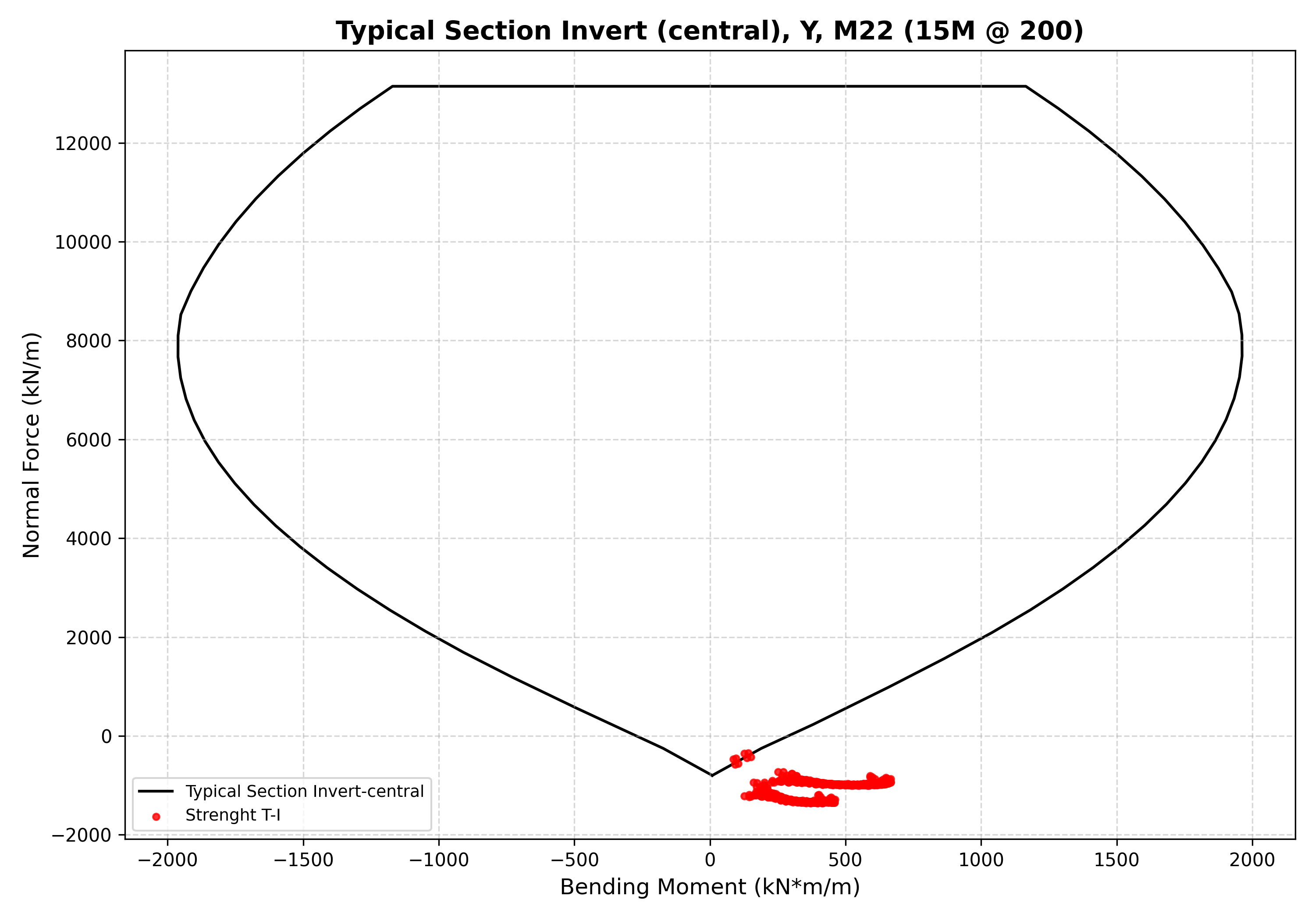
Figure 16: N-M diagram for Typical Section Invert central Y M22 15M 200

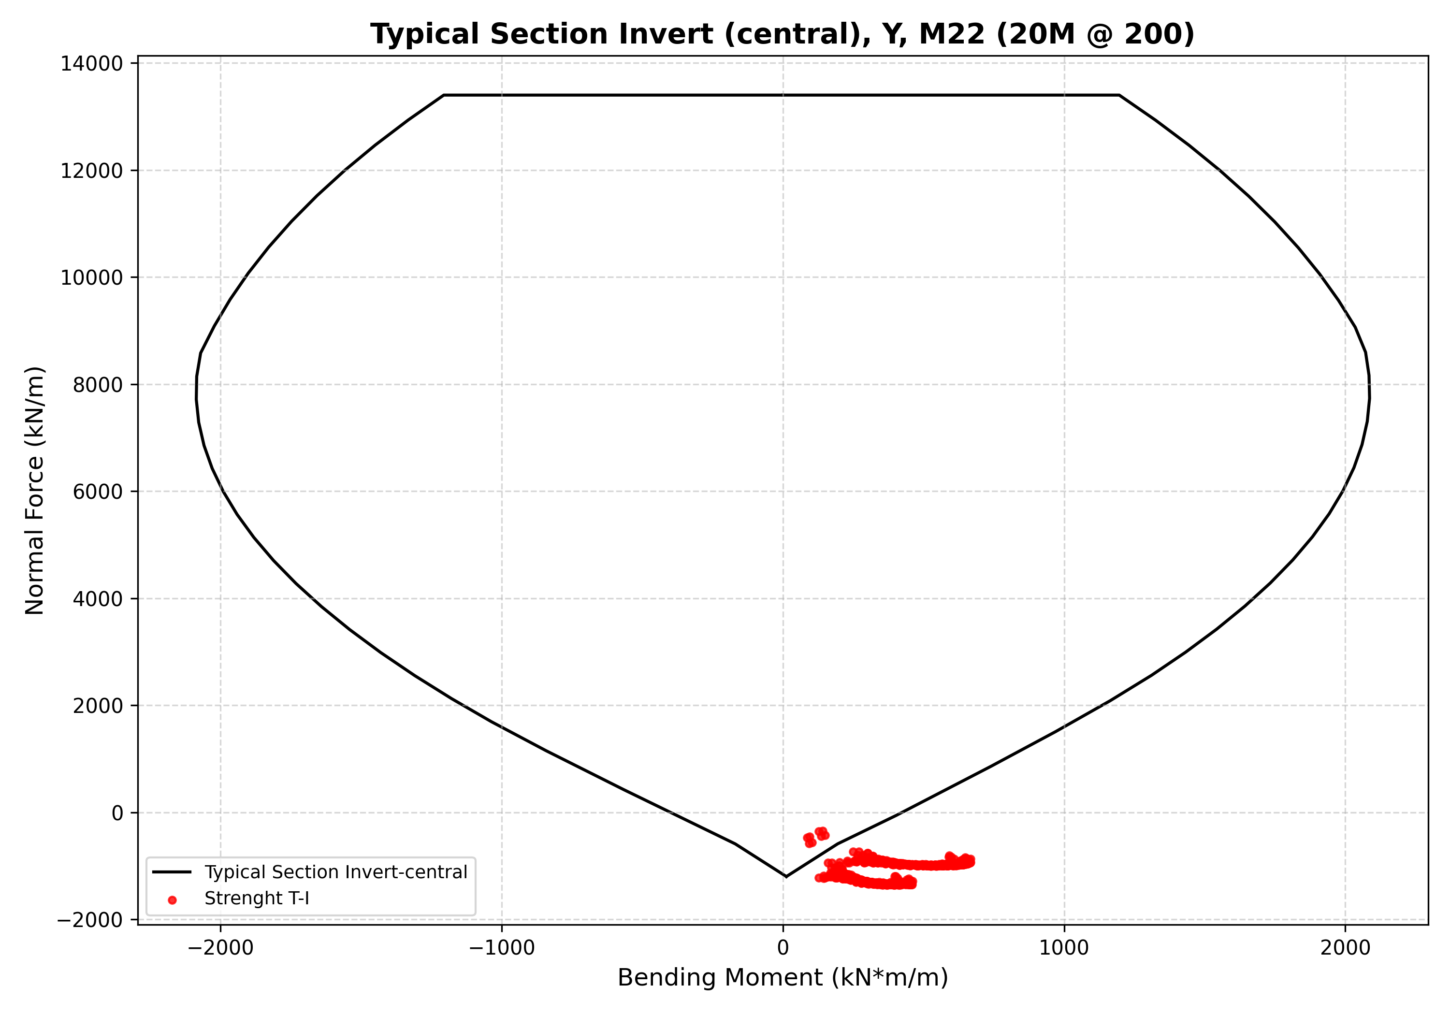
Figure 17: N-M diagram for Typical Section Invert central Y M22 20M 200

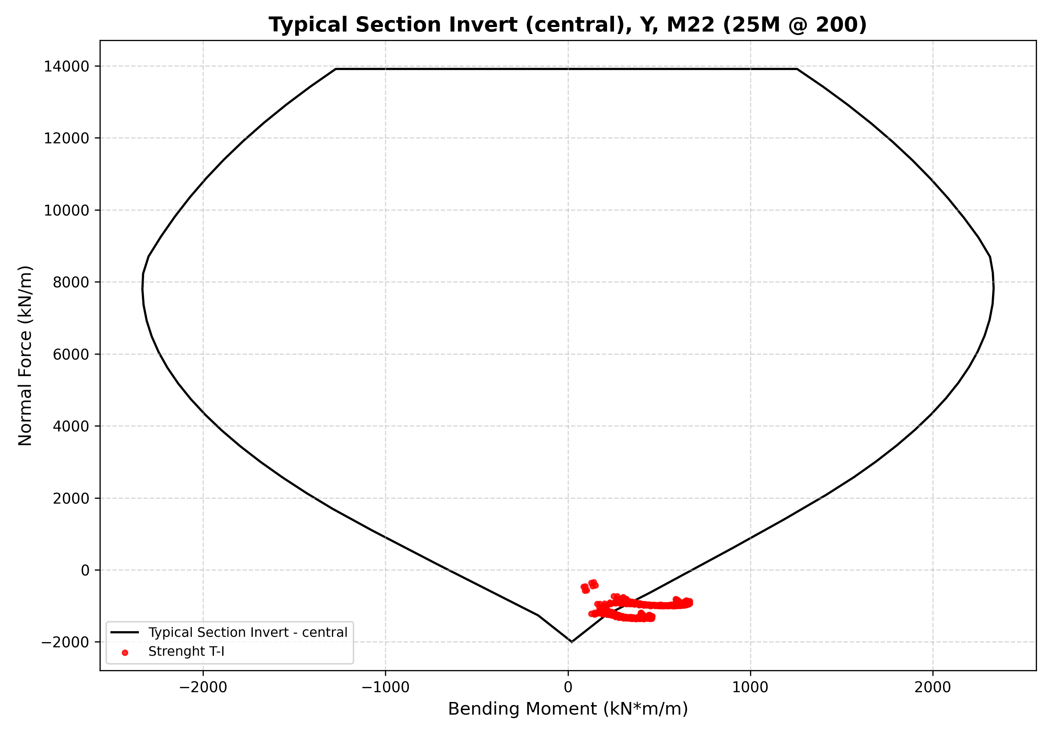
Figure 18: N-M diagram for Typical Section Invert central Y M22 25M 200

