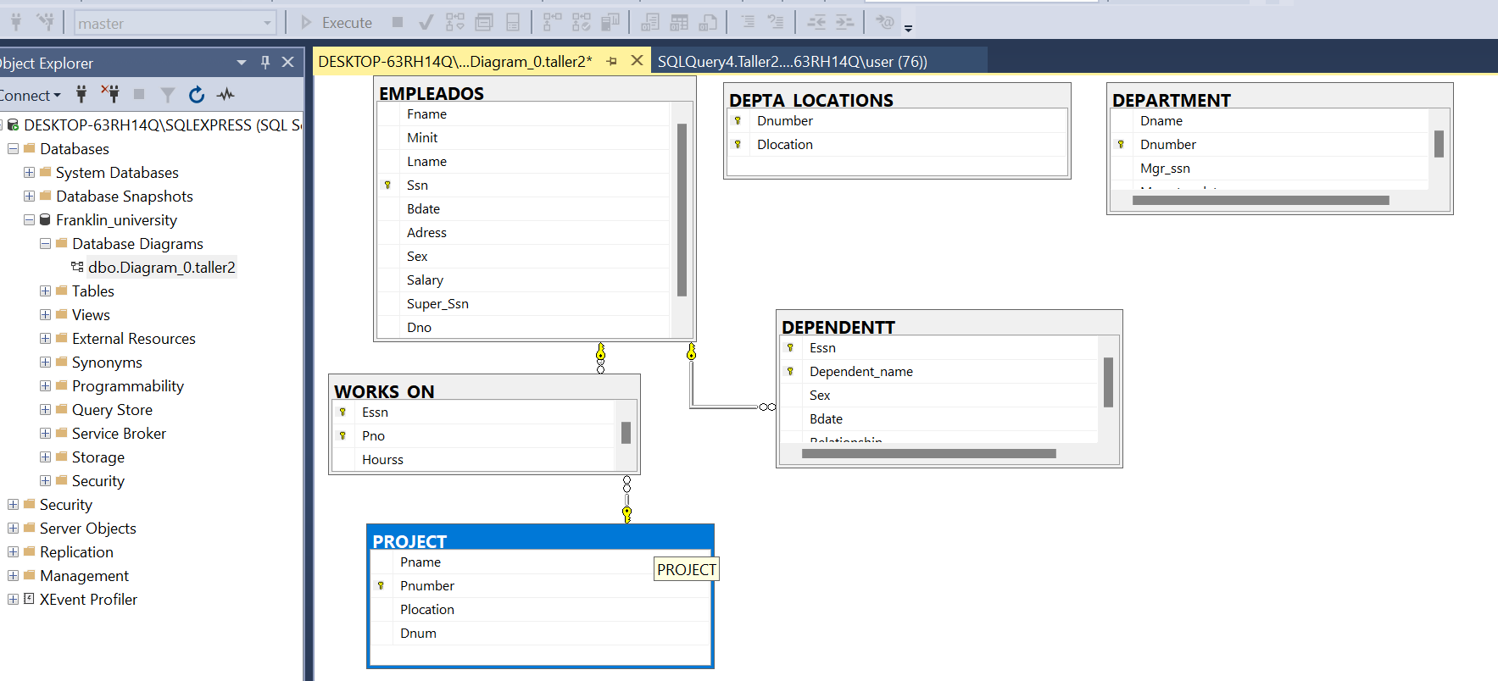

El diagrama no abre a la hora de guardarlo, adjuntamos captura. Por si acaso, la documentación de la creación de las tablas

--CREATE DATABASE Franklin_University;

Use Franklin_University;

/*CREATE TABLE EMPLOYEES (

Fname varchar(50),

Minit varchar(50),

Lname varchar(50),

Ssn float,

Bdate varchar(50),

Adress varchar(50),

Sex varchar(50),

Salary float,

Super_ssn int,

Dno float,

);

INSERT INTO EMPLOYEES VALUES

('John','B','Smith',123456789,'1965-01-09','731 Fondren, Houston TX','M',30000,333445555,5),

('Franklyin','T','Wong',333445555,'1965-12-08','638 Voss, Houston TX','M',40000,888665555,5),

('Alicia','J','Zelaya',999887777,'1968-01-19','3321 Castle, Spring TX','F',25000,987654321,4),

('Jennifer','S','Wallace',987654321,'1941-06-20','291 Berry, Bellaire TX','F',43000,888665555,4),

('Ramesh','K','Narayan',666884444,'1962-09-15','975 Fire Oak, Humble TX','M',38000,333445555,5),

('Joyce','A','English',453453453,'1972-07-31','5631 Rice, Houston TX','F',25000,333445555,5),

('Ahmad','V','Jabbar',987987987,'1969-03-29','980 Dallas, Houston TX','M',25000,987654321,4),

('James','E','Borg',888665555,'1937-11-10','450 Stone, Houston TX','M',55000,null,1);*/

/*CREATE TABLE DEPARTAMENT (

Dname varchar(50),

Dnumber float,

Mgr_ssn float,

mgr_start_date varchar(50),

);

INSERT INTO DEPARTAMENT VALUES

('Research',5,333445555,'1988-05-22'),

('Administration',4,987654321,'1995-01-01')

('Headquarters',1,888665555,'1981-06-19');*/

/*CREATE TABLE DEPT_LOCATIONS (

Dnumber float,

Dlocations varchar(50),

);

INSERT INTO DEPT_LOCATIONS VALUES

(1,'Houston'),

(4,'Stafford'),

(5,'Bellaire'),

(5,'Sugarland'),

(5,'Houston');*/

/*CREATE TABLE PROJECT (

Pname varchar(50),

Pnumber float,

Plocation varchar(50),

Dnum float,

);

INSERT INTO PROJECT VALUES

('ProductX',1,'Bellaire',5),

('ProductY',2,'Sugarland',5),

('ProductZ',3,'Houston',5),

('Computerization',10,'Stafford',4),

('Reorganization',20,'Houston',1),

('Newbenefits',30,'Stafford',4);*/

/*CREATE TABLE WORKS_ON (

Essn float,

Pno float,

Hourss float,

);

INSERT INTO WORKS_ON VALUES

(123456789,1,32.5),

(123456789,2,7.5),

(666884444,3,40.0),

(453453453,1,20.0),

(453453453,2,20.0),

(333445555,2,10.0),

(333445555,3,10.0),

(333445555,10,10.0),

(333445555,20,10.0),

(999887777,30,30.0),

(999887777,10,10.0),

(987987987,10,35.0),

(987987987,30,5.0),

(987654321,30,20.0),

(987654321,20,15.0),

(888665555,20,16.0);*/

CREATE TABLE DEPENDENTT (

Essn float,

Dependent_name varchar(50),

Sex varchar(50),

Bdate varchar(50),

Relationship varchar(50),

);

INSERT INTO DEPENDENTT VALUES

(333445555,'Alice','F','1986-04-04','Daughter'),

(333445555,'Theodore','M','1983-10-25','Son'),

(333445555,'Joy','F','1958-05-03','Spouse'),

(987654321,'Abner','M','1942-02-28','Spouse'),

(123456789,'Michael','M','1988-01-04','Son'),

(123456789,'Alice','F','1988-12-30','Daughter'),

(123456789,'Elizabeth','F','1967-05-05','Spouse');