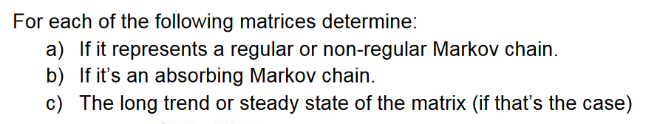

1.-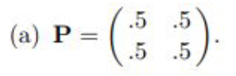(n-1)^2+1 = 2

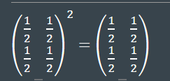 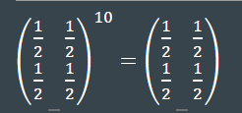

1. Regular Markov Chain
2. Not absorbing markov chain
3. The long trend is (.5 .5)

2.-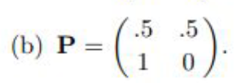(n-1)^2+1 = 2

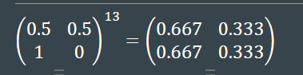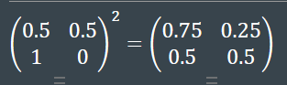 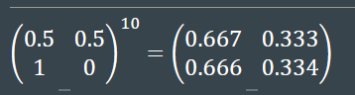  
a)Regular markov chain  
b) Not absorbing   
c) The long trend is (.667 .333)

3.- 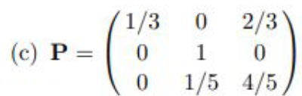(n-1)^2+1 = 5

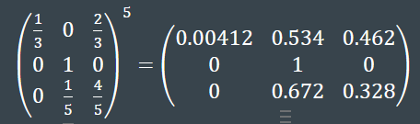 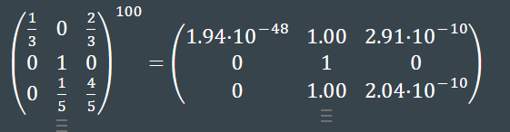

1. Not regular Markov Chain
2. Absorbing
3. Not long trend

4.- 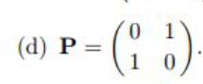max = 2  
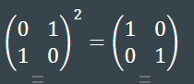 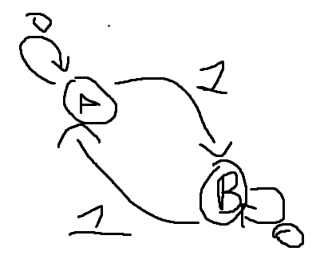

a) Not regular  
b) Not absorbing  
c) Not Long Trend

5.- 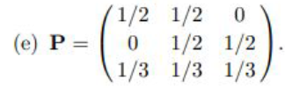max = 5

a) 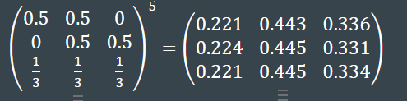 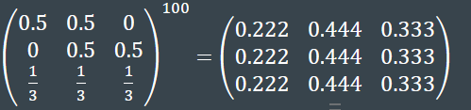

a)Regular Markov Chain  
b)Not absorbing  
c) The long Trend is (.222 .444 .333)

6.-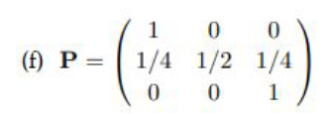max = 5

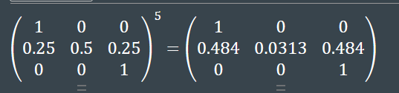 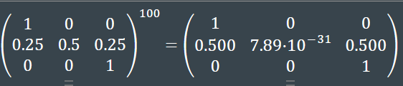

1. Not Regular   
   b) Absorbing Chain  
   c) Not long trend

7.- 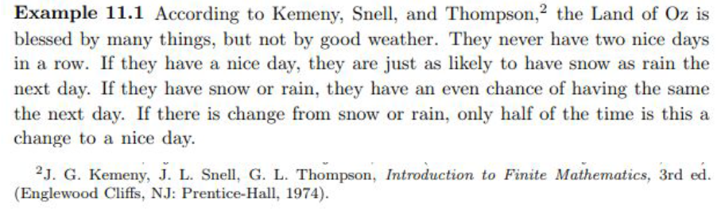

n s r

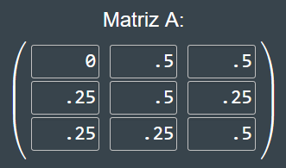a) n

s

r

b) Tuesday is the initial matrix, Wednesday would me A^2 and Thursday A^3 so P = .406

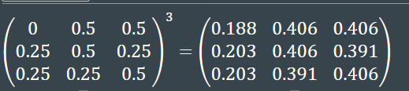

c) 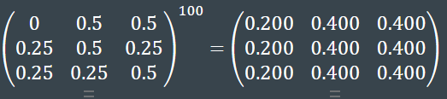 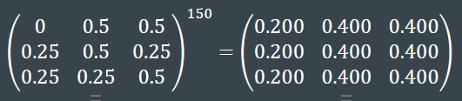

The long trend is (.200 .400 .400)

8.- 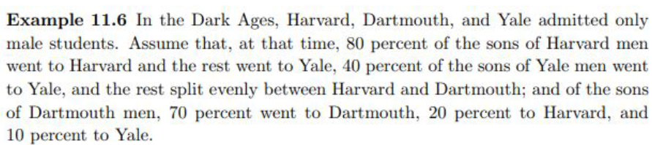

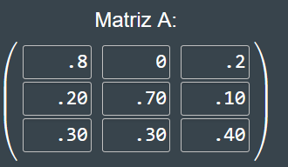a) H D Y

H

D

Y

1. This matrix represents the probability of the next gen, grandson would be next next gen so M^3 would give me this. P = .217

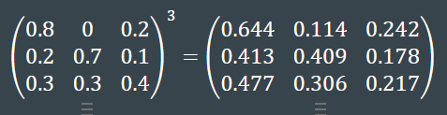

1. P = .114