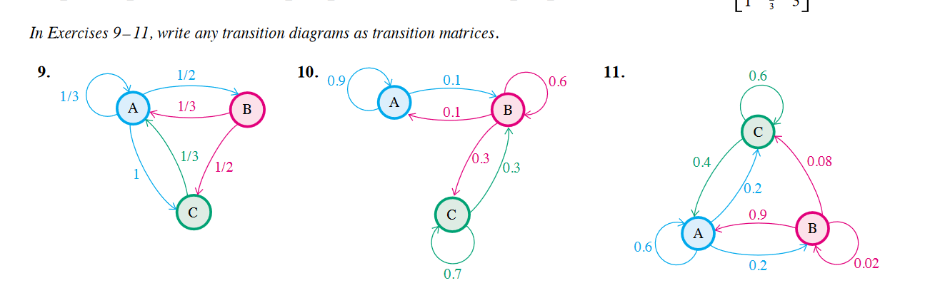

|  |  |  |  |
| --- | --- | --- | --- |
|  | A | B | C |
| A | .9 | .1 | 0 |
| B | .1 | .6 | .3 |
| C | 0 | .3 | .7 |



|  |  |  |  |
| --- | --- | --- | --- |
|  | A | B | C |
| A | .6 | .2 | .2 |
| B | .9 | .02 | .08 |
| C | .4 | 0 | .6 |

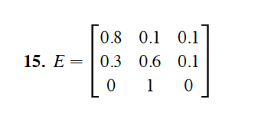

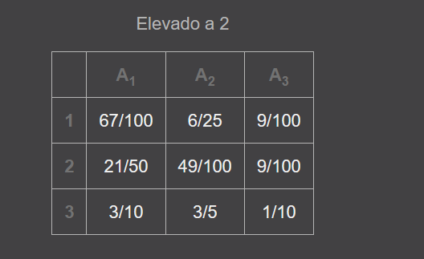 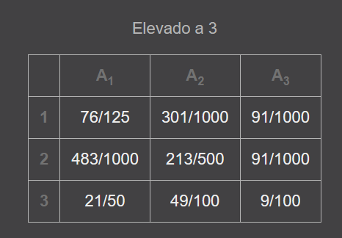

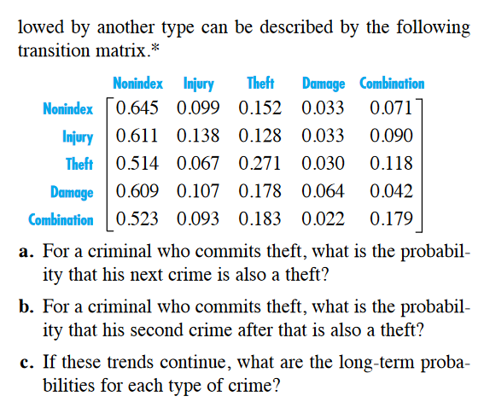

1. P = .271
2. 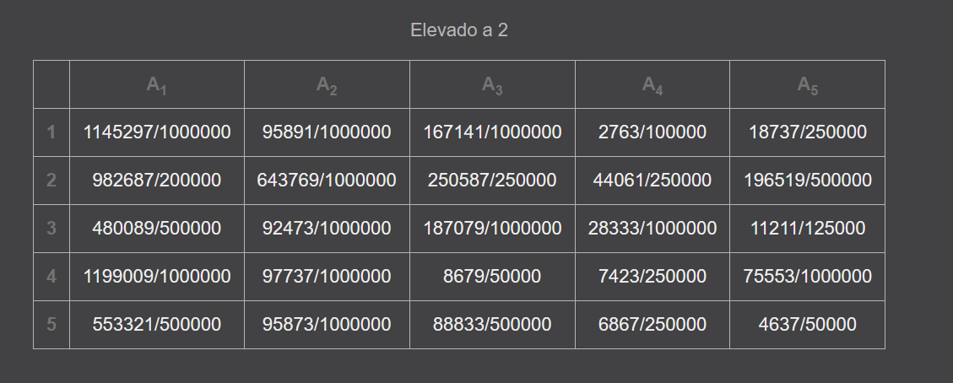

P = 187079/1000000000 = 0.000187079

1. 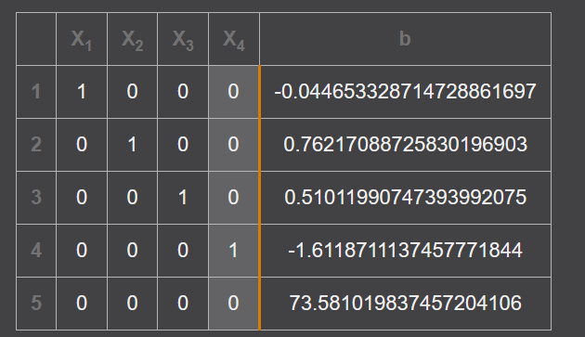

Al resolver la matriz se vuelve inconsistente