**1.**-The linear congruential method produces a sequence of integers between zero and m-1 using the relationship:

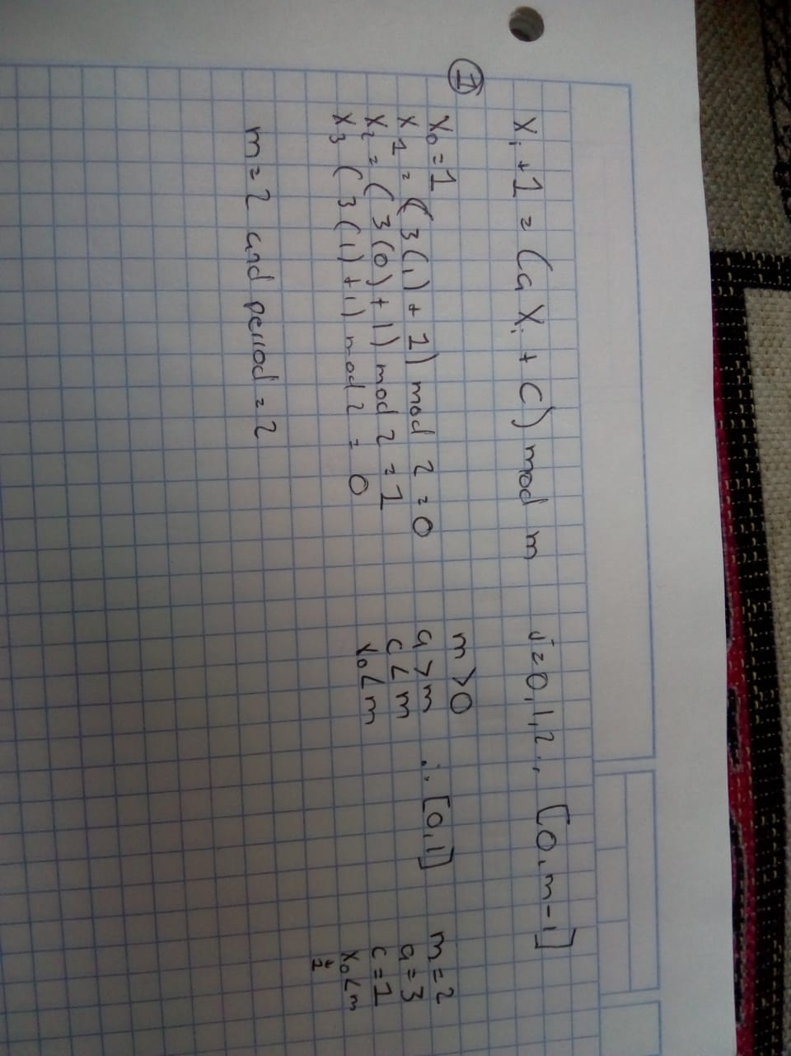

* The initial value $X_0$is called the seed;
* a is called the constant multiplier;
* c is the increment
* m is the modulus

When c != 0 the form is called the mixed congruential method; When c = 0, the form is known as the multiplicative congruential method.

**2**.-

**3.-** What is the best way to choose the parameters for the generator? (The seed, the multiplier, the increment and the modulus)

The interval will be [0, m-1]

m > 0 and a < m, c < m, X < m

It has full period if and only if the following three conditions hold (Hull and Dobell, 1962):

1. The only positive integer that (exactly) divides both m and c is 1

2. If q is a prime number that divides m, then q divides a-1

3. If 4 divides m, then 4 divides a-1

•For m a power 2, m=2b, and c≠0  
 Longest possible period P=m=2b is achieved if c is relative prime to m and a=1+4k, where k is an integer

•For m a power 2, m=2b, and c=0   
Longest possible period P=m/4=2b-2 is achieved if the seed X0 is odd and a=3+8k or a=5+8k, for k=0,1,...

•For m a prime and c=0   
Longest possible period P=m-1 is achieved if the multiplier a has property that smallest integer k such that ak-1 is divisible by m is k = m-1

**4.-** 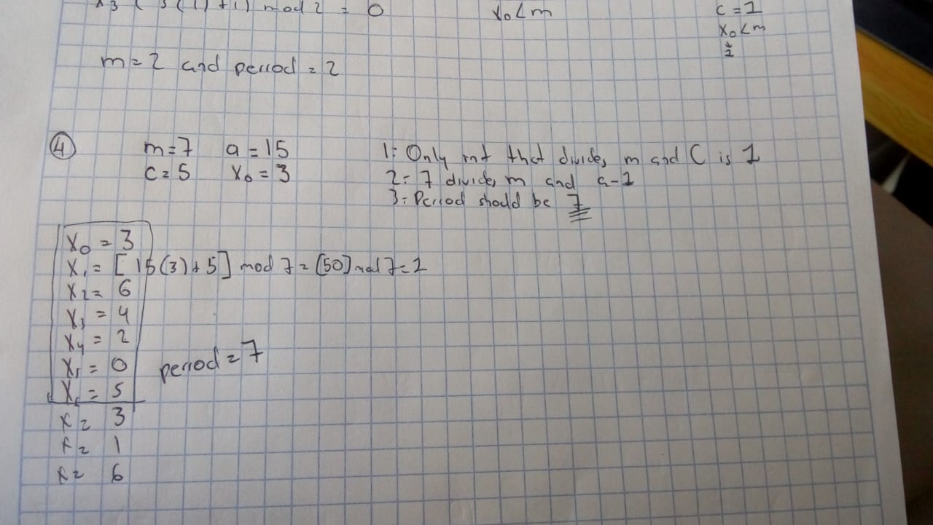

M=7 period =7 (with the conditions established before meet)

M=2 period = 2

https://www.mi.fu-berlin.de/inf/groups/ag-tech/teaching/2012\_SS/L\_19540\_Modeling\_and\_Performance\_Analysis\_with\_Simulation/06.pdf