The following analysis arises from the data sent, it contains two columns: V1 and V2 respectively.

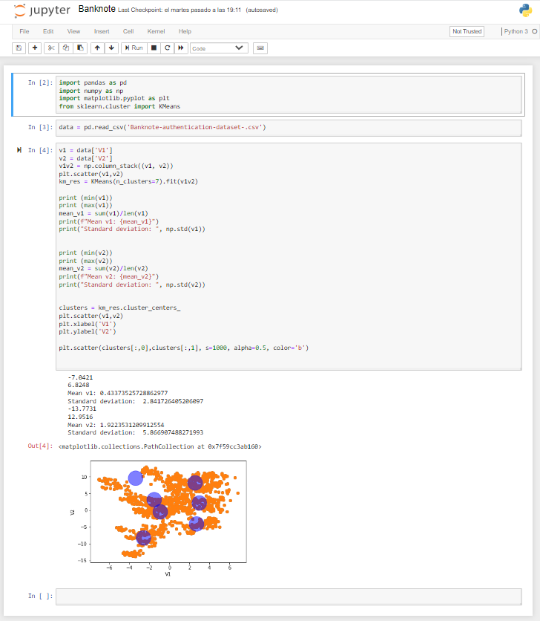

1_According to the visualization of the attached graph, it can also be concluded that data contained in V2 gives is a standard deviation close to twice that of V1.

standard deviation V1: 2.8417

standard deviation V2: 5.8669

standard deviation V1*2 = 5.6834

This would mean that the data of V2 have an excessive deviation respect to V1.

2_ We can also ensure that the standard deviation of V2 is well above 0, also taking into account the same data from V1.

3_In conjunction with the previous points, it is detected that the mean of V2 contain 4.43 times the mean of V1.

4_In relation to the minimums and maximums of each of the columns (v1, v2) it can be verified that the relationship that arises from the minimums and the maximums is double.

Min. v1: -7.0421

Min. v2: -13.7731

max. v1: 6.8248

max. v2: 12.9516