

Implementation of the wazuh system in the sysnet company
Engineering Project Final Report

Juan Alejandro Moreno Santos (juamoreno@utb.edu.co)
Carlos Mario Guzmán Zúñiga (guzmanc@utb.edu.co)
Andrés Felipe Caicedo Gómez (ancaicedo@utb.edu.co)

Project Advisors:
Rafael Enrique Monterroza Barios

Course Advisor:
Rafael Enrique Monterroza Barios

Program:
Engineering Project

05 23, 2025
Table of Contents

Acknowledgments 4
Abstract 5
Resumen 5
1 Problem Statement 6
1.1 Needs 6
1.2 Objectives 6
1.3 Operational Environment 6
1.4 Requirements 6
1.5 Intended Users and Uses 7
1.6 Assumptions and Limitations 7
1.7 Expected End Product and Deliverables 7
1.8 Background and Literature Survey 7
2 Conceptual Design 9
2.1 System Design Decomposition 9
2.2 Evaluation of Design Alternatives 9
3 Implementation and testing 10
3.1 Prototype 10
3.2 Testing 10
3.3 Results 10
4 Detailed Design 11
4.1 Alternative selection 11
4.2 Design Description and Drawings 11
4.3 Analysis and Calculations 11
4.4 Evaluation 11
Conclusions 12
References 13

Acknowledgments
We want to express our sincere gratitude to the individuals and institution who contributed to the successful development of this project.
A special thanks to Professor and Engineer Rafael Enrique Monterroza Barios, for his constant support, technical guidance, and valuable contributions throughout the entire process. His support was fundamental in defining the architecture and validating the implementation of the monitoring system.
We also extend our gratitude to the Universidad Tecnológica de Bolívar (UTB), particularly to the engineering laboratories, for providing the infrastructure and equipment necessary for the prototyping and testing phase.

Abstract
This project aims to implement Wazuh Security Information and Event Management (SIEM) in Sysnet, following a detailed analysis of its architecture, key components, and functionalities. The adoption of this platform seeks to strengthen the organization's system security through advanced monitoring, threat detection, and automated response.
The implementation process includes the installation and configuration of the system's main components, including agents, servers, and the management console. Additionally, Wazuh will be integrated with other existing security solutions in Sysnet to optimize incident detection and management. The infrastructure will be designed to be scalable, allowing adaptation to the company's future needs while ensuring compliance with security regulations.
Wazuh SIEM is a centralized platform that enables real-time telemetry collection and analysis for system protection. Its capability to process event data from endpoints, network devices, cloud workloads, and applications provides comprehensive security coverage, enhancing Sysnet’s ability to prevent and respond to threats.

Resumen
Este proyecto tiene como objetivo la implementación de Wazuh Security Information and Event Management (SIEM) en la empresa Sysnet, tras un análisis detallado de su arquitectura, componentes clave y funcionalidades. La adopción de esta plataforma busca fortalecer la seguridad de los sistemas de la organización mediante monitoreo avanzado, detección de amenazas y respuesta automatizada.
El proceso de implementación abarca la instalación y configuración de los principales componentes del sistema, incluyendo agentes, servidores y la consola de administración. Asimismo, se integrará Wazuh con otras soluciones de seguridad ya existentes en Sysnet para optimizar la detección y gestión de incidentes. Se garantizará que la infraestructura sea escalable, permitiendo su adaptación a las futuras necesidades de la empresa y asegurando el cumplimiento de normativas de seguridad.
Wazuh SIEM es una plataforma centralizada que permite la recopilación y análisis de telemetría en tiempo real para la protección de los sistemas. Su capacidad para procesar datos de eventos provenientes de endpoints, dispositivos de red, cargas de trabajo en la nube y aplicaciones proporciona una cobertura de seguridad integral, mejorando la capacidad de prevención y respuesta ante amenazas en Sysnet.

Problem Statement

Needs
In an environment where cyber threats are increasingly sophisticated and frequent, companies must have robust systems for detecting and managing security incidents. Sysnet, as a company with a growing technological infrastructure, faces significant challenges in protecting its systems and sensitive data from cyberattacks. The lack of a centralized solution for security event monitoring increases the risk of unauthorized access, undetected vulnerabilities, and prolonged response times to incidents.
Currently, Sysnet employs various security management tools, but they operate in isolation, making it difficult to correlate events and generate efficient alerts. Additionally, manual security event monitoring consumes significant resources and does not guarantee early detection of advanced threats such as zero-day attacks, ransomware, or unauthorized access to critical information.
According to a report by Vanson Bourne, 60% of companies have experienced at least one serious security breach in the past two years, and 31% of these organizations reported multiple incidents within the same period (blog.camelsecure.com). Furthermore, the average time to detect a critical vulnerability can exceed 200 days, significantly increasing the risk of exploitation before mitigation (es.vectra.ai).
These figures highlight the need for an automated solution capable of integrating monitoring across multiple devices and generating immediate responses to anomalies. Without an effective security strategy, Sysnet risks economic losses, reputational damage, and potential penalties for non-compliance with security regulations.
The implementation of a Security Information and Event Management (SIEM) system would help overcome these limitations through centralized and real-time monitoring, enhancing the company’s ability to respond to threats and optimizing incident management.

Objectives

General Objective:
Implement the Wazuh SIEM system in Sysnet’s infrastructure to strengthen detection, monitoring, and response to security incidents, optimizing protection against internal and external threats. Additionally, the solution will enable real-time data collection and analysis, providing key insights for the continuous improvement of the company's cybersecurity strategy.
Specific Objectives:
- Assess Sysnet's current infrastructure to determine the technical and operational requirements for Wazuh implementation.
- Configure and deploy Wazuh agents on critical systems, ensuring their proper functionality and compatibility with the existing infrastructure.
- Implement monitoring policies and manage security alerts generated by Wazuh, ensuring an effective response to potential incidents.
- Analyze the scalability of the solution to ensure its adaptability to Sysnet’s future needs and its alignment with security regulations.

Operational Environment
Physical Environment
- Server Infrastructure: Wazuh will be deployed on physical or virtual servers within Sysnet’s data center, which has temperature controls and protection against dust and humidity.
- Location: It will be hosted in an internal data center or a private cloud, ensuring security and availability.
- Environmental Conditions: The system’s physical infrastructure will be in a controlled environment with cooling measures and backup power to prevent failures due to overheating or power outages.
Logical Environment
- Operating System: Wazuh Server will run on Linux (Ubuntu, CentOS, or Debian), while agents will be installed on Linux.
- Network Infrastructure: The implementation will consider a secure environment with network segmentation, firewalls, and VPNs to ensure secure communication between agents and the server.
- Integrations: Wazuh will integrate with other security solutions such as firewalls and IDS/IPS.

Requirements
Functional Requirements
- Implement Wazuh SIEM for real-time threat monitoring and detection, enhancing Sysnet’s infrastructure security.
- Configure and deploy Wazuh agents on 30 laptops and 10 servers, ensuring proper communication with the central server.
- Establish automatic alerts and generate security reports to enable proactive responses to potential threats.
- Integrate Wazuh with Sysnet’s existing administration and security tools for centralized and efficient management.

Non-Functional Requirements
- Scalability: Ensure the solution can adapt to future growth, allowing the incorporation of more endpoints without affecting performance.
- Performance: Optimize the load on monitored devices, minimizing the impact on their performance and the company’s network.
- Availability: Guarantee continuous system monitoring through high availability and redundancy of critical components.
- Security: Restrict and control access to the management console and security data by implementing multi-factor authentication and privilege segmentation.
- Maintainability: Facilitate system updates and maintenance, ensuring compatibility with future versions of Wazuh and other security systems.
- Compliance: Align the implementation with security regulations and standards such as ISO 27001, NIST, GDPR, among others, to ensure data protection and privacy.

Intended Users and Uses
The Wazuh SIEM system will primarily be used by Sysnet's cybersecurity team and IT administrators. Additionally, other key stakeholders within the organization may utilize the system for strategic decision-making in cybersecurity. The main users include:
- Cybersecurity Team: Responsible for monitoring and responding to security incidents.
- System and Network Administrators: In charge of managing IT infrastructure and integrating it with Wazuh.
- Chief Technology Officer (CTO) and Chief Information Security Officer (CISO): Will use the generated data to assess risks and define security strategies.
Wazuh SIEM will be implemented at Sysnet to enhance the management and protection of its technological infrastructure. Its main uses include:
- Real-Time Monitoring: Continuous supervision of security events across 30 laptops and 10 servers.
- Threat Detection and Forensic Analysis: Identification and evaluation of potential attacks or system vulnerabilities.
- Automated Incident Response: Configuration of alerts and automated actions to mitigate threats.
- Security Report Generation: Creation of detailed reports on security status and regulatory compliance.
- Integration with Other Security Tools: Connection with existing security solutions at Sysnet to enhance defense-in-depth strategies.

Assumptions and Limitations
Assumptions:
  - The initial number of monitored devices will be 40 (30 laptops and 10 servers).
    - This number of endpoints is based on Sysnet's current inventory, although the solution must be scalable.

  - Sysnet has trained personnel to manage and operate Wazuh.
    - The IT team is expected to have basic knowledge of system administration and security to manage the SIEM.

  - The servers where Wazuh will be deployed have sufficient resources (CPU, RAM, and storage).
    - It is assumed that Sysnet’s infrastructure meets the minimum recommended requirements for Wazuh to function properly.

  - Wazuh will be integrated with other security solutions already implemented in Sysnet.
    - Compatibility is expected with firewalls, intrusion detection systems (IDS/IPS), and other security tools used by the company.

  - Sysnet’s network provides stable and secure connectivity for communication between agents and the Wazuh server.
    - It is assumed that there will be no significant latency issues or critical communication interruptions.
Limitations:
- The implementation of Wazuh will be limited to the 40 initially planned devices.
    - Although the system is scalable, the initial deployment will only include these devices due to time and resource constraints.

- The Wazuh server must be installed in a Linux environment.
    - Wazuh Server is only compatible with Linux-based operating systems, so Windows Server will not be an option.

- The project budget is limited and does not allow for the acquisition of additional infrastructure.
    - The existing infrastructure at Sysnet must be used for implementation.

- Access to the Wazuh management console will be restricted to authorized personnel.
    - Only designated security administrators will have access to the console to prevent security risks.

- The system will be implemented in an on-premise environment and not in the cloud.
    - Due to Sysnet’s policies, security infrastructure and data will not be stored in public cloud services.

Expected End Product and Deliverables
The outcome of this project will be the implementation of Wazuh SIEM in Sysnet’s infrastructure, providing a centralized solution for monitoring, detecting, and responding to security incidents. This system will enhance the company’s cybersecurity posture by collecting, analyzing, and correlating real-time events.

Deliverables:
- Deployed and Operational Infrastructure
  - Installation and configuration of Wazuh Server on a Linux server.
  - Deployment of Wazuh agents on 30 laptops and 10 servers.
  - Integration with existing administration and security tools at Sysnet.

- Configured Security Policies and Rules
  - Definition of threat detection rules specific to Sysnet.
  - Configuration of automated alerts and notifications.
  - Creation of customized dashboards for security event visualization.

- Technical Documentation
  - Installation and configuration manual for Wazuh in Sysnet’s infrastructure.
  - Guide for managing and monitoring security events with Wazuh.
  - Procedures for alert management and incident response.

- Training for Sysnet's IT Team
  - Training sessions on using Wazuh’s management console.
  - Guidance on interpreting alerts and generating security reports.
  - Best practices for system maintenance and scalability.

- Functionality Testing and Validation
  - Evaluation of the system’s performance in threat detection and response.
  - Scalability tests to validate the system’s capacity for future growth.
  - Compliance validation with applicable security regulations.

Background and Literature Survey
The increasing digitalization of business processes has significantly expanded the attack surface of organizations, making cybersecurity a critical aspect of technological infrastructure. According to a Gartner report, 75% of companies will experience at least one significant security incident by 2025, highlighting the need to adopt robust threat monitoring and management solutions [1].
SIEM Concept and Its Evolution
Security Information and Event Management (SIEM) systems emerged as a solution to collect, analyze, and correlate security events in complex business environments. These tools enable real-time threat detection, automated response, and compliance with regulations such as ISO 27001, GDPR, and PCI DSS [2]. Over the past decade, SIEM platforms have evolved to incorporate artificial intelligence and machine learning, enhancing the identification of anomalous patterns and reducing false positives in alert generation [3].
Wazuh as a SIEM Solution
Wazuh is an open-source platform that integrates intrusion detection, file integrity monitoring, security auditing, and event correlation functionalities. Its modular architecture allows agents to be deployed on multiple devices, which send information to a centralized server where events are analyzed for potential threats [4]. Unlike commercial solutions such as Splunk or ArcSight, Wazuh offers a low-cost alternative with advanced integration and scalability capabilities.

Comparison with Other Security Monitoring Tools
A comparison between Wazuh and other widely used SIEM solutions is presented in Table 1.
Feature | Wazuh | Splunk | ArcSight
Open source | ✅ | ❌ | ❌
Real-time threat  Detection | ✅ | ✅ | ✅
Integration with third-party tools | ✅ | ✅ | ✅
Implementation cost | Low | High | Medium
Ease of setup | Medium | High | Low
Table 1. Comparison of Wazuh with other SIEM solutions.
Implementation of Wazuh in Enterprises
Various organizations have chosen to implement Wazuh as their SIEM system due to its flexibility and adaptability to diverse business environments. According to Lian et al., a proper implementation of Wazuh improves incident detection by 40% and optimizes response time to security events [5]. Companies in the financial, government, and telecommunications sectors have reported enhancements in their cybersecurity posture by integrating Wazuh with forensic analysis and incident response solutions.

Conceptual Design

System Design Decomposition
The security architecture for Sysnet was designed based on Wazuh SIEM implementation standards, following industry best practices. Different design alternatives were analyzed, considering factors such as scalability, performance, and integration with existing Sysnet tools.

Evaluation of Design Alternatives
The evaluation of the architecture design was primarily based on Sysnet's specific requirements, including its existing hardware infrastructure, network capacity, and security needs. The selection of components and system architecture was influenced by the number of servers and endpoints requiring monitoring, the expected log volume, and the necessity for real-time threat detection. These factors determined the scalability, performance, and redundancy requirements of the proposed design.

Implementation and testing

Prototype
To validate the monitoring and security architecture proposed with Wazuh, a functional prototype was built within the network environment of the Technological University of Bolívar (UTB), using both physical hardware and virtual machines. This prototype allowed us to verify the technical feasibility of the solution and its performance when interacting with different types of agents.
Hardware Implemented
Three iMac (Apple) computers were used to deploy the main components of the Wazuh stack, all with the following specifications:
- Model: iMac (21.5-inch, Late 2015)
- Processor: 2.8 GHz quad-core Intel Core i5
- RAM: 8 GB DDR3 at 1867 MHz
- Graphics: Intel Iris Pro Graphics 6200 (1536 MB)
- Operating System: Ubuntu 24.04.2 LTS (installed over macOS Monterey 12.7.6)
The role distribution was as follows:
- Wazuh Server: 1 iMac running Ubuntu
- Dashboard (web interface): 1 iMac running Ubuntu
- Indexer (based on OpenSearch): 1 iMac running Ubuntu
Client Devices
- 2 iMacs running Ubuntu 24.04.2 LTS
- 1 laptop running Windows 11
- 2 Linux virtual machines (used to simulate additional hosts and test monitoring policies)
Software Implemented
Since version 4.12 of Wazuh was used, the updated architecture that no longer requires components like Kibana or Filebeat was deployed. The stack included the following modules:
- Wazuh Manager 4.12
- Wazuh Dashboard 4.12 (based on OpenSearch Dashboards)
- Wazuh Indexer (OpenSearch 2.x)
- Wazuh Agents for Linux and Windows
Installation was performed using the automated installation scripts provided by Wazuh, with network configurations adjusted to enable communication between nodes and clients.
System Interface
The main interface of the system is the Wazuh Dashboard, accessible via web browser, from which the following actions can be performed:
- View security events
- Configure monitoring policies
- Analyze real-time alerts
- Manage connected agents
Below are real screenshots of the prototype in operation:
- Wazuh Dashboard Overview:
The image shows the main view of the Wazuh Dashboard, a web interface used to centralize the monitoring of security events in real time. At the top, key metrics are displayed, such as:
- Total events detected (35)
- Level 7 or higher alerts (0)
- Rule execution failures (13)
- Authentication failure alerts (2)
In the lower section, bar and donut charts summarize information about:
- The rule groups generating the most alerts
- The most common event types
- The agent groups reporting activity
- MITRE ATT&CK-based classifications (if enabled)
This view allows administrators to quickly identify anomalies, prioritize incidents, and manage security policies on the monitored endpoints.
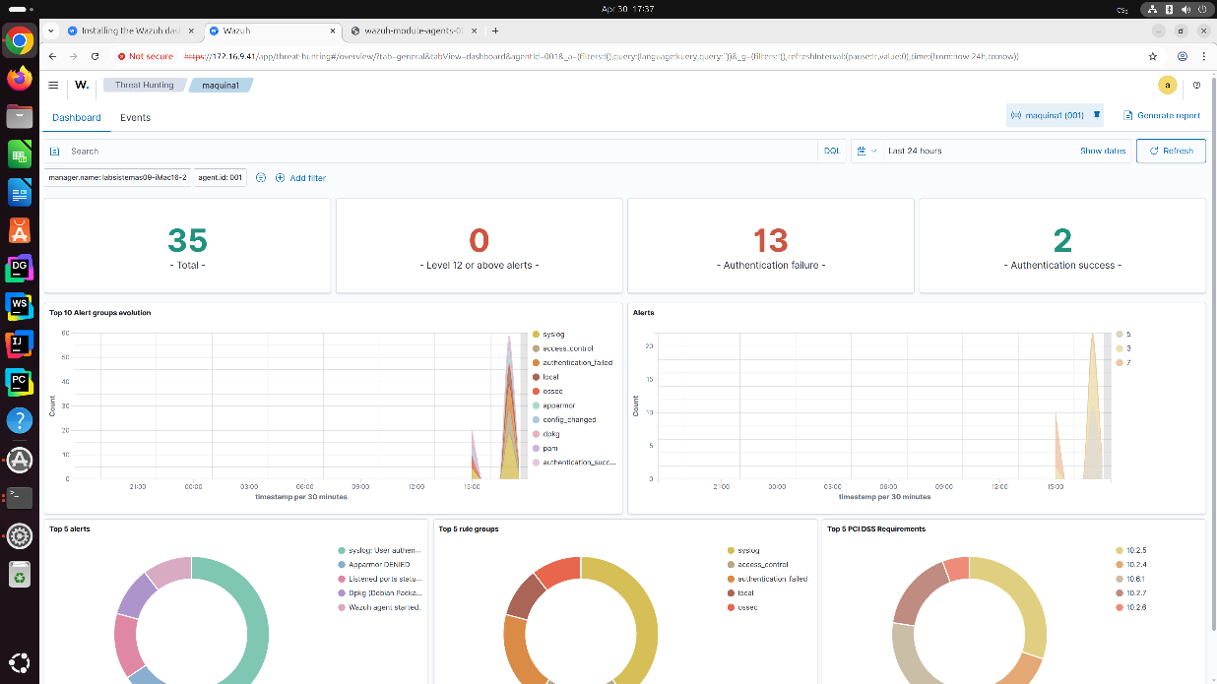
Page 1. Wazuh Dashboard Overview

- Wazuh Indexer Status:
The image shows the terminal of one of the machines where the Wazuh Indexer component is deployed, which is responsible for storing and searching the data collected by the agents. At the top, it can be seen that the wazuh-indexer.service is active and enabled, indicating that the component is running correctly and configured to start automatically with the system.
Additionally, the service startup command is shown, which uses java to run the OpenSearch component. At the bottom of the terminal, several WARNING messages appear, which do not represent critical errors but rather notifications about modules that will be deprecated in future versions or best practice recommendations. Finally, the message "Started wazuh-indexer.service - wazuh-indexer" confirms that the service was successfully started.
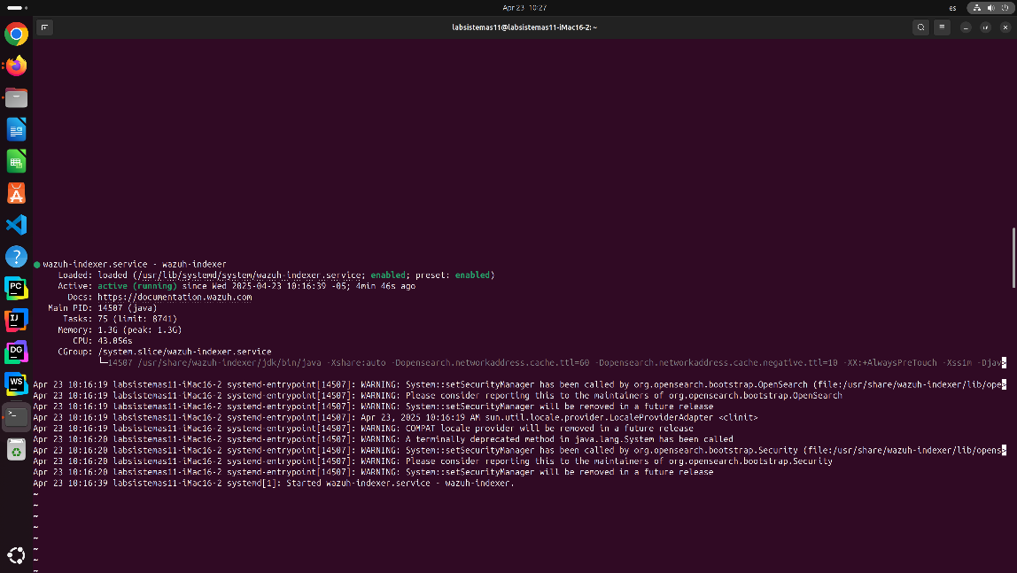
Page 2. Wazuh Indexer Status

- Wazuh Server Status:
In the image, the Wazuh Manager component can be seen, which is the core of the system, responsible for receiving, processing, and generating alerts based on the information sent by the agents.
At the top of the terminal, it is shown that the wazuh-manager.service is also active and enabled. This means that the server is functioning correctly and ready to operate with the agents.
At the bottom, system log messages (systemd) are displayed, confirming the successful loading of the manager's essential modules, including:
  - wazuh-analysisd (log analysis)
  - wazuh-remoted (communication with agents)
  - wazuh-execd, wazuh-authd, among others
Finally, the message "Started wazuh-manager.service - Wazuh manager" indicates that the server was started correctly, validating the proper functioning of the central component of the Wazuh system.
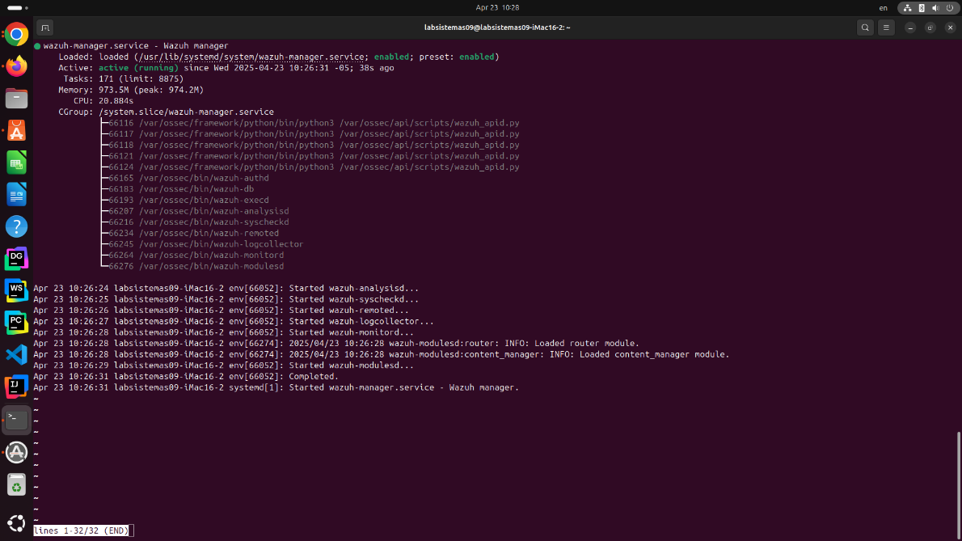
Page 3. Wazuh Server Status

Testing
The testing process consisted of multiple lab-based deployments simulating real-world conditions, where we implemented the full Wazuh stack, including the Wazuh Indexer, Wazuh Server, and Wazuh Dashboard on three separate virtual machines.
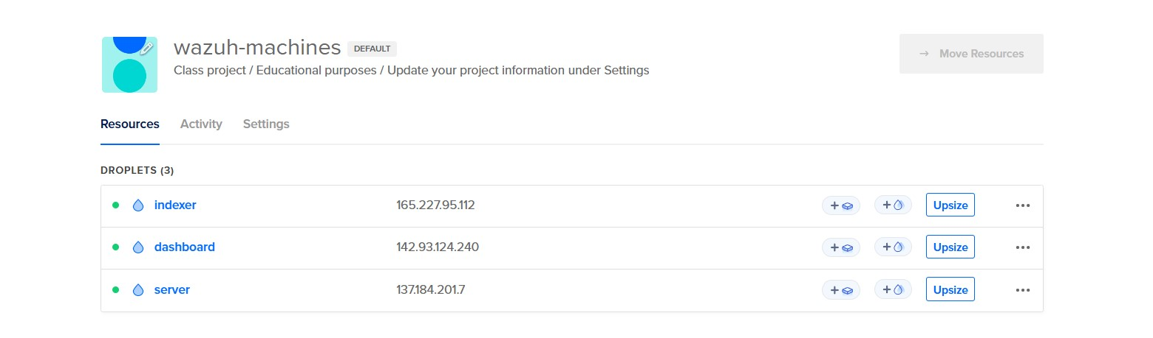
Page 4. Laboratory on DigitalOcean
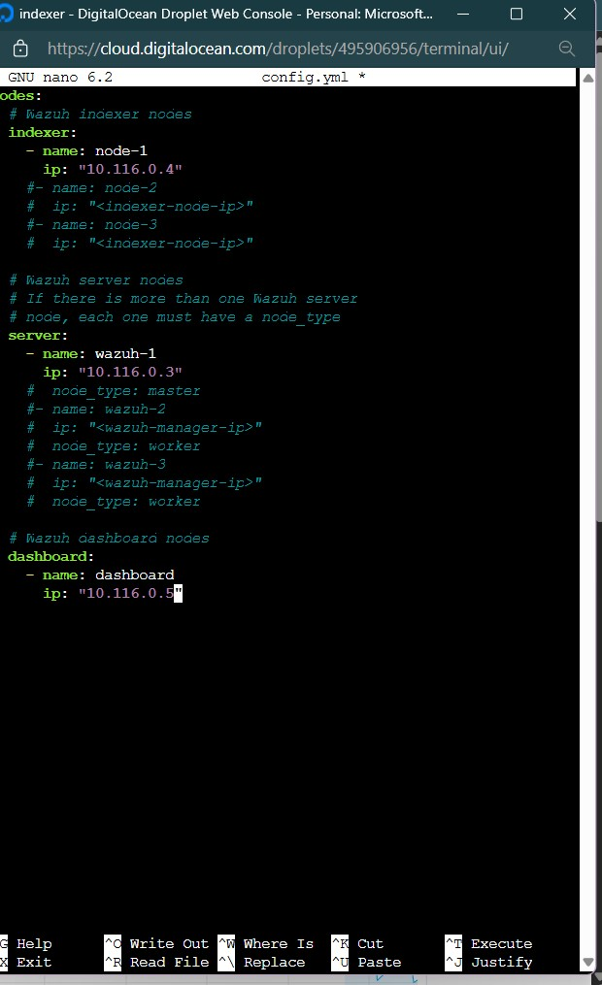
These machines were provisioned inside a private network within DigitalOcean’s Virtual Private Cloud (VPC). This allowed for secure internal communication between the components using private IP addresses, which were manually set in the config.yml file prior to installation.

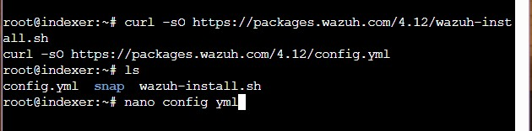

Page 5. Console view on the Indexer

Page 6. config.yml
We also tested secure file transfer capabilities by sending the wazuh-install-files.tar (containing cluster credentials and certificates) from the Indexer node to the Server and Dashboard nodes using SCP (Secure Copy Protocol):
scp wazuh-install-files.tar root@<private-ip>:~
This ensured that all components used a synchronized and secure configuration for the cluster deployment.
Page 7. Usign SCP to send the wazuh-install-files.tar to the server
After setting the private IP addresses in the config.yml file and having the wazuh-install-files.tar in each machine, we proceeded to install each of the components by following the official Wazuh documentation, which provides detailed instructions for installing the Indexer, Server, and Dashboard in distributed environments. This guide was essential to ensure a correct and secure configuration between the nodes.
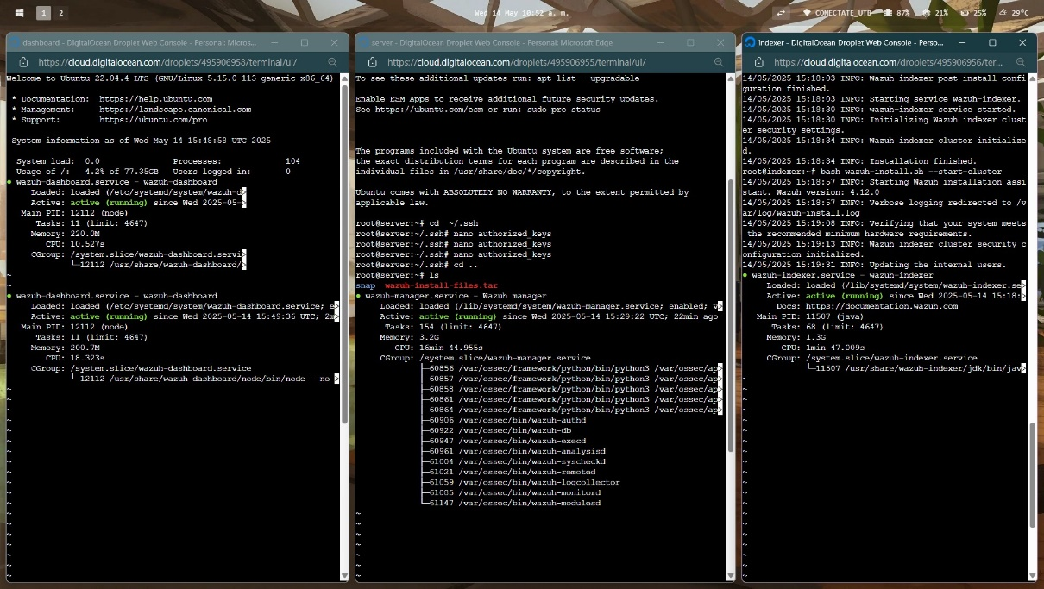
Page 8. Console view of the components running

During testing and laboratories, we evaluated:
  - Component connectivity (Indexer, Server, Dashboard).
  - API communication between the dashboard and the Wazuh manager.
  - Port accessibility between nodes.
  - Automated certificate handling and secure file transfers.
  - Initial agent registration and alert visibility.

We encountered several issues related to closed ports, which initially blocked communication between nodes. For example, the Wazuh Dashboard was unable to connect to the API of the Wazuh Server. These issues were resolved by opening the necessary ports (e.g., 55000, 443, 9200) using UFW (Uncomplicated Firewall):
sudo ufw allow 55000/tcp
sudo ufw allow 443/tcp
sudo ufw allow 9200/tcp
sudo ufw reload

The testing phase validated that the architecture functioned correctly in a segmented and cloud-based environment, simulating the future deployment target in Azure. It also helped identify key operational requirements like proper firewall rules, correct IP configuration, and certificate-based authentication between components.

Results
Wazuh was successfully installed on a virtual machine running Ubuntu Server 22.04 LTS. During the process, all the system's main components were configured, including the Wazuh Server, the Wazuh Indexer, the Wazuh Dashboard, and the Wazuh Agent. These elements comprise the solution's basic architecture, enabling the collection, analysis, and visualization of security events in real time from client computers to the centralized monitoring environment.

Results obtained

- The Wazuh server and its web interface (Dashboard) were fully installed and deployed.

- The required ports were enabled to allow communication between components (55000, 1514, 1515, 9200, 5601, among others).

- The Wazuh agent was successfully installed on a client machine, and communication with the server was established.

- The flow of events generated by the client was logged and displayed in real time.

- 35 events were detected over a 24-hour period, of which:

- 13 events were user authentication failures.
- 2 events corresponded to successful authentications.
- No critical alerts of level 12 or higher were recorded.

- Alerts were identified from various system sources, such as:

- Syslog
- Apparmor
- Dpkg
- PAM (Pluggable Authentication Modules)

These results reflect the proper operation of the monitoring system and the agent's ability to capture operating system events.

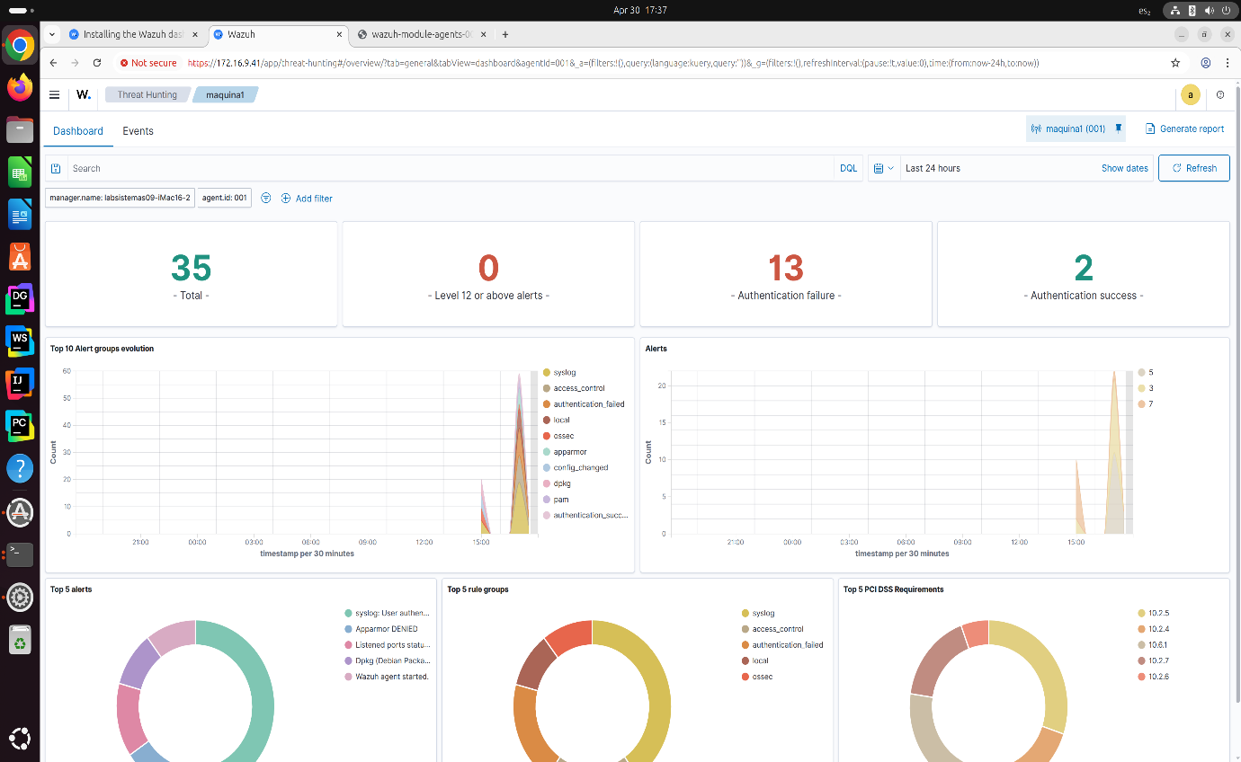
Page 9. Results Obtained

Issues Encountered

During the initial configuration, several issues were identified:
- Wazuh API in Offline status
Symptom: The Dashboard showed the API connection status as "Offline".
Cause: Port 55000 was closed on the firewall.
Solution: The port was opened using the command sudo ufw allow 55000, which restored the API connection.

- Cluster disabled
Symptom: The cluster option appeared as “Disabled” in the API connections section. Cause: The cluster is not enabled by default in single-node installations.
Solution: Enabling the cluster was not necessary in this environment, but the procedure was documented for use in distributed setups.

- Persistent “Checking” connection status
Symptom: The Dashboard continuously displayed the API connection status as “Checking”.
Solution: Wazuh services were restarted on the server, and the API connection was refreshed from the Dashboard.

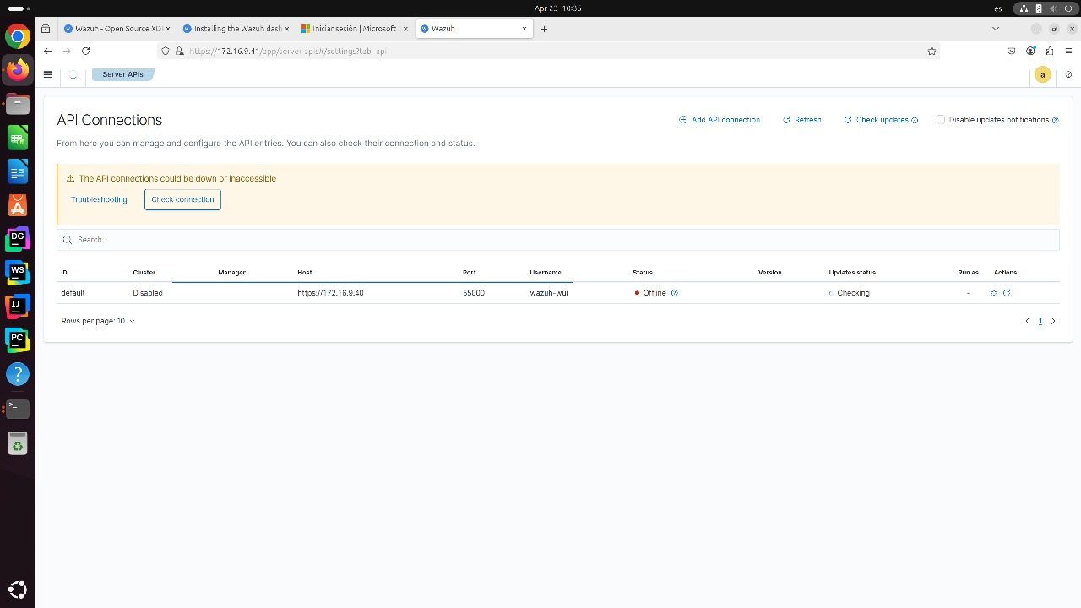Page 10. Issues Encountered
Final System Status

After resolving the initial issues, the system was left fully operational with the following capabilities:
- Real-time detection and visualization of security events.
- Continuous monitoring of system log files.
- Remote agent management from a centralized web interface.
- Stable API communication between the Dashboard and the Wazuh Server.
- Ready to scale to distributed environments with multiple agents or analysis nodes.

Detailed Design

Alternative selection
Although section 2.2 addressed some general criteria for choosing the architecture, this section delves into the comparative analysis that led to the selection of Wazuh as the monitoring and security solution for Sysnet.
During the evaluation phase, several widely used alternatives in corporate environments were considered, including:
- Splunk.
- AlienVault OSSIM.
- Graylog.
- Customized ELK Stack (Elasticsearch, Logstash, Kibana).
- Wazuh.
Each option was evaluated based on the following criteria:
- Compatibility with existing infrastructure.
- Ease of implementation.
- Threat detection and correlation capabilities.
- Licensing and cost.
- Scalability.
- Ease of use and maintenance.
Comparison and Justification
- Splunk offers advanced data analysis and visualization capabilities, but its licensing model based on indexed data volume represents a high cost for an organization like Sysnet, which seeks a low-cost solution for an environment with multiple endpoints.
- AlienVault OSSIM is a robust open-source solution that includes SIEM, but its interface is less intuitive, and its performance can be compromised in high-volume environments without optimized infrastructure.
- Graylog has good integration with agents and offers basic visualizations but lacks advanced security event correlation capabilities like those offered by Wazuh.
- Customized ELK Stack requires manual configuration of multiple components, which implies greater operational and maintenance complexity. Additionally, it does not natively include threat detection or centralized agent management capabilities.
Selection of Wazuh
Wazuh was selected for the following key reasons:
- It is an open-source solution, eliminating licensing costs.
- It includes threat detection, log analysis, vulnerability management, and integrity monitoring in a single platform.
- Its modular and scalable architecture allows deployments ranging from small environments to large corporations.
- It offers a modern web interface (Wazuh Dashboard) and an optimized indexer (OpenSearch) that enhance the user experience.
- It provides agents for Windows, Linux, and macOS, which aligns with the diversity of devices in Sysnet.
- It allows for relatively simple implementation using automated scripts, ideal for university or testing environments such as the one used in the prototype.
In summary, Wazuh offered the ideal balance between functionality, cost, ease of implementation, and compatibility with the goals and capabilities of Sysnet, which justified its selection over other alternatives.

Design Description and Drawings
The final architecture of the system implemented for Sysnet is shown in the following diagram. This solution is composed of three main layers: the endpoint layer, the Wazuh server cluster, and the visualization and indexing layer.
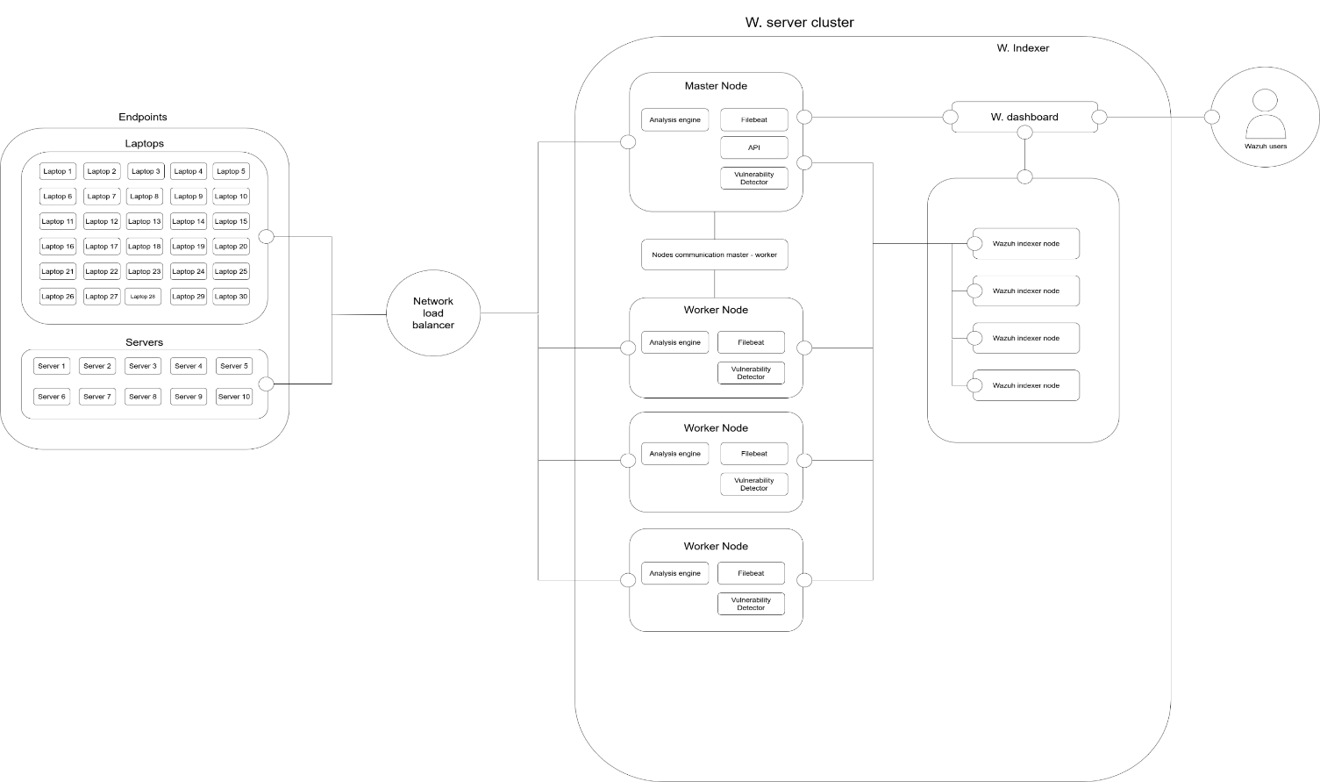
Diagram 1. Wazuh System Architecture Implemented at Sysnet
- In the endpoint layer, there are 30 laptops and 10 servers, which send security data, system logs, and events through a network load balancer to the Wazuh cluster.
- The Wazuh server cluster consists of one master node and several worker nodes. Each node includes components such as:
  - Analysis engine.
  - Filebeat (for log forwarding).
  - Vulnerability Detector.
Additionally, the master node incorporates the Wazuh API and manages the communication between the nodes in the cluster (master and workers).
- The indexing and visualization layer includes:
  - Wazuh Indexer, composed of multiple nodes responsible for data storage and search via OpenSearch.
  - Wazuh Dashboard, which provides a modern web interface for monitoring, event analysis, and alert management by users.
The system was designed to be modular, scalable, and easy to maintain, allowing its adaptation to both testing environments and corporate environments with medium data loads. Additionally, its distributed structure improves fault tolerance and service availability.

Analysis and Calculations
To ensure optimal performance of the monitoring and security system based on Wazuh, a resource estimation was conducted for each component of the architecture, considering approximately 40 monitored endpoints and a moderate log volume. Below are the recommended specifications for each component, based on best practices and Wazuh’s official documentation:
Wazuh Server (Manager)
Responsible for analyzing, correlating, and storing data received from agents.
- Processor: 4 - 8 cores (Intel Xeon/E5 or AMD EPYC/Ryzen 7).
- RAM: 8 - 16 GB.
- Storage: 100 - 200 GB SSD (depending on log volume)
- Operating System: Linux (Ubuntu 16.04, 18.04, 20.04, 22.04, 24.04, CentOS 7.8).

Wazuh Indexer (based on OpenSearch)
Handles the storage, indexing, and searching of logs.
- Processor: 8 - 16 cores.
- RAM: 16 - 32 GB (recommended for large data volumes).
- Storage: 500 GB - 2 TB SSD (depending on log retention and volume).
- Operating System: Linux.

Wazuh Dashboard
Graphical interface for viewing events, alerts, and managing the system.
- Processor: 4 - 8 cores.
- RAM: 8 - 16 GB.
- Storage: 100 - 200 GB SSD.
- Operating System: Linux.

Wazuh Worker
Distributes the processing load when the number of agents is high.
- Processor: 4 - 8 cores.
- RAM: 8 - 16 GB.
- Storage: 100 - 500 GB SSD.
- Operating System: Linux.

Wazuh Agents (Endpoints)
Installed on devices to be monitored (servers, laptops, etc.).
- Processor: 2 - 4 cores.
- RAM: 2 - 4 GB.
- Storage: 10 - 50 GB (depending on logs and system type).
- Operating System: Windows, Linux, macOS.

Additional Estimates:
- Estimated daily log volume: ~400 MB/day (assuming 40 endpoints generating an average of 10 MB/day each).
- Estimated retention period: 30 days, which implies at least 12 GB of storage for logs alone.
- Network usage: Moderate, with peaks during log transfers or policy updates.
- Expected response times: Under 2 seconds for simple dashboard queries, depending on log volume and indexer capacity.

Evaluation
During the development of the project, both the functional and non-functional requirements outlined in section 1.4 were validated. Although the initial plan included the connection and integration of 50 endpoints (30 laptops and 20 servers), this phase was not completed due to time and scope constraints. However, the complete architecture was successfully designed and deployed in the cloud using Azure DevOps, with the Wazuh environment configured along with the corresponding automatic alerts and security settings.

Verification of Functional Requirements
Requirement | Status | Verification Evidence
Implement Wazuh SIEM for real-time monitoring | Fulfilled | Successful deployment in Azure DevOps environment with configured alerts
Configure and deploy agents on 50 endpoints | Partially fulfilled | Architecture for endpoint connection was designed, but implementation was not completed
Set up automatic alerts and generate reports | Fulfilled | Configuration applied in the Wazuh dashboard with examples of alerts and logs
Integration with administration tools | Partially fulfilled | Integration points with Sysnet’s existing tools were defined for future use
Table 1. Verification of Functional Requirements
Verification of Non-Functional Requirements
Requirement | Status | Comment
Scalability | Fulfilled | Designed architecture allows horizontal scaling as endpoint count grows
Performance | Fulfilled | System configured with optimal parameters to minimize network and processing impact
Availability | Fulfilled | Architecture includes basic redundancy and failover possibility
Security | Fulfilled | Restricted access to the dashboard with multi-factor authentication in Azure DevOps
Maintainability | Fulfilled | Scripts and automation used to facilitate future updates
Compliance | Partially fulfilled | Design aligned with security best practices, although no formal audit against ISO/NIST was conducted
Table 2. Verification of Non-Functional Requirements

Conclusions
The development of this project represented a rewarding experience both technically and academically. Throughout the design and implementation process of the security architecture with Wazuh 4.12, practical knowledge was acquired regarding SIEM system configuration, cloud deployment, automation using tools like Azure DevOps, and the integration of real-time security alerts.
One of the main lessons learned was the importance of carefully planning the architecture before beginning the implementation, as well as the need to thoroughly understand the capabilities and limitations of each component involved. The relevance of considering from the start factors such as scalability, performance, and ease of maintenance was also understood, to ensure a sustainable solution over time.
Although the initial goal was to connect 50 real endpoints to the system, logistical and time constraints were identified during the development, which led to a redefinition of the project scope. The focus shifted to building and validating functional and adaptable architecture, which was successfully achieved.
If we had to repeat the process, it would be valuable to begin earlier testing on the performance of system modules under different workloads and to further automate the configuration and deployment processes. Additionally, documenting each step in more detail from the beginning would have facilitated future implementations.
In summary, the project met its core objectives and laid the foundation for a potential full implementation in a corporate infrastructure. Beyond the technical design, this process helped strengthen problem-solving skills, collaborative work, and informed decision-making—essential elements in the field of systems engineering.

References
[1] Microsoft, “What is Azure DevOps?,” Microsoft Learn, 2023. [Online]. Available: https://learn.microsoft.com/en-us/azure/devops/user-guide/what-is-azure-devops
[2] OpenSearch Project, “Welcome to OpenSearch documentation,” OpenSearch.org, 2024. [Online]. Available: https://opensearch.org/docs/latest/
[3] Wazuh, “Wazuh 4.12 Documentation,” Wazuh, 2024. [Online]. Available: https://documentation.wazuh.com/current/
[4] Wazuh, “Wazuh cloud and architecture overview,” Wazuh, 2024. [Online]. Available: https://documentation.wazuh.com/current/deployment-options/index.html

