**DELIVERY 21 APRIL**

Irene Blanco Fabregat

Juan Antonio Muñoz

**USE CASE DIAGRAM**

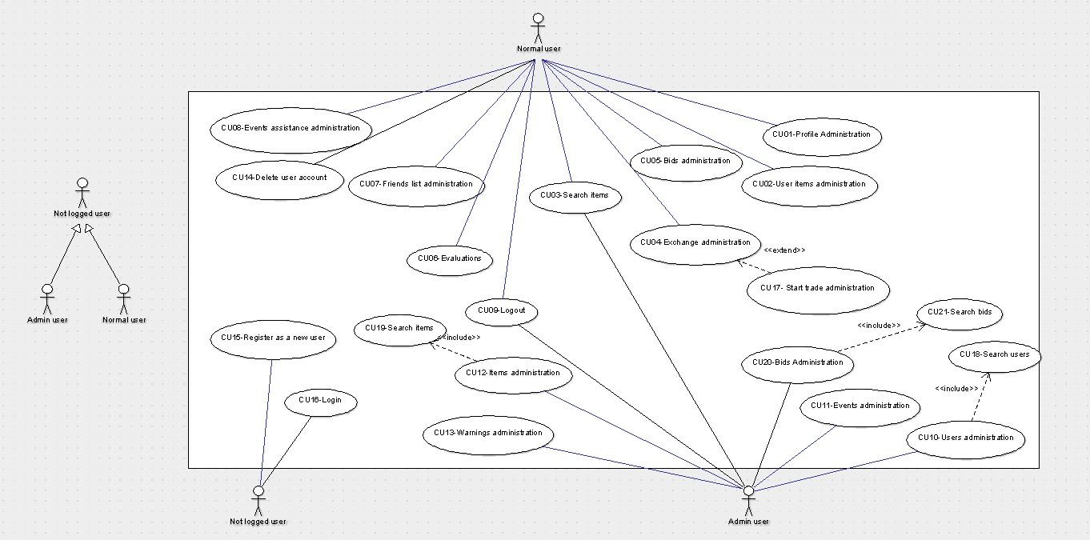



**USE CASE DESCRIPTIONS**

|  |  |
| --- | --- |
| **Name** | **CU01 – Profile administration** |
| **Author** | Irene Blanco Fabregat / Juan Antonio Muñoz |
| **Date** | 17/03/2015 |
| **Description** | **In this case the user can choose the next four options**  **A.** The user is able to add or modify his profile image  **B.** The user can delete his profile image  **C.** The user is able to add or modify his basic data  **D.** The user can add or modify all his preferences |
| **Actors** | Normal user |
| **Preconditions** | Be registered as a normal user |
| **Postconditions** | **A.** The profile image is added or modified  **B.** The profile image is deleted  **C.** The basic data is added or modified  **D.** The preferences are added or modified |
| **Normal way** | **A.1.** The user makes a request to add or modify his profile image  **A.2.** The system asks for an image on the computer’s user  **A.3.** The user selects an image  **A.4.** The system validates the image  **B.1.** The user makes an a request to delete his current profile image  **C.1.** The user makes a request to add or modify his basic data (username, city, country and email)  **C.2.** The system shows a form with all the old data if exists, and empty otherwise  **C.3.** The user inputs all the data  **C.4.** The system validates all the data  **D.1.** The user makes a request to add or modify his preferences  **D.2.** The system shows a form with all the old preferences if exists, and empty otherwise  **D.3.** The user inputs all the preferences he want  **D.4.** The system validates all the preferences |
| **Alternative way** | **A.4.1.** The image size is not accepted  **A.4.2.** The system shows a message and return to A.2  **C.4.1.** Some fields of form are not valid  **C.4.2.** The system shows the invalid fields  **C.4.3.** Return to C.2  **D.4.1.** Some fields of form are not valid  **D.4.2.** The system shows the invalid fields  **D.4.3.** Return to D.2 |

|  |  |
| --- | --- |
| **Name** | **CU02 – User items administration** |
| **Author** | Irene Blanco Fabregat / Juan Antonio Muñoz |
| **Date** | 17/03/2015 |
| **Description** | **In this case the user can choose the next three options:**  **A.** The user is able to add an item to his own list.  **B.** The user is able to modify an item of his own list  **C.** The user is able to delete an item of his own list |
| **Actors** | Normal user |
| **Preconditions** | Be registered as a normal user |
| **Postconditions** | **A.** The new item is added in database  **B.** An item from the database is modified  **C.** An item from the database is deleted |
| **Normal way** | **A.1.** The user makes a request to add a new item in his own list.  **A.2.** The system shows an empty formulary to put the item data and image  **A.3.** The user puts all item data and selects item images  **A.4.** The system validates image  **A.5**. The system validates the item data  **B.1.** The user makes an a request to modify one item from his own items list  **B.2.** The system shows a form with all the old data if exists, and empty otherwise  **B.3.** The user puts all the data and puts the new image If he wants  **B.4**. The system validates all the data  **B.5.** The system validates the modified image  **C.1.** The user makes a request to delete an item from his own list.  **C.2.** The system shows a confirm, to see if user is sure to delete this item |
| **Alternative way** | **A.4.1.** The image size is not accepted  **A.4.2.** The system shows a message and return to A.2  **A.5.1.** Some fields of form are not valid  **A.5.2.** The system shows the invalid fields  **A.5.3.** Return to A.2  **B.4.1**. Some field of form are not valid  **B.4.2.** The system shows the invalid fields  **B.4.3**. Return to B.2  **B.5.1**. The image size or type is not accepted  **B.5.2**. The system shows a message and return tu B.2  **C.2.1.** User clicks 'Cancel'. The system returns user to item list. |

|  |  |
| --- | --- |
| **Name** | **CU03 – Search items** |
| **Author** | Irene Blanco Fabregat / Juan Antonio Muñoz |
| **Date** | 17/03/2015 |
| **Description** | **A.** The user and admin are able to search items by different filters (can search by title, artist, genre, release year, condition and offering type) |
| **Actors** | Normal user and admin |
| **Preconditions** | Be registered as a normal user or admin |
| **Postconditions** | **A.** The system shows items with the filter condition from database. |
| **Normal way** | **A.1.** The user/admin makes a request to search items by different filters introduced.  **A.2.** The system shows items with the filter condition and his information (user who have this item, location, etc) |
| **Alternative way** | **A.4.1.** Any item exist with this filter conditions.  **A.4.2.** The system shows an error message and returns to A.1, showing a new field to search. |

|  |  |
| --- | --- |
| **Name** | **CU04 – Exchange administration** |
| **Author** | Irene Blanco Fabregat / Juan Antonio Muñoz |
| **Date** | 17/03/2015 |
| **Description** | **In this case the user can choose the next three options:**  **A.** The user is able to start trade.  **B.** The user is able to accept trade.  **C.** The user is able to deny trade. |
| **Actors** | Normal user |
| **Preconditions** | Be registered as a normal user |
| **Postconditions** | **A.** The user starts a trade with other user in order to exchange items.  **B.** The user accepts trade so the next step is talk with the other user in order to get the item in the place where they wants.  **C.** The trade is denied from the user. |
| **Normal way** | **A.1.** The user wants an item he look and makes a request to start trade.  **A.2.** This point calls the CU17 in order to do differents actions.  **B.1.** Any user offer an item and the other user accepts trade.  **B.2.** The system shows a direct message to talk with the other user in order to get the item in the place where they wants.  **C.1.** The user denies the trade with one user.  **C.2.** The system returns to the offered items list. |
| **Alternative way** | **A.1.1.** This item is already in process to exchange.  **A.1.2.** The system shows an error message and return to the item list searched.  **B.2.1.** This item is already in process to exchange.  **B.2.2.** The system shows an error message and return to the offered items list. |

|  |  |
| --- | --- |
| **Name** | **CU17 – Start trade administration** |
|  |  |
| **Author** | Irene Blanco Fabregat / Juan Antonio Muñoz |
| **Date** | 17/03/2015 |
| **Description** | **In this case the user can choose the next three options:**  **A.** The user is able to offer an item.  **B.** The user is able to deny an item.  **C.** The user is able to send a direct message. |
| **Actors** | Normal user |
| **Preconditions** | Be registered as a normal user |
| **Postconditions** | **A.** The user provides one of his items in order to exchange this item.  **B.** The user denies an item which one user offers him  **C.** The user sends a direct message in order to start a trade. |
| **Normal way** | **A.1.** After giving trade with one item, the user makes a request to offer an item from his items list.  **A.2.** The system shows his items with one button for each item.  **A.3.** The user clicks in one of his items and this item is offered to the other user.  **B.1.** The user denies an offered item.  **B.2.** The system returns to the offered items list.  **C.1.** After giving trade with one item, the user makes a request to send a direct message.  **C.2.** The system shows a window where you can write a direct message. |
| **Alternative way** | **A.2.1.** The user don't have any item in his items list.  **A.2.2.** The system prompts to upload a new item. (*)  **A.2.3.** The system calls the CU02 point A.  **C.1.1.** The item was exchanged with other user.  **C.1.2.** The system returns to the items list which user is looking. |

|  |  |
| --- | --- |
| **Name** | **CU05 – Bids administration** |
| **Author** | Irene Blanco Fabregat / Juan Antonio Muñoz |
| **Date** | 17/03/2015 |
| **Description** | **In this case the user can choose the next five options:**  **A.** The user is able to add a bid tag to an item.  **B.** The user is able to set/change the bid duration for each item.  **C.** The user is able to set/change the bid start price.  **D.** The user can close the bid if he likes the achieved price.  **E.** The user is able to cancel bid. |
| **Actors** | Normal user |
| **Preconditions** | Be registered as a normal user |
| **Postconditions** | **A.** One item has now a bid tag and the other users can view the bid conditions.  **B.** The duration of bid is changed for one item.  **C.** One item has now a bid start price.  **D.** The bid of one item is closed.  **E.** The bid of one item is canceled. |
| **Normal way** | **A.1.** The user makes a request to add a bid tag in one item from his items list.  **A.2.** The system shows formulary to put the bid basic data (duration bid, bid start price). This basic data aren't required because later can set or change this data.  **B.1.** If one item have a bid tag, the user makes a request to set or change the bid duration of this item.  **B.2.** The system shows formulary to introduce the bid duration.  **C.1.** If one item have a bid tag, the user makes a request to set or change the bid start price of this item.  **C.2.** The system shows a formulary to introduce the bid start price.  **D.1.** The user makes a request to close the bid of one item.  **D.2.** The system shows the last maximum bidder in order to contact with him.  **E.1.** The user makes a request to cancel the bid of one item.  **E.2.** The system returns to the items list. |
| **Alternative way** | **B.2.1.** The bid duration introduced is empty or incorrect.  **B.2.2.** The system returns to the formulary to introduce the bid duration.  **C.2.1.** The start price introduced is empty or incorrect.  **C.2.2.** The system return to the formulary to introduce the bid price.  **D.1.1.** The item don't have the bid tag.  **D.1.2.** The system shows an error message.  **E.1.1.** The item don't have the bid tag.  **E.1.2.** The system shows an error message. |

|  |  |
| --- | --- |
| **Name** | **CU06 – Evaluations** |
| **Author** | Irene Blanco Fabregat / Juan Antonio Muñoz |
| **Date** | 17/03/2015 |
| **Description** | **A.** The user is able to evaluate the trade process when ends the exchange. |
| **Actors** | Normal user |
| **Preconditions** | Be registered as a normal user |
| **Postconditions** | **A.** The evaluation has been send to the admin. |
| **Normal way** | **A.1.** The two users close the exchange.  **A.2.** The system shows a formulary to complete an evaluation in order to know if any problem has been occurred. |
| **Alternative way** | **A.2.1.** The user cancels the evaluation.  **A.2.2.** The system returns to the home page. |

|  |  |
| --- | --- |
| **Name** | **CU07 – Friends list administration** |
| **Author** | Irene Blanco Fabregat / Juan Antonio Muñoz |
| **Date** | 17/03/2015 |
| **Description** | **In this case the user can choose the next two options:**  **A.** The user is able to add a friend to his friends list.  **B.** The user is able to delete a friend from his friends list. |
| **Actors** | Normal user |
| **Preconditions** | Be registered as a normal user |
| **Postconditions** | **A.** One friend is added to the friends list.  **B.** One friend is deleted from the friends list. |
| **Normal way** | **A.1.** The user looks a user profile and makes a request to add this user to his friends list.  **A.2.** The user must wait for the other user accept him.  **B.1.** The user looks friends list and makes a request to delete one of this users. |
| **Alternative way** | **A.2.1.** The second user don't accept the friend request.  **A.2.2.** This user isn't added to friends list. |

|  |  |
| --- | --- |
| **Name** | **CU08 – Events assistance administration** |
| **Author** | Irene Blanco Fabregat / Juan Antonio Muñoz |
| **Date** | 17/03/2015 |
| **Description** | **In this case the user can choose the next three options:**  **A.** The user is able to see the events details.  **B.** The user is able to confirm his assistance in the event.  **C.** The user is able to add comment on the event. |
| **Actors** | Normal user |
| **Preconditions** | Be registered as a normal user |
| **Postconditions** | **A.** The user knows the event details.  **B.** The assistance is confirmed in the event and the admin of the event knows it.  **C.** The comment is added on the event. |
| **Normal way** | **A.1.** The user looks the day of calendar he wants participate in the event and clicks in the event to enter.  **A.2.** The user clicks in 'See more' to see the details.  **A.3.** The system shows a window with the information of event (hour, location, group, price, participants, etc)  **B.1.** In the event the user clicks to confirm assistance.  **B.2.** The system shows a message accepting.  **C.1.** In the event the user clicks in the text box to write a comment. |
| **Alternative way** | **B.1.** If user is already joinned in the event and clicks one more time to confirm assistance, the confirmation is cancelled.  **C.1.1.** The length of comment exceeds the limit.  **C.1.2.** The system shows a message and don't allows add this comment. |

|  |  |
| --- | --- |
| **Name** | **CU09 – Logout** |
| **Author** | Irene Blanco Fabregat / Juan Antonio Muñoz |
| **Date** | 17/03/2015 |
| **Description** | **A.** The user can logout from his profile. |
| **Actors** | Normal user and admin |
| **Preconditions** | Be registered and logged as a normal user or admin |
| **Postconditions** | **A.** The user or admin session is closed. |
| **Normal way** | **A.1.** The user or admin makes a request to logout. |
| **Alternative way** | - |

|  |  |
| --- | --- |
| **Name** | **CU10 – Users administration** |
| **Author** | Irene Blanco Fabregat / Juan Antonio Muñoz |
| **Date** | 17/03/2015 |
| **Description** | **In this case the admin can choose the next three options:**  **A.** The admin is able to add a new user.  **B.** The admin is able to modify a user.  **C.** The admin is able to delete a user. |
| **Actors** | Admin |
| **Preconditions** | Be logged as admin |
| **Postconditions** | **A.** The new user is added by admin.  **B.** The user is modified by admin.  **C.** The user is deleted by admin. |
| **Normal way** | **A.1.** The admin makes a request to add a new user.  **A.2**. The system calls the CU18 in order to view if user exist. This CU returns a user.  **A.3.** The system shows a form to puts the user data.  **B.1.** The admin makes a request to modify one user data.  **B.2.** The system calls the CU18 in order to search users. This CU returns a user.  **B.3.** The system shows a form with latest data of this user in order to modify them.  **C.1.** The admin makes a request to delete one user.  **C.2.** The system calls the CU18 in order to search users. This CU returns a user.  **C.3.** The admin confirms delete this user. |
| **Alternative way** | **A.2.1.** This user already exist.  **A.2.2.** The system returns to A.2  **A.3.1.** Any field is empty or with incorrect data.  **A.3.2.** The system shows an error message and returns to A.3  **B.3.1.** Any field contains incorrect data or is empty.  **B.3.2.** The system shows an error message and return to B.3. |

|  |  |
| --- | --- |
| **Name** | **CU18 – Search users** |
| **Author** | Irene Blanco Fabregat / Juan Antonio Muñoz |
| **Date** | 17/03/2015 |
| **Description** | **A.** The admin can search users by userID |
| **Actors** | Admin |
| **Preconditions** | Be logged as admin |
| **Postconditions** | **A.** This CU returns a user |
| **Normal way** | **A.1.** The system shows a form to introduce the id of user to search.  **A.2.** Search in database and return the user. |
| **Alternative way** | **A.2.1.** The user with this id doesn't exist.  **A.2.2.** The system returns to A.1 |

|  |  |
| --- | --- |
| **Name** | **CU11 – Events administration** |
| **Author** | Irene Blanco Fabregat / Juan Antonio Muñoz |
| **Date** | 17/03/2015 |
| **Description** | **In this case the admin can choose the next three options:**  **A.** The admin is able to add an event  **B.** The admin is able to modify an event  **C.** The admin is able to delete an event |
| **Actors** | Admin |
| **Preconditions** | Be logged as admin |
| **Postconditions** | **A.** A new event is added  **B.** One event is modified  **C.** One event is deleted |
| **Normal way** | **A.1.** The admin makes a request to create a new event.  **A.2.** The system shows a form to input the event information  **B.1.** The admin makes a request to modify one event.  **B.2.** The system shows a form with latest event data in order to modify them.  **C.1.** The admin makes a request to delete an event.  **C.2.** The admin confirms delete this event. |
| **Alternative way** | **A.2.1.** Any field is empty or with incorrect data.  **A.2.2.** The system returns to A.2  **B.2.1.** Any field is empty or with incorrect data.  **B.2.2.** The system returns to B.2 |

|  |  |
| --- | --- |
| **Name** | **CU12 – Items administration** |
| **Author** | Irene Blanco Fabregat / Juan Antonio Muñoz |
| **Date** | 17/03/2015 |
| **Description** | **In this case the admin can choose the next three options:**  **A.** The admin is able to add an item  **B.** The admin is able to modify an item  **C.** The admin is able to delete an item |
| **Actors** | Admin |
| **Preconditions** | Be logged as admin |
| **Postconditions** | **A.** A new item is added  **B.** One item is modified  **C.** One item is deleted |
| **Normal way** | **A.1.** The admin makes a request to add a new item.  **A.2**. The system calls the CU19 in order to view if item exist. This CU returns an item.  **A.3.** The system shows a form to puts the item data.  **B.1.** The admin makes a request to modify one item data.  **B.2.** The system calls the CU19 in order to search items. This CU returns an item.  **B.3.** The system shows a form with latest data of this item in order to modify them.  **C.1.** The admin makes a request to delete one item.  **C.2.** The system calls the CU19 in order to search items. This CU returns an item.  **C.3.** The admin confirms delete this item. |
| **Alternative way** | **A.2.1.** This item already exist.  **A.2.2.** The system returns to A.2  **A.3.1.** Any field is empty or with incorrect data.  **A.3.2.** The system shows an error message and returns to A.3  **B.3.1.** Any field contains incorrect data or is empty.  **B.3.2.** The system shows an error message and return to B.3. |

|  |  |
| --- | --- |
| **Name** | **CU19 – Search items** |
| **Author** | Irene Blanco Fabregat / Juan Antonio Muñoz |
| **Date** | 17/03/2015 |
| **Description** | **A.** The admin can search items by itemID |
| **Actors** | Admin |
| **Preconditions** | Be logged as admin |
| **Postconditions** | **A.** This CU returns an item |
| **Normal way** | **A.1.** The system shows a form to introduce the id of item to search.  **A.2.** Search in database and return the item. |
| **Alternative way** | **A.2.1.** The item with this id doesn't exist.  **A.2.2.** The system returns to A.1 |

|  |  |
| --- | --- |
| **Name** | **CU13 – Warnings administration** |
| **Author** | Irene Blanco Fabregat / Juan Antonio Muñoz |
| **Date** | 17/03/2015 |
| **Description** | **A.** The admin can to user a warning direct message. |
| **Actors** | Admin |
| **Preconditions** | Be logged as admin |
| **Postconditions** | **A.** The warning message has been send to user. |
| **Normal way** | **A.1.** The admin makes a request to send a warning message to one user.  **A.2.** The system shows a form to input the warning message. |
| **Alternative way** |  |

|  |  |
| --- | --- |
| **Name** | **CU14 – Delete user account** |
| **Author** | Irene Blanco Fabregat / Juan Antonio Muñoz |
| **Date** | 17/03/2015 |
| **Description** | **A.** The user is able to delete his account. |
| **Actors** | User |
| **Preconditions** | Be logged as user |
| **Postconditions** | **A.** The user account has been deleted. |
| **Normal way** | **A.1.** The user makes a request to delete his account.  **A.2.** The system shows a confirm.  **A.3.** The user confirms the delete. |
| **Alternative way** | **A.2.1.** The user clicks cancel and returns to home page. |

|  |  |
| --- | --- |
| **Name** | **CU15 – Register as a new user** |
| **Author** | Irene Blanco Fabregat / Juan Antonio Muñoz |
| **Date** | 17/03/2015 |
| **Description** | **A.** The not registred and logged user is able to create an account. |
| **Actors** | Not registred and logged user |
| **Preconditions** | - |
| **Postconditions** | **A.** The user account is created. |
| **Normal way** | **A.1.** The system shows a form to input the basic data.  **A.2.** The system redirects to your profile page in order to inputs your data. |
| **Alternative way** | **A.1.1.** Any field is empty or with incorrect data.  **A.1.2.** The system return to A.1  **A.2.1.** Any field is empty or with incorrect data.  **A.2.2.** The system return to A.2 |

|  |  |
| --- | --- |
| **Name** | **CU16 – Login** |
| **Author** | Irene Blanco Fabregat / Juan Antonio Muñoz |
| **Date** | 17/03/2015 |
| **Description** | **A.** The not logged user is able to login in his account. |
| **Actors** | Not logged user |
| **Preconditions** | - |
| **Postconditions** | **A.** The user is logged. |
| **Normal way** | **A.1.** The system shows a form to input the mail or nickname and the password.  **A.2.** The system redirects to the home page. |
| **Alternative way** | **A.1.1.** Any field is empty or with incorrect data.  **A.1.2.** The system shows an error message and returns to A.1. |

|  |  |
| --- | --- |
| **Name** | **CU20 – Bids administration** |
| **Author** | Irene Blanco Fabregat / Juan Antonio Muñoz |
| **Date** | 17/03/2015 |
| **Description** | **In this case the admin can choose the next three options:**  **A.** The admin is able to add a bid  **B.** The admin is able to modify a bid  **C.** The admin is able to delete an item |
| **Actors** | Admin |
| **Preconditions** | Be logged as admin |
| **Postconditions** | **A.** A new bid is added  **B.** One bid is modified  **C.** One bid is deleted |
| **Normal way** | **A.1.** The admin makes a request to add a new bid.  **A.2**. The system calls the CU21 in order to view if bid exist. This CU returns a bid.  **A.3.** The system shows a form to puts the bid data.  **B.1.** The admin makes a request to modify one bid data.  **B.2.** The system calls the CU21 in order to search bids. This CU returns a bid.  **B.3.** The system shows a form with latest data of this bid in order to modify them.  **C.1.** The admin makes a request to delete one bid.  **C.2.** The system calls the CU21 in order to search bids. This CU returns a bid.  **C.3.** The admin confirms delete this bid. |
| **Alternative way** | **A.2.1.** This bid already exist.  **A.2.2.** The system returns to A.2  **A.3.1.** Any field is empty or with incorrect data.  **A.3.2.** The system shows an error message and returns to A.3  **B.3.1.** Any field contains incorrect data or is empty.  **B.3.2.** The system shows an error message and return to B.3. |

|  |  |
| --- | --- |
| **Name** | **CU21 – Search bids** |
| **Author** | Irene Blanco Fabregat / Juan Antonio Muñoz |
| **Date** | 17/03/2015 |
| **Description** | **A.** The admin can search bids by bidID |
| **Actors** | Admin |
| **Preconditions** | Be logged as admin |
| **Postconditions** | **A.** This CU returns a bid |
| **Normal way** | **A.1.** The system shows a form to introduce the id of bid to search.  **A.2.** Search in database and return the bid. |
| **Alternative way** | **A.2.1.** The bid with this id doesn't exist.  **A.2.2.** The system returns to A.1 |

**ENTITY RELATION DIAGRAM**

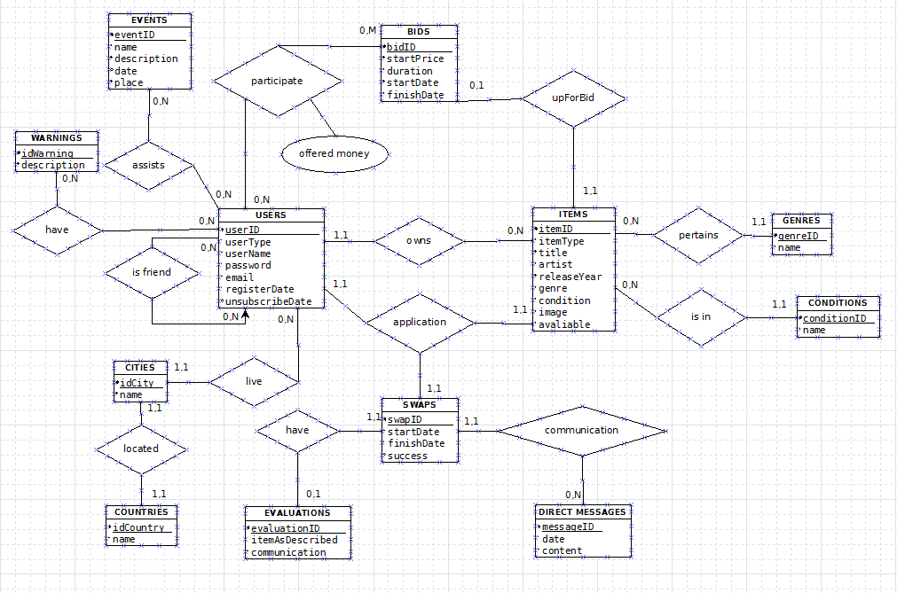

**Conversion from E-R to Relational:**

**PK** **FK PK&FK**

**USERS** (**userID(PK)**, **regionID (FK)**, userType, userName, password, email, registerDate, unsubscribeDate)

**PROVINCES** (**provinceID(PK)**, **regionID (FK)**, name)

**REGIONS** (**regionID(PK)**, name)

**EVENTS** (**eventID(PK)**, name, description, date, place)

**ITEMS** (**itemID(PK),** **userID(FK)**, **bidID(FK),** itemType, title, artist, releaseYear, genreID, conditionID, image, avaliable)  
**BIDS** (**bidID(PK), itemID(FK),**  startPrice, duration, startDate, finishDate)

**WARNINGS** (**warningID(PK)**, description)

**EVALUATIONS** (**evaluationID(PK)**, itemAsDescribed, comunication)

**SWAPS** (**swapID(PK)**, startDate, finishDate, succes)

**DIRECT_MESSAGES** (**messageID(PK)**, **swapID(FK)**, date, content)

**EVENTS_ASSISTANCE** (**userID(PK&FK)**, **eventID(PK&FK)**)

**BIDS_PARTICIPATION** (**userID(PK&FK)**, **bidID(PK&FK)**, offered money)

**WARNING_USERS** (**warningID(PK&FK)**, **userID(PK&FK)**)

**FRIENDS** (**userID(PK&FK)**, **friendID(PK&FK)**)

**APPLICATIONS** (**userID(PK&FK)**, **swapID (PK&FK)**, **itemID (FK)**)

**GENRES**(**genreID(PK),** name)

**CONDITIONS(conditionID(PK), name)**

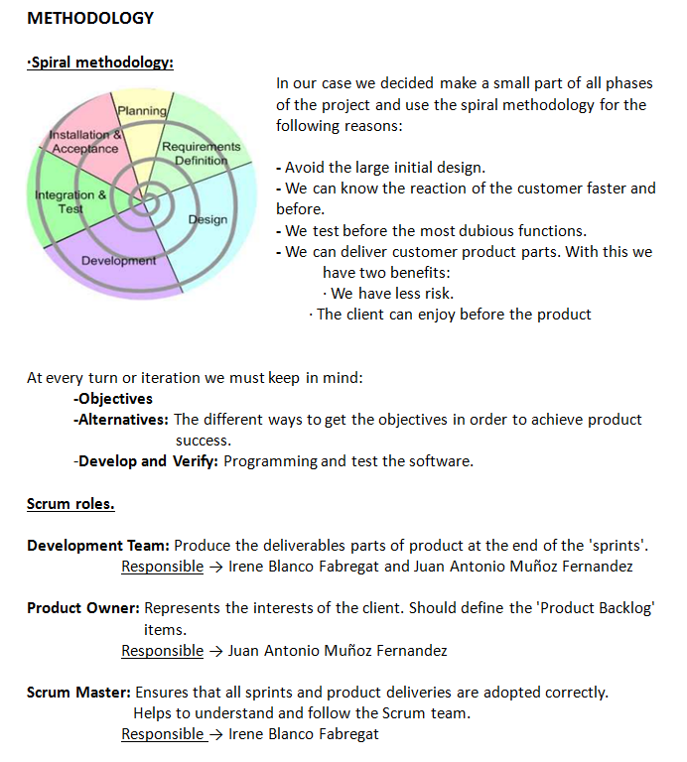

**PROJECT BACKLOG**

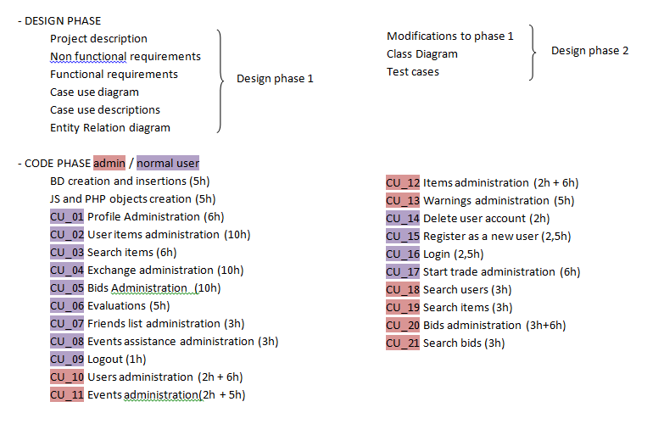

**PROJECT PLANNING** 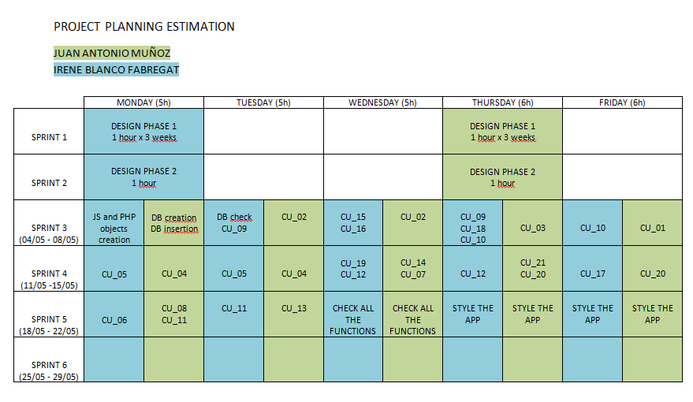

**Tables and inserts**

**Users:**

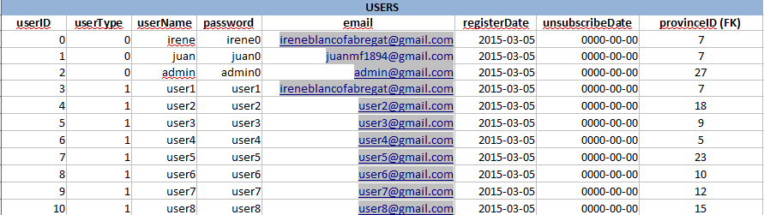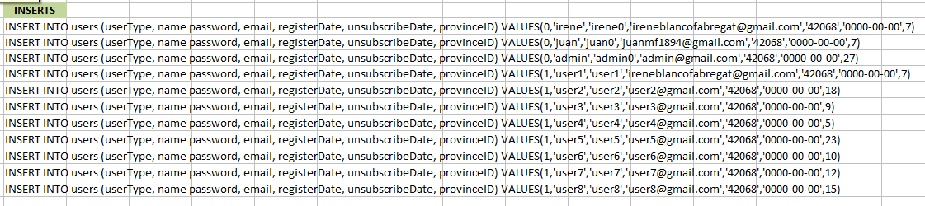

**Provinces:**

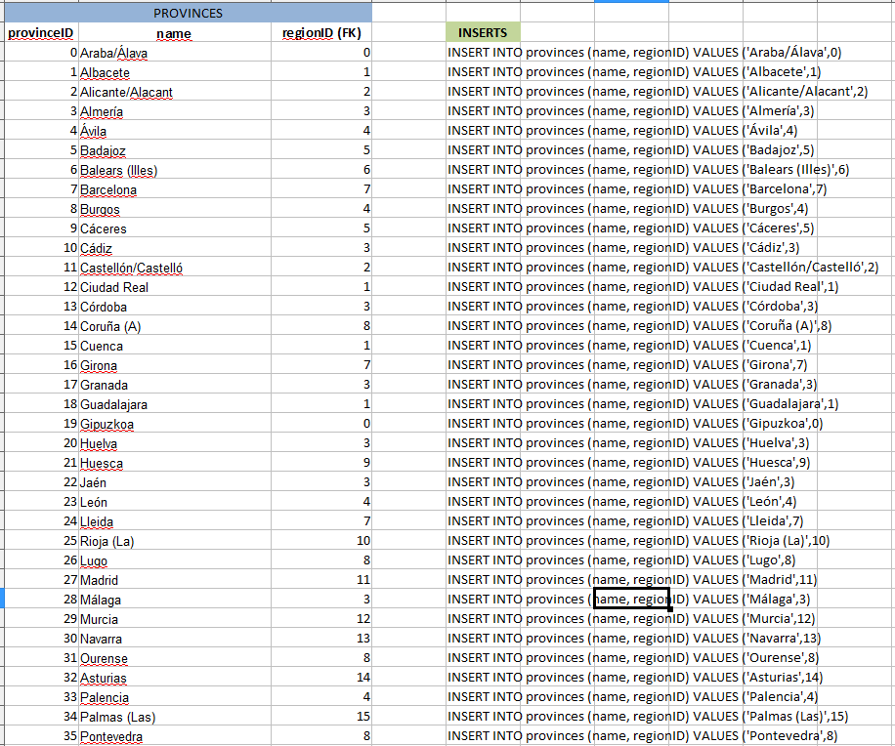

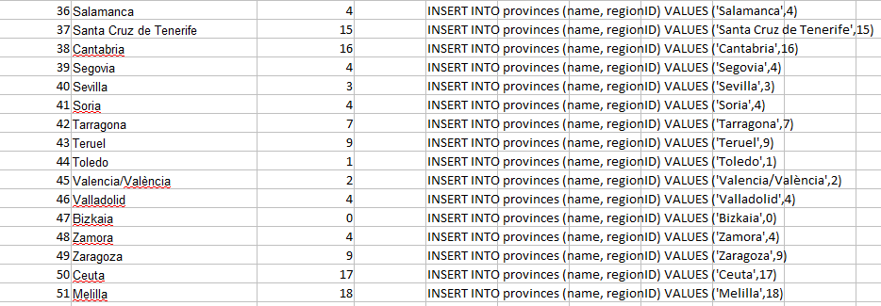

**Regions:**

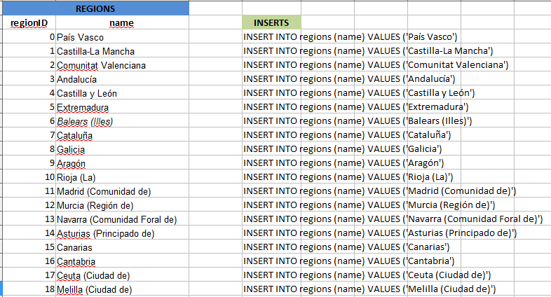

**Events:**



**Items:**

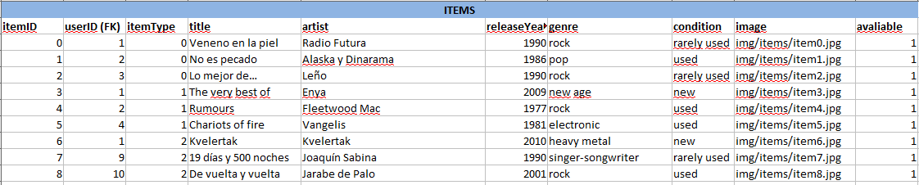

**Bids:  
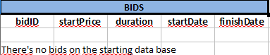**

**Warnings:**

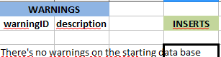

**Swaps:**

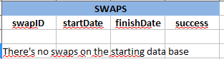

**Evaluations:**

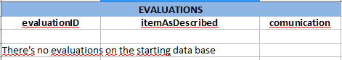

**Direct messages:**

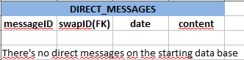

**Events assitance:**

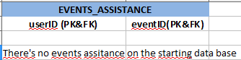

**Bids participations:**

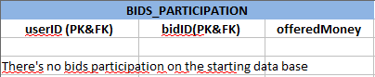

**Warning users:**

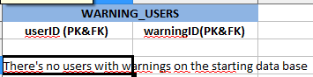

**Friends:**

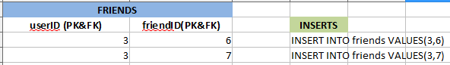

**Applications:**

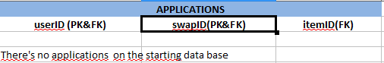

**Genres:**

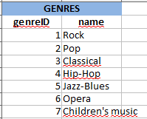

**Conditions:**

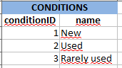

**Class diagram**

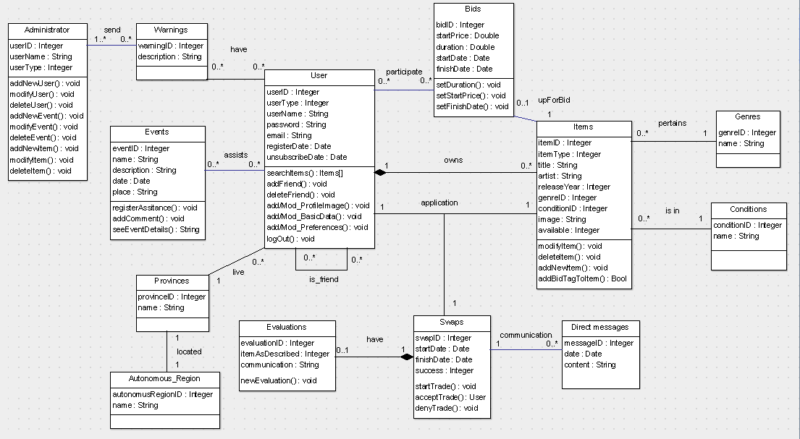

**Test cases**

Valid way

Not valid way -> invalid data underlined

|  |  |
| --- | --- |
| **Test Case ID:** TestCase_1 | **Test Designed by:** Juan Antonio Muñoz |
| **Test Priority (Low/Medium/High):** Med-High | **Test Designed date:** 03/05/2015 |
| **Module Name:** Login | **Test Executed by:** <Name> |
| **Test Title:** Verify login with valid username and password | **Test Execution date:** <Date> |
| **Description:** Test the user login page | |
| **Pre-conditions:** User has valid username and password | |

|  |  |  |  |  |  |
| --- | --- | --- | --- | --- | --- |
| Step | Test steps | Test data | Expected result | Actual Result | Status  (Pass/Fail) |
| 1 | Navigate to login page | Username: user1@  gmail.com  Password: 123456 | User should be able to login | User is redirected with successful login | Pass |
| 2 | Provide valid username | Username: user1@  gmail.com  Password: 1234 | User should be able to login | The system shows the field where the user fails | Fail |
| 3 | Provide valid password |  |  |  |  |
| 4 | Check on login button |  |  |  |  |
| **Post-conditions:** User is validated with database and successfully login to account. | | | | | |

|  |  |
| --- | --- |
| **Test Case ID:** TestCase_2 | **Test Designed by:** Juan Antonio Muñoz |
| **Test Priority (Low/Medium/High):** Med | **Test Designed date:** 03/05/2015 |
| **Module Name:** Add/Modify basic data | **Test Executed by:** <Name> |
| **Test Title:** Add/modify basic data | **Test Execution date:** <Date> |
| **Description:** Test the data introduction and the behaviour of this function | |
| **Pre-conditions:** User has valid username and password and has entered | |

|  |  |  |  |  |  |
| --- | --- | --- | --- | --- | --- |
| Step | Test steps | Test data | Expected result | Actual Result | Status  (Pass/Fail) |
| 1 | Navigate to add/modify basic data page | Username: user1  City: Hospitalet  Password:123456  Email: user1@gmail.com | User data should be added or modified | User is informed that the data are added | Pass |
| 2 | Provide valid data(username, city, password, email, etc) | Username: user1  City: Hospitalet  Password: 123456  Email: “” | User data should be added or modified | The system shows the field where the user fails | Fail |
| 3 | Check on add/modify basic data button |  |  |  |  |
| **Post-conditions:** User data are introduced into database. | | | | | |

|  |  |
| --- | --- |
| **Test Case ID:** TestCase_3 | **Test Designed by:** Juan Antonio Muñoz |
| **Test Priority (Low/Medium/High):** Med | **Test Designed date:** 03/05/2015 |
| **Module Name:** Add/Modify preferences | **Test Executed by:** <Name> |
| **Test Title:** Add/Modify preferences | **Test Execution date:** <Date> |
| **Description:** Test the preferences introduction and the behaviour of this function | |
| **Pre-conditions:** User has valid username and password and has entered | |

|  |  |  |  |  |  |
| --- | --- | --- | --- | --- | --- |
| Step | Test steps | Test data | Expected result | Actual Result | Status  (Pass/Fail) |
| 1 | Navigate to add/modify user preferences | Genre: Hip Hop  Release year: 1993  Artist: WuTang-Clan, Big-L | User preferences should be added or modified | User is informed that the preferences are added | Pass |
| 2 | Provide valid preferences data(genre, release year, artists, etc) | Genre: Hip Hop  Release year: 2020  Artist: WuTang-Clan, Big-L | User preferences should be added or modified | The system shows the field where the user fails | Fail |
| 3 | Check on add/modify preferences button |  |  |  |  |
| **Post-conditions:** User preferences are introduced into database. | | | | | |

|  |  |
| --- | --- |
| **Test Case ID:** TestCase_4 | **Test Designed by:** Juan Antonio Muñoz |
| **Test Priority (Low/Medium/High):** Med | **Test Designed date:** 03/05/2015 |
| **Module Name:** Add/Modify item | **Test Executed by:** <Name> |
| **Test Title:** Add/Modify item | **Test Execution date:** <Date> |
| **Description:** Test the item data introducted and the last behaviour | |
| **Pre-conditions:** User has valid username and password and has entered | |

|  |  |  |  |  |  |
| --- | --- | --- | --- | --- | --- |
| Step | Test steps | Test data | Expected result | Actual Result | Status  (Pass/Fail) |
| 1 | Navigate to add/modify item | Item type: CD  Genre: Hip Hop  Release year: 1993  Title: Dangerous species  Artist: Big Pun | Item data should be added or modified | User is informed that the item data are added or modified | Pass |
| 2 | Provide valid item data(item type, artist, title, release year, genre, etc) | Item type: CD  Genre: Hip Hop  Release year: 1993  Title: “ ”  Artist: Big Pun | Item data should be added or modified | The system shows the field where the user fails | Fail |
| 3 | Check on add/modify item button |  |  |  |  |
| **Post-conditions:** Item data are introduced or modified in database | | | | | |

|  |  |
| --- | --- |
| **Test Case ID:** TestCase_5 | **Test Designed by:** Juan Antonio Muñoz |
| **Test Priority (Low/Medium/High):** Med | **Test Designed date:** 03/05/2015 |
| **Module Name:** Search item | **Test Executed by:** <Name> |
| **Test Title:** Seacrh item | **Test Execution date:** <Date> |
| **Description:** Test the 'search item' function | |
| **Pre-conditions:** User has valid username and password and has entered | |

|  |  |  |  |  |  |
| --- | --- | --- | --- | --- | --- |
| Step | Test steps | Test data | Expected result | Actual Result | Status  (Pass/Fail) |
| 1 | Navigates to search item | Genre: Hip Hop  Release year: 2007  Artist: K Camp | The user receives an item list with filter option applied | User is informed that the item data are added or modified | Pass |
| 2 | Provide valid item fileters(title, artist, genre, release year, etc) | Any field informed | The user receives an item list with filter option applied | The system shows a message: “You must inform any field” | Fail |
| 3 | Check on search items button |  |  |  |  |
| **Post-conditions:** The user receives a item list. | | | | | |

|  |  |
| --- | --- |
| **Test Case ID:** TestCase_6 | **Test Designed by:** Juan Antonio Muñoz |
| **Test Priority (Low/Medium/High):** Med | **Test Designed date:** 03/05/2015 |
| **Module Name:** Send a direct message | **Test Executed by:** <Name> |
| **Test Title:** Send a direct message | **Test Execution date:** <Date> |
| **Description:** Test the '**s**end a direct message' function | |
| **Pre-conditions:** User has valid username and password and has entered. The user should make a request to start trade with other user. | |

|  |  |  |  |  |  |
| --- | --- | --- | --- | --- | --- |
| Step | Test steps | Test data | Expected result | Actual Result | Status  (Pass/Fail) |
| 1 | Navigates to the user items and makes a request to start trade for one item. | Subject: Start trade  Item: Vinyl-216  Content: Hi! I'm... | The second user receives a message in order to start the trade | The second user receives the message | Pass |
| 2 | Provide valid message data (subject, content, item to trade, etc) | Subject: Start trade  Item: “ ”  Content: Hi! I'm... | The second user receives a message in order to start the trade | The system shows the field where the user fails | Fail |
| 3 | Check on send message button |  |  |  |  |
| **Post-conditions:** The message has been send to the user. Normally in order to come to an agreement. | | | | | |

|  |  |
| --- | --- |
| **Test Case ID:** TestCase_7 | **Test Designed by:** Juan Antonio Muñoz |
| **Test Priority (Low/Medium/High):** Med | **Test Designed date:** 03/05/2015 |
| **Module Name:** Evaluations | **Test Executed by:** <Name> |
| **Test Title:** Evaluations | **Test Execution date:** <Date> |
| **Description:** Test the 'evaluations' function | |
| **Pre-conditions:** User has valid username and password and has entered. The evaluations only occur when two users change an item. | |

|  |  |  |  |  |  |
| --- | --- | --- | --- | --- | --- |
| Step | Test steps | Test data | Expected result | Actual Result | Status  (Pass/Fail) |
| 1 | Two users finish the trade and the system shows a formulary to input the trade evaluation. | Item traded: CD-078  Content: The trade was successful This web is amazing!  Points: 4/5 | The system receives the trade evaluation.  The user sees 'OK'. | The system receives the trade evaluation.  The user sees 'OK'. | Pass |
| 2 | Provide valid evaluation (content, item traded, etc) | Item traded: CD-078  Content: The trade was successful This web is amazing!  Points: “ ” | The system receives the trade evaluation.  The user sees 'OK'. | The system shows the field where the user fails.  (Puntuation is mandatory. Content not.) | Fail |
| 3 | Check on send evaluation button |  |  |  |  |
| **Post-conditions:** The system receives the trade evaluation. | | | | | |

|  |  |
| --- | --- |
| **Test Case ID:** TestCase_8 | **Test Designed by:** Juan Antonio Muñoz |
| **Test Priority (Low/Medium/High):** Med | **Test Designed date:** 03/05/2015 |
| **Module Name:** Add comment on event | **Test Executed by:** <Name> |
| **Test Title:** Add comment on event | **Test Execution date:** <Date> |
| **Description:** Test the 'Add comment on event' function | |
| **Pre-conditions:** User has valid username and password and has entered. The user is logged in an event. | |

|  |  |  |  |  |  |
| --- | --- | --- | --- | --- | --- |
| Step | Test steps | Test data | Expected result | Actual Result | Status  (Pass/Fail) |
| 1 | The user enters in an event where his assistance was confirmed and makes a request to add a comment. | Content: Past year I went to this event and was fantastic! | The comments is added in event. | The comments is added in event. | Pass |
| 2 | Provide valid message content (keeping in mind the maximum characters and bad language) | Content: Past year I went to this event and was fantastic! My name is User4 and i'm exceeding the maximum characters | The comments is added in event. | The system shows that the content is exceeding the length of characters allowed | Fail |
| 3 | Check on 'Add comment' button |  |  |  |  |
| **Post-conditions:** The comment is added in event. | | | | | |

|  |  |
| --- | --- |
| **Test Case ID:** TestCase_9 | **Test Designed by:** Juan Antonio Muñoz |
| **Test Priority (Low/Medium/High):** Med | **Test Designed date:** 03/05/2015 |
| **Module Name:** Add/Modify user (Admin) | **Test Executed by:** <Name> |
| **Test Title:** Add/Modify user (Admin) | **Test Execution date:** <Date> |
| **Description:** Test the 'Add/modify user' admin's functions | |
| **Pre-conditions:** Admin has valid admin username and password and has entered | |

|  |  |  |  |  |  |
| --- | --- | --- | --- | --- | --- |
| Step | Test steps | Test data | Expected result | Actual Result | Status  (Pass/Fail) |
| 1 | Navigate to add/modify user | Username: user1  City: Hospitalet  Password:123456  Email: [user1@gmail.com](mailto:user1@gmail.com)  birthdate: 20/02/1990 | User data should be added or modified | Admin is informed that the user is added or modified in database. | Pass |
| 2 | Provide valid data(username, city, password, email, birthdtae, etc) | Username: user1  City: Hospitalet  Password:123456  Email: ” ”  birthdate: 20/02/1990 | User data should be added or modified | The system shows the field where the admin fails | Fail |
| 3 | Check on add/modify user button |  |  |  |  |
| **Post-conditions:** The user is added or modified in database | | | | | |

|  |  |
| --- | --- |
| **Test Case ID:** TestCase_10 | **Test Designed by:** Juan Antonio Muñoz |
| **Test Priority (Low/Medium/High):** Med | **Test Designed date:** 03/05/2015 |
| **Module Name:** Add/Modify event (Admin) | **Test Executed by:** <Name> |
| **Test Title:** Add/Modify event (Admin) | **Test Execution date:** <Date> |
| **Description:** Test the 'Add/modify event' admin's functions | |
| **Pre-conditions:** Admin has valid admin username and password and has entered | |

|  |  |  |  |  |  |
| --- | --- | --- | --- | --- | --- |
| Step | Test steps | Test data | Expected result | Actual Result | Status  (Pass/Fail) |
| 1 | Navigate to add/modify event | Name: Music Festival Barcelona  Location: Barclona  Price: 20,00€  Image: ../images/.. | Event data should be added or modified | Event has been added or modified. | Pass |
| 2 | Provide valid event data(name, location, price, image, etc) | Name: Music Festival Barcelona  Location: “ ”  Price: 20,00€  Image: ../images/.. | Event data should be added or modified | The system shows the field where the admin fails | Fail |
| 3 | Check on add/modify event button |  |  |  |  |
| **Post-conditions:** The user is added or modified in database | | | | | |

|  |  |
| --- | --- |
| **Test Case ID:** TestCase_11 | **Test Designed by:** Juan Antonio Muñoz |
| **Test Priority (Low/Medium/High):** Med | **Test Designed date:** 03/05/2015 |
| **Module Name:** Add/Modify item (Admin) | **Test Executed by:** <Name> |
| **Test Title:** Add/Modify item (Admin) | **Test Execution date:** <Date> |
| **Description:** Test the 'Add/modify item' admin's functions | |
| **Pre-conditions:** Admin has valid admin username and password and has entered | |

|  |  |  |  |  |  |
| --- | --- | --- | --- | --- | --- |
| Step | Test steps | Test data | Expected result | Actual Result | Status  (Pass/Fail) |
| 1 | Navigate to add/modify item | Artist: Ray Charles  Genre: Jazz-Blues  Title: My lovin'  Image: ../images/.. | Item should be added or modified | Item has been added or modified. | Pass |
| 2 | Provide valid item data(Artist, genre, title, image, etc) | Artist: Ray Charles  Genre: Jazz-Blues  Title: “ ”  Image: ../images/.. | Item should be added or modified | The system shows the field where the admin fails | Fail |
| 3 | Check on add/modify item button |  |  |  |  |
| **Post-conditions:** The item is added or modified in database | | | | | |

|  |  |
| --- | --- |
| **Test Case ID:** TestCase_12 | **Test Designed by:** Juan Antonio Muñoz |
| **Test Priority (Low/Medium/High):** Med | **Test Designed date:** 03/05/2015 |
| **Module Name:** Add/Modify bid (Admin) | **Test Executed by:** <Name> |
| **Test Title:** Add/Modify bid (Admin) | **Test Execution date:** <Date> |
| **Description:** Test the 'Add/modify bid' admin's functions | |
| **Pre-conditions:** Admin has valid admin username and password and has entered. The item should have the bid tag. | |

|  |  |  |  |  |  |
| --- | --- | --- | --- | --- | --- |
| Step | Test steps | Test data | Expected result | Actual Result | Status  (Pass/Fail) |
| 1 | Navigate to add/modify bid | Start price: 5,95€  Duration: 5 days  Start Date: 04/04/2015  Finish date: 09/05/2015 | Bid should be added or modified | Bid has been added or modified. | Pass |
| 2 | Provide valid bid data(Start price, duration, start date, finish date, etc) | Start price: “ ”  Duration: 5 days  Start Date: 04/04/2015  Finish date: 09/05/2015 | Bid should be added or modified | The system shows the field where the admin fails | Fail |
| 3 | Check on add/modify bid button |  |  |  |  |
| **Post-conditions:** The bid is added or modified in database | | | | | |