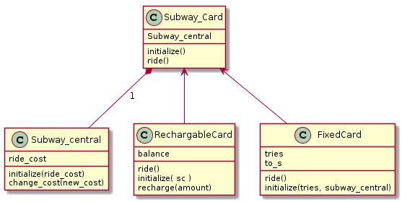

@startuml
class Subway_Card{
Subway_central
initialize()
ride()
}

class Subway_central{
ride_cost
initialize(ride_cost)
change_cost(new_cost)

}

class RechargableCard {
balance
ride()
initialize( sc )
recharge(amount)

}

Subway_Card*--Subway_central : 1
Subway_Card<-- RechargableCard
Subway_Card<-- FixedCard

class FixedCard {
tries
ride()
initialize(tries, subway_central)
to_s
}
@enduml

