# Contents

HomeWork 2 problem 2.b problem 3.a problem 3.b problem 3.c problem 4.a problem 4.b problem 4.c problem 4.d

# HomeWork 2

Juan Alejandro Ormaza Sep 7 2020 CS375

clear all; clc; format long e

# problem 2.b

x=12:1:15;

x_k=num2str(1+(1./10.^(x)),25);

fprintf(x_k); % this line prints the x_k values for k=12 to k=15

1.000000000001000088900582 1.000000000000099920072216 1.000000000000009992007222 1.000000000000001110223025

# problem 3.a

sinErrorExpansion=@(n) 1/(factorial(2*n+1)); n=1;

while sinErrorExpansion(n)>2e-8 n=n+1;

end

n=n-1; %we take one from n because we know that at the last loop of the while

% loop the condition for n was not met. n

n =

5

# problem 3.b

test=my_sin(1,5) % this is a test to find if my_sin works test2=sin(1) % and it appears it did, since the answer resembles

% the built-in sin(x) function

test =

8.414709846480680e-01

test2 =

8.414709848078965e-01

# problem 3.c

x=linspace(0,pi/2,100); % creates the x array for the domain of the function. error1 = abs(sin(x)-my_sin(x,3));

error2 = abs(sin(x)-my_sin(x,5));

figure(); semilogy(x,error1,x,error2); xlabel('x');

ylabel('absolute error of approximation'); title('absolute error of sin(x)'); legend('n=3','n=5')

% from the figure we see that the error is smaller than 2e-8 (the bound)

% for n=5 (my result from 3.a). For n=3, the situation is different as we

% find the error is larger and actually exceeds 2e-8 after x~=0.5.

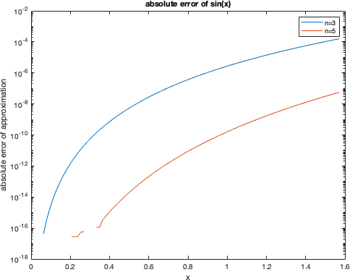

**problem 4.a**

right_side=@(a,b,c) sqrt(b^2 - 4*a*c);

y=right_side(0.5,1000,5e-7); x=1000; %% this is the same as b

%%%from the lost of precision theorem we get. lostOfPrecision=1-y/x

lostOfPrecision = 5.000444502911705e-13

# problem 4.b

%%%here we compute the "true" roots using the matlab built-in functions. poli = [0.5 1000 5e-7];

realRoots = roots(poli)

realRoots =

-1.999999999999500e+03

-5.000000000001249e-10

# problem 4.c

rootFunction=@(a,b,c) -b + sqrt(b^2 - 4*a*c); myResult = rootFunction(0.5,1000,5e-7)

%%%the result of using equation is innacurate because of loss of precision.

%%%However, this is to be expected as we lost 12 to 13 bits of precision

%%%according to part a of this problem.

myResult =

-4.999947122996673e-10

# problem 4.d

newRootFunction=@(a,b,c) -2*c/(b + sqrt(b^2 - 4*a*c)); newRootFunction(0.5,1000,5e-7)

%%%by modifying the formulation for our solution we get to a more

% "accurate" solution that more closely resembles the result given by the

% roots function. In fact, it is the same result up to the 16 decimal

% point.

ans =

-5.000000000001249e-10

*Published with MATLAB® R2021a*