Assignment 05 WEB322

Juan Rivera

ID: 137647228

For this assignment I had to update and improve existing code previously submitted. The important parts were updating the hard coded parts that we did before. I had to change all the JSON related methods to retrieve information from them and then modify said methods to retrieve information from our Postgres database. After installing PGadmin I have created a connection and used the provided script to transfer the JSON data to the database where it can be accessed online.

Furthermore, I had to change all the html files to .ejs files to comply with the requirements of EJS. Also I have added the required middleware to handle req.body to be treated as a JSON object.



Moving on, I have implemented the addSet and editSet forms to accept the input from user to be later proceeded by our express application. Retrieving the data and storing it via Sequalize commands to the database.

Furthermore, I have added CRUD methods and UI buttons for the user to navigate and access these methods easily.

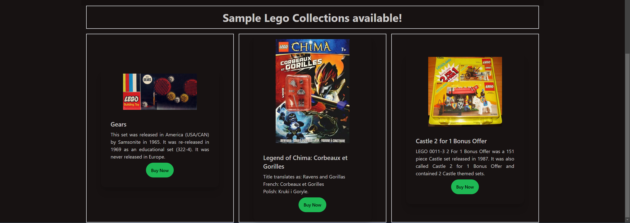

On a closing thought, it was interesting to work with a proper database instead of a static JSON file that will accept user input and will be updated in real time with the current deployment. My app is currently hosted using cyclic at https://ruby-real-cougar.cyclic.app/