**Noun Project website -** [**https://thenounproject.com**](https://thenounproject.com)

**Tipo de letra fuenestes Defont.com**

Luxury - expensive - pricey - valuable - costly - important - beneficial

Fast - express - agile - [run](https://thenounproject.com/search/?q=run) - rapid - quick - light - [flash](https://thenounproject.com/search/?q=quick)

Delivery - mail - drop - ship - contribution -

Happy - - glad - peaceful - satisfied - [smile](https://thenounproject.com/search/?q=smile&i=727849) -

Hands: [box](https://thenounproject.com/search/?q=hand&i=11675) e

Elegance - quality - - glamur - unique - top - high - better - novelty - power

Looks good, feel good - stand out

El timón del carro de entorno del logo como marco de un reloj. En el centro con una manecilla marcando las 3pm un rayo de flash y rapidez

Product

Un [chulo](https://thenounproject.com/search/?q=V&i=580779) de nike  como V de Vicky, chulo de IN STOCK 

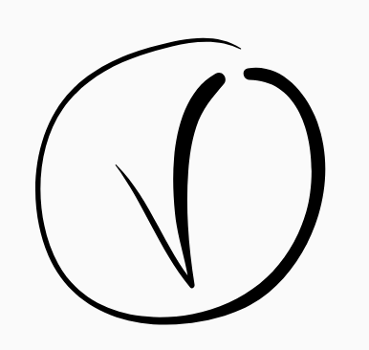[Padlock](https://thenounproject.com/sarafrongia/uploads/?i=580723) 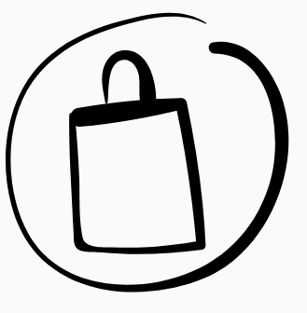[GIFT](https://thenounproject.com/sarafrongia/uploads/?i=672511) 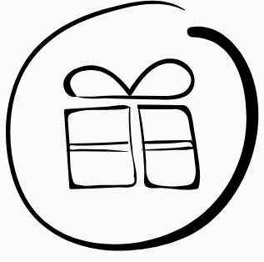

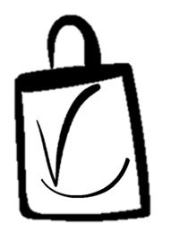

<https://thenounproject.com/sarafrongia/uploads/?i=580720>

