I had to do this assignment twice since I was not happy with the colors of the page in my first attempt. below are the two assignments but the link of the page is based on the colors of the second and final attempt.

First attempt:

I decided to go with green. it is not my favorite color, but I like what it stands for. Green is the color of growth, balance and harmony of the mind, the body, and the emotions." Green is associated with nature, health, and healing. Green in business is the "color of growth and vitality, associated with new life and renewal".

I might use green on my project page since it is going to be about my hobby: Cycling. Green is the perfect color that brings an emotionally positive vibe into my life. It totally relates with cycling because when I go out and ride my bike, I want to exercise, restores depleted energy, stay away from the stresses of modern living, and relax. Green has the same effect on me.

In fact, below are more related information in regard of the **Positive and Negative Traits**

**Positive keywords include**: growth and vitality, renewal and restoration, self-reliance, reliability and dependability, being tactful, emotionally balanced and calm, nature lover and family oriented, practical and down to earth, sympathetic, compassionate and nurturing, generous, kind and loyal with a high moral sense, adaptable, encourages 'social joining' of clubs and other groups, a need to belong.

**Negative keywords include**: being possessive and materialistic, indifferent and over-cautious, envious, selfish, greedy and miserly, devious with money, inconsiderate, inexperienced, a hypochondriac and a do-gooder.

**Positive Color Meanings in Business:**

* growth and vitality, renewal and restoration
* self-reliance, reliability and dependability
* being tactful, emotionally balanced and calm
* nature lover and family oriented
* practical and down to earth
* sympathetic, compassionate and nurturing
* generous, kind and loyal with a high moral sense
* adaptable and flexible
* encourages 'social joining' of clubs and other groups, a need to belong

Here is the link where I got all the information to make my decision.

Finally, below is a screenshot of My Color Scheme I decide to use for my project. the color might change a little bit if I don’t like it on the page but it will still be a set of greens.

[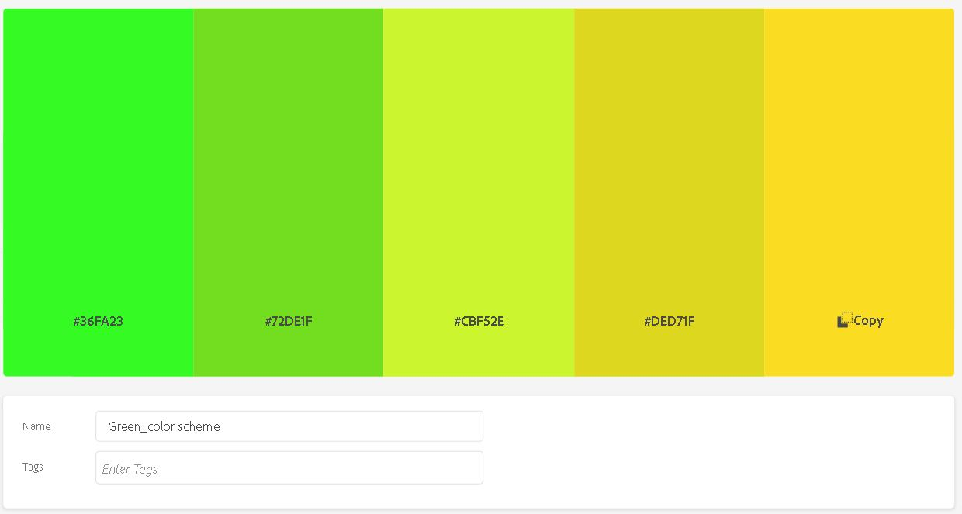](http://students.cpcc.edu/~jdiaz028/web210/images/greenColorScheme.JPG)

My CSS color scheme using green as my basic color:

/* Color in Hex */

Color1: #36FA23;

Color2: #72DE1F;

Color3: #CBF52E;

Color4: #DED71F;

Color5: #FADD23;

/* Color in RGBA */

Color1: rgba(54, 250, 35, 1);

Color1: rgba(114, 222, 31, 1);

Color1: rgba(203, 245, 46, 1);

Color1: rgba(222, 215, 31, 1);

Color1: rgba(250, 221, 35, 1);

/* Color in HSLA */

Color1: hsla(114, 95, 55, 1);

Color1: hsla(93, 75, 49, 1);

Color1: hsla(72, 90, 57, 1);

Color1: hsla(57, 75, 49, 1);

Color1: hsla(51, 95, 55, 1);

Second attempt:

I decided to switch from green to earth colors just because it looks much better on the website. I also decided to use monochromatic colors instead. They just work with my introduction page and it gives a more peaceful vibe. Brown is the color for security, stability, structure, and support. It reflects a more serious page but also a more friendly and familiar site.

Here are some of the **Positive and Negative Traits of Brown**

**Positive keywords include**: down-to-earth, wholesome, practical, approachable, friendly, stable, structured, supportive, comforting, reliable, protective, strength, quietly confident, sensual, sensitive, warm, reassured, honest, sincere, quality.

**Negative keywords include**: dull, boring, frugal, materialistic, lack of humor, lack of sophistication, predictable, cheap and stingy

[Here](https://www.empower-yourself-with-color-psychology.com/color-brown.html) is the link where I got all the information to make my decision.

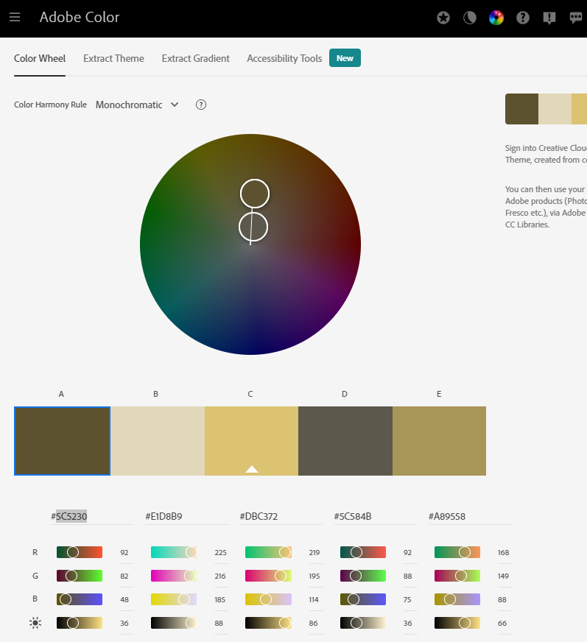

/* Color in Hex */

Color1: #5C5230;

Color2: #E0D7B8;

Color3: #DBC372;

Color4: #5C584B;

Color5: #A89558;

/* Color in RGBA */

Color1: rgba(92, 82, 48, 1);

Color2: rgba(224, 215, 184, 1);

Color3: rgba(219, 195, 114, 1);

Color4: rgba(92, 88, 75, 1);

Color5: rgba(168, 149, 88, 1);

/* Color in HSLA */

Color1: hsla(46, 31, 27, 1);

Color2: hsla(46, 39, 80, 1);

Color3: hsla(46, 59, 65, 1);

Color4: hsla(45, 10, 32, 1);

Color5: hsla(45, 31, 50, 1);

