Mike Rieker
CSC500

SparcSim - The Educational Sparc Simulator

SparcSim is a program written in Java that emulates a Sparc CPU and memory sufficiently for educational purposes. It is GUI based, using the Swing package that is part of standard Java.

All interaction is via buttons and text boxes on the GUI. The GUI is organized as a pseudo-desktop, which contains windows that the user can choose and place as desired.

Control Buttons Window

There is a main menu (across the top) that provides the following buttons:

- Exit Simulator - this causes the simulator to close up completely. If there are any unsaved source changes, the user is prompted as to whether or not to save the changes.
- Open Sparc CPU - this creates a new Sparc CPU window. There can be more than one CPU, as in a multiprocessor system. The window displays a real-time monitoring of the CPU's register contents and provides Step, Run, Halt and Reset buttons for controlling the CPU.
- Open Source Editor - this creates a new source editor window. The user can then open an existing Sparc assembler source file or type in a new source file. The source editor window also has a Save(As) function to write any changes made back to a file. The source editor window has an 'Assemble' button which will cause the simulator to assemble all source files into object code and store the object code into the simulator's memory.
- Open Memory Viewer - this opens a box that will provide a real-time display of the contents of a selected portion of memory. The user must enter the starting and ending addresses of the range of memory to display. A grid is then shown which will monitor and display memory in the range of given addresses. The user can also modify the memory contents by editing the displayed digits.

When the simulator is started, the Control Buttons box is created along the top of the main window, plus one of each of the other three windows. The command line can be given a list of source filenames, in which case the simulator will create a source editor window for each source file named on the command line.

Sparc CPU Window

The Sparc CPU window consists of a set of 8-digit hexadecimal boxes, labeled with the name of the register being displayed next to the box. When the CPU is not running, the user can manually modify the contents of any register by directly editing the contents of the box. There are boxes for PC, NPC, PS and Y, as well as G0-G7, O0-O7, L0-L7 and I0-I7. The G0 box is not modifiable and always contains zeroes.

Since the Sparc has a windowed register architecture, the display area for the O, L and I registers has an horizontal scrollbar along the bottom. If the scrollbar is all the way to the left, the innermost (active) register set will be displayed. If the scrollbar is all the way to the right, the outermost register set will be displayed. The user can tell which register set is being shown by looking at the relative position of the scrollbar as well as the contents of the FP (I6) and SP (O6) registers. When there is only one register set (e.g., just after reset), the scrollbar is inactive.

One way the simulator operates differently than a 'real' CPU is that it has no window overflow trap as such. As frames are needed, it simply keeps extending the number of register sets available. This should be transparent to any normal programs.

The Step button causes the simulated CPU to fetch and execute the one instruction pointed to by the PC register. It then copies the contents of NPC into PC and comes up with a new value for NPC according to the functionality of the instruction just executed.
If the instruction causes an exception (such as unaligned address), a modal dialog box is displayed and neither PC nor NPC are altered.

The Run button causes the simulated CPU to execute instructions continuously (starting at PC) until an exception happens, a breakpoint is hit or the user clicks either the Halt or Reset button. The execution is performed in a sub-thread so all other GUI functions are still available (like looking at memory). All register and memory displays are kept up-to-date in real time. If there is an exception, a modal dialog box is displayed and the CPU halts. If a breakpoint is hit, the CPU halts.

The Halt button is enabled only when the CPU is running in response to the Run button. Clicking it causes the CPU to halt at the end of the current instruction.

The Reset button can be pressed at any time. It clears the CPU to have only one register frame and zeroes all the registers, except:

- the PC is set to global symbol _start in the source file
- the NPC is set to _start+4
- the SP is set to the top of memory

Closing a Sparc CPU window deletes that CPU from the simulator.

Source Editor Window

The source editor window provides the user with a means to enter and edit Sparc assembly language source code. Buttons are provided for the following functions:

- Open – opens a dialog box for the user to select an existing source file then displays its contents in the window. If there is already something in the window that has not been saved, the user is prompted as to whether to save it to disk or not, before opening the new file. In any case, any old contents are erased before the new file's contents are loaded.
- Save (As) - opens a dialog box to ask user where to store the existing contents of the window. The default is the name of the file most recently opened or saved in this window. This button will gray-out immediately after a Save or Open operation. It will be re-enabled when any change is made to the source text.
- Assemble - causes the simulator to assemble all source code in all source editor windows. It starts from the first window opened and proceeds sequentially. The object code is written directly to the simulator's memory (not to any disk file). Finally, all CPUs are reset so they point to the instruction labeled by global symbol _start in the source code.

Once assembled, the addresses and machine code are displayed alongside the source code statements. There is also a small checkbox displayed on lines with object code, which serves as a breakpoint button. When a CPU is about to execute an instruction that has a checkmark on it, it will halt (with its PC pointing to the checked instruction).

The editor window does not check syntax of the source code as it is being entered. The user must click the Assemble button, at which time the simulator will attempt to assemble the code, flagging any errors it finds with a message in red. A popup dialog is also generated (the user may click the Cancel button to disable the popups for the rest of this assembly).

Closing a source editor window removes the window from the simulator. If there are any unsaved changes, the user is asked whether or not to save the changes before the window is closed.

Memory Viewer Window

The memory viewer window provides a real-time monitor of the contents of a user-selected portion of the simulated memory. The user may also modify the contents of memory by directly editing the hexadecimal display. There is also an ASCII interpretation of memory provided along the right side of the display.

The addresses given for the start and end are clipped to the size of memory and are rounded to a 16-byte boundary.

The user may create as many windows as desired and the addresses displayed may overlap. Closing a memory viewer window removes the window from the simulator.

Emulated Instructions

This simulator is not a full Sparc CPU emulation. The instructions emulated are limited to the following:

Arithmetic:

ADD, ADDCC, ADDX, ADDXCC
SUB, SUBCC, SUBX, SUBXCC
MULSCC, RDY, WRY

Logical:

AND, ANDCC, ANDN, ANDNCC
OR, ORCC, ORN, ORNCC
XOR, XORCC, XNOR, XNORCC

Shift:

SLL, SRL, SRA

Load/Store:

LDUB, LDSB, LDUH, LDSH, LD, LDD
STB, STH, ST, STD, SWAP

Conditional branch:

BA, BN, BE, BNE, BL, BLE, BGE, BG
BLU, BLEU, BGEU, BGU, BPOS, BNEG
BCS, BCC, BVS, BVC

Miscellaneous:

CALL, JMPL, SETHI, SAVE, RESTORE

The assembler supports the following synthetic instructions:

CMP, JMP, MOV, NOP
RESTORE, RET, RETL, TST

The following directives are available in the assembler:

.align <expression>
align to a 1, 2, 4, 8 or 16 byte boundary

.ascii “<quoted string>”
create ASCII strings

.byte <value>,...
create 8-bit data items

define (symbol, substitute)
substitutes substitute for every subsequent use of symbol

.global <symbol>,...
mark the given symbols as global

.half <value>,...
create 16-bit data items

.include “<filename>”
include the named file as part of this module
the name of the file must be given in quotes

.macro name arg1,arg2,...
start definition of a macro
the definition ends with a line containing a .endm directive
values given for the arguments are substituted in the body
when the macro is invoked

.skip <numberofbytes>
skip the given number of bytes

.word <value>,...
create 32-bit data items

Assembler Operands

The SparcSim internal assembler handles most common operand forms accepted by the GNU assembler used on the CS Department’s Sparc system. The registers are named using the same names and syntax. Address operands for the load and store instructions have the form:

- [register]
- [register+offset]
- [register-offset]
- [register+register]

The address operand for the jmpl instruction is the same as the load and store address operand except it does not have the brackets.

The RDY instruction takes a single register for an operand. The WRY instruction takes two registers or a register and offset as an operand that are XORed together and written to the Y register.

IODevMuldiv Device

There is a pseudo-IO device that programs can use to perform multiplication and division. While these functions could be coded in Sparc assembler (and it might be a good class assignment), having them done this way is more efficient timewise.

Here is definition of the available registers, accessible only with 32-bit loads and stores:

- IODevMulM1 – one multiply operand (write-only)
- IODevMulM2 – other multiply operand (write-only)
- IODevMulUPH – unsigned product, hi-order (read-only)
- IODevMulUPL – unsigned product, lo-order (read-only)
- IODevMulSPH – signed product, hi-order (read-only)
- IODevMulSPL – signed product, lo-order (read-only)
- IODevDivDH – dividend, hi-order (write-only)
- IODevDivDL – dividend, lo-order (write-only)
- IODevDivDiv – divisor (write-only)
- IODevDivUQ – unsigned quotient (read-only)
- IODevDivUR – unsigned remainder (read-only)
- IODevDivSQ – signed quotient (read-only)
- IODevDivSR – signed remainder (read-only)

The above symbols are permanently defined in the assembler; they need not be defined in any source file. They are guaranteed to be in the upper 4K of the address range, so a simple offset from %g0 will suffice. Sample code can be found in the supplied source file muldiv.s.

Operation of the divide functions with a zero divisor or that results in overflow will produce unpredictable results, but will not crash the simulator. Calling code should check for these conditions before performing the divide and take whatever steps are appropriate.

IODevPrint Window

There is an IO device that programs can use to generate printed output. Whenever a simulated program writes to the special simulated IO register locations, the corresponding output will be displayed on the IODevPrint window. At first the window is invisible, but it becomes visible on the first write.

- To output a null-terminated string, write its address to IODevPrintStrz
- To output an integer in hexadecimal, write its value to IODevPrintHex
- To output a signed decimal integer, write its value to IODevPrintInt
- To output an unsigned decimal integer, write its value to IODevPrintUint
- For a printf-like arg list, write its address to IODevPrintfArgs

The above four symbols are permanently defined in the assembler; they need not be defined in any source file. They are guaranteed to be in the upper 4K of the address range, so a simple offset from %g0 will suffice:

astring: .ascii “Here is an signed integer: “,0
bstring: .ascii “.”,10,0

sethi astring/1024,%o0
add %o0,astring%0x3FF,%o0
st %o0,[%g0+IODevPrintStrz]

mov -1234,%o1
st %o1,[%g0+IODevPrintInt]

add %o0,bstring-astring,%o0
st %o0,[%g0+IODevPrintStrz]

Here is some sample code using the printf-like function:

format: .ascii “one %d, two %d, three %d”,10,0
.align 4
arglst: .word format
.word 1
.word 2
.word 3

sethi arglst/1024,%o0
add %o0,arglst%0x3FF,%o0
mov %o0,[%g0+IODevPrintfArgs]

There is a printf.s file included with the source code that has a general printf routine much like the normal C equivalent.

Screen Shots

Here is a screen shot of SparcSim. It has examples of each of the SparcSim windows. The simulator has a program called hanoi.s open and has stopped at a breakpoint after having written a couple lines of output to the IODevPrint window.

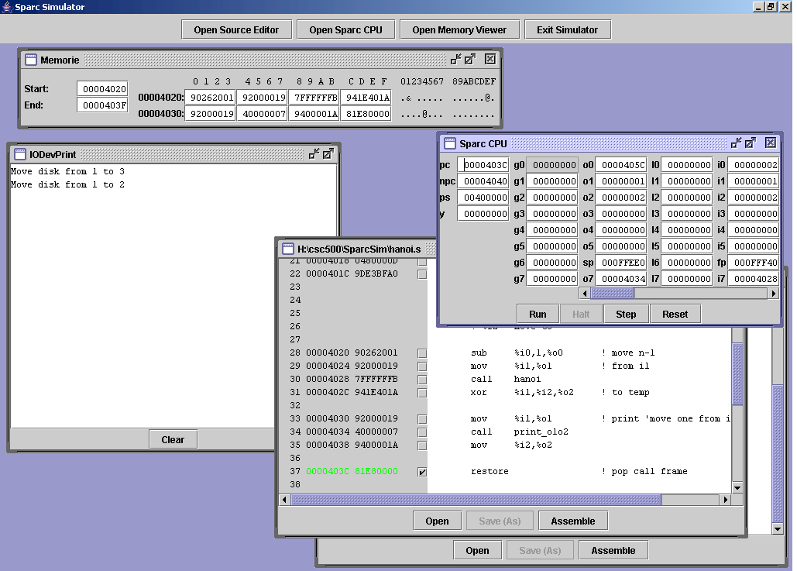

The user can re-position and re-size any window. The control buttons in the upper left corner let the user create new windows as desired or close the simulator.

A file called hanoi.s is open in the Source Editor window in the lower right corner. Here it is in detail:

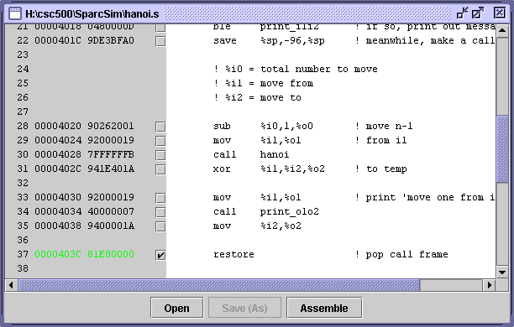

At the very left of the screen are source file line numbers (starting at one), followed by the address of the instruction and its object code. The little boxes on each line are breakpoint checkboxes that, if checked, cause the CPU to halt when it is about to execute that instruction. The Save (As) button is grayed out because there has been no modification since the file was opened or last saved.

The green line shows which statement the CPU is currently pointing to (by its PC). The checkmark indicates that that line’s breakpoint is enabled.

Here is a screenshot of the SparcCPU window at the time of the breakpoint:

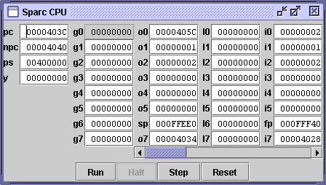

With the scrollbar completely to the left, the innermost (active) register set is being displayed. Since the purple part is one-quarter the total length, there are four register frames currently being used. The user can select which set to display by moving the scrollbar. The user can modify the register contents by editing the contents of the text boxes.

[End.]

