Title: ITCS 6190 – Docker Hands-On 2 (Flask + Redis)
GitHub Repository:
https://github.com/JuanR15/ITCS-6190-docker-handson-2
Overview
This project containerizes a simple Flask web application that tracks page visits using Redis. The application is run using Docker Compose, which starts both the Flask “web” container and the Redis container. Please see all screenshots in the repo for more.
How to Run
- Open a terminal in the project folder.
- Run: docker compose up --build
- Visit: http://localhost:8000
Evidence (Screenshots)
1) Docker Desktop – Containers Running
(Screenshot: DockerContainersPage.png)
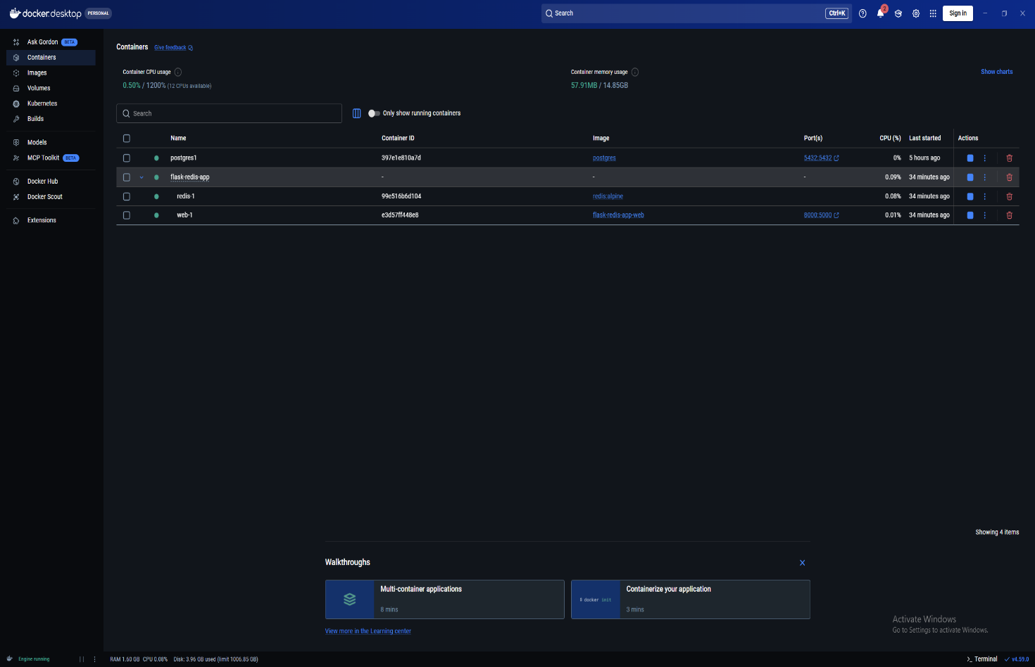
2) Docker Desktop – Web Container Logs
(Screenshot: DockerFlaskRedisAppWebLogs.png)
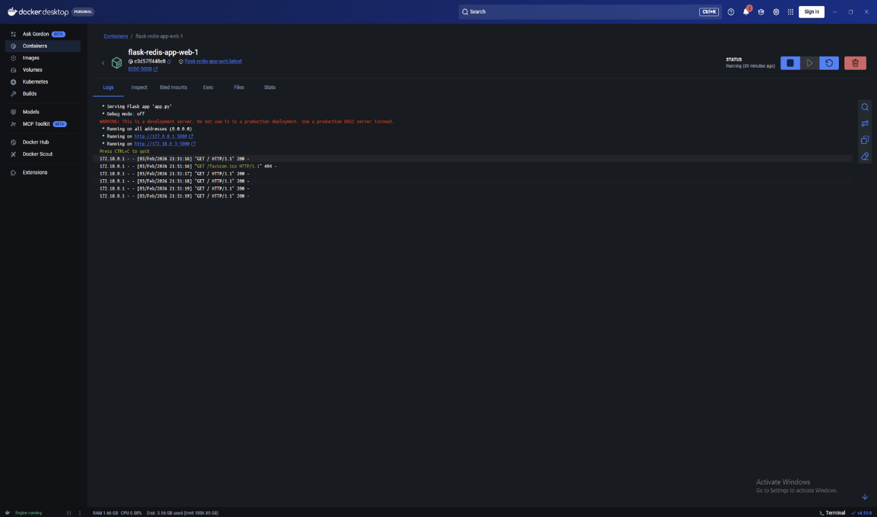
3) Application Output in Browser (refreshed 5 times)
(Screenshot: PageOutput.png)
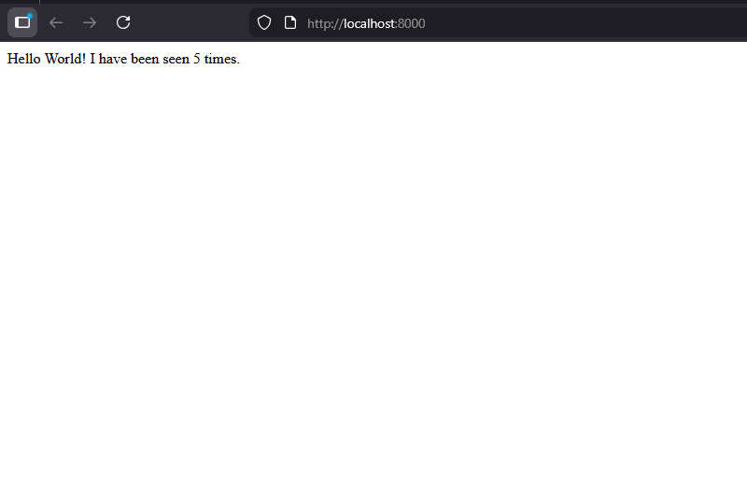

Issues Encountered
1. Flask Command Not Found in Container
During the initial Docker build and container startup, the application failed with an error indicating that the flask executable could not be found in the container’s PATH.
Cause:
The Flask dependency was not properly available when the container attempted to run the flask run command.
Resolution:
The issue was resolved by ensuring Flask was installed via requirements.txt and that the container executed the application using the correct runtime configuration. After rebuilding the image using docker compose up --build, the container started successfully.

2. Git Push Rejected Due to Existing Remote History (please see screenshot)
When pushing the local repository to GitHub, the push was rejected because the remote repository already contained a README file created through GitHub.
Cause:
The local Git history and the remote GitHub repository had unrelated commit histories.
Resolution:
The conflict was resolved by pulling the remote repository using --allow-unrelated-histories, manually resolving the README merge conflict, committing the fix, and successfully pushing the merged changes to GitHub.
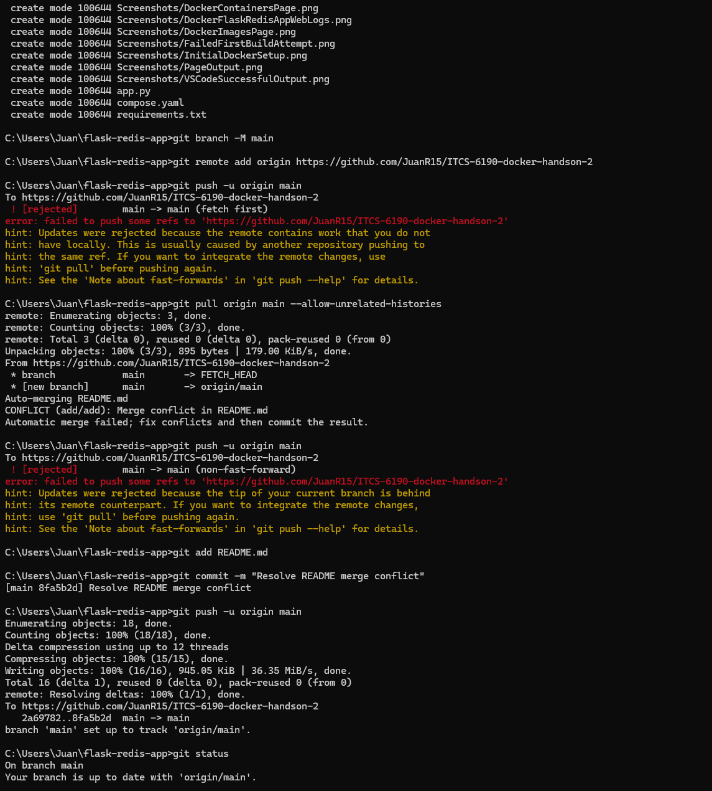

Lessons Learned
- Learned how to build and run a multi-container application using Docker Compose.
- Gained experience troubleshooting container startup errors and interpreting Docker logs.
- Learned how Docker networking allows services (Flask and Redis) to communicate using service names.
- Improved understanding of Git version control, including resolving merge conflicts and synchronizing local and remote repositories in my case.
- Gained hands-on experience documenting technical work using Markdown and managing screenshots within a GitHub repository.

