Predict Electricity Generation from Renewable Energy Sources
Context:
To remain stable, electricity grids require that the amount generated, and the amount consumed are always equal. Because of this, (electrical) power grid operators set up daily “day-ahead” auctions. Between 10:00 and 12:00 CET on each day of the year, suppliers and consumers of electricity make nominations for how much electricity they intend to supply or consume every hour on the next day (hence “day-ahead”). At 12:00 CET the auction closes, all nominations must be done before then.
Renewable energy sources (wind onshore, wind offshore, solar, ignore others i.e. hydro or geothermal) fluctuate a lot hence it is not a trivial task to be able to state today how much electricity one will produce tomorrow. But this is necessary for many of our clients who operate wind or solar parks.
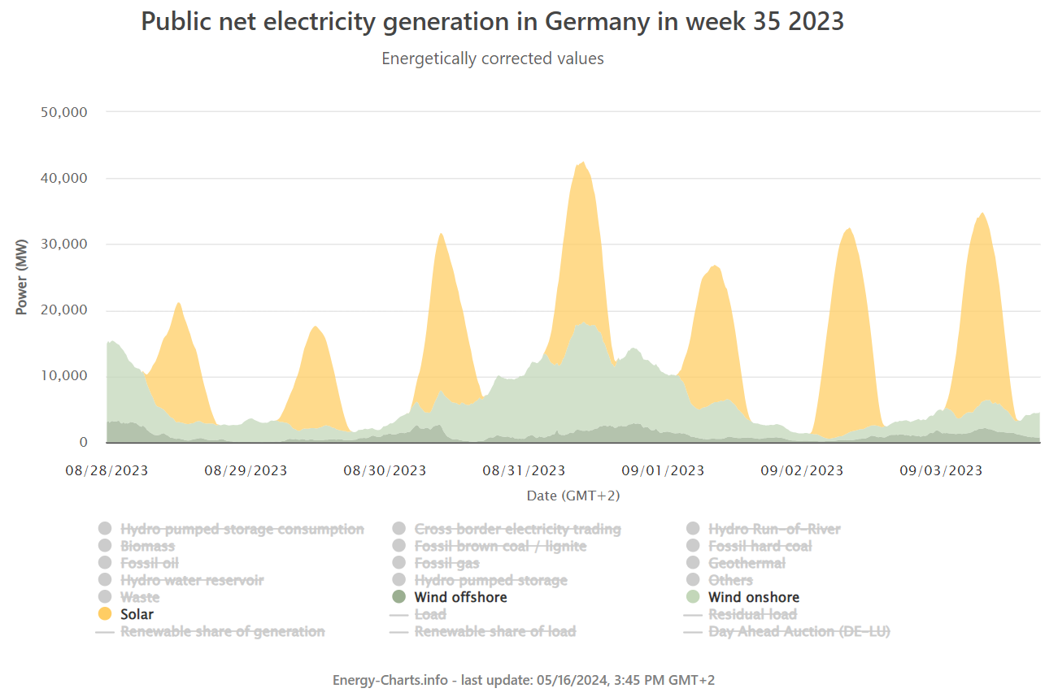
The Task:
Imagine that a client of ours owns all the renewable energy capacity in Germany and needs to nominate its production on the day-ahead auction. Every wrongly predicted MWh carries a penalty of 50 Euro. Currently the client assumes that the production tomorrow will be the same as the production yesterday. Can you build a model to help our client improve the prediction and reduce their costs? You can use any kind of model and setup that you think is appropriate. You can find enough data to have a minimal viable solution to the task here: https://energy-charts.info/index.html?l=en&c=DE. Any data that you find on the website you can use. If you have additional time, feel free to search for other data sources. In all cases consider Requirement 3 below.

Requirements:
- Create a working version of a model that solves the task (github repo with code)
- Create a 3-5 slide presentation in which you present the solution together with evidence how it performs (i.e. appropriate evaluation/backtest)
- The data source above is missing one key piece of data, can you guess what that is? If you had this additional data, how would you use it in the evaluation part? How about when running the model in a production environment?

