# Daily Scrum 06-04-2022

[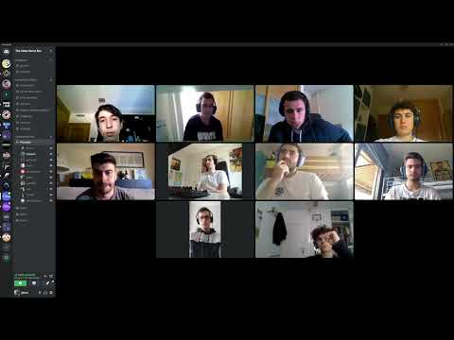](https://www.youtube.com/embed/LbU5sRXQrgk?feature=oembed)