Seat Assignment Problem in Airlines

Juan Felipe Saucedo Forero a, Andres Felipe Montaño Diaz b

a Departamento de Ingeniería Industrial, Bogotá, Colombia, jf.saucedo@uniandes.edu.co

b Departamento de Ingeniería Industrial, Bogotá, Colombia, af.montanod@uniandes.edu.co

**Abstract**

This paper will cover the seat assignment optimization problem under the aviation and airlines context. In which, by using an allocation algorithm we search for the minimum cost of assigning non-booked airplane seats, in which we. With it, we look for the optimality of the solution of an existing real word assignment problem by using the data provided by the Colombian airline “Viva Airlines” . This was tackled by using a linear problem formulation of a minimum cost flow problem, where the greatest barrier was dealing with its implications of relative stochasticity of given that clients booking times and seat purchasing times differ and there’s not a guaranteed number of seats that will be purchased at the time of assigning seats to passengers without booked seats

**Keywords**

Network; Seat-Assignment;; Optimization; Algorithm; Allocation; Minimum cost.

1. Introduction

The main purpose of tackling a commonly known problem such as the seat assignment problem is to identify the main obstacles at the time of assigning seats to passengers who didn´t purchase a specific seat. As it conflicts with the other type of passengers that are on the same flight are willing to purchase and pay for a specific seat, either due to their increased comfort, leg size, or distance to the nearest exit. What this causes is an opportunity cost that every airline loss when they assign a specific seat to a non-profitable passenger. And therefore, the main purpose is to look for the optimal solution of a minimum cost flow problem (MCFP) by modelling the airplane seat assignments.

Here we introduce a model description which contains the model setup & model readings, subsequently a seat assignment problem will be solved using the proposed algorithm:

* 1. Model Description

To solve for every instance of the problem, we modeled the problem as an Allocation algorithm, in which we base the decisioning on heuristics that ensure the feasibility of the solution.

In this case, we took this approach and not a purely LP approach given that for each instance there are different constraints depending on the booked passengers or other exogenous variables, and for each booking in each instance there must be a different scenario depending on the already assigned bookings and the remaining seats.

Given this, the approach used in here is based on an allocation algorithm where similarly to the Dijkstra’s algorithm the main goal is to assign a value (in this case passenger) to each of the positions of a given array, while we empty the array of the unassigned passengers.

In order to show the extent of using multiple linear programing solutions, here is a graph in which we can see how many positions we must iterate over, as we would need to determine to which row each of the passengers from every booking should be assigned and also would need to take into account that no pair of passengers from one booking could go into the same row due to company policies, as they aren´t allowed to assigned passengers from the same booking next to each other, if they did not purchase or booked any specific seat, and in this way try to incentive passengers to acquire their desired seats.

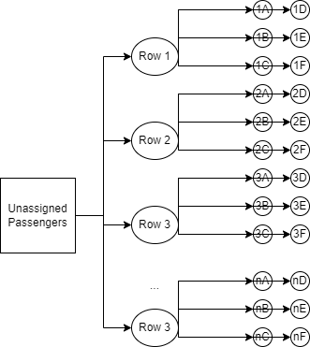

However, in our approach, the cost associated to assigning a passenger to each of the nodes is shown below:



And with it we can

Costs are in thousands of Colombian Pesos (COP) and can be seen in this preview of the cost matrix

Moreover, there are specific caveats to take into account in this case study, as the plane needs a minimum of 85% of occupation to be profitable and take off, and due to this, the weight balance problem becomes trivial, as by fulfilling the 85% of the plane capacity, we ensure the minimum weight distribution among the frontal and back areas of the plane.

* 1. Modelling and Mathematical formulation

**In order to mathematically formulate the problem, we have the following parameters:**

**Sets:**

**C:** Costs {Cost per each specific seat in the plane}

**Ch:** Chairs {Chosen seat in the booked subset}

**B:** Bookings {Number of bookings in a specific flight}

**P:** Passengers {Passengers in a specific booking}

**N**: Nodes {Bookings, rows, letters of the rows}

**A**: Edges {Maximum of people per row/seats (including restriction of one person per booking per row)}

**B:** Bookings

**BB:** Bookings before booking b

**R:** Rows

**Variables:**

$$xi_{br}:if one person of the booking b∈B is going to be assigned to a seat in the row r∈R$$

$$x_{brl}:if one person of the booking b∈B is going to be assigned to a seat in the row r∈R with the letter l∈L$$

**Parameters:**

$${num}_{b}:number of people in booking b∈B$$

$$c_{brl}:cost of purchasing the seat in the row r∈R with the letter l∈L (note that it is the same for all bookinks b∈B)$$

**Objective functions:**

$$\min{\sum_{b∈B}{\sum_{r∈R}{\sum_{l∈L}{c_{brl}*x_{brl}}}}}$$

**Heuristics:**

For each of the bookings

If there’s no assigned seat for the booking i then

Assign min cost to the first passenger in the booking i

Else, if the minimum of the L2 norm is above 1.5 then

Assign the furthest minimum cost to the passenger in the booking i

Else, if there are at least 3 available seats with minimum cost,

Assign the passengers in booking i in the first seat that the L2 norm is above 1.5

Else, repeat the same logic with the second minimum cost.

2 Computational Results

In order to display the results for this case study we are showing one iteration of the seat assignment problem, for which it was chosen a specific flight (Flight-56261) on the date of the 26th of June of 2022.

In this case, these are the bookings that required a specific seat assignment during the check in time frame, as the ones booked before are excluded from the assigning set and are seats that the airline has already received a profit from

Unit Designator: The seat that was actually assigned for this passenger by the airline.

Assigned Seat: The seat that the allocation algorithm suggests

In this case, the first passengers/bookings have matching seats in the *UnitDesignator* and in the *AssignedSeat* columns, this happens in the first bookings given that the bookings are ordered in a FIFO manner, so all the passengers that bought their seat before the check in was open always get to pick their specific seats, which cant be modified later on.



For the specific case study, the outputs shown above help us conclude that, for that specific flight, the airline assigned non-booked passengers with a minimum cost of 2521.0 (thousands of COP). As this is the opportunity cost of previously assigning these seats, under the assumption that anybody could look to purchase these seats immediately after the airline has already assigned them for free.

However, during the 2 day period of the check-in, which is when the airline needs to ensure each passenger a place, the linear programming model, always looks to minimize the opportunity cost and assigned the passengers in their booking order by always looking for the cheapest seat available in order to spare the more exclusive seats for upcoming passengers, and always avoiding to book people from the same booking within the same row.

Methodology comparison:

For this specific case we can compare the results to the first version of the algorithm, as we can compare both Objective functions and see if it reaches an optimal solution, or a better solution using the heuristics algorithm.

Previous version results:

For the specific case study, the outputs shown above help us conclude that, for that specific flight, the airline assigned non-booked passengers with a minimum cost of 2538 (thousands of COP). As this is the opportunity cost of previously assigning these seats, under the assumption that anybody could look to purchase these seats immediately after the airline has already assigned them for free.

Where the seats were assigned as it follows:

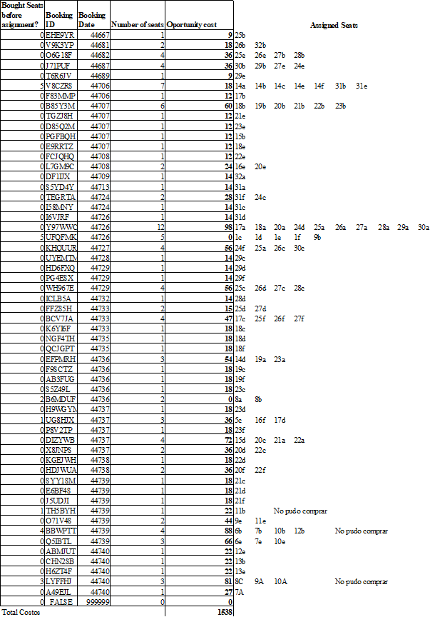

In this case, if we compare the above results with the ones obtained with the allocation algorithm, we can observe that the allocation algorithm reduces the cost in 17 thousend COP, which isn’t a significant reduction but it ensures that both solutions are feasible and even proves that for this specific flight we reached a better solution.

Lastly, as a disclaimer its important to note that there isn’t an absolute optimal value for the objective function, as there is certain stochasticity in the assignment process, given that passenger that we still haven’t assigned could pay for a free seat.

Iterating for all the flights:

In order to compute the seat assignment solution for all the flights, we run the allocation algorithm for all the flights provided by the airlines. This can be found attached in the report folder, and also we plotted the objective function obtained for each iteration, which can be seen below.

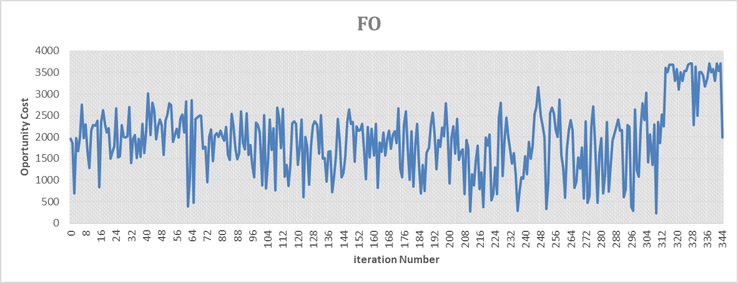

Furthermore, in order to evaluate one specific flight, we created a report spreadsheet, in which the user can enter the flight credentials and immediately see in which seat each passenger was assigned in a displayed fashion. This helps with the operational usability of this algorithm and is a relevant tool if this is ever used in bigger scale situations



1. Conclusion

This method allows for a sequential understanding of the seat assignment problem with components of both networks and discrete optimization, allowing for a versatile implementation of the algorithm while considering the opportunity costs the airline has every time, they need to assign a non-purchased seat. And in this way aim for a more profitable service in which the airline can increase their net margins per flight and ensure that their costumers find value in purchasing specific seats.

1. REFERENCES

AMPL Book examples: 2nd edition. (2002, November 24). Retrieved October 29, 2022, from https://portal.ampl.com/docs/archive/first-website/BOOK/EXAMPLES/EXAMPLES2/index_files.html

Alzahrani, Mohammed. (2013). Seat Assignment Problem Optimization. World Academy of Science, Engineering and Technology. 7. 441 - 444.

Pavlik, John & Ludden, Ian & Jacobson, Sheldon & Sewell, Edward. (2021). Airplane Seating Assignment Problem. Service Science. 13. 10.1287/serv.2021.0269.