**Version control system (VCS)**

It allows you to:

* Work on files maintaining flow and working in a team. It allows you to review line by line if something goes wrong, making backups.
* Keep a history of changes.
* View changes.
* Experiment new things with ease to rollback.

Two types:

* Distributed VCS: The repo is hosted locally in each machine. This allows you to work without internet connection.
* Centralised VCS: the repo is hosted in a single machine. You need to have a connection to that machine.

**Basic commands**

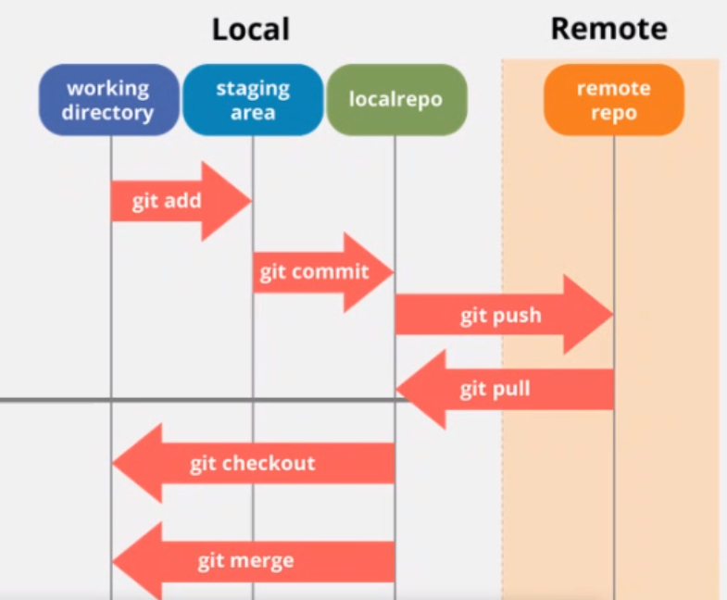

**Git README.md**

<https://github.com/adam-p/markdown-here/wiki/Markdown-Cheatsheet>

With info about the repository.

**Commit graph**

git log: shows a list of commits from the repo.

gitk: it opens an external tool

git status: current status of the repo

**Gitignore**

Create file .gitignore inside .git/, containing extensions that you don’t want to be in your project (.o, .exe…)

Add and commit the .gitignore