

**Bangladesh University of Engineering and Technology**

A Project on

***Resistor Color Code Detector: Calculating Values of Multiple Resistors via Image Processing***

**Course No:** EEE 212

**Course Title:** Numerical Technique Laboratory

**Prepared for: Prepared by:**

Jewel Mahajan, Khondker Shihabul Hoque (1606067)

Lecturer Uddrity Mansur (1606069)

Shailie Chakma,

Lecturer Level:2 Term:1

Section:B1

Department of Electrical and Department of Electrical and

Electronic Engineering Electronic Engineering

Bangladesh University of Engineering Bangladesh University of Engineering

and Technology and Technology

**CONTENTS**

* Objective
* Theory
* Challenges
* Procedure
* How to Use
* Features
* Discussion

**Objective:**

Resistors are a very important part of circuit making. We use resistors in circuits all the time. So knowing and identifying the color codes of resistors are very important. Resistor calculators are often used to determine the values of resistors when they are applied to circuit making. When making complex circuits, it might be time consuming to calculate values of multiple resistors manually. Even if we put the colors as inputs to find the values, it may take time.

So we have used MATLAB to come up with a faster solution for calculating values of multiple resistors, regardless of how they are placed. Our project emphasizes on taking resistor pictures as inputs and calculates the values of multiple given resistors. Our motive was to use MATLAB programs in such a way to detect the color bands of resistors and also find out which band comes after which one. Then we have simply just calculated the values using the color bands which MATLAB helps us to find.

We have also thought of the possible glitches that might occur and also developed our codes to work on solving the problems. Even the orientation of the resistors won’t be a problem. We have also built a GUI (Graphical User Interface) to make the program user friendly. Using this GUI, users can easily select the desired picture as input and the program will detect the resistors in the picture, calculate its color codes and show both the image and the value of all the resistors separately. Our objective for this project was to work on image processing and use image processing tools to detect the color bands of resistors and calculate the values for output without even needing to input the color codes manually for each resistor.

**Theory:**

Resistors have different color bands which are used to identify their values. Any resistor may have 4 or 5 color bands including a tolerance band. These bands and their sequences are used for calculating the values of a particular resistor. If we consider the following picture we will be able to get a better idea.

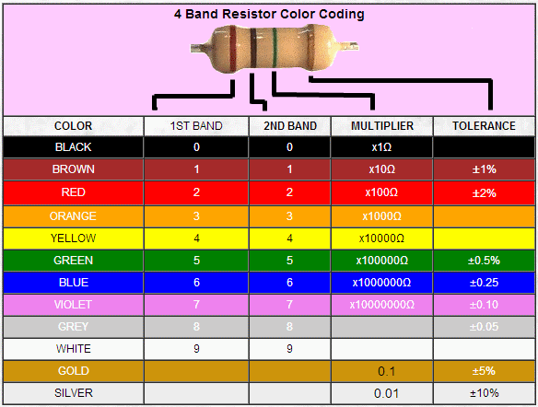

**Fig-1:** Color coding for 4 band resistors.

The tolerance band of resistors are often placed on one end and is kept at a distance from the other color bands. The tolerance band is kept for adding or subtracting a percentage of error from the values calculated. The rest of the color bands are used for calculating the values. Each color is given a specific number for a specific band. The specific color of each band gives us some specific numbers. We can simply understand how to use these numbers by using a simple method.

Band 1, Band 2, Band 3 = Color, Color x 10color  in Ohm (Ω)

Now if we take a resistor shown in the image, we see that the color band sequence is red, purple and brown.

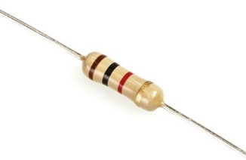

**Fig-2:** A 1000 Ohm (Ω) resistor.

If we put these values in the equation, we will get the desired value of the resistor (tolerance excluded).

Band 1, Band 2, Band 3= Brown, Black x 10Red  in Ohm (Ω)

= 10 x 102 Ohm (Ω)

= 1000 Ohm (Ω)

And 270 + 5% Ohm (Ω) for the tolerance.

**Challenges:**

Some of the challenges that we came across doing this project are discussed in this section. Resistor color detection was not the only obstacle for us. The major challenges that we faced were:

* Evaluating values for multiple resistors. Regardless of their orientation being parallel.
* Finding resistors amongst other electrical components such as capacitors, MOSFETs, inductors, LEDs, switches etc.
* Detecting the color bands of resistors even if the pictures are very bright or have shadows.
* Detecting the color bands even if the same color has different shades. Also calculating values of resistors with the same color for two or three bands.
* Detecting color bands in the desired order even if the orientations of the resistors are vertical, horizontal or angled.

**Procedure:**

* **Segmenting Images of the Resistors from Main Image:**

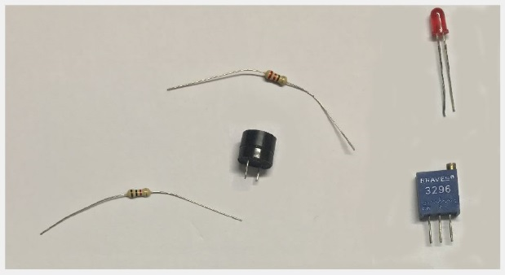The first job is to take an image as input from the user, the format can be any readable image format with RGB color space. Then the program detects the objects present on the image using various image segmentation techniques and creates a binary mask. From this binary mask, information about the objects can be extracted

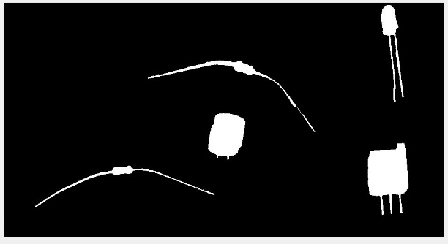

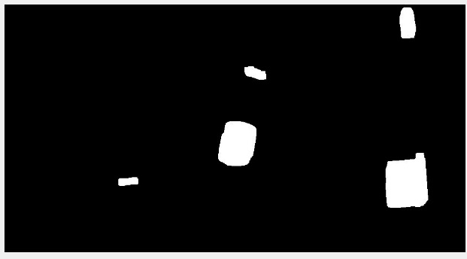

**Fig-4:** Binary Mask

**Fig-5:** Morphological Structuring

**Fig-3:** Main Image

* **Cropping and Detecting the resistors from other components:**

Using the binary mask, images of each components is cropped. Because every resistor has an unique light brown color, we can use this to differentiate from other electrical components. So, by using a mask, we detect the resistors and keep only the cropped images of resistors.

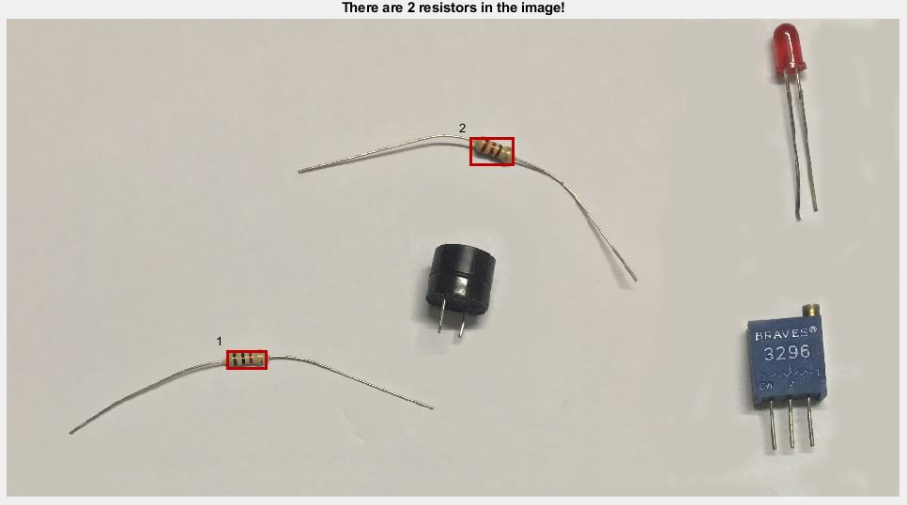

**Fig-6:** Detection of Resistors

* **Detecting the Color Bands along with values for each Resistor:**

After we have cropped the images of the resistors, we can concentrate on detecting the color bands. For that, the program has different mask functions for different colors. When going through these functions, a structure array is created which includes information and values of different detected bands.

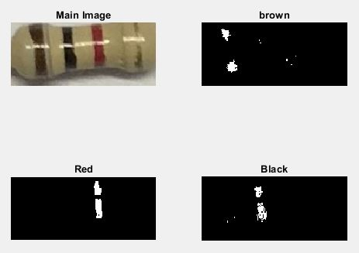

**Fig-7:** Binary Images from Different Color Masks

* **Calculating Value of the Resistor using Different Band Values:**

After determining the corresponding color code values for Band1, Band2 and Band3, We calculate the value of resistor using ,

Resistor Value = (Band1, Band2) × 10Band3

* **Showing both Resistor Image and Value as Output:**

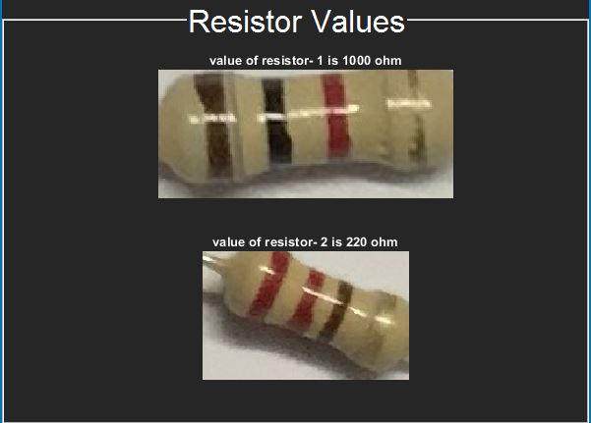The output will be shown according to how it was marked in the main image with the same numbers, both the value and image of the resistor will be shown.

**Fig-8:** Final Output with Resistor Images and Values

**How to Use:**

1. At first, user needs to open and run “MainGui.m” in MATLAB. After clicking on run, the graphical user interface (GUI) will come up. User needs to click on “Select Image” . This will open the file explorer which can be used to open an image from anywhere of the hard drive of the computer. The process is illustrated:

1. click to select an image

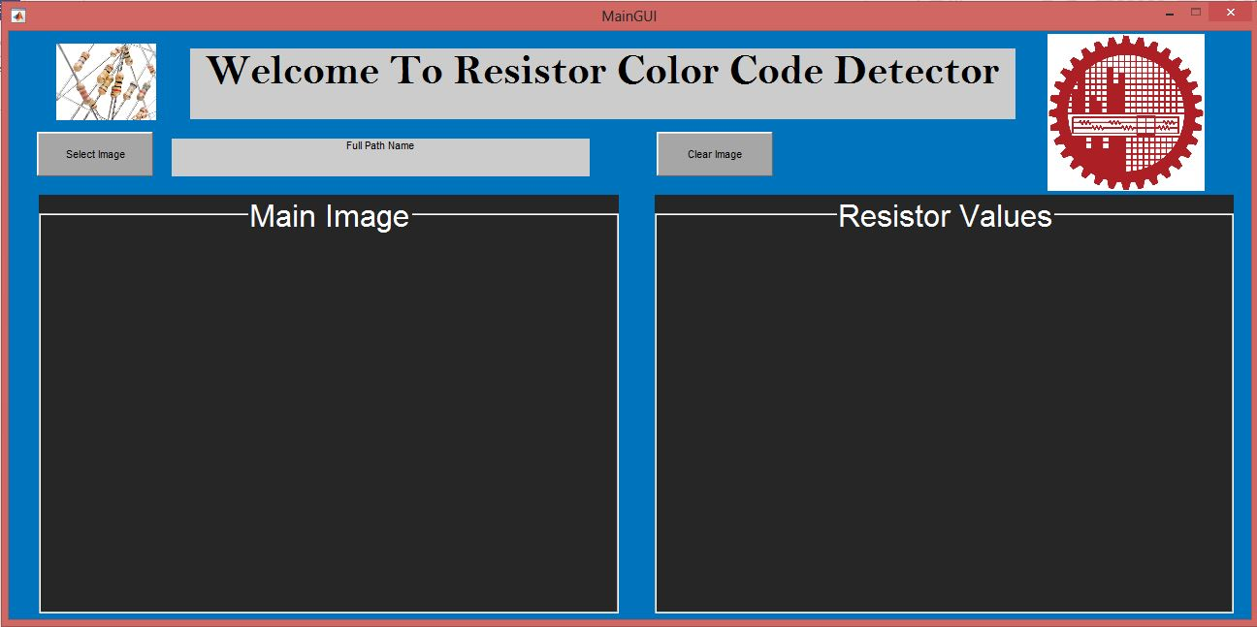

1. 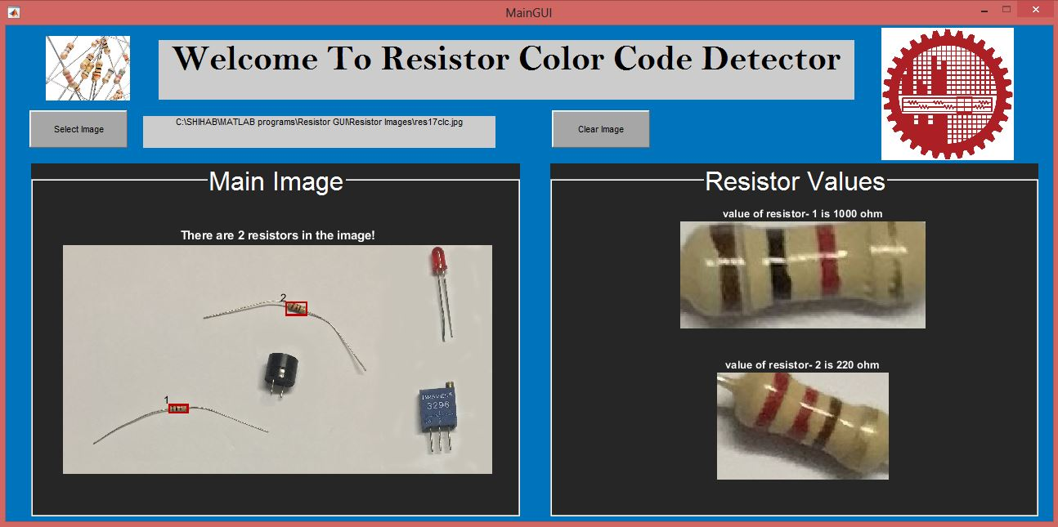Then the program will start working. After it has finished analyzing the images, in the “Main Image” panel, the selected image will be shown with the detected resistors numbered and boxed out. In the “Resistor Values” panel, each resistor’s image will be shown separately along with their value in Ohm(Ω).

2. Output is shown

1. To select another image, user need to click on “Clear Image” first. Then the user can go on to select a new image following the process already discussed. It is mandatory to click on “Clear Image” first before selecting a new image.

3. click to clear the previous image and start again



**Features:**

This program possesses some versatile features which make this user-friendly and precise. The main features are:

* 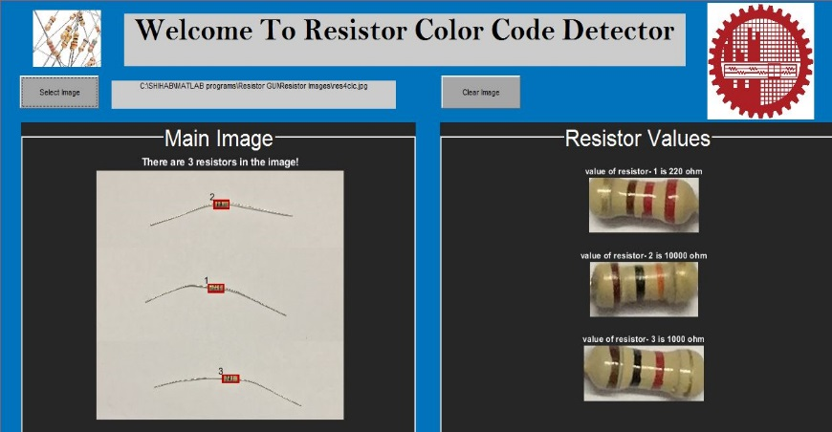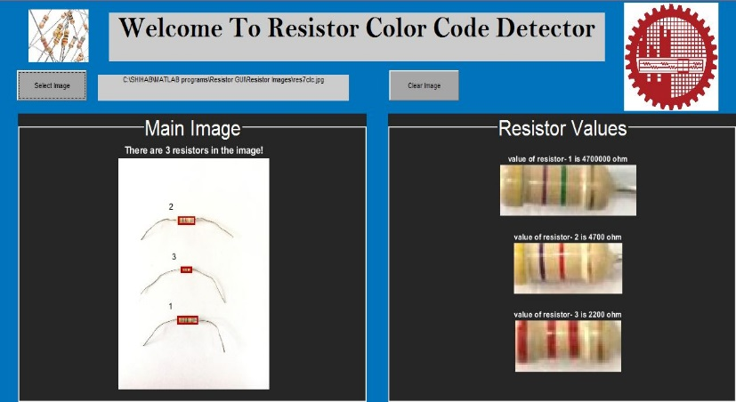Works on images with different level of brightness and shadow.
* Works with different orientation of resistor, it really doesn’t matter how the resistors are placed, it will show the correct values.

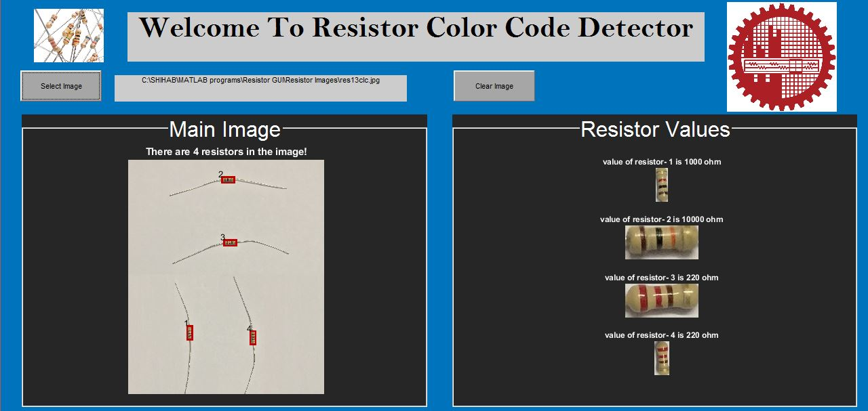

* Can find the resistors precisely even if they are lying amongst different other electrical components like LEDs, MOSFETs, inductors, switches, buzzers etc. The resistors are indicated with numbers so user can easily understand which value refers to which resistor.

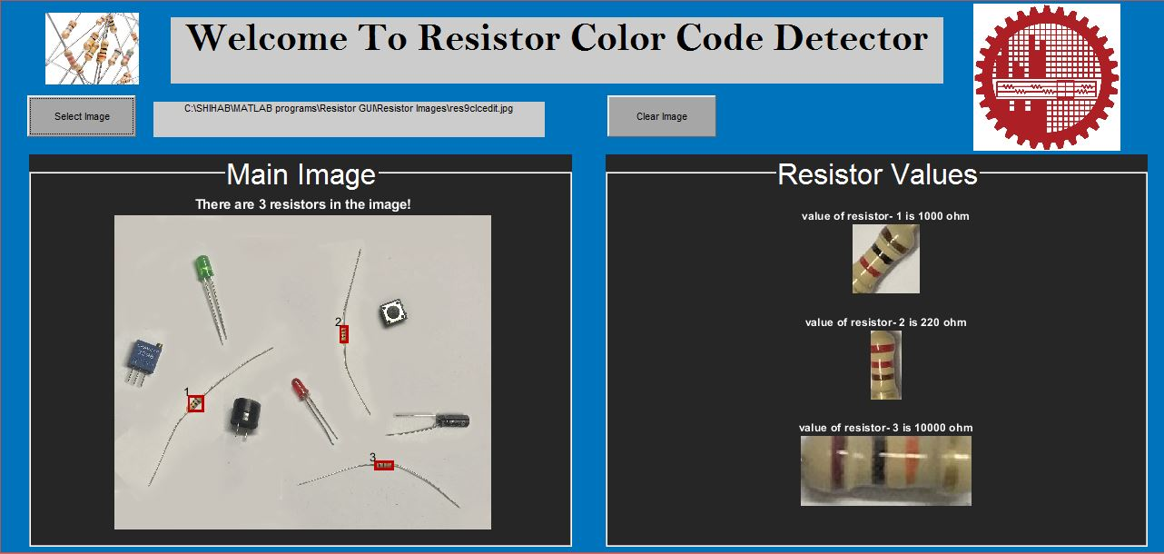

**Discussion:**

The motive of our project was to detect and determine values of resistors from a given picture input. The pictures contained other electrical components other than multiple valued resistors. Firstly we detected the resistors and eliminated the other elements from the given input pictures. Then we used those cropped resistor pictures and detected the color bands using image processing. We faced the discussed challenges while working on this project, but successfully managed to modify our codes for the worst possible cases.

The pictures that we used were clicked using original resistors and circuit elements. All our pictures are original and authentic. We worked our way through the difficulties step by step and tried to solve them with efficiency. Though there might be a few limitations, our codes work perfectly for the inputs that we have provided. We also attempted to make a GUI so that the process becomes easier for the user. The GUI also works perfectly and shows accurate outputs.

Regardless of the difficulties, our attempts were quite satisfactory. With a bit more efficiency we might be able to simplify the code making it easier to understand. Even though the codes work perfectly, the total length is quite a lot. We have used many techniques in completing our project hence the long length. The codes and all the techniques that we used are easy to understand despite of the length. So the overall project is user friendly and appropriate.