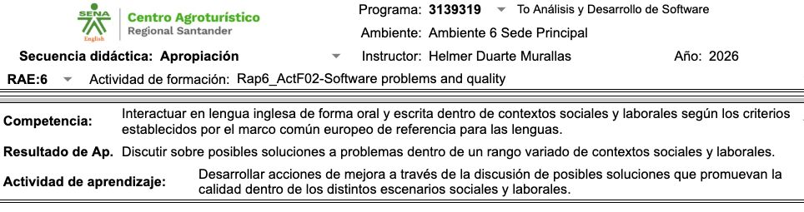
LINK GITHUB:
https://github.com/JuanViviescas00/INGLES_EXPO.git
