Juan Alvarez  
HND Software Development 2018/9  
West Lothian College  
  
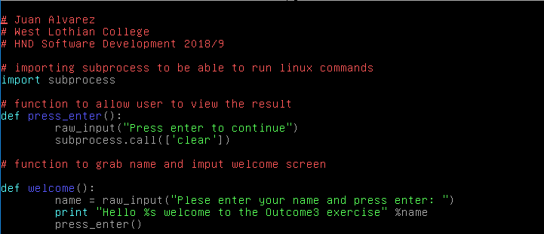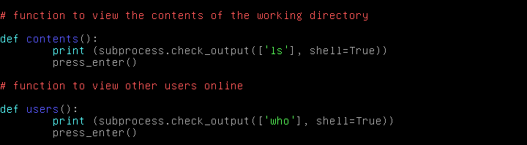  
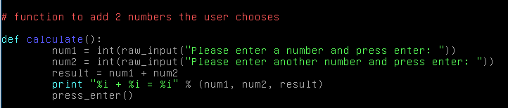  
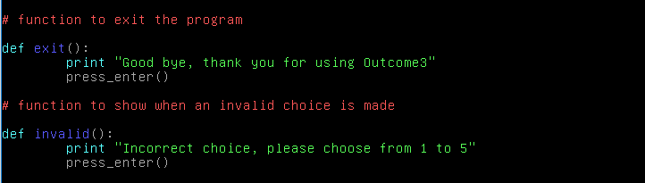  
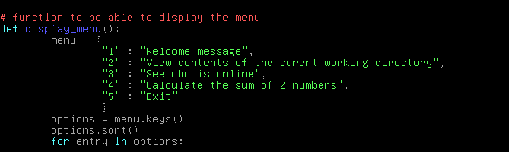  
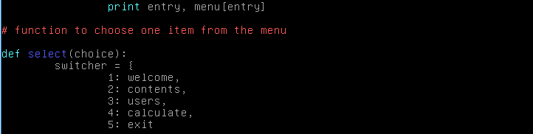  
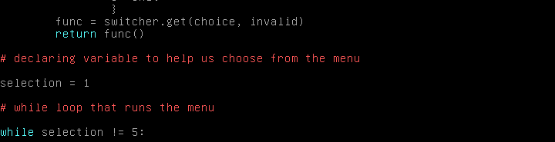  


This is now the working result:

Menu:



Choice 1:

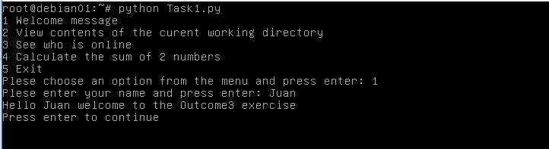

Choice 2:

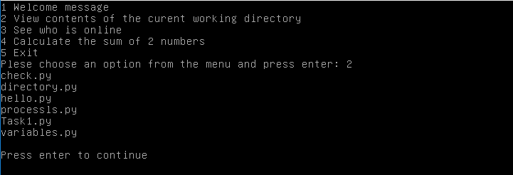

Choice 3:



Choice 4:

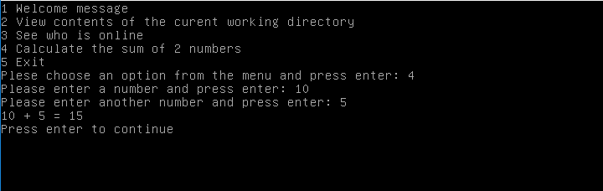

Choice 5:



**TASK2**

Code:

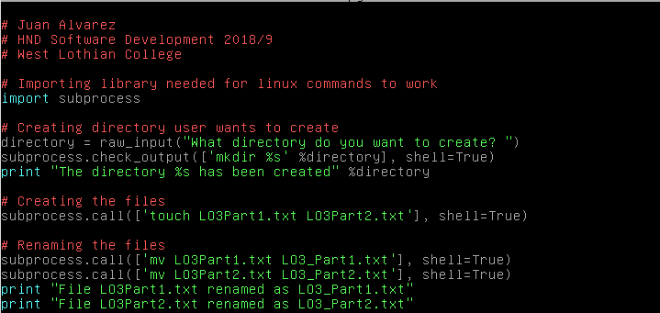  
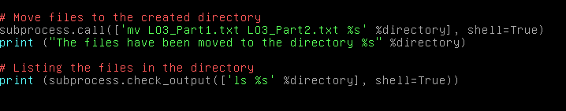

Working:

