Simply Handy™

## 

## User Guide

The tool for

**Simply Rugby club**

© May 2019

Table of Contents

User Guide 1

**Introduction** 1

**Getting Started** 2

**System Requirements** 2

**Quick Start** 2

**Launching the Application** 3

**Login Page** 4

**Admin Page** 5

**Searching** 5

**Deleting** 5

**Adding Players** 6

**Updating player’s details** 6

**Viewing Emails** 6

**Exiting the application** 7

**Coach Page** 8

**Searching** 8

**Editing Skills Development** 9

**Exiting the application** 9

**Glossary** 9

# **Introduction**

Keeping data safe and secure is necessary with the new data privacy laws. Simply handy will do that for any Rugby Club that desires to do so.

With Simply handy you can:

* Have secure login so only authorized personnel can access the information stored between it.
* Store player data securely.
* Each user will have access only to the data he/she needs
* Coaches will be able to keep track of the performance of the players.
* Administrators of the system will be able to gather the emails of all players to use as needed.

Simply Handy keeps players records and allows coaches to keep track of the current player performance and will be able to gather notes for each of the areas the players train on.

Simply Handy is simple to use and learning to use it will only take a few minutes.

# **Getting Started**

## **System Requirements**

Personal computer

Windows 10 environment

SQL server

Net Framework

## **Quick Start**

1. Open Simply Handy.
2. Introduce Login data.
3. Once correct Login data is introduced the app is ready for use.

# **Launching the Application**

To launch the application from the computer:

* Navigate to the installed folder “Release”
* Find the Simply Handy™ icon
* Double click it

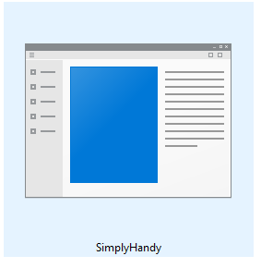

That will bring up the Login screen of the application.

# **Login Page**

Under Username introduce the username provided.

Under Password introduce the password provided.

Then press Login:

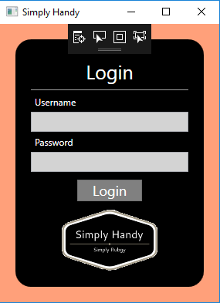

If the login details are from an administrator, the application will send you to the Admin Page.

If the login details are from a coach, the application will send you to the Coach Screen.

# **Admin Page**

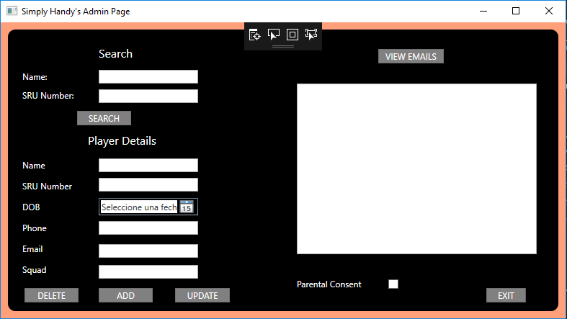

## **Searching**

In the Admin Page the user Admin will be able to search either by Name or SRU Number.

Admin will have to enter one of those details and press the button “SEARCH”.

That will populate the fields under Player Details.

If there are no matching records a message will inform of it.

If a matching record if found the fields under “Player Details” will be populated with the information stored in the system.

## **Deleting**

Once a record is found the Admin will have the choice to delete the record from the database.

The action is taken once the “DELETE” button is pressed.

There will be a confirmation message to ensure the action wants to be taken.

## **Adding Players**

Steps to add a player’s record to Simply Handy App:

* Fill in the Name field
* Fill in the SRU Number (only numbers are permitted)
* Choose the date of birth from the calendar (if player is underage the system will prompt to get and mark parental consent)
* If needed (player under age) tic the Parental Consent box
* Enter a phone number in the field Phone, only numbers are permitted
* Fill in the Email field, only the email format is permitted on this field
* Fill in the Squad field
* Press the button “ADD”

## **Updating player’s details**

Steps to update players details in Simply Handy App:

* Search for a player
* Edit the data you need to change
* Press the button “UPDATE”

Please note that the correct format needs to be kept and the system will prompt you to correct the data entered if it is not in a correct format.

The correct format is mentioned on the “Adding Players” area.

## **Viewing Emails**

Simply Handy App allows the Admin to search for all Emails stored on the application. Steps to view emails:

* Log into the application with the correct login details
* Press the button “VIEW EMAILS”

The desired data will be displayed in the right-hand side panel of the screen.

## **Exiting the application**

To exit the application, you must press the button “EXIT”, the application will go back to the Login page, where another user will be able to enter into the system.

If you want to close the application totally, you can do so clicking on the cross in the top right corner of the application.

# **Coach Page**

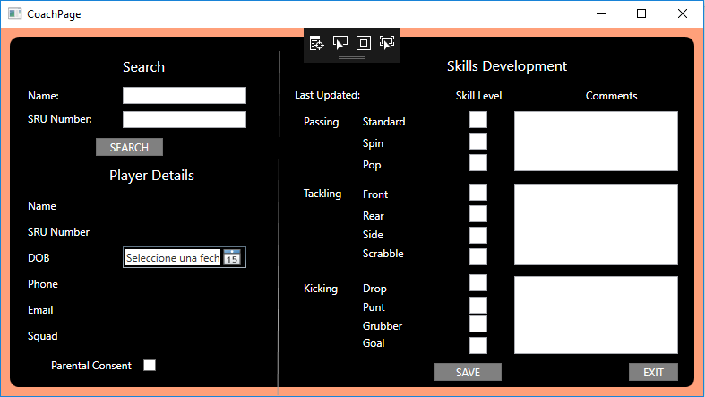

## **Searching**

In the Coach Page the user Coach will be able to search either by Name or SRU Number.

Coach will have to enter one of those details and press the button “SEARCH”.

That will populate the fields under Player Details and under Skill Developments.

If there are no matching records a message will inform of it.

If a matching record if found the fields under “Player Details” and “Skills Development” will be populated with the information stored in the system.

The user Coach does not have access to edit Player Details.

## **Editing Skills Development**

Once a search has been made and a player has been found, Coach will be able to edit the Skills Development of that player.

To edit the Skills Development of any player in Simply Handy:

* The fieldsStandard, Spin, Pop, Front, Rear, Side, Scrabble, Drop, Punt, Grabber and Goal can only be filled with numbers 0-5, and it represents the level of that player on those areas
* The 3 comment fields (Passing, Tackling and Kicking) are freely editable by the Coach, the user can add as much information and in the format he wants regarding the performance of that player
* Once all data is entered correctly the user must press “SAVE”
* If any of the data is not properly formatted the system will prompt the user to correct the incorrect formatted field
* When the button “SAVE” is pressed the system will store the current date, that will be displayed the next time Coach searches for that player in the field “Last Updated”

## **Exiting the application**

To exit the application, you must press the button “EXIT”, the application will go back to the Login page, where another user will be able to enter into the system.

If you want to close the application totally, you can do so clicking on the cross in the top right corner of the application.

# **Glossary**

Skills Development

Group of skills a player demonstrates over the playing field, be it at training or in a match that the Coach sees feet to store.

SRU Number

Number of player registration with the Scottish Rugby Union.