FIELD GUIDE · PLAIN LANGUAGE
How Nexxo works
Power companies plan new lines and substations years before they build them. When two neighboring companies are building near each other at the same time, they can share crews, land, equipment and power shutoffs, and both save money. Nexxo finds those spots, says how likely each one is to really happen, and which few date changes would save the most. This guide walks through every part of the screen.
Prepared for Juan · ShellHacks 2026 · Nexxo compares Dominion Energy South Carolina with Georgia's power companies along the Savannah River.
Contents
00 Words to know
01 The screen at a glance
02 The headline numbers and the four tiers
03 The map
04 The ranked list
05 A pair up close
06 How plans change
07 The schedule optimizer
08 The build-windows chart
09 Data checks
10 Briefs, proposals and reports
11 Asking questions
12 The 3D illustration
13 Adding another company's plans
14 Looking at one company
15 How savings are estimated
16 Shared yards
17 A one-minute demo

00 · BEFORE YOU START

Words to know
The built-in example compares Dominion Energy South Carolina with Georgia's power companies. The Savannah River runs between the two states, and both sides are building along it.
Utility | A power company. Here, Dominion Energy SC (DESC) on one side and Georgia on the other: Georgia Power, Georgia Transmission and MEAG, which plan together and show up in the app as Georgia ITS.
Project | One planned piece of the grid: a new power line, a rebuilt line, a substation, or a power plant.
kV (kilovolts) | How much voltage a line carries. Bigger number, bigger towers and bigger job. 115 kV is local; 500 kV is a highway for power.
In-service date | When the project is supposed to be finished and running. Plans always list this.
Build window | The stretch of time a project is under construction, from start to in-service. Georgia's detail pages often publish the start; when a plan doesn't, Nexxo estimates it from the type and size of the job.
Pair | One project from each company. Nexxo checks every possible pair: 64 × 161 = 10,304 of them in the built-in example.
Chance | How likely it is that both crews are really in the field at the same time, from today on, given how much each company's dates have moved before.
Expected savings | What a pair would save, with the timing-dependent items counted only by that chance. The list is ranked by it.

The built-in data comes from the challenge's own PDFs: 262 official records (44 DESC projects and 218 Georgia rows), placed on OpenStreetMap substations, plus the newer published lists. With everything loaded that is 64 DESC projects on the map against 161 Georgia ones.

01 · THE WHOLE SCREEN

The screen at a glance
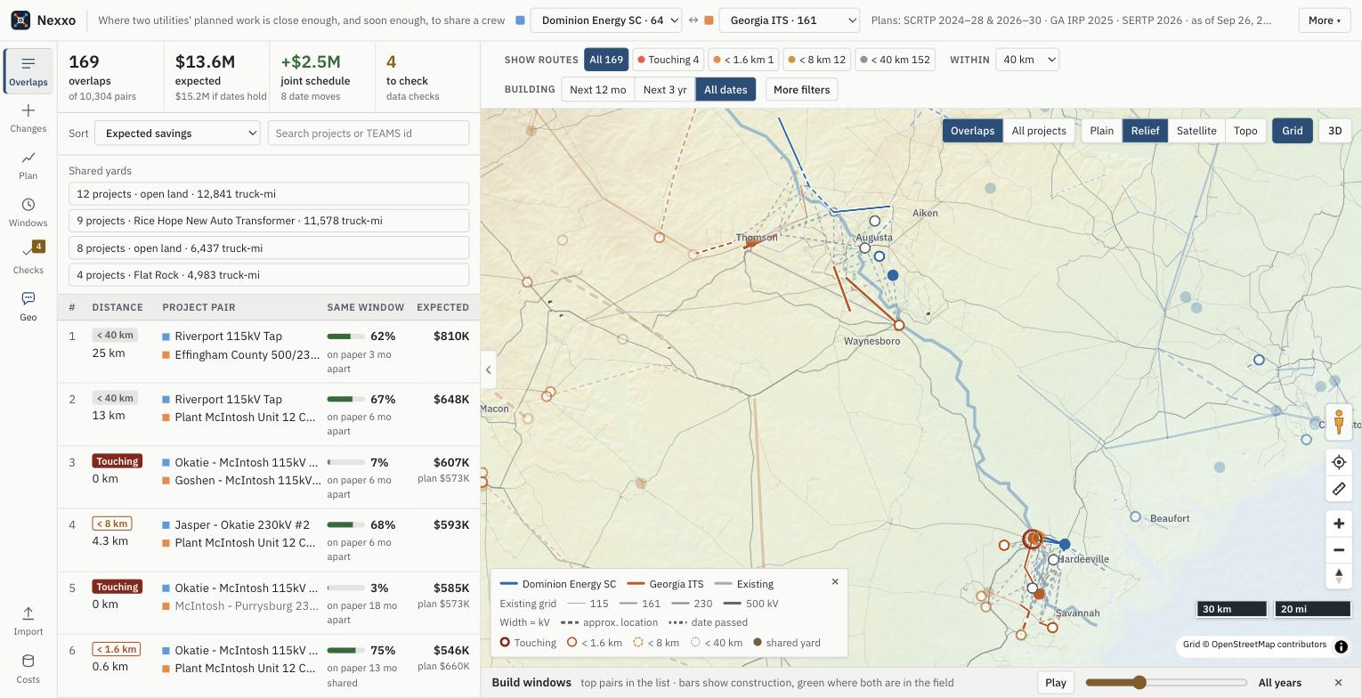
The whole screen: the top bar, the filter bar over the map, the rail on the left, the Overlaps panel with the headline strip, the map, and the build-windows bar underneath.
One screen, laid out like the coordination tools planners already use: the ranked overlaps on the left, the map on the right, and the build windows underneath, all linked. Clicking something in one place highlights it in the others.
Top bar | The Nexxo logo and tagline, then the two utility pickers. The number after each name is how many planned projects it has. Pick None: just list projects in the second box to look at one company on its own (section 14). The plans in use and their as-of date follow, and More sits at the right.
More | Share this view copies a link to exactly what's on screen (companies, filters, tab, selected pair, basemap, 3D and camera), so the other company opens the same view. Export CSV downloads the list for Excel or Google Sheets. Import plans and Unit costs open the same dialogs as the rail. About, terms and privacy opens a dialog with three tabs: About and sources (the plans, map data and software behind the app), Terms (a planning aid, not engineering, legal or financial advice) and Privacy (no Nexxo server and no account; what stays in your browser, and what goes to Anthropic, only when you ask Geo an open-ended question with your own key).
Filter bar | The bar over the map. Show routes chips filter by tier: All 169, Touching 4, < 1.6 km 1, < 8 km 12 and < 40 km 152 (section 2). Within sets how close counts as an overlap: 40 km (about 25 miles) by default, roughly how far one crew yard can serve in a day. Building limits the build period: Next 12 mo, Next 3 yr or All dates. More filters unfolds the rest: Window buffer (how many months apart two build windows can be and still count as the same time), Near / Near + same window / Same window, and Include dates already passed.
The rail | The labeled buttons down the left switch the panel: Overlaps, Changes (how plans moved, section 6), Plan (the schedule optimizer, section 7), Windows (unfolds the build-windows chart under the map, section 8), Checks (section 9) and Geo, the assistant (section 11). Press Geo again to close it and go back to the view you had. Import and Costs sit at the bottom.
Panel tab | The small tab on the edge of the results panel collapses it, leaving the rail, the filter bar and the map. Press it again, or any rail button, to bring the panel back.

02 · THE SUMMARY

The headline numbers and the four tiers
The Overlaps panel opens with a strip of four headline numbers. Read them first: they are the answer in one glance.
169 overlaps of 10,304 pairs | Of the 10,304 pairs checked, 169 come within 40 km of each other, all along the Savannah River between Savannah and Lake Thurmond. Most planned work is far apart, which is why finding these matters.
$13.6M expected ($15.2M if dates hold) | What the flagged pairs could save by coordinating, weighted by the chance they really share a window. If every date held it would be $15.2M (section 15).
+$2.5M joint schedule (8 date moves) | What the optimizer's 8 suggested date moves would add. Click it to open Plan (section 7).
4 to check (data checks) | Data checks that flagged records to review. Click it to open Checks (section 9). The same number sits on the Checks button in the rail.

Each close pair falls into one of four tiers based on the distance between the closest points of the two projects, measured between the lines and points themselves, not their centers. Closer means more can be shared.
Tier | Distance | What they can share
Touching | 0 km, lines cross or meet | They must plan together: one power shutoff and shared crossing towers.
Shared land | Under 1.6 km (1 mile) | The cleared strip of land, access roads and permits.
Shared site | Under 8 km (5 miles) | One storage yard for materials and deliveries.
Shared crews | Under 40 km (25 miles) | Work crews, cranes and contractors.

The Show routes chips in the filter bar over the map narrow the pairs by tier: All 169, Touching 4, < 1.6 km 1, < 8 km 12 and < 40 km 152. The app opens on All 169.

03 · WHERE

The map
Colored lines and dots | Blue is the first company, orange is the second. Lines are power lines; dots are substations and plants. Thicker lines carry higher voltage.
Dashed and dotted | Dashed means the location is approximate. Dotted or faded means the in-service date has already passed.
Existing grid | Grid draws today's transmission lines underneath: 10,092 lines of 115 kV and up in Georgia and South Carolina, from OpenStreetMap, colored by voltage. It shows when the app is served (npm start or the website), not when index.html is opened straight from disk.
Links and rings | Each thin link joins the two closest points of a flagged pair, in its tier's color, and is labeled with the gap (the open pair always, all of them from closer zoom). Rings mark how close a pair is; round dots mark shared staging yards. Click one to open it.
Top buttons | Overlaps zooms to where the flagged pairs are; All projects shows everything. Plain (works offline), Relief (color by elevation with hillshade), Satellite and Topo switch the basemap. Grid toggles the existing lines, and 3D tilts the map.
Bottom right | The orange walker figure (see below), recenter, a click-to-measure ruler (each leg and the total in miles and km), zoom, compass, and scale bars in miles and km.

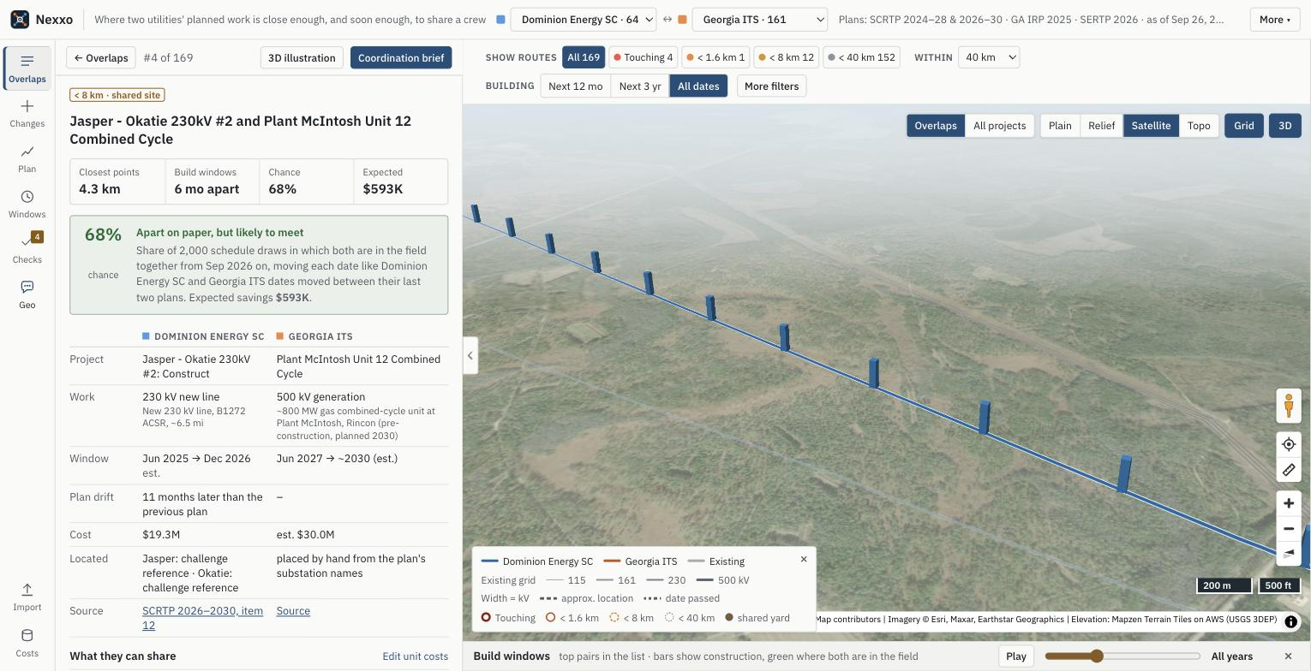
The map in 3D over satellite imagery: towers along the Jasper - Okatie 230 kV line, with pair #4 open on the left.
3D tilts the map over real terrain (elevation exaggerated 3× because the Southeast is low), adds hillshading and a sky, and raises a tower about every 450 m along each planned line. Satellite imagery and terrain need an internet connection; Plain works without one.
Drop in and walk
Drag the orange figure from the bottom right of the map onto any project, like Street View. The 3D illustration of that project's most valuable pair opens at ground level where it landed (section 12). Walk with W A S D or the arrow keys, drag to look around, hold Shift to run.

04 · WHAT MATTERS MOST

The ranked list
Every flagged pair, best first. Sort puts them in order of expected savings (the default), chance of a shared window, or distance. Each row reads left to right:
- The rank, then the distance: the tier tag (Touching, < 1.6 km, < 8 km or < 40 km) and the distance between the closest points, for example 4.3 km.
- The project pair: the two project names, marked with each company's color.
- Same window: a bar with the chance both are in the field together, and what the plan says, for example "on paper 6 mo apart".
- Expected: the expected savings. When it differs a lot from the plan's figure, that figure shows underneath.
Type in the search box to find a project, place or TEAMS id. Shared yards above the list shows groups of projects that could use one yard (section 16). Export CSV under More downloads the list.
Just outside the line
Under the list, Nexxo also names the pairs that just miss the distance screen: 13 more pairs sit between 40 and 42 km, the closest at 40.3 km. They are kept out of the ranking and every total, but shown so the 40 km line reads as a chosen threshold, not a cliff. Widen Within in the filter bar to include them.

05 · CLICK ANY PAIR

A pair up close
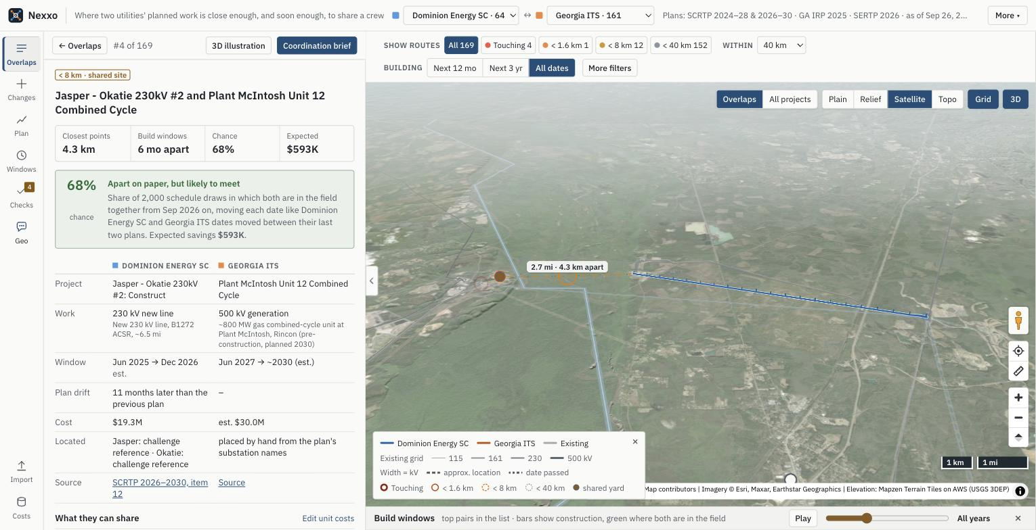
Pair #4 of 169, Jasper - Okatie #2 and Plant McIntosh Unit 12, with the map flown to it in 3D over satellite imagery.
The top line. Back to Overlaps, the pair's rank (#4 of 169), and the 3D illustration and Coordination brief buttons. The tag gives the tier, and the four facts give the closest points, how the build windows line up, the chance and the expected savings.
The chance. A colored box explains it in words. Pair #4 is six months apart on paper, but it has a 68% chance of both crews being in the field together, because DESC's dates usually move later. The number is the share of 2,000 schedule draws in which both are working at the same time from today on.
Side by side. Each project's work, build window ("est." when the start is estimated), plan drift since the previous plan, cost, how each end point was located, and a link to the page of the public plan it came from.
What they can share. Every item the pair's tier allows, each with its own dollar figure and the math under it, like "20 days × $6.5K/day × 50%". Edit unit costs opens the numbers behind them. Below that, the pair's best shared yard.
Schedule what-if. Choose which company's project to move, then slide it up to three years earlier or later. The chart shows both build windows and the months they share, with a dashed outline where the moved project was; the savings update as you slide. Try … jumps to the suggested move when there is one, and Reset to plan puts the dates back.
Status. Mark the pair Open, Contacted, Coordinating or Not pursuing. It's saved on that device and shows in the list.

06 · PLANS MOVE

How plans change
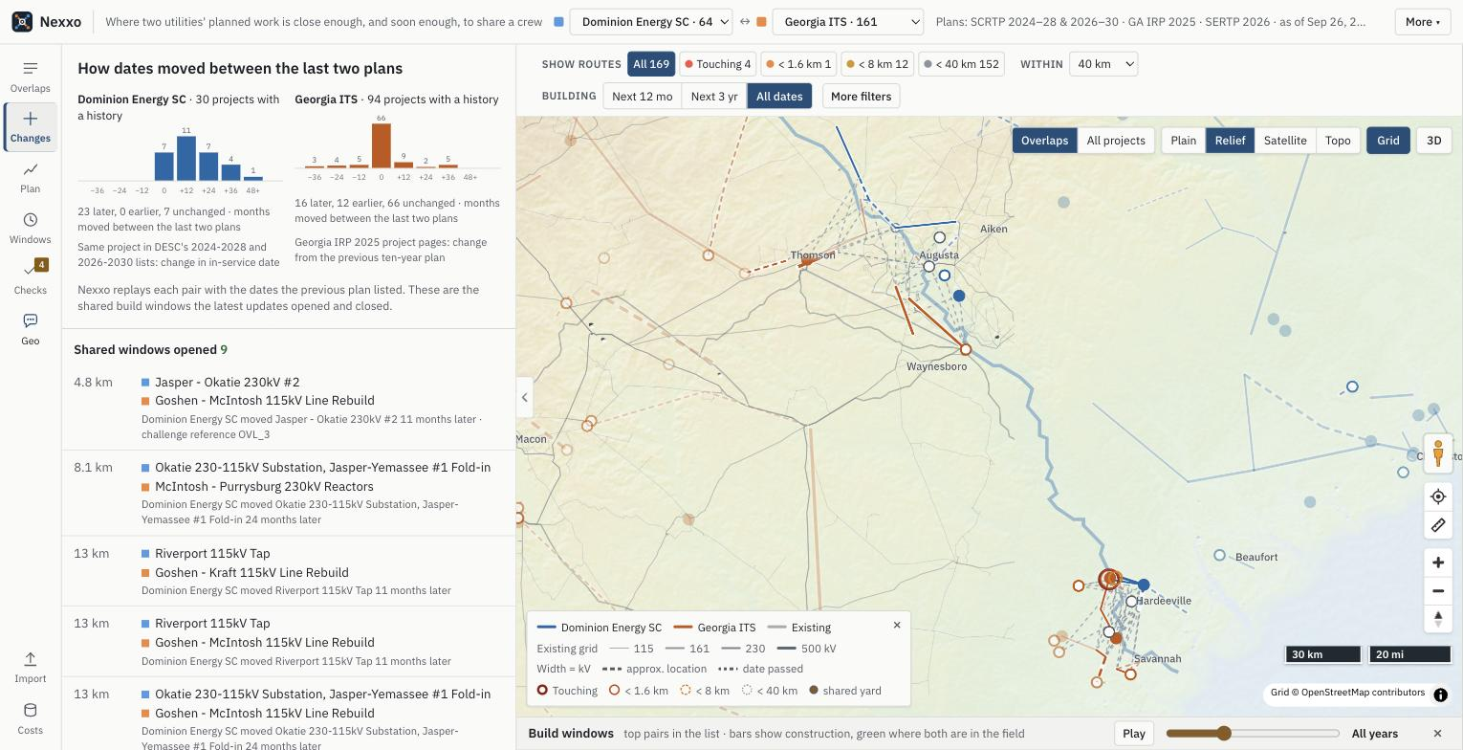
Changes: how each company's dates moved, and the shared windows the latest plans opened.
An overlap on paper is not an overlap in the field, because planned dates move. Changes shows how much, from the plans themselves.
- DESC: 30 projects appear in both the 2024-2028 and the 2026-2030 lists. 23 of them moved later, 12 months at the median; none moved earlier.
- Georgia: each project page says how it changed since the previous ten-year plan. Of 94 projects with a history, 66 kept their date, 16 moved later and 12 earlier.
Nexxo then replays every pair with the dates the previous plan listed. The latest updates opened 9 shared windows and closed 3, each listed with the reason. For example, the challenge's reference overlap OVL_3 shares a window only because DESC moved Jasper - Okatie #2 eleven months later. The same history drives every chance in the app.

07 · WHAT TO DO ABOUT IT

The schedule optimizer
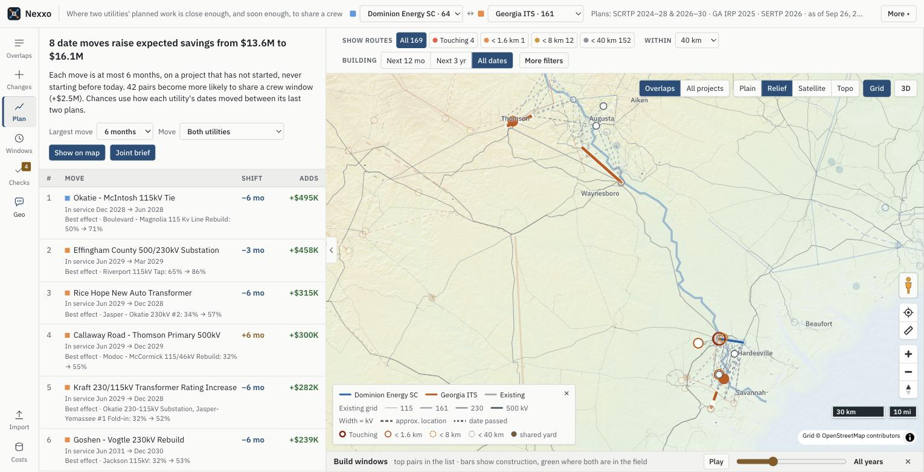
Plan: the date moves that raise expected savings the most.
Plan asks which few date moves would raise the pairs' total expected savings the most. It only moves projects that haven't started, by 3 or 6 months, never to before today, and stops when no move is worth $25K.
On the built-in data, 8 moves of at most 6 months raise expected savings from $13.6M to $16.1M, and 42 pairs become more likely to share a crew window. Most bring a Georgia project earlier, toward where DESC's usually late dates are likely to land. Each row names the move, the new in-service date, the pair it helps most, and what it adds.
Largest move and Move (both companies, or just one) set the limits. Show on map draws the moves; Joint brief prints them as a joint schedule proposal for both planning teams (section 10).

08 · WHEN

The build-windows chart
Press Windows in the rail to unfold the build-windows chart under the map. It has one bar per project for the top pairs in the list, running from the start to the planned in-service date, green where both projects in a pair are in the field. When you pick a pair, its two bars stay bright and the rest fade.
Play the build years
Press Play in the Build windows bar under the map and it steps forward one month at a time. Projects light up while they're under construction and fade outside it. When both projects in a flagged pair are under construction in the same month, the pair sparks: that's a live chance to share. Drag the slider to jump to any month; the label at the end goes back to All years.

09 · WHERE THE NUMBERS COME FROM

Data checks
Checks shows the data pipeline's validation report. The top line traces the numbers: 2 PDFs → 262 official records → the newer SCRTP and SERTP lists → the projects on the map → 169 overlaps. A test confirms Nexxo reproduces all 6 overlaps in the challenge's reference table (6 of 6), measured between closest points as the challenge asks.
Below that are the 10 checks that run on every rebuild: every row of both PDFs read, detail pages matched, start dates before need dates, TEAMS numbers unique, projects in two plans counted once, OpenStreetMap namesakes rejected, line end points consistent with the plan's line length, projects not placed, dates already passed, and plan-change notes not understood. Open one to see the records it caught. The report downloads as JSON. The 4 marked for review are the number on the rail.

10 · SOMETHING TO HAND OVER

Briefs, proposals and reports
Nexxo prints three kinds of page. Each opens in a window with Print or save as PDF and Copy text to paste into an email. Printing works when the app is opened from the repo or a website.
Coordination brief | Press Coordination brief on any pair. A one-page memo addressed to both companies' planning teams: how close the projects are, when they overlap, the chance and what coordinating would save, a small locator map, both projects, each shareable item with its dollar figure and math, the best shared yard, and next steps. If you used the what-if and the move helps, the brief includes it and marks the new dates as proposed.
Joint schedule proposal | Press Joint brief in Plan. The optimizer's date moves, what each adds, and the pairs they help, for both companies to agree on.
Report | A report over the whole comparison: pairs checked, pairs flagged, expected savings and the pairs just outside the screen, with the projects ranked. Ask Geo for it, for example "a report of the longest projects"; this works without a key too.

Geo can open any of the three for you, in Spanish when you ask in Spanish.

11 · JUST ASK

Asking questions
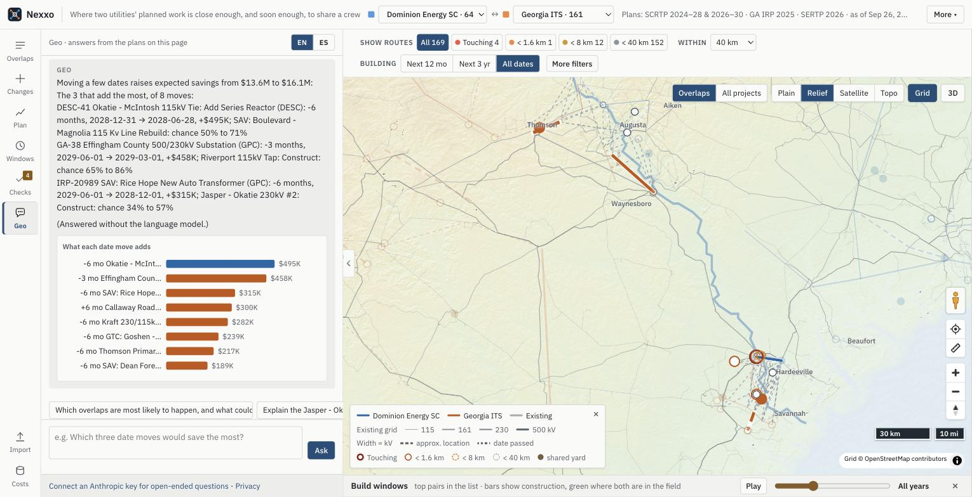
Geo answering "Which three date moves would save the most?" with no API key: the moves, and a bar chart of what each adds.
Press Geo in the rail to open the assistant; press it again to close it. The panel opens with "Hey, I'm Geo", one line on what it answers from, a short What I can do list (in English only), and four example questions. Type a question in plain language, in English or Spanish (the EN / ES toggle at the top), or click an example. Others to try: "Which overlaps near Augusta are most likely to happen?", "Why isn't DESC-11 paired with IRP-20277?" or "¿Qué cambió en el plan de DESC?".
Geo answers from the same data as the screen, using 14 tools: search and rank projects, list and explain overlaps, compare two projects, say why a pair is not flagged, plan changes, the schedule optimizer and the data checks, plus four that act on the page: show something on the map, and open a coordination brief, the joint schedule proposal or a report.
No key needed for the common questions
Without an API key, or when it can't reach the internet, Geo still answers the common questions: the top overlaps, pairs within a distance, the most likely ones, pairs in the same window, what's planned near a place, one project or pair, what changed between plans, which date moves pay most, how many pairs were checked, and the data checks. Those answers end with "(Answered without the language model.)". Anything it can't place with confidence asks for a key instead of guessing.

For open-ended questions, click Connect an Anthropic key for open-ended questions under the input and paste your own key; Privacy next to it says what is sent where. The site has no server: the key stays in that browser and is sent only to Anthropic.

12 · SEE IT

The 3D illustration
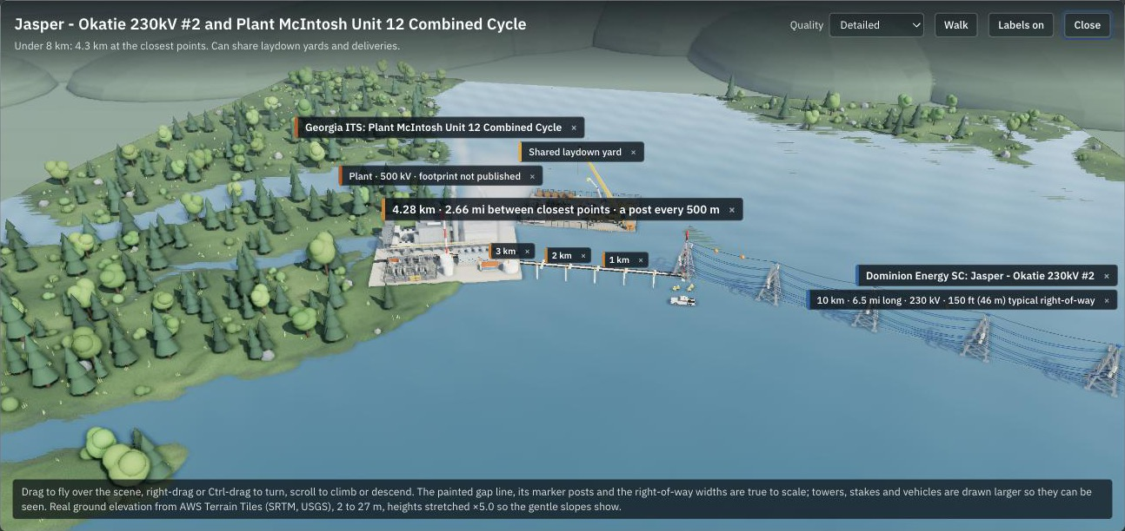
Pair #4 as a landscape: Plant McIntosh's combined-cycle unit, the shared laydown yard, and the Jasper - Okatie line's towers, a span apart, with the 4.28 km gap marked.
Press 3D illustration on a pair, or drop the walker on a project, to see it as a small landscape: both companies' towers and wires in their colors, substations with transformers and breakers, a power plant modeled on a combined-cycle station, work crews with pickups, bucket trucks, a crane and an excavator, and what the tier lets them share, like a cleared strip and road for close pairs or a laydown yard for farther ones.
The ground is a cut-out block shaped from real elevation data; heights are stretched so the flat river country reads, and the footer gives the real range. Distances along the ground are to scale. Towers stand a span apart along each line, as on a real line, rather than packed together; they are drawn taller than the ground scale so they read. Offline, it falls back to an illustrative ground.
Drag to look around and scroll to zoom. Walk switches between the orbit view and walking at ground level. Labels off hides the floating name tags for a clean view. Quality has two looks: Detailed, the default, stylized and fast, and Ultra-realistic, with textured siding, concrete and gravel, metal wires, loblolly pines, denser ground cover and finer terrain for a fast computer.

13 · ANY COMPANY, ANY FILE

Adding another company's plans
Press Import at the bottom of the rail and drop in the file the way the company published it. Nexxo reads the file types power companies actually use:
- Spreadsheets: Excel, CSV and TSV. Every sheet is read, and title rows above the header are skipped.
- Map files: KML and KMZ (Google Earth), shapefiles (from GIS departments), GeoJSON, and GPX (from GPS surveys).
It matches column names loosely, so "Owner", "Voltage (kV)" or "ISD" all work. If a file has no company name or no dates, type them in the boxes above the drop area. The report underneath says what loaded and why any rows were skipped. Tick These are existing lines to load a file like a HIFLD download as a background layer instead of comparing it. After loading, Nexxo compares the new company with whichever one has the closest project.
The samples folder in the repo has nine made-up plans, one per file type, plus an example existing-lines layer, to try this with.

14 · JUST BROWSING

Looking at one company
Set the second utility picker in the top bar to None: just list projects and Nexxo stops pairing. It lists every project for the first company with voltage, type, name, in-service date and cost. The headline numbers and pair links go away because there's nothing to compare.
Click a project to see its details and source, or press Play to watch that company's building years. Pick a second company at the top to find projects near it again.

15 · THE MONEY

How savings are estimated
These are rough, planning-level figures meant to show which pairs are worth a phone call, not a budget. Each item a pair can share gets its own figure, and the pair's total is their sum. A pair only earns the items its tier allows, and yards, deliveries, crews, cranes and contractors only count if the two jobs are built at the same time.
When one company's cost can be shared, each side saves its share, 50% by default. A coordinated power shutoff and a crossing designed once are counted in full.
Item | When it counts | Default math
Outage timing | Touching | One $250K shutoff instead of two
Crossing structures | Touching | One $120K design and structure set
Right-of-way | Under 1.6 km | 11.1 acres (1 km × 45 m) × $15K per acre × 50% = $83K
Access roads | Under 1.6 km | 1 km × $90K per km × 50% = $45K
Permits | Under 1.6 km | One $150K package instead of two × 50% = $75K
Laydown yards | Under 8 km, same time | One $400K yard instead of two × 50% = $200K
Deliveries | Under 8 km, same time | 12 loads × $5K × 50% = $30K
Crews | Under 40 km, same time | 5% of the smaller job's cost × 50%
Cranes | Under 40 km, same time | 20 days × $6.5K per day × 50% = $65K
Contractors | Under 40 km, same time | 1% of the smaller job's cost × 50%

Chance and expected savings. Land and permit items, and a shared shutoff or crossing, don't depend on timing, so they count in full. Yards, deliveries, crews, cranes and contractors need both crews in the field together, so they are counted by the pair's chance. That's the expected savings: $13.6M over all 169 pairs, against $15.2M if every date held.
Change any number. Press Costs at the bottom of the rail to open Unit costs. Type a new value and every pair, the totals and the briefs update at once. Your numbers are remembered on that device, and Reset to defaults puts them back. To check them, compare with USDA NASS Land Values for land, the MISO Transmission Cost Estimation Guide for line, road and yard costs, and local crane rental and heavy-haul rates.
When a plan doesn't list a cost, Nexxo estimates one from typical prices: about $2.5M per km for a new 500 kV line, $1.4M at 230 kV, $0.95M at 115 kV, half that for rebuilds, and $8M to $60M for a substation depending on voltage.
Keep in mind
Locations are matched from substation names to OpenStreetMap and checked by hand, start dates are estimated unless the plan publishes them, and costs are estimates unless the plan lists them. The chance assumes each project moves once more, like the moves already seen. Nexxo points at where to look; the two companies confirm the details.

16 · ONE YARD FOR MANY JOBS

Shared yards
A staging yard is where a job keeps its materials, trucks and equipment. Crews drive from it to the work every day, so it only works for sites within about 40 km. Nexxo looks for the one best spot for a shared yard: the point with the least total driving to every work site. If an existing substation or power plant is almost as good, it picks that instead, because those already have road access and fenced land.
Shared yards at the top of the Overlaps list shows groups of projects, from both companies, that are built at the same time and could all use one yard. Click one to see the yard, how far each site is from it, and what it saves on the road: truck-miles, driver-hours and tons of CO2, using the EPA's figure for diesel. Heavy loads for every extra project can ride shared trips to one yard; the extra driving from the yard to each site is subtracted.
The biggest group has 12 projects, with every site within 38 km of one yard on open land. That saves about 12,841 truck-miles, 285 driver-hours and 21.9 t of CO2, plus 11 yards that don't need building.
Each pair's details and its brief also name the pair's own best yard. The numbers behind all of this are under Costs.

17 · FOR THE JUDGES

A one-minute demo
- Open the app with Relief and Grid on. Point at the headline strip: 169 overlaps of 10,304 pairs, $13.6M expected savings. The thin lines underneath are today's grid, 10,092 real lines.
- Press Checks: 2 PDFs → 262 official records, and all 6 of the challenge's reference overlaps reproduced.
- Press Changes: 23 of 30 DESC projects slipped, 12 months at the median, and the last updates opened 9 shared windows and closed 3.
- Back in Overlaps, open pair #4, Jasper - Okatie #2 × McIntosh Unit 12: six months apart on paper, but a 68% chance both crews meet.
- Drag the orange walker onto the Jasper - Okatie line, walk with W toward the towers and the shared yard, then close it.
- Switch to Satellite and 3D: the real place, with the new line's towers and Plant McIntosh 4.3 km away.
- Press Plan: 8 date moves of at most 6 months raise expected savings from $13.6M to $16.1M. Joint brief prints the proposal.
- More → Share this view: the other company opens exactly this.
- Press Geo and click the example "Which three date moves would save the most?". The common questions work even without a key.

