FIELD GUIDE · PLAIN LANGUAGE
How Seamline works
Power companies plan new lines and substations years before they build them. When two neighboring companies are building near each other at the same time, they can share crews, land, equipment and power shutoffs, and both save money. Seamline finds those spots. This guide walks through every part of the screen.
Prepared for Juan · ShellHacks 2026 · Seamline compares Dominion Energy South Carolina with Georgia's power companies along the Savannah River.
Contents
00 Words to know
01 Choosing who to compare
02 The four numbers and the four tiers
03 The map
04 The ranked list
05 A pair up close
06 The construction timeline
07 The coordination brief
08 The 3D view
09 Adding another company's plans
10 Looking at one company
11 How savings are estimated
12 Shared yards
13 A one-minute demo

00 · BEFORE YOU START

Words to know
The built-in example compares Dominion Energy South Carolina with Georgia's power companies. The Savannah River runs between the two states, and both sides are building along it. That border is "the seam" the app is named after.
Utility | A power company. Here, Dominion Energy SC on one side and Georgia Power (planning together with Georgia Transmission and MEAG) on the other.
Project | One planned piece of the grid: a new power line, a rebuilt line, a substation, or a power plant.
kV (kilovolts) | How much voltage a line carries. Bigger number, bigger towers and bigger job. 115 kV is local; 500 kV is a highway for power.
In-service date | When the project is supposed to be finished and running. Plans always list this.
Build window | The stretch of time a project is under construction, from start to in-service. Plans rarely list the start, so Seamline estimates it from the type and size of the job.
Pair | One project from each company. Seamline checks every possible pair: 54 × 39 = 2,106 of them in the example.
01 · TOP OF THE PAGE

Choosing who to compare
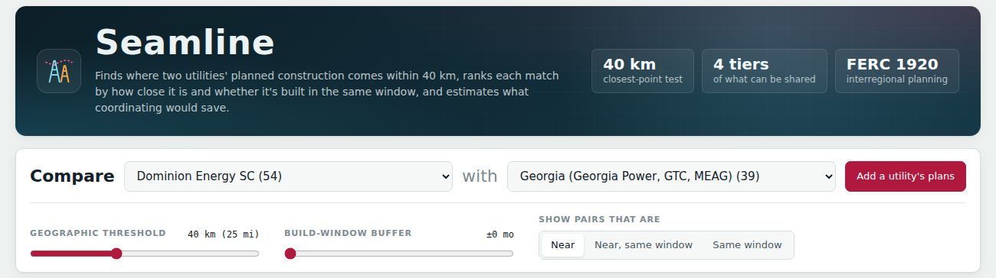
The header, and the bar where you choose what to compare.
Compare … with … | Pick the two companies. The number in brackets is how many planned projects each one has. Pick None in the second box to just look at one company's projects (section 10).
Add a utility's plans | Load another company's plan from a file (section 9).
Geographic threshold | How close two projects must be to count. The default is 40 km (about 25 miles), roughly how far one crew yard can serve in a day. Slide it to be stricter or looser.
Build-window buffer | How many months apart two build windows can be and still count as "at the same time". At ±0 they must actually overlap. At ±6, jobs half a year apart also count.
Show pairs that are | Near shows every close pair. Near, same window keeps only close pairs built at the same time, the best opportunities. Same window ignores distance and shows everything built at the same time.
02 · THE SUMMARY

The four numbers and the four tiers
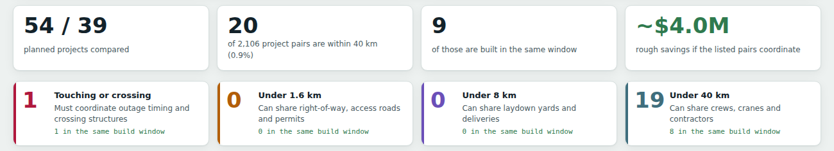
Read this row first: it is the answer in one glance.
54 / 39 | Planned projects for each company.
20 | Of the 2,106 possible pairs, 20 come within 40 km of each other. Most planned work is far apart, which is why finding the 20 matters.
9 | Of those 20, nine are also built at the same time. Those are the strongest chances to share.
~$4.0M | A rough total of what the listed pairs could save by coordinating (section 11).

Each close pair falls into one of four tiers based on the distance between the closest points of the two projects. Closer means more can be shared. Click a tier card in the app to hide or show that tier.
Tier | Distance | What they can share
Touching | 0 km, lines cross or meet | They must plan together: one power shutoff and shared crossing towers.
Shared land | Under 1.6 km (1 mile) | The cleared strip of land, access roads and permits.
Shared site | Under 8 km (5 miles) | One storage yard for materials and deliveries.
Shared crews | Under 40 km (25 miles) | Work crews, cranes and contractors.

03 · WHERE

The map
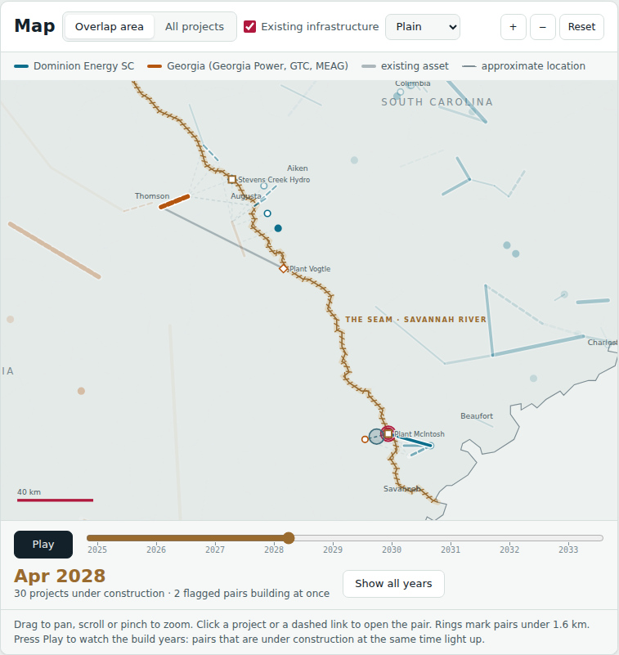
The map, paused on April 2028 during playback.
Colored lines and dots | Blue is the first company, orange is the second. Lines are power lines; dots are substations and plants. Thicker lines carry higher voltage.
Dashed lines, hollow dots | Public plans name places but don't give exact coordinates, so locations were placed by hand. Dashed or hollow means "best guess".
Grey lines and diamonds | Things that already exist, like Plant Vogtle, shown for reference.
Thin dotted links | Each link joins the two closest points of a flagged pair. Its color is the pair's tier. Click one to open that pair.
Rings | Mark pairs that touch or are under 1.6 km apart.
The stitched line | The Georgia and South Carolina border, which is the Savannah River. It's drawn as a seam because that's where the two companies' work meets.
Map buttons | Overlap area zooms to where the flagged pairs are; All projects shows everything. The style box switches between Plain, Streets, Satellite and Terrain. Drag to move, scroll to zoom.

Play the build years
Press Play under the map and it steps forward one month at a time. Projects brighten while they're under construction and fade before they start. When both projects in a flagged pair are under construction in the same month, a pulsing ring appears between them: that's a live chance to share. Drag the slider to jump to any month, and press Show all years to go back.

04 · WHAT MATTERS MOST

The ranked list
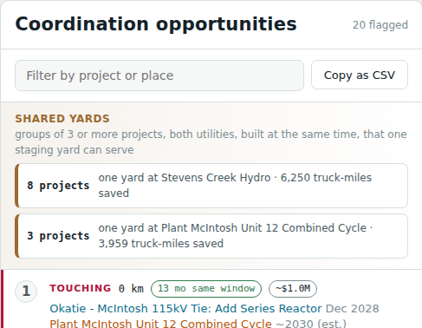
Best opportunities first.
Every flagged pair, best first. The order is: closer tier first, then pairs built at the same time, then shorter distance. Each row reads left to right:
- The tier, for example TOUCHING or SHARED CREWS, in the tier's color.
- The distance between the closest points, for example 0 km.
- The timing: "13 mo same window" means both jobs are under way together for 13 months; "6 mo apart" means they miss each other.
- The rough savings, for example ~$1.0M.
- Below that, the two project names, colored by company, with their in-service dates.
Type in the filter box to search by project or place. Copy as CSV copies the list so you can paste it into Excel or Google Sheets.
05 · CLICK ANY PAIR

A pair up close
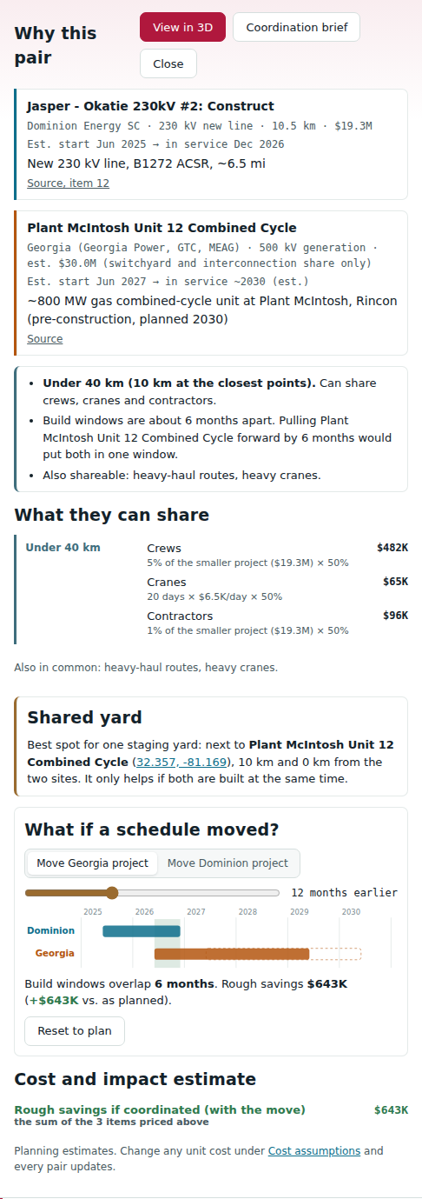
A pair's details after pressing the suggested move.
Project cards. Each project's company, voltage, type, length, cost, estimated start and in-service date, with a link to the public plan it came from.
Why this pair. A plain summary: how close they are, what that tier lets them share, how their schedules line up, and anything else they have in common, like the same crew type or heavy cranes.
What if a schedule moved? Choose which project to move, then slide it earlier or later. The bars show both build windows, the green band is the time they overlap, and the dashed outline is where the moved project was. The savings update as you slide, and the note says how much better or worse the move is than the plan.
The Try … button picks the smallest move that gives both jobs at least six months together. It only appears when the plan doesn't already share that much time. Reset to plan puts the dates back. In this example, the Jasper to Okatie line and McIntosh Unit 12 miss each other by six months. Starting McIntosh a year earlier gives them six months together and unlocks about $643K: $482K of shared crew mobilization, $65K of crane time and $96K of contractor setup.
What they can share. Every item the pair's tier allows, each with its own dollar figure and the math under it, like "20 days × $6.5K/day × 50%". Items that need both jobs running at the same time are greyed out until they are.
Cost and impact estimate. The total of those items.
06 · WHEN

The construction timeline
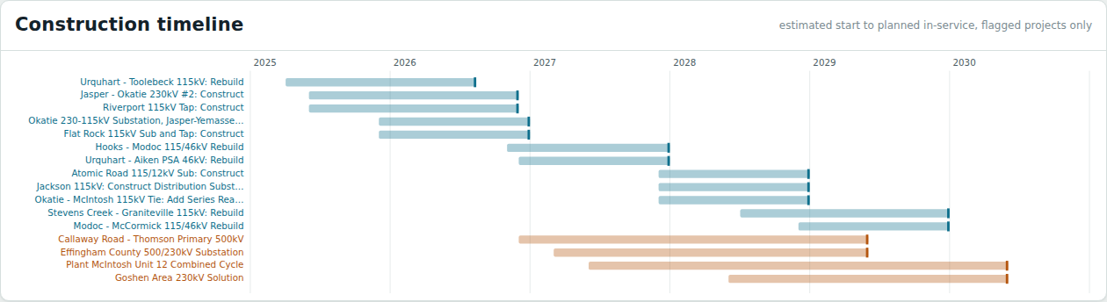
One bar per flagged project.
Each bar runs from the estimated start to the planned in-service date, with a solid tick at the end. When you pick a pair, its two bars stay bright, the rest fade, and the months they share are shaded. During playback, a line marks the current month.
07 · SOMETHING TO HAND OVER

The coordination brief
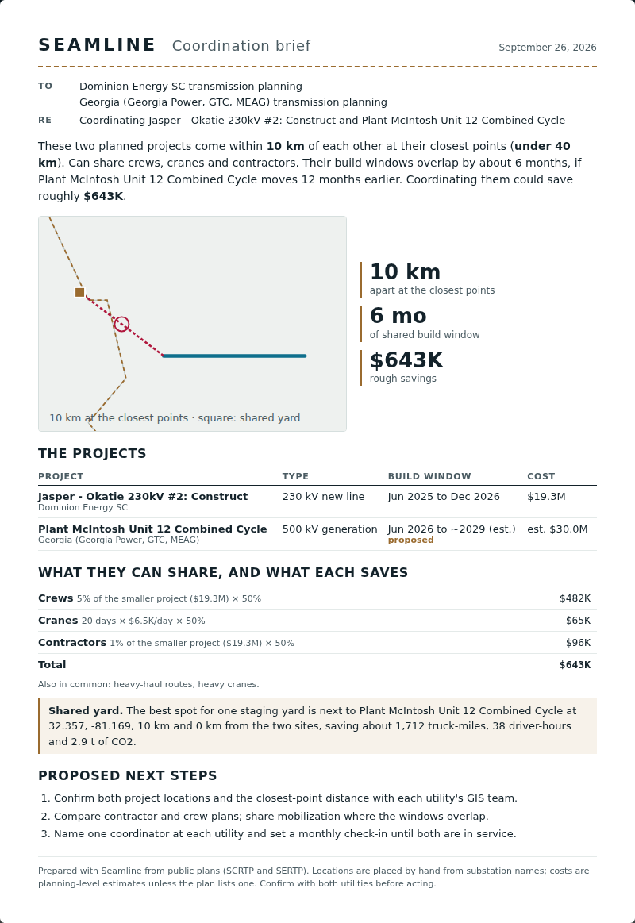
One page per pair, addressed to both companies.
Press Coordination brief on any pair and Seamline writes a one-page memo addressed to both companies' planning teams.
It says in one paragraph how close the projects are, when they overlap, and roughly what coordinating would save. Then it shows a small locator map, the three key numbers, both projects, each shareable item with its dollar figure and math, and the next steps to take.
If you used the what-if slider and the move improves the plan, the brief includes that move and marks the new dates as proposed. A move that makes things worse is left out, and the brief describes the plan as published.
Print or save as PDF prints just the memo, and it fits on one Letter page. Copy text copies it to paste into an email. Printing works when the app is opened from the repo or a website; the Claude preview blocks printing.
08 · SEE IT

The 3D view
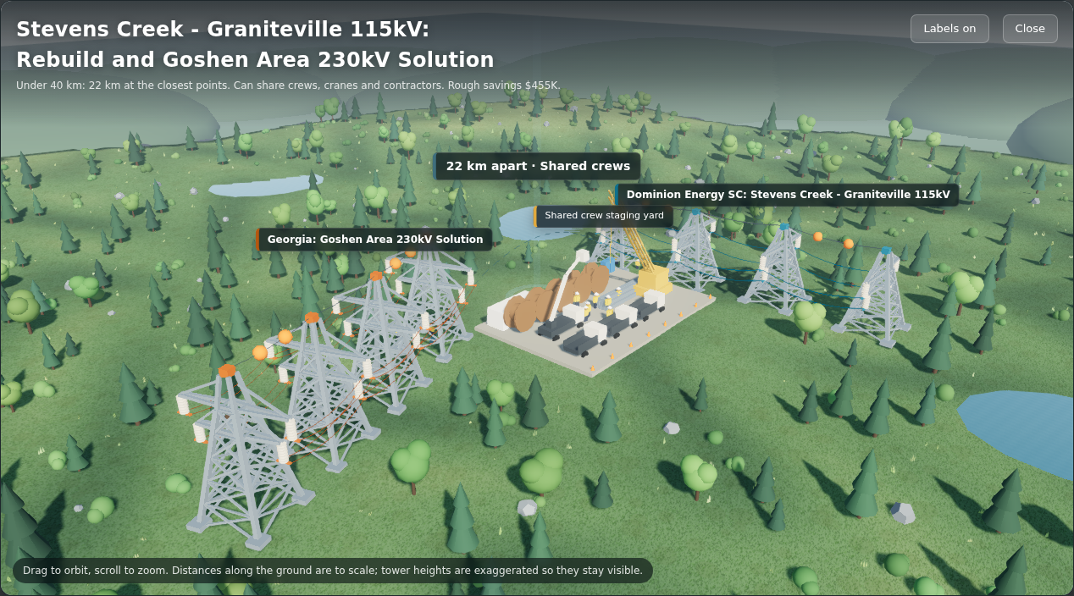
A shared crew yard between two lines about 22 km apart.
Press View in 3D on a pair to see it as a small landscape: both companies' towers and wires (in their colors), substations or plants, work crews, and what the tier lets them share. That's a cleared strip and road for close pairs, or a storage or crew yard for farther ones. The glowing marker is the closest point, labeled with the distance.
Drag to look around and scroll to zoom. Distances along the ground are to scale; towers are drawn taller than life so you can see them.
The Labels on / Labels off button next to Close hides the floating name tags and the hint for a clean view. The app remembers your choice next time.
Quality sets how sharp the scene is. High, the default, is sharp with soft shading where towers and trees meet the ground. Ultra renders at your screen's full resolution for the crispest picture on a fast computer, and Standard is a lighter look for slower ones.
09 · ANY COMPANY, ANY FILE

Adding another company's plans
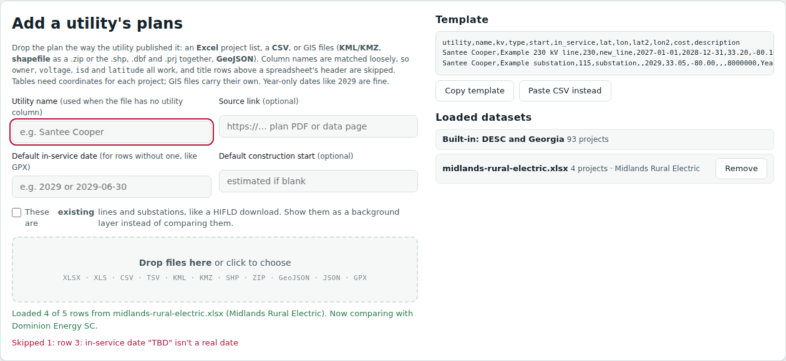
After dropping an Excel plan: 4 rows loaded, 1 skipped with the reason.
Press Add a utility's plans and drop in the file the way the company published it. Seamline reads the file types power companies actually use:
- Spreadsheets: Excel, CSV and TSV.
- Map files: KML and KMZ (Google Earth), shapefiles (from GIS departments), GeoJSON, and GPX (from GPS surveys).
It matches column names loosely, so "Owner", "Voltage (kV)" or "ISD" all work. If a file has no company name or no dates, type them in the boxes above the drop area. The report underneath says what loaded and why any rows were skipped. After loading, Seamline compares the new company with whichever existing one has the closest project.
The samples folder in the repo has nine made-up plans, one per file type, to try this with.
10 · JUST BROWSING

Looking at one company
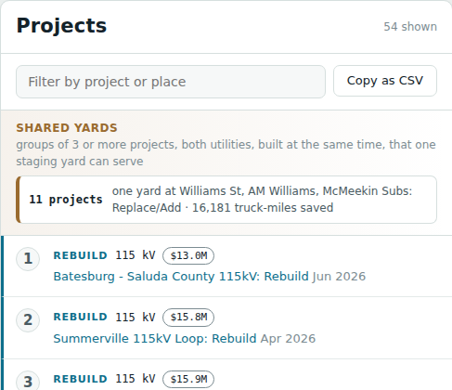
Compare set to None.
Set the second Compare box to None and Seamline stops pairing. It lists every project for the first company in the order they start, with type, voltage and cost.
The four numbers change to project count, kilometers of line, in-service years and total cost. The sliders grey out because there's nothing to compare. Click a project to see its details, or press Play to watch that company's building years.
11 · THE MONEY

How savings are estimated
These are rough, planning-level figures meant to show which pairs are worth a phone call, not a budget. Each item a pair can share gets its own figure, and the pair's total is their sum. A pair only earns the items its tier allows, and yards, deliveries, crews, cranes and contractors only count if the two jobs are built at the same time.
When one company's cost can be shared, each side saves its share, 50% by default. A coordinated power shutoff and a crossing designed once are counted in full.
Item | When it counts | Default math
Outage timing | Touching | One $250K shutoff instead of two
Crossing structures | Touching | One $120K design and structure set
Right-of-way | Under 1.6 km | 11.1 acres (1 km × 45 m) × $15K per acre × 50% = $83K
Access roads | Under 1.6 km | 1 km × $90K per km × 50% = $45K
Permits | Under 1.6 km | One $150K package instead of two × 50% = $75K
Laydown yards | Under 8 km, same time | One $400K yard instead of two × 50% = $200K
Deliveries | Under 8 km, same time | 12 loads × $5K × 50% = $30K
Crews | Under 40 km, same time | 5% of the smaller job's cost × 50%
Cranes | Under 40 km, same time | 20 days × $6.5K per day × 50% = $65K
Contractors | Under 40 km, same time | 1% of the smaller job's cost × 50%

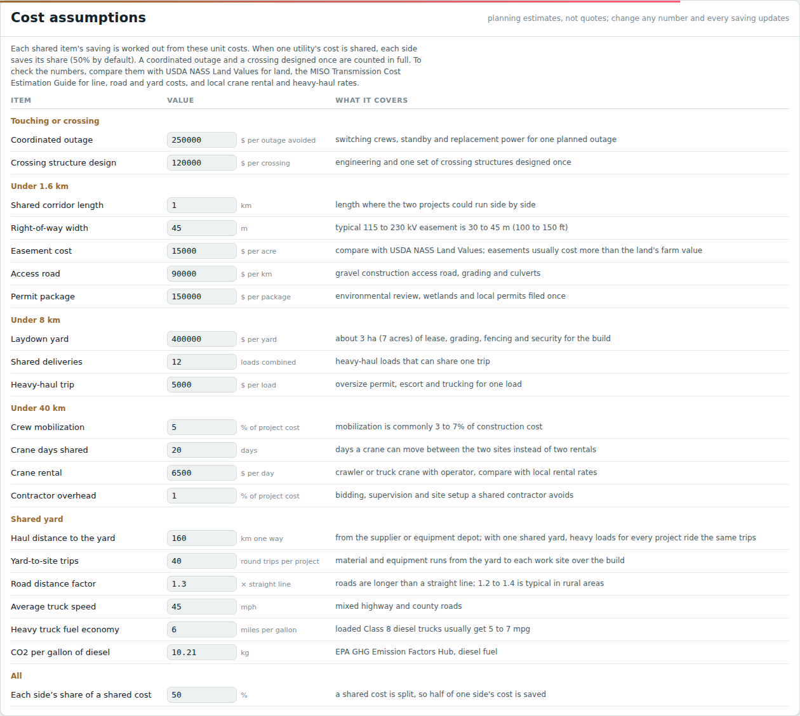
Cost assumptions, at the bottom of the page. A changed number is outlined and shows its default.
Change any number. Every unit cost above is in the Cost assumptions table at the bottom of the page. Type a new value and every pair, the total and the brief update at once. Your numbers are remembered on that device, and Reset to defaults puts them back. To check them, compare with USDA NASS Land Values for land, the MISO Transmission Cost Estimation Guide for line, road and yard costs, and local crane rental and trucking rates.
When a plan doesn't list a cost, Seamline estimates one from typical prices: about $2.5M per km for a new 500 kV line, $1.4M at 230 kV, $0.95M at 115 kV, half that for rebuilds, and $8M to $60M for a substation depending on voltage.
Keep in mind
Locations are placed by hand from substation names, start dates are estimated, and costs are estimates unless the plan lists them. Seamline points at where to look; the two companies confirm the details.

12 · ONE YARD FOR MANY JOBS

Shared yards
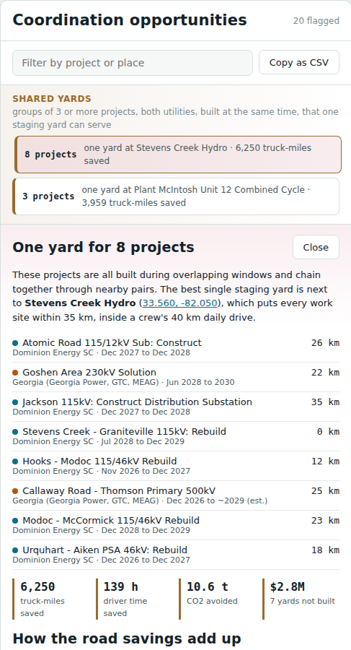
The 8-project group around Augusta.
A staging yard is where a job keeps its materials, trucks and equipment. Crews drive from it to the work every day, so it only works for sites within about 40 km. Seamline looks for the one best spot for a shared yard: the point with the least total driving to every work site. If an existing substation or power plant is almost as good, it picks that instead, because those already have road access and fenced land.
Shared yards at the top of the list shows groups of 3 or more projects, from both companies, that are built at the same time and could all use one yard. Click one to see the yard, how far each site is from it, and what it saves on the road: truck-miles, driver-hours and tons of CO2, using the EPA's figure for diesel. Heavy loads for every extra project can ride shared trips to one yard; the extra driving from the yard to each site is subtracted.
The biggest group is 8 projects around Augusta. Its best yard is at Stevens Creek Hydro, DESC's own plant in Georgia, with every site within 35 km. That saves about 6,250 truck-miles, 139 driver-hours and 10.6 t of CO2, plus 7 yards that don't need building.
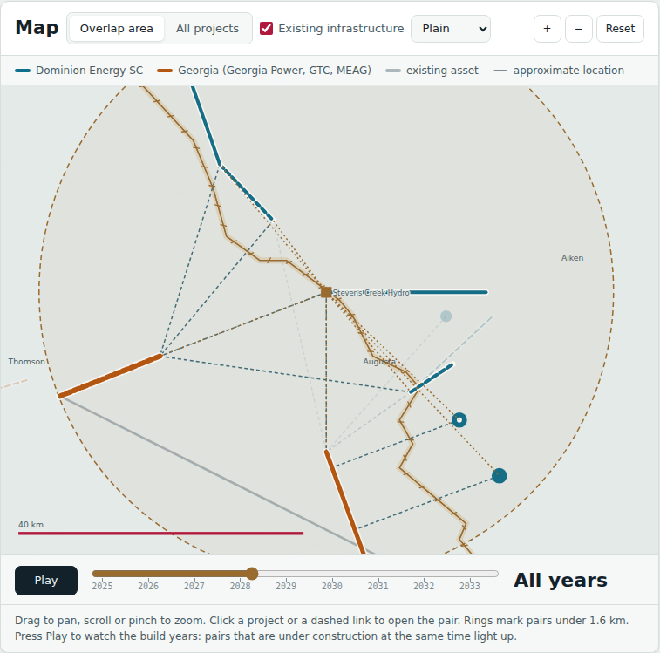
The square is the yard. The dashed circle is a 40 km day's drive, and a dotted line runs to each site.
Each pair's details and its brief also name the pair's own best yard. The numbers behind all of this are under Cost assumptions.
13 · FOR THE JUDGES

A one-minute demo
- Open the app. Point at the four numbers: 2,106 pairs checked, 20 close, 9 at the same time, about $4.0M.
- Point at the stitched river on the map: that's the seam where the two companies meet.
- Press Play. Watch pairs spark when both are being built in the same month.
- Click pair #1, Okatie to McIntosh. They touch, so one shared shutoff saves money on its own.
- Press View in 3D to show the shared strip of land and road. Turn Labels off for a clean shot, then close it.
- Open a pair that misses by a few months, press the suggested move, and watch the savings appear.
- Press Coordination brief: this is the page you'd send to both companies.
- Click the 8-project group under Shared yards: one yard at Stevens Creek Hydro serves them all.
- Finish by dropping a sample file into Add a utility's plans to show it works for any company.

