relatorio de usinagem

SENAI Hermenegildo Campos de Almeida 1.22
Av. Dr. Renato de Andrade Maia, 601 - Jardim Paraventi Guarulhos, SP, 07114-000

Telefone: 11 97221-7283
Email: luis.santos89@senaisp.edu.br

Machining report

Apart from the fact that the material is very fragile and has a lot of vibration, it was smooth machining, smooth programming, going through roughing and finishing, and after machining some manual finishing. There were a total of 4 fixings, the first two for roughing and finishing the chassis and after first two for roughing and finishing the chassis and the other two for finishing some areas that were not possible to machine on the last respective sides. The part was made on a Romi D600, 3 axes, we used Mastercam software to program and post-process the operations, we used a Ø6 mm caribe milling cutter and a Ø6 mm spherical milling cutter and hydraulic cones were used for the tools.

The first fixing we place the part zero in the center of the block diameter.

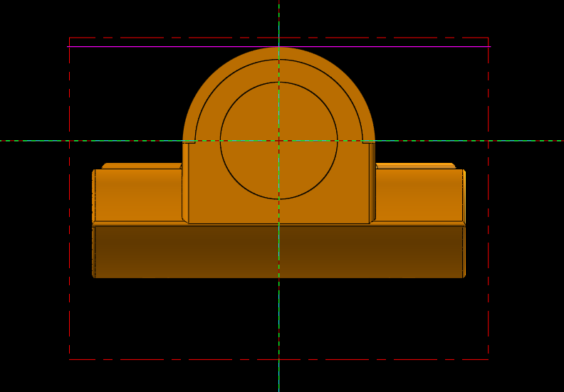

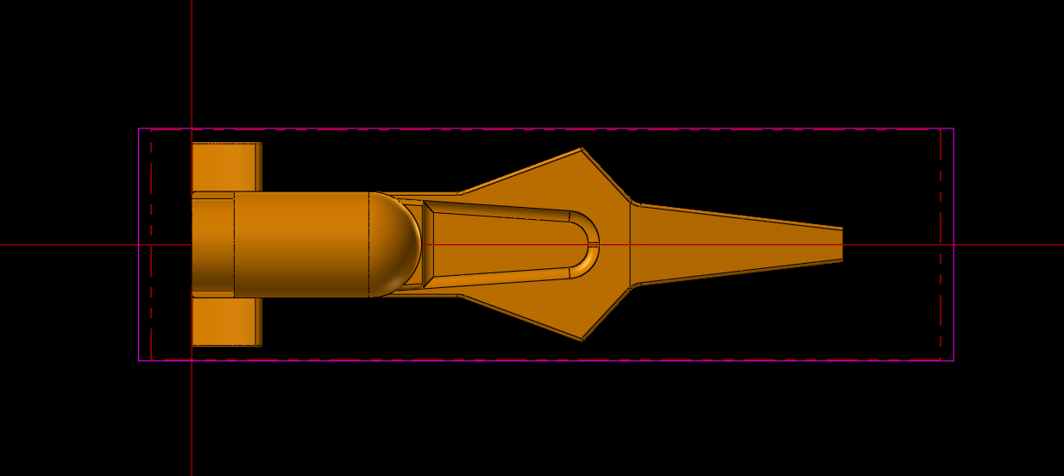

We use more efficient parameters and slightly longer machining, we use 7500 RPM and 2000 Feed. The roughing and finishing machining time together was a total of 1 hour and 20 minutes.
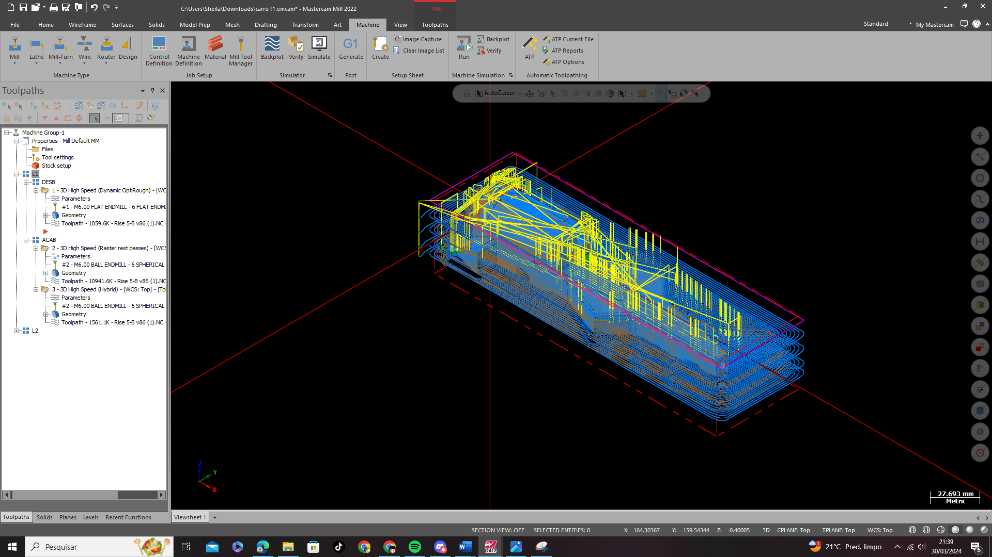
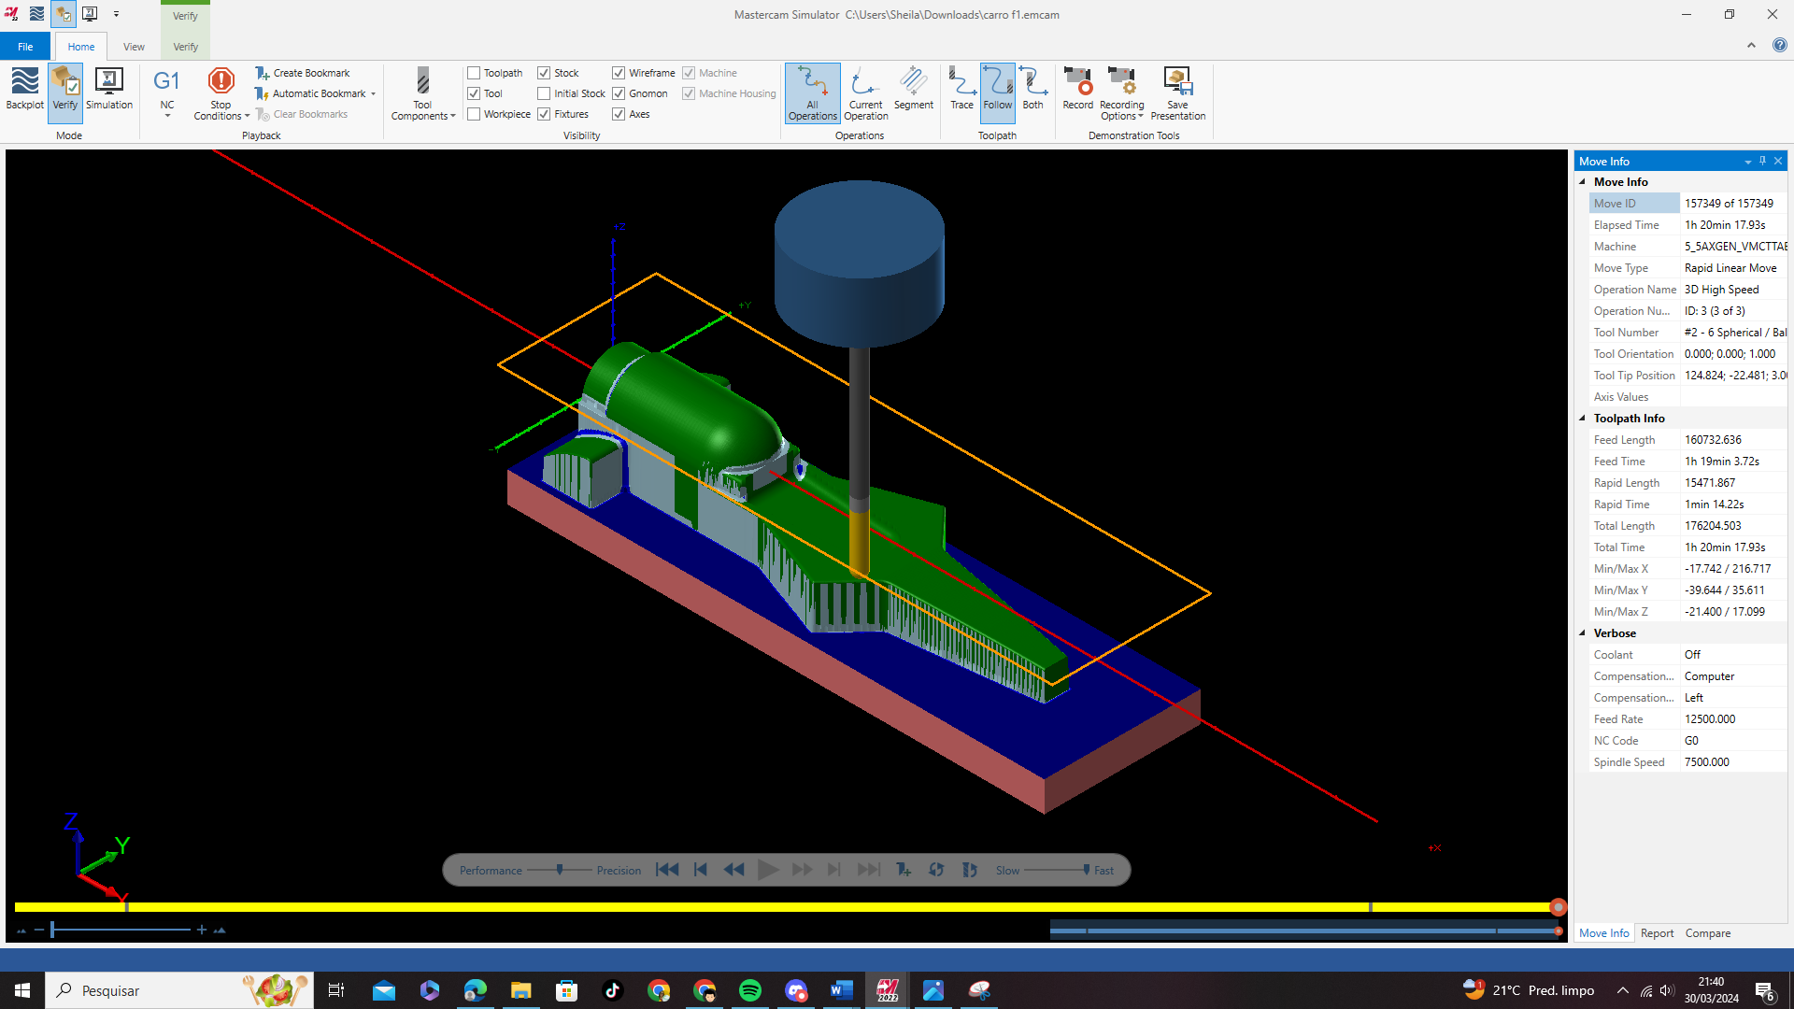

On the second side we place the X at the top of the vise and the Y in the center of the piece. And the machining time for roughing and finishing was 30 minutes.

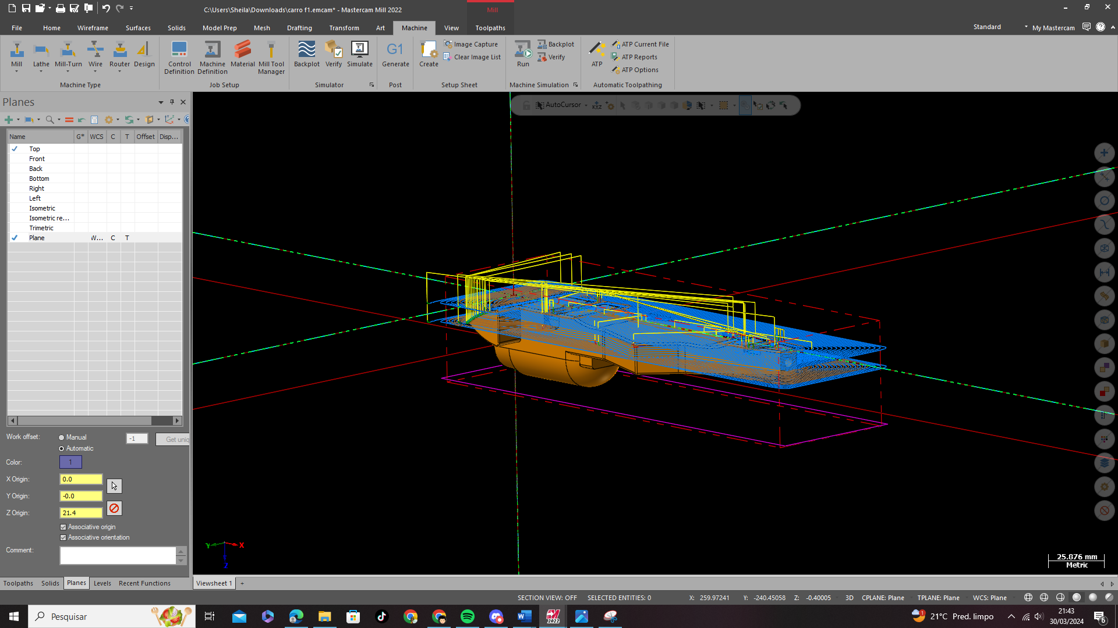
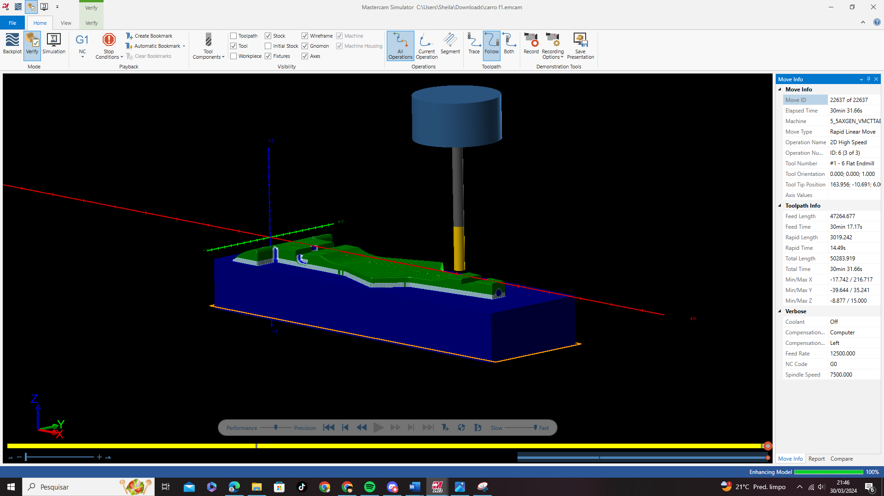

On sides 3 and 4, the same method was used on both sides, as they were identical areas, just two contours. The two sides together had a total of 20 seconds, as these were simple measurements.

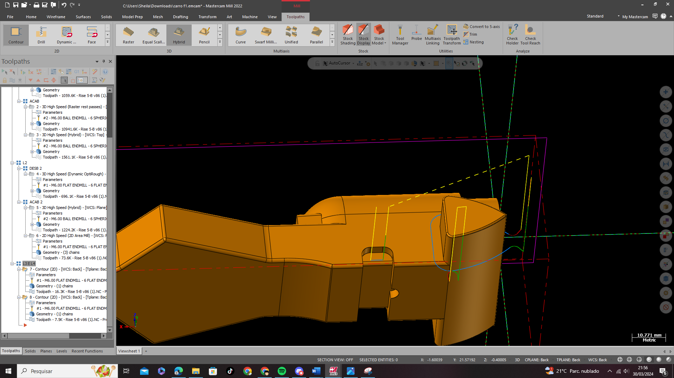

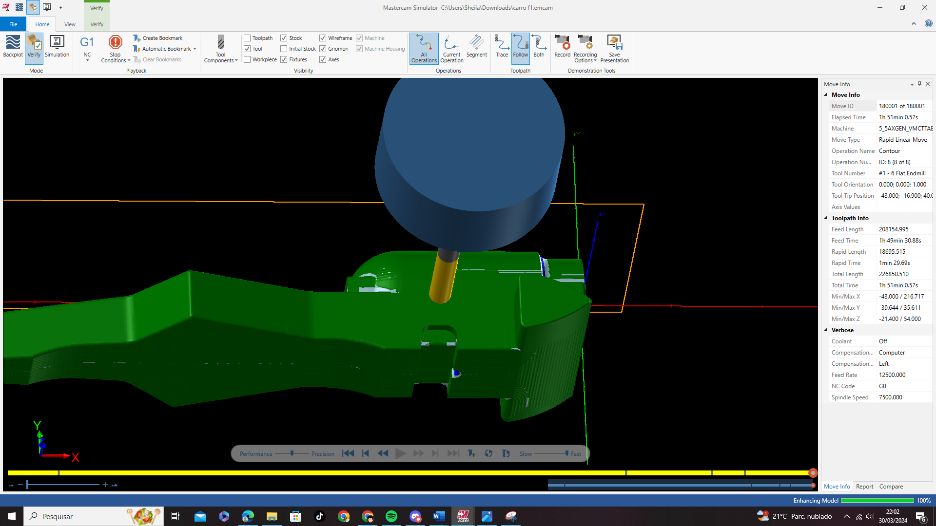

In total, it took 1 hour and 51 minutes of machining and these blue areas were removed manually using files.

