**Automatic Coding of HCI Papers using NLP Topic Modeling Techniques**

**Abstract**

*The Human Computer Interaction research field is quite broad, there is a plethora of papers that have been published in this field. When conducting a literature review the process of reading and analyzing such publications and coding them to come up with overarching themes can be quite daunting. As a solution, I propose an automatic method to eliciting the key themes in research papers by leveraging natural language processing techniques. In this paper I will use three NLP techniques (LDA, LSA & NMF) to auto-code 50 research papers. I would also compare the topics generated with the ones derived from performing the same task manually. The results suggest that NLP techniques can be used to support researchers coding qualitative data. I found that NMF produced the most coherent topics, it was also the most accurate in classifying papers under a topic. I also discovered that NMF and LSA often produced the same results was also the most accurate when coding papers.*

**Key words: Qualitative analysis, auto-coding, NLP**

1. **Introduction**

There are a lot of publications being released today in the Human Computer Interaction (HCI) field. To keep up with the growing trends and innovation and to better understand the evolution of research in this fields literature review is done [1]. Literature review is a basis for research in nearly every academic field. The information gained from literature reviews is useful for several reasons such as managing and organizing research proposals [4], predicting the likely impact of research plans and visualizing research themes [5].

The process of writing a literature review involves several activities; researchers usually have to read and analyze multiple research papers, code them and further categorize each paper under an overarching topic. This process requires a lot of effort and can be quite grueling, especially when the dataset is huge [4]. There are software applications that help in analyzing research papers, however, they are mostly assistive, and still dependent on the the researcher for further interpretation. A possible alternative to help reduce the effort and also biases immanent in manual analysis is to use NLP topic modelling techniques to auto-code research papers and further categorize them under a topic.

NLP is a subfield of computer science and linguistics that deals with algorithms, methodologies, and tools to analyze natural language text and studies grammatical, syntactic, and semantic structure of text [4]. One of the primary applications of natural language processing is to automatically extract what topics people are discussing from large volumes of text, also known as topic modelling. Topic modelling is the process ofextracting the most representative topics occurring in a collection of documents and clustering the documents with the same topic [14].A typical application topic modeling is, Resume Summarization, Search Engine Optimization, Recommender System Optimization, Customer support improvement.

There are several approaches used for topic modeling, the most common of it are, Latent Semantic Analysis (LSA/LSI), Probabilistic Latent Semantic Analysis (pLSA), Latent Dirichlet Allocation (LDA) and Non-Negative Matrix (NMF). With LDA being the most popular. These approaches also have several variations e.g PLSA, GLDA. In a later section, we will briefly review some of these approaches and will see how they can be applied to topic modeling in Python. [13]

With that being said the goal of this paper is to apply NLP techniques to automate the coding process usually involved during literature review. I will be using three topic modelling techniques LSA, LDA and NMF. I will compare the codes and topics generated by these techniques to the ones generated manually by myself. The rest of the paper is as follows. I introduce the problem in section one. In the next section I discuss the work that has been done in this area. In section 3, I will describe my methodology and how I went about this experiment. I discuss my results in section 4 and discuss them is section 5, I also discuss the limitations of my experiment in section 5. In the 6th section I conclude and also talk about my future works.

1. **Related work**

There have been several works relating to how NLP has been used in the qualitative analysis and classification of textual data.

The authors in [1], presented an automatic method for extracting and examining key research themes using natural language processing. They used this method to analyze 8,845 academic papers published over the past 2 decades. They identified and visualized key research themes and used them to highlight trends.

In [2], a novel method was introduced that used graph theory to extend the natural language-based processing of qualitative data analysis.

In the paper [3] they perform theme and sentiment analysis of blog entries using statistical text-mining techniques. Theme identification was performed using a novel technique called ‘Best Separators Algorithm’ and sentiment analysis was performed using logistic regression combined with dimension reduction technique (singular value decomposition). Their results showed significant improvement in accuracy compared to popular approaches.

Guetterman et al. [4] conducted a study to compare the benefits/advantages of a traditional qualitative text analysis using qualitative software, an NLP based analysis, and an augmented approach that combines the two methods, in theme analysis. These three methods were applied to data generated from message survey questions. They found that NLP methods were able to validate major themes found with traditional qualitative analysis but were not useful in identifying nuances. However traditional qualitative text analysis added important details and context.

The authors in [5] applied latent semantic analysis (LSA) in the analysis of transcripts of interviews in order to automate the coding of interview transcripts into higher level concepts to be investigated. In the paper they present two LSA-based algorithms. They evaluate the algorithms against two separate real-life cases taken from the automobile industry and from the Austrian mobile phone market. They compared their results against marketing expert judgements and show that the algorithms proposed provide perfect reliability with appropriate validity in automated coding and textual analysis.

The paper [6] presents a hybrid approach to classification of natural language textual data that combines automated data extraction with human qualitative analysis in the. In the framework, they iteratively develop a set of categories to classify the text messages in a mailing list. Next, they use inter-rater agreement measures to refine the list of categories until a high degree of agreement is achieved. The refined categories are then used to classify a representative sample of the textual data. They claim their approach is transparent, generalizable, and suitable for large projects.

The authors in [7] propose a semi-automatic tool that initially uses natural language processing (NLP) and machine learning (ML) techniques for automatic coding, then follows it up with which human analysis for validation and correction. They discuss design strategies adopted to optimize the system performance in automatic coding.

In [8], the authors demonstrated how to use NLP and ML to assist the qualitative researcher in improving the reproducibility and traceability of the coding process through recommendations. They integrated an already existing commercial machine–learning (ML) based concept extraction service into an NLP pipeline. They applied their prototype in three qualitative studies to evaluate its ability to support researchers by giving recommendations congruous with their initial work. They claim that their approach can be applied to interviews from any domain, without the need for researcher to create new rulesets.

Crowston and his team were one of the first to demonstrate the use of high-level NLP techniques for qualitative data analysis. In [9], they presented a case study in which they built a rule–system to perform auto-coding for 12 predefined codes on a set of instant messaging logs and compared the results to a manual coding. Similarly, in [11] they present a case study of the use of NLP for qualitative analysis in which the NLP rules showed good performance on a number of codes.

In a related work [10], they explore semi-automatic coding of textual data by leveraging (NLP) techniques using the same data in [9] [11]. They compare the performance of human-developed NLP rules to those inferred by machine learning (ML) algorithms. The results suggest that NLP with ML may be useful to support researchers coding qualitative data. They concluded that both approaches show promise but they also have shortcomings.

1. **Dataset**

The dataset used in this paper consisted of 50 HCI related papers published in the last two decades. The oldest paper was published in 1995. The selected papers were relating to providing accessibility for the visually impaired people in computing. These papers were gotten from databases online, they were either published at a conference or in a journal.

1. **Model**

This paper focuses on 3 widely used topic modeling approaches:

1. Latent Dirichlet Allocation
2. Latent Semantic Analysis
3. Non-negative Matrix Factorization

Each of these models were designed with different goals and are supported by different statistical theories. However, all 3 topic models are based on the same basic assumption:

* each document consists of a mixture of topics, and
* each topic consists of a collection of words.

Based on these assumption, the different models can be condensed into a shared representation. For a corpus with M documents and N words, we construct a m × n document-term matrix A. Based on T topics we decompose the matrix A into two matrices:

1. m × t matrix, **U,** that indicates the weight each topic has in each document.
2. t × n matrix, **V,** that indicates the weight each word has in each topic.
   1. LDA

LDA or Latent Derelicht is a generative probabilistic model that assumes that documents are probability distributions over latent topics, and topics are probability distributions over words. [13]

Based on these assumptions, we can describe the generative process of LDA as, given the M number of documents and N number of words, represented as a Document-Term Matrix A, and prior T number of topics, the model trains to output:

* ϕ, the word distribution for each topic t
* θ, the topic distribution for each document *i.*
* $z_{i,j}$, the topic for each $w_{i,j}$, the *j*-th word in document *i.*

{\displaystyle w_{ij}}These two distributions are based on two hyper parameters. θ is based on **Alpha parameter** *α,* which is Dirichlet prior concentration parameter that represents document-topic density. ϕ is based on **Beta parameter** *β*, which is the prior concentration parameter that represents topic-word density. These two sets of distributions correspond to the **U** and **V** matrices, respectively.

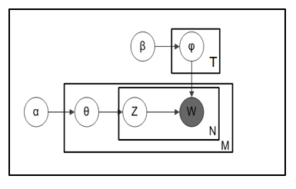

Fig 1. LDA Model representation

* 1. LSA

Latent semantic Analysis or  Latent semantic indexing (LSI) is an indexing and retrieval method that uses a mathematical technique called [singular value decomposition](https://en.wikipedia.org/wiki/Singular_value_decomposition) (SVD) to identify patterns in the relationships between the [terms](https://en.wikipedia.org/wiki/Terminology) and [concepts](https://en.wikipedia.org/wiki/Concept) contained in an unstructured collection of text [21]. LSI is based on the assumption that words that are used in the same contexts tend to have similar meanings.

Similar to LDA, given M documents and N words in our vocabulary, we can construct an m × n document-term matrix *A*, in which each row represents a document and each column represents a word. Unlike LDA, LSA models typically replace raw counts in the document-term matrix with a term frequency-inverse document frequency (tf-idf) score. Tf-idf assigns a weight for term *j*in document *i*as follows:

$$w_{i,j}= {tf}_{i,j} × \log{\frac{N}{{df}_{j}}}$$

where ${tf}_{i,j}$ is the number of occurrences of a term in the document, N is the total number of documents and ${df}_{j}$ is the number of documents containing term.

A= US $V^{T}$

Using SVD, the matrix A is decomposed into three partial matrices U, S, and VT(transpose of matrix V).

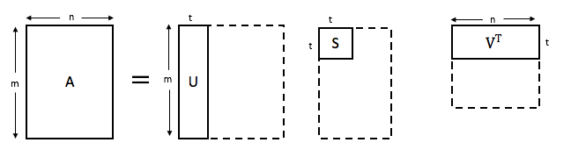

Fig 2. LSA Matrix Decomposition

where U is our document-topic matrix, S is a diagonal matrix of the [singular values](https://en.wikipedia.org/wiki/Singular_value) of A, and V is the term-topic matrix. In both U and V, the columns correspond to each of the *k* topics. In U*,*rows represent document vectors expressed in terms of topics; in V, rows represent term vectors expressed in terms of topics [22]. The length of each vector would be k. These vectors are used to find similar words and documents using the cosine similarity method [16].

* 1. NMF

As the name implies, non-negative matrix factorization is a linear algebraic method where a non-negative matrix is [factorized](https://en.wikipedia.org/wiki/Matrix_decomposition) into two non-negative matrices.

Like the other two models, NMF takes as input the m x n term-document matrix A. Each element in the document represented the weight of a certain word. The weight might be the raw count like in LDA or the tf-idf weighted count like in LSA.

A ≈ U V

NMF factorizes the matrix A to yield two non-negative factors U and V. Where, the U factor contains document weights across the t topics. Each row corresponds to a different document, and each column corresponds to a topic. The V factor contains term weights relative to t topics. Each row corresponds to a topic, and each column corresponds to a unique term in the corpus.

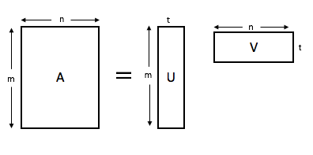

Fig 3. NMF Matrix Factorization

The V factor contains term weights relative to each of the t topics. Each row corresponds to a topic, and each column corresponds to a unique term in the corpus vocabulary.

By default, the values in factors U and V are given random initial values and then updated according to the following iterative update rules:

U = U $\frac{AV^{T}}{U VV^{T}}$ V = V $\frac{U^{T}A}{U^{T}UV}$

1. **Methodology**

In this paper, I compare the three NLP topic modeling techniques. I compare the results they generated to a gold standard, the codes I generated manually. I give further details of my approach in the next subsections.

* 1. Document Collection

The first phase of this project involved gathering a selection of papers for analysis. This was done me and another PhD student in my laboratory. The objective was to collect the full text of HCI papers relating to the concept of accessibility. The ACM, IEE and Google scholar database was used to identify academic papers with the phrases *“Accessibility”,* *“Computer science”,* *“blind programmers”,* “*block-based programmers*”, “accessible”, “*programming environments”,* in their title, abstract or keywords. If any of the key words were found, we downloaded the full text of the publication freely using the university’s access.

After gathering the papers, we quickly schemed through them to see if they were relevant or not. At the end of this process we were able to come up with a total of 50 papers. The contents of each paper was entered into an excel sheet with columns containing the title, authors name, year of publication and conference, abstract and conclusion if exists. This excel file was then converted to a CSV data file to enable it to be parsed by my methods.

* 1. Human Annotation

Having collected the papers, the next step was to manually assign codes. Before starting, we created an initial set of codes with clear definitions which we expected to come across. We then performed the coding task independently. While reading each paper, we assigned codes that were most representative of the contents of the paper. The list of codes grew as we read more papers and discovered more concepts [6].

After we were both done, we compared the codes assigned to each paper. We were able to achieve a fleiss kappa of. On papers where we were in disagreement, we jointly revaluated the paper and came to an agreed on the codes to be assigned. This process is repeated until an acceptable level of agreement was achieved on all papers. The goal was to achieve a high degree of agreement among ourselves on which set of code to be assigned to a paper.

The last step in this process was to iteratively coalesce codes with similar meaning into a single category, and assign a new code to the category. When the list has coalesced into a handful of categories with distinct meanings, we then assigned papers to each category. Some papers fell under multiple categories.

codes become the codes that are assigned to text fragments during the content analysis phase.

* 1. NLP-based Annotation

In this phase we perform the coding of our papers using NLP topic modelling algorithms. First, we preprocess our data. Then we apply our algorithm on the pre-processed data. We also perform parameter tuning on the number of topics.

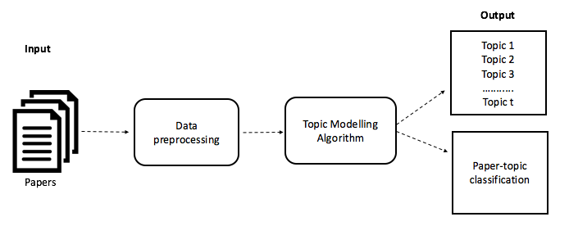

Fig 4. Methodology

* + 1. Data Cleaning

First the csv data file is loaded on Jupyter notebook. Before beginning preprocessing, I cleaned up the data a bit. (show table). Since the goal of this analysis is to perform topic modeling, I dropped the unnecessary columns like ‘ID’, ‘Reference’, ‘Author’, ‘Year’, ‘Conference/ Journal’, and focused solely on the **abstract** and **conclusion** columns of each paper entry. For papers with no conclusions, I filled in the empty cell with the text “No conclusion”. Next, I merged the two columns abstract and conclusion to form a new column called ‘**Paper_text’**. The text in this new column is what I would apply the topic models to.

* + 1. Preprocessing

After cleaning up the data, I applied a couple of simple preprocessing techniques on the content of ‘**Paper_text’** column to make it more amenable for analysis, and improve the reliability of results. First, I tokenized each sentence into a list of words. Next, I used a regular expression to remove any punctuation present in the tokens. I then converted all tokens to lowercase. Additionally, I removed the tokens of length < 3, and tokens that were stop words i.e. words that are frequent and do not convey useful information. Each token was then lemmatized i.e. reduced to its most basic form. Based on the tokens that frequently occurred together, I used Gensim’s Phrases model to create Bigrams and Trigrams, examples include “computer_science”, “visually_impaired”, “Programming_language”. Lastly, I combined the tokens back into sentences.

* + 1. Exploratory analysis

To better understand the data and to confirm that the preprocessing was done correctly, I performed an exploratory analysis. I created a word cloud using the wordcloud package to get a visual representation of most common words in the corpus. This can be seen in figure 1, the most significant words are depicted the largest and smaller words less prominent. I also used a barchart to display the top 10 most common words. The most frequent word with a count of 175 is the word ‘blind’.

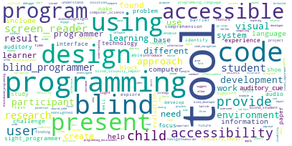

Fig 5. Word cloud

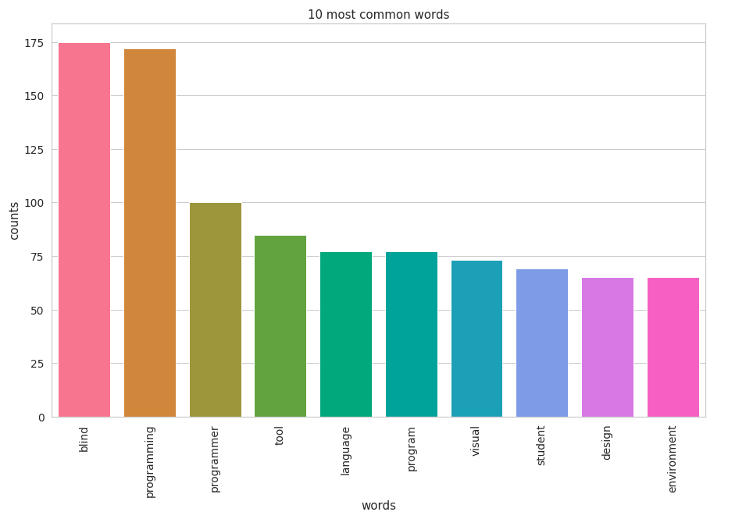

Fig 6. Barchart of top 10 most frequent words

* + 1. Topic Modelling Algorithm

In this step, I applied the three topic modelling techniques LDA, LSA, &NMF to my data. These three models take as input a document-term matrix (Bag of Words BOW). Using sklearn's TfidfVectorizer for my NMF and LSA model, and Vectorizer for my LDA model, I transformed my data to a document-term matrix of 1000 terms. I could have used all the terms in my corpus to create this matrix but that would require a lot of computation. Hence, I restricted the number of features to 1000. The difference between TfidfVectorizer and Vectorizer, is that TfidfVectorizer replaces raw counts of each term in the document-term matrix with a term frequency-inverse document frequency (tf-idf) score.

The next step in each model is to decompose the corresponding document-term matrix into multiple matrices. In LDA and NMF I use sklearn’s decomposition models LatentDirichletAllocation and NMF respectively.

For LSA, I use sklearn's TruncatedSVD for matrix decomposition. The number of topics in each model can be specified by using the *n_components* parameter. In this experiment I selected 10 as my number of topics. I talk about why I selected this number in the next subsection.

The resulting matrices derived after running each topic model are the document-topic matrix and term-topic matrix. In the term-topic matrix, sorting the rows in reverse, reveals the top terms for each topic. The document-topic matrix represents the “weights” of each topic in the document, using these weights we are able to classify a document under the topic with the most weight. The components of *svd_model* are our topics, and we can access them using *svd_model.components_*.

* + 1. Parameter Tuning

The parameter selection decision for topic modelling involves choosing the optimum number of topics t. The most common approach involves measuring and comparing the topic coherence of the models generated for different values of t.

Topic Coherence measures score a single topic by measuring the degree of semantic similarity between high scoring words in the topic. These measurements help distinguish between topics that are semantically interpretable topics and topics that are outcomes of statistical inference [18].

There are various metrics for measuring topic coherence e.g. NPMI, UMass, UCI, C_V. To measure the topic coherence of my model, I used the C_V metric from gensim’s built-in library. I selected the LSI model for this task and used the values of k from 2 to 12. I found that the t with the highest coherence was t= 10. Therefore, I selected 10 as my number of topics. The second best value for k was 8.

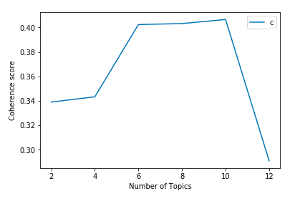

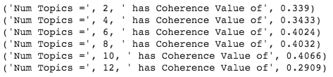

Fig 7. Coherence scores for different number of topics

1. **Results**

In this section I discuss the results generated after running each of the models on my dataset. I break down the results into 3 sections, topic similarity, topic coherence, and model accuracy. Table 1, 2, and 3 shows the 10 topics along with their top 10 terms. Based on the top words for each topic we can infer what the topic is about, for example topic 5 of the LDA Model is about the challenges blind student face in computer science.

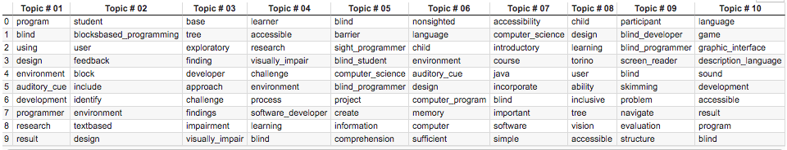

Table 1. LDA Model topics and top 10 words

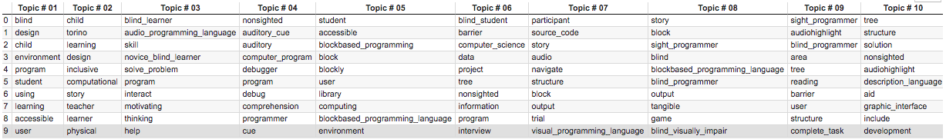

Table 2. LSA Model topics and top 10 words

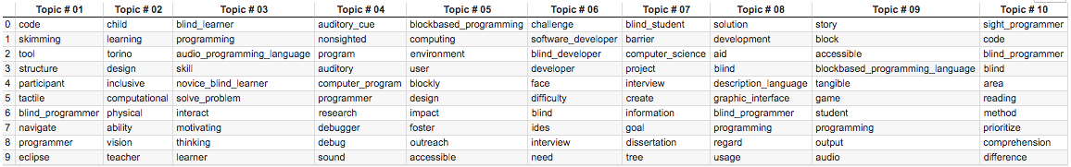

Table 3. NMF Model topics and top 10 words

* 1. Topic Similarity

Looking at the table 1, 2, and 3 above, we can observe that there are recurring topics across the 3 models, for example topic #02 in LDA model, Topic #05 in the LSA model and topic #05 in the NMF models are talking about the same concept which is accessible block-based programming environment. Likewise, topic #05 in LDA, topic #06 in LSA and topic #07 in NMF are all on the barriers blind students face in computer science. Similarly, topic #10 in LDA and LSA corresponds to topic #08 in the NMf model.

Additionally, LSA and NMF not only produced similar topics, but also topics with the same top words. i.e topic #08 in LSA and topic #09 in NMF, topic #06 in LSA and topic #07. Topic #04 in both LSA and NMF. Looking at the top words in these matching topics, we can see that over 50% of the top words are the same. This can be seen across several topics in both of these models

* 1. Topic Coherence

After evaluating each of the topics produced by the 3 models, I found that NMF sometimes produces more meaningful topics out of the 3. Looking at the three tables above. We can see that there is some coherence between the words in each topic produced by the NMF model. For example, Topic #02 in NMF shows words associated with creating an inclusive physical environment for learning, Topic #04 shows word associated with an audio debugger for computer programs. NMF also produced highly distinguishable topics, each topic it produced were unique and involved a new concept.

On the other hand, comparing the results of LDA to NMF. We can see that NMF performs better. The topics created by the LDA was not very coherent. For some topics looking at the top words it is hard to say what that topic is about, for example Topic #07. The LDA model also produced topics with repeated words, for example topic #03 and Topic #04 we can see there are repeated words like challenges, developer, visually impair. These two topics describe the same concepts. Likewise, topic #01 and topic #06.

LSA performed almost as good as NMF. Looking at the topics it produced, it is easy to tell what the topic is about, for example topic #06 is on the challenges blind developers face in programming environments, and topic #05 is on accessible block-based programming environments. Looking at the top words in each topic they all have semantic similarity. Along with producing coherent topics, LSA also produced highly distinguishable topics with the exception of topic #01, all other topics catered to different concepts. However, LSA did repeat some key words across topics like the word “audiohighlight” in topic #09 and topic #10. Having read the papers I know the word “audiohighlight” belongs in topic #09 and not topic #10.

* 1. Model Accuracy

In last part of this experiment I evaluated the models for accuracy. I compared the results produced by each of the 3 models to the gold standard which is my manually annotated data.

1. **LIMITATIONS**

My research study had the following limitations; Firstly, the experiment in this study was conducted using only the abstract and conclusion of each of the selected research papers, as opposed to using the complete text of the paper. Also, the dataset in this study consisted of only 50 research papers, this is considerably small compared to the dataset in other studies. Additionally, the 50 selected papers were closely related, they were all HCI papers relating to the concept of accessibility.

Notwithstanding, the models performed quite well, particularly, the NMF model. In a previous study it has been found that NMF sometimes produces more meaningful topics for smaller datasets. This could infer that parsing the entire text of a paper and a large dataset is not required for good performance of topic models.

1. **CONCLUSIONS AND FUTURE WORK**

NLP techniques have been found to be helpful in the analysis and coding process done during literature reviews. They provide objective and require less effort as they are mostly automated.

This research project investigated the automatic coding of 50 HCI research papers published in the past 2 decades using NLP topic modelling techniques. The 3 topic modelling techniques used were LSA, LDA & NMF. The outcomes of these modelling techniques were evaluated and compared not only to one another but also to a golden standard which was manually annotated.

The results prove that NLP techniques are truly helpful to researchers when coding qualitative data. In particular, NMF was found to produce the most comprehensible topics, it also had the highest accuracy in paper topic classification. Another finding was that the topic models often produced the similar results, especially the models LSA and NMF.

A future work would be to apply the topic modelling algorithm on not only the abstract and conclusion of a paper but on the entire paper text. A comparison would then be made to see if more data improves the accuracy of the models. Additionally, I also plan to implement a supervised version of the topic models, where the topic models are fed training data with topics as labels, and asked to predict the labels (topics) of the test data.

1. REFERENCES

[1] Kenneth Cosh, Sakgasit Ramingwong, Narissara Eiamkanitchat, Lachana Ramingwong. *Automatically Identifying Themes and Trends in Software Engineering Research*, IEEE, 2018.

[2] Patrick J. Tierney. *A Qualitative Analysis Framework Using Natural Language Processing and Graph Theory* 2012.

[3] Jayanta Kumar Pal, Abhisek Saha. Identifying Themes in Social Media and Detecting Sentiments. International Journal of Statistics and Applications: 2011; 1(1): 14-19 DOI: 10.5923/j.statistics.20110101.04.

[4] Timothy C Guetterman, PhD; Tammy Chang, MD, MPH, MS; Melissa DeJonckheere, PhD; Tanmay Basu, PhD; Elizabeth Scruggs, MD; VG Vinod Vydiswaran, PhD. Augmenting Qualitative Text Analysis with Natural Language Processing: Methodological Study.

[5] Ingo Feinerer. Automated Coding of Qualitative Interviews with Latent Semantic Analysis. 2006.

[6] John Noll, Dominik Seichter, Sarah Beecham. A Qualitative Method for Mining Open Source Software Repositories. 8th International Conference on Open Source Systems (OSS), Sep 2012, Hammamet, Tunisia. pp.256-261, 10.1007/978-3-642-33442-9_18 . hal-01519053

[7] Yan, J. L. S., McCracken, N., & Crowston, K. (2014). Semi-Automatic Content Analysis of Qualitative Data. In *iConference 2014 Proceedings* (p. 1128–1132). doi:10.9776/14399

[8] Andreas Kaufmann, Ann Barcomb, Dirk Riehle. Supporting Interview Analysis with Autocoding

[9] K. Crowston, E. E. Allen, and R. Heckman, “Using natural language processing technology for qualitative data analysis,” *International Journal of Social Research Methodology*, vol. 15, no. 6, pp. 523–543, 2012.

[10]  K.Crowston,X.Liu,andE.E.Allen,“Machinelearning and rule-based automated coding of qualitative data,” *Proceedings of the American Society for Information Science and Technology*, vol. 47, no. 1, pp. 1–2, 2010.

[11] Kevin Crowstona*, Eileen E. Allena, Na, “Lina” Lib, Michael J. Scialdonea and Robert Heckmana. Using natural language processing technology for qualitative data analysis. 2010.

[12] Liddy, E. D. (2003). Natural Language Processing *Encyclopedia of Library and Information Science* (2nd ed.). New York: Marcel Decker.

[13] <https://stackabuse.com/python-for-nlp-topic-modeling/>

[14] <https://towardsdatascience.com/end-to-end-topic-modeling-in-python-latent-dirichlet-allocation-lda-35ce4ed6b3e0>

[15] <https://medium.com/mlreview/topic-modeling-with-scikit-learn-e80d33668730#.vivglhmhv>

[16] <https://www.analyticsvidhya.com/blog/2018/10/stepwise-guide-topic-modeling-latent-semantic-analysis/>

[17] <https://www.machinelearningplus.com/nlp/topic-modeling-gensim-python/>

[18] Keith Stevens Philip Kegelmeyer David Andrzejewski David Buttler. Exploring Topic Coherence over many models and many topics. Proceedings of the 2012 Joint Conference on Empirical Methods in Natural Language Processing and Computational Natural Language Learning, pages 952–961, Jeju Island, Korea, 12–14 July 2012

<https://www.aclweb.org/anthology/D12-1087.pdf>

[19] <https://www.datacamp.com/community/tutorials/discovering-hidden-topics-python>

[20] <https://stackabuse.com/python-for-nlp-working-with-the-gensim-library-part-2/>

[21] Wikipedia contributors. (2020, February 7). Latent semantic analysis. In *Wikipedia, The Free Encyclopedia*. Retrieved 12:38, April 6, 2020, from <https://en.wikipedia.org/w/index.php?title=Latent_semantic_analysis&oldid=939659515>

[22] <https://medium.com/@souravboss.bose/comprehensive-topic-modelling-with-nmf-lsa-plsa-lda-lda2vec-part-1-20002a8e03ae>

[23] <http://derekgreene.com/slides/topic-modelling-with-scikitlearn.pdf>