A distributed maturation delay in the profit–investment cycle: differentiable inverse calibration and identifiability limits
Juan I. Tollo

Abstract
We study the profit–investment cycle of the U.S. economy (quarterly, 1948–2026) through the lens of overaccumulation: past investment depresses current profitability with a delay. Using the cross-correlation function and a recession event study, we show a dominant contemporaneous co-movement together with a negative feedback centred about one year, which builds up before recessions—consistent with Tapia Granados (2012). Fixed-phase predator–prey oscillators (Lotka–Volterra, FitzHugh–Nagumo) cannot reproduce this shape. We instead pose a physical maturation-chain model, a distributed-delay ODE, and calibrate it by a differentiable inverse (physics-informed neural network with Fourier features). The inverse recovers the maturation lag cleanly on synthetic data (8.9% error) and estimates ≈1 year on real data; the lag is stable to transform choice and leave-one-crisis-out. Our central result is one of identifiability: the centre of the delay is robustly identified, but its distributional width is not, and the feedback is observationally equivalent to a linear VAR(p≥4) at the level of the second-order autocovariance.

1. Introduction
The Marxian tradition of overaccumulation (Astarita; Tapia Granados, 2023) holds that capital accumulation eventually depresses the rate of profit, generating endogenous cycles and crises. A long line of nonlinear models—starting from Goodwin's (1967) growth cycle, a Lotka–Volterra (LV) predator–prey system, and its empirical predator–prey estimate by Goldstein (1999)—formalises this as an antagonism between profits and a second variable. These models impose an instantaneous coupling with a fixed 90° phase lag.
We ask a narrower, mechanistic question: is the feedback from investment to profits an instantaneous antagonism, or a delayed one whose timing reflects the maturation (gestation) of investment? We find the latter. The empirical signature is a contemporaneous co-movement plus a negative feedback concentrated about one year out—a shape no fixed-phase oscillator can generate, but a distributed-delay system can. We formalise this as a physical maturation-chain ODE and calibrate it by a differentiable inverse problem. The contribution is descriptive and methodological: a transform-robust, leave-one-out-stable estimate of a structural maturation lag, recovered by an inverse method where classical single-shooting fails, together with an explicit characterisation of what cannot be identified from these data.

2. Data and methods
We use quarterly U.S. corporate profits and gross private domestic investment (FRED, 1948–2026, n=313). To avoid the spurious order-4 structure that the year-over-year transform injects at the lag of interest, we work in quarter-over-quarter growth (x_t = Δlog), which we verified roughly halves the apparent feedback magnitude vs YoY.
Descriptive. We compute the sample cross-correlation function (CCF) ρ(k) = corr(profits_t, investment_{t+k}) and, around the twelve NBER recessions, a superposed-epoch (event-study) composite aligned at the investment trough.
Physical model. Investment matures through n stages before depressing profits; by the linear-chain trick this realises a Gamma-distributed delay of mean μ:
dP/dt = c·I − d·P − k·m, dI/dt = a·P − b·I, m(t) = Σ_j w_j(μ)·I(t−j),
with P profits, I investment, m matured investment, and w(μ) a Gamma kernel of mean μ (the maturation lag).
Differentiable inverse. We calibrate (a,b,c,d,k,μ) by an inverse physics-informed neural network (PINN): a network t↦[P,I] trained with a data loss on the observations and a physics-residual loss enforcing the ODE, optimising network weights and ODE parameters jointly (loss = L_data + λ·L_phys, λ=1; after Raissi et al., 2019; Rackauckas et al., 2020). On long windows a plain network suffers spectral bias and the lag collapses; Fourier-feature inputs remove this. We validate recovery on synthetic data with a known lag, and assess identifiability by a profile over μ, a leave-one-crisis-out analysis, and the theoretical CCF of a fitted VAR(p) from the discrete Lyapunov equation.

3. Results
The pattern: a delayed feedback, not an instantaneous antagonism. The CCF oscillates rather than decaying: a dominant contemporaneous peak (ρ(0)≈+0.6) and a negative lobe at lags 4–5 quarters (≈−0.3 in QoQ), returning to zero by lag 6 (Fig. 1). The event study (Fig. 2) shows profits turning down first and an investment–profit gap that builds up ~1–1.5 years before the trough—the overaccumulation buildup documented by Tapia Granados (2012), here re-confirmed by an independent method. The effective phase is near co-movement (~10°), not the 90° of LV/FN; fixed-phase oscillators are accordingly refuted, as their CCF is a rigid cosine, not an isolated pulse plus a delayed negative lobe.
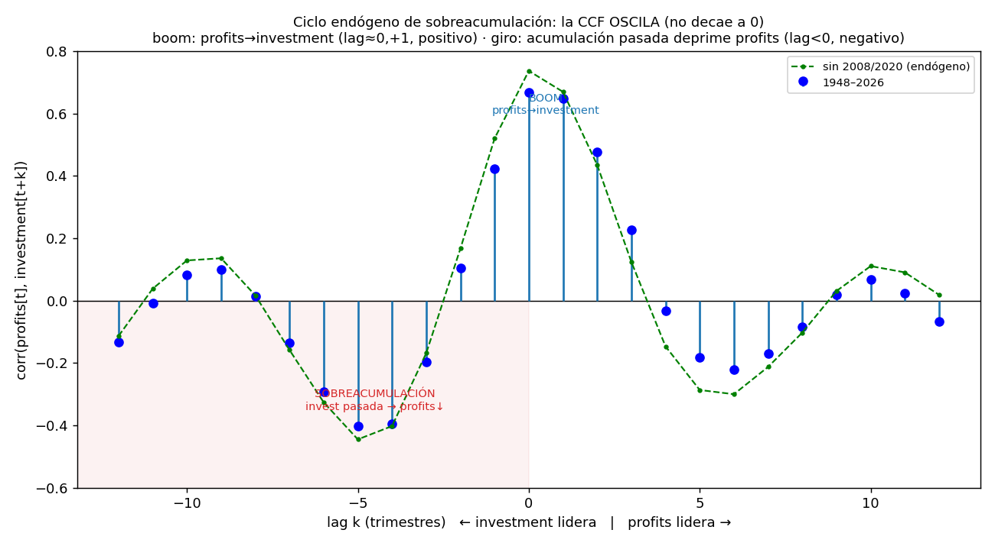
Figure 1. Cross-correlation profits↔investment: a strong contemporaneous co-movement and a delayed negative feedback (investment maturing ~1 year earlier depresses current profits). Robust to excluding 2008/2020.
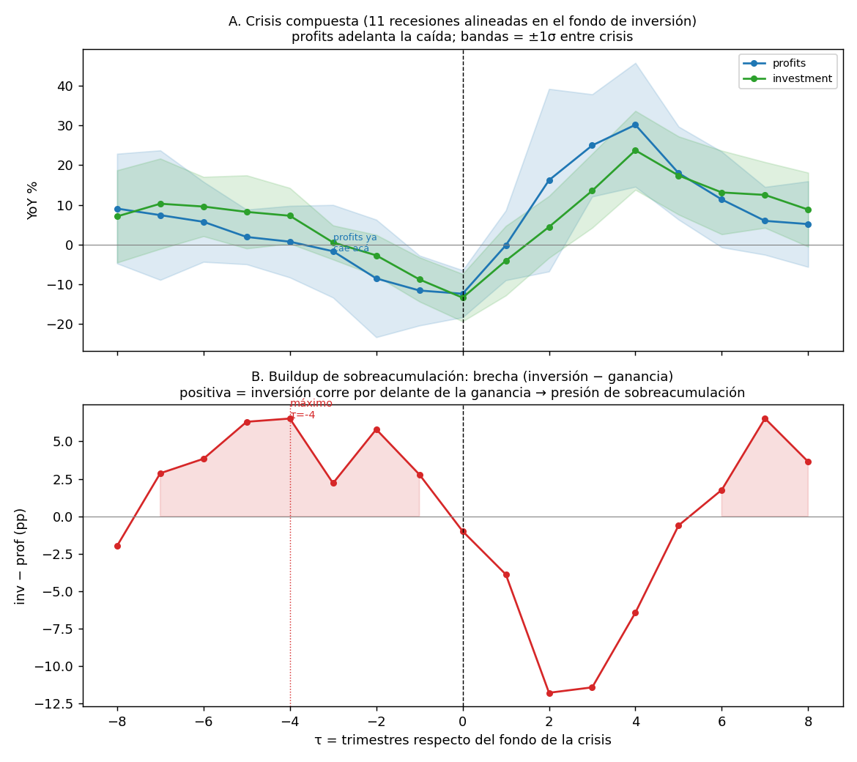
Figure 2. Composite of NBER recessions aligned at the investment trough. Profits lead the downturn and the investment−profit gap builds up ~1–1.5 years before the trough.
The maturation lag is identifiable and stable. Five methods converge on a maturation lag of ≈4 quarters: the empirical kernel, the distributed-lag regression, a VAR(p≥4), a hierarchical pooled estimate (μ_pop≈4.7–4.9), and the differentiable inverse. The Fourier-feature inverse PINN recovers a known synthetic lag with 8.9% error (4.0→4.36 quarters) and estimates 3.90 quarters = 0.98 years on real data; the lag is stable across difference transforms (QoQ, Δlog) and to leave-one-crisis-out (span 0.62 quarter). The classical single-shooting and the latent-state inverse fail (lag collapses or biases by ~55%); the well-posed convolution form with Fourier features succeeds.
What cannot be identified. The feedback explains only ~3% of the variance of profit growth (vs ~35% for the contemporaneous co-movement). Consequently the width of the delay distribution is not identifiable (flat likelihood profile; AIC favours a point delay), nor is its variation across crises. Moreover, the negative lobe is reproduced by the theoretical CCF of a linear VAR(p≥4) from its coefficients alone (Fig. 3): the distributed-delay kernel is observationally equivalent, at the level of the second-order autocovariance, to a linear stochastic system with longer memory. The maturation model is an interpretable reparameterisation of that linear content, not a mechanism separable from it with these data. A bifurcation analysis of the calibrated system does not yield a delay-induced Hopf instability, so we do not claim crises to be an endogenous delayed-feedback instability.
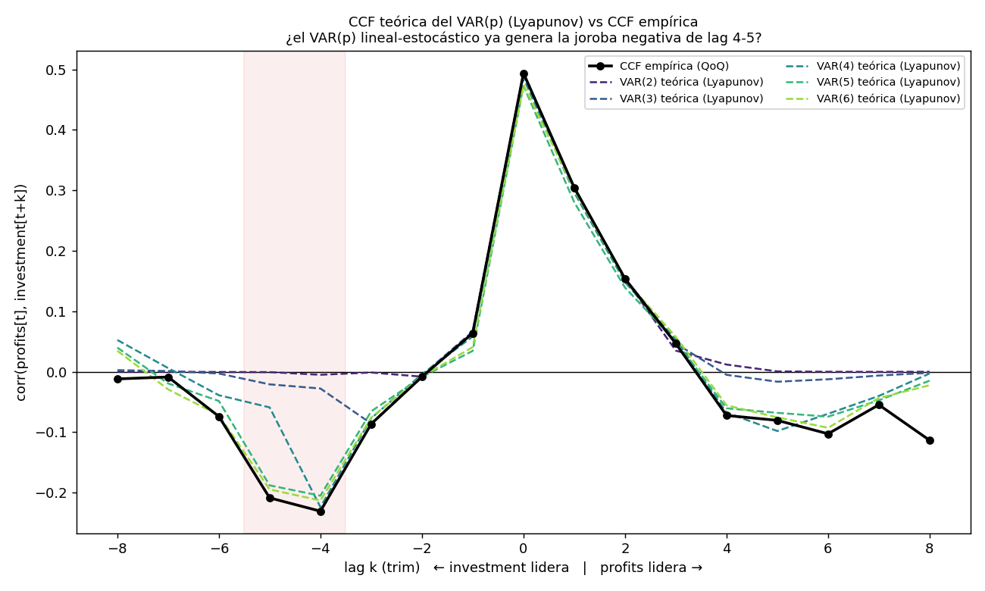
Figure 3. Theoretical CCF of a fitted VAR(p) (Lyapunov) vs the empirical CCF. For p≥4 the linear model already reproduces the negative lobe at lags 4–5 from its coefficients, establishing observational equivalence with the distributed-delay kernel.

4. Discussion
The substantive picture is consistent and honest. There is an endogenous overaccumulation feedback with a maturation lag of about one year, stronger near recessions, and we recover it with a physical, differentiable model where classical inversion fails. But two limits bound the claim. First, the economic content of the lag—its ~1-year centre and pre-recession buildup—is already in Tapia Granados (2012); our addition is the model and the inverse method, not the phenomenon. Second, with nine usable post-war crises and a ~3% signal-to-variance ratio, the data cannot separate a genuinely distributed (stochastic) delay from a point delay, nor the maturation mechanism from a linear long-memory VAR. The microfoundation of a distributed delay is the aggregation of heterogeneous investment gestation lags (Kalecki, 1935; Kydland and Prescott, 1982), so a distributed kernel is the mechanical consequence of aggregation rather than a conjecture; but confirming its shape requires either a multi-country panel (many more episodes, to identify the width) or measured sectoral gestation times (to predict the macro kernel, a test a reduced-form VAR cannot pass). These are the natural next steps.

5. Conclusion
The profit–investment overaccumulation feedback is well described by a distributed maturation delay centred at ~1 year, recovered by a differentiable inverse that overcomes the spectral bias and ill-posedness of classical calibration. The robust, transferable result is the location of the identifiability frontier: the delay's centre is recoverable and stable, while its width and its separation from a linear model are not—a boundary set by signal strength and episode count, not by tuning. Pushing past it requires new data, not a reparameterisation.

References
Almon, S. (1965). The distributed lag between capital appropriations and expenditures. Econometrica 33(1), 178–196.
Goldstein, J.P. (1999). Predator–prey model estimates of the cyclical profit squeeze. Metroeconomica 50(2), 139–173.
Goodwin, R.M. (1967). A growth cycle. In Socialism, Capitalism and Economic Growth. Cambridge University Press.
Kalecki, M. (1935). A macrodynamic theory of business cycles. Econometrica 3(3), 327–344.
Kydland, F.E., Prescott, E.C. (1982). Time to build and aggregate fluctuations. Econometrica 50(6), 1345–1370.
Raissi, M., Perdikaris, P., Karniadakis, G.E. (2019). Physics-informed neural networks. Journal of Computational Physics 378, 686–707.
Rackauckas, C., et al. (2020). Universal differential equations for scientific machine learning. arXiv:2001.04385.
Ramsay, J., Hooker, G. (2017). Dynamic Data Analysis. Springer.
Tapia Granados, J.A. (2012). Statistical evidence of falling profits as cause of recession. Review of Radical Political Economics 44(4), 484–493.

