EJERCICIOS. Halla el factor común de los siguientes ejercicios:

- 6x - 12 = | - 4x - 8y =
- 24a - 12ab = | - 10x - 15x² =
- 14m²n + 7mn = | - 4m² -20 am =
- 8a³ - 6a² = | - ax + bx + cx =
- b⁴-b³ = | - 4a³bx - 4bx =
- 14a - 21b + 35 = | - 3ab + 6ac - 9ad =
- 20x - 12xy + 4xz = | - 6x⁴ - 30x³ + 2x² =
- 10x²y - 15xy² + 25xy = | - 12m²n + 24m³n² - 36m⁴n³ =
- 2x² + 6x + 8x³ - 12x⁴ = | - 10p²q³ + 14p³q² - 18p⁴q³ - 16p⁵q⁴ =
- m³n²p⁴ + m⁴n³p⁵ - m⁶n⁴p⁴ + m²n⁴p³ =
- 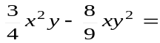
- 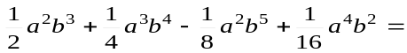
- 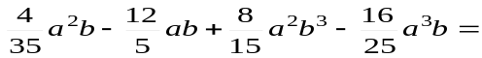

EJERCICIOS

- a(x + 1) + b ( x + 1 ) = | - m(2a + b ) + p ( 2a + b ) =
- x²( p + q ) + y²( p + q ) = | - ( a² + 1 ) - b (a² + 1 ) =
- ( 1 - x ) + 5c( 1 - x ) = | - a(2 + x ) - ( 2 + x ) =
- (x + y )(n + 1 ) - 3 (n + 1 ) = | - (a + 1 )(a - 1 ) - 2 ( a - 1 ) =
- a( a + b ) - b ( a + b ) = | - (2x + 3 )( 3 - r ) - (2x - 5 )( 3 - r ) =

EJERCICIOS :
- a² + ab + ax + bx = | - ab + 3a + 2b + 6 =
- ab - 2a - 5b + 10 = | - 2ab + 2a - b - 1 =
- am - bm + an - bn = | - 3x³ - 9ax² - x + 3a =
- 3x² - 3bx + xy - by = | - 6ab + 4a - 15b - 10 =
- 3a - b² + 2b²x - 6ax = | - a³ + a² + a + 1 =
- ac - a - bc + b + c² - c =
- 6ac - 4ad - 9bc + 6bd + 15c² - 10cd =
- ax - ay - bx + by - cx + cy =
- 3am - 8bp - 2bm + 12 ap =
- 18x - 12 - 3xy + 2y + 15xz - 10z =
- 
 