CATIA TOOLBOX
  - User guide | English edition
A concise visual guide to the CATIA Toolbox workflow: identify CATParts, prepare Composer conversions, inspect assembly structure, and export reviewable plans.
Purpose
Support CATIA and Composer preparation using exported, neutral data.
Operating model
Plan-first and non-destructive: the application generates reviewable CSV and script outputs; it does not modify CATIA files.
Audience
Engineering, technical documentation, and quality-control teams.

Workflow at a glance
CATIA Toolbox is organized around a five-step production workflow. Each step can be reviewed independently before any generated script is executed.
- 1. Identification: Read the nomenclature workbook and DE archive metadata to identify CATParts and single-body parts.
- 2. Preparation: Create a CATIA 3D to Composer conversion plan.
- 3. Processing: Review structure, colorization, SMGXML color changes, and optimization proposals.
- 4. Integration: Prepare SMGXML rename and part-replacement plans.
- 5. Quality control: Complete the assembly checklist and export the review result.

Design principles
- Metadata-first processing keeps source files untouched.
- Dry-run outputs make every proposed action reviewable.
- Local folders, synchronized OneDrive folders, and neutral listings can be used as sources.
- Exports are designed for traceability: CSV plans, scripts, macros, and visual previews.

Screen-by-screen reference
The captures below were taken with the EN language switch enabled. Empty states are intentional: they show the interface before a source import is selected.

1. Identification
Route /identification
Reads the nomenclature workbook and DE archive metadata to identify CATParts and single-body parts.
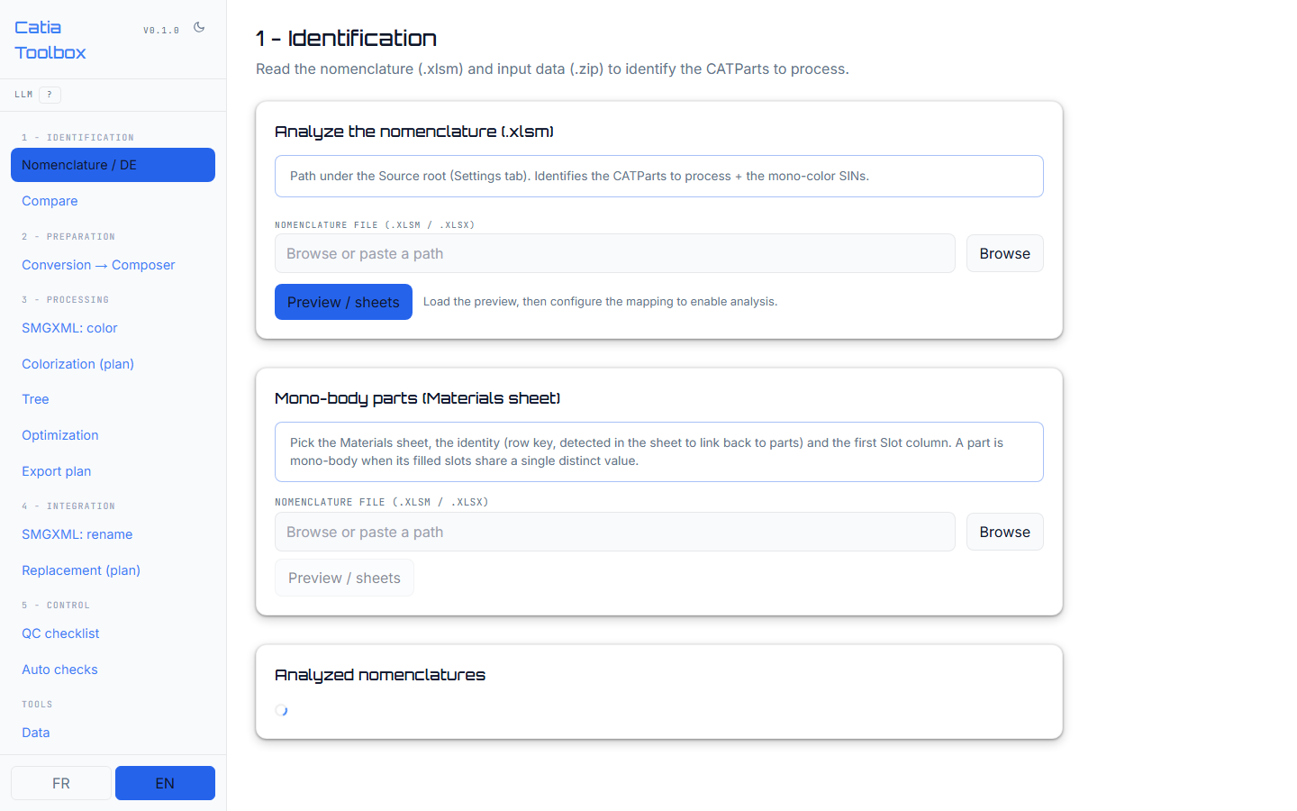
Key actions Select the workbook, preview its tabs, configure the mapping, and launch analysis. Operational when source files are configured.

2. Compare
Route /diff
Compares two imports and reports added, removed, and modified parts.
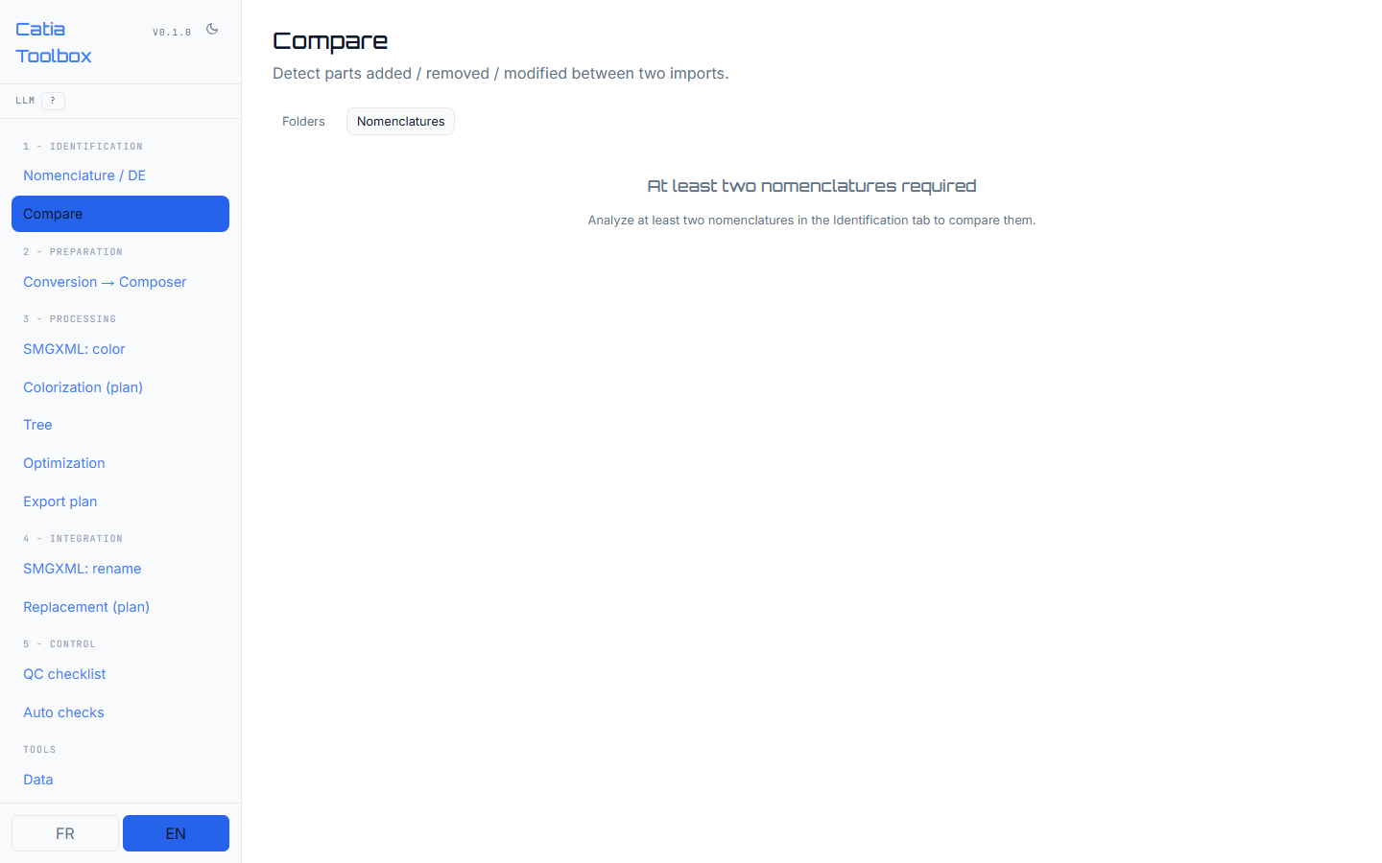
Key actions Select the two imports, run the comparison, review entries, and export the result. Requires imported listings.

3. Composer conversion
Route /conversion
Prepares a CATIA 3D to Composer conversion plan with a reviewable mapping and script.
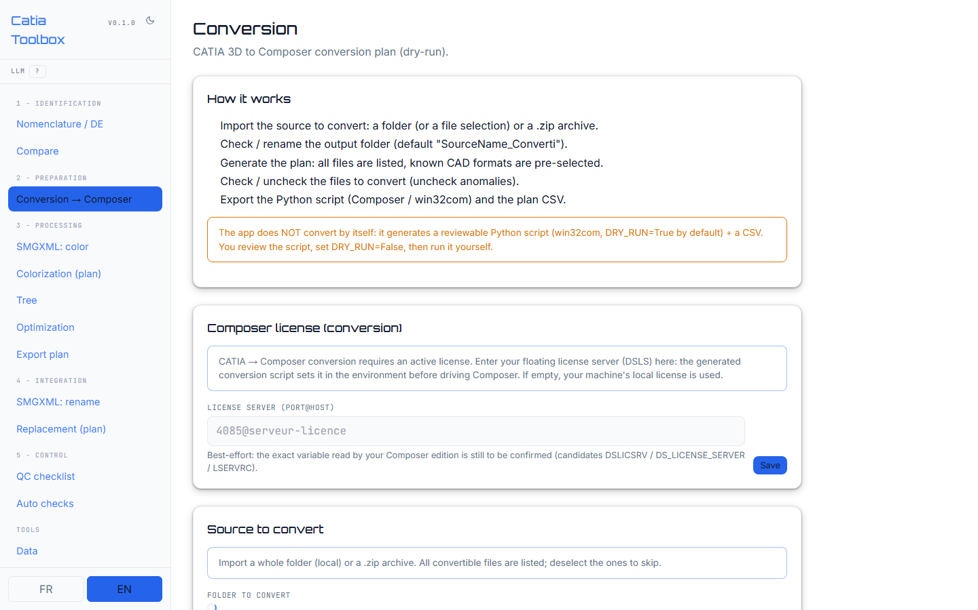
Key actions Select an import, review the plan, and export the script. Execution remains user-controlled and dry-run by default.

4. SMGXML color
Route /smgxml-recolor
Inspects and prepares color changes for mono-color SIN parts in an SMGXML file.
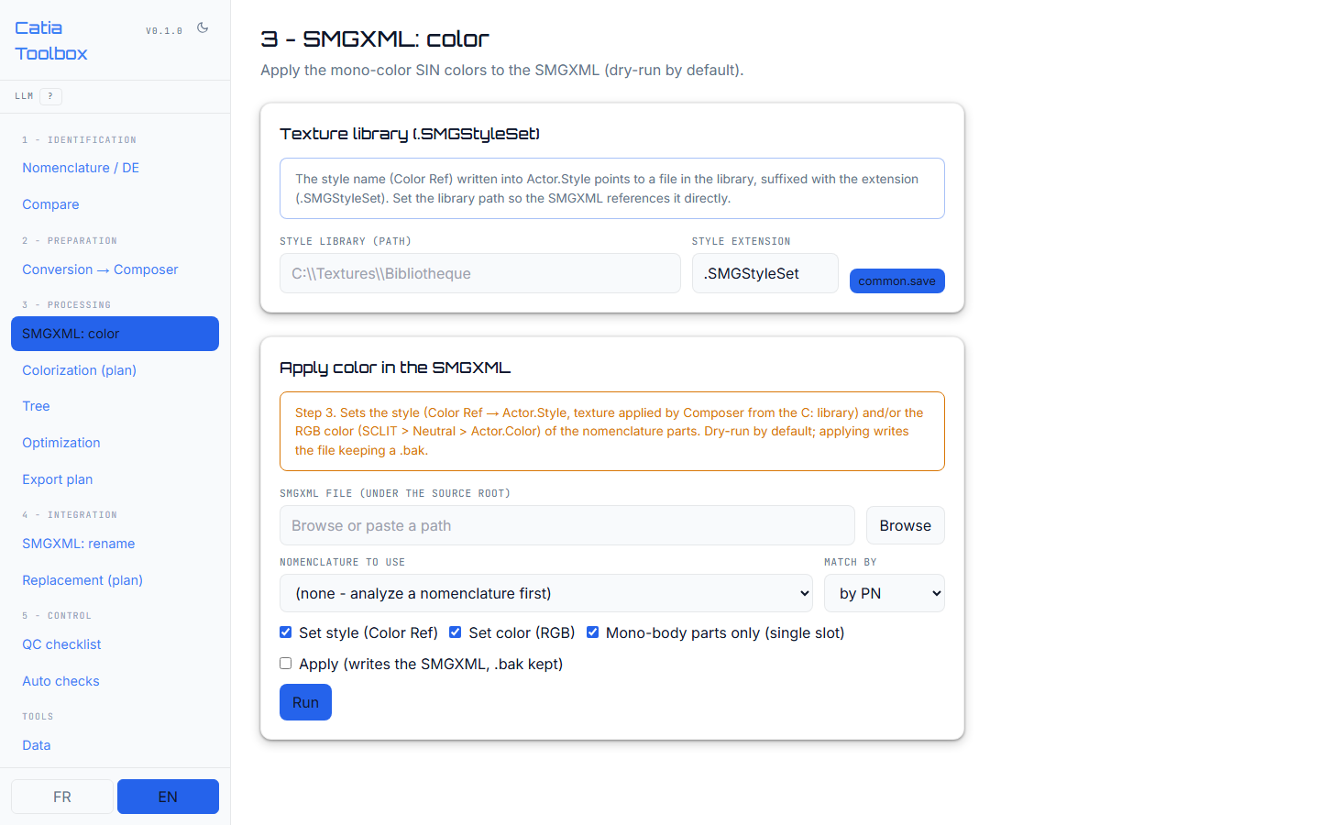
Key actions Inspect the SMGXML, review proposed changes, and choose dry-run or apply mode. Exact attributes depend on the target file format.

5. Colorization
Route /colorization
Assigns RGB colors by change, type, or depth and provides a visual simulation.
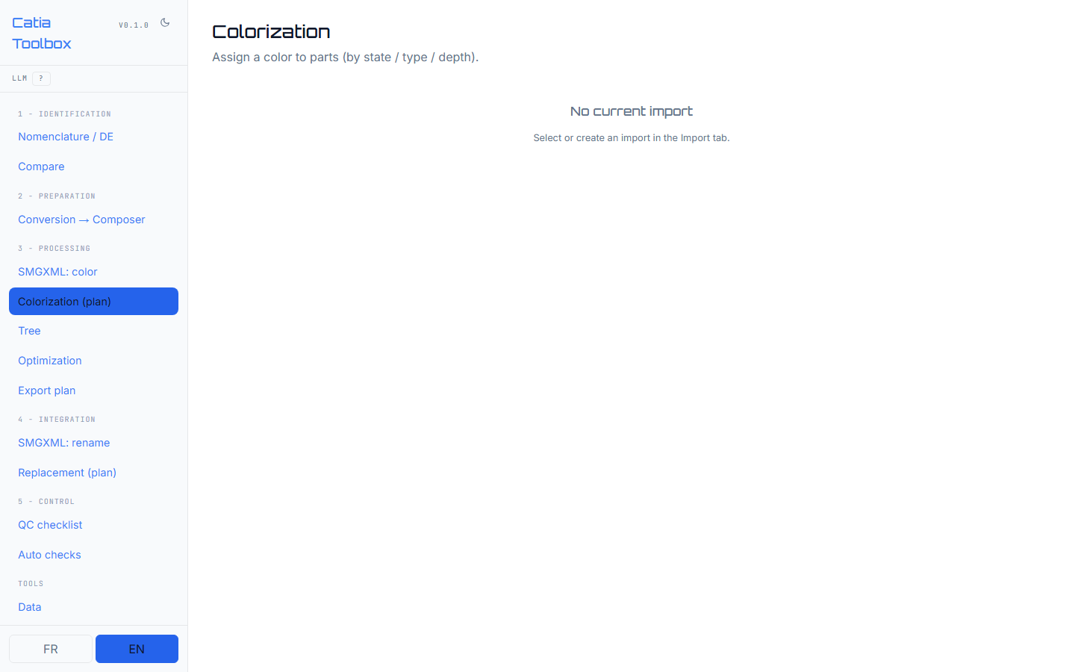
Key actions Choose a strategy, generate the plan, inspect the tile preview, and export CSV, macro, or Composer script.

6. Tree
Route /tree
Displays the current import hierarchy and structural metrics such as depth and nesting.
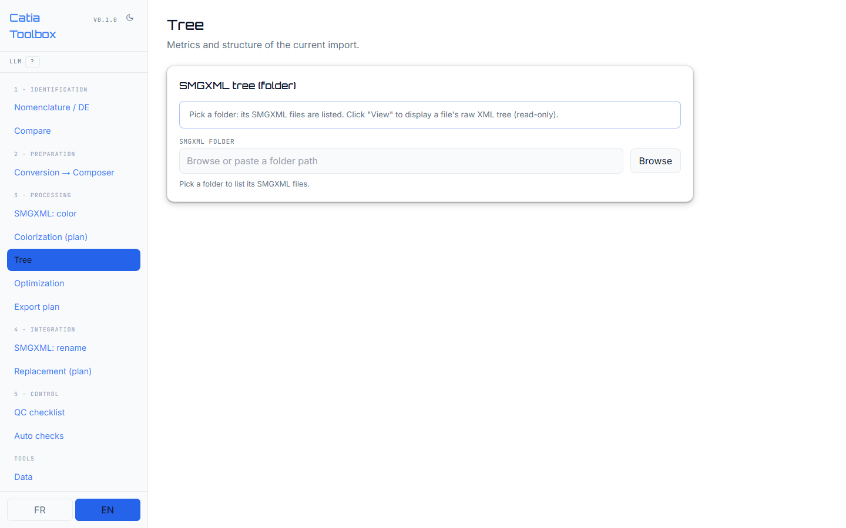
Key actions Expand the tree and use the metrics to identify structural hotspots. Requires an import.

7. Suggestions
Route /suggestions
Generates a reorganization proposal for an imported structure.
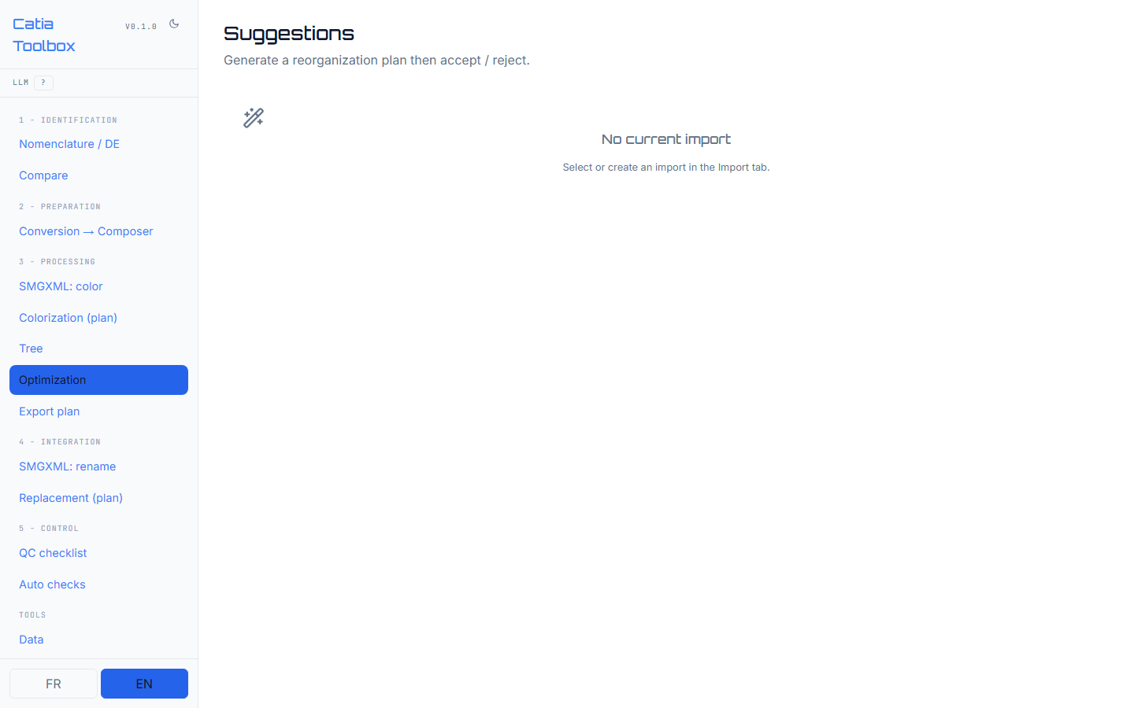
Key actions Review each proposed action and accept or reject it before exporting. LLM-assisted suggestions depend on configuration.

8. Export
Route /export
Exports reviewable plans and scripts generated by the toolbox.
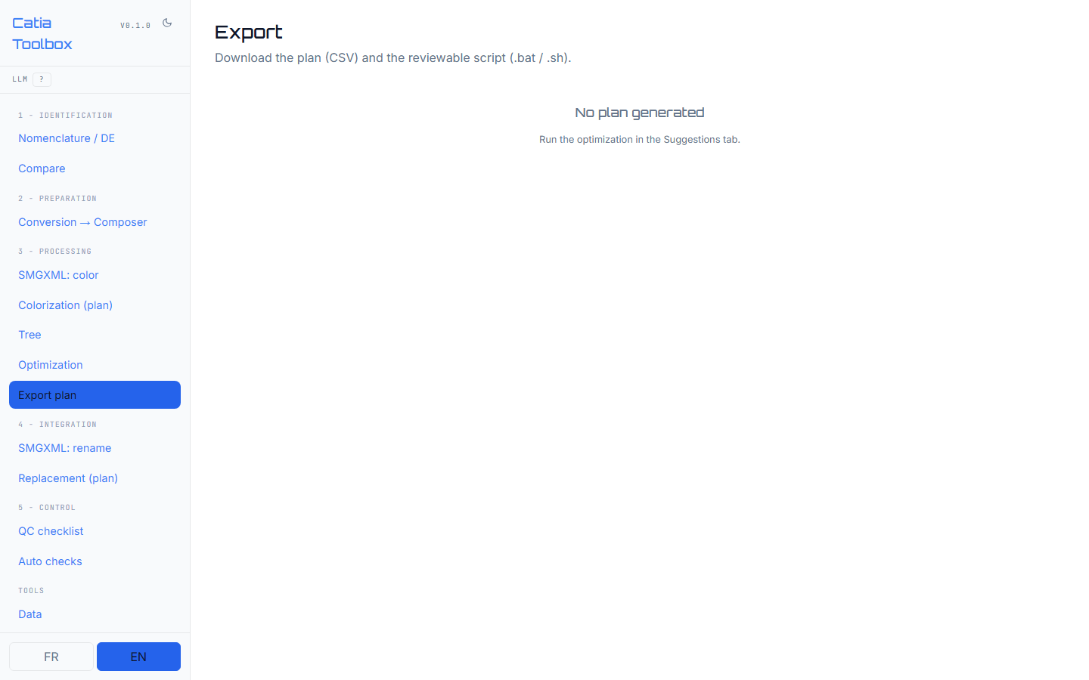
Key actions Choose the run and output format. No source CATIA file is changed by the export action.

9. SMGXML rename
Route /smgxml-rename
Prepares replacement of an old part name with a new name in SMGXML.
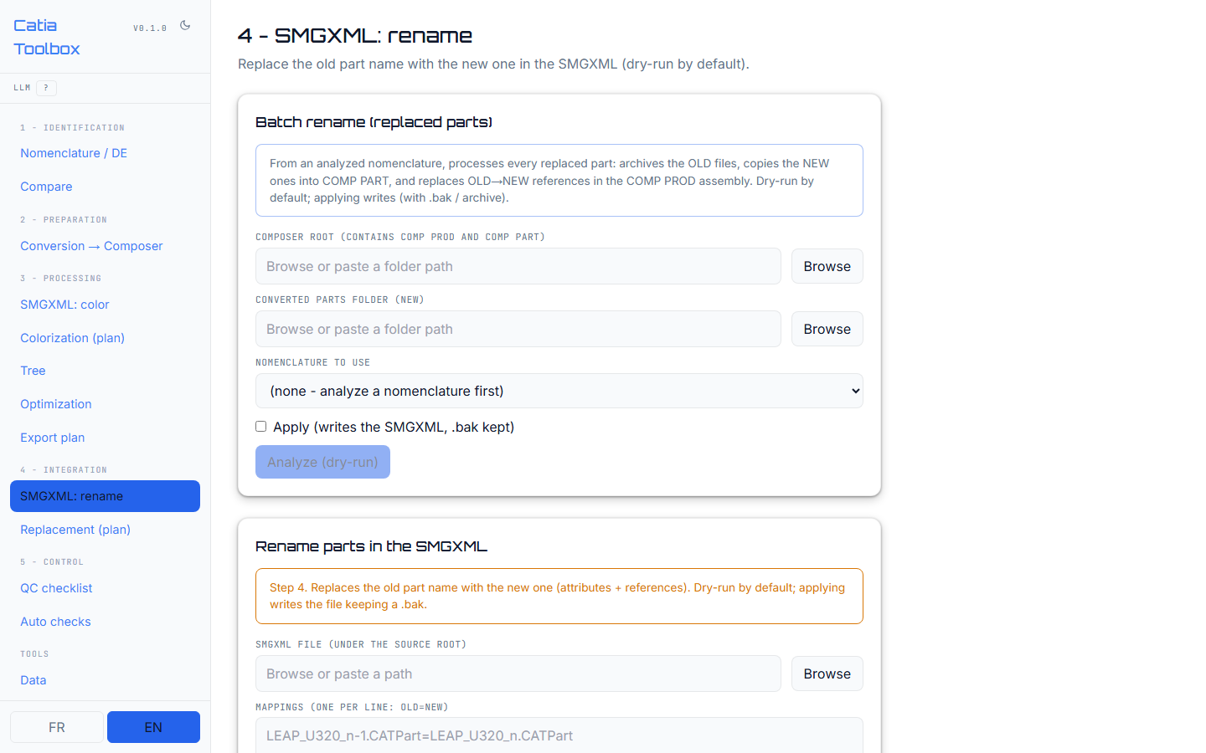
Key actions Inspect the proposed rename, review the change set, and apply only after validation. Dry-run is the default.

10. Replacement
Route /replacement
Creates a part replacement plan from a CSV or JSON mapping.
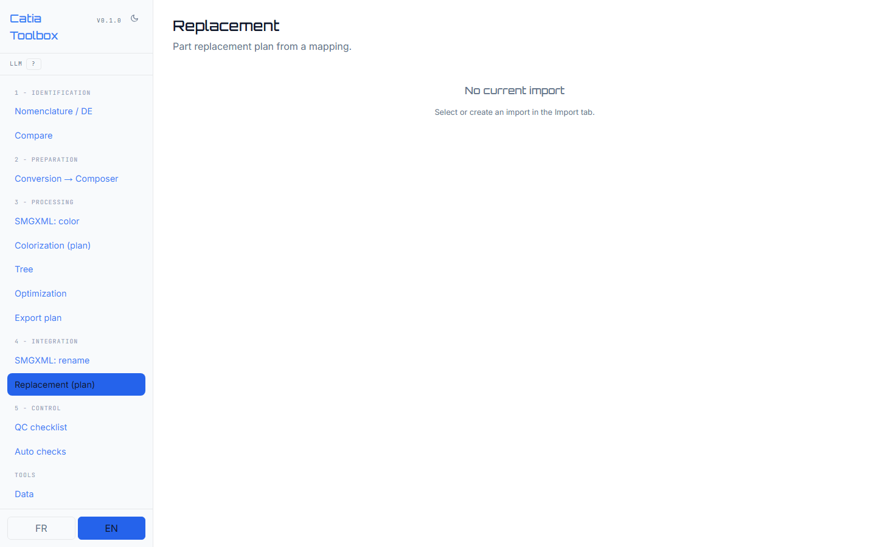
Key actions Upload the mapping, review the proposed replacements, and export the CATIA macro skeleton.

11. Quality control
Route /qc
Provides an interactive checklist for verifying parts in the assembly.
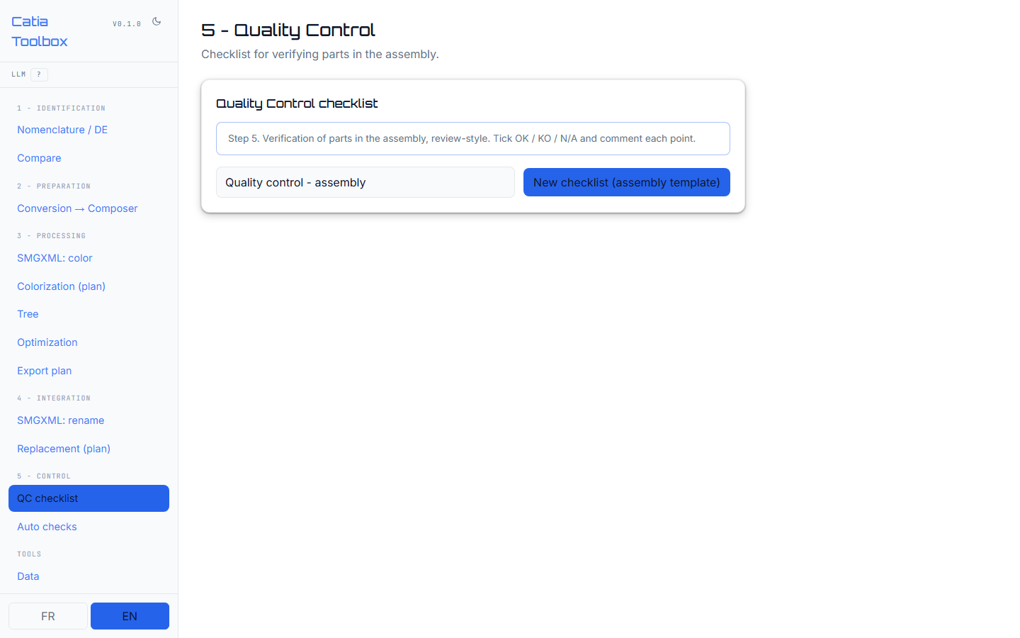
Key actions Create or open a checklist, mark items as OK, KO, or N/A, add comments, and export the review.

12. Checks
Route /checks
Runs configurable checks for depth, naming, forbidden extensions, duplicates, and empty folders.
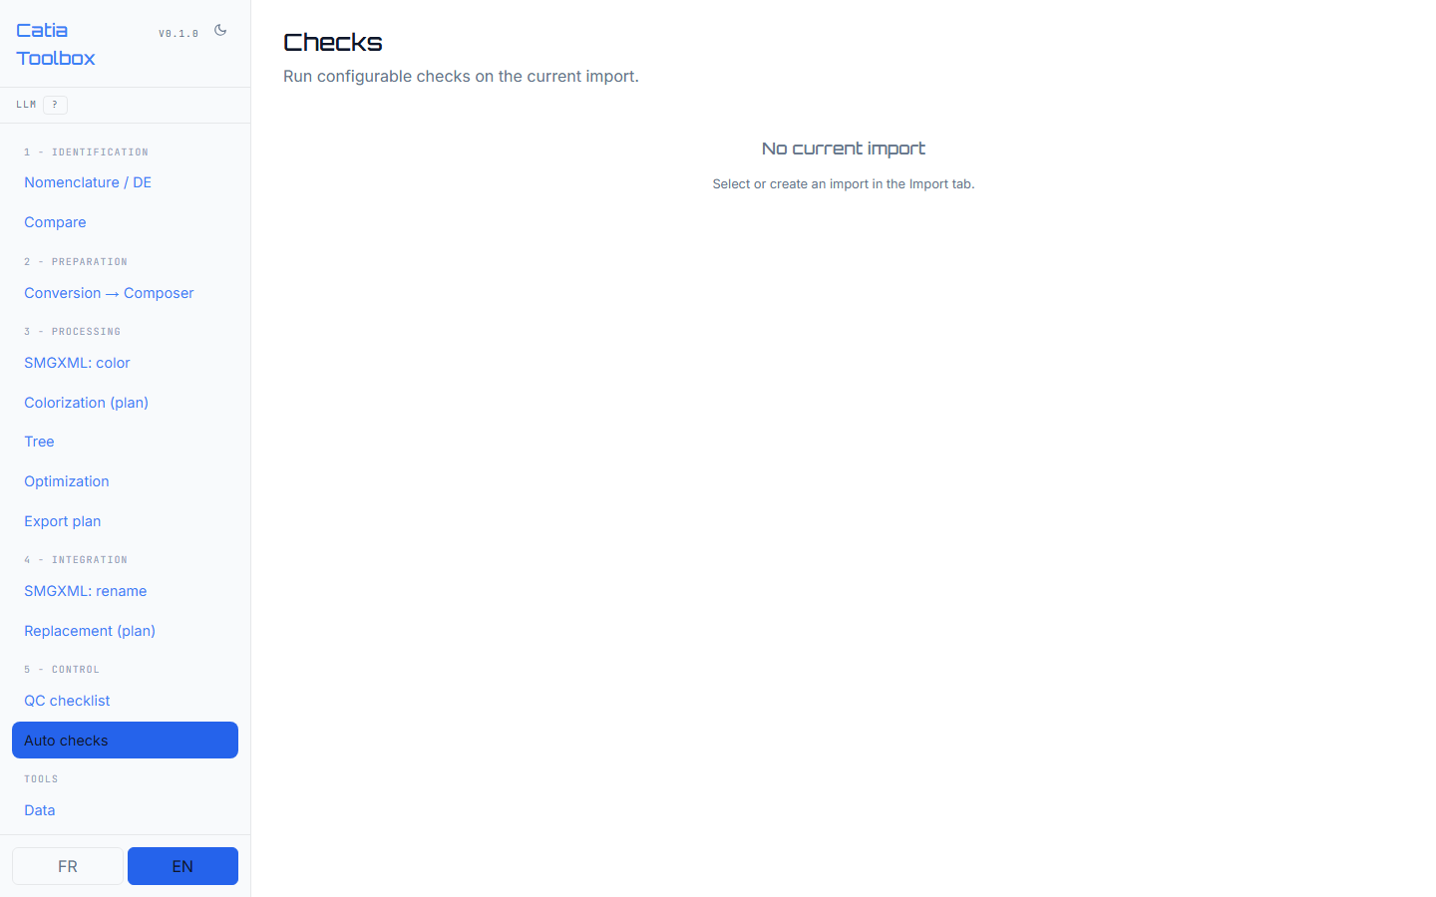
Key actions Select an import, run the checks, review findings, and export the results.

13. Data
Route /data
Shows stored import, run, and suggestion data and provides reset operations.
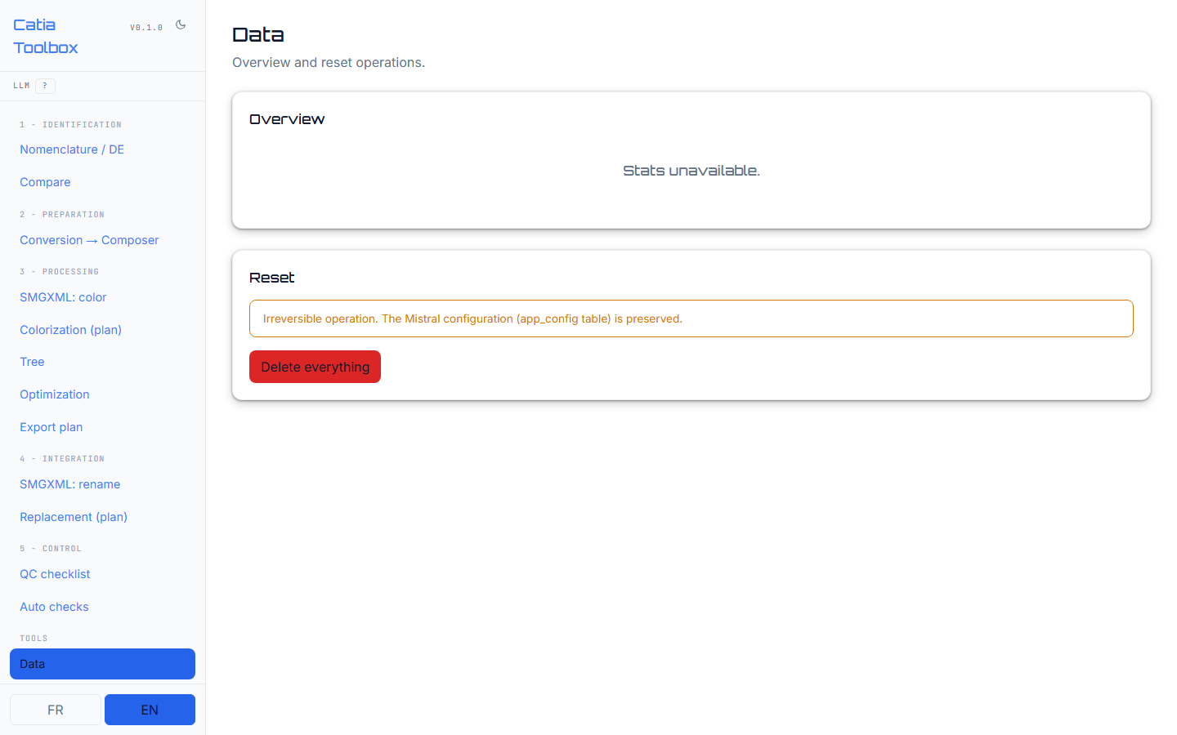
Key actions Review counters and use reset actions deliberately. Persistent configuration is preserved by convention.

14. Settings
Route /settings
Configures Mistral connectivity, models, source roots, and output roots.
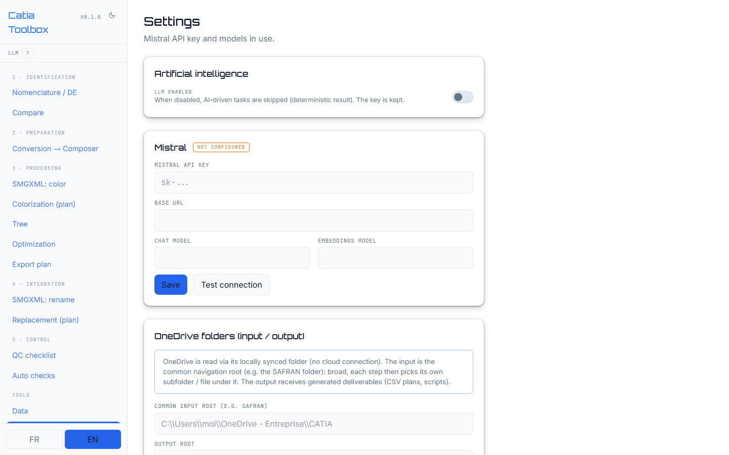
Key actions Set runtime values, test the LLM connection, and verify the health badge before using AI-assisted modules.

Outputs and review
All generated outputs are intended to be reviewed by the user before execution. Typical deliverables include CSV plans, batch or shell scripts, Python Composer scripts, CATIA macros, SMGXML change sets, and visual colorization previews.

Operational safeguards
- The backend does not move, rename, delete, or convert CATIA files automatically.
- Dry-run is the default for Composer and SMGXML operations.
- Apply-mode SMGXML changes preserve a backup before writing.
- Input scanning is metadata-oriented and remains confined to configured roots.
CATIA Toolbox | Internal product documentation

