DIY Site

Introduction
The DIY site is intended to be a repository of small-scale construction projects, designed so that anyone can carry them out by following the instructions posted on the repository in a genuine Do-It-Yourself style.
In this first phase of implementation, people of any age and skill level can explore the projects named "Things" that are publicly presented in this repository and use the project instructions to replicate them. The contents of the projects (things) are entered into the repository by the creators who require private access with certain privileges, assigned by an administrator, in order to access the repository management system.
Public access to this website can be made completely anonymous, allowing the users to browse the entire published repository, and encouraging them to register on a permanent basis, which will also allow users to mark which projects are their favourites.
From a technical standpoint, this site is implemented in Python, JavaScript, HTML and CSS languages, on the Django framework and using MVC design. It includes user authentication, email validation and full CRUD functionality to manage the content of the repository.
In future phases of implementation, the options to publish content by users from public access and the ability to sell their creations to other users will be implemented. Advanced functions will also be added, such as the search and filtering of projects based on content, or the use of shopping carts, user profiles, payment gateways, etc.
Access the website deployed on Heroku

Table of Contents
Introduction 1
User experience (UX) 3
Functional specifications 3
The User 3
Goals 3
Customer requirements for users 3
Other requirements 4
Development plan 4
Web Site Sketches 12
Database 14
Features 15
Users Home page 15
Footer 15
Users Navigation Bar 15
Sign Up 16
Sign In 16
Sign Out 16
Email 16
DIY Project details 17
Administration pages 18
Future Enhancements 24
Testing 25
Testing Strategy 25
Testing Overview 25
Validator Testing 25
Notable Bugs 25
Technologies Used 25
Packages Used 26
Resources Used 26
Deployment 27
Project Deployment 27
Forking the repository 28
Create a clone of this repository 28
Acknowledgements 28

User experience (UX)
DIY Site aims to be a friendly public site for users to access DIY style projects that they can replicate. The presentation of the content is dynamic and attractive, and the information about the projects is clear and easy to read.
Registered project creators will also be able to add and edit their own creations. This administrative interface is geared towards a more functional purpose, so that project content can be easily edited and expanded.

Functional specifications

The User
There are four types of users segregated by their role and purpose.
- Anonymous: A non registered user
- Regular: A registered user
- Creator: A user with privileges to add/edit/publish content
- Administrator: User that can validate users and perform all actions.

Goals
- For all users, the user interface should be minimalistic and intuitive
- For anonymous and regular users the user interface should be friendly, dynamic, clear and fun.
- For Creators and administrators, The user interface should be clear, flexible and functional.

Customer requirements for users
The following are the customer requirements that are part of the user stories list for the initial delivery iteration backlog.
Epic | Story | Requirements for users | Anonymous | Regular | Creator | Admin
38 | 12 | Register an account using e-mail and password | x
38 | 13 | Validate own e-mail |  | x | x | x
38 | 14 | Login in main page with e-mail and password | x | x | x | x
38 | 15 | Change e-mail |  | x | x | x
38 | 16 | Delete own e-mail account |  |  | x | x
37 | 17 | Register own account using user and password |  |  |  | x
37 | 17 | Login in admin page with user and password |  |  | x | x
37 | 17 | Change own user data (name, lastname) |  |  | x | x
38 | 18 | Change own password |  | x | x | x
37 | 17 | Delete own user-account |  |  |  | x
38 | 35 | Sign out/log out |  | x | x | x
37 | 17 | Administrate users and password |  |  |  | x
41 | 19 | view list of published DIY projects | x | x | x | x
41 | 20 | View details of a published DIY project | x | x | x | x
41 | 21 | View published components of a DIY project | x | x | x | x
41 | 20 | View instructions of a DIY project | x | x | x | x
38 | 22 | Mark a DIY project as own favourite |  | x | x | x
39 | 23/24 | Create a DIY project and its details |  |  | x | x
39 | 26 | Create components (DIY subprojects) |  |  | x | x
39 | 25 | Create instructions |  |  | x | x
39 | 27 | Modify a DIY project and its details |  |  | x | x
39 | 28 | Modify a component and its details |  |  | x | x
39 | 29 | Modify the instructions of a DIY project |  |  | x | x
39 | 30 | Delete a DIY project and its details |  |  | x | x
39 | 31 | Delete a component |  |  | x | x
39 | 32 | Delete instructions |  |  | x | x
39 | 33 | Change state published/Draft a DIY project |  |  | x | x
39 | 34 | Change state published/Draft a component |  |  | x | x

Other requirements
- There should be a main landing page to display the content.
- There should be an administrator page for manage users and content.
- Web pages should be able to be used from desktops and mobile devices
- Content and user informations should be stored in Elephant PostgreSQL servers
- Multimedia content (Images, videos, data files, etc) should be stored in Cloudinary servers.
- The web site should be able to be deployed on Heroku servers from GitHub
- The project should be develop under Agile methodology.

Development plan
Since development must be managed under the agile methodology. `Epics`, and their corresponding `user stories` must be defined and, when needed, meet a consensus between the developers and the project owner through agreed acceptance criteria. Also, from a more technical point of view, development tasks and their corresponding `story points` are defined in order to better evaluate the development effort. The following information lists all these issues. Please follow the links to access the full information stored on github.

#37 EPIC: Setup initial development environment
As a **developer**, I can **setup initial environment**, so that **The website can be developed**

#36 USER STORY: Create Development Environment
As **developer**, I can **setup the development environment**, so that **I can start developing the website**

## Tasks
- [x] Task 1 – Install Visual Studio Code in local environment
- [x] Task 2 – Create website Github repository and start remote environment
- [x] Task 3 – Install Django and all required libraries for runtime and development of the website
- [x] Task 4 – Create Django project and application
- [x] Task 5 - Create database in ElepantSQL servers
- [x] Task 6 - Create media storage in Cloudinary servers
- [x] Task 7 – create env.py and add all security risk keys
- [x] Task 8 - Migrate Django project to use the new database and media storage
- [x] Task 9 - Setup Heroku service for the website
- [x] Task 10 – Setup automatic deployment from Github on Heroku servers

## Story Points: 8

#17 USER STORY: Administrate users
As **Administrator**, I can **Create/modify/delete user accounts and their privileges**, so that **I can assign who signs in on the website and who can create or modify content**
---
## Acceptance Criteria
- Acceptance Criteria 1
**Given** that I am an `Administrator` user
**When** I am in any website page
**Then** I can access the admin web page selecting the `Admin` option in the user menu
- Acceptance Criteria 2
**Given** that I am an `Administrator` user
**When** I am in admin website page
**Then** I can add/delete/modify any user
- Acceptance Criteria 2
**Given** that I am an `Administrator` user
**When** I am in admin website page
**Then** I can add/delete/modify any user group
- Acceptance Criteria 2
**Given** that I am an `Administrator` user
**When** I am in admin website page
**Then** I can add/delete/modify any privilege of any user and any group
- Acceptance Criteria 3
**Given** that I am an `Administrator` user
**When** I am in admin website page
**Then** I can add/delete/modify any privilege of any user and any group

## Tasks
- [x] Task 1 - Install and setup Django's allauth and its accounts and interfaces, extensions.
- [x] Task 2 - Create at least one administrator account
- [x] Task 3 - Customize allauth templates to the website base template
- [x] Task 4 - Create `Content Creators` user group with necessary privileges for content creators

## Story Points: 8

#39 EPIC: DIY Project creation and management
As a **content creator**, I can **add/modify/delete DIY projects**, so that **the DIY Projects can be published and access by users in the website**

#40 USER STORY: Register users as Content Creators
As **Administrator**, I can **Give privileges to users to became Content Creators**, so that **This content creators can handle DIY projects**
---

## Acceptance Criteria
- Acceptance Criteria 1
**Given** that I am an administrator
**When** a user is designed as Content Creator
**Then** I can assign this user to the Content Creator user group
- Acceptance Criteria 2
**Given** that I am an administrator
**When** a user is no longer designed as Content Creator
**Then** I can revoke their Content Creator user privileges
- Acceptance Criteria 3
**Given** that I am a Content Creator
**When** I want to create/modify/delete a DIY Project
**Then** I have sufficient privileges to perform those tasks

## Tasks
- [x] Task 1 Create ` Content Creators` users group
- [x] Task 2 Assign sufficient privileges to the ` Content Creators` users group
- [x] Task 3 Assign designated users to the ` Content Creators` users group

## Story Points: 3

#23 USER STORY: Create a DIY project
As **content creator**, I can **Create a DIY project**, so that **I can publish it and share it on the website**
---
## Acceptance Criteria
- Acceptance Criteria 1
**Given** that I am a `Creator` user (member of the `Content Creator` group)
**When** I am in any website page
**Then** I can access the admin web page selecting the `Admin` option in the user menu
- Acceptance Criteria 2
**Given** that I am a `Creator` user (member of the `Content Creator` group)
**When** I am in admin website page
**Then** I can create a new DIY Project
- Acceptance Criteria 3
**Given** that I am a `Creator` user (member of the `Content Creator` group)
**When** I have created a new DIY Project
**Then** The Created date, Modified_Date and Parent fields are automatically created for this DIY project

## Tasks
- [x] Task 1 - Allow the `Admin` option menu in the user menu in the base template for Staff users (from group `Content Creators`)
- [x] Task 2 - Create at least one user from the `Content Creator` user group and the `Staff` flag enabled
- [x] Task 3 - Create the DIY Project object model (`Thing`) that will be used to instantiate each `Thing` and each `Component`
- [x] Task 4 - Create the Admin view for the DIY Project (`ThingAdmin`)

## Story Points: 8

#24 USER STORY: Create DIY project details
As **content creator**, I can **create the DIY project details**, so that **project can have a featured image and description**
---
## Acceptance Criteria
- Acceptance Criteria 1
**Given** that I am a `Creator` user (member of the `Content Creator` group)
**When** I have created a new DIY Project (`Thing`)
**Then** I can assign a Title, Author, Status, and Featured Image
- Acceptance Criteria 2
**Given** that I am a `Creator` user (member of the `Content Creator` group)
**When** I have created a new DIY Project (`Thing`)
**Then** I can edit a WSWG document to the description
- Acceptance Criteria 3
**Given** that I am a `Creator` user (member of the `Content Creator` group)
**When** I have created a new DIY Project (`Thing`)
**Then** Slug field should be assign/updated automatically.
- Acceptance Criteria 4
**Given** that I am a `Creator` user (member of the `Content Creator` group)
**When** I have created a new DIY Project (`Thing`)
**Then** I need to use a Save button to permanently store the changes in the database

## Tasks
- [x] Task 1 - Install Django Summernote extension for adding embedded WSWG editing functionality.
- [x] Task 2 - Modify the DIY Project Admin view (`ThingAdmin`) to accommodate all detail fields
- [x] Task 3 - Add the modifiable fields to the fieldsets in the DIY Project Admin view (`ThingAdmin`) to allow updating of these fields.

## Story Points: 8

#25 USER STORY: Create Instructions
As **content creator**, I can **create a list of project instructions**, so that **the users can read and follow them**
---
## Acceptance Criteria
- Acceptance Criteria 1
**Given** that I am a `Creator` user (member of the `Content Creator` group)
**When** I am modifying a DIY Project (`Thing`)
**Then** I can create a new `instructions` element that will be automatically assigned to the current DIY Project

## Tasks
- [x] Task 1 - Create the DIY Instructions class model (`Instructions`) that will be used to instantiate each `instructions` object
- [x] Task 2 - Modify the DIY Project object model 'Thing' to include the instructions model
- [x] Task 2 - Create the DIY Component Admin view (`InstructionsInLine`) to handle new instructions elements as a list.
- [x] Task 3 - Add inline admin view `InstructionsInLine` to the DIY Project Admin view (`ThingAdmin`) to allow new instructions elements to be added as a list.

## Story Points: 5

#26 USER STORY: Create component
As **content creator**, I can **create a list of components**, so that **a user can view and gather the building blocks to fulfil the project**
---
## Acceptance Criteria
- Acceptance Criteria 1
**Given** that I am a `Creator` user (member of the `Content Creator` group)
**When** I am modifying a DIY Project (`Thing`)
**Then** I can create a new component that will be automatically assigned to the current DIY Project

## Tasks

- [x] Task 1 - Modify the DIY Project object model 'Thing' to include a relation to itself as `components`
- [x] Task 1 - Create the DIY Component Admin view (`ComponentInLine`) to handle new components as a list.
- [x] Task 2 - Add inline admin view `ComponentInLine` to the DIY Component Admin view (`ComponentInLine`) to allow new components to be added as a list.

## Story Points: 5

#27 USER STORY: Modify a project details
As **content creator**, I can **modify the DIY project details**, so that **the project can be corrected or upgraded**
---
## Acceptance Criteria
- Acceptance Criteria 1
**Given** that I am a `Creator` user (member of the `Content Creator` group)
**When** I am modifying a DIY Project (Thing)
**Then** I can change the Title, Author, Status, and Featured Image
- Acceptance Criteria 2
**Given** that I am a `Creator` user (member of the `Content Creator` group)
**When** I am modifying a DIY Project (Thing)
**Then** I can edit a WSWG document to the description

## Tasks
- Built in #24

## Story Points: 0

#28 USER STORY: Modify component
As **content creator**, I can **modify the component details**, so that **the component can be corrected or upgraded**
---
## Acceptance Criteria
- Acceptance Criteria 1
**Given** that I am a `Creator` user (member of the `Content Creator` group)
**When** I am modifying a DIY Project (`Thing`)
**Then** I can change the title of the Instructions element
- Acceptance Criteria 2
**Given** that I am a `Creator` user (member of the `Content Creator` group)
**When** I am modifying a DIY Project (`Thing`)
**Then** I can change the content of Instructions with a WSWG built-in editor
- Acceptance Criteria
**Given** that I am a `Creator` user (member of the `Content Creator` group)
**When** I am modifying a DIY Project (`Thing`)
**Then** I need to use a `Save` button to permanently store the changes in the database

## Tasks
- built in #24
- [x] Task 1 - Add Summernote edit functionality to the `description` field in inline DIY Component Admin view (`ComponentInLine') to allow for the WSWG edit features in the DIY Component list.
- [x] Task 4 - Add the modifiable fields to the fieldsets in the inline DIY Component Admin view (`ComponentInLine`) to allow updating of these fields.

## Story Points:3

#29 USER STORY: Modify instructions
As **content creator**, I can **modify the project instructions**, so that **the project can be corrected or upgraded**
---
## Acceptance Criteria
- Acceptance Criteria 1
**Given** that I am a `Creator` user (member of the `Content Creator` group)
**When** I am modifying a DIY Project (`Thing`)
**Then** I can change the title of the Instructions element
- Acceptance Criteria 2
**Given** that I am a `Creator` user (member of the `Content Creator` group)
**When** I am modifying a DIY Project (`Thing`)
**Then** I can change the content of Instructions with a WSWG built-in editor
- Acceptance Criteria
**Given** that I am a `Creator` user (member of the `Content Creator` group)
**When** I am modifying a DIY Project (`Thing`)
**Then** I need to use a `Save` button to permanently store the changes in the database

## Tasks
- [x] Task 1 - Add Summernote edit functionality to the `instructions` field in DIY Instructions Admin view (`InstructionsAdmin') to allow for the WSWG edit features.
- [x] Task 2 - Add the `title` and `instructions` fields to the fieldsets in the DIY Instructions Admin view (`InstructionsAdmin`) to allow updating of these fields.
- [x] Task 3 - Add Summernote edit functionality to the `instructions` field in inline DIY Instructions Admin view (`InstructionsInLine') to allow for the WSWG edit features in the DIY Project Details Instructions list.
- [x] Task 4 - Add the `title` and `instructions` fields to the fieldsets in the inline DIY Instructions Admin view (`InstructionsInLine`) to allow updating of these fields.

## Story Points: 5

#30 USER STORY: Delete a project
As **content creator**, I can **delete a DIY project**, so that **the project does no longer exist on the website**
---
## Acceptance Criteria
- Acceptance Criteria 1
**Given** that I am a `Creator` user (member of the `Content Creator` group)
**When** I select a DIY project from the DIY Projects list in the admin website page
**Then** I can delete all the selected projects
- Acceptance Criteria 2
**Given** that I am a `Creator` user (member of the `Content Creator` group)
**When** I am modifying a DIY Project in admin website page
**Then** I can delete the current DIY Project
- Acceptance Criteria 3
**Given** that I am a `Creator` user (member of the `Content Creator` group)
**When** I have requested to delete one or more DIY projects
**Then** I will have to explicitly confirm the deletion

## Tasks
Built in #23
## Story Points: 0

#31 USER STORY: Delete component
As **content creator**, I can **delete a component**, so that **the component does no longer exist on the website**
---
## Acceptance Criteria
- Acceptance Criteria 1
**Given** that I am a `Creator` user (member of the `Content Creator` group)
**When** I am modifying a DIY Project (`Thing`)
**Then** I can delete an existing DIY Component from the current DIY Project
- Acceptance Criteria 2
**Given** that I am a `Creator` user (member of the `Content Creator` group)
**When** I have requested to delete one or more DIY Components
**Then** I will have to explicitly confirm the deletion

## Tasks
Built in #26
## Story Points: 0

#32 USER STORY: Delete Instructions
As **content creator**, I can **delete project instructions**, so that **those instructions do no longer exist on the website**
---
## Acceptance Criteria
- Acceptance Criteria 1
**Given** that I am a `Creator` user (member of the `Content Creator` group)
**When** I am modifying a DIY Project (`Thing`)
**Then** I can delete an existing Instructions element from the current DIY Project
- Acceptance Criteria 2
**Given** that I am a `Creator` user (member of the `Content Creator` group)
**When** I have requested to delete one or more Instructions elements
**Then** I will have to explicitly confirm the deletion
## Tasks
Built in #25
## Story Points: 0

#33 USER STORY: Change project Published status
As **content creator**, I can **change a project published status **, so that **the project is available to users when marked as published or hidden when it is marked as draft**
---
## Acceptance Criteria
- Acceptance Criteria 1
**Given** that I am a `Creator` user (member of the `Content Creator` group)
**When** I have selected one or more DIY Projects from the DIY projects list
**Then** I can toggle the published flag `Status` so that the DIY Project can be shown or hidden from viewing users.

## Tasks
- [x] Task 1 - Modify the DIY Project Admin view (`ThingAdmin`) to update the `status` field
- [x] Task 2 - Add `publish` and `set_as_draft` actions to the DIY Project Admin view

## Story Points: 5

#34 USER STORY: Change component published status
As **content creator**, I can **change a component published status**, so that **the component information is available to users when marked as published or hidden when it is marked as draft**
---
## Acceptance Criteria
- Acceptance Criteria 1
**Given** that I am a `Creator` user (member of the `Content Creator` group)
**When** I have selected a component from a DIY Project
**Then** I can toggle the published flag `Status` so that this Component from the DIY Project can be shown or hidden from viewing users.

## Tasks
- [x] Task 1 - Modify the DIY Component Admin view (`ComponentInLiner`) to update the `status` field

## Story Points: 1

#41 EPIC: View DIY Projects
As a **user**, I can **access the published DIY Projects**, so that **I can follow their instructions and replicate them**

#19 USER STORY: View list of published projects
As **user**, I can **view a list of published projects**, so that **I can choose what projects to view in detail**
---
## Acceptance Criteria
- Acceptance Criteria 1
**Given** that I am a user
**When** I am in any website page
**Then** I can access the website home page clicking on the website logo or brand name
- Acceptance Criteria 2
**Given** that I am a user
**When** I am in the home website page
**Then** I can view the list of all the published DIY Projects
- Acceptance Criteria 3
**Given** The list of all the published DIY Projects is displayed
**When** each DIY project is displayed
**Then** The Title, featured pictured, author, published date and number of likes should be displayed
- Acceptance Criteria 4
**Given** that I am a user
**When** I select a DIY Projects from the DIY Project list
**Then** I get redirected to the selected DIY Project details webpage

## Tasks
- [x] Task 1 - Add a paginated list of DIY Published projects to the index template

## Story Points: 5

#20 USER STORY: View details of a DIY project
As **user**, I can **Access the details of the selected DIY project**, so that **I can view the components and the instructions**
---
## Acceptance Criteria
- Acceptance Criteria 1
**Given** that I am a user
**When** I am redirected to the DIY Project details website page
**Then** I can view the DIY Project's Title, featured image, author, Published date, Description, number of components, number of Instructions, Number of likes, the components list and the Instructions list
- Acceptance Criteria 2
**Given** that I am a user
**When** viewing the components list
**Then** I can see each component's title, featured image, and description
- Acceptance Criteria 3
**Given** that I am a user
**When** viewing the instructions list
**Then** I can see each instruction's title, and its content

## Tasks
- [x] Task 1 - Create the Django view and controllers to handle DIY details
- [x] Task 2 - Create a template for the DIY Project details
- [x] Task 3 - Add to the details template a presentation header with all the DIY Project details
- [x] Task 4 - Add to the details template a list of the components related to the DIY Project
- [x] Task 5 - Add to the details template a list of the instructions related to the DIY Project

## Story Points: 8

#21 USER STORY: View Components
As **user**, I can **select and view a project component**, so that **I can access the details of the component**
---
## Acceptance Criteria
- Acceptance Criteria 1
**Given** that I am a user
**When** in the DIY Project details webpage, and selecting a component from the components list
**Then** if the component is also a DIY Project, I get redirected to this DIY Project detail website page

## Tasks
- [x] Task 3 - In the DIY Project details template, add a link to its DIY project detail for all the components related to the DIY Project and are DIY Projects themselves.

## Story Points: 3

#38 EPIC: User registration
As a **user**, I can **register myself on the website**, so that **hold my information about the website**

#12 USER STORY: Register an account
As **anonymous user**, I can **register myself**, so that **I can select my favourite content**
---
## Acceptance Criteria
- Acceptance Criteria 1
**Given** that I am an `Anonymous` user (non registered)
**When** I am in the sign-in website page
**Then** I can access the sign-up page following the `sign up` link
- Acceptance Criteria 2
**Given** that I am an `Anonymous` user (non registered)
**When** I am in any website page
**Then** I can access the sign-up page selecting the sin-up option in the user menu
- Acceptance Criteria 3
**Given** that I am a non `Anonymous` user (user already registered)
**When** I am in the home page
**Then** the `join us ...` link should not be available
- Acceptance Criteria 4
**Given** that I am in the sign-up webpage
**When** I have entered a valid e-mail address and a valid password
**Then** The new account is created

## Tasks
- [x] Task 1 - Adapt Django's allauth accounts application to allow user registration via email.
- [x] Task 2 - Create the sign-up option menu in the user menu in the base template

## Story Points: 3

#13 USER STORY: Validate e-mail
As **user**, I can **validate my own e-mail**, so that **I can sign in the website**
---
## Acceptance Criteria
- Acceptance Criteria 1
**Given** that I am a new `Registered` user
**When** I have created an account using the sign-up webpage
**Then** an e-mail validation is sent to the new account e-mail address
**Then** we will be redirected to a webpage with instructions on how to verify the e-mail Address.
- Acceptance Criteria 2
**Given** that I am a new `Registered` user that has received an e-mail verification e-mail
**When** I follow the link contained in the e-mail verification e-mail
**Then** I will be directed to the `confirm-Email` webpage
- Acceptance Criteria 3
**Given** that I am a new `Registered` user redirected to the `confirm-Email` webpage
**When** I click the confirm button
**Then** the e-mail is confirmed
**Then** I am redirected to the sign-in webpage

## Tasks
- [x] Task 1 - Create an e-mail account for Django's automated e-mail (on Gmail, Yahoo, etc)
- [x] Task 1 - Adapt Django's allauth accounts application to allow e-mail validation.

## Story Points: 3

#14 USER STORY: Sign in
As **user**, I can **sign on the website**, so that **I can mark my favourite content**
---
## Acceptance Criteria
- Acceptance Criteria 1
**Given** that I am a `Registered` user not logged in
**When** I am in any website page
**Then** I can access the sign-in web page selecting the `sign in` option in the user menu
- Acceptance Criteria 2
**Given** that I am a `Registered` user not logged in
**When** I am in the home page
**Then** I can access the sign-in web page following the `join us ...` link
- Acceptance Criteria 3
**Given** that I am in the sign-in webpage
**When** I have entered a valid e-mail address and a valid password
**Then** I become logged in the website
**Then** The user menu button should contain my username
- Acceptance Criteria 4
**Given** that I am a user not logged in
**When** I am in any website page
**Then** The user menu button should contain `Anonymous`

## Tasks
- [x] Task 1 - Adapt Django's allauth accounts application to allow user sign-in via email.
- [x] Task 2 - Create the `sign in` option menu in the user menu in the base template

## Story Points: 3

#15 USER STORY: Change e-mail
As **user**, I can **change my own e-mail address**, so that **I can sign in on the website with new e-mail address**
---
## Acceptance Criteria
- Acceptance Criteria 1
**Given** that I am a `Registered` user
**When** I am in any website page
**Then** I can access the E-mail web page selecting the `E-mail` option in the user menu
- Acceptance Criteria 2
**Given** that I am in the e-mail webpage
**When** I fill the email field with a valid e-mail address and use the button `Add Email`
**Then** The e-mail address is added to user's list of addresses
- Acceptance Criteria 3
**Given** that I am in the e-mail webpage and I have more than one e-mail addresses
**When** I select an e-mail address from the list and use the button `Make Primary`
**Then** The selected e-mail address will be the new `Primary` that will be used for sign-in

## Tasks
- [x] Task 1 - Adapt Django's allauth accounts application to allow users to manage their e-mail addresses.

## Story Points: 1

#16 USER STORY: Delete own account
As **user**, I can **Delete my own account**, so that **I can erase my information from the website**

Note: This user story is not included in the [DIY Site Backlog](https://github.com/Juanma1313/dys/milestone/1) iteration.

#17 USER STORY: Administrate users
As **Administrator**, I can **Create/modify/delete user accounts and their privileges**, so that **I can assign who signs in on the website and who can create or modify content**
---
## Acceptance Criteria
- Acceptance Criteria 1
**Given** that I am an `Administrator` user
**When** I am in any website page
**Then** I can access the admin web page selecting the `Admin` option in the user menu
- Acceptance Criteria 2
**Given** that I am an `Administrator` user
**When** I am in admin website page
**Then** I can add/delete/modify any user
- Acceptance Criteria 2
**Given** that I am an `Administrator` user
**When** I am in admin website page
**Then** I can add/delete/modify any user group
- Acceptance Criteria 2
**Given** that I am an `Administrator` user
**When** I am in admin website page
**Then** I can add/delete/modify any privilege of any user and any group
- Acceptance Criteria 3
**Given** that I am an `Administrator` user
**When** I am in admin website page
**Then** I can add/delete/modify any privilege of any user and any group

## Tasks
- [x] Task 1 - Install and setup Django's allauth and its accounts and interfaces, extensions.
- [x] Task 2 - Create at least one administrator account
- [x] Task 3 - Customize allauth templates to the website base template
- [x] Task 4 - Create `Content Creators` user group with necessary privileges for content creators

## Story Points: 8

#18 USER STORY: Reset/Change password
As **user**, I can **Reset and change my own password**, so that **I can recover my account if I forget my password or enforce security to my account**
---
## Acceptance Criteria
- Acceptance Criteria 1
**Given** that I am in the sign-in webpage
**When** following the link `Forgot your password?'
**Then** I get redirected to the Password/reset webpage
- Acceptance Criteria 2
**Given** that I am in the Password/reset webpage
**When** I fill my user e-mail address and use the `Reset My Password` button
**Then** a password reset e-mail is sent to the e-mail address
**Then** we will be redirected to a webpage with instructions on how to reset the password.
- Acceptance Criteria 3
**Given** that I am a Registered user that has received a password reset e-mail
**When** I follow the link contained in the password reset e-mail
**Then** I will be redirected to the change password webpage
- Acceptance Criteria 4
**Given** that I am a Registered user that has been redirected to the change password webpage
**When** I fill in a valid password
**Then** The account password will be changed to the new password
**Then** I will be redirected to the change password done webpage

## Tasks
- [x] Task 1 - Adapt Django's allauth accounts application to allow user password reset.

## Story Points: 1

#22 USER STORY: Mark a project as favourite
As **a registered user**, I can **mark a project as favourite**, so that **I can keep a collection of favourite projects and the projects get rated**
---
## Acceptance Criteria
- Acceptance Criteria 1
**Given** that I am a signed-in user
**When** I am viewing a DIY Project details
**Then** I can click on the favourite icon to toggle the current DIY Project as favourite for me.

## Tasks
- [x] Task 1 - Modify the DIY Project class model to handle DIY likes.
- [x] Task 2 - Create the Django view and controllers to handle DIY likes
- [x] Task 3 - Modify DIY Project detail template to handle DIY likes

## Story Points: 5

Web Site Sketches
To outline the design of the website, I have created the following sketches to guide the development of the user interface. But, since for the administration of the website I will mainly rely on the Django administration interface, and even though it will be customized, I didn't find the need to design the wireframes of those pages, since the style is already defined in the framework and regular users will not access it anyways.
For this type of website content, I assume that the authors will produce descriptions and instructions with long texts, so the main design is also oriented towards large screens. I then adapt this content so that it can also be viewed by an eventual user of a small screen device.

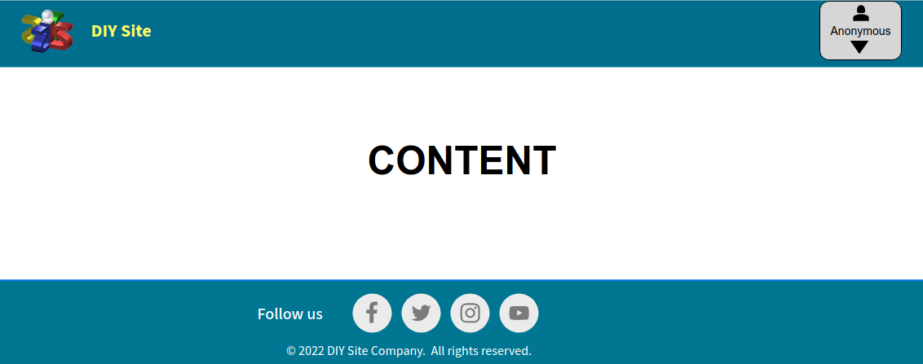
Base Page
This design only sketches the header and footer of the pages. This should be consistent across all pages.

Home page and DIY projects list
This page is the landing page and displays a carousel of images and phrases that define the website and shows the list of available DIY projects as well as inviting the users to register to allow them to select their favourite projects.
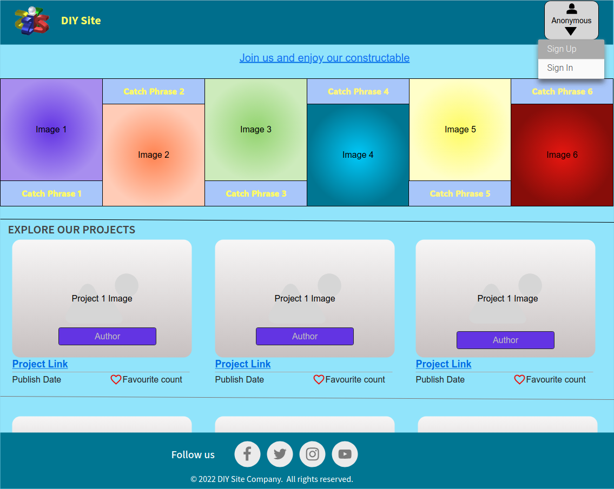

DIY project Details

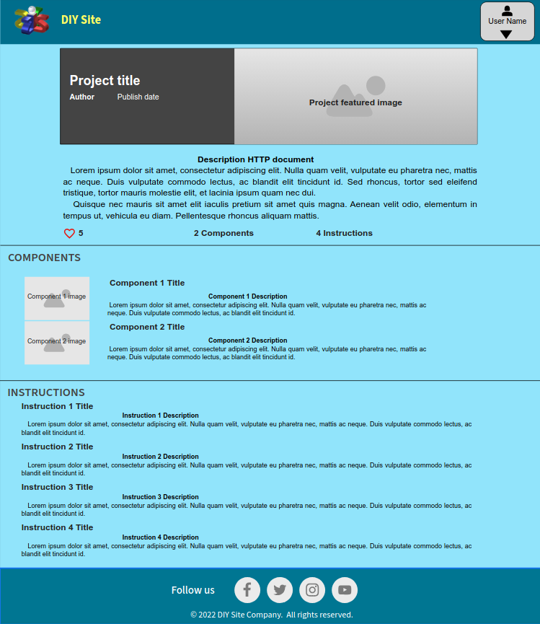

Database
It is a customer requirement to use the services of Elephant as an external SQL service to host the website database. This service provider has servers running PostgreSQL servers.
Since the development framework is based on Django, we will use its built in user management functionality from its allauth package.
Django's Allauth uses a database user table that its represented on the leeft of the following figure, which is included in this figure tu identify the relations with the website non built in database model.
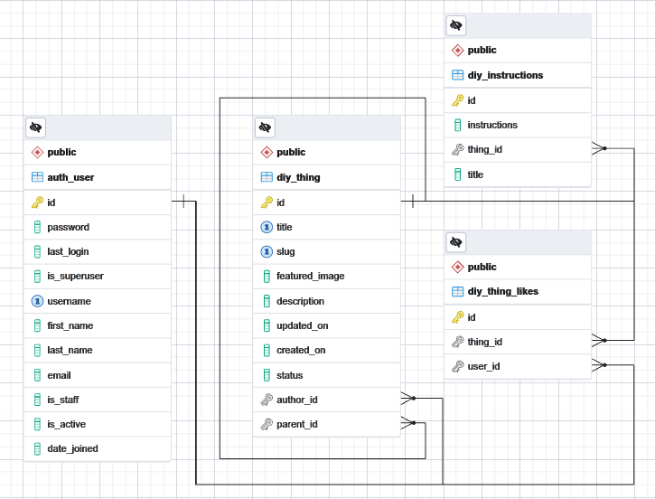
The table named `diy_thing` stores the details of DIY projects and DIY components. A special detail of the implementation is that this table has a cyclic reference to itself in order to accommodate a tree structure for the DIY components, which in turn are DIY projects themselves.
The table named 'diy_instructions' stores the details of the DIY Project Instructions and a 'one-to-many' relationship with its corresponding DIY Project.
The table called `diy_thing_likes` functions as an intermediate table that stores references to all of each user's favourite DIY Projects as a `many to many` relationship.
All these tables are automatically created by Django from the application model classes `Thing` and `Instructions`, so with only two classes, all the necessary database structure is created.
Although there is no specific class for the diy_thing_likes table, it is also produced by Django when it recognizes the `many-to-many` relationship in the `Thing` class in the application model.

Features

Users Home page
The home page or landing page is presented on the root page of the site's domain. Since the sole purpose of this website is to share personal DIY projects, I designed it in a minimalist way with a single carousel banner that explains the purpose of the site and a paginated list of DIY projects available for sharing, where each of the DIY projects is represented by a link showing its title, featured image, author, time of publication and number of likes.
When an unregistered user browses the site, a link at the top of the page encourages them to register and redirects them to the registration page. On the other hand, if the user is already logged in, the link will encourage them to view and rate the DIY projects, and this link will redirect them to the list of DIY projects below..
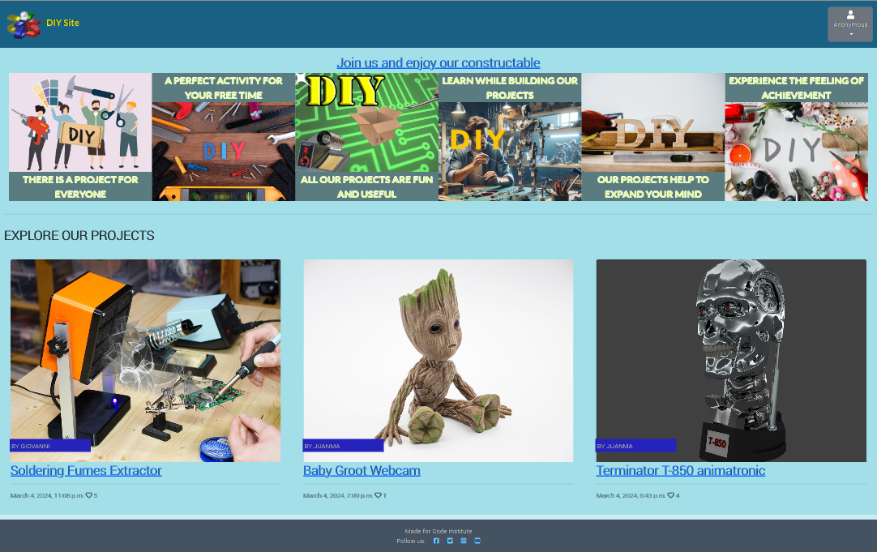

Footer
The main navigation bar appears at the top of all user web pages containing links to the social media sites where the website owner have presence.

Users Navigation Bar
The main navigation bar appears at the top of all user web pages, and maintains the minimalist style. It displays only the site's logo and name, as a link to the home page, and a drop-down menu that allows the user to access registration, login, logout and other functions.
The drop-down menu is located in the top right corner and is represented by a user icon containing the user's name if signed in.

User Dropdown Menu
This menu is located at the top right of the user's navigation bar, and its drop-down content varies depending on the user's context.

User Menu options:
- Sign Up: This menu option redirects the user to the accounts/registration web page so that he/she can self-register on the website.
- Sign In: This menu option redirects the user to the accounts/login webpage so that the user can sign in the website with an email address
- Sign Out: This menu option redirects the user to the accounts/logout webpage so that the user can sign out the website.
- E-mail: This menu option redirects the user to the accounts/email webpage so that the user can self-manage his/her email addresses.
- Admin: This menu option redirects the user to the admin web page so that he/she can perform administrative tasks.

Drop-down Menu content.
Anonimous User | Regular User | Administrators/Content Creators
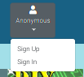 | 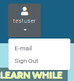 | 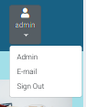

Sign Up
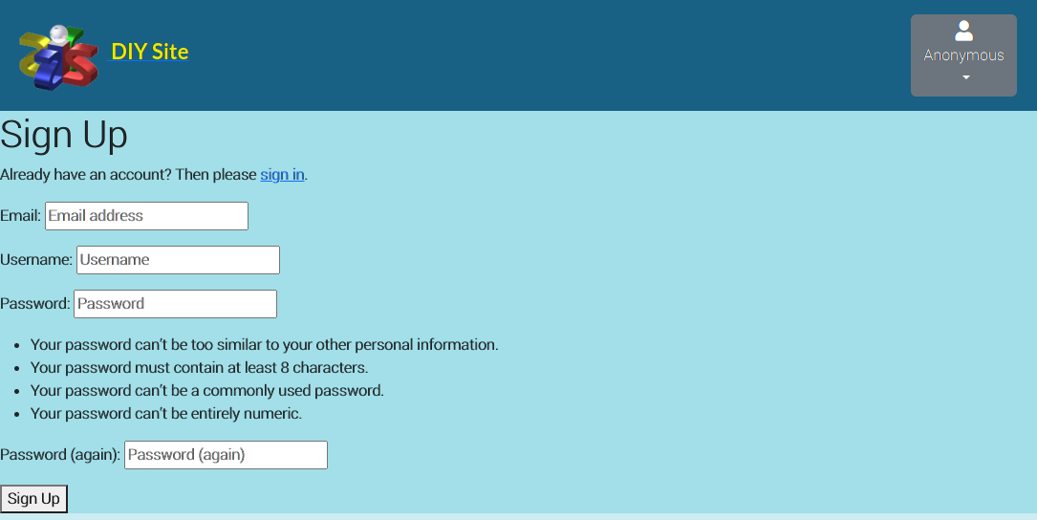

Sign In
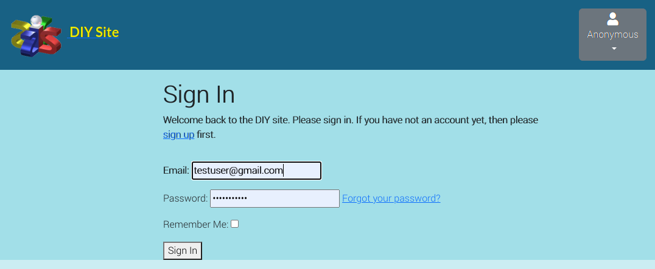

Sign Out
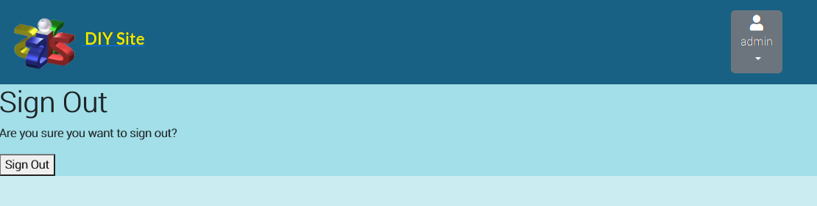

Email
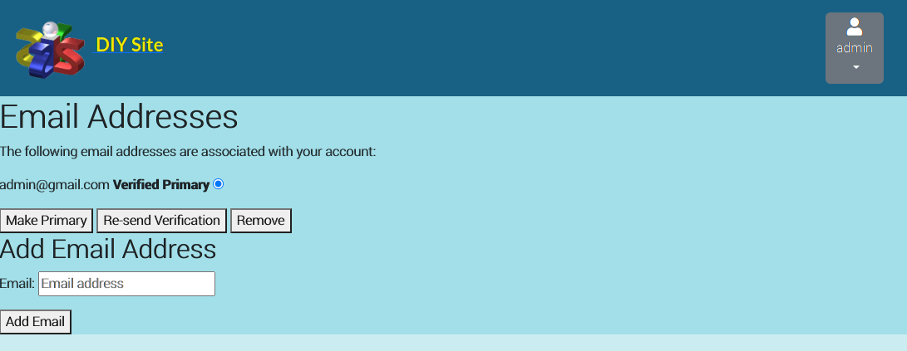

DIY Project details
Once the user has selected a DIY project link, the details web page is displayed giving access to the details, the DIY components and the Instructions, so that the user can follow them to reproduce the object described in the project..
The layout of this page is highly dependent on the design of the DIY project content creator, as the description fields and instructions are displayed as HTML documents that can be fully customized with colours and images, allowing for a very flexible result.The order in which the information is presented is one of the few limitations that have been set when displaying the DIY project.

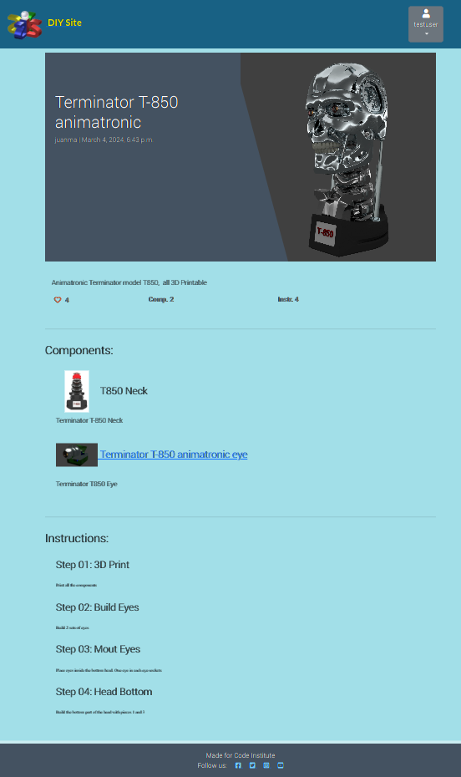

Administration pages
All the administrative tasks have been delegated to Django Allauth extensions, wich brings a lot of development releaf, but also comes with layout design limitations. Only the logo, website name and color schemas are customized using a modified copy of the original Django Allouth templates.

Content Creators homepage
This page gives the content creators access to all DIY project (Things), individual instructions documents or any document attachment stored by Django's Sumernote extension.
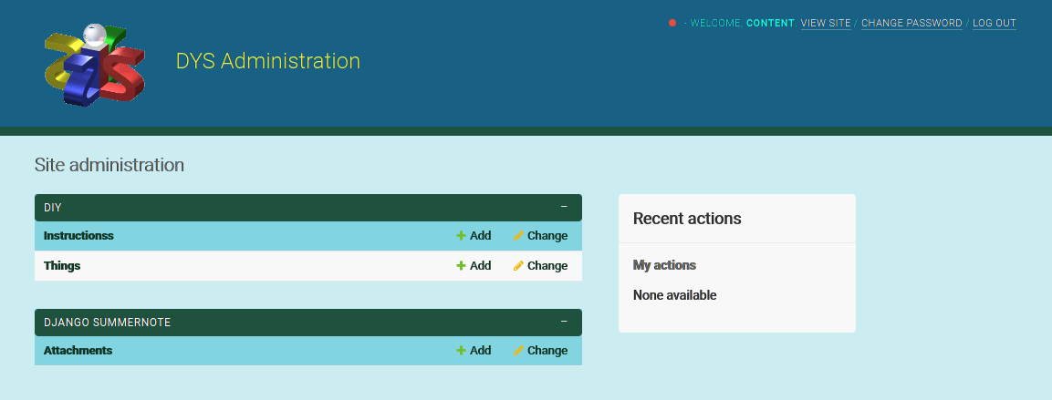

DIY-Things webpage
This page provides a list of the DIY projects (Things) created. The filter pannel will allow the creator to narrow down the list based on its parent project, the published status and the creation date. We can also search a particular text in the title or description text of the DIY projects if we want to locate a particular project.
Marking the desired Things we can use the Delete/Publish/Set as draft actions on any number of selected Things at once.
Clicking on any Thing's tytle from the list will present the Change Thing page for the selected Thing, where all the DIY Project data can be edited
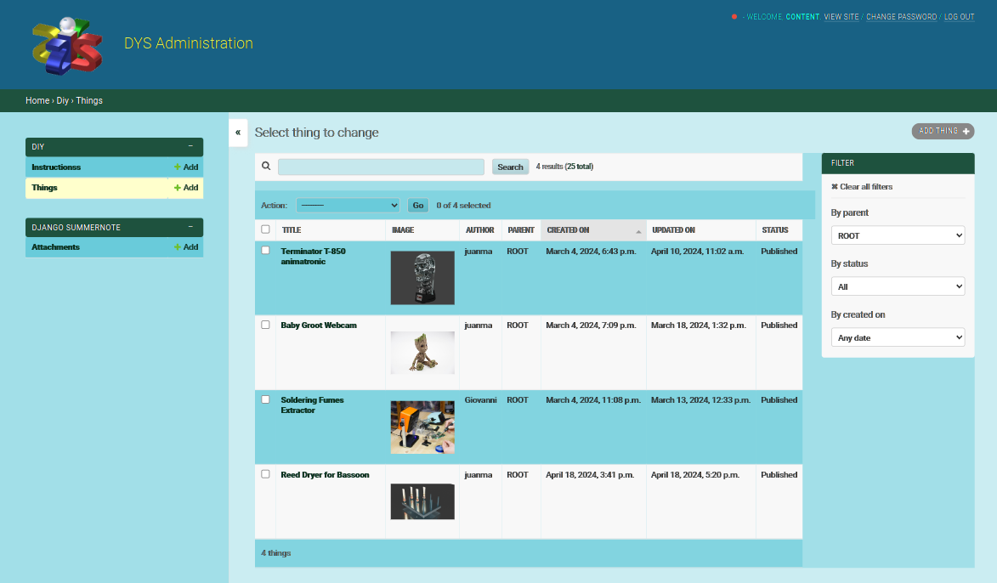

Change Thing webpages
This is probably the most complex administrative web page on this website. It combines the functions of adding/deleting/modifying DIY project details, components and instructions on a single page. It is designed so that the Creator can manage the DIY project information without having to navigate through many pages or make unnecessary clicks.
Once you have made changes to your DIY Project, there are three ways to save. Save all changes and return to the list, save all changes and continue editing in the current DIY Project, or save all changes and create a new blank DIY Project. Exiting this page or reloading without saving, will immediately delete all changes made to the DIY Project.
On this web page we can distinguish three areas: the details of the DIY Project at the top, followed by the list of components called "Things", and at the bottom, the list of instructions called "Instructions".
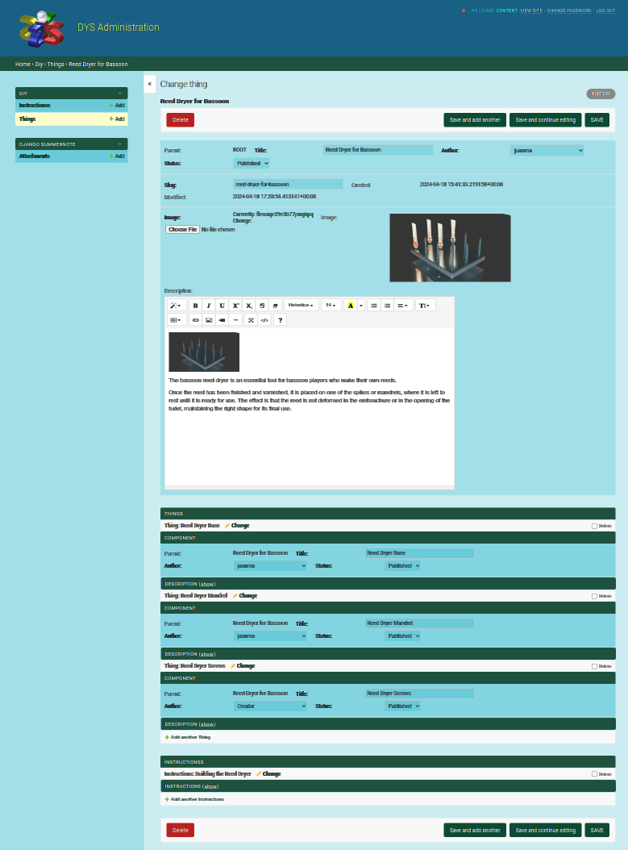

Change the DIY Project details
This upper area of the "Change Thing webpage" allows the content creator to change the Title, the Author, and the Status (Draft/Published). It allows also to assign a Featured Image that will be used in the list of DIY Projects at the home page.
The most important element that can be modified in this area areis the Description. This field has an embebded WSIWYG editor from the Django Sumernote extension, that allows to insert text, images, videos, links and any HTML/CSS needed to present the project. It is the responsability of the creator to write a description that will be displayed correctly to the final user .
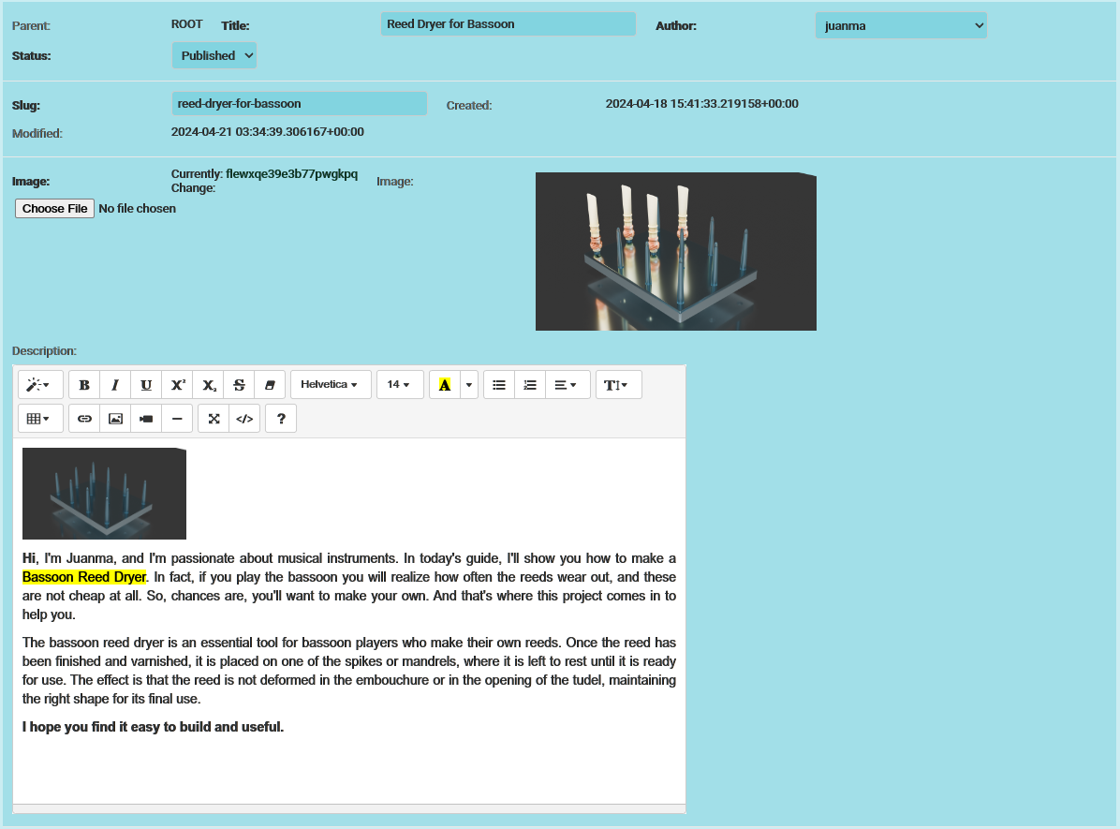DIY Project (Thing) details

Change the DIY Project Components (Things)
The DIY Components (Things) of a DIY Project (Thing) are in fact themselves Thing elements, so they can also be edited like a normal DIY Project. The only difference is that DIY Components have a "parent" object to which they belong.
New DIY Components can be added using the "Add another Thing" link at the bottom of the list.
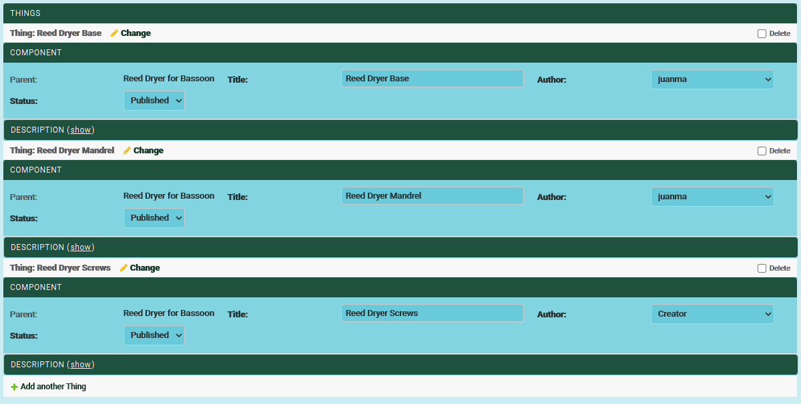Default DIY Componets list
On the Change Thing web page, each of its DIY Components are listed under "Things", and only their Title, Author, Status and Description are shown. To minimize screen space and rendering time, the Description is hidden by default, but can be displayed and edited using the `show` link next to the 'DESCRIPTION' label.
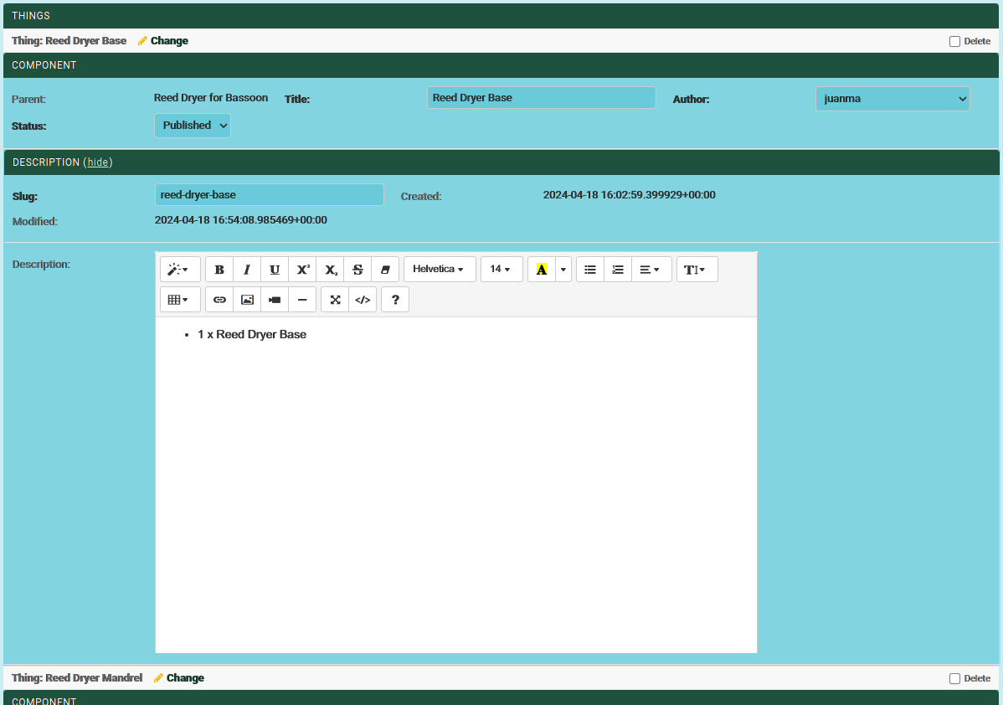DIY Component `show` Description
The rest of the information about a DIY component is not displayed, but can be edited by clicking on the 'change' link next to the DIY component name, which will bring up a new, separate modal Change Thing page for this DIY component.

Change the DIY Project Instructions
On the Change Thing website, each of your DIY Instructions is listed under "INSTRUCTIONSS", and only its Title is displayed. To minimise screen space and rendering time, the Description is hidden by default, but can be displayed and edited using the `show` link next to the 'INSTRUCTIONS' label.
Note: The list name "INSTRUCTIONSS" is automatically created by Django admin based on the name assigned to the class model. More research on Django is needed to modify this name or further customize the layout of the list.
The list of Instructions is ordered by Title. This is useful if you need to maintain a particular order in the instructions, so assigning titles such as "Step 01", "Step 02", etc. could be used to maintain a strict order.
New Instructions elements can be added using the "Add another Instructions" link at the bottom of the list.
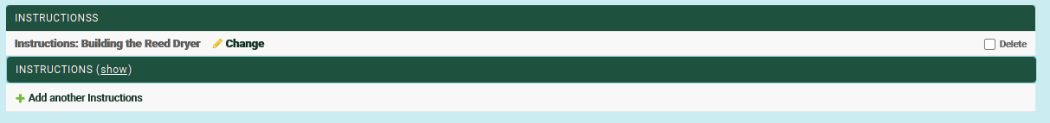Default DIY Instructions list

Instructions field, like the Description fields, has an embebded WSIWYG editor from the Django Sumernote extension, that allows to insert text, images, videos, links and any HTML/CSS needed to present the instructions. It is the responsability of the creator to write a Instructions element that will be displayed correctly to the final user .
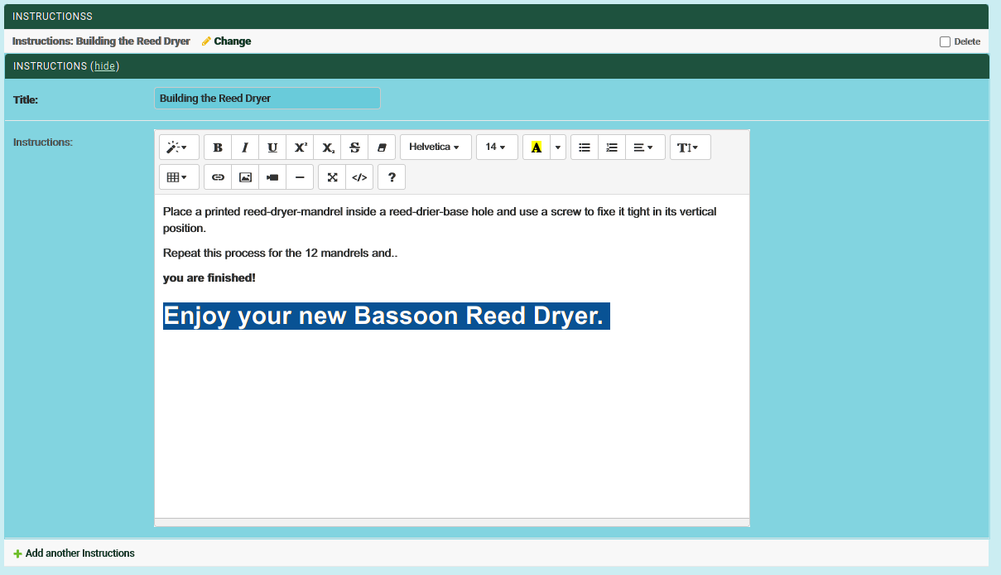DIY Instructions element `show` Description
The Instructions element can be also edited by clicking on the 'change' link next to the DIY Instructions element title, which will bring up a new, separate modal Change Instructions page.

DIY-Instructions webpage
This page provides a list of the Instruction items created, and is a convenient way to access a particular Instruction item without having to open the DIY Project to which it belongs.
The filtering panel will allow the creator to narrow down the list according to their DIY Project (By Thing) or by the parent of the DIY Project. It is also possible to search on a specific text in the title or in the text of the DIY Project Instructions if we want to locate a specific Instructions element.
By marking the desired Instruction items, the Delete action can be used on any number of selected Instruction items at the same time.
Clicking on the title of any Instructions item in the list opens its Change Instructions page, where the Instructions data can be edited.
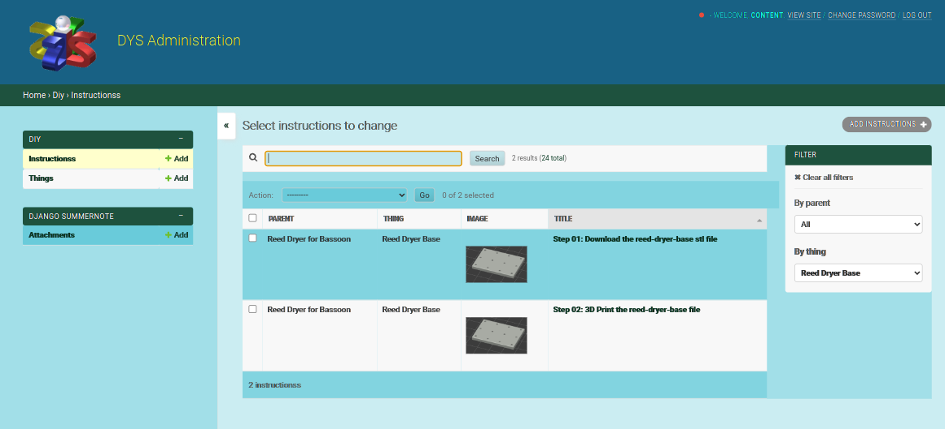

Change Instructions webpage
In this page Instructions item data can be edited.
Once all the required changes to the Instructions item have been made, there are three ways to save the data. Save all changes and return to the list, save all changes and continue editing in the current Instructions item, or save all changes and create a new blank Instructions item. Exiting this page or reloading without saving, will immediately delete all changes made to the Instructions item.
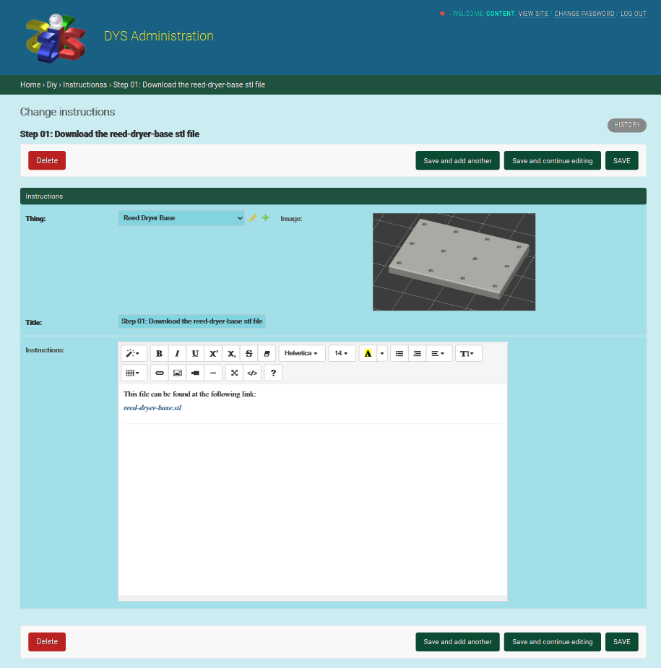

The Instructions field has an embebded WSIWYG editor from the Django Sumernote extension, that allows to insert text, images, videos, links and any HTML/CSS needed to present the instructions. It is the responsability of the creator to write a Instructions element that will be displayed correctly to the final user .
The Instructions elements are presented to the end user sorted by Title. This is useful if a particular order needs to be maintained in the instructions, so assigning titles such as "Step 01", "Step 02", etc. could be used to maintain a strict order. Special care should be taken when changing the Title, as it may affect the order in which the instructions are presented to the end-user.

Administrators webpage
This web page is only available when the user is an administrator, and provides full access to all website settings.
This documentation only shows the main admin page, as the DIY pages are the same as described for content creators, and the rest can be found in the Django documentation.
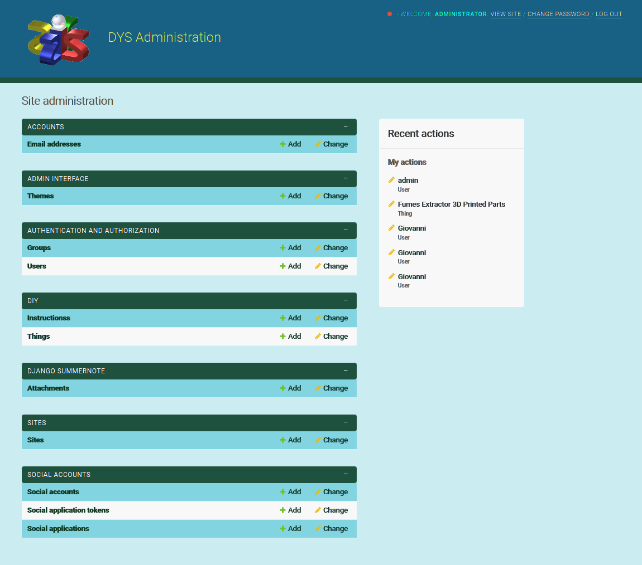

Future Enhancements
In the current project it is assumed that content creation is done by administrators and staff, who have unrestricted access to all content in the system, and that users can only browse a master list of DIY projects. In a future implementation, the following capabilities would be desired:
- Users should be able to browse the list of their favorite DIY Projects
- The list of DIY projects should be prioritised based on user ratings.
- Users should be able to filter and search the DIY project database
- Projects should be clasified by DIY Project type
- Users should be able to comment on any DIY Project
- There should be a moderator function, automatic or manual, to validate and control user comments.
- Users should be able to loging using their social networks accounts
- The user should be able to exchange messages directly with other users.
- Users should be able to upload and modify their own DIY projects by becoming content creators.
- Users should be able to modify their own DIY projects
- A shopping bag should be implemented for user to buy published DIY-Projects
- A online payment system should be added to the website.
- Grant access to free content and restrict user access to pay per view content
- Users should be able to put a price on their DIY projects
- Users should be able to buy DIY Projects
- Users should be able to receive compensation for their DIY projects sold.
- Users should have the option to donate for any free shared content

Testing

Testing Strategy
Since the webpages for the unknown or regular users that are the webpages handled from scratch by the project which are minimalistic and simple, and the administrative pages are mostly handled by a well tested Django Allauth extensions, I decided that a manual testing strategy for the application can be easyer to deploy and more effective in terms of time and human efforts.
As for the code validation, I use online applications to check that the source code for all the languages used are in line with the required standards.

Testing the application
Most of the bugs have been detected and fixed in the development process. And Deployment in heroku counts for me as a Smoke Test for the application. Then all the specific features can be tested.
In order to test most of the developed features, I created a list of test cases to run in the deployed website
TC1 Unregistered used website navigation
Performed | Step | Description | Expectations | Result | Pass | Additional info
x | 1 | navigate to the home page | Home page should be shown | correct | x | -
x | 1 | The banner carrousel | automatically move left one picture evey 3-4 seconds | correct | -
x | 3 | Click on header brand logo | redirects to home page | correct
x | 3 | Click on header brand name | redirects to home page | correct
x | 3 | Click on user menu button | offers only `Sign Up`/`Sign In` options | correct
x | 3 | Click on `Sign Up` option menu | redirects to the sign-up page | correct
x | 3 | Click on `Sign In` option menu should redirects to the sign-in page |  | correct
x | 2 | Click on 'join us ..' link should redirect to the sign-in page |  | correct | -
x | 3 | Click on `<` on the banner carrousel should make the carrusel move one picture left |  | correct | -
x | 3 | Click on `>` on the banner carrousel should make the carrusel move one picture right |  | correctx | -
x | 3 | Click on any DIY project featured picture redirects to that DIY Project details page |  | correct
x | 3 | Click on any DIY project Title redirects to that DIY Project details page |  | correct

Validator Testing
All code files were validated using suitable validators for the specific language. The full details can be found in the testing.md file. All code passed the validation, with only code generated by other parties producing errors or warnings.
- Django built in code within the settings file produced five line length errors.
- Bootstrap code produced 260 warnings in the CSS validation.
- Fontawesome cdn produced 6 HTML validation errors relating to css variables within the cdn css code.
- The HTMX library that is inserted into the HTML template by django produces a warning stating that the link does not need to have the javascript file type declared.

Notable Bugs
The use of CloudinaryFields for the images in the recipe and profile models does not enforce input validation to image file types. I could also not find anything related to enforcing the file types within the cloudinary documentation. This enabled users to attempt to upload non-image file types. To combat this issue, within the view that handles the form submission, I utilised a try, except statement that attempts to upload the file, but if the upload fails due to the file type error on the cloudinary servers, it gracefully handles the error and provides the user with an error message informing them what happened and why. This prevents users from breaking the functionality of the site, whilst still enabling them to correct the file they are trying to upload.
Development bugs: One major bug encountered during development still has me puzzled. I would repeatedly be unable to access the deployed site through Google Chrome on my home computer. Other users and I could access the deployed site on Google Chrome on other computers without issue, or in other browsers on the developement computer, however something on the computer used for development of the site would cause an issue repeatedly in chrome. This created a number of issues during the development of the site that had to be overcome.
No other bugs of note were found during development of the site. Several minor bugs were encountered due to small logic mistakes or scenario's unaccounted for, however these were found during the several rounds of testing and corrected. There are no known bugs left in the site.

Technologies Used
- Python
  - The following python modules were used on this project:
    - asgiref==3.5.0
    - certifi==2021.10.8
    - cffi==1.15.0
    - charset-normalizer==2.0.12
    - cloudinary==1.29.0
    - cryptography==36.0.1
    - defusedxml==0.7.1
    - dj-database-url==0.5.0
    - dj3-cloudinary-storage==0.0.6
    - Django==3.2
    - django-allauth==0.48.0
    - django-htmx==1.9.0
    - gunicorn==20.1.0
    - idna==3.3
    - oauthlib==3.2.0
    - psycopg2==2.9.3
    - pycparser==2.21
    - PyJWT==2.3.0
    - python3-openid==3.2.0
    - pytz==2021.3
    - requests==2.27.1
    - requests-oauthlib==1.3.1
    - six==1.16.0
    - sqlparse==0.4.2
    - urllib3==1.26.8
- Django
  - Django was used as the main python framework in the development of this project
  - Django AllAuth was utilised to provide enhanced user account management functionality.
- Heroku
  - Was used as the cloud based platform to deploy the site on
- Heroku PostgreSQL
  - Heroku PostgreSQL was used as the database for this project during development and in production.
- HTMX
  - HTMX is a JavaScript library that enables forms to be submitted and data to be retrieved from the backend without refreshing the entire page. It was used extensively for pages that included form submission such as the creation of the recipes where creating ingredients in another model, and creating steps in a third model was required. This package provided a simpler approach to using multiple formsets and custom JavaScript.
- JavaScript
  - Custom JavaScript was utilised to enable the colour scheme functionality, the mobile menu, the enabling and disabling of buttons on forms to prevent users inadvertantly causing errors when trying to submit multiple forms at the same time, and to display the current image in the form rather than a hyperlink to the image itself.
- Bootstrap 5.13
  - Bootstrap was used for general layout and spacing requirements for the site.
- Font Awesome
  - Was used for access to several icons for different sections where icons were appropriate.
- CSS
  - Custom css was written for a large number of areas on the site to implement custom styling and escape a bootstrap look and feel to the site.
- Jinja/Django Templating
  - Jinja/Django templating language was utilised to insert data from the database into the sites pages. It was also utilised to perform queries on different datasets.
- HTML
  - HTML was used as the base language for the templates created for the site.

Packages Used
- VS Code was used to develop the site
- Git was utilised for version control and transferring files between the code editor and the repository
- GitHub was utilised for storing the files for this project
- Balsamiq was utilised to develop wireframes for the site from which the design was based
- Adobe Illustrator was used to adapt images for use within the site.
- DrawSQL.app was used to develop the database schema during development

Resources Used
- The Django documentation was used extensively during development of this project
- The HTMX documentation was used as a reference source for the development of the HTMX features
- The Django AllAuth documentation was used as a reference and a guide for implementing the package and its features.
- The Cloudinary documentation was used extensively during development to setup the configuration between django and the cloudinary apis
- The Code Institute reference material was used as a general reference for things that I had previously done during the course.
- All other resources used are referenced where appropriate.

Other Libraries Used

Deployment
The site was deployed via Heroku, and the live link can be found here - The Pantry

Project Deployment
To deploy the project through Heroku I followed these steps:
- Sign up / Log in to Heroku
- From the main Heroku Dashboard page select 'New' and then 'Create New App'
- Give the project a name - I entered The-Pantry and select a suitable region, then select create app. The name for the app must be unique.
- This will create the app within Heroku and bring you to the deploy tab. From the submenu at the top, navigate to the resources tab.
- Add the database to the app, in the add-ons section search for 'Heroku Postgres', select the package that appears and add 'Heroku Postgres' as the database
- Navigate to the setting tab, within the config vars section copy the DATABASE_URL to the clipboard for use in the Django configuration.
- Within the django app repository create a new file called env.py - within this file import the os library and set the environment variable for the DATABASE_URL pasting in the address copied from Heroku. The line should appear as os.environ["DATABASE_URL"]= "Paste the link in here"
- Add a secret key to the app using os.environ["SECRET_KEY"] = "your secret key goes here"
- Add the secret key just created to the Heroku Config Vars as SECRET_KEY for the KEY value and the secret key value you created as the VALUE
- In the settings.py file within the django app, import Path from pathlib, import os and import dj_database_url
- insert the line if os.path.isfile("env.py"): import env
- remove the insecure secret key that django has in the settings file by default and replace it with SECRET_KEY = os.environ.get('SECRET_KEY')
- replace the databases section with DATABASES = { 'default': dj_database_url.parse(os.environ.get("DATABASE_URL"))} ensure the correct indentation for python is used.
- In the terminal migrate the models over to the new database connection
- Navigate in a browser to cloudinary, log in, or create an account and log in.
- From the dashboard - copy the CLOUDINARY_URL to the clipboard
- in the env.py file created earlier - add os.environ["CLOUDINARY_URL"] = "paste in the Url copied to the clipboard here"
- In Heroku, add the CLOUDINARY_URL and value copied to the clipboard to the config vars
- Also add the KEY - DISABLE_COLLECTSTATIC with the Value - 1 to the config vars
- this key value pair must be removed prior to final deployment
- Add the cloudinary libraries to the list of installed apps, the order they are inserted is important, 'cloudinary_storage' goes above 'django.contrib.staitcfiles' and 'cloudinary' goes below it.
- in the Settings.py file - add the STATIC files settings - the url, storage path, directory path, root path, media url and default file storage path.
- Link the file to the templates directory in Heroku TEMPLATES_DIR = os.path.join(BASE_DIR, 'templates')
- Change the templates directory to TEMPLATES_DIR - 'DIRS': [TEMPLATES_DIR]
- Add Heroku to the ALLOWED_HOSTS list the format will be the app name given in Heroku when creating the app followed by .herokuapp.com
- In your code editor, create three new top level folders, media, static, templates
- Create a new file on the top level directory - Procfile
- Within the Procfile add the code - web: guincorn PROJECT_NAME.wsgi
- In the terminal, add the changed files, commit and push to GitHub
- In Heroku, navigate to the deployment tab and deploy the branch manually - watch the build logs for any errors.
- Heroku will now build the app for you. Once it has completed the build process you will see a 'Your App Was Successfully Deployed' message and a link to the app to visit the live site.

Forking the repository
By forking the GitHub Repository you can make a copy of the original repository to view or change without it effecting the original repository This can be done by * Log into GitHub or create an account. * Locate the repository at https://github.com/MattBCoding/pp4-the-pantry . * At the top of the repository, on the right side of the page, select "Fork" from the buttons available. * A copy of the repository should now be created in your own repository.

Create a clone of this repository
Creating a clone enables you to make a copy of the repository at that point in time - this lets you run a copy of the project locally: This can be done by:
- Navigate to https://github.com/MattBCoding/pp4-the-pantry
- click on the arrow on the green code button at the top of the list of files
- select the clone by https option and copy the URL it provides to the clipboard
- navigate to your code editor of choice and within the terminal change the directory to the location you want to clone the repository to.
- type 'git clone' and paste the https link you copied from github
- press enter and git will clone the repository to your local machine

Acknowledgements
I'd like to thank the following:
- Daisy McGirr for all her help during this project.
- Sean and Ed at CI Tutor support for their patience and pointing me in the right direction when I went off course.

