**Setting up the FILD2 APDCAM measurement software**

8 October, 2015

S. Zoletnik

# Computer setup

The camera was on since June. it was communicating but sent corrupted data. After switching it off/on the communication is OK.

We got a temporary computer. The name is lxfild.aug.ipp.mpg.de (130.183.204.117 )

User: fild pw: fildcamera

The home directory of the user is on AFS. For the measurement I created a local directory structure under /opt/FILD:

|  |  |
| --- | --- |
| **Directory under /opt/FILD** | **Purpose** |
| Software | All programs. This directory contains packages, ad-hoc programs for data evaluation can be placed into Measurement. |
| Software/IDL | Various IDL packages. The measurement programs are in FILD_measurment |
| Software/APDTest_1G_LInux | The C language control program for APDCAM. |
| Doc | All documentation |
| Measurement | This is the working directory for the measurement. Start IDL from here. |

The computer setup necessary for APDCAM is described in a document in the Doc directory.

# Camera tests

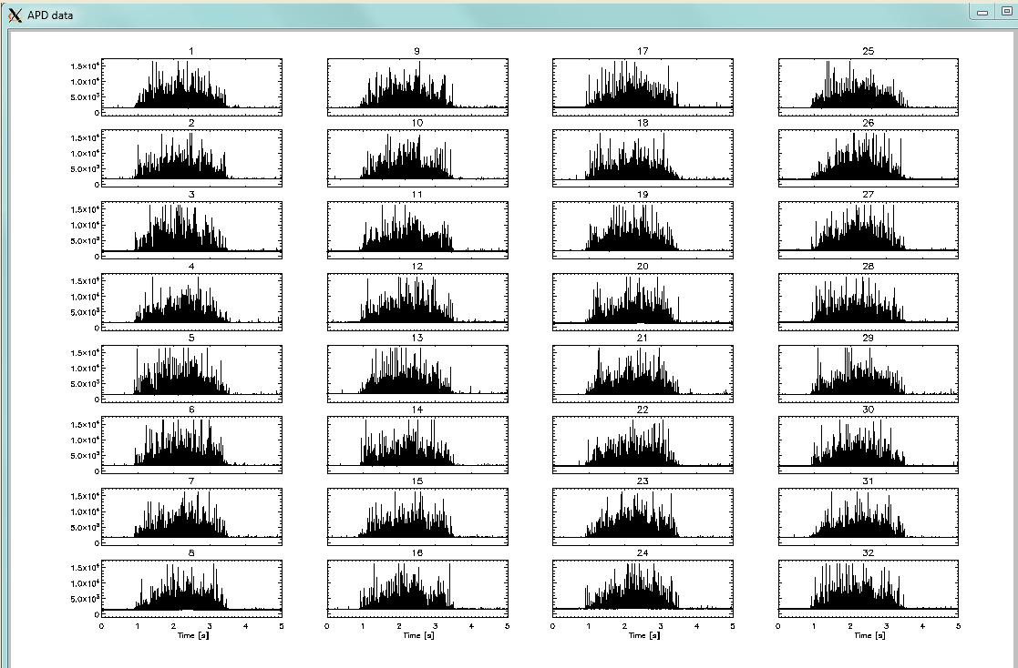The analog signal offsets are set to 1100. The noise level is around 2 mV. The spectra are smooth. Doing a triggered measurement in shot 32278. The triggering works there are some (light) signals during the shot.

# Grounding scheme and connections to the camera

The camera was hanging in the morning of 13 October again. The communication was working but the ADC PLL did not lock. Factory reset did no help. We switched off/on the camera which solved the problem. This did not happen during the shot day.

We connected the APDCAM main power to the FILD2 camera, it can be connected with it. 2 times we have seen that the communication did not start after the power is switched on. This is not reproducible, if it happens the power has to be cycled again. The connection can be tested by pinging the camera from the lxfild computer:

ping 10.123.13.101

The APDCAM trigger is connected from the FILD2 tower. On 12 October we also got a 1 MHz clock from the same tower (Christian Aubanel) which works with a long Lemo cable.

Due to the hanging of the camera I suspect there might be some electric disturbance due to the multiple ground connections. I measured the grounding: APDCAM is grounded to the port. We would need optical isolation for the trigger and clock. Christian will arrange a fibre optical module to drive the trigger and the clock on optics. If that is done it would be necessary to isolate or cut the ground in the power cable which connects power to the APDCAM power supply in the iron box. The power supply is basically ground independent, but the mains ground is connected to the output 12 V -.

# FILD APDCAM measurement program.

The IDL program is called aug_fild_gui, it is located in IDL/FILD_measurement. The run the program go to directory Measurement, start IDL and run aug_fild_gui.

There is a configuration file called AUG_FILD.cfg in directory Measurement. At present it looks the following:

TRIGGER_TIME 0 The time of the trigger pulse

MEASUREMENT_TIME 5 The length of the measurement in seconds

MEASUREMENT_START_TIME 0 The start time of the measurment relative to plasma

APDCAM_ANALOG_OFFSET 1100 The offset of the analog amplifiers

CLOCK_SOURCE INTERNAL The source of APDCAM clock. External or internal

The measurement time and the start time can be adjusted in the graphical user interface (GUI) as well, the values in the configuration file are only for the defaults. The clock source cannot be adjusted in the GUI. If the 1 MHz clock is plugged in normally the last entry would always be EXTERNAL.

# Measuring

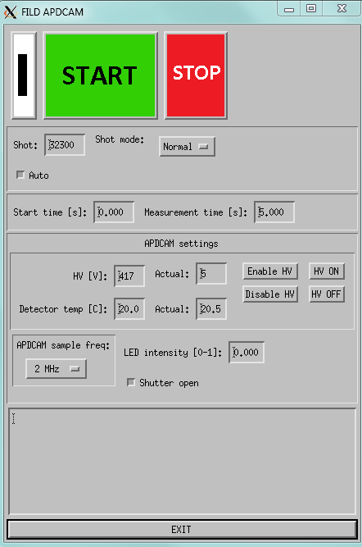The GUI window is shown to the right. There might be small differences depending on the X-server features, e.g. the checkboxes have a checkmark on the Solaris terminals, while it has the dark depressed state on Xming as shown here. When the program is active and user actions are accepted the white-black mark in the upper left corner changes state every second. (Heartbeat.) With each hartbeat the program also reads the camera status. Also the actual shotnumber is read if the “Auto” checkbox is checked and normal shot mode selected.

In the APDCAM settings fields the parameters are sent to the camera when an Enter is pressed on the field.

The program can do two types of measurements: normal and test. Test measurements are done without trigger otherwise they are the same. Data will be stored in a shot directory under Measurement/data/<shot> using the actual shot number in the Shot field.

To start the measurement, first check that the LED intensity is 0. Then set the high voltage. The nominal gain of 50 for this detector is at 417 V. (Detector datasheet is in the Doc directory.) The breakdown voltage is 454 W at 23 C. Press “Enable HV” followed by “HV on”. In response the Actual HV should go to close the set value. (It is usually a bit below.) Also check that the shutter is open.

The measurement can started by the green button and aborted by the red. In normal mode when the “Auto” box is checked the program will wait for the shotnumber to change and arm APDCAM only after that. (To prevent measurement on false triggers.) If the “Auto” box is not checked the camera is armed immediately. This can be used if the measurement is started too late and the shot cycle already started. In test mode no shot number or trigger is waited for.

When APDCAM arms a window pops up. (This can be removed later if not necessary.) When the trigger is received the measurement is done and the popup windows disappears. The data are still in the data directory. Then the program creates the shot directory and places an XML configuration file there with the settings. If a shot directory with the same name exists it is not overwritten but a “_1”, “_2”... extension is added to the name. Finally all the data files are moved to the shot directory and a plot is prepared showing the 32 signals following the pixel arrangement. This plot is done by diag_aug_fild.pro, it can changed as necessary.) the After the shot the shot number is increased. In normal mode the measurement proceeds to the next shot, in test mode the measurement cycle stops.

The measurement time, start time, sampling frequency and detector temperature can be set in the corresponding widgets when the measurement is not active. To exit the program use the big button at the bottom.

# Data evaluation

Data evaluation can be done by command-line IDL programs. A few basic possibilities are shown below:

Read in a signal to IDL variable:

get_rawsignal,0,’APD-<x>-<y>’,t,d,datapath=’data/<shot>’

where <x> and <y> are the row (1...4) and column (1...8) of the pixel. <shot> is the shot number. The signal is returned in d, the time vector in t.

Similarly a signal can be plotted as

show_rawsignal,0,’APD-<x>-<y>’,t,d,datapath=’data/<shot>’

To show all the signals:

show_all_apdcam,datapath=’data/<shot>

This program plots the signals according to their measurement location on the scintillator as seen by the CCD camera. If this is not right the arrangement can be flipped either horizontally or verticallz using the /flip_horizontal and /flip_vertical keywords. These can also be entered into the fluct_local_config.dat file in the Measurement directory so as the right orientation is achieved without keywords.

The above programs accept timerange=[<t1>,<t2>] parameter to limit processing for a time interval. The latter program also accepts various inttime (temporal integration time in microsec) boxcar smooth (in microsec length), bandpass filter parameters. Information is in the program header.

At data read-in the program also does radiation pulse removal (see below) and automatic offset correction by subtracting the mean signal at the beginning of the shot. (The time ranges are seet in fluct_local_config.dat in the Measurement directory.) If the measurement is not done from the beginning of the shot no offset correction is applied.

# Radiation induced pulses

APDACAM is located in teh torus hall, therefore neutrons and gammas cause some noise in the signals. These can beee distunguished from the light signal by their width: they are 1-2 sample wide. Using this property an automatic pulse removal algorithm is implemented in the read-in routines, which is based on the following procedure. The raw signal is differentiated and places are searched for where a positive derivative is above a limit followed by a negative derivative below -1 times the limit. There are other slightly different cases as the pulses happen randomly relative to the sampling. If the above condition is fulfilled the 1 or 2 sample in the signal is replaced by interpolated data.

The selection of the limit is done the following way. The procedure is repeated for different limits and the number of removed pulses is plotted as a function of limit as shown below. In the early phase of the shot there is no NBI heating, negligible neutron flux and therefore there is a negligible number of pulses. (The neutrons are dominated by beam-plasma interaction on present-day devices.) An example plot is shown below in the Ohmic phase (0-0.2 s) of shot 32300. The number of cut pulses falls to practically 0 at a limit of 0.01. Below that the algorithm starts to cut pulses from noise.

The next plot shows the same processing during 1 s of beam operation (3-4s) in the same shot. Clearly there is a break in the curve at 0.1, and the program finds about 8000 pulses in one second at a limit of 0.01. This means somewhat less than 1% of the samples is extrapolated which causes negligible problem. (We measured with 2 MHz sampling rate.)

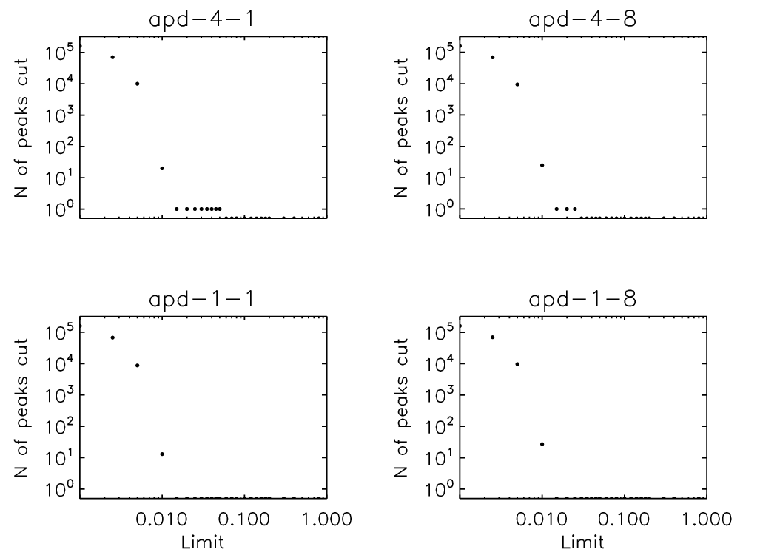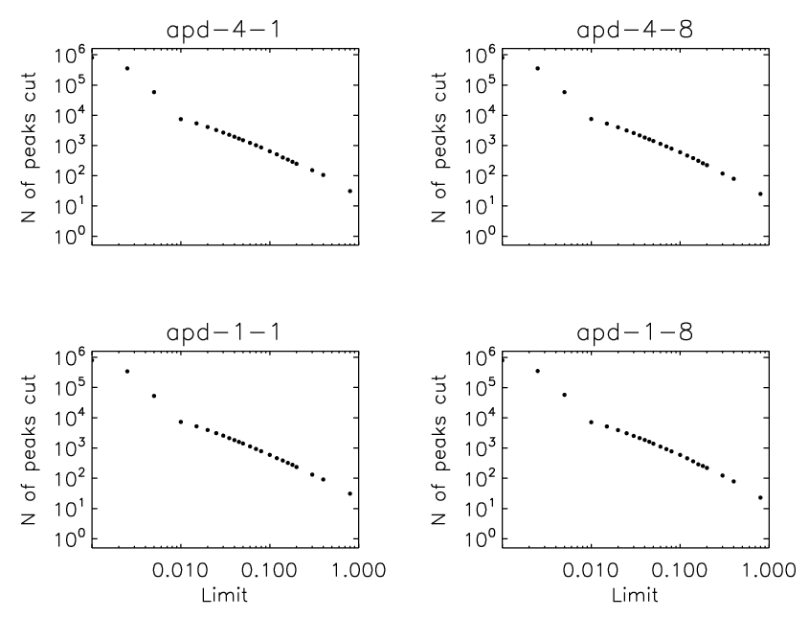

*Number of found radiation induced pulses as a function of amplitude limit for Ohmic (left) and NBI phase of shot 32300.*

The RMS noise level of the signal is about 2 mV, thus the limit is about 5 times the RMS noise level. From an extrapolation of the curve (by eye) one sees that the number of removed pulses at a very low limit is only slightly higher than 10000, therefore in the corrected signal we have not more than a few thousand radiation induced pulses left with an amplitude a few times the noise level. This increases a noies level in the range of 1%, what is negligible.

The number of removed pulses depend on the NBI heating power as the neutrons originate from beam-plasma interaction. This dependence was measured in shot 32304.

*Number of found radiation induced pulses as a function of NBI heating power in shot 32304.*

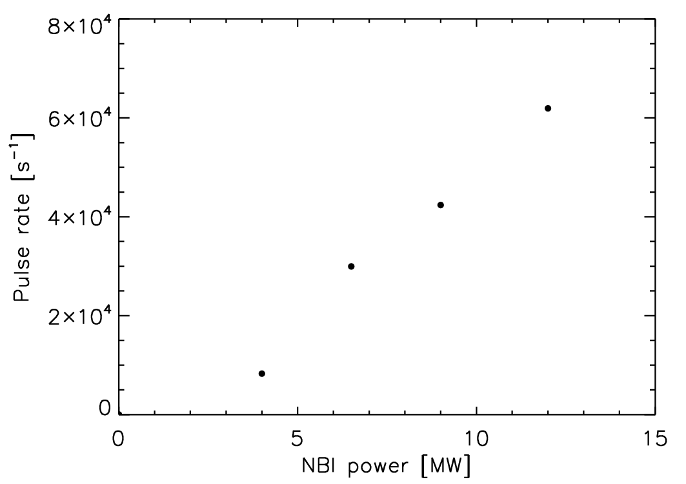

Number of pulses above limit 0.015 in shot 32304 is shown in the Table below and in the plot to the right.

|  |  |  |
| --- | --- | --- |
| Timerange | NBI power [MW] | No pulses |
| 0-0.5 | 0 | 4 |
| 1.5-2.0 | 4 | 4139 |
| 2.2-2.7 | 6.5 | 14980 |
| 2.8-3.1 | 9 | 12713 |
| 3.5-4 | 12 | 30965 |

The number of pulses can reach 6 104 s-1, what affects about 5% of the measurement points. At the highest power pilup of the pulses causes same mV increase of the signal level, therefore some radiation shielding can be considered.

# Tests with lamp

A few tests were done with the calibration lamp of the FILD2 system:

|  |  |  |  |
| --- | --- | --- | --- |
| Test shot No | Lamp status | APD detector voltage | Signal peak level |
| 400 | off | 200 V | 0 |
| 401 | on | 200 V | ~5 mV |
| 402 | on | 350 V | 30 mV |
| 403 | on | 417 V | ~100 mV |
| 404 | off | 417 V |  |

# First measurements

10s is measured from 0s with 2 MHz sampling frequency.

|  |  |
| --- | --- |
| Shot | Comment |
| 32302 | FILD2 head out from plasma. APDCAM HV set to 417 V |
| 32303 | FILD2 head out from plasma. APDCAM HV set to 430 V. |
| 32304 | Number of radiation pulses removed is around few times 104. From the Ohmic phase it looks that the correct pulse limit is about 0.015. Changing to this after the shot. |
| 32305 |  |
| 32306 | First shot of fast particle program. AUG failed, no data |
| 32307 | FILD2 manipulator lost position, probe is out. |
| 32308-  32315 | APD measurement is running but FILD2 manipulator is out from plasma |