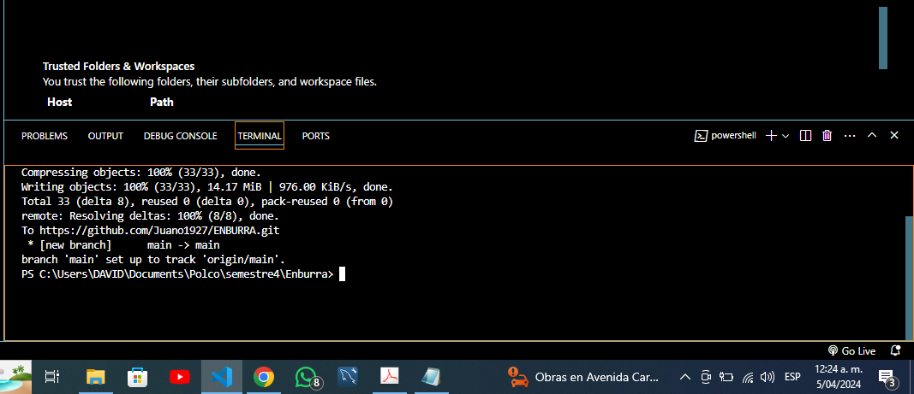

<https://github.com/Juano1927/ENBURRA.git>

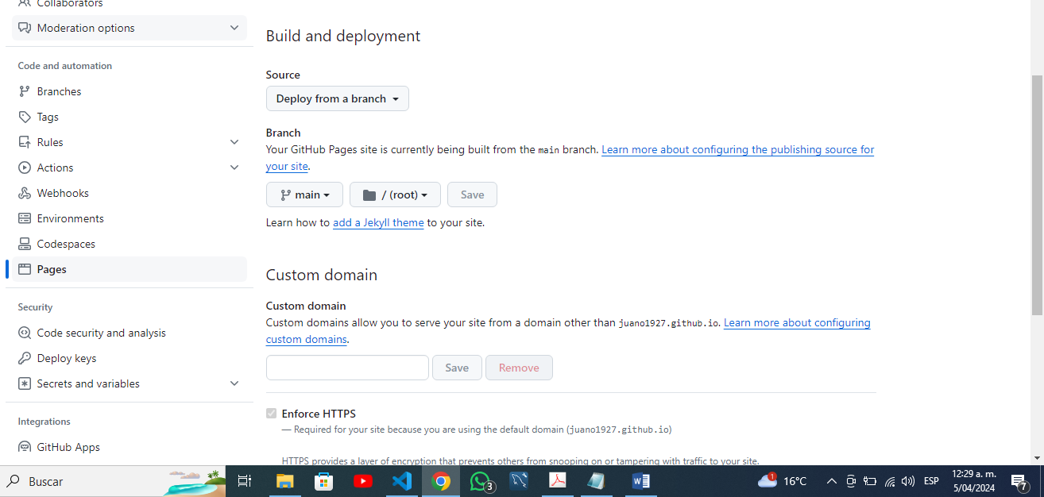

**Your site is live at**[**https://juano1927.github.io/ENBURRA/**](https://juano1927.github.io/ENBURRA/)